Supplementary Materials
This document supplements the manuscript entitled “Establishment and application of real-world datasets for precocious puberty from electronic health records based on large language models”.
Feixiang Zhou, PhD student¹, Taowei Zhong, PhD student¹, Simin He, PhD student¹, Guiyan Yang, MD, PhD¹, Xianglong Ding, MD student¹, Gang Tian, MD, PhD², Shiting Xiang, MD³, Shan Tan, MD⁴, Sha Zhao, MD, PhD⁵,Yan Yan, MD, PhD^{1*}

* Correspondence author:

Yan Yan, Department of Epidemiology and Health Statistics, Xiangya School of Public Health, Central South University, Changsha 410078, Hunan, China.

Email: yanyan802394@126.com

eMethod
eTable 1. Rule-based retrieval
eTable 2. Precocious puberty data element classification framework and identifier arrangement
eTable 3. Description of precocious puberty data element directory and attributes
eTable 4. Prompt engineering based on the CRISPE framework
eTable 5. Information extraction performance of large language model
eTable 6. Model parameters and semantic similarity of inputs and outputs
eTable 7. Correlations between semantic similarity metrics and input length, output length, and average response time
eTable 8.Summary of measurements in female children with precocious puberty
eTable 9.Goodness of fit of growth charts under BCT, BCPE and BCCG distributions in the GAMLSS model
eTable 10. Percentile values for height, weight, and BMI in females aged 4-12 years
eTable 11.Descriptions of GLM-4-9b under prompts to demonstrate knowledge
eTable 12.A summary of some issues in information extraction with the large language model
eFigure 1. Flow diagram of patient selection for follow-up visit prediction and growth charts studies
eFigure 2. Age-specific growth charts in non-hormone treated female children with precocious puberty
eFigure 3. HuggingFists low-code interface for llm-based data processing workflow
eFigure 4. Performance comparison of five large language models on precocious puberty risk factor information extraction from Chinese electronic health records.

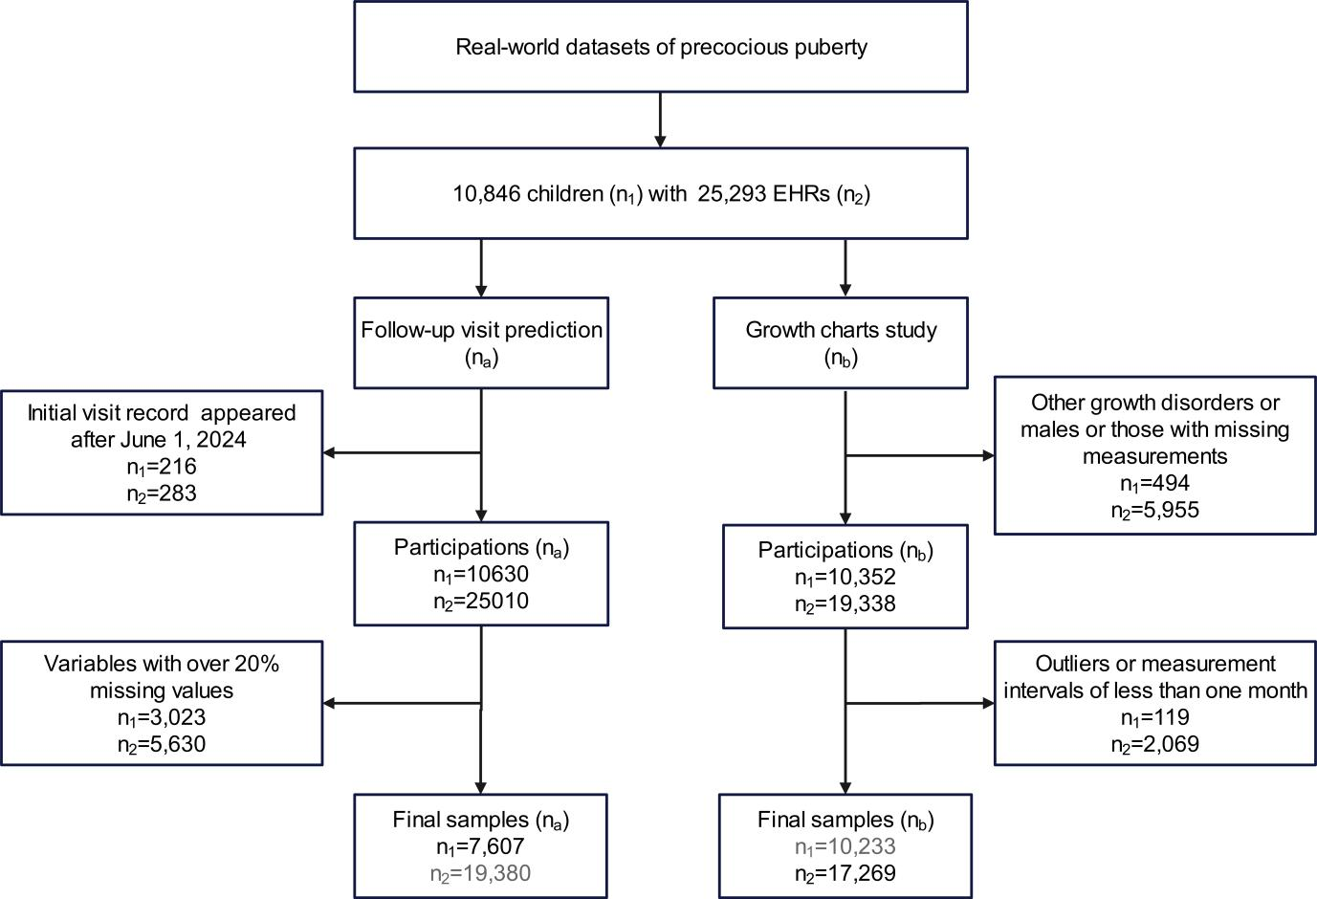

eFigure 1. Flow diagram of patient selection for follow-up visit prediction and growth charts studies. This flow diagram illustrates the patient selection process from the real-world datasets of precocious puberty. Starting with 10,846 children (n₁) contributing 25,293 Electronic Health Records (EHRs, n₂), the datasets were used for two independent studies. Follow-up visit prediction (Left path, n_{a}): Records with initial visits after June 1, 2024 (n₁=216, n₂=283) were excluded, leaving 10,630 participants (n₂=25,010 EHRs). Further exclusion based on variables with over 20% missing values (n₁=3,023, n₂=5,630) resulted in a final sample of n_{a}= 7,607 children (n₂=19,380 EHRs) for the follow-up visit prediction. Growth charts study (Right path, n_{b}): Records for males or those with missing measurements (n₁=494, n₂=5,955) were excluded, leaving 10,352 participants (n₂=19,338 EHRs). Additional exclusions for outliers or measurement intervals less than one month (n₁=119, n₂=2,069) yielded a final sample of n_{b}=17,269 EHRs (n₁= 10,233 children) for the growth charts study, from which height and weight measurements were subsequently used. (n₁ represents the number of unique children; n₂ represents the number of EHRs).

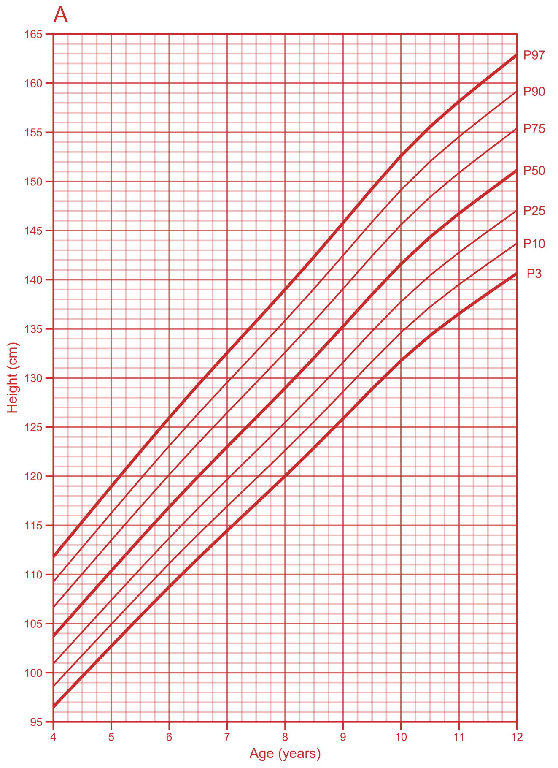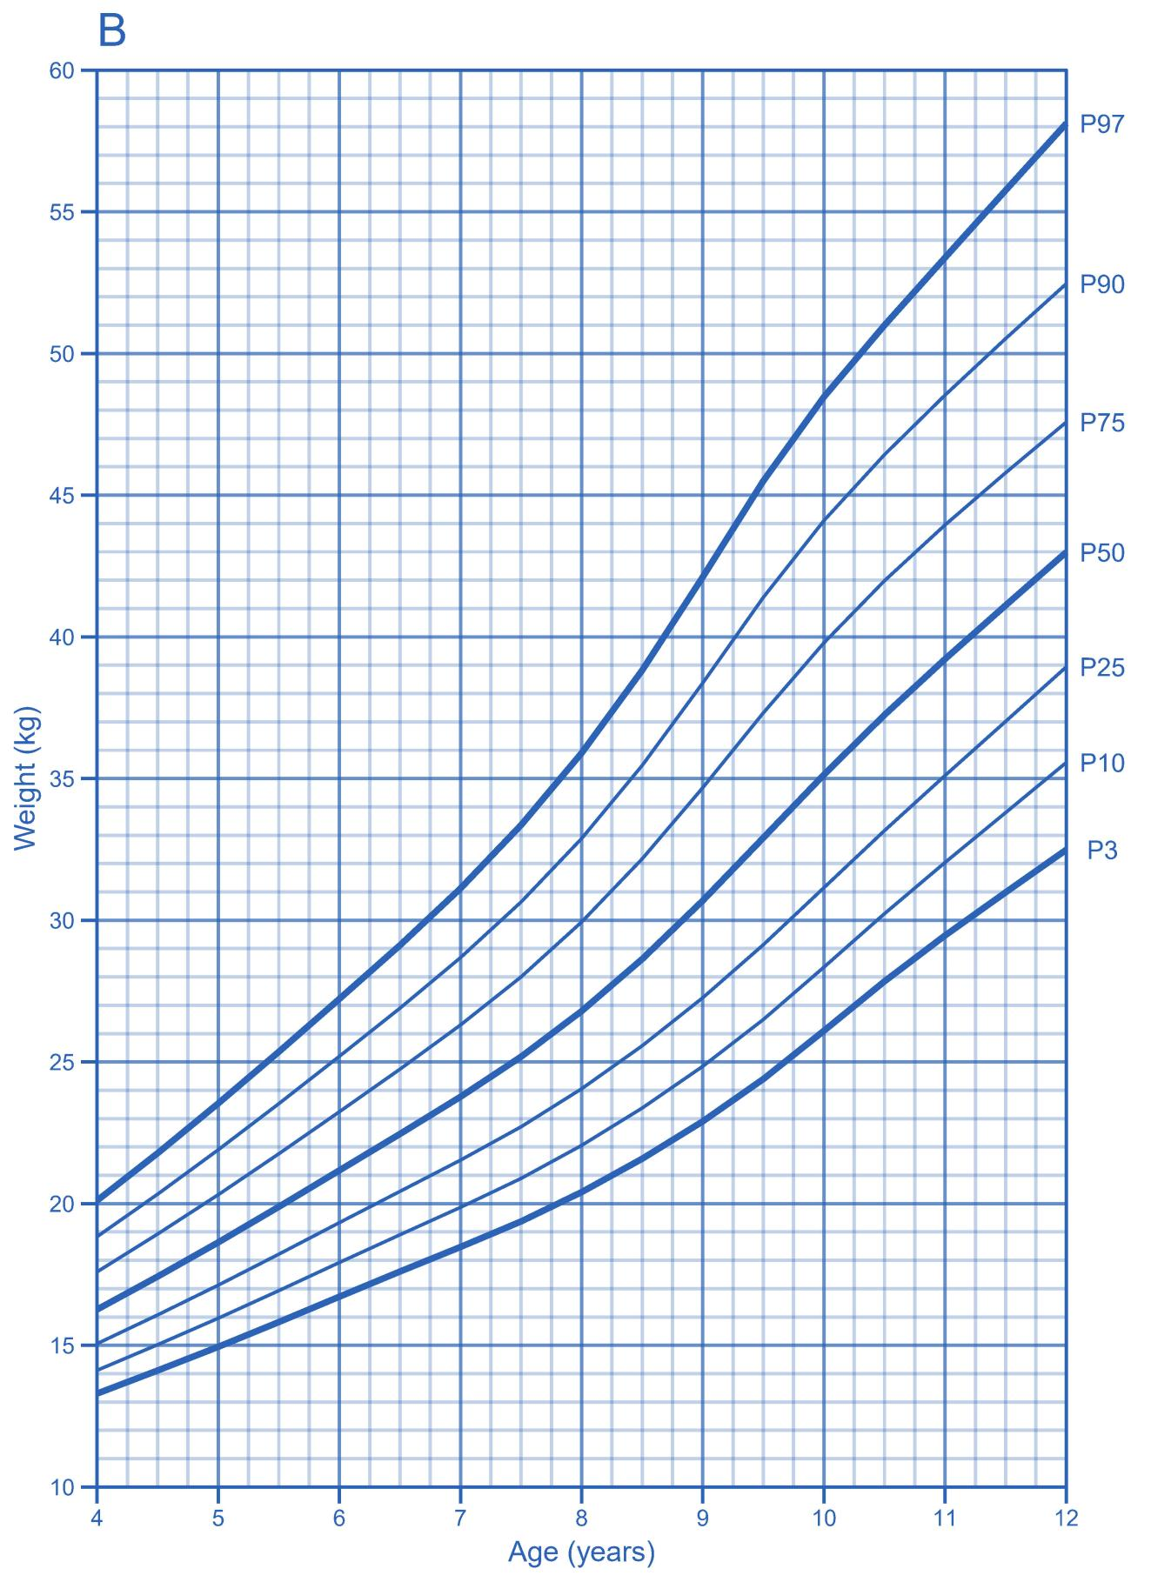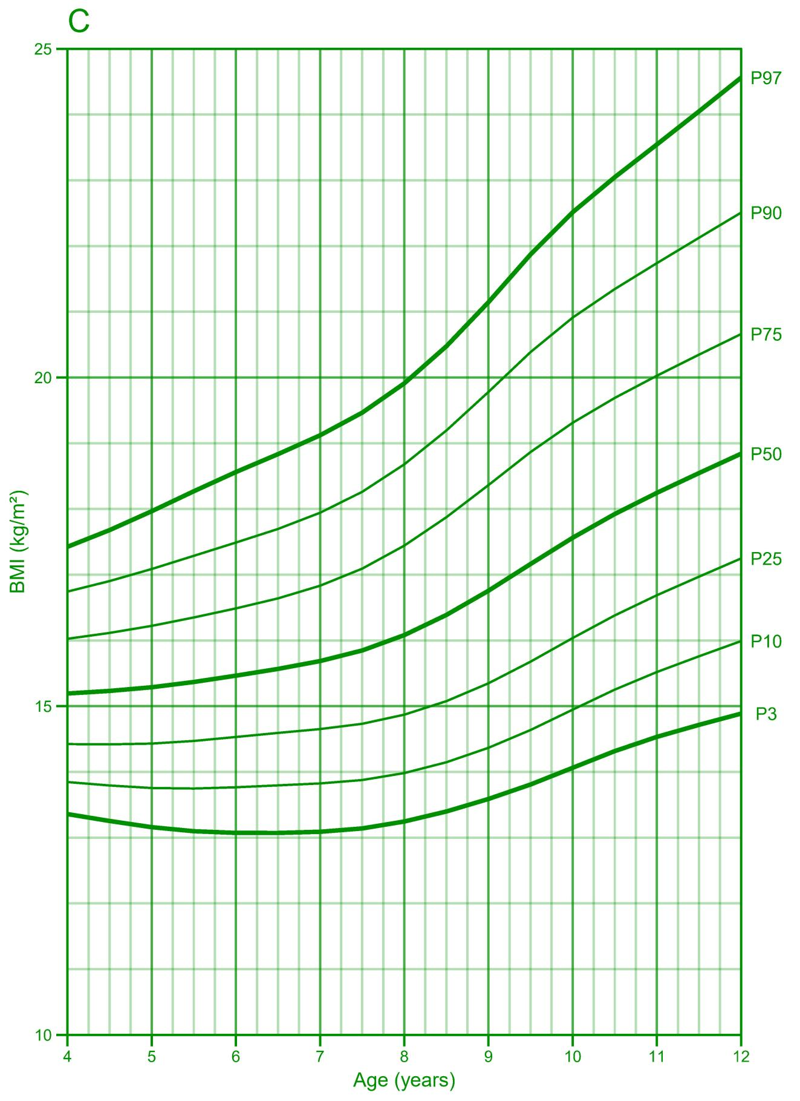
eFigure 2. Age-specific growth charts in non-hormone treated female children with precocious puberty. Growth charts display standard percentile lines (P3, P10, P25, P50, P75, P90, P97) for height (A), weight (B), and BMI (C).

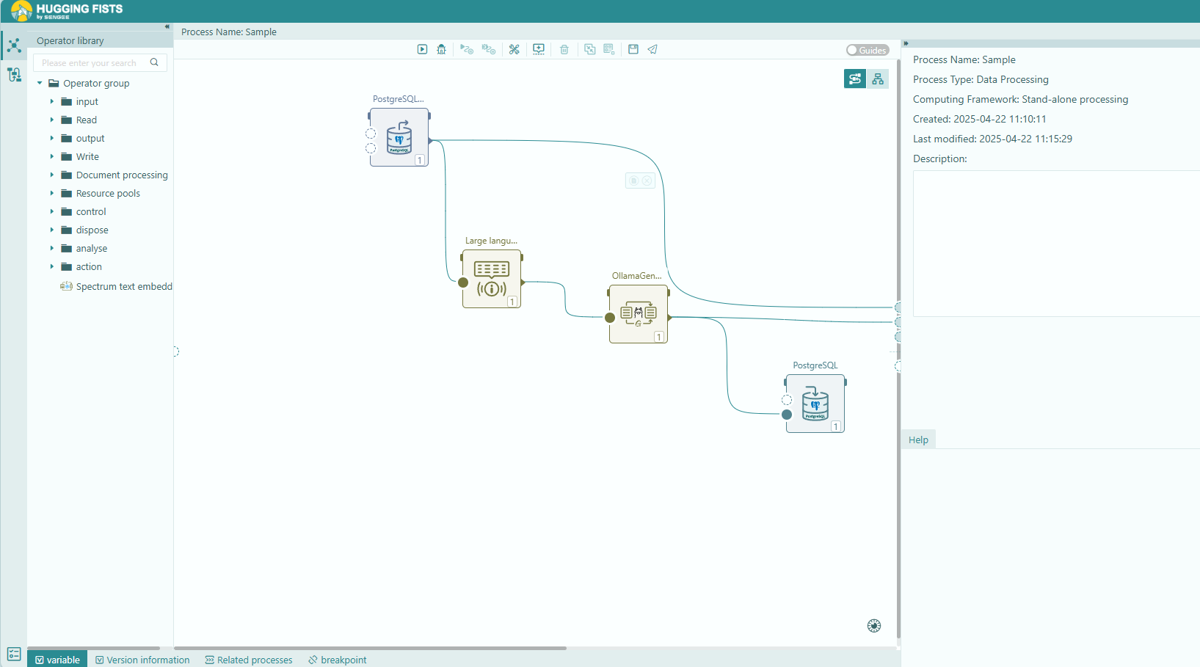
eFigure 3. HuggingFists low-code interface for llm-based data processing workflow. This figure is the HuggingFists user interface, illustrating the low-code, visual data streaming tool used to implement the large language model (LLM) processing component of the workflow. The example process depicted involves: reading data (implied by the 'PostgreSQLReader' operator), processing the text (implied by the 'CommonPrompt' operator), making a call to the locally hosted LLM (implied by the 'OllamaGenerator' operator), and writing the results (implied by the 'PostgreSQLWriter' operator). This visual tool simplifies the integration and execution of LLM tasks for clinical researchers, offering an alternative to traditional programming approaches (e.g., Python API calls).

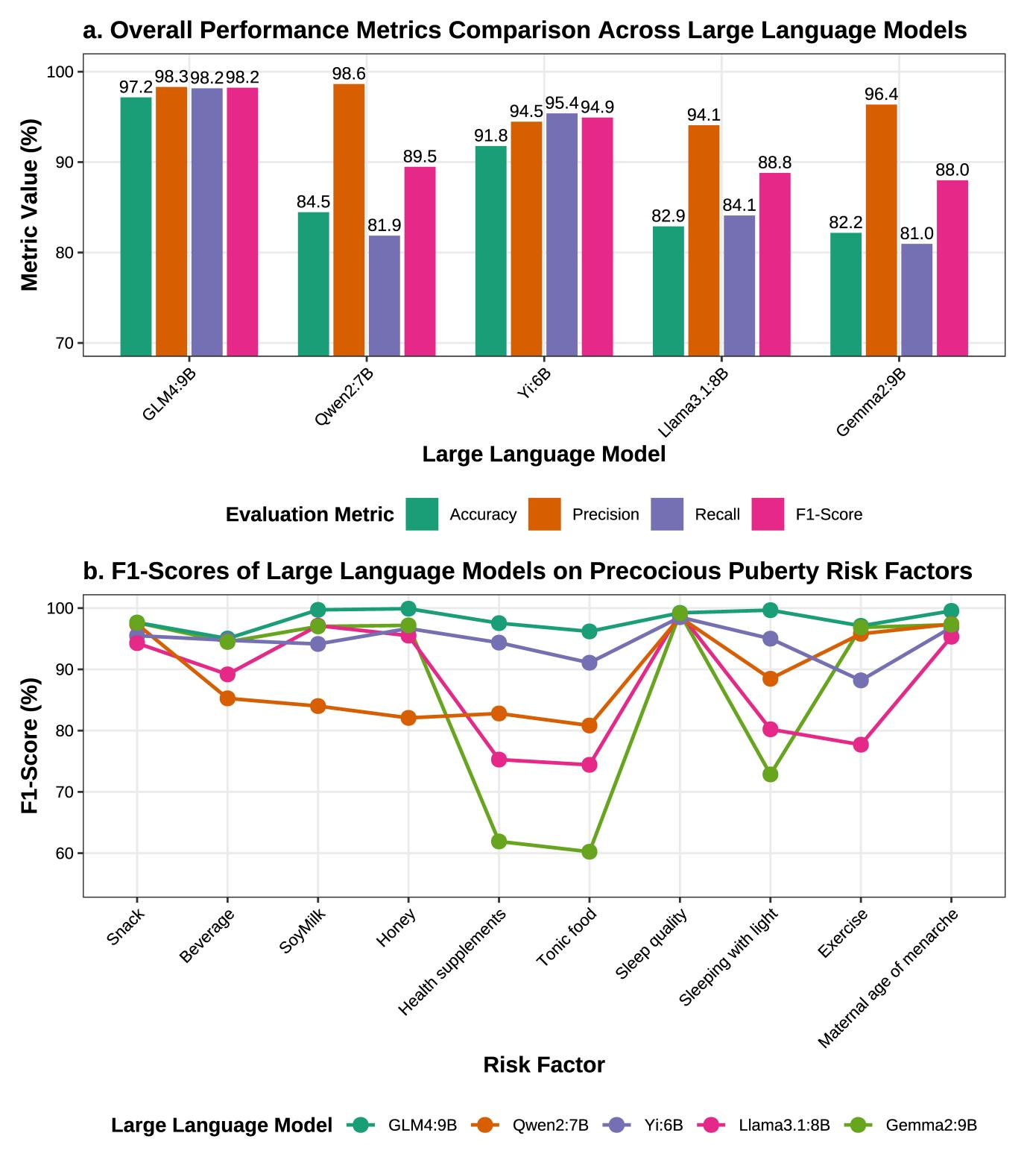
eFigure 4. Performance comparison of five large language models on precocious puberty risk factor information extraction from Chinese electronic health records.
(a) Overall performance of each model across four evaluation metrics (Accuracy, Precision, Recall, and F1-Score). GLM4:9B achieved the highest scores across all metrics, while the remaining models showed varying degrees of performance trade-offs, particularly between Precision and Recall. (b) F1-scores for each model across ten precocious puberty risk factors. GLM4:9B demonstrated consistently high F1-scores across all features, whereas Gemma2:9B and Llama3.1:8B exhibited notably lower performance on certain features, including Health supplement use and sleeping with lights on.

