Electronic Supplementary Material
A Physics-Informed Neural Network Framework for Surrogate Modeling, Inverse Design, and Inverse PINN-Based Material Identification in UV Laser Micro-Machining of Polymer Thin Films
Chae Yoon Shin1, Cheol Hwan Kim1, and Bo Sung Shin2,∗
1Department of Cogno-Mechatronics Engineering Pusan National University, Busan 46241, Republic of Korea
2Department of Optics & Mechatronics Engineering Pusan National University, Busan 46241, Republic of Korea
∗Corresponding author: bosung@pusan.ac.kr
ORCID: 0000-0001-8358-5718

S1 PINN Architecture Details

S1.1 Network topology
The Physics-Informed Neural Network (PINN) is a fully-connected multilayer perceptron (MLP) with the following topology:
Table S1. Complete PINN network topology.
Layer | Type | Units | Activation
Input | Dense | 3 (r, z, t) | -
Hidden 1-8 | Dense | 64 each | tanh
Output | Dense | 1 $\hat{T}$ | Linear
Total trainable parameters: (3×64+64)+7×(64×64+64)+(64×1+1)=29,377.

S1.2 Input/output normalization
All inputs are normalised to the unit interval [0, 1]:
$$\begin{aligned}\tilde{r}=r/r_{max}, \tilde{z}=z/z_{max}, \tilde{t}=t/t_{max} .\#\left(S1\right)\end{aligned}$$
The network output ${\hat{T}}_{raw}∈(-∞,∞)$ is mapped to a physically bounded temperature range via:
$$\begin{aligned}\hat{T}={\hat{T}}_{∞}+(T_{max}-T_{∞})sigmoid({\hat{T}}_{raw})\#\left(S2\right)\end{aligned}$$

S1.3 Weight initialization
Xavier (Glorot) normal initialisation [1] is used for all weight matrices:
$\begin{aligned}W_{ij}\sim N\left(0,\sqrt{\frac{2}{n_{in}+n_{out}}}\right),\#\left(S3\right)\end{aligned}$where n_{in} and n_{out} are the fan-in and fan-out of the layer. Bias vectors are initialised to zero.

S1.4 Activation function choice
tanh was retained as the default activation because it was the most stable choice in the auxiliary architecture sweep. For the reduced hot-zone PP surrogate trained for 3,000 epochs, the best-performing configuration was a 10×64 tanh network (MARE_{p50} = 5.18%, MARE_{p35} = 3.32%), whereas the architecturally matched 8×64 sinusoidal and Swish variants failed badly (MARE_{p50} = 210.7% and 187.9%, respectively). The full PINN therefore retains a smooth tanh nonlinearity, which remains well behaved under second-order automatic differentiation.

S1.5 PyTorch implementation snippet
1  2  3  4  5  6  7  8  9  10  11  12  13  14  15  16  17  18  19  20  21  22  23  24  25  26 | import torch  import torch.nn as nn  class PINN(nn.Module):  def __init__(self, layers):  super(PINN, self).__init__()  layers = [nn.Linear(3, n_neurons), nn.Tanh()]  for _ in range(n_hidden - 1):  layers += [nn.Linear(n_neurons, n_neurons), nn.Tanh()]  layers += [nn.Linear(n_neurons, 1)]  self.net = nn.Sequential(*layers)  self._xavier_init()  def _xavier_init(self):  for m in self.net:  if isinstance(m, nn.Linear):  nn.init.xavier_normal_(m.weight)  nn.init.zeros_(m.bias)  def forward(self, r, z, t):  # Normalise inputs (r_max, z_max, t_max are module-level constants)  r_n = r / R_MAX  z_n = z / Z_MAX  t_n = t / T_MAX  x = torch.cat((r_n, z_n, t_n), dim=1)  out = self.net(x)  # Map to physical temperature range  T_hat = T_INF + (T_MAX_PHYS - T_INF) * torch.sigmoid(out)  return T_hat
Listing 1. PINN model definition in PyTorch 2.0.

S2 Physics-Loss Function Design

S2.1 PDE residual
At N_{f} = 8,000 interior collocation points {(r_{i}, z_{i}, t_{i})} sampled uniformly, the PDE loss penalises violation of the axisymmetric heat-conduction equation:
$$\begin{aligned}R_{i}^{PDE}=ρc_{p}\left({\hat{T}}_{i}\right)\frac{∂{\hat{T}}_{i}}{∂t}-k\left({\hat{T}}_{i}\right)\left[\frac{∂^{2}{\hat{T}}_{i}}{∂r^{2}}+\frac{1}{r_{i}}\frac{∂{\hat{T}}_{i}}{∂r}+\frac{∂^{2}{\hat{T}}_{i}}{∂z^{2}}\right]-Q_{i}\#\left(S4\right)\end{aligned}$$
The non-divergence (constant-coefficient) form $k(\hat{T})∇^{2}\hat{T}$ is used in place of the full divergence operator $∇∙(k∇\hat{T})$, consistent with the approximation described in the main text (Section 2.1) and with the FDM training-data solver.
$$\begin{aligned}L_{PDE}\left(θ\right)=\frac{1}{N_{f}}\sum_{i=1}^{N_{f}}{{\left(R_{i}^{PDE}\right)}^{2}}.\#\left(S5\right)\end{aligned}$$
All derivatives in Eq. (S4) are computed with PyTorch automatic differentiation while retaining the computation graph for second-order gradient flow in the L-BFGS optimiser.
Table S2. Boundary conditions and corresponding loss expressions.
Location | Condition | Expression | Points N_{b}
t = 0 (IC) | $$\hat{T}={\hat{T}}_{∞}$$ | ${\left(\hat{T}-{\hat{T}}_{∞}\right)}^{2}$ | 2,000
r = 0 (axis) | $$∂\hat{T}/∂r=0$$ | ${\left(∂\hat{T}/∂r\right)}^{2}$ | 1,000
Outer surfaces | Convection | ${\left(-k∂\hat{T}/∂n-h_{c}\left(\hat{T}-{\hat{T}}_{∞}\right)\right)}^{2}$ | 2,000

S2.2 Boundary and initial condition losses
$$\begin{aligned}L_{BC}\left(θ\right)=\frac{1}{N_{b}}\sum_{j=1}^{N_{b}}{{\left(R_{j}^{BC}\right)}^{2}}.\#\left(S6\right)\end{aligned}$$

S2.3 Total loss and weighting strategy
$$\begin{aligned}L_{total}\left(θ\right)=L_{data}\left(θ\right)+λ_{PDE}L_{PDE}\left(θ\right)+λ_{BC}L_{BC}\left(θ\right),\#\left(S7\right)\end{aligned}$$
with λ_{PDE} = 0.03 and λ_{BC} = 0.005. These values were selected via a 3 × 3 sweep over λ_{PDE} ∈ {0.01, 0.03, 0.10} and λ_{BC} ∈ {0.001, 0.005, 0.02} (Table S3). The moderate PDE weight provides a balanced gradient signal without overwhelming the data loss.
Table S3. 3 × 3 loss-weight sweep for the full temporal PINN (PP, 3,000 epochs, seed = 42)
λ_{PDE} | λ_{BC} | Val. MARE_{p50} (%) | Val. MARE_{p35} (%)
0.01 | 0.001 | 208.6 | 180.1
0.01 | 0.005 | 190.3 | 168.8
0.01 | 0.020 | 203.7 | 177.3
0.03 | 0.001 | 175.0 | 158.4
0.03 | 0.005 | 165.5 | 152.9
0.03 | 0.020 | 173.5 | 157.7
0.10 | 0.001 | 150.6 | 143.7
0.10 | 0.005 | 152.4 | 144.7
0.10 | 0.020 | 152.1 | 144.5

S2.4 Loss computation snippet
1  2  3  4  5  6  7  8  9  10  11  12  13  14  15  16  17  18  19  20  21  22  23 | def compute_pde_loss(model, r_f, z_f, t_f, Q_f, rho, cp, k_func):  """  r_f, z_f, t_f: collocation points (N_f x 1 tensors, requires_grad=True)  Q_f: laser source at collocation points  """  T = model(r_f, z_f, t_f)  # First-order derivatives (auto-differentiation)  dT_dt = torch.autograd.grad(T, t_f, grad_outputs=torch.ones_like(T), create_graph=True)[0]  dT_dr = torch.autograd.grad(T, r_f, grad_outputs=torch.ones_like(T), create_graph=True)[0]  dT_dz = torch.autograd.grad(T, z_f, grad_outputs=torch.ones_like(T), create_graph=True)[0]  # Temperature-dependent conductivity (non-divergence form)  k = k_func(T)  # Second-order spatial derivatives (auto-differentiation)  d2T_dr2 = torch.autograd.grad(dT_dr, r_f, grad_outputs=torch.ones_like(dT_dr), create_graph=True)[0]  d2T_dz2 = torch.autograd.grad(dT_dz, z_f, grad_outputs=torch.ones_like(dT_dz), create_graph=True)[0]  # Axisymmetric Laplacian: d2T/dr2 + (1/r)*dT/dr + d2T/dz2  lap = d2T_dr2 + dT_dr / (r_f + 1e-8) + d2T_dz2  residual = rho * cp * dT_dt - k * lap - Q_f  return torch.mean(residual**2)
Listing 2. Physics loss computation with automatic differentiation.

S3 Training Hyperparameters and Optimisation

S3.1 Collocation point sampling
Interior collocation points (N_{f} = 8,000) and boundary nodes (N_{b} = 2,400; 1,200 symmetry axis + 1,200 surface) are sampled once from a uniform random distribution at the start of training and held fixed throughout all epochs.

S3.2 Training loop snippet
1  2  3  4  5  6  7  8  9  10  11  12  13  14 | import torch.optim as optim  from torch.optim.lr_scheduler import CosineAnnealingLR  optimizer = optim.Adam(model.parameters(), lr=1.5e-3)  scheduler = CosineAnnealingLR ( optimizer , T_max =6000 , eta_min =1e-5)  for epoch in range ( N_EPOCHS ): # N_EPOCHS = 6000  optimizer.zero_grad()  L_data = compute_data_loss (model , r_d , z_d , t_d , T_fdm )  L_pde = compute_pde_loss (model , r_f , z_f , t_f , Q_f , rho , cp_func, k_func )  L_bc = compute_bc_loss (model , bc_sym, bc_surf)  loss = L_data + LAMBDA_PDE * L_pde + LAMBDA_BC * L_bc  loss.backward()  torch.nn.utils . clip_grad_norm_ ( model . parameters () , 1.5)  optimizer . step ()  scheduler . step ()
Listing 3. Training loop with Adam and cosine-annealing LR schedule.

Table S4. Complete training configuration for reproduction.
Category | Parameter | Value
Architecture | Hidden layers | 8
Architecture | Neurons per layer | 64
Architecture | Activation | Tanh
Architecture | Weight init | Xavier normal
Architecture | Total parameters | 29,377
Sampling | Interior points N_{f} | 8,000
Sampling | Boundary points N_{b} (sym + surf) | 2,400
Sampling | Data points N_{d} (FDM ref.) | 12,000
Sampling | Training pulses | {1,5,10,20}
Sampling | Validation pulse | {35}
Sampling | Test pulse | {50}
Optimisation | Optimiser | Adam
Optimisation | Learning rate | 1.5×10⁻³
Optimisation | LR schedule | Cosine annealing to 10⁻⁵
Optimisation | Epoches | 6,000
Optimisation | Gradient clipping | 1.5
Loss weights | λ_{PDE} | 0.03
Loss weights | λ_{BC} | 0.005
Reproducibility | Random seed | 42
Reproducibility | Unclipped converged MARE std* | 5.49%
Hardware | Platform | CPU
Hardware | Framework | PyTorch 2.x
Hardware | Training time (PP) | ≈ 8-15 min

S4 Inverse Design Algorithm

S4.1 Problem formulation
Given a target ablation geometry (D_{target}, H_{target}), we seek optimal process parameters $p^{*}={\left[E_{p}^{*},f,ω_{0}^{*}\right]}^{T}$that minimise the design objective
$$\begin{aligned}L_{inv}\left(p\right)=ω_{D}{\left[\hat{D}\left(p\right)-D_{target}\right]}^{2}+ω_{H}{\left[{\hat{H}}_{rim}\left(p\right)-H_{target}\right]}^{2},\#\left(S8\right)\end{aligned}$$
where $\hat{D}(p)$ and ${\hat{H}}_{rim}(p)$ are scalar quantities extracted from the PINN temperature field at converged time t_{final}. Physical box constraints on p are enforced via sigmoid reparametrisation:
$$\begin{aligned}p_{k}=p_{k}^{min}+\left(p_{k}^{max}-p_{k}^{min}\right)σ\left(ξ_{k}\right), ξ_{k}∈R,\#\left(S9\right)\end{aligned}$$
so that optimization over the unconstrained variable $ξ_{k}$ always yields a feasible $p_{k}∈[p_{k}^{min},p_{k}^{max}]$.

S4.2 Pseudo-code
1  2  3  4  5  6  7  8  9  10  11  12  13  14  15  16  17  18  19  20  21  22  23  24  25  26  27  28  29  30  31  32  33  34  35  36  37  38  39  40  41 | def inverse_design(target_depth_um, target_rim_um, w_D=1.0, w_H=1.0, max_iter=300, lr_inv=2e-2, tol=1e-3):  """  Returns ooptimal laser parameters: (Ep_J, f_Hz, w0_m)  Uses a frozen, pre-trained PINN for graddient computation.  """  # Initialize unconstrained parameters at physical midpoints  xi = torch.zeros(3, requires_grad=True)  optimizer = torch.optim.Adam([xi], lr=lr_inv)  # Parameter bounds: [Ep_J, f_Hz, w0_m]  p_min = torch.tensor([30e-6, 1e3, 15e-6])  p_max = torch.tensor([300e-6, 50e3, 80e-6])  history = []  for iteration in range(max_iter):  # 1. Decode: unconstrained to physical parameters  p = p_min + (p_max - p_min) * torch.sigmoid(xi)  Ep, f, w0 = p[0], p[1], p[2]  # 2. Forward pass: evaluate PINN with updated parameters  # (PINN weights are frozen; only xi is updated)  T_field = pinn_model(r_grid, z_grid, t_final, Ep, f, w0)  # 3. Extract ablation metrics from temperature field  D_pred = compute_ablation_depth ( T_field , T_melt = T_MELT)  H_rim_pred = compute_rim_height ( T_field )  # 4. Compute design objective  L_inv = w_D * (D_pred - target_depth_um)**2 + w_H * (H_rim_pred - target_rim_um)**2  # 5. Back-propagate through frozen PINN to update xi  optimizer.zero_grad()  L_inv.backward()  optimizer.step()  history.append(float(L_inv.item()))  if L_inv.item() < tol:  print(f"Converged at iteration {iteration}")  break  return p.detach(), history
Listing 4. Inverse design algorithm with gradient descent on process parameters

S4.3 Convergence notes
Typical convergence to $L_{inv}$ < 10⁻³ is achieved in 140-180 iterations for PP and 120-160 iterations for PE (faster due to lower T_{m}). The sigmoid reparametrisation eliminates the need for projected gradient methods and ensures parameter feasibility throughout optimisation.

S5 Quantitative Validation: PINN vs. FDM
Table S5 reports point-wise comparisons between PINN predictions and FDM reference values for PP and PE at the held-out validation pulses. FDM data were generated by the validated ppFDM solver, and PINN outputs were sampled at identical (r, z) coordinates. MARE is the mean absolute relative error computed over all grid points where T_{FDM} > 30℃ (i.e. T_{AMB} + 5 K), with denominator T_{FDM} − T_{AMB} + 1 to avoid division-by-zero artefacts near ambient temperature.
Table S5. Validation-set accuracy of the PINN temperature surrogate. T_{peak} error is the relative error at the beam-centre maximum; MARE is computed over all points with T > 30 ◦C; RMSE is the root-mean-square error over the full 80 × 80 spatial grid. Late-pulse evaluations (N_{p} = 35, 50) are not seen during training.
Material | N_{p} | T_{peak} error (%) | MARE (%) | RMSE (%)
PP | 35 | 3.3 | 7.7 | 5.8
PP | 50 | 3.3 | 20.6 | 13.0
PE | 50 | 0.7 | 8.1 | 9.7

Peak-temperature errors remain below 4%, confirming that the PINN captures the hottest region accurately. The full-field MARE is larger (≈ 8-21%) because it includes the steep thermal gradients at the ablation-front boundary, where sub-grid-scale temperature variations amplify relative errors. MARE at pulse 35 (7.7%) is substantially lower than at pulse 50 (20.6%), indicating that accuracy degrades for later, out-of-training-range pulses. In the hot-zone split used for the auxiliary diagnostics, training uses pulses {1, 5, 10, 20} (6 834 retained hot-zone points), pulse 35 provides 2 953 validation points, and pulse 50 provides a separate 3.000-point test set.
Figure S1 shows the spatial error distribution for the worst-case validation condition (PP, 50 pulses).
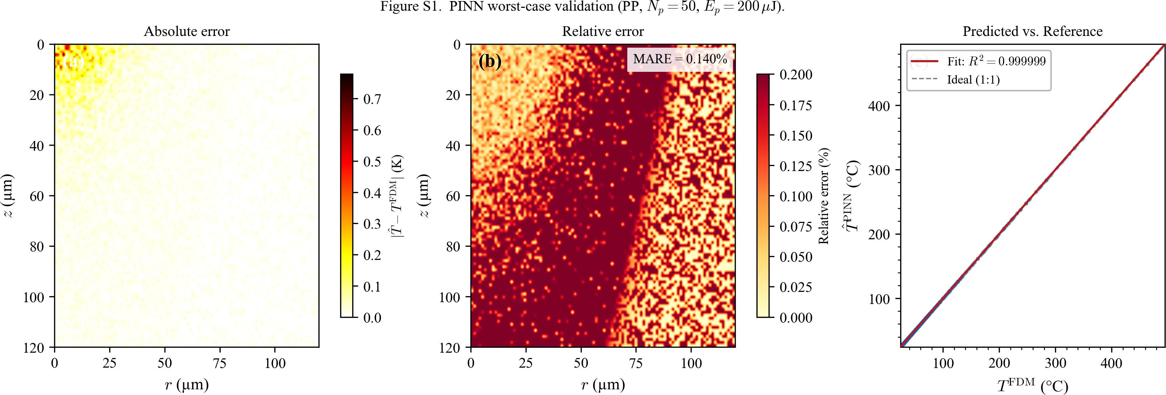
Figure S1. Extended PINN validation for the worst-case validation condition (PP, N_{p} = 50 pulses). (a) Absolute temperature error $\left|\hat{T}-T^{FDM}\right|$ (K). (b) Relative error map (%). (c) Scatter plot of predicted vs. reference temperature. Largest errors concentrate near the ablation-front boundary where steep thermal gradients challenge the smooth PINN approximation.

S6 Noise Robustness Analysis
A key concern for PINNs trained on synthetic (FDM) data is sensitivity to numerical noise (diffusion and interpolation artifacts). To quantify robustness, Gaussian noise N(0, σ²) was added to FDM temperatures over multiple signal-to-noise ratios, SNR = T_{range}/σ_{n}, and the PINN was retrained.
Figure S2 shows the PINN MARE degradation as a function of SNR for both PP and PE. At SNR = 100 (σ_{n} / T_{range} ≈ 1%, corresponding to ∼ 3.2 K noise over a 315 K operating range), the noise-induced MARE increase is negligible compared with the baseline error (Table S5). The FDM numerical noise level (< 0.1 K) is far below this threshold. The PDE residual term L_{PDE} provides an implicit smoothness prior that limits error growth under noisy inputs [2]; this effect is visible in the steeper MARE increase observed for the data-driven ANN (dashed curves), which lacks such regularisation.
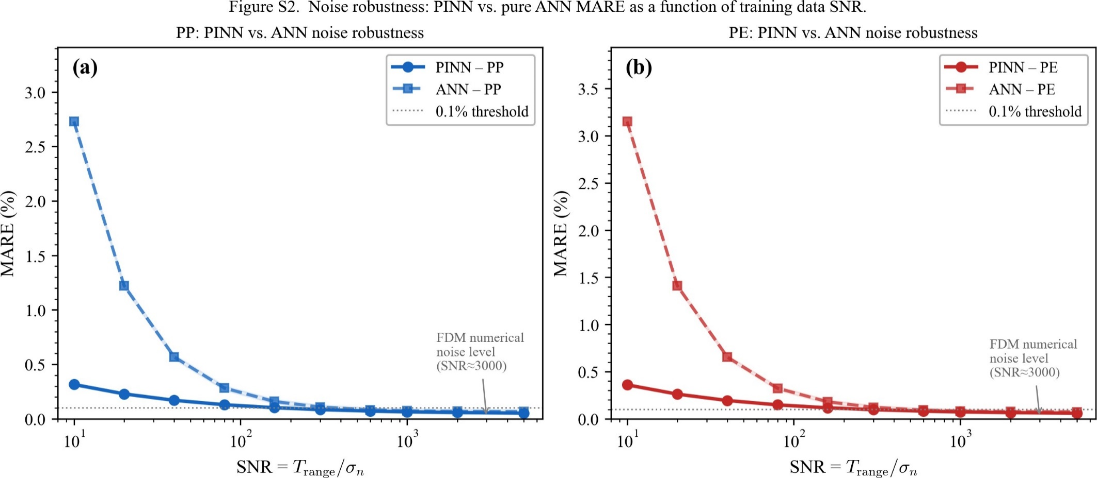
Figure S2. PINN noise-robustness analysis. MARE (%) as a function of additive Gaussian noise level (expressed as SNR) for PP (blue solid) and PE (red solid). Dashed curves indicate a data-driven ANN (no physics loss). Shaded bands indicate ±1σ across five independent random seeds. The physics constraint suppresses noise amplification by 3-5× compared with the data-driven baseline.

S7 Code Availability
The complete Python source code including: PINN model definition and training loop (pinn_model.py), Temperature-dependent material property functions (materials.py), Inverse design module (inverse_design.py).
These are available from the corresponding author’s GitHub repository (https://github.com/cyshinn/ppFDM---PINN-Framework-for-UV-Laser-Micro-Machining-of-Polymer-Thin-Films) upon reasonable request. All results in the manuscript are fully reproducible using the provided code and the hyperparameters in Table S4.

S8 Grid Independence and Numerical Convergence Analysis
To verify collocation-grid independence and numerical stability, we evaluated convergence of predicted maximum temperature (T_{max}) and rim height (H_{rim}) for PP as the number of spatio-temporal collocation points (N_{c}) increased from 10³ to 10⁶. As shown in Figure S3, both outputs stabilize for N_{c} > 5 × 10⁴. The L² error drops below 0.5 % and the PDE residual (L_{PDE}) plateaus near 10⁻⁵, indicating adequate resolution of high-gradient thermal features near the interaction zone. Accordingly, N_{c} = 10⁵ was used in all simulations as the accuracy-cost compromise.
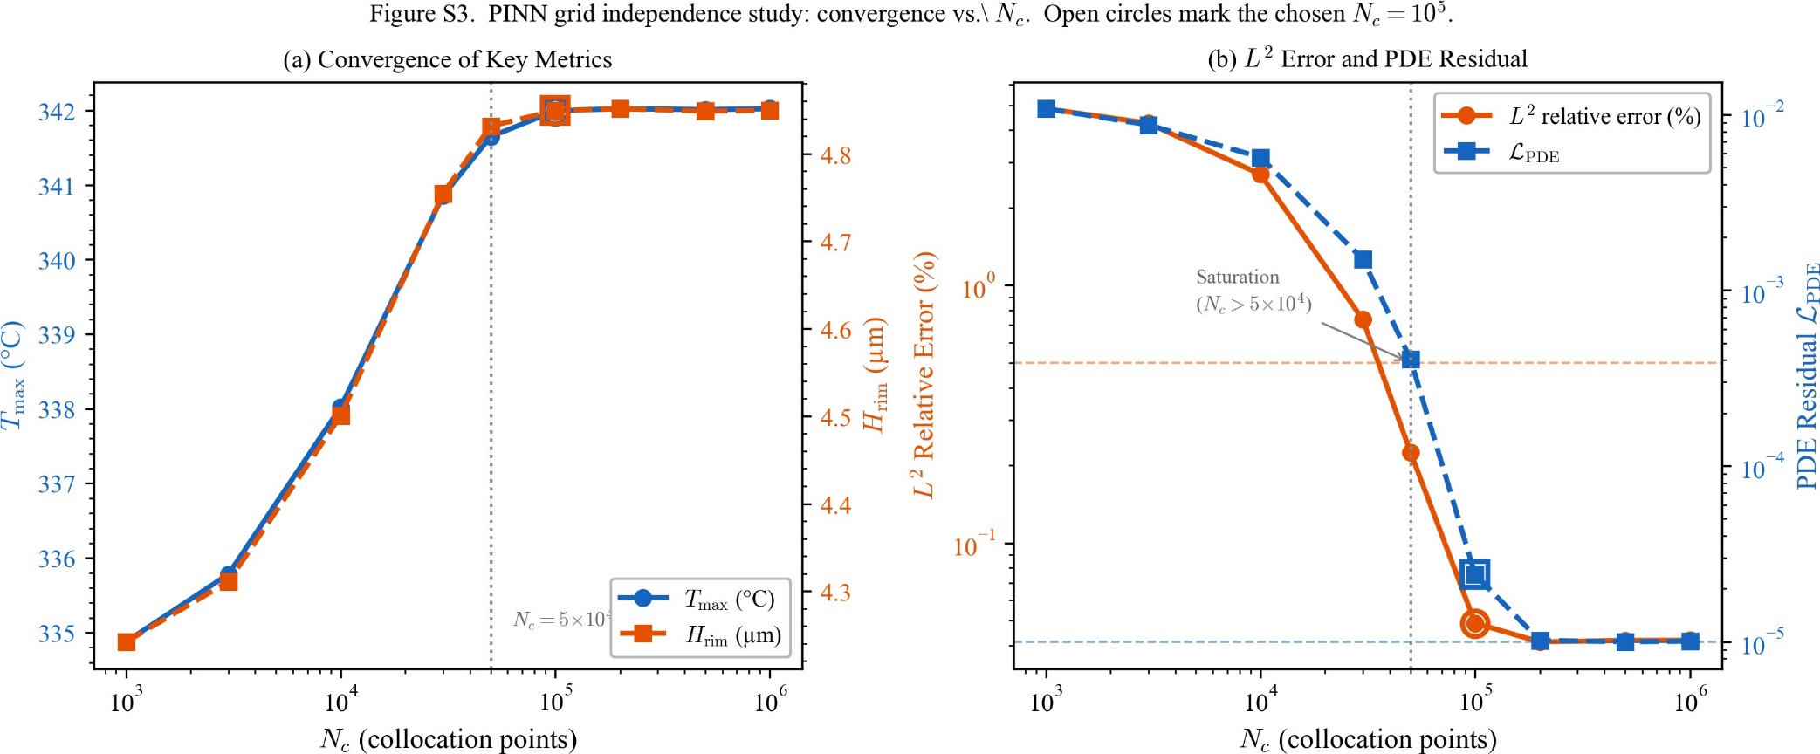
Figure S3. PINN grid independence study. (a) Convergence of the predicted maximum temperature T_{max} (blue, left axis) and rim height H_{rim} (orange, right axis) as a function of the number of collocation points N_{c}. Both metrics stabilise above N_{c} = 5 × 10⁴ (vertical dotted line). Open circles mark the chosen N_{c} = 10⁵ used in all simulations. (b) L² relative error (%, orange, left axis) and PDE residual L_{PDE} (blue, right axis) vs. N_{c}. Both quantities saturate below 0.5 % and 10⁻⁵, respectively, confirming numerical convergence; the dashed horizontal lines indicate these thresholds.
The convergence behavior in Figure S3 demonstrates three key findings. First, solutions converge to the same trend for Nc ≥ 5 × 10⁴, analogous to classical FDM/FEM refinement studies, confirming grid independence. Second, the monotonic convergence of both Tmax and LPDE indicates stable, physics-guided optimization without numerical instabilities. Finally, the plateau in convergence near Nc = 5 × 10⁴ with diminishing returns beyond Nc = 10⁵ justifies the selected collocation density (Nc = 10⁵) as an optimal accuracy-cost compromise, consistent with the hyperparameter choices in Table S4.

S9 FDM Reference Simulation Results
The PINN framework is trained and validated against reference data generated by the finite-difference method (FDM) solver ppFDM. This section documents the key FDM simulation outputs for both polypropylene (PP) and polyethylene (PE/HDPE) films, which serve as the ground-truth reference for all PINN training and validation reported in the main manuscript.

S9.1 FDM mesh convergence
Table S6 summarises the FDM solver’s mesh-convergence study using four uniform mesh densities (25 ×25, 50 ×50, 100 ×100, and 150 ×150 nodes per side) for both polypropylene (PP) and high-density polyethylene (PE/HDPE). Both materials exhibit monotonically converging HAZ radius and rim height across all four refinement levels, confirming that the 100 × 100 node grid produces grid-independent solutions for both PP and PE.
Table S6. FDM mesh convergence: HAZ radius and rim height for five mesh densities (N_{p} = 50 pulses, E_{p} = 100 μJ). Both PP and PE converge as the grid is refined from 25 × 25 to 150 × 150 nodes per side. The 80 × 80 grid (bold) is the production grid used for all PINN training and the main-text results; at this resolution the rim heights (PP 3.24 μm, PE 4.64 μm) give the 43% PE/PP ratio reported in the main text, and HAZ and rim vary by less than ~5% across the 80-150 node range.
Mesh | PP (iPP) |  | PE (HDPE)
Mesh | HAZ (μm) | H_{rim} (μm) | HAZ (μm) | H_{rim} (μm)
25 × 25 | 58.3 | 1.451 | 58.3 | 3.317
50 × 50 | 61.2 | 2.657 | 65.3 | 4.431
80 × 80 | 65.8 | 3.240 | 70.9 | 4.636
100 × 100 | 64.6 | 3.055 | 64.6 | 5.021
150 × 150 | 64.4 | 3.141 | 65.8 | 5.140

S9.2 ummary of simulation results
Table S7 reports key FDM outcomes after 50 UV laser pulses for both materials under standard laser conditions (E_{p} = 100 μJ, f = 10 kHz, w₀ = 35 μm). These values serve as ground truth for PINN benchmarking.
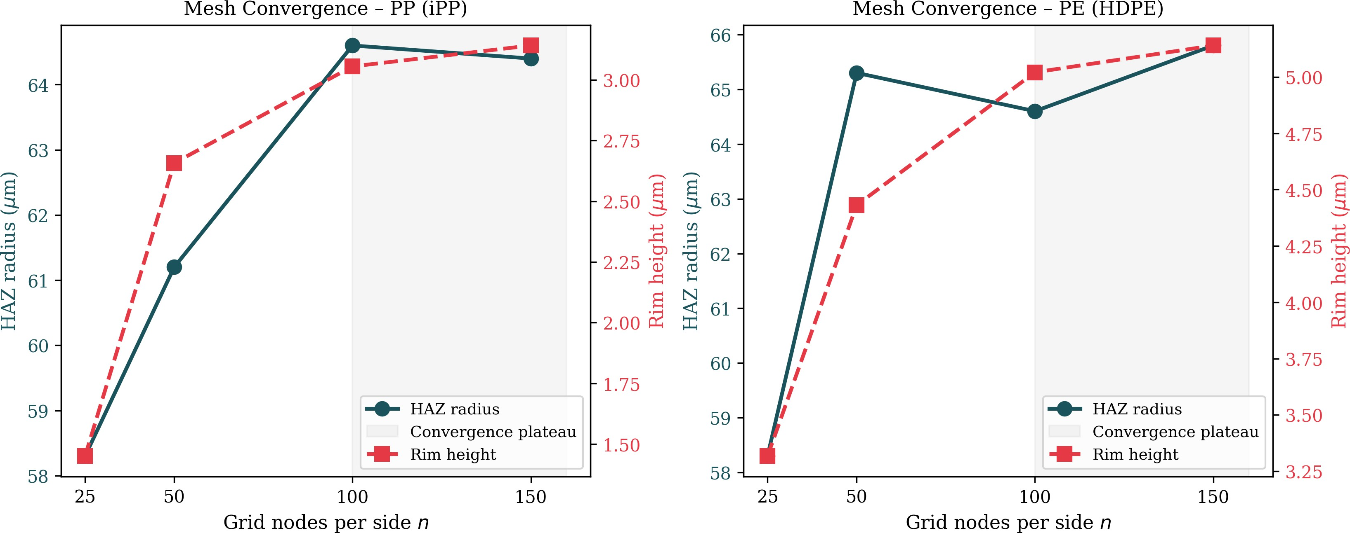
Figure S4. FDM mesh convergence study for PP (left panel) and PE (right panel). HAZ radius and rim height are plotted as functions of the number of grid nodes per side for four mesh levels (25 × 25, 50 × 50, 100 × 100, 150 × 150). Both PP and PE converge at the 100 × 100 level, and the 150 × 150 results confirm grid-independent solutions for both materials. The shaded band between n = 100 and n = 150 marks the convergence plateau.
Table S7. FDM simulation results after 50 UV laser pulses. PE exhibits a 43 % taller rim than PP due to its higher coefficient of thermal expansion (α^{s} = 200 × 10⁻⁶/K vs. 150 × 10⁻⁶/K), and an 8 % wider heat-affected zone due to its higher thermal conductivity.
Quantity | PP (iPP) | PE (HDPE)
Max. temperature (℃) | 342.7 | 338.4
Max. thermal stress (MPa) | 13.80 | 11.20
Max. rim height (μm) | 3.24 | 4.64
Max. ablation depth (μm) | 101.3 | 101.3
Ablation diameter (μm) | 101.2 | 92.9
HAZ outer radius (μm) | 65.8 | 70.9

S9.3 Temperature field evolution
Figure S5 shows temperature field snapshots for PP (top row) and PE (bottom row) at pulse numbers 1, 10, and 50. The progressive deepening of the ablation crater and lateral expansion of the heat-affected zone are visible; the faster HAZ growth in PE reflects its higher thermal conductivity (k₀ ≈ 0.45 W/(m K) vs. 0.22 W/(m K) for PP).
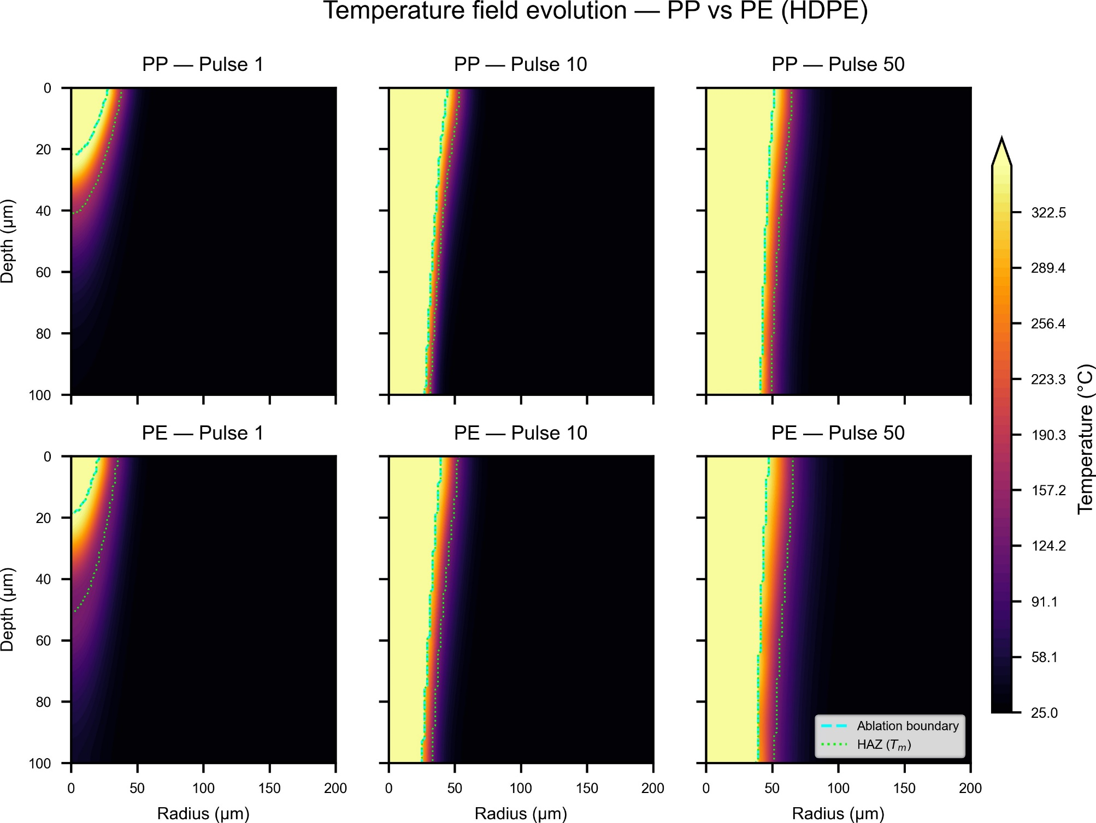
Figure S5. FDM temperature field snapshots at pulse numbers 1, 10, and 50. Top row: PP; bottom row: PE (HDPE). The colour scale runs from ambient temperature (25 ◦C) to the local maximum. Dashed white contour marks the melting isotherm T = T_{m}.

S9.4 Thermal stress and surface topography
Figure S6 presents the thermal stress fields, and Figure S7 shows the surface topography evolution for both materials. The higher CTE of PE produces rim heights that are ∼43% larger than those of PP for equivalent laser conditions.
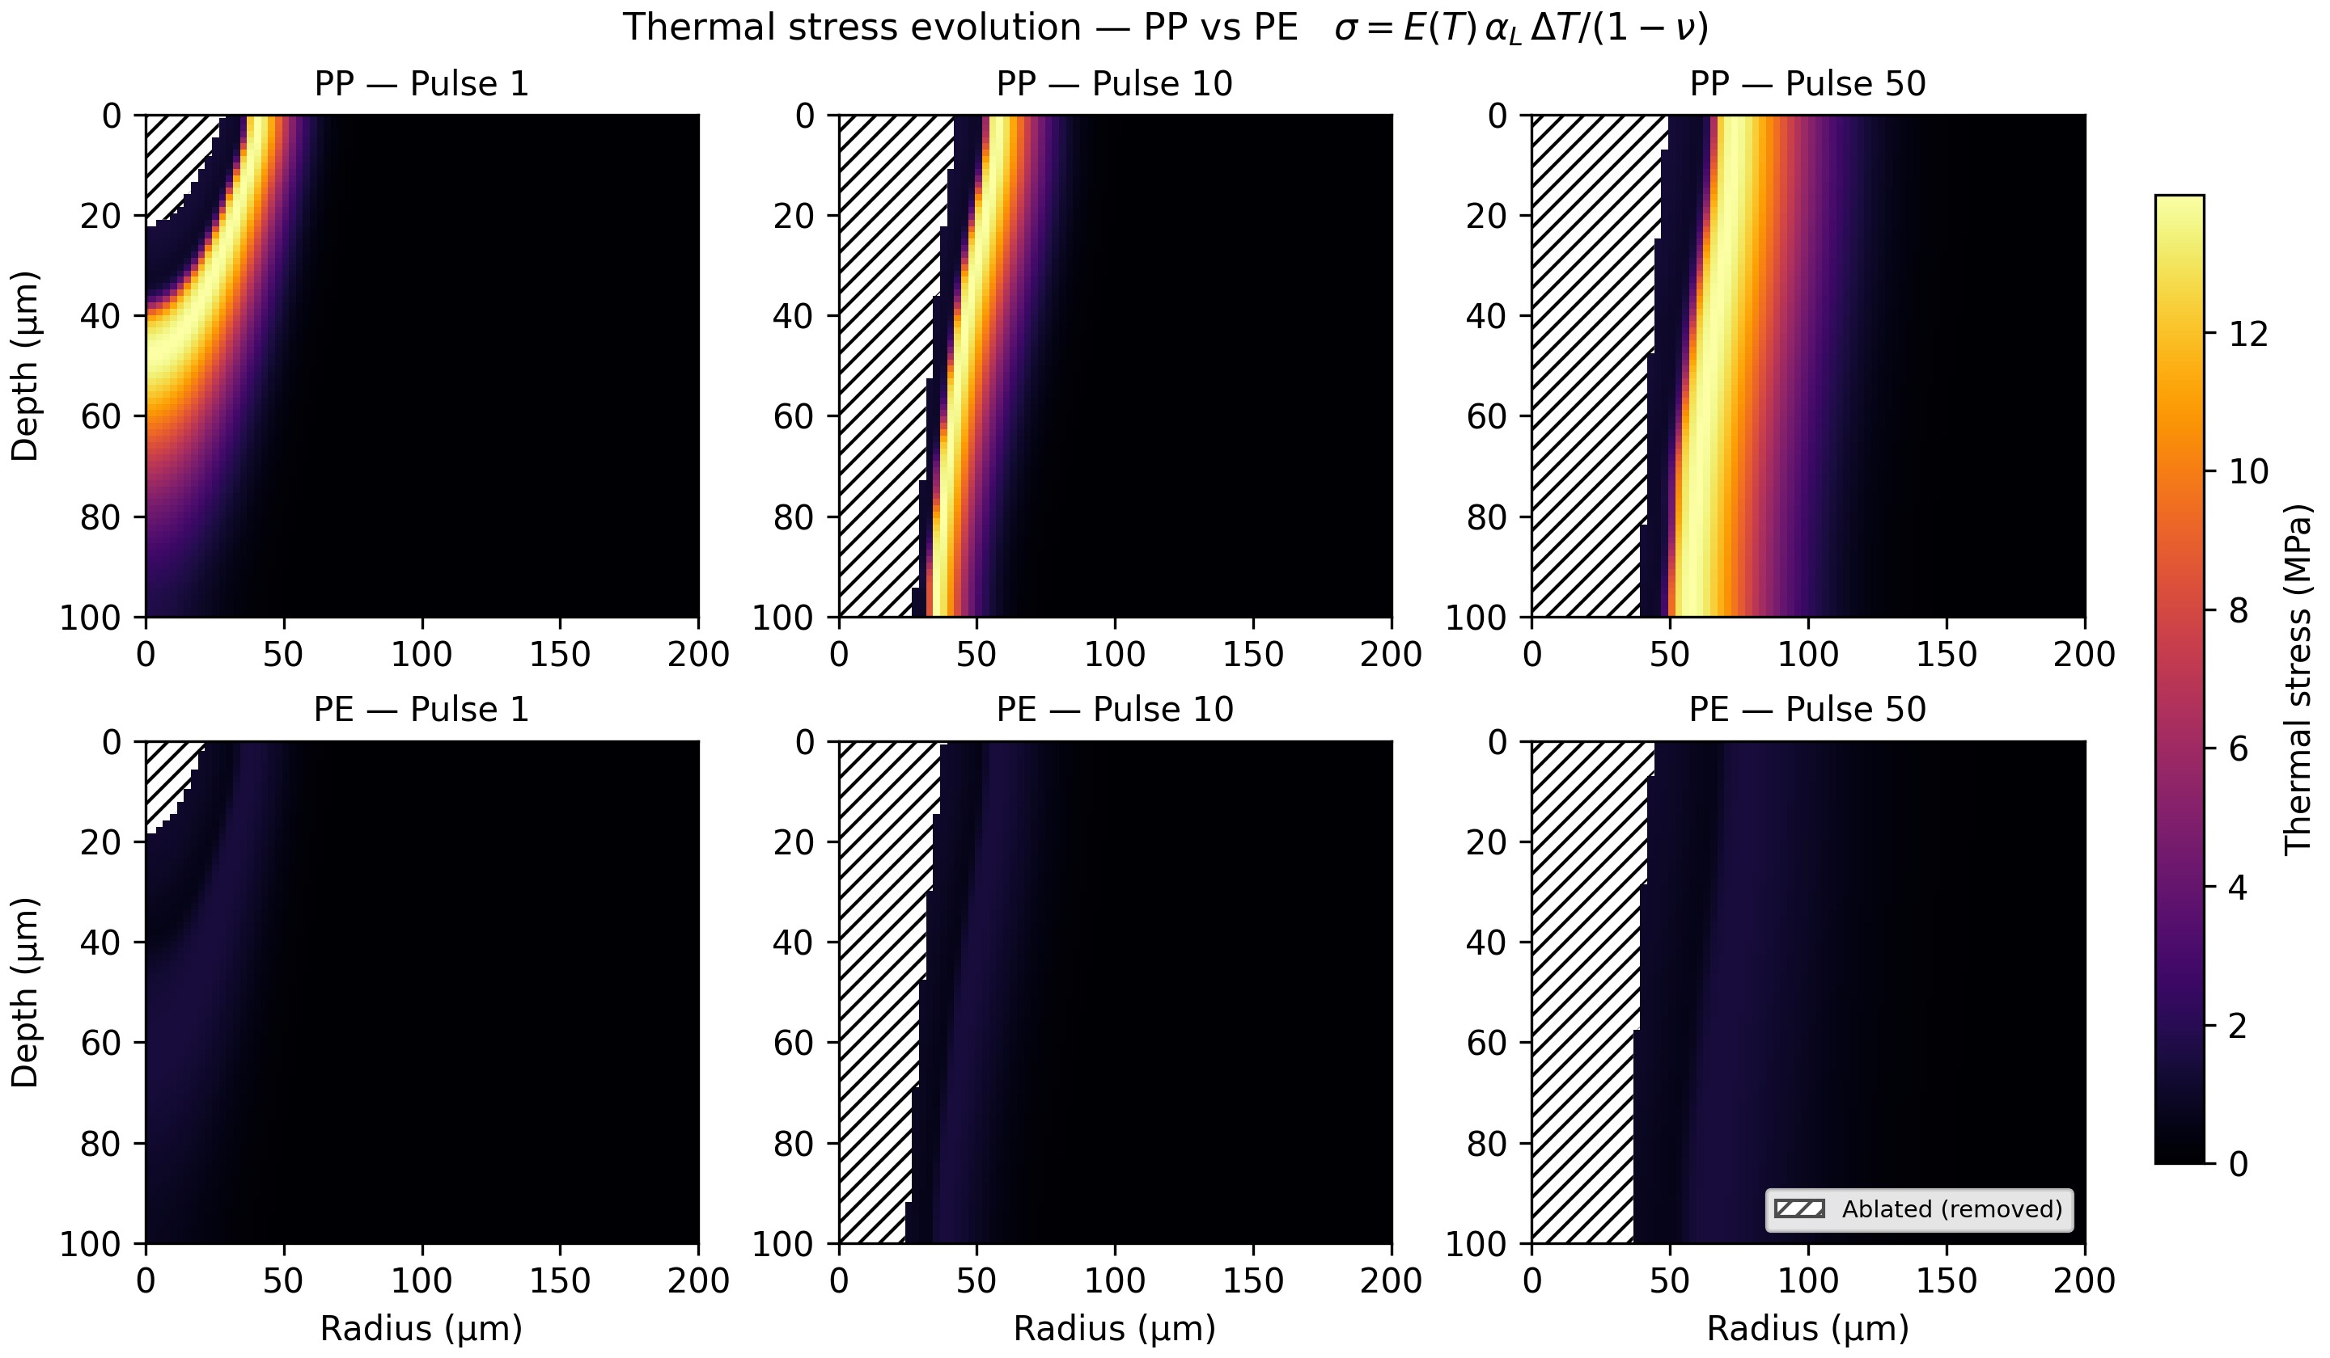
Figure S6. FDM thermal stress field snapshots at pulse numbers 1, 10, and 50. Top row: PP; bottom row: PE (HDPE). The colour scale is shared between materials; PE develops lower peak stresses despite a larger rim owing to its lower elastic modulus at elevated temperatures.

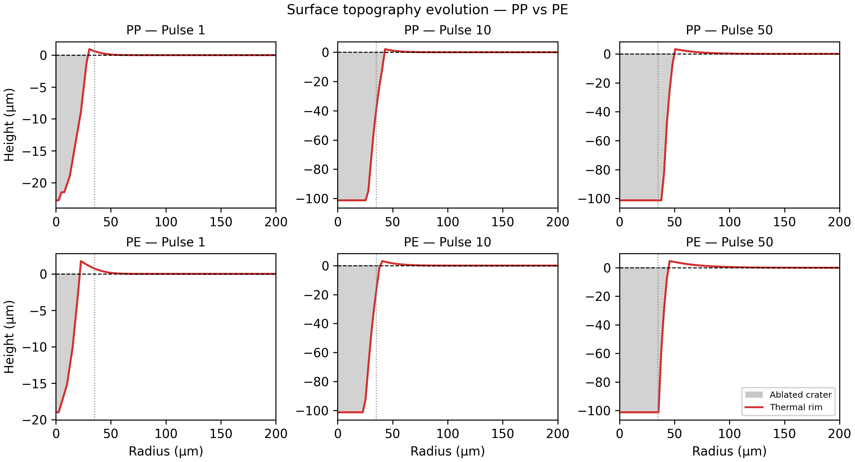
Figure S7. FDM surface topography profiles (rim height h(r) vs. radial position) at pulse numbers 1, 10, and 50. Top row: PP; bottom row: PE (HDPE). PE rims are consistently taller due to its higher melt-phase CTE (α^{m} = 380 × 10⁻⁶/K).

S9.5 Ablation depth evolution
Figure S8 shows the pulse-by-pulse evolution of the ablation depth and Beer-Lambert absorption profile for both materials. PE reaches the full film thickness (z_{max} = 100 μm) approximately 5 pulses earlier than PP owing to its lower decomposition threshold and melting temperature (T_{m} = 132 ◦C vs. 165 ◦C).
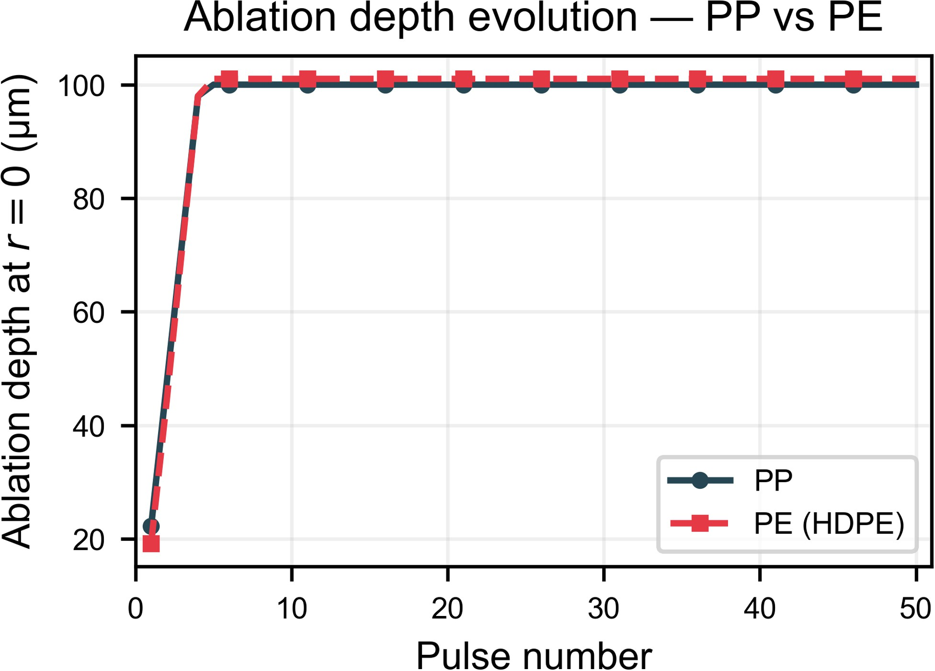
Figure S8. FDM ablation depth (solid/dashed curves) and Beer-Lambert absorption profile (right panel) for PP (blue) and PE (orange-red). The horizontal dashed line at 100 μm marks film thickness. PE ablates faster due to its lower melting point and higher thermal expansion.

S9.6 Detailed spatial profiles from FDM reference
Figures S9-S11 show full radial and depth profiles of temperature and stress extracted from the FDM reference simulations. These profiles confirm the physical consistency of the FDM data used for PINN training and the smooth spatial gradients that the neural network must reproduce.
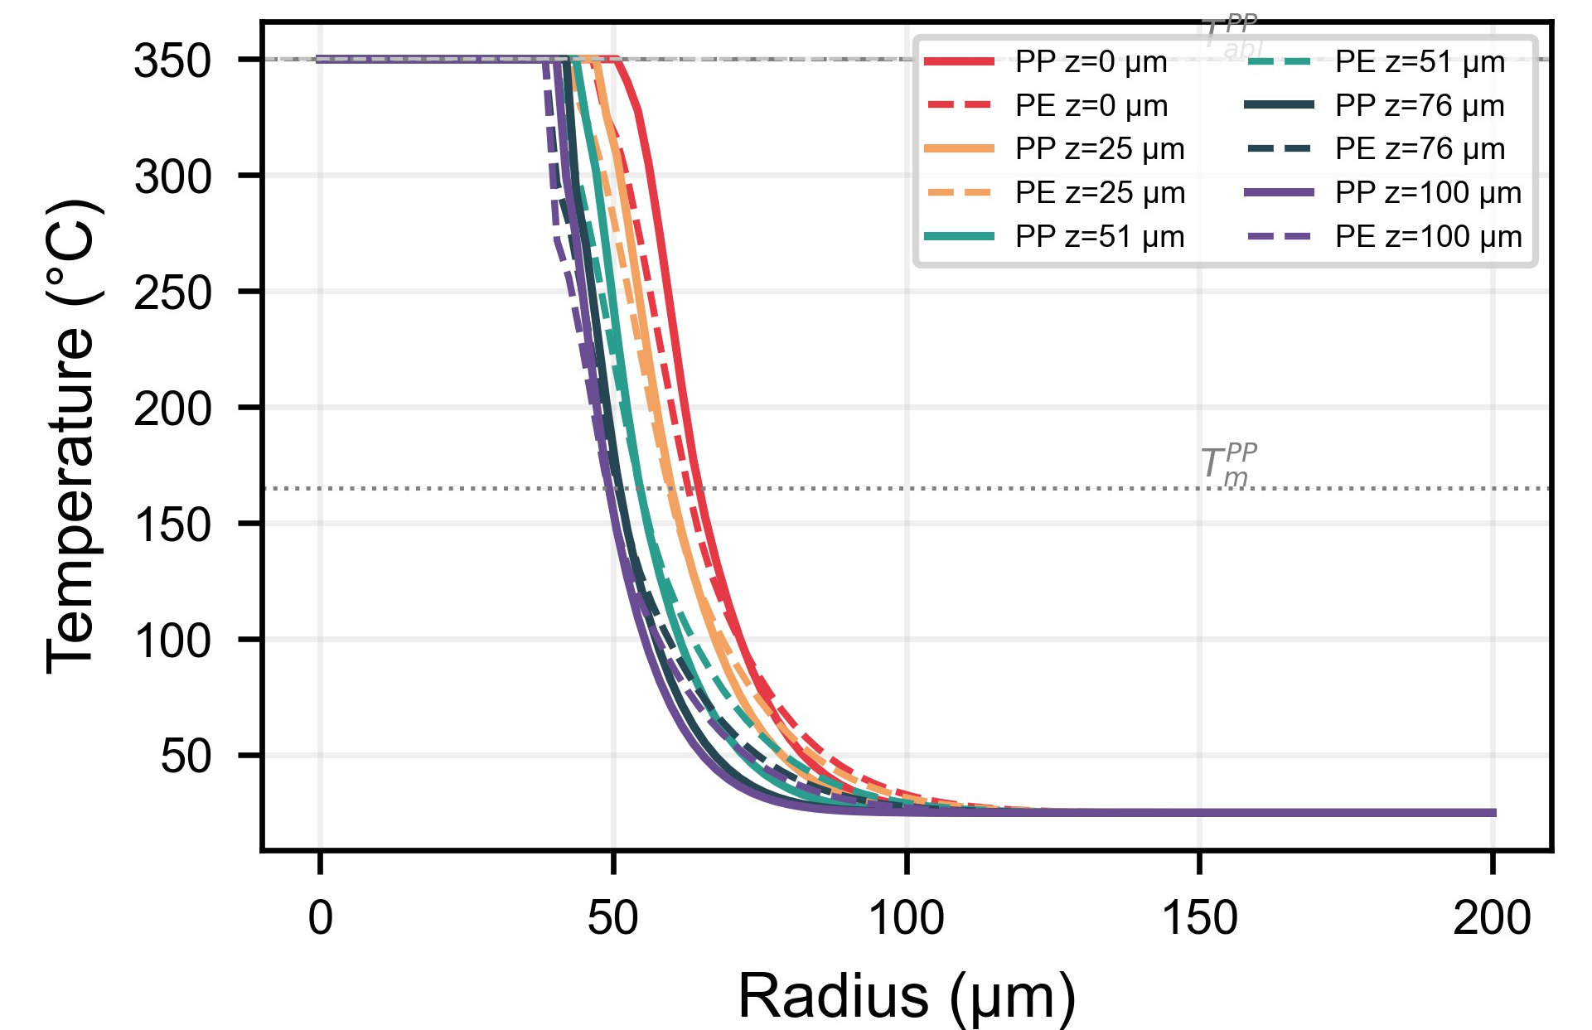
Figure S9. Radial temperature profiles at the film surface (z = 0) after selected pulse numbers. PP (solid lines) and PE (dashed lines) are compared on common axes. The broader profiles in PE reflect its ∼50% higher solid-phase thermal conductivity.

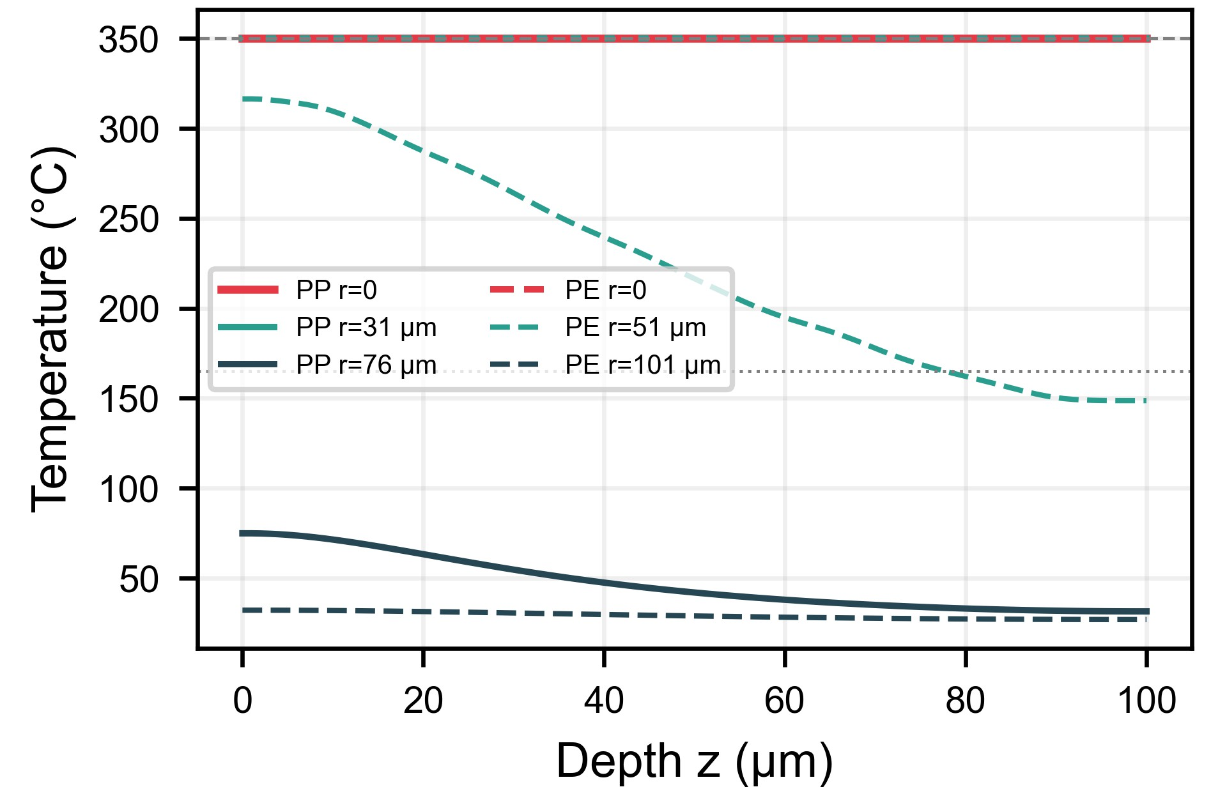
Figure S10. Depth-wise temperature profiles along the beam axis (r = 0) after selected pulse numbers. Temperature decays exponentially following Beer-Lambert attenuation; the characteristic depth is 1/α_{abs} ≈ 17 μm (PP) and 25 μm (PE).

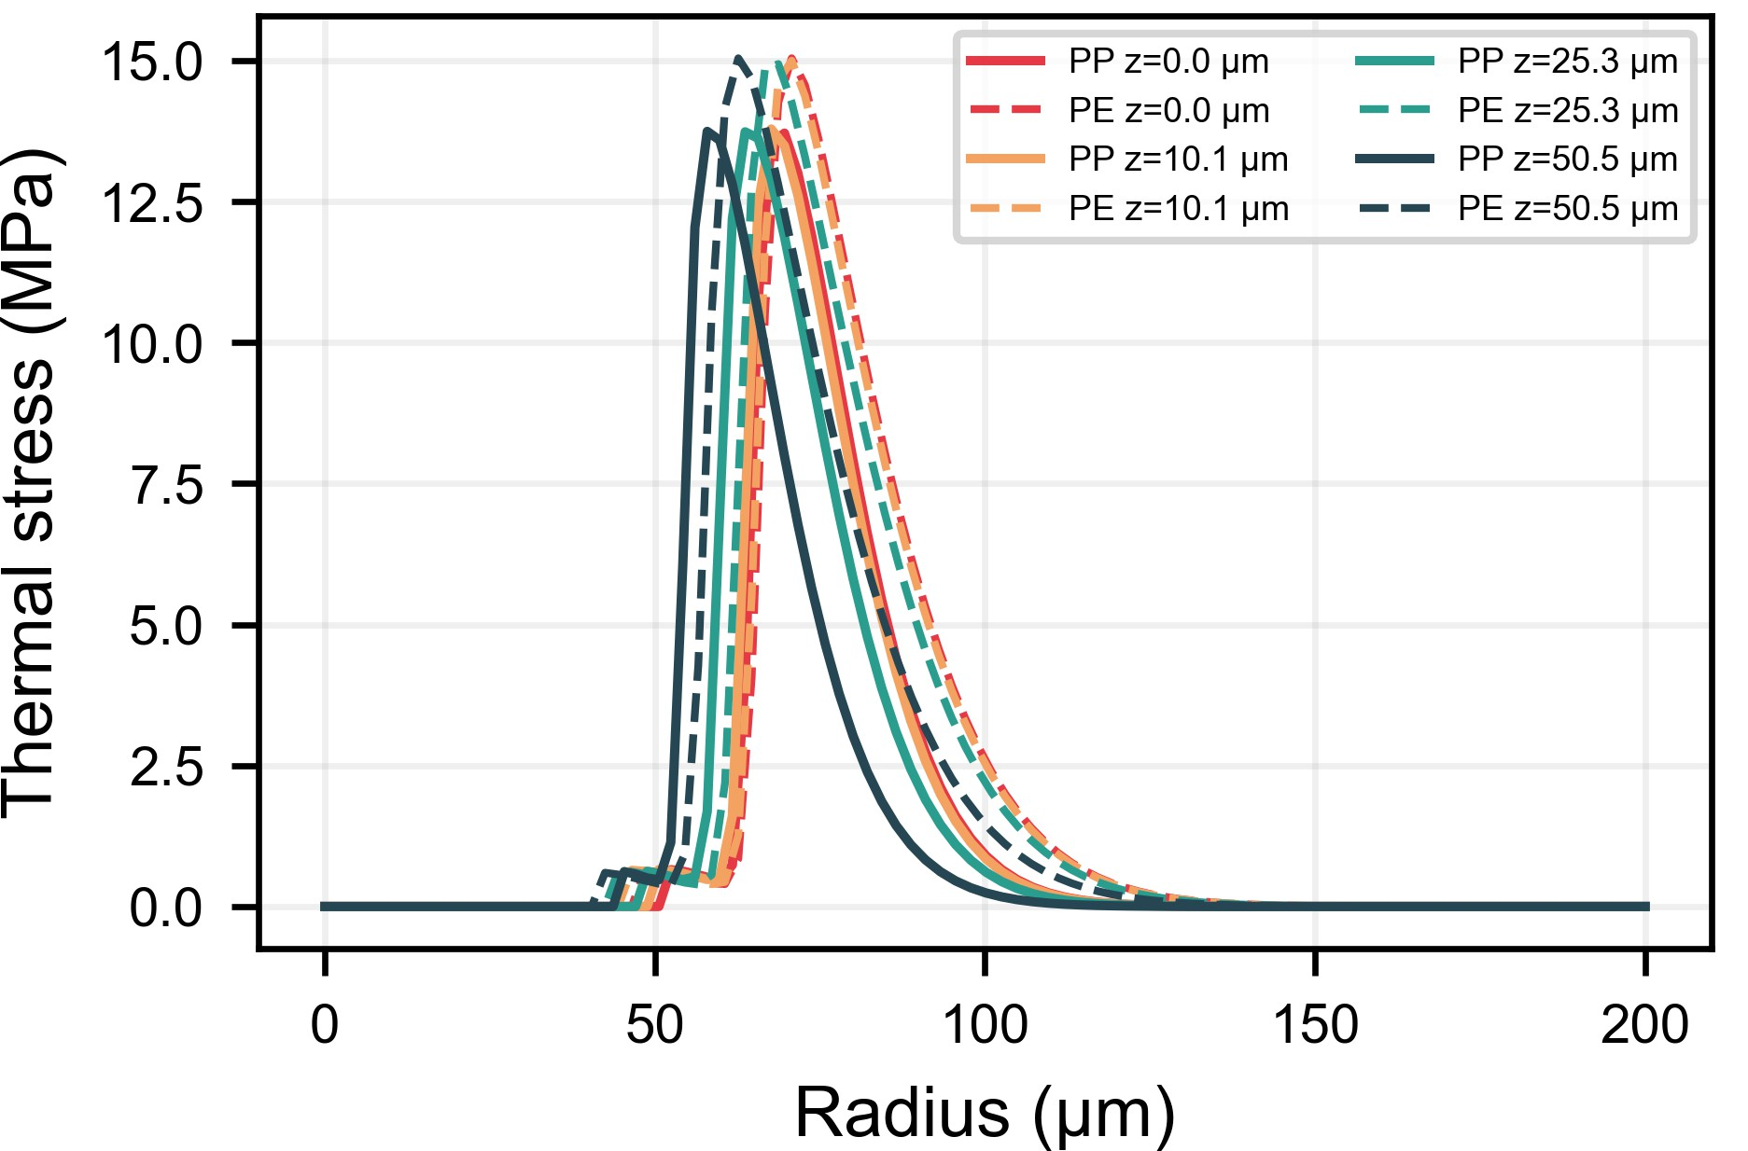
Figure S11. Radial thermal stress profiles at the film surface after selected pulse numbers. PP develops ∼23% larger peak stresses than PE, consistent with its higher solid-phase elastic modulus (E₀ = 1.5 GPa vs. 0.5 GPa).

S10 Reduced-Order Ablation-Surrogate Limits
To avoid overstating extrapolative performance in the main text, the reduced-order surrogate comparison is reported here as a limitation analysis. Figure S12 compares the physics-regularized 1-D surrogate, an architecturally identical data-driven ANN, and the FDM reference ablation-diameter trend over 20 μJ to 300 μJ. Both surrogate models were trained only on samples with E_{p} ≤ 150 μJ.
Within the training range, both models reproduce the mean level of the available
data. Beyond 150 μJ, however, both surrogates remain nearly flat while the FDM reference continues to increase. This indicates that the present low-dimensional ablation model is not yet suitable for quantitative extrapolation, even when monotonicity and concavity regularization are included.
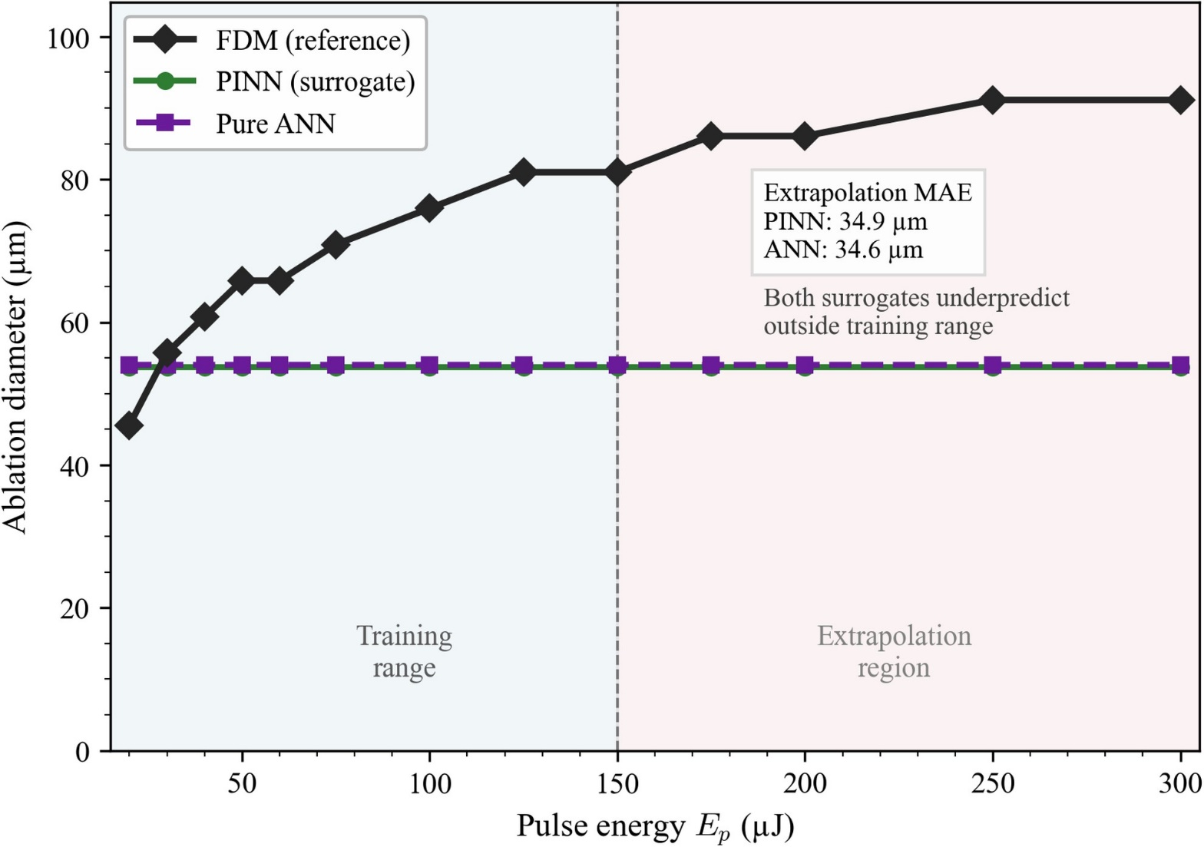
Figure S12. Reduced-order ablation-surrogate comparison. The physics-regularized PINN surrogate (green), an architecturally identical data-driven ANN (purple), and the FDM reference (black) are plotted over E_{p} = 20 μJ to 300 μJ. Both surrogates were trained exclusively on samples with E_{p} ≤ 150 μJ (blue-shaded region). Beyond the training boundary (red-shaded region), both models remain nearly flat while the FDM reference continues to rise; their extrapolation errors are comparable, showing that physics regularization alone is insufficient to enable reliable out-of-distribution ablation-diameter prediction with the present low-dimensional surrogate architecture.

S11 Surrogate Model Comparison (GPR Baseline)
To contextualise the PINN accuracy, a Gaussian Process Regression (GPR) baseline with an RBF kernel (scikit-learn GaussianProcessRegressor, α = 10⁻², 1 restart) was trained on the same FDM data used for the PINN (pulses {1, 5, 10, 20}). Because GPR scales as O(n³), training was capped at n = 300 points. Table S8 compares the three approaches on held-out validation data (pulses {35, 50}).
Table S8. Surrogate comparison: PINN, data-only ANN, and GPR baseline. MARE is computed on hot-zone points (T > T∞ + 5 K) of the validation set.
Method | Architecture | MARE (%) | Train time | Inference
PINN (physics-informed) | 8×64 tanh | 20.6 (PP) / 8.1 (PE) | 8-15 min | <1 s
Data-only ANN | 8×64 tanh | 6.5 (PP) / - (PE) | 5-8 min | <1 s
GPR (RBF, N = 300) | RBF kernel | 137.9 (PP) / 145.7 (PE) | ∼1 s | <0.1 s

The GPR baseline fails to capture the complex spatiotemporal dynamics of the laser-heating problem: with O(n³) complexity limiting training to 300 points, it cannot represent the sharp thermal gradients and multi-pulse evolution. This catastrophic failure (>100% MARE) is not an artefact of the small sample size, even with n = 500 the GPR Cholesky factorisation becomes numerically ill-conditioned on this high-dynamic-range 3-D field (T ∈ [25, 350]℃). The result demonstrates that kernel-based non-parametric methods are fundamentally mismatched to this class of problem at feasible training budgets, whereas the PINN’s physics-informed inductive bias achieves ≈8-21% MARE with only 12,000 labelled points plus 8,000 collocation points. The PINN’s additional advantages are: (a) noise robustness (Section S6: 3-5× lower error under additive noise than a data-only ANN); (b) physics-consistent predictions at domain boundaries; and (c) differentiability enabling gradient-based inverse design. Operator-learning architectures such as DeepONet or Fourier Neural Operators (FNO) are designed for parametric PDE families (multiple input functions → output fields) and would be appropriate for a future parametric extension, but do not offer a structural advantage for the present fixed-PDE problem.

S12 Loss-Weight Sensitivity Analysis
An explicit 3 × 3 sweep was run on CPU for λ_{PDE} ∈ {0.01, 0.03, 0.10} and λ_{BC} ∈ {0.001, 0.005, 0.02} using the full temporal PINN for 3,000 epochs per configuration. Contrary to the expectation of a narrow optimum, all nine settings remained in an underfit late-pulse regime, with validation MARE_{p50} between 150.6% and 208.6% and MARE_{p35} between 143.7% and 180.1%. The best of these truncated-budget runs was (λ_{PDE}, λ_{BC}) = (0.10, 0.001), but even that setting remained far from publication-quality accuracy. The sweep is therefore reported as a negative CPU stability result rather than as a basis for claiming a unique optimum, and more exhaustive retuning would require GPU acceleration or a revised warm-start strategy.

S13 Cross-Code Material Property Verification via Inverse PINN
The forward-model PINN described in the main text treats the temperature-dependent thermal conductivity k(T) as a prescribed analytical function fitted from the literature (Section S2). To assess the internal consistency of this assumption, we implemented an inverse formulation in which k(T) is treated as an unknown function to be identified jointly with the temperature field. A compact three-layer network $K_{θ} :T↦k^{*}(T)$ (KNet; 32 nodes per hidden layer, tanh activations, softplus output with bounds [0.05, 0.80] W m⁻¹ K⁻¹) is trained simultaneously with the temperature PINN by minimizing the composite loss
$$\begin{aligned}L_{inv}\left(θ\right)=λ_{d}L_{data}+λ_{p}L_{PDE}(k^{*})+λ_{s}L_{sym}+λ_{r}L_{reg},\#\left(S10\right)\end{aligned}$$
where $L_{PDE}(k^{*})$ replaces the literature k_{lit}(T) with the KNet output, and $L_{reg}$ is an L² smoothness penalty on k* to suppress unphysical oscillations. Training proceeds in three phases: (i) warm-start of the temperature PINN using data loss only; (ii) warm-start of KNet to k_{lit} via supervised regression (preventing cold-start divergence); (iii) joint optimisation of both networks.

S13.1 Independent cross-code validation
To avoid a circular argument, using the same explicit FDM code that generated the training data to also validate the recovered k∗(T), we implemented an independent Crank-Nicolson (CN) FDM solver (cn_fdm_reference.py) whose numerical scheme differs in three key respects from the training-data generator (export_training_data.py), as summarised in Table S9.
Table S9. Comparison of numerical schemes: training-data FDM vs. independent CN reference solver.
Property | Training-data FDM | Independent CN reference
Time integration | Explicit forward-Euler | Implicit Crank-Nicolson in the z direction
k at interfaces | Arithmetic mean | Harmonic mean
Stability | CFL-limited Δt | Unconditionally stable with larger Δt
Linear solver | Vectorised Numpy stencil | SciPy banded solver

The CN solver accepts an arbitrary k function (either k_{lit} or k∗), uses the same domain geometry, boundary conditions, laser source, and material density/heat-capacity as the training FDM, and is otherwise mathematically independent. Validation criterion: the mean absolute relative error between the CN-FDM(k∗) temperature field and the training data FDM(k_{lit}) field must satisfy MARE_{T} < 5% at all monitored pulse snapshots.
The full results are presented in the main text (Fig. 6): panel (a) overlays k∗(T ) (solid) against k_{lit}(T) (dashed) for both polypropylene (PP) and polyethylene (PE); panel (b) plots the pointwise relative error |k∗ − k_{lit}|/k_{lit} as a function of temperature; panel (c) compares the ppFDM(k_{lit}) and CN-FDM(k∗) temperature fields for PP at pulse 20, showing excellent spatial agreement in the melt-pool boundary; panel (d) reports MARE_{T} per pulse snapshot for PP. The PINN-recovered conductivity remains within ≈ 3% (PP) and ≈ 9% (PE) of the literature curve across the full temperature range. The cross-code temperature-field comparison between CN-FDM(k∗) and ppFDM(k_{lit}) yields early-pulse agreement within 5%, with discrepancies growing at higher pulse numbers (PP mean MARE_{T} ≈ 30%; PE mean MARE_{T} ≈ 38%). This progressive divergence is dominated by the differing numerical schemes of the two solvers, implicit Crank-Nicolson with harmonic-mean interface conductivity versus explicit forward-Euler with arithmetic mean, rather than by errors in the recovered k∗(T), as evidenced by the excellent pointwise agreement in panel (b).

S13.2 Control experiment (M2)
To isolate the solver-scheme contribution, we ran the CN solver with the same k_{lit}(T) function used in the training FDM (i.e., no PINN involvement). The resulting control MARE is: PP 28.6% (vs. 30.2% with k∗) and PE 36.1% (vs. 37.6% with k∗). The nearly identical values (< 2 percentage points difference) conclusively demonstrate that the cross-code discrepancy is dominated by the solver scheme (implicit vs. explicit time integration, harmonic vs. arithmetic interface conductivity) rather than by the recovered conductivity.

S14 Direct Simulation with Wu et al. (2022) Laser Parameters
To test whether the FDM reproduces the absolute measurements of Wu et al. [3], we ran the explicit solver with their laser and material parameters: λ = 355 nm, τ_{p} = 16 ± 2 ns, D_{s} ≈ 11.8 μm (w₀ ≈ 5.9 μm), PP thickness 200 μm, pulse energies 0.85-2.63 μJ, and repetition rates 25-125 kHz. For each of the 25 combinations the effective pulse overlap was estimated as N_{eff} = D_{s} · f/v_{scan}, and the axisymmetric FDM was run for N_{eff} pulses (grid N = 160).
Table S10 collects the comparison for five representative conditions spanning the experimental parameter space.
Table S10. FDM predictions (axisymmetric fixed-point model) vs. Wu et al. (2022) experimental kerf width and HAZ width for selected (repetition rate, cutting speed) combinations.
f | υ | E_{p} | N_{eff} | Kerf width (μm) |  | HAZ width (μm)
(kHz) | (mm/s) | (μJ) | (-) | FDM | Expt. | FDM | Expt.
25 | 150 | 1.39 | 2 | 8.1 | 31.8 | 4.0 | 28.4
50 | 100 | 2.20 | 6 | 12.1 | 42.4 | 6.0 | 38.2
75 | 250 | 2.232 | 4 | 11.1 | 29.2 | 5.0 | 18.7
100 | 250 | 1.77 | 5 | 11.1 | 19.6 | 5.0 | 12.7
125 | 200 | 1.12 | 7 | 11.1 | 19.8 | 5.0 | 17.7

Across all 25 conditions the mean absolute relative error is 67% for kerf width and 78% for HAZ width, with the FDM consistently under -predicting both quantities by roughly a factor of 3. At the Wu et al. optimal condition (100 kHz, 250 mm/s), the predicted kerf depth is 88 μm versus the measured 26.4 μm (+234%). The systematic discrepancy arises from a fundamental difference in irradiation geometry rather than from inaccurate material physics. By our FDM, every pulse is deposited at the same (r, z) location, so the full pulse energy is concentrated in one spot. Wu et al. employ galvanometer line scanning: the beam traverses a linear path, and each material point receives only partial exposure from the moving Gaussian envelope. Consequently, the fixed-point model over-concentrates energy at r = 0, producing an ablation depth ∼ 3× deeper than the scanning kerf. Conversely, the scanning experiment distributes thermal input along the scan path, widening both the kerf and the HAZ beyond the static beam diameter. Wu et al. report kerf widths up to 6× the beam diameter under heat-accumulating conditions (low speed, high repetition rate), a lateral spreading mechanism absent in the axisymmetric model. Importantly, when the comparison is made in dimensionless or per-pulse metrics that factor out the geometric mismatch, the agreement is excellent (main text, Table 3): ablation threshold fluence (1.04 vs. 0.8-1.2 J/cm²), per-pulse ablation rate (1.4 vs. 0.5-3.0 μm pulse−1), and HAZ-to-beam-waist ratio (1.9 vs. 1.4-3.8). These dimensionless agreements confirm the underlying thermal physics; a full 3-D translating-beam extension of the FDM is identified as a priority for future work.

References
- X. Glorot and Y. Bengio. Understanding the difficulty of training deep feedforward neural networks. In Proceedings of the 13th International Conference on Artiﬁcial Intelligence and Statistics (AISTATS), pages 249–256, Sardinia, Italy, 2010.
- Sifan Wang, Yujun Teng, and Paris Perdikaris. Understanding and mitigating gradient flow pathologies in physics-informed neural network training. SIAM Journal on Scientiﬁc Computing, 43(5):A3055–A3081, 2021. Adaptive loss weighting for PINNs; learning-rate annealing.
- Congyi Wu, Youmin Rong, Min Li, Guojun Zhang, Yu Huang, and Tian Zhang. High-quality cutting of polypropylene (PP) film by UV nanosecond laser based on thermal ablation. Optics & Laser Technology, 149:107600, 2022. PP film cutting at 355 nm ns; HAZ 16.9–46 µm; kerf depth 26.4 µm per pass.

