Bdh1-mediated βOHB metabolism ameliorates diabetic kidney disease by activation of Nrf2-mediated antioxidative pathway
Sheng-rong Wan^{1,2,3}, Fang-yuan Teng^{1,2,3}, Wei Fan⁴, Xin-yue Li^{1,2,3}, Bu-tuo Xu^{1,2,3}, Xiao-zhen Tan^{1,2,3}, Man Guo^{1,2,3}, Chen-lin Gao^{1,2,3}, Zong-zhe Jiang^{1,2,3*}, Yong Xu^{1,2,3*}
¹Department of Endocrinology and Metabolism, The Affiliated Hospital of Southwest Medical University, Luzhou, Sichuan, 646000, China.
²Cardiovascular and Metabolic Diseases Key Laboratory of Luzhou, Sichuan, 646000, China.
³Sichuan Clinical Research Center for Nephropathy, Sichuan, 646000, China.
⁴Department of Orthopaedics, The Affiliated Hospital of Southwest Medical University, Luzhou, Sichuan, 646000, China.
*Corresponding author: Zong-zhe Jiang, Cardiovascular and Metabolic Diseases Key Laboratory of Luzhou, Sichuan, 646000, China. E-mail address: Jiangzongzhe555@126.com. & Yong Xu, Department of Endocrinology and Metabolism, The Affiliated Hospital of Southwest Medical University, Luzhou, Sichuan, 646000, China. E-mail address: xywyll@swmu.edu.cn.

Supplementary materials

Table S1. List of primers used in the present study.
Species | NCBI Gene ID | Gene name | Sequence (5' to 3') | Length of product (bp)
Mus | 71911 | Bdh1 | F: CGGCTAGTGGCAAAGCTATC  R: GTTGCAGACATTGAGCTGGA | 194
Mus | 67041 | Oxct1 | F: CATAAGGGGTGTGTCTGCTACT  R: GCAAGGTTGCACCATTAGGAAT | 106
Mus | 110446 | Acat1 | F: CAGGAAGTAAGATGCCTGGAAC  R: TTCACCCCCTTGGATGACATT | 228
Mus | 208715 | Hmgcs1 | F: AACTGGTGCAGAAATCTCTAGC  R: GGTTGAATAGCTCAGAACTAGCC | 180
Mus | 11461 | β-Actin | F: ACCTCTATGCCAACACAGTG  R: GGACTCATCGTACTCCTGCT | 221
Homo | 622 | Bdh1 | F: GACAGCCTAAACAGTGACCGA  R: GAGCGGACAATCTCCACCA | 89
Homo | 60 | β-Actin | F: CATGTACGTTGCTATCCAGGC  R: CTCCTTAATGTCACGCACGAT | 250
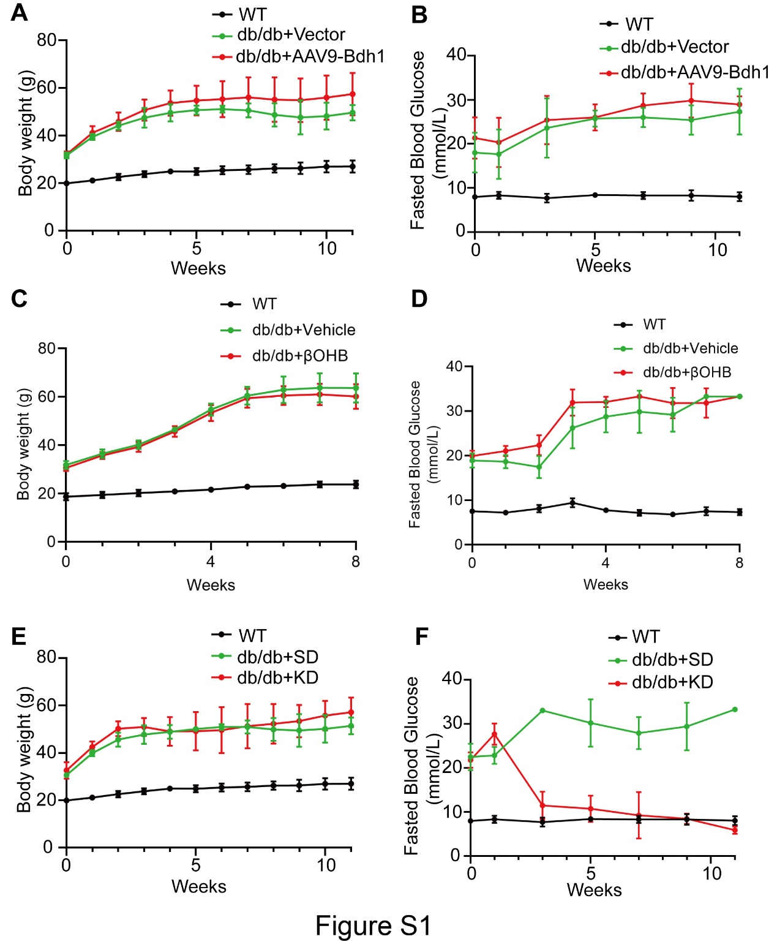
Figure S1. Body weight and fasted blood glucose of mice with indicated treatment.

