Table 1: Enrichment report
Total actives: 25
Total ligands (actives + decoys): 1275
Number of ranked actives: 25
BEDROC(alpha=160.9, alpha*Ra=3.1549): 0.341
BEDROC(alpha=20.0, alpha*Ra=0.3922): 0.741
BEDROC(alpha=8.0, alpha*Ra=0.1569): 0.883
ROC: 0.98
RIE: 12.27
Area under accumulation curve: 0.97
Ave. Number of outranking decoys: 20
Minimum Tc over all active pairs: 0.0093

Count and percentage of actives in top N% of decoy results.
% Decoys | 1%| 2%| 5%| 10%| 20%|
# Actives | 4| 12| 25| 25| 25|
% Actives | 16.0| 48.0| 100.0| 100.0| 100.0|
Count and percentage of actives in top N% of results.
% Results | 1%| 2%| 5%| 10%| 20%|
# Actives | 4| 6| 25| 25| 25|
% Actives | 16.0| 24.0|100.0| 100.0| 100.0|
1-Specificity | Sensitivity | %Screen
0.96  0.92  0.88  0.84  0.8  0.76  0.72  0.68  0.64  0.6  0.56  0.52  0.48  0.44  0.4  0.36  0.32  0.28  0.24  0.2  0.16  0.12  0.08  0.04  0 | 0.04  0.08  0.12  0.16  0.2  0.24  0.28  0.32  0.36  0.4  0.44  0.48  0.52  0.56  0.6  0.64  0.68  0.72  0.76  0.8  0.84  0.88  0.92  0.96  1 | 0.156862745  0.392156863  0.470588235  0.62745098  1.647058824  1.725490196  2.352941176  2.431372549  2.588235294  2.666666667  2.745098039  2.823529412  2.980392157  3.058823529  3.137254902  3.215686275  3.294117647  3.37254902  3.450980392  3.529411765  3.607843137  3.68627451  3.764705882  3.843137255  3.921568627

Table 2: Results of the QSAR model, Test and Train Dataset for the QSAR model
S.D. R^2 RMSE Q^2
0.6427 0.7123 0.7338 0.6223
ID Set Y(Obs) Y(Pred) Error Name
1 train 4.8800 5.7227 0.8427 CHEMBL400239
2 train 7.4700 6.5353 -0.9347 CHEMBL442802
3 train 7.3900 9.0828 1.6928 CHEMBL186290
4 test 8.9600 9.0255 0.0655 CHEMBL362558
5 train 4.9700 5.0129 0.0429 CHEMBL4065388
6 train 4.8200 5.2340 0.4140 CHEMBL4087456
7 test 5.8600 5.8129 -0.0471 CHEMBL1270230
8 train 4.9700 6.1570 1.1870 CHEMBL403404
9 test 4.3000 5.0520 0.7520 CHEMBL105712
10 test 7.8900 7.1753 -0.7147 CHEMBL331190
11 test 4.5700 5.3096 0.7396 CHEMBL78264
12 test 7.9000 7.0010 -0.8990 CHEMBL66900
13 train 4.5400 6.2484 1.7084 CHEMBL290436
14 train 7.4000 7.0574 -0.3426 CHEMBL302490
15 train 6.0500 6.0633 0.0133 CHEMBL431634
16 train 4.9200 6.9230 2.0030 CHEMBL120355
17 train 5.2000 6.6253 1.4253 CHEMBL442363
18 test 6.6300 5.9356 -0.6944 CHEMBL4450851
19 train 8.3800 6.4029 -1.9771 CHEMBL2094331
20 train 4.8900 5.9992 1.1092 CHEMBL4436958
21 train 8.0800 7.9012 -0.1788 CHEMBL102714
22 train 5.6200 5.4658 -0.1542 CHEMBL3915489
23 train 5.2600 5.4011 0.1411 CHEMBL3890986
24 test 6.6800 5.1562 -1.5238 CHEMBL3914252
25 test 5.6800 5.6645 -0.0155 CHEMBL3899197
26 train 5.4700 5.2254 -0.2446 CHEMBL3966595
27 train 7.9200 8.2341 0.3141 CHEMBL6041961
28 train 7.9200 8.2341 0.3141 CHEMBL6041961
29 train 7.3500 7.1181 -0.2319 CHEMBL3735835
30 test 7.3500 7.1181 -0.2319 CHEMBL3735835
31 train 5.8600 5.9415 0.0815 CHEMBL3734985
32 train 5.8600 5.9415 0.0815 CHEMBL3734985
33 test 4.6400 5.2311 0.5911 CHEMBL414128
34 train 5.0700 5.1116 0.0416 CHEMBL399696
35 train 4.9800 5.2512 0.2712 CHEMBL403562
36 train 6.6100 6.2698 -0.3402 CHEMBL248219
37 train 6.3000 6.4836 0.1836 CHEMBL251375
38 test 5.5500 6.4211 0.8711 CHEMBL249531
39 train 7.6800 8.0574 0.3774 CHEMBL4071773
40 train 5.3200 5.7518 0.4318 CHEMBL4077010
41 train 6.9200 7.4673 0.5473 CHEMBL3398204
42 train 5.7500 5.8832 0.1332 CHEMBL1938954
43 train 6.1100 6.2190 0.1090 CHEMBL1669585
44 train 5.7200 5.2837 -0.4363 CHEMBL464381
45 train 5.7200 5.2203 -0.4997 CHEMBL464381
46 train 6.8500 6.8166 -0.0334 CHEMBL261720
47 train 7.4300 6.9603 -0.4697 CHEMBL1940906
48 train 5.2000 5.3064 0.1064 CHEMBL1938963
49 train 4.3000 5.3067 1.0067 CHEMBL1081198
50 train 5.1800 4.0677 -1.1123 CHEMBL5071369
51 train 6.7000 6.2183 -0.4817 CHEMBL318471
52 train 5.9200 6.7295 0.8095 CHEMBL574233
53 train 6.4700 6.6183 0.1483 CHEMBL1940252
54 train 6.6000 5.9874 -0.6126 CHEMBL233149
55 train 6.1400 7.0573 0.9173 CHEMBL1630477
56 train 6.7000 6.7812 0.0812 CHEMBL3398205
57 train 6.3200 6.4383 0.1183 CHEMBL3398190
58 train 6.2200 6.4890 0.2690 CHEMBL318911
59 train 6.3000 6.2082 -0.0918 CHEMBL98501
60 train 7.5800 7.8091 0.2291 CHEMBL336179
61 train 5.6800 5.3861 -0.2939 CHEMBL316485
62 train 6.8700 7.8091 0.9391 CHEMBL131035
63 test 7.4600 7.0795 -0.3805 CHEMBL574591
64 test 6.7000 7.1259 0.4259 CHEMBL573480
65 train 6.1700 7.5412 1.3712 CHEMBL574600
66 test 7.4700 7.0795 -0.3905 CHEMBL574588
67 train 7.7000 7.1124 -0.5876 CHEMBL574613
68 train 6.1900 5.8686 -0.3214 CHEMBL75680
69 train 7.6600 7.8091 0.1491 CHEMBL340259
70 train 5.6000 5.6677 0.0677 CHEMBL142824
71 train 4.6600 4.6284 -0.0316 CHEMBL178179
72 test 6.6100 6.8998 0.2898 CHEMBL4868956
73 train 7.1100 7.1728 0.0628 CHEMBL4865061
74 train 5.4100 6.4376 1.0276 CHEMBL596073
75 train 5.4100 6.4376 1.0276 CHEMBL596073
76 test 7.6000 8.6777 1.0777 CHEMBL469509
77 train 6.7000 6.9333 0.2333 CHEMBL569998
78 train 5.7000 5.7028 0.0028 CHEMBL296271
79 train 5.2600 5.6895 0.4295 CHEMBL444169
80 train 6.8000 6.7427 -0.0573 CHEMBL573933
81 train 6.7500 7.1525 0.4025 CHEMBL573192
82 train 8.1500 7.8944 -0.2556 CHEMBL3410104
83 test 5.3000 5.9824 0.6824 CHEMBL316512
84 test 5.0000 5.5159 0.5159 CHEMBL99779
85 train 4.5200 6.6648 2.1448 CHEMBL572922
86 train 7.6000 7.1523 -0.4477 CHEMBL3652551
87 train 6.9600 7.4916 0.5316 CHEMBL319265
88 test 6.0000 5.3652 -0.6348 CHEMBL140061
89 train 6.5200 6.4572 -0.0628 CHEMBL461139
90 train 5.0000 5.3332 0.3332 CHEMBL142764
91 train 4.3000 5.0520 0.7520 CHEMBL105712
92 train 5.0000 4.5854 -0.4146 CHEMBL403233
93 train 9.2200 8.4977 -0.7223 CHEMBL1082152
94 train 7.6600 7.7279 0.0679 CHEMBL1087243
95 train 8.6200 7.7814 -0.8386 CHEMBL1088149
96 test 7.1100 7.0801 -0.0299 CHEMBL322970
97 train 9.0000 8.5967 -0.4033 CHEMBL1082151
98 train 7.4600 7.4855 0.0255 CHEMBL1081128
99 test 6.3900 6.5449 0.1549 CHEMBL402228
100 train 5.1500 5.3635 0.2135 CHEMBL26241
101 test 5.7300 5.5510 -0.1790 CHEMBL512208
102 test 6.3700 6.1852 -0.1848 CHEMBL261439
103 train 6.2800 6.2485 -0.0315 CHEMBL408634
104 train 7.6800 6.9330 -0.7470 CHEMBL407730
105 test 7.6800 6.9330 -0.7470 CHEMBL407730
106 train 6.3700 6.7176 0.3476 CHEMBL260344
107 train 6.3700 6.7176 0.3476 CHEMBL260344
108 train 8.1500 8.1493 -0.0007 CHEMBL264161
109 test 8.1500 8.1493 -0.0007 CHEMBL264161
110 train 6.8500 6.6466 -0.2034 CHEMBL101804
111 train 6.8500 6.6466 -0.2034 CHEMBL101804
112 train 7.6200 7.4858 -0.1342 CHEMBL427909
113 test 7.6200 7.4858 -0.1342 CHEMBL427909
114 train 8.1500 7.6329 -0.5171 CHEMBL259838
115 train 8.1500 7.6329 -0.5171 CHEMBL259838
116 test 7.6600 7.1133 -0.5467 CHEMBL259744
117 test 7.1500 7.1967 0.0467 CHEMBL347681
118 test 6.3200 6.6309 0.3109 CHEMBL160829
119 test 7.1200 6.5307 -0.5893 CHEMBL156987
120 test 7.2800 7.3847 0.1047 CHEMBL158885
121 train 6.8600 6.8980 0.0380 CHEMBL157089
122 train 6.9400 6.6170 -0.3230 CHEMBL156277
123 train 7.1300 6.9715 -0.1585 CHEMBL345212
124 train 6.4300 7.0977 0.6677 CHEMBL160937
125 train 6.1500 6.5555 0.4055 CHEMBL350435
126 train 6.5200 6.1554 -0.3646 CHEMBL351356
127 train 6.2300 5.8751 -0.3549 CHEMBL346551
128 train 7.4700 7.4469 -0.0231 CHEMBL337642
129 train 6.7200 6.9138 0.1938 CHEMBL7463
130 test 5.1700 6.1542 0.9842 CHEMBL1164353
131 train 5.1700 6.1542 0.9842 CHEMBL1164353
132 train 6.5100 5.8569 -0.6531 CHEMBL5271833
133 test 8.0500 7.7106 -0.3394 CHEMBL5284249
134 train 7.1400 7.3467 0.2067 CHEMBL5290908
135 test 8.5200 8.1011 -0.4189 CHEMBL5266186
136 train 8.7400 8.8137 0.0737 CHEMBL5266570
137 test 8.3800 8.6984 0.3184 CHEMBL5276840
138 train 8.3900 7.9385 -0.4515 CHEMBL5271312
139 train 5.9800 5.6922 -0.2878 CHEMBL403406
140 train 6.3500 5.9873 -0.3627 CHEMBL400240
141 test 5.4500 6.5567 1.1067 CHEMBL249141
142 test 5.7500 6.1626 0.4126 CHEMBL399287
143 train 4.0000 4.5029 0.5029 CHEMBL449317
144 test 5.1100 6.1265 1.0165 CHEMBL2312654
145 train 4.5200 5.0784 0.5584 CHEMBL2312645
146 train 6.7000 6.3124 -0.3876 CHEMBL316940
147 train 6.5200 6.6409 0.1209 CHEMBL99803
148 train 7.3200 7.0805 -0.2395 CHEMBL599428
149 train 6.0000 5.2930 -0.7070 CHEMBL341572
150 train 8.8300 7.8787 -0.9513 CHEMBL2203552
151 train 7.2800 8.5631 1.2831 CHEMBL369572
152 test 6.9600 8.8518 1.8918 CHEMBL361948
153 train 4.7700 5.8365 1.0665 CHEMBL111895
154 test 6.9200 6.8417 -0.0783 CHEMBL329063
155 train 7.0500 6.7705 -0.2795 CHEMBL333894
156 test 7.1000 6.0649 -1.0351 CHEMBL1230607
157 train 7.1000 6.0649 -1.0351 CHEMBL1230607
158 train 6.4000 5.9749 -0.4251 CHEMBL308293
159 train 5.2300 5.0330 -0.1970 CHEMBL306355
160 train 7.9200 6.7826 -1.1374 CHEMBL1097003
161 test 7.9200 6.7826 -1.1374 CHEMBL1097003
162 train 5.9600 5.4132 -0.5468 CHEMBL77066
163 test 5.2100 4.4952 -0.7148 CHEMBL218301
164 test 5.5900 5.2837 -0.3063 CHEMBL464381
165 train 5.5900 5.2203 -0.3697 CHEMBL464381
166 test 6.1000 6.0836 -0.0164 CHEMBL483841
167 train 9.0700 7.7687 -1.3013 CHEMBL1940981
168 train 5.1000 4.9314 -0.1686 CHEMBL341655
169 test 5.4000 6.3643 0.9643 CHEMBL99280
170 train 6.8900 6.9202 0.0302 CHEMBL317964
171 train 7.6200 7.1131 -0.5069 CHEMBL98153
172 train 6.0000 5.2930 -0.7070 CHEMBL341572
173 train 6.1800 5.9871 -0.1929 CHEMBL559472
174 train 4.9100 5.6244 0.7144 CHEMBL559241
175 train 5.8900 5.6574 -0.2326 CHEMBL260358
176 train 5.8900 5.6574 -0.2326 CHEMBL260358
177 train 6.2300 5.5754 -0.6546 CHEMBL406863
178 test 6.5500 5.2065 -1.3435 CHEMBL256517
179 train 4.5100 4.9532 0.4432 CHEMBL563143
180 train 7.0300 6.3418 -0.6882 CHEMBL470566
181 train 5.0000 4.7462 -0.2538 CHEMBL24693
182 train 7.1900 7.0876 -0.1024 CHEMBL456218
183 train 8.0800 8.3716 0.2916 CHEMBL471832
184 test 6.7700 6.9752 0.2052 CHEMBL1210406
185 train 6.7700 6.9752 0.2052 CHEMBL1210406
186 train 5.7000 5.8337 0.1337 CHEMBL5182770
187 train 5.5200 5.1913 -0.3287 CHEMBL342402
188 test 6.0900 5.9113 -0.1787 CHEMBL40021
189 train 6.1700 6.5446 0.3746 CHEMBL603197
190 train 6.1700 6.5446 0.3746 CHEMBL603197
191 train 7.5700 7.1274 -0.4426 CHEMBL3091547
192 train 9.8000 9.0625 -0.7375 CHEMBL5284020
193 train 8.1600 7.6311 -0.5289 CHEMBL5281994
194 train 8.3900 8.4011 0.0111 CHEMBL5272462
195 train 7.4200 7.3784 -0.0416 CHEMBL3093033
196 train 5.0100 5.9835 0.9735 CHEMBL3093045
197 train 5.7500 6.2918 0.5418 CHEMBL3093039
198 train 5.7500 6.2918 0.5418 CHEMBL3093039
199 train 6.6600 7.8091 1.1491 CHEMBL340259
200 train 7.4600 7.2218 -0.2382 CHEMBL119963
201 train 8.4000 7.5435 -0.8565 CHEMBL321315
202 test 5.2500 6.3792 1.1292 CHEMBL270262
203 test 6.8600 7.3296 0.4695 CHEMBL334555
204 test 7.2900 7.8091 0.5191 CHEMBL130774
205 train 5.8400 6.3339 0.4939 CHEMBL6012976
206 train 7.3700 7.4916 0.1216 CHEMBL103628
207 test 8.7000 8.4349 -0.2651 CHEMBL412142
208 train 8.7000 8.4349 -0.2651 CHEMBL412142
209 train 6.8000 7.2444 0.4444 CHEMBL388978
210 train 5.0000 5.5159 0.5159 CHEMBL99779
211 train 6.0100 5.2276 -0.7824 CHEMBL203569
212 train 8.4000 7.9404 -0.4596 CHEMBL66453
213 train 5.6800 5.3861 -0.2939 CHEMBL316485
214 train 5.0000 5.5159 0.5159 CHEMBL99779
215 train 7.5500 6.8027 -0.7473 CHEMBL599224
216 train 6.4500 6.5508 0.1008 CHEMBL597754
217 train 7.4200 6.9612 -0.4588 CHEMBL578628
218 train 7.3000 7.2330 -0.0670 CHEMBL573257
219 test 7.1300 6.8769 -0.2531 CHEMBL573486
220 train 7.1100 6.9770 -0.1330 CHEMBL582853
221 train 6.5500 7.1508 0.6008 CHEMBL578861
222 train 7.8900 7.4874 -0.4025 CHEMBL584976
223 train 6.8900 5.8766 -1.0134 CHEMBL2062563
224 train 6.5500 6.5375 -0.0125 CHEMBL594523
225 train 6.5500 6.5375 -0.0125 CHEMBL594523
226 train 8.4000 7.6072 -0.7928 CHEMBL50894
227 train 7.1000 7.3762 0.2762 CHEMBL1095366
228 train 7.1000 7.3762 0.2762 CHEMBL1095366
229 train 5.5700 6.2286 0.6586 CHEMBL1095038
230 train 5.5700 6.2286 0.6586 CHEMBL1095038
231 test 4.5400 5.8632 1.3232 CHEMBL40022
232 train 6.1100 6.6459 0.5359 CHEMBL1210405
233 test 6.1100 6.6459 0.5359 CHEMBL1210405
234 train 6.5700 6.1935 -0.3765 CHEMBL571486
235 train 5.4000 6.9531 1.5531 CHEMBL67241
236 train 6.2700 5.8427 -0.4273 CHEMBL1630448
237 test 6.0100 6.0718 0.0618 CHEMBL1630460
238 train 7.6800 6.9453 -0.7347 CHEMBL5282740
239 train 8.9200 8.5504 -0.3696 CHEMBL1235645
240 train 8.9200 8.5504 -0.3696 CHEMBL1235645
241 test 5.8600 5.5604 -0.2996 CHEMBL1630431
242 test 7.9700 6.5701 -1.3999 CHEMBL1630434
243 train 7.9700 6.5701 -1.3999 CHEMBL1630434
244 train 6.7000 6.8031 0.1031 CHEMBL1086780
245 train 6.7000 6.8031 0.1031 CHEMBL1086780
246 train 5.3000 5.3951 0.0951 CHEMBL1084681
247 train 5.3000 5.3951 0.0951 CHEMBL1084681
248 train 5.1400 5.5959 0.4559 CHEMBL1077258
249 train 5.1400 5.5959 0.4559 CHEMBL1077258
250 train 4.6900 5.7717 1.0817 CHEMBL1084693
251 train 4.6900 5.7717 1.0817 CHEMBL1084693
252 train 5.7900 6.3801 0.5901 CHEMBL5402554
253 train 5.4900 6.2199 0.7299 CHEMBL5410239
254 train 6.4000 6.7544 0.3544 CHEMBL334031
255 test 6.8000 6.4577 -0.3423 CHEMBL1809120
256 train 7.0400 6.4369 -0.6031 CHEMBL570580
257 train 8.2100 7.3309 -0.8791 CHEMBL1682851
258 train 5.6600 6.5222 0.8622 CHEMBL95827
259 train 5.5700 6.0728 0.5028 CHEMBL1096290
260 train 7.1000 6.5765 -0.5235 CHEMBL1098938
261 test 6.4000 6.6251 0.2251 CHEMBL419054
262 test 7.2100 6.8087 -0.4013 CHEMBL1682839
263 test 7.7700 7.3296 -0.4404 CHEMBL340935
264 train 8.1500 7.9012 -0.2488 CHEMBL102714
265 train 6.4100 6.6735 0.2635 CHEMBL288064
266 train 7.6000 7.8340 0.2340 CHEMBL103055
267 test 6.2700 5.5920 -0.6780 CHEMBL458210
268 train 7.1600 7.6794 0.5194 CHEMBL4076038
269 train 7.1500 7.9329 0.7829 CHEMBL106061
270 train 7.9000 6.8795 -1.0205 CHEMBL1809117
271 train 6.5000 6.5843 0.0843 CHEMBL1809121
272 train 6.5000 5.9493 -0.5507 CHEMBL1809122
273 test 7.7000 6.1788 -1.5212 CHEMBL1809109
274 train 6.4000 6.5798 0.1798 CHEMBL1809110
275 test 7.1000 7.3551 0.2551 CHEMBL1809113
276 train 5.4000 6.2050 0.8050 CHEMBL1809116
277 test 5.2000 6.5843 1.3843 CHEMBL1809121
278 train 5.7200 5.2837 -0.4363 CHEMBL464381
279 test 5.7200 5.2203 -0.4997 CHEMBL464381
280 test 4.1100 4.6720 0.5620 CHEMBL2207938
281 test 4.4000 5.0247 0.6247 CHEMBL2334799
282 test 8.8900 8.8442 -0.0458 CHEMBL178737
283 train 5.9200 5.9269 0.0069 CHEMBL175845
284 train 7.0000 6.9755 -0.0245 CHEMBL319373
285 test 6.0600 6.3936 0.3336 CHEMBL565612
286 train 4.6300 6.1587 1.5287 CHEMBL5424881
287 test 4.7000 5.8447 1.1447 CHEMBL5402529
288 train 6.9200 6.9559 0.0359 CHEMBL5398463
289 train 5.1200 4.8506 -0.2694 CHEMBL405384
290 train 4.8200 6.1184 1.2984 CHEMBL104264
291 train 7.2800 7.5412 0.2612 CHEMBL1232916
292 train 9.0500 7.9078 -1.1422 CHEMBL5415012
293 test 9.3500 9.3254 -0.0246 CHEMBL5438689
294 test 8.4100 8.5707 0.1607 CHEMBL5434336
295 train 9.6000 9.2616 -0.3384 CHEMBL5407971
296 train 9.8200 9.8233 0.0033 CHEMBL5404581
297 train 7.7000 8.1219 0.4219 CHEMBL5434002
298 train 4.8500 4.9881 0.1381 CHEMBL38043
299 test 5.6200 5.9927 0.3727 CHEMBL404689
300 train 7.6400 6.6056 -1.0344 CHEMBL253956
301 train 7.8900 7.1025 -0.7875 CHEMBL402541
302 train 8.7400 8.3271 -0.4129 CHEMBL54547
303 train 5.7700 6.3235 0.5535 CHEMBL3110134
304 train 5.4700 6.4648 0.9948 CHEMBL256559
305 train 9.1300 9.6054 0.4754 CHEMBL5428013
306 train 7.5200 7.2394 -0.2806 CHEMBL403405
307 train 6.0800 6.4626 0.3826 CHEMBL482632
308 test 8.2700 8.7358 0.4658 CHEMBL522464
309 train 7.2600 7.9692 0.7092 CHEMBL489410
310 train 6.0800 6.2278 0.1478 CHEMBL261660
311 test 6.0800 6.2278 0.1478 CHEMBL261660
312 test 7.3700 7.0281 -0.3419 CHEMBL406701
313 train 7.3700 7.0281 -0.3419 CHEMBL406701
314 train 7.8500 7.8359 -0.0141 CHEMBL317657
315 train 7.8500 7.8359 -0.0141 CHEMBL317657
316 train 7.4100 6.9198 -0.4902 CHEMBL540245
317 train 7.1900 6.9088 -0.2812 CHEMBL557354
318 train 6.8000 6.8697 0.0697 CHEMBL557273
319 train 6.0600 6.7194 0.6594 CHEMBL521774
320 train 6.6300 7.2307 0.6007 CHEMBL491064
321 train 9.1400 8.8711 -0.2689 CHEMBL490636
322 train 7.9900 8.3774 0.3874 CHEMBL490637
323 train 4.8700 4.9152 0.0452 CHEMBL460627
324 test 5.6800 5.6383 -0.0417 CHEMBL3734776
325 train 5.6800 5.6383 -0.0417 CHEMBL3734776
326 train 5.9200 6.4084 0.4884 CHEMBL1099281
327 train 5.9600 6.1391 0.1791 CHEMBL1096634
328 train 5.9800 6.1391 0.1591 CHEMBL1096626
329 train 6.0300 6.1620 0.1320 CHEMBL1083208
330 test 6.0300 6.1620 0.1320 CHEMBL1083208
331 train 5.4200 5.8513 0.4313 CHEMBL1095039
332 train 5.4200 5.8513 0.4313 CHEMBL1095039
333 train 7.6400 7.2980 -0.3420 CHEMBL1091083
334 train 7.6400 7.2980 -0.3420 CHEMBL1091083
335 train 7.2600 6.9595 -0.3005 CHEMBL1093745
336 train 7.2600 6.9595 -0.3005 CHEMBL1093745
337 train 5.9900 6.3183 0.3283 CHEMBL1098241
338 test 6.5200 6.2015 -0.3185 CHEMBL1098316
339 train 4.7800 6.2017 1.4217 CHEMBL1085920
340 train 7.3800 7.4433 0.0633 CHEMBL523113
341 test 6.1500 7.1317 0.9817 CHEMBL483465
342 train 9.6400 8.4320 -1.2080 CHEMBL491647
343 train 8.9200 8.4451 -0.4749 CHEMBL490842
344 test 6.5000 7.1947 0.6947 CHEMBL306692
345 train 5.4000 4.9911 -0.4089 CHEMBL24537
346 train 5.1700 4.8967 -0.2733 CHEMBL5438325
347 train 5.4300 5.6575 0.2275 CHEMBL5409693
348 test 5.4300 6.2206 0.7906 CHEMBL5394513
349 train 6.9200 6.4141 -0.5059 CHEMBL5414801
350 test 5.2300 5.2452 0.0152 CHEMBL5412372
351 train 5.8500 5.5244 -0.3256 CHEMBL284861
352 test 4.1300 5.0506 0.9206 CHEMBL2334791
353 train 5.7000 6.8734 1.1734 CHEMBL69526
354 test 6.0000 5.0948 -0.9052 CHEMBL307941
355 train 7.8500 6.4726 -1.3774 CHEMBL396614
356 train 5.2400 5.2793 0.0393 CHEMBL4093852
357 test 6.8700 7.0116 0.1416 CHEMBL3699443
358 train 7.6000 6.9981 -0.6019 CHEMBL3093054
359 train 7.4100 6.7345 -0.6755 CHEMBL3093049
360 train 6.7000 6.0691 -0.6309 CHEMBL404174
361 train 7.3500 7.0506 -0.2994 CHEMBL109944
362 train 7.4600 7.1124 -0.3476 CHEMBL574159
363 test 7.2700 7.1553 -0.1147 CHEMBL576183
364 test 7.1400 7.2067 0.0667 CHEMBL572793
365 train 7.8500 8.4373 0.5873 CHEMBL5286727
366 train 7.0600 7.0970 0.0370 CHEMBL4439321
367 train 5.2300 4.8952 -0.3348 CHEMBL1170126
368 test 5.7000 6.2569 0.5569 CHEMBL3545157
369 train 8.3000 6.4809 -1.8191 CHEMBL1276127
370 train 6.9600 6.1153 -0.8447 CHEMBL4074938
371 test 5.6000 5.1913 -0.4087 CHEMBL342402
372 train 4.6000 5.1350 0.5350 CHEMBL343821
373 train 5.7000 5.5657 -0.1343 CHEMBL143273
374 train 6.3000 5.4879 -0.8121 CHEMBL357136
375 train 5.3000 5.0666 -0.2334 CHEMBL356459
376 train 5.3400 5.6887 0.3487 CHEMBL1230165
377 train 5.5100 6.2852 0.7752 CHEMBL5081787
378 train 6.8000 6.9347 0.1347 CHEMBL4873449
379 train 6.8000 6.9347 0.1347 CHEMBL4873449
380 train 9.3000 7.9659 -1.3341 CHEMBL4095848
381 test 6.5500 6.6585 0.1085 CHEMBL326705
382 train 6.5500 6.6585 0.1085 CHEMBL326705
383 test 4.5100 5.6751 1.1651 CHEMBL4102903
384 test 4.9000 5.6962 0.7962 CHEMBL4098364
385 test 6.4800 6.4801 0.0001 CHEMBL2158866
386 train 6.0000 5.8138 -0.1862 CHEMBL458857
387 train 4.8900 6.0433 1.1533 CHEMBL2347086
388 train 5.2200 5.4736 0.2536 CHEMBL417835
389 train 4.8000 5.0422 0.2422 CHEMBL4090889
390 test 6.8300 6.9169 0.0869 CHEMBL1092802
391 train 6.8300 6.9169 0.0869 CHEMBL1092802
392 train 7.0100 7.2827 0.2727 CHEMBL1077243
393 train 7.0100 7.2827 0.2727 CHEMBL1077243
394 test 5.7600 6.7735 1.0135 CHEMBL1093746
395 train 5.7600 6.7735 1.0135 CHEMBL1093746
396 train 5.2600 5.9745 0.7145 CHEMBL1084683
397 test 5.2600 5.9745 0.7145 CHEMBL1084683
398 test 4.9600 6.2115 1.2515 CHEMBL1085918
399 train 4.9600 6.2115 1.2515 CHEMBL1085918
400 train 4.6000 6.0326 1.4326 CHEMBL1083528
401 train 4.6000 6.0326 1.4326 CHEMBL1083528
402 train 6.8000 7.0733 0.2733 CHEMBL294592
403 test 5.7000 5.6360 -0.0640 CHEMBL3765061
404 train 5.7000 5.5616 -0.1384 CHEMBL3765061
405 train 5.7000 5.5616 -0.1384 CHEMBL3765061
406 train 6.4400 6.0876 -0.3524 CHEMBL3734911
407 test 6.4400 6.0876 -0.3524 CHEMBL3734911
408 train 6.2900 5.7993 -0.4907 CHEMBL3735863
409 train 6.2900 5.7993 -0.4907 CHEMBL3735863
410 train 7.3500 6.7821 -0.5679 CHEMBL3735079
411 train 7.3500 6.7821 -0.5679 CHEMBL3735079
412 test 7.2800 7.0215 -0.2585 CHEMBL3735627
413 train 7.2800 7.0215 -0.2585 CHEMBL3735627
414 train 7.7700 7.3049 -0.4651 CHEMBL3735856
415 train 7.7700 7.3049 -0.4651 CHEMBL3735856
416 train 8.0200 7.6096 -0.4104 CHEMBL3735176
417 train 8.0200 7.6096 -0.4104 CHEMBL3735176
418 train 7.2700 6.3418 -0.9282 CHEMBL470360
419 test 6.7000 6.6563 -0.0437 CHEMBL513040
420 train 6.5500 6.5364 -0.0136 CHEMBL470567
421 train 7.0400 6.8630 -0.1770 CHEMBL469736
422 test 8.4600 8.1245 -0.3355 CHEMBL471833
423 train 4.9900 4.5854 -0.4046 CHEMBL403233
424 test 8.1500 7.6843 -0.4657 CHEMBL408564
425 train 8.1500 7.6843 -0.4657 CHEMBL408564
426 test 7.5200 7.6371 0.1171 CHEMBL396327
427 test 9.1000 8.3595 -0.7405 CHEMBL178766
428 test 4.9700 7.5056 2.5356 CHEMBL2203563
429 train 7.8000 7.3128 -0.4872 CHEMBL2203556
430 train 7.4400 6.1303 -1.3097 CHEMBL5434004
431 test 5.3700 5.7865 0.4165 CHEMBL95477
432 test 6.6200 6.7559 0.1359 CHEMBL334084
433 train 5.8900 5.1068 -0.7832 CHEMBL50498
434 test 4.8700 5.6622 0.7922 CHEMBL559040
435 train 7.2500 7.2444 -0.0056 CHEMBL388978
436 train 6.5200 6.2507 -0.2693 CHEMBL383104
437 train 6.5200 6.2507 -0.2693 CHEMBL383104
438 test 5.6500 6.1267 0.4767 CHEMBL562814
439 train 5.7500 5.5295 -0.2205 CHEMBL564437
440 train 6.7000 7.2444 0.5444 CHEMBL388978
441 train 7.1400 5.9144 -1.2256 CHEMBL5436993
442 test 7.8500 6.3155 -1.5345 CHEMBL5397959
443 train 7.2900 6.8311 -0.4589 CHEMBL5440008
444 train 7.3600 6.9671 -0.3929 CHEMBL5439156
445 test 4.8200 5.1465 0.3265 CHEMBL259141
446 train 5.8500 5.8583 0.0083 CHEMBL260000
447 test 8.8000 8.8682 0.0682 CHEMBL362814
448 test 5.1700 5.7240 0.5540 CHEMBL77947
449 train 6.0900 6.8118 0.7218 CHEMBL4100916
450 train 7.8900 6.5568 -1.3332 CHEMBL215803
451 train 5.7000 6.8647 1.1647 CHEMBL1086733
452 train 5.2300 5.1831 -0.0469 CHEMBL5400270
453 train 5.1200 5.1811 0.0611 CHEMBL5415622
454 train 6.2200 6.0299 -0.1901 CHEMBL1834110
455 test 6.3600 6.9875 0.6275 CHEMBL1834113
456 test 5.9300 6.2795 0.3495 CHEMBL428596
457 train 5.9300 6.2795 0.3495 CHEMBL428596
458 train 5.9300 6.2795 0.3495 CHEMBL428596
459 train 5.5500 4.8150 -0.7350 CHEMBL1630458
460 train 7.2800 7.1855 -0.0945 CHEMBL1630483
461 train 7.6600 6.4965 -1.1635 CHEMBL126077
462 test 5.1300 6.1180 0.9880 CHEMBL3185434
463 train 5.4400 6.0327 0.5927 CHEMBL604712
464 train 5.4400 6.0327 0.5927 CHEMBL604712
465 test 5.4200 5.2793 -0.1407 CHEMBL4096612
466 train 5.0500 4.9232 -0.1268 CHEMBL4074837
467 train 5.5100 4.9232 -0.5868 CHEMBL4095283
468 train 5.2800 5.1070 -0.1730 CHEMBL4067286
469 train 5.0700 5.1248 0.0548 CHEMBL4104341
470 test 5.0300 5.1050 0.0750 CHEMBL4066679
471 test 7.5800 6.7841 -0.7959 CHEMBL1210236
472 test 7.5800 6.7841 -0.7959 CHEMBL1210236
473 train 7.8000 6.8952 -0.9048 CHEMBL1210175
474 train 7.8000 6.8952 -0.9048 CHEMBL1210175
475 test 9.8500 7.1597 -2.6903 CHEMBL564450
476 train 8.2200 7.9329 -0.2871 CHEMBL105477
477 train 5.7000 6.0342 0.3342 CHEMBL44541
478 train 7.7500 7.8340 0.0840 CHEMBL103055
479 train 6.3000 6.6719 0.3719 CHEMBL1809107
480 train 6.9000 6.7506 -0.1494 CHEMBL1738953
481 train 6.2000 6.9782 0.7782 CHEMBL1809115
482 test 7.3200 7.4469 0.1269 CHEMBL337642
483 train 4.3000 4.6662 0.3662 CHEMBL359135
484 train 8.5200 8.1631 -0.3569 CHEMBL2048662
485 test 8.5200 8.1631 -0.3569 CHEMBL2048662
486 train 7.7700 7.7694 -0.0006 CHEMBL2046466
487 train 7.7700 7.7694 -0.0006 CHEMBL2046466
488 train 7.5700 7.6414 0.0714 CHEMBL2048668
489 test 7.5700 7.6414 0.0714 CHEMBL2048668
490 train 8.0000 7.7665 -0.2335 CHEMBL2048669
491 train 8.0000 7.7665 -0.2335 CHEMBL2048669
492 train 7.8900 7.7394 -0.1506 CHEMBL2048674
493 test 7.8900 7.7394 -0.1506 CHEMBL2048674
494 train 7.5200 7.6582 0.1382 CHEMBL2048675
495 train 7.5200 7.6582 0.1382 CHEMBL2048675
496 train 8.5200 8.3778 -0.1422 CHEMBL2048678
497 train 8.5200 8.3778 -0.1422 CHEMBL2048678
498 train 8.7000 8.6938 -0.0062 CHEMBL2048680
499 train 8.7000 8.6938 -0.0062 CHEMBL2048680
500 train 5.3000 5.5573 0.2573 CHEMBL102953
501 train 5.3000 5.7743 0.4743 CHEMBL105348
502 train 5.3500 5.7721 0.4221 CHEMBL1801632
503 test 8.4000 6.2651 -2.1349 CHEMBL430574
504 test 6.7000 6.8900 0.1900 CHEMBL121543
505 train 5.8200 6.2711 0.4511 CHEMBL328627
506 train 5.8100 5.4602 -0.3498 CHEMBL5426735
507 test 6.1800 5.7457 -0.4343 CHEMBL5417890
508 train 6.4400 6.0281 -0.4119 CHEMBL5418722
509 train 6.9900 5.5632 -1.4268 CHEMBL5441121
510 train 5.2100 5.5576 0.3476 CHEMBL5398474
511 train 6.4000 5.4715 -0.9285 CHEMBL1957100
512 train 7.7000 6.4910 -1.2090 CHEMBL1957228
513 train 5.7000 5.7668 0.0668 CHEMBL1957099
514 train 5.5000 5.4715 -0.0285 CHEMBL1957100
515 train 7.1600 7.5084 0.3484 CHEMBL1093747
516 train 7.1600 7.5084 0.3484 CHEMBL1093747
517 train 5.4700 5.7646 0.2946 CHEMBL5086263
518 test 5.3000 5.0022 -0.2978 CHEMBL5283849
519 test 7.4600 7.8121 0.3521 CHEMBL1997924
520 train 7.4600 7.8121 0.3521 CHEMBL1997924
521 train 5.9400 6.6722 0.7322 CHEMBL1096291
522 train 4.5200 6.5268 2.0068 CHEMBL1096292
523 train 5.3000 5.1829 -0.1171 CHEMBL5440511
524 train 5.2900 5.1043 -0.1857 CHEMBL5423907
525 train 5.2900 5.1070 -0.1830 CHEMBL5439392
526 train 6.2100 5.5632 -0.6468 CHEMBL5438728
527 train 7.3900 8.1819 0.7919 CHEMBL5278542
528 train 10.0000 8.5333 -1.4667 CHEMBL5268011
529 test 5.0000 6.8676 1.8676 CHEMBL5274110
530 train 6.0200 8.3425 2.3225 CHEMBL5267631
531 train 7.1100 7.3985 0.2885 CHEMBL5269649
532 train 7.0200 7.5887 0.5687 CHEMBL5272425
533 train 6.1000 7.4364 1.3364 CHEMBL5278847
534 train 7.9600 7.6076 -0.3524 CHEMBL5278701
535 train 8.3300 7.5532 -0.7768 CHEMBL5287898
536 train 8.4300 8.0261 -0.4039 CHEMBL5280241
537 train 7.2800 7.5412 0.2612 CHEMBL1232916
538 train 8.1500 7.8762 -0.2738 CHEMBL489422
539 test 6.3500 5.6766 -0.6734 CHEMBL5273659
540 train 7.4000 7.2470 -0.1530 CHEMBL3736449
541 test 7.4000 7.2470 -0.1530 CHEMBL3736449
542 train 6.5000 6.5290 0.0290 CHEMBL3735621
543 train 6.5000 6.5290 0.0290 CHEMBL3735621
544 train 5.6700 5.9262 0.2562 CHEMBL3735579
545 train 5.6700 5.9262 0.2562 CHEMBL3735579
546 train 6.0900 5.6696 -0.4204 CHEMBL3735291
547 train 6.0900 5.6696 -0.4204 CHEMBL3735291
548 train 8.3000 7.2444 -1.0556 CHEMBL388978
549 train 6.4400 6.2160 -0.2240 CHEMBL1210310
550 train 6.4400 6.2160 -0.2240 CHEMBL1210310
551 train 5.8000 6.2243 0.4243 CHEMBL1099298
552 train 5.3900 6.0520 0.6620 CHEMBL1080583
553 train 6.1800 5.9542 -0.2258 CHEMBL1086782
554 train 6.1800 5.9542 -0.2258 CHEMBL1086782
555 train 5.5400 6.2286 0.6886 CHEMBL1095038
556 train 5.5400 6.2286 0.6886 CHEMBL1095038
557 test 8.0000 7.3762 -0.6238 CHEMBL1095366
558 train 8.0000 7.3762 -0.6238 CHEMBL1095366
559 train 7.2500 7.0808 -0.1692 CHEMBL1093390
560 test 7.2500 7.0808 -0.1692 CHEMBL1093390
561 test 5.2700 6.2286 0.9586 CHEMBL1084682
562 train 5.2700 6.2286 0.9586 CHEMBL1084682
563 train 4.9800 5.8234 0.8434 CHEMBL1077282
564 train 4.9800 5.8234 0.8434 CHEMBL1077282
565 test 7.3600 6.5050 -0.8550 CHEMBL1082237
566 train 7.3600 6.5050 -0.8550 CHEMBL1082237
567 test 7.2600 6.9524 -0.3076 CHEMBL1088618
568 train 7.2600 6.9524 -0.3076 CHEMBL1088618
569 train 7.1200 6.5050 -0.6150 CHEMBL1086638
570 test 7.1200 6.5050 -0.6150 CHEMBL1086638
571 train 6.5800 6.5502 -0.0298 CHEMBL1086781
572 train 6.5800 6.5502 -0.0298 CHEMBL1086781
573 train 5.9300 6.0579 0.1279 CHEMBL1085927
574 train 5.9300 6.0579 0.1279 CHEMBL1085927
575 train 7.6600 6.7467 -0.9133 CHEMBL1091082
576 test 7.6600 6.7467 -0.9133 CHEMBL1091082
577 train 7.2600 7.5638 0.3038 CHEMBL1089722
578 train 7.2600 7.5638 0.3038 CHEMBL1089722
579 train 4.7700 5.7514 0.9814 CHEMBL1084692
580 train 4.7700 5.7514 0.9814 CHEMBL1084692
581 test 7.1700 7.5587 0.3887 CHEMBL5284964
582 train 7.0500 6.3932 -0.6568 CHEMBL3093043
583 train 5.6800 6.2724 0.5924 CHEMBL3093037
584 train 5.6800 6.2724 0.5924 CHEMBL3093037
585 train 9.6000 8.3573 -1.2427 CHEMBL4076186
586 train 7.6600 7.2821 -0.3779 CHEMBL4070244
587 test 8.7000 8.5001 -0.1999 CHEMBL4088777
588 train 7.7200 7.7797 0.0597 CHEMBL4102920
589 train 8.6600 8.4428 -0.2172 CHEMBL4074586
590 train 8.3800 7.2444 -1.1356 CHEMBL388978
591 train 5.8500 5.5244 -0.3256 CHEMBL284861
592 train 4.5700 4.4341 -0.1359 CHEMBL2207939
593 train 6.7000 6.6867 -0.0133 CHEMBL2386101
594 train 8.3200 7.5486 -0.7714 CHEMBL2386096
595 train 6.7000 6.2460 -0.4540 CHEMBL578427
596 train 6.2100 6.2651 0.0551 CHEMBL430574
597 test 6.1700 6.4214 0.2514 CHEMBL4277917
598 train 7.2000 5.7153 -1.4847 CHEMBL5278787
599 train 6.6800 6.6926 0.0126 CHEMBL456219
600 test 6.6600 7.0062 0.3462 CHEMBL470565
601 train 6.2000 6.6109 0.4109 CHEMBL471015
602 test 8.0700 8.3874 0.3174 CHEMBL472043
603 test 6.3300 6.0816 -0.2484 CHEMBL5398642
604 train 5.7800 5.8733 0.0933 CHEMBL5424946
605 train 7.2300 6.2773 -0.9527 CHEMBL5416124
606 train 5.2800 6.2040 0.9240 CHEMBL5396759
607 train 7.5000 6.8886 -0.6114 CHEMBL5426638
608 train 4.7800 4.8761 0.0961 CHEMBL252672
609 train 7.5000 6.9905 -0.5095 CHEMBL66910
610 train 4.4000 5.0118 0.6118 CHEMBL3358804
611 train 7.8900 7.8541 -0.0359 CHEMBL4095172
612 train 5.9200 7.0267 1.1067 CHEMBL4070575
613 train 7.3600 8.3573 0.9973 CHEMBL4076186
614 train 7.2700 7.5354 0.2654 CHEMBL4087402
615 train 8.4600 8.1517 -0.3083 CHEMBL4096472
616 train 5.1000 6.0389 0.9389 CHEMBL416975
617 train 5.1700 6.0598 0.8898 CHEMBL40439
618 train 5.1300 5.5081 0.3781 CHEMBL4166399
619 train 5.0600 5.7162 0.6562 CHEMBL2016642
620 train 5.9200 6.3179 0.3979 CHEMBL4539700
621 train 6.6600 7.4353 0.7753 CHEMBL4578996
622 train 6.2000 6.8238 0.6238 CHEMBL4442834
623 test 5.8200 6.3015 0.4815 CHEMBL5207871
624 train 5.1000 5.0123 -0.0877 CHEMBL306347
625 train 8.4000 7.6218 -0.7782 CHEMBL111298
626 train 6.9800 6.7077 -0.2723 CHEMBL259850
627 train 6.7500 6.6503 -0.0997 CHEMBL1940251
628 train 7.4000 7.1997 -0.2003 CHEMBL1940977
629 train 8.8500 7.8499 -1.0001 CHEMBL1940979
630 train 6.0700 6.1034 0.0334 CHEMBL4761851
631 test 6.5200 7.0773 0.5573 CHEMBL4851835
632 train 7.0900 7.1277 0.0377 CHEMBL4857955
633 train 5.3100 5.8361 0.5261 CHEMBL4849828
634 train 6.0800 7.3309 1.2509 CHEMBL1682851
635 test 4.3000 4.7252 0.4252 CHEMBL143525
636 train 6.2700 6.4122 0.1422 CHEMBL1164177
637 train 6.2700 6.4122 0.1422 CHEMBL1164177
638 train 6.4000 6.1967 -0.2033 CHEMBL3735837
639 train 6.4000 6.1967 -0.2033 CHEMBL3735837
640 train 6.4100 6.6735 0.2635 CHEMBL288064
641 train 9.2400 8.1836 -1.0564 CHEMBL1080901
642 train 6.9800 6.7077 -0.2723 CHEMBL259850
643 test 7.4400 7.1431 -0.2969 CHEMBL1241659
644 train 6.5500 6.6585 0.1085 CHEMBL326705
645 train 6.5500 6.6585 0.1085 CHEMBL326705
646 train 7.8000 7.5436 -0.2564 CHEMBL306865
647 train 6.8100 5.2704 -1.5396 CHEMBL5284219
648 train 5.2500 6.8736 1.6236 CHEMBL5289425
649 test 5.1600 4.9332 -0.2268 CHEMBL5439952
650 train 5.0300 4.8967 -0.1334 CHEMBL5403037
651 train 5.0500 5.1829 0.1329 CHEMBL5396081
652 train 5.2500 5.1829 -0.0671 CHEMBL5436754
653 test 5.5700 5.5057 -0.0643 CHEMBL5409730
654 train 5.5500 5.9400 0.3900 CHEMBL5435495
655 train 7.0300 6.0690 -0.9610 CHEMBL5422486
656 train 5.5800 5.6091 0.0291 CHEMBL5428132
657 train 5.9000 5.2109 -0.6891 CHEMBL5414635
658 test 5.2500 5.1070 -0.1430 CHEMBL5401217
659 test 5.0800 5.6781 0.5981 CHEMBL5406568
660 test 5.5500 6.0707 0.5207 CHEMBL5439185
661 test 6.2200 5.7758 -0.4442 CHEMBL1802358
662 train 5.7800 5.7888 0.0088 CHEMBL5417527
663 test 5.1800 5.3266 0.1466 CHEMBL5424363
664 train 5.5600 5.1838 -0.3762 CHEMBL5424272
665 train 5.1400 4.9396 -0.2004 CHEMBL5405233
666 train 4.3000 5.4299 1.1299 CHEMBL361231
667 test 6.0000 6.6668 0.6668 CHEMBL261440
668 train 6.0000 6.6668 0.6668 CHEMBL261440
669 test 6.5500 6.6585 0.1085 CHEMBL326705
670 train 6.5500 6.6585 0.1085 CHEMBL326705
671 train 4.3000 4.8260 0.5260 CHEMBL382607
672 train 7.4800 7.2444 -0.2356 CHEMBL388978
673 test 8.1900 7.8558 -0.3342 CHEMBL4747410
674 train 7.1400 7.7450 0.6050 CHEMBL4796602
675 train 7.4100 7.1798 -0.2302 CHEMBL4785004
676 train 7.3700 7.1899 -0.1801 CHEMBL4753347
677 train 4.6000 4.6295 0.0295 CHEMBL399493
678 train 6.7500 6.5034 -0.2466 CHEMBL251601
679 test 6.1000 6.8168 0.7168 CHEMBL250183
680 train 6.7500 6.9839 0.2339 CHEMBL5288565
681 train 7.2100 7.7468 0.5368 CHEMBL5273872
682 train 8.7000 7.8814 -0.8186 CHEMBL5265990
683 test 5.6800 5.5629 -0.1170 CHEMBL4779572
684 test 5.7000 6.0342 0.3342 CHEMBL44541
685 train 8.0000 8.3666 0.3666 CHEMBL361708
686 test 8.0000 8.3897 0.3897 CHEMBL361708
687 train 5.2200 5.8153 0.5953 CHEMBL134501
688 train 6.6800 6.8986 0.2186 CHEMBL5639827
689 train 4.3700 4.8143 0.4443 CHEMBL206659
690 train 4.7000 4.6881 -0.0119 CHEMBL202695
691 train 4.9600 5.2323 0.2723 CHEMBL203571
692 train 6.7200 5.2276 -1.4924 CHEMBL203407
693 train 4.5400 5.3306 0.7906 CHEMBL206109
694 train 7.3000 7.2444 -0.0556 CHEMBL388978
695 train 7.1900 7.0502 -0.1398 CHEMBL5598350
696 test 7.3800 6.9332 -0.4468 CHEMBL584757
697 test 7.1800 6.8019 -0.3781 CHEMBL572973
698 test 6.8500 7.0795 0.2295 CHEMBL575021
699 train 5.3000 5.1251 -0.1749 CHEMBL143419
700 train 6.0400 6.0675 0.0275 CHEMBL257834
701 train 8.0000 8.3666 0.3666 CHEMBL361708
702 train 8.0000 8.3897 0.3897 CHEMBL361708
703 train 8.0600 8.1416 0.0816 CHEMBL3301610
704 train 4.8000 6.1240 1.3240 CHEMBL4129590
705 train 5.1400 6.2646 1.1246 CHEMBL3931871
706 test 5.1400 6.2646 1.1246 CHEMBL3931871
707 train 7.7600 6.4128 -1.3472 CHEMBL501724
708 train 7.7600 6.4128 -1.3472 CHEMBL501724
709 train 7.1100 6.2569 -0.8531 CHEMBL3545157
710 train 5.3100 6.0835 0.7735 CHEMBL5429577
711 train 7.6200 7.1131 -0.5069 CHEMBL98153
712 train 7.7500 6.5473 -1.2027 CHEMBL3735506
713 test 7.7500 6.5473 -1.2027 CHEMBL3735506
714 train 6.6000 6.8429 0.2429 CHEMBL1940908
715 test 7.1600 6.3714 -0.7886 CHEMBL3736086
716 train 7.1600 6.3714 -0.7886 CHEMBL3736086
717 train 4.3900 6.6591 2.2691 CHEMBL120941
718 test 5.9000 6.9081 1.0081 CHEMBL4460479
719 train 7.1500 6.8573 -0.2927 CHEMBL4467668
720 train 6.6200 6.8829 0.2629 CHEMBL4550261
721 train 6.7000 7.4673 0.7673 CHEMBL4535643
722 train 6.4200 7.0801 0.6601 CHEMBL322970
723 train 5.7500 6.5476 0.7976 CHEMBL4459001
724 test 5.8400 5.9961 0.1561 CHEMBL4519366
725 train 6.3900 7.5039 1.1139 CHEMBL4452888
726 train 6.6200 6.3092 -0.3108 CHEMBL3110144
727 train 6.1600 5.9792 -0.1808 CHEMBL3110140
728 train 6.3000 5.9209 -0.3791 CHEMBL142826
729 train 6.6100 7.1316 0.5216 CHEMBL4462530
730 train 6.0500 5.9216 -0.1284 CHEMBL2022421
731 test 5.9600 5.8174 -0.1426 CHEMBL2024374
732 test 6.3000 5.9736 -0.3264 CHEMBL77540
733 train 8.1500 7.6636 -0.4864 CHEMBL4752296
734 train 6.0000 5.7648 -0.2352 CHEMBL182904
735 test 4.2200 5.1933 0.9733 CHEMBL77002
736 train 8.0500 7.0439 -1.0061 CHEMBL3091545
737 train 5.7200 6.0156 0.2956 CHEMBL3093044
738 test 4.0000 5.5521 1.5521 CHEMBL26000
739 test 4.7500 5.1457 0.3957 CHEMBL4284111
740 test 4.6800 6.1797 1.4997 CHEMBL4287420
741 train 4.3500 5.0638 0.7138 CHEMBL4289419
742 test 6.7900 6.3318 -0.4582 CHEMBL2391133
743 train 6.8200 6.4621 -0.3579 CHEMBL2390958
744 train 7.0800 6.6464 -0.4336 CHEMBL2391132
745 test 7.5400 6.6241 -0.9159 CHEMBL2391121
746 train 7.8200 7.2444 -0.5756 CHEMBL388978
747 train 7.8400 7.7842 -0.0558 CHEMBL4744911
748 train 7.5800 7.4757 -0.1043 CHEMBL4756424
749 train 7.5100 7.7622 0.2522 CHEMBL4799661
750 train 7.6600 7.1192 -0.5408 CHEMBL4789145
751 train 6.6200 7.4261 0.8061 CHEMBL4746403
752 test 7.3900 7.0469 -0.3431 CHEMBL4749327
753 train 4.6400 5.8492 1.2092 CHEMBL428968
754 train 6.2200 6.0295 -0.1905 CHEMBL76941
755 train 8.6000 7.9307 -0.6693 CHEMBL66292
756 test 7.2000 7.1301 -0.0699 CHEMBL302969
757 train 6.6000 7.2796 0.6796 CHEMBL67310
758 train 8.3000 7.9517 -0.3483 CHEMBL309152
759 train 7.0000 6.7486 -0.2514 CHEMBL260163
760 train 7.0000 6.7486 -0.2514 CHEMBL260163
761 train 8.0000 7.0013 -0.9987 CHEMBL308455
762 train 6.0200 5.9816 -0.0384 CHEMBL3734973
763 train 6.0200 5.9816 -0.0384 CHEMBL3734973
764 train 6.4400 6.3724 -0.0676 CHEMBL3734924
765 test 6.4400 6.3724 -0.0676 CHEMBL3734924
766 train 7.7000 7.3049 -0.3951 CHEMBL3735856
767 test 7.7000 7.3049 -0.3951 CHEMBL3735856
768 train 6.6800 6.8341 0.1541 CHEMBL3736600
769 test 6.6800 6.8341 0.1541 CHEMBL3736600
770 train 6.3500 6.1910 -0.1590 CHEMBL3735154
771 train 6.3500 6.1910 -0.1590 CHEMBL3735154
772 test 5.0900 6.3708 1.2808 CHEMBL4205137
773 train 7.2300 7.4400 0.2100 CHEMBL4476724
774 test 7.2300 7.4400 0.2100 CHEMBL4476724
775 train 6.8900 6.7448 -0.1452 CHEMBL4546384
776 train 6.3000 5.9080 -0.3920 CHEMBL44545
777 train 7.2800 7.0130 -0.2670 CHEMBL5598425
778 test 8.1000 7.4489 -0.6511 CHEMBL2048679
779 train 8.1000 7.4489 -0.6511 CHEMBL2048679
780 train 7.7000 7.2807 -0.4193 CHEMBL1940985
781 train 7.7000 7.2807 -0.4193 CHEMBL1940985
782 test 7.8200 8.6294 0.8094 CHEMBL363058
783 test 5.2800 5.6923 0.4123 CHEMBL120078
784 train 6.6300 5.9972 -0.6328 CHEMBL3673983
785 train 8.4000 7.6072 -0.7928 CHEMBL50894
786 test 5.7000 5.5244 -0.1756 CHEMBL284861
787 test 6.5800 6.8305 0.2505 CHEMBL596072
788 train 6.5800 6.8305 0.2505 CHEMBL596072
789 train 6.8000 6.4761 -0.3239 CHEMBL596290
790 train 6.8000 6.4761 -0.3239 CHEMBL596290
791 train 5.1600 5.3635 0.2035 CHEMBL26241
792 test 5.5200 5.5283 0.0083 CHEMBL335357
793 train 4.1200 4.6416 0.5216 CHEMBL142327
794 train 6.0000 5.4822 -0.5178 CHEMBL142711
795 train 4.0900 4.4005 0.3105 CHEMBL2334796
796 train 7.6600 7.2124 -0.4476 CHEMBL2180854
797 test 9.3100 9.0986 -0.2114 CHEMBL5414551
798 train 9.3500 9.2908 -0.0592 CHEMBL5435368
799 train 4.7200 5.7825 1.0625 CHEMBL5411871
800 train 6.3800 6.8221 0.4421 CHEMBL5419581
801 test 6.2300 6.8822 0.6522 CHEMBL5402699
802 test 6.4200 7.0426 0.6226 CHEMBL5412373
803 test 7.0400 7.9012 0.8612 CHEMBL102714
804 train 7.5700 7.4315 -0.1385 CHEMBL3093053
805 train 6.0000 5.8662 -0.1338 CHEMBL2062565
806 train 5.5800 5.9492 0.3692 CHEMBL2062575
807 train 4.4000 4.8456 0.4456 CHEMBL2435287
808 train 6.0100 6.4050 0.3950 CHEMBL2391124
809 test 7.3000 6.6958 -0.6042 CHEMBL2177142
810 train 5.0200 4.9539 -0.0661 CHEMBL5395027
811 train 5.3600 5.7197 0.3597 CHEMBL5397157
812 train 5.0800 5.7879 0.7079 CHEMBL1336
813 train 7.0100 7.2944 0.2844 CHEMBL3949162
814 train 9.7000 8.0138 -1.6862 CHEMBL3963605
815 train 5.5100 5.3688 -0.1412 CHEMBL3892099
816 train 5.8200 5.1179 -0.7021 CHEMBL3909349
817 train 5.1900 5.2780 0.0880 CHEMBL3980746
818 train 8.5600 7.5178 -1.0422 CHEMBL1684800
819 test 8.1500 7.5244 -0.6256 CHEMBL1957947
820 train 8.0000 7.4222 -0.5778 CHEMBL1957960
821 train 5.3000 5.6888 0.3888 CHEMBL4105195
822 train 6.1500 7.1313 0.9813 CHEMBL1630490
823 test 6.0000 6.6648 0.6648 CHEMBL4472277
824 train 7.3400 6.4085 -0.9315 CHEMBL3891139
825 train 8.8500 6.7571 -2.0929 CHEMBL4579826
826 train 6.6600 6.2804 -0.3796 CHEMBL4557360
827 train 5.4200 6.3509 0.9309 CHEMBL4442898
828 train 8.3100 8.4349 0.1249 CHEMBL412142
829 train 8.3100 8.4349 0.1249 CHEMBL412142
830 test 4.8000 5.5074 0.7074 CHEMBL4214720
831 train 5.2600 5.5047 0.2447 CHEMBL4206546
832 test 5.2200 5.9827 0.7627 CHEMBL4210913
833 train 5.2200 5.2756 0.0556 CHEMBL4212059
834 train 5.2200 5.2756 0.0556 CHEMBL4212059
835 train 5.1600 4.6836 -0.4764 CHEMBL569595
836 train 6.4800 6.3815 -0.0985 CHEMBL451857
837 train 8.5100 8.2215 -0.2885 CHEMBL499006
838 train 5.5300 5.0522 -0.4778 CHEMBL4792670
839 train 7.8500 6.6170 -1.2330 CHEMBL156277
840 train 4.3000 4.7252 0.4252 CHEMBL143525
841 train 6.8900 6.7467 -0.1433 CHEMBL1091082
842 test 6.8900 6.7467 -0.1433 CHEMBL1091082
843 train 5.2300 6.2115 0.9815 CHEMBL1085918
844 test 5.2300 6.2115 0.9815 CHEMBL1085918
845 test 6.5700 6.1473 -0.4227 CHEMBL1092134
846 train 6.5700 6.1473 -0.4227 CHEMBL1092134
847 test 8.0000 7.6096 -0.3904 CHEMBL3735176
848 train 8.0000 7.6096 -0.3904 CHEMBL3735176
849 train 6.4000 6.3474 -0.0526 CHEMBL3736399
850 train 6.4000 6.3474 -0.0526 CHEMBL3736399
851 train 5.4900 5.4056 -0.0844 CHEMBL5412998
852 train 5.5200 6.9187 1.3987 CHEMBL5421699
853 train 6.1000 6.6783 0.5783 CHEMBL5289972
854 test 6.8000 6.6435 -0.1565 CHEMBL4872690
855 train 6.7000 7.0345 0.3345 CHEMBL4851865
856 train 6.4200 5.7758 -0.6442 CHEMBL1802358
857 train 7.2000 7.5524 0.3524 CHEMBL4282154
858 train 5.9600 6.6561 0.6961 CHEMBL398647
859 train 7.4300 7.4199 -0.0101 CHEMBL392167
860 train 7.1200 6.5307 -0.5893 CHEMBL156987
861 train 5.8100 6.0155 0.2055 CHEMBL270046
862 train 4.6400 5.3612 0.7212 CHEMBL2163999
863 train 6.2400 5.6807 -0.5593 CHEMBL3736396
864 train 6.2400 5.6807 -0.5593 CHEMBL3736396
865 train 6.8900 6.8200 -0.0700 CHEMBL3919644
866 train 7.5700 6.7851 -0.7849 CHEMBL1082236
867 train 7.5700 6.7851 -0.7849 CHEMBL1082236
868 train 5.9600 6.3881 0.4281 CHEMBL1083209
869 train 5.9600 6.3881 0.4281 CHEMBL1083209
870 test 5.8900 5.7540 -0.1360 CHEMBL1086174
871 train 5.8900 5.7540 -0.1360 CHEMBL1086174
872 train 8.1000 7.3762 -0.7238 CHEMBL1095041
873 train 8.1000 7.3762 -0.7238 CHEMBL1095041
874 train 7.9200 7.4395 -0.4805 CHEMBL1077213
875 test 7.9200 7.4395 -0.4805 CHEMBL1077213
876 train 7.8500 7.3047 -0.5453 CHEMBL1097694
877 test 7.8500 7.3047 -0.5453 CHEMBL1097694
878 train 4.9100 5.6316 0.7216 CHEMBL1085919
879 train 4.9100 5.6316 0.7216 CHEMBL1085919
880 train 6.2600 5.9972 -0.2628 CHEMBL3673983
881 test 6.2600 5.8777 -0.3823 CHEMBL5750517
882 test 4.9300 6.6288 1.6988 CHEMBL5396715
883 test 5.3000 5.3210 0.0210 CHEMBL24753
884 train 7.1500 6.6055 -0.5445 CHEMBL201511
885 train 7.4000 6.6958 -0.7042 CHEMBL2177142
886 train 6.2100 6.2169 0.0069 CHEMBL182283
887 test 8.2200 7.9329 -0.2871 CHEMBL105477
888 train 7.5200 7.2444 -0.2756 CHEMBL388978
889 train 5.7200 6.3818 0.6618 CHEMBL368895
890 train 5.3300 5.8517 0.5217 CHEMBL1630438
891 train 6.0700 6.3285 0.2585 CHEMBL1630474
892 train 6.0900 6.7963 0.7063 CHEMBL1630478
893 train 7.7500 7.4240 -0.3260 CHEMBL1630487
894 train 5.7200 4.8103 -0.9097 CHEMBL306263
895 train 4.1100 6.3385 2.2285 CHEMBL1448
896 train 5.3800 6.0094 0.6294 CHEMBL5091238
897 test 5.4800 5.5345 0.0545 CHEMBL5431535
898 test 6.8200 7.3904 0.5704 CHEMBL5270055
899 train 6.8200 6.7907 -0.0293 CHEMBL336961
900 test 5.9200 4.9129 -1.0071 CHEMBL74015
901 train 6.4300 6.2658 -0.1642 CHEMBL178945
902 train 6.7000 6.9808 0.2808 CHEMBL175956
903 test 6.0500 6.4575 0.4075 CHEMBL360304
904 test 4.7700 6.4454 1.6754 CHEMBL476851
905 train 6.0500 5.8401 -0.2099 CHEMBL3763944
906 train 6.0500 5.7718 -0.2782 CHEMBL3763944
907 train 6.0500 5.7718 -0.2782 CHEMBL3763944
908 train 4.8300 4.3531 -0.4769 CHEMBL3752684
909 train 4.8300 4.1354 -0.6946 CHEMBL3752684
910 test 4.8300 4.6807 -0.1493 CHEMBL3752684
911 train 6.0000 6.5595 0.5595 CHEMBL2064535
912 train 6.5100 6.7108 0.2008 CHEMBL4646272
913 train 4.7200 4.3771 -0.3429 CHEMBL4076026
914 train 5.0600 4.3771 -0.6829 CHEMBL4092659
915 train 7.4000 7.2444 -0.1556 CHEMBL388978
916 train 7.2700 7.2444 -0.0256 CHEMBL388978
917 train 6.8200 6.7081 -0.1119 CHEMBL4648941
918 train 7.7700 7.3471 -0.4229 CHEMBL4645337
919 test 6.2800 5.3385 -0.9415 CHEMBL454662
920 test 6.2800 5.2542 -1.0258 CHEMBL454662
921 train 7.2100 7.0083 -0.2017 CHEMBL4800403
922 train 6.8800 7.2261 0.3461 CHEMBL4750284
923 train 4.7700 5.1959 0.4259 CHEMBL3763264
924 train 4.7700 5.1933 0.4233 CHEMBL3763264
925 train 6.7200 5.6887 -1.0313 CHEMBL1230165
926 train 7.5000 5.9259 -1.5741 CHEMBL1957092
927 train 6.1000 5.2676 -0.8324 CHEMBL1957097
928 train 7.7000 6.4173 -1.2827 CHEMBL1957102
929 train 6.1000 5.9259 -0.1741 CHEMBL1957091
930 train 4.4000 5.5277 1.1277 CHEMBL1957095
931 train 4.5000 5.2676 0.7676 CHEMBL1957097
932 train 4.2000 5.8870 1.6870 CHEMBL1957101
933 test 5.3200 5.7358 0.4158 CHEMBL77697
934 train 4.9200 5.0584 0.1384 CHEMBL77458
935 train 4.3000 6.2674 1.9674 CHEMBL4094440
936 train 6.5700 6.2850 -0.2850 CHEMBL366668
937 train 5.2800 5.2870 0.0070 CHEMBL361833
938 train 7.5200 6.4446 -1.0754 CHEMBL405759
939 test 6.2200 5.8668 -0.3532 CHEMBL120497
940 test 5.8500 5.5052 -0.3448 CHEMBL3734853
941 train 5.8500 5.5052 -0.3448 CHEMBL3734853
942 train 6.2400 5.6807 -0.5593 CHEMBL3736396
943 train 6.2400 5.6807 -0.5593 CHEMBL3736396
944 train 5.8500 5.9636 0.1136 CHEMBL3735882
945 train 5.8500 5.9636 0.1136 CHEMBL3735882
946 test 6.1600 5.8152 -0.3448 CHEMBL3735293
947 train 6.1600 5.8152 -0.3448 CHEMBL3735293
948 test 9.1900 8.5162 -0.6738 CHEMBL3091544
949 train 8.1900 8.7589 0.5689 CHEMBL3091543
950 train 7.7500 7.8340 0.0840 CHEMBL103055
951 train 6.4100 6.2118 -0.1982 CHEMBL3298823
952 train 6.1700 6.3277 0.1577 CHEMBL1669586
953 train 7.1000 7.1816 0.0816 CHEMBL4089331
954 test 9.7000 8.1995 -1.5005 CHEMBL4063206
955 train 7.8500 8.1165 0.2665 CHEMBL4095163
956 train 8.0000 8.4349 0.4349 CHEMBL412142
957 train 8.0000 8.4349 0.4349 CHEMBL412142
958 test 4.3900 4.1619 -0.2281 CHEMBL5971041
959 train 4.3900 4.4434 0.0534 CHEMBL5971041
960 train 4.3900 4.4052 0.0152 CHEMBL5971041
961 test 8.0200 7.8121 -0.2079 CHEMBL1997924
962 train 8.0200 7.8121 -0.2079 CHEMBL1997924
963 train 8.5800 7.2444 -1.3356 CHEMBL388978
964 train 8.4000 8.7952 0.3952 CHEMBL4640019
965 test 8.4000 8.7952 0.3952 CHEMBL4640019
966 train 5.6000 5.5035 -0.0965 CHEMBL413032
967 test 6.2000 7.2183 1.0183 CHEMBL1272270
968 train 8.1000 7.2529 -0.8471 CHEMBL408019
969 test 8.1000 7.2529 -0.8471 CHEMBL408019
970 train 7.8900 7.2553 -0.6347 CHEMBL470167
971 test 7.8000 7.9619 0.1619 CHEMBL469507
972 test 7.8000 7.9619 0.1619 CHEMBL469507
973 train 5.3600 6.0671 0.7071 CHEMBL4454916
974 train 6.1600 5.1459 -1.0141 CHEMBL122899
975 test 5.9400 6.9415 1.0015 CHEMBL552470
976 test 7.4200 7.8305 0.4105 CHEMBL6291
977 train 6.1700 5.3155 -0.8545 CHEMBL3099839
978 test 6.0200 5.5371 -0.4829 CHEMBL563685
979 train 5.3100 5.5371 0.2271 CHEMBL550052
980 train 6.7000 7.2444 0.5444 CHEMBL388978
981 test 5.9600 6.3829 0.4229 CHEMBL560585
982 train 8.9600 9.0255 0.0655 CHEMBL362558
983 train 8.7000 8.2007 -0.4993 CHEMBL549953
984 train 8.5500 7.8305 -0.7195 CHEMBL6291
985 train 4.2200 5.1933 0.9733 CHEMBL77002
986 train 8.0000 7.8420 -0.1580 CHEMBL69588
987 train 9.2100 8.1465 -1.0635 CHEMBL5417641
988 train 5.9600 6.0535 0.0935 CHEMBL2022423
989 train 6.5200 6.3631 -0.1569 CHEMBL2022415
990 train 5.9200 6.1436 0.2236 CHEMBL2024370
991 test 9.0700 8.2536 -0.8164 CHEMBL5290181
992 train 9.6000 8.3905 -1.2095 CHEMBL5283410
993 train 9.1000 8.6939 -0.4061 CHEMBL5272041
994 train 8.4300 7.9076 -0.5224 CHEMBL5291257
995 train 8.6000 7.9264 -0.6736 CHEMBL5276314
996 train 7.8200 7.5846 -0.2354 CHEMBL4748993
997 train 6.5800 7.6719 1.0919 CHEMBL4759253
998 test 7.7200 7.7772 0.0572 CHEMBL4796437
999 test 7.3500 7.2012 -0.1488 CHEMBL4791089
1000 train 6.6500 7.1490 0.4990 CHEMBL520147
1001 train 6.5000 7.3031 0.8031 CHEMBL491859
1002 train 6.1200 6.1542 0.0342 CHEMBL2064538
1003 train 6.2400 7.6977 1.4577 CHEMBL399139
1004 train 5.6600 6.2648 0.6048 CHEMBL251885
1005 train 7.8500 7.2277 -0.6223 CHEMBL3401120
1006 train 7.9200 7.8775 -0.0425 CHEMBL3091536
1007 test 7.5000 7.2233 -0.2767 CHEMBL3401125
1008 train 9.5100 8.7403 -0.7697 CHEMBL5410665
1009 train 7.9200 7.8775 -0.0425 CHEMBL3091536
1010 train 5.6100 6.3197 0.7097 CHEMBL3091533
1011 train 5.3500 5.2837 -0.0663 CHEMBL464381
1012 train 5.3500 5.2203 -0.1297 CHEMBL464381
1013 train 5.2000 5.6565 0.4565 CHEMBL4095689
1014 test 5.3200 4.8746 -0.4454 CHEMBL4103963
1015 test 5.1100 5.1022 -0.0078 CHEMBL4078207
1016 test 5.1400 5.1403 0.0003 CHEMBL4071797
1017 train 5.4700 6.5418 1.0718 CHEMBL1834116
1018 train 7.8900 6.6483 -1.2417 CHEMBL1834315
1019 test 7.3100 7.0165 -0.2935 CHEMBL1834326
1020 test 8.5900 8.8442 0.2542 CHEMBL178737
1021 train 8.4000 7.6072 -0.7928 CHEMBL50894
1022 train 5.2200 6.3356 1.1156 CHEMBL4214903
1023 train 4.7400 6.2833 1.5433 CHEMBL394683
1024 train 5.2200 6.2458 1.0258 CHEMBL4208450
1025 train 8.0600 8.7021 0.6421 CHEMBL178851
1026 train 8.1100 9.1168 1.0068 CHEMBL181339
1027 test 7.0100 6.6321 -0.3779 CHEMBL1824331
1028 train 6.8000 6.5307 -0.2693 CHEMBL156987
1029 train 4.9200 5.5874 0.6674 CHEMBL178268
1030 test 5.0600 5.8048 0.7448 CHEMBL178769
1031 train 4.8500 5.4216 0.5716 CHEMBL5082923
1032 train 4.0400 5.5523 1.5123 CHEMBL5081821
1033 train 6.0400 6.2784 0.2384 CHEMBL5085851
1034 train 6.4800 6.1830 -0.2970 CHEMBL5078303
1035 test 6.3100 6.7077 0.3977 CHEMBL259850
1036 test 7.7300 7.2444 -0.4856 CHEMBL388978
1037 test 7.3000 6.2189 -1.0811 CHEMBL380946
1038 train 7.3000 6.2189 -1.0811 CHEMBL380946
1039 train 6.0000 5.4466 -0.5534 CHEMBL5078490
1040 train 5.6000 5.7728 0.1728 CHEMBL5075604
1041 train 7.4600 7.5084 0.0484 CHEMBL301138
1042 train 6.7400 6.9817 0.2417 CHEMBL489407
1043 train 6.5800 6.3948 -0.1852 CHEMBL522760
1044 train 8.1500 7.8762 -0.2738 CHEMBL489422
1045 train 9.2900 8.6375 -0.6525 CHEMBL489833
1046 train 7.8800 8.2511 0.3711 CHEMBL490861
1047 train 7.4400 6.4719 -0.9681 CHEMBL3398203
1048 train 7.2900 6.0146 -1.2754 CHEMBL4089159
1049 train 8.1900 7.1857 -1.0043 CHEMBL513878
1050 train 8.6000 8.0893 -0.5107 CHEMBL513570
1051 train 7.6400 7.3915 -0.2485 CHEMBL296586
1052 train 6.8600 6.6249 -0.2351 CHEMBL494089
1053 test 5.4000 6.3333 0.9333 CHEMBL1095624
1054 train 5.5800 6.4163 0.8363 CHEMBL1098943
1055 test 6.4000 6.4084 0.0084 CHEMBL1098944
1056 test 6.7200 6.2363 -0.4837 CHEMBL1099296
1057 test 7.6400 6.4116 -1.2284 CHEMBL404507
1058 train 5.1000 5.1702 0.0702 CHEMBL24073
1059 train 7.0000 7.0083 0.0083 CHEMBL402367
1060 train 6.3800 6.6198 0.2398 CHEMBL250369
1061 train 5.5100 5.7376 0.2276 CHEMBL1170317
1062 test 5.5000 6.7072 1.2072 CHEMBL2064521
1063 train 6.5000 6.6055 0.1055 CHEMBL2064515
1064 train 6.8900 7.6747 0.7847 CHEMBL398498
1065 train 6.8900 7.6463 0.7563 CHEMBL398498
1066 train 6.6300 6.4974 -0.1326 CHEMBL2391123
1067 train 7.0800 6.1039 -0.9761 CHEMBL2391099
1068 train 7.4600 7.3739 -0.0861 CHEMBL2391100
1069 test 7.9600 8.0118 0.0518 CHEMBL4787873
1070 train 7.3100 7.5639 0.2539 CHEMBL4785551
1071 train 5.8900 6.2524 0.3624 CHEMBL590109
1072 train 5.8900 6.2524 0.3624 CHEMBL590109
1073 train 6.6600 6.6195 -0.0405 CHEMBL593374
1074 test 6.6600 6.6195 -0.0405 CHEMBL593374
1075 train 6.5500 6.5186 -0.0314 CHEMBL594755
1076 test 6.5500 6.5186 -0.0314 CHEMBL594755
1077 train 7.3600 6.5266 -0.8334 CHEMBL3929715
1078 test 7.0000 7.1355 0.1355 CHEMBL63803
1079 train 6.9000 7.0158 0.1158 CHEMBL2386111
1080 train 5.5000 6.2752 0.7752 CHEMBL66004
1081 train 6.9600 6.7004 -0.2596 CHEMBL1834121
1082 train 6.0000 6.2340 0.2340 CHEMBL1834319
1083 train 7.1200 7.0497 -0.0703 CHEMBL1834325
1084 train 7.2400 6.8686 -0.3714 CHEMBL1834329
1085 train 7.9200 6.8686 -1.0514 CHEMBL1834330
1086 train 8.5900 8.8442 0.2542 CHEMBL178737
1087 train 8.2800 9.0828 0.8028 CHEMBL186290
1088 train 8.8900 8.8442 -0.0458 CHEMBL178737
1089 test 6.5100 6.3537 -0.1563 CHEMBL250145
1090 test 5.3400 6.6197 1.2797 CHEMBL399078
1091 train 5.0100 6.2848 1.2748 CHEMBL249734
1092 train 7.1000 7.1131 0.0131 CHEMBL99037
1093 train 4.0000 4.7166 0.7166 CHEMBL451532
1094 train 6.8300 5.9863 -0.8437 CHEMBL3827726
1095 test 6.9800 6.2173 -0.7627 CHEMBL3828609
1096 train 6.5200 6.5167 -0.0033 CHEMBL2022413
1097 train 6.3000 6.0040 -0.2960 CHEMBL2024372
1098 train 6.0000 6.2929 0.2929 CHEMBL2024368
1099 test 6.0000 6.3821 0.3821 CHEMBL2024367
1100 train 6.2200 5.5637 -0.6563 CHEMBL2024362
1101 train 5.7000 6.0368 0.3368 CHEMBL2024361
1102 train 5.5200 5.5620 0.0420 CHEMBL554295
1103 test 5.2200 7.1953 1.9753 CHEMBL550950
1104 train 5.2200 5.3635 0.1435 CHEMBL24311
1105 train 7.6600 6.4965 -1.1635 CHEMBL126077
1106 train 5.5200 5.9209 0.4009 CHEMBL1801611
1107 test 4.4200 4.5711 0.1511 CHEMBL2334794
1108 train 4.5600 4.9030 0.3430 CHEMBL2334793
1109 test 4.6000 4.6536 0.0536 CHEMBL2207940
1110 train 4.3700 4.5612 0.1912 CHEMBL2334786
1111 test 4.1700 5.1510 0.9810 CHEMBL2334798
1112 test 4.6400 5.1718 0.5318 CHEMBL2334795
1113 train 7.5100 7.2830 -0.2270 CHEMBL1969664
1114 train 4.9300 4.1377 -0.7923 CHEMBL4064706
1115 train 4.5700 4.3771 -0.1929 CHEMBL4073006
1116 train 4.7200 4.3771 -0.3429 CHEMBL4076026
1117 train 8.9200 7.8281 -1.0919 CHEMBL4077048
1118 train 8.4200 7.9648 -0.4552 CHEMBL4065956
1119 test 6.5000 6.0505 -0.4495 CHEMBL362030
1120 train 6.0200 5.7160 -0.3040 CHEMBL3099837
1121 test 5.7200 5.9241 0.2041 CHEMBL3099836
1122 test 6.4200 5.4988 -0.9212 CHEMBL3099835
1123 train 6.4400 5.9367 -0.5033 CHEMBL3099832
1124 train 5.2500 5.8888 0.6388 CHEMBL564091
1125 train 6.3000 5.4879 -0.8121 CHEMBL357136
1126 test 4.7700 5.3420 0.5720 CHEMBL4279567
1127 test 4.7200 5.3901 0.6701 CHEMBL4293500
1128 train 5.7000 5.5443 -0.1557 CHEMBL26515
1129 test 7.3600 7.0497 -0.3103 CHEMBL1834323
1130 train 6.9200 7.1115 0.1915 CHEMBL323657
1131 train 7.7500 6.7907 -0.9593 CHEMBL336961
1132 train 8.5200 7.8305 -0.6895 CHEMBL6291
1133 test 6.7500 6.4050 -0.3450 CHEMBL2391131
1134 train 5.4500 4.9539 -0.4961 CHEMBL5427842
1135 train 5.0600 4.9539 -0.1061 CHEMBL5413743
1136 train 5.2600 4.9231 -0.3369 CHEMBL5428629
1137 train 6.7700 6.2705 -0.4995 CHEMBL5438158
1138 test 7.6000 7.8441 0.2442 CHEMBL2386107
1139 train 4.8200 4.8315 0.0115 CHEMBL77416
1140 train 6.4600 7.4142 0.9542 CHEMBL5276530
1141 train 6.3700 7.2577 0.8877 CHEMBL5282998
1142 train 7.7400 7.9890 0.2490 CHEMBL5267729
1143 train 5.8000 6.0929 0.2929 CHEMBL2024375
1144 train 6.3600 6.1086 -0.2514 CHEMBL360878
1145 train 6.5000 6.1753 -0.3247 CHEMBL182891
1146 train 6.3400 5.6476 -0.6924 CHEMBL3099833
1147 train 5.0800 5.1238 0.0438 CHEMBL131770
1148 train 5.0800 4.9518 -0.1282 CHEMBL131770
1149 train 4.8200 5.3385 0.5185 CHEMBL103006
1150 test 4.8200 5.2542 0.4342 CHEMBL103006
1151 test 4.5900 7.2943 2.7043 CHEMBL2203554
1152 test 5.0500 6.1429 1.0929 CHEMBL3093041
1153 train 5.0500 6.1429 1.0929 CHEMBL3093041
1154 train 5.6000 6.5949 0.9949 CHEMBL63595
1155 train 5.3800 6.8590 1.4790 CHEMBL333066
1156 train 7.6600 8.0385 0.3785 CHEMBL4638321
1157 train 7.6600 8.0385 0.3785 CHEMBL4638321
1158 train 8.4000 8.4480 0.0480 CHEMBL4632807
1159 test 8.4000 8.4480 0.0480 CHEMBL4632807
1160 train 7.5500 7.5123 -0.0377 CHEMBL4636306
1161 test 7.5500 7.5123 -0.0377 CHEMBL4636306
1162 train 7.3100 6.2180 -1.0920 CHEMBL368193
1163 train 6.8200 6.3956 -0.4244 CHEMBL368416
1164 test 5.8900 6.2335 0.3435 CHEMBL359808
1165 test 5.4100 6.3427 0.9327 CHEMBL359486
1166 train 7.3700 7.4373 0.0673 CHEMBL4078869
1167 train 7.1100 7.1274 0.0174 CHEMBL3091530
1168 train 9.1500 8.7161 -0.4339 CHEMBL181031
1169 train 5.8200 6.0660 0.2460 CHEMBL1801622
1170 train 6.1900 6.3065 0.1165 CHEMBL4632385
1171 train 6.1900 6.3065 0.1165 CHEMBL4632385
1172 train 7.0300 5.9672 -1.0628 CHEMBL4641105
1173 train 5.8700 6.0025 0.1325 CHEMBL4645499
1174 train 7.0500 6.5291 -0.5209 CHEMBL4641587
1175 train 6.6800 6.2240 -0.4560 CHEMBL4636075
1176 train 6.5700 6.9092 0.3392 CHEMBL4639781
1177 test 6.5000 6.6503 0.1503 CHEMBL4633926
1178 test 6.8200 7.9945 1.1745 CHEMBL4649363
1179 test 6.0500 5.8067 -0.2433 CHEMBL4636722
1180 train 6.0500 5.7983 -0.2517 CHEMBL4636722
1181 train 6.0500 5.7983 -0.2517 CHEMBL4636722
1182 train 7.5100 7.8340 0.3240 CHEMBL103421
1183 train 5.5000 5.4037 -0.0963 CHEMBL496779
1184 train 7.3000 7.0054 -0.2946 CHEMBL524059
1185 train 6.0700 6.8620 0.7920 CHEMBL496162
1186 train 7.5800 7.3472 -0.2328 CHEMBL3735522
1187 train 7.5800 7.3472 -0.2328 CHEMBL3735522
1188 train 4.8200 4.8867 0.0667 CHEMBL305627
1189 train 7.4000 5.3492 -2.0508 CHEMBL3969996
1190 train 7.6400 7.3915 -0.2485 CHEMBL296586
1191 train 4.6000 5.0207 0.4207 CHEMBL25829
1192 train 8.8200 7.0597 -1.7603 CHEMBL270473
1193 test 5.9200 5.6460 -0.2740 CHEMBL80785
1194 train 5.8500 5.5976 -0.2524 CHEMBL260463
1195 test 6.3000 5.5754 -0.7246 CHEMBL406863
1196 test 5.0900 6.4682 1.3782 CHEMBL98350
1197 train 6.3100 6.4480 0.1380 CHEMBL256306
1198 train 5.5500 5.9986 0.4486 CHEMBL256366
1199 train 5.7000 6.0605 0.3605 CHEMBL2024366
1200 test 5.7900 6.4622 0.6722 CHEMBL403238
1201 train 5.8000 6.5222 0.7222 CHEMBL258259
1202 train 5.7000 5.9547 0.2547 CHEMBL106072
1203 train 7.7500 7.8790 0.1290 CHEMBL3736455
1204 test 7.7500 7.8790 0.1290 CHEMBL3736455
1205 train 6.6200 6.5473 -0.0727 CHEMBL3735506
1206 train 6.6200 6.5473 -0.0727 CHEMBL3735506
1207 train 6.1900 7.9357 1.7457 CHEMBL4788432
1208 train 7.2000 7.6310 0.4310 CHEMBL4755345
1209 train 7.6200 7.4357 -0.1843 CHEMBL4760111
1210 train 7.6400 7.3915 -0.2485 CHEMBL296586
1211 train 5.1900 4.8199 -0.3701 CHEMBL568905
1212 train 4.7400 4.6699 -0.0701 CHEMBL290184
1213 test 4.9100 4.5854 -0.3246 CHEMBL403233
1214 train 4.6400 5.5355 0.8955 CHEMBL40835
1215 train 4.6400 6.3942 1.7542 CHEMBL408732
1216 train 4.6400 6.3942 1.7542 CHEMBL408732
1217 train 6.6300 7.6400 1.0100 CHEMBL261883
1218 train 6.6300 7.6400 1.0100 CHEMBL261883
1219 test 8.1000 7.4182 -0.6818 CHEMBL260345
1220 train 8.1000 7.4182 -0.6818 CHEMBL260345
1221 train 7.7500 7.9078 0.1578 CHEMBL407373
1222 train 7.7500 7.9078 0.1578 CHEMBL407373
1223 train 5.5500 6.6166 1.0666 CHEMBL408809
1224 train 5.5500 6.6166 1.0666 CHEMBL408809
1225 train 7.2500 7.0844 -0.1656 CHEMBL258701
1226 test 7.2500 7.0844 -0.1656 CHEMBL258701
1227 train 7.7500 8.0068 0.2568 CHEMBL260680
1228 train 7.7500 8.0068 0.2568 CHEMBL260680
1229 train 7.8000 7.9396 0.1396 CHEMBL406644
1230 train 7.8000 7.9396 0.1396 CHEMBL406644
1231 train 5.8500 5.6504 -0.1996 CHEMBL156524
1232 train 6.7900 6.5070 -0.2830 CHEMBL156153
1233 test 6.6700 6.7047 0.0347 CHEMBL156218
1234 train 6.2800 5.8727 -0.4073 CHEMBL351342
1235 train 7.0400 6.6381 -0.4019 CHEMBL347134
1236 train 6.5000 6.1498 -0.3502 CHEMBL156808
1237 train 6.3500 5.9612 -0.3888 CHEMBL160938
1238 test 6.2900 5.6055 -0.6845 CHEMBL160968
1239 train 7.1000 6.7177 -0.3823 CHEMBL159149
1240 train 7.7000 7.3216 -0.3784 CHEMBL352222
1241 train 7.1600 6.5634 -0.5966 CHEMBL345801
1242 test 6.5900 6.2891 -0.3009 CHEMBL346829
1243 train 6.8700 7.1862 0.3162 CHEMBL350702
1244 test 7.0300 7.2528 0.2228 CHEMBL157258
1245 train 6.0000 5.6655 -0.3345 CHEMBL4088216
1246 train 6.0000 6.4096 0.4096 CHEMBL1801627
1247 train 8.1000 7.0701 -1.0299 CHEMBL497564
1248 train 6.5000 6.8231 0.3231 CHEMBL1630486
1249 train 4.7000 5.0207 0.3207 CHEMBL26101
1250 train 5.5800 5.2918 -0.2882 CHEMBL307943
1251 train 5.1900 4.8011 -0.3889 CHEMBL77584
1252 train 8.4000 6.4809 -1.9191 CHEMBL1276127
1253 train 5.6000 4.8616 -0.7384 CHEMBL143090
1254 test 6.1900 5.8686 -0.3214 CHEMBL75680
1255 train 9.0200 7.8551 -1.1649 CHEMBL522590
1256 train 7.8200 7.3362 -0.4838 CHEMBL503469
1257 train 7.0500 8.0015 0.9515 CHEMBL293542
1258 train 6.7100 7.3081 0.5981 CHEMBL3983434
1259 train 5.3000 5.1497 -0.1503 CHEMBL143743
1260 test 6.0000 5.7653 -0.2347 CHEMBL593628
1261 train 6.6700 6.3431 -0.3269 CHEMBL2180881
1262 train 5.8200 6.1734 0.3534 CHEMBL1801623
1263 train 6.0000 6.2931 0.2931 CHEMBL1801626
1264 train 4.5700 4.6105 0.0405 CHEMBL399121
1265 test 8.5200 8.5736 0.0536 CHEMBL2048670
1266 train 8.5200 8.5736 0.0536 CHEMBL2048670
1267 train 8.0500 8.0886 0.0386 CHEMBL2048672
1268 train 8.0500 8.0886 0.0386 CHEMBL2048672
1269 test 4.6000 5.5644 0.9644 CHEMBL496778
1270 train 4.6000 5.4972 0.8972 CHEMBL497196
1271 test 7.5200 7.2061 -0.3139 CHEMBL545053
1272 test 8.3000 6.2205 -2.0795 CHEMBL182419
1273 train 8.0500 7.4011 -0.6489 CHEMBL337300
1274 train 7.4400 7.2873 -0.1527 CHEMBL549804
1275 train 7.4000 7.3104 -0.0896 CHEMBL562089
1276 train 7.2100 6.3106 -0.8994 CHEMBL3673984
1277 train 6.0000 5.9308 -0.0692 CHEMBL4069163
1278 train 6.1800 5.8899 -0.2901 CHEMBL4064316
1279 train 4.9100 5.0226 0.1126 CHEMBL4079572
1280 train 5.0000 5.5032 0.5032 CHEMBL1802401
1281 test 6.8900 7.5363 0.6463 CHEMBL573267
1282 train 7.9200 8.8682 0.9482 CHEMBL362814
1283 train 7.4100 7.3891 -0.0209 CHEMBL3735061
1284 test 7.4100 7.3891 -0.0209 CHEMBL3735061
1285 train 8.3300 8.5599 0.2299 CHEMBL3410097
1286 test 8.6200 8.4510 -0.1690 CHEMBL3410096
1287 train 8.6200 8.5900 -0.0300 CHEMBL3410094
1288 train 5.6600 5.4320 -0.2280 CHEMBL485745
1289 train 6.3200 6.4130 0.0930 CHEMBL404488
1290 test 7.7500 6.7907 -0.9593 CHEMBL336961
1291 train 6.3100 5.8216 -0.4884 CHEMBL578803
1292 train 4.1200 5.2845 1.1645 CHEMBL596364
1293 train 4.3000 4.6662 0.3662 CHEMBL359135
1294 train 5.0000 5.3332 0.3332 CHEMBL142764
1295 train 5.1000 4.9314 -0.1686 CHEMBL341655
1296 test 6.0000 5.6158 -0.3842 CHEMBL593629
1297 test 5.1600 4.4206 -0.7394 CHEMBL5205303
1298 train 5.1600 4.3002 -0.8598 CHEMBL5205303
1299 train 5.1600 4.7197 -0.4403 CHEMBL5205303
1300 train 5.4000 6.3200 0.9200 CHEMBL324064
1301 test 6.2500 6.1722 -0.0778 CHEMBL595944
1302 train 6.2500 6.1722 -0.0778 CHEMBL595944
1303 train 4.8000 5.8077 1.0077 CHEMBL330398
1304 train 5.0000 5.5172 0.5172 CHEMBL284365
1305 train 7.3000 6.7765 -0.5235 CHEMBL1682838
1306 train 7.2000 7.3309 0.1309 CHEMBL1682852
1307 train 6.1000 6.8613 0.7613 CHEMBL1682842
1308 test 4.7000 6.4345 1.7345 CHEMBL5432523
1309 train 5.3200 6.1420 0.8220 CHEMBL426587
1310 train 7.3600 7.2553 -0.1047 CHEMBL514401
1311 train 7.1700 7.1774 0.0074 CHEMBL472249
1312 train 7.5500 7.1414 -0.4086 CHEMBL470168
1313 train 8.2400 7.6214 -0.6186 CHEMBL512144
1314 train 6.4700 6.1817 -0.2883 CHEMBL470380
1315 train 6.1700 5.9664 -0.2036 CHEMBL513576
1316 test 8.3100 8.0033 -0.3067 CHEMBL471430
1317 train 7.7500 7.8192 0.0692 CHEMBL469508
1318 train 8.0300 7.7370 -0.2930 CHEMBL461261
1319 test 6.7000 7.2863 0.5863 CHEMBL333006
1320 train 7.1200 6.4156 -0.7044 CHEMBL332678
1321 train 5.6600 6.7467 1.0867 CHEMBL121957
1322 train 7.0000 6.8836 -0.1164 CHEMBL1164526
1323 train 7.0000 7.2801 0.2801 CHEMBL572779
1324 train 7.0300 7.4116 0.3816 CHEMBL574601
1325 train 7.5200 7.0327 -0.4873 CHEMBL329505
1326 train 4.8900 6.8538 1.9638 CHEMBL567824
1327 train 6.1100 7.8116 1.7016 CHEMBL4101984
1328 train 8.7400 8.1128 -0.6272 CHEMBL4065624
1329 train 6.6600 7.7295 1.0695 CHEMBL4077867
1330 train 8.6400 8.4122 -0.2278 CHEMBL4072455
1331 train 8.1300 8.2678 0.1378 CHEMBL4089283
1332 train 8.0700 6.8447 -1.2253 CHEMBL1682850
1333 test 5.6600 6.7765 1.1165 CHEMBL1682838
1334 test 5.4900 6.8899 1.3999 CHEMBL1682849
1335 train 6.2100 6.8447 0.6347 CHEMBL1682850
1336 test 5.8200 7.3309 1.5109 CHEMBL1682852
1337 test 5.5100 7.2339 1.7239 CHEMBL1081261
1338 test 5.5500 6.7389 1.1889 CHEMBL1081260
1339 train 8.6800 6.6126 -2.0674 CHEMBL3949218
1340 train 7.0900 5.6819 -1.4081 CHEMBL567958
1341 test 6.8800 6.0697 -0.8103 CHEMBL3827901
1342 train 6.4200 6.4664 0.0464 CHEMBL3828571
1343 test 6.9700 6.6072 -0.3628 CHEMBL3827727
1344 train 6.4900 5.6998 -0.7902 CHEMBL1630451
1345 train 6.6800 6.2692 -0.4108 CHEMBL1630467
1346 test 7.6600 6.9448 -0.7152 CHEMBL325403
1347 train 6.2700 7.2524 0.9824 CHEMBL4781112
1348 train 5.0000 5.5172 0.5172 CHEMBL24338
1349 train 5.3800 4.8694 -0.5106 CHEMBL41016
1350 train 6.4700 5.5674 -0.9026 CHEMBL564033
1351 train 6.7200 6.8167 0.0967 CHEMBL1834120
1352 test 7.1900 6.8507 -0.3393 CHEMBL1834123
1353 train 5.8200 6.5989 0.7789 CHEMBL1834317
1354 train 6.3600 7.1887 0.8287 CHEMBL1834327
1355 test 6.8000 7.1887 0.3887 CHEMBL1834328
1356 train 6.0000 5.3652 -0.6348 CHEMBL140061
1357 test 7.0300 6.6525 -0.3775 CHEMBL1086639
1358 train 7.0300 6.6525 -0.3775 CHEMBL1086639
1359 train 7.9600 7.7179 -0.2421 CHEMBL1077218
1360 train 7.9600 7.7179 -0.2421 CHEMBL1077218
1361 test 7.8500 6.7535 -1.0965 CHEMBL1089723
1362 train 7.8500 6.7535 -1.0965 CHEMBL1089723
1363 test 7.3100 7.2699 -0.0401 CHEMBL1093079
1364 train 7.3100 7.2699 -0.0401 CHEMBL1093079
1365 train 8.3000 7.5084 -0.7916 CHEMBL1093747
1366 test 8.3000 7.5084 -0.7916 CHEMBL1093747
1367 train 7.0000 6.8746 -0.1254 CHEMBL63727
1368 train 7.8000 8.4998 0.6998 CHEMBL67374
1369 train 6.1400 7.3386 1.1986 CHEMBL1086732
1370 train 8.1500 7.1131 -1.0369 CHEMBL1087499
1371 test 5.8200 4.9764 -0.8436 CHEMBL141190
1372 train 6.3000 6.1282 -0.1718 CHEMBL309347
1373 train 5.5000 5.4939 -0.0061 CHEMBL80644
1374 train 6.8500 6.6034 -0.2466 CHEMBL402560
1375 train 5.5400 5.8286 0.2886 CHEMBL403948
1376 test 6.1300 5.9955 -0.1345 CHEMBL254155
1377 train 6.3200 6.7606 0.4406 CHEMBL404242
1378 train 6.5500 6.0533 -0.4967 CHEMBL255948
1379 test 7.7000 7.2322 -0.4678 CHEMBL3652541
1380 train 6.7000 7.1515 0.4515 CHEMBL3661030
1381 train 6.6800 7.0116 0.3316 CHEMBL3699445
1382 train 7.5200 7.7179 0.1979 CHEMBL1077218
1383 train 7.5200 7.7179 0.1979 CHEMBL1077218
1384 train 7.4000 7.9520 0.5520 CHEMBL321529
1385 train 7.0800 6.9038 -0.1762 CHEMBL4550702
1386 train 5.4000 5.8343 0.4343 CHEMBL270045
1387 train 8.3000 9.1047 0.8047 CHEMBL368246
1388 train 5.6000 5.5035 -0.0965 CHEMBL413032
1389 test 7.0000 6.9755 -0.0245 CHEMBL319373
1390 train 5.1200 5.0618 -0.0582 CHEMBL6246
1391 train 5.0700 6.1965 1.1265 CHEMBL1084684
1392 train 5.0700 6.1965 1.1265 CHEMBL1084684
1393 train 8.4000 7.6072 -0.7928 CHEMBL50894
1394 train 7.9600 7.9554 -0.0046 CHEMBL3410095
1395 train 9.3500 7.8769 -1.4731 CHEMBL3410090
1396 test 5.0000 4.7811 -0.2189 CHEMBL140045
1397 train 8.3800 7.8121 -0.5679 CHEMBL1997924
1398 test 8.3800 7.8121 -0.5679 CHEMBL1997924
1399 train 7.8000 7.9036 0.1036 CHEMBL303433
1400 train 4.6000 5.3124 0.7124 CHEMBL595061
1401 train 8.2000 7.5436 -0.6564 CHEMBL306865
1402 test 6.4800 7.0159 0.5359 CHEMBL118162
1403 train 6.8900 6.9202 0.0302 CHEMBL317964
1404 train 6.3000 5.6847 -0.6153 CHEMBL120030
1405 train 5.9300 6.2170 0.2870 CHEMBL1084134
1406 test 5.9300 6.2170 0.2870 CHEMBL1084134
1407 train 6.4500 6.2568 -0.1932 CHEMBL1082235
1408 train 6.4500 6.2568 -0.1932 CHEMBL1082235
1409 train 5.6100 6.0244 0.4144 CHEMBL1086176
1410 train 7.7500 7.5060 -0.2440 CHEMBL1091081
1411 train 7.7500 7.5060 -0.2440 CHEMBL1091081
1412 test 5.3800 6.3158 0.9358 CHEMBL1077260
1413 train 5.3800 6.3158 0.9358 CHEMBL1077260
1414 train 8.4000 7.6072 -0.7928 CHEMBL50894
1415 test 6.3900 7.4469 1.0569 CHEMBL131254
1416 train 5.7200 5.2937 -0.4263 CHEMBL507249
1417 train 5.7200 5.2937 -0.4263 CHEMBL507249
1418 train 5.1200 5.5051 0.3851 CHEMBL4095674
1419 train 8.0900 8.6290 0.5390 CHEMBL1081972
1420 train 5.8900 6.7790 0.8890 CHEMBL1081293
1421 train 7.8900 7.9808 0.0908 CHEMBL4068148
1422 test 7.0500 7.2444 0.1944 CHEMBL388978
1423 train 6.8200 5.9790 -0.8410 CHEMBL5426515
1424 train 7.0500 6.6198 -0.4302 CHEMBL5440304
1425 train 5.0300 5.5079 0.4779 CHEMBL112483
1426 test 7.9000 7.7178 -0.1822 CHEMBL308430
1427 train 5.3000 5.9824 0.6824 CHEMBL316512
1428 train 6.3100 5.2143 -1.0957 CHEMBL1938959
1429 train 5.8900 6.3323 0.4423 CHEMBL119932
1430 test 5.6000 5.6677 0.0677 CHEMBL142824
1431 train 8.3000 6.2569 -2.0431 CHEMBL3545157
1432 test 8.0000 6.2050 -1.7950 CHEMBL1809116
1433 train 7.0000 6.3125 -0.6875 CHEMBL1809118
1434 train 6.6000 6.6028 0.0028 CHEMBL1809111
1435 train 7.3200 7.7978 0.4778 CHEMBL489845
1436 train 7.7900 7.5678 -0.2222 CHEMBL484685
1437 train 7.1600 7.2330 0.0730 CHEMBL576165
1438 train 6.9600 6.5109 -0.4491 CHEMBL573007
1439 test 6.1000 6.0836 -0.0164 CHEMBL483841
1440 train 5.6500 6.8200 1.1700 CHEMBL3699446
1441 train 4.5000 5.0155 0.5155 CHEMBL524901
1442 train 7.7000 7.0054 -0.6946 CHEMBL523735
1443 train 6.7100 6.3323 -0.3777 CHEMBL1086640
1444 test 6.7100 6.3323 -0.3777 CHEMBL1086640
1445 train 6.0000 5.8797 -0.1203 CHEMBL103009
1446 test 8.8000 9.0282 0.2282 CHEMBL362588
1447 train 5.4000 5.9457 0.5457 CHEMBL24494
1448 train 4.7000 5.6265 0.9265 CHEMBL523586
1449 test 6.2100 7.4469 1.2369 CHEMBL132223
1450 test 7.4000 6.4973 -0.9027 CHEMBL319467
1451 train 5.4700 5.1435 -0.3265 CHEMBL178785
1452 train 6.4000 6.3692 -0.0308 CHEMBL318208
1453 test 7.8200 6.7362 -1.0838 CHEMBL575138
1454 train 5.1400 6.4334 1.2934 CHEMBL582893
1455 train 8.9600 8.6743 -0.2857 CHEMBL4165510
1456 test 8.8900 8.5060 -0.3840 CHEMBL4162850
1457 train 5.1700 5.4363 0.2663 CHEMBL310036
1458 train 4.5700 5.7754 1.2054 CHEMBL5409837
1459 train 7.0100 6.7225 -0.2875 CHEMBL5423339
1460 train 6.8500 6.6855 -0.1645 CHEMBL5413227
1461 train 6.5300 8.3644 1.8344 CHEMBL369316
1462 train 5.7000 6.7467 1.0467 CHEMBL100309
1463 test 5.5700 6.7077 1.1377 CHEMBL259850
1464 test 6.9500 6.2684 -0.6816 CHEMBL1630446
1465 test 5.7000 5.5279 -0.1721 CHEMBL1630453
1466 train 6.8600 5.5648 -1.2952 CHEMBL1288549
1467 train 6.6100 6.4658 -0.1442 CHEMBL1630466
1468 train 6.2700 6.4222 0.1522 CHEMBL1630482
1469 train 5.7400 5.8515 0.1115 CHEMBL360340
1470 train 7.6400 8.4727 0.8327 CHEMBL5288206
1471 train 8.1900 7.1497 -1.0403 CHEMBL5272358
1472 test 8.3200 7.6533 -0.6667 CHEMBL5285396
1473 train 8.2400 7.6737 -0.5663 CHEMBL5267564
1474 train 6.5700 6.4102 -0.1598 CHEMBL572560
1475 test 6.5700 6.8578 0.2878 CHEMBL3091673
1476 train 5.6900 4.9404 -0.7496 CHEMBL4781499
1477 train 7.3000 6.3338 -0.9662 CHEMBL3735779
1478 train 7.3000 6.3338 -0.9662 CHEMBL3735779
1479 test 6.6000 6.0146 -0.5854 CHEMBL3735962
1480 train 6.6000 6.0146 -0.5854 CHEMBL3735962
1481 train 6.0000 5.8707 -0.1293 CHEMBL3735681
1482 train 6.0000 5.8707 -0.1293 CHEMBL3735681
1483 train 6.0600 5.7178 -0.3422 CHEMBL3735497
1484 test 6.0600 5.7178 -0.3422 CHEMBL3735497
1485 test 6.1700 6.0007 -0.1693 CHEMBL3736404
1486 train 6.1700 6.0007 -0.1693 CHEMBL3736404
1487 train 6.4400 6.4950 0.0550 CHEMBL3736476
1488 test 6.4400 6.4950 0.0550 CHEMBL3736476
1489 train 8.0000 7.9651 -0.0349 CHEMBL4756451
1490 train 7.5800 7.3463 -0.2337 CHEMBL4795876
1491 train 6.7100 7.3312 0.6212 CHEMBL4749550
1492 train 5.1400 5.7373 0.5973 CHEMBL489421
1493 train 6.7800 6.9102 0.1302 CHEMBL2064519
1494 test 4.9900 4.5854 -0.4046 CHEMBL403233
1495 train 8.5200 7.5850 -0.9350 CHEMBL1650951
1496 test 6.6200 6.7559 0.1359 CHEMBL334084
1497 train 5.6300 6.0836 0.4536 CHEMBL483842
1498 train 6.8200 6.3428 -0.4772 CHEMBL253272
1499 train 6.2200 6.4003 0.1803 CHEMBL250148
1500 train 5.9300 6.3468 0.4168 CHEMBL249165
1501 test 7.4000 6.9571 -0.4429 CHEMBL191384
1502 train 7.1200 6.8178 -0.3022 CHEMBL328194
1503 train 7.3500 7.0155 -0.3345 CHEMBL1761791
1504 train 4.5200 5.4449 0.9249 CHEMBL2312652
1505 test 4.5200 5.4646 0.9446 CHEMBL2312646
1506 train 8.0000 8.3666 0.3666 CHEMBL361708
1507 test 8.0000 8.3897 0.3897 CHEMBL361708
1508 test 7.6200 7.6103 -0.0097 CHEMBL516261
1509 test 6.7200 7.1124 0.3924 CHEMBL575882
1510 train 9.7000 8.6048 -1.0952 CHEMBL5270781
1511 test 9.0200 8.5218 -0.4982 CHEMBL5273034
1512 train 6.6000 6.8686 0.2686 CHEMBL1940904
1513 train 7.3400 7.9612 0.6212 CHEMBL1957958
1514 train 5.6800 6.3559 0.6759 CHEMBL112819
1515 test 8.1900 7.8986 -0.2914 CHEMBL1081617
1516 train 7.3300 6.8672 -0.4628 CHEMBL1834118
1517 test 7.0000 6.7071 -0.2929 CHEMBL1834119
1518 test 5.4600 5.7330 0.2730 CHEMBL4204286
1519 train 6.5000 5.9944 -0.5056 CHEMBL251886
1520 train 7.7000 7.3216 -0.3784 CHEMBL352222
1521 train 5.3500 5.2837 -0.0663 CHEMBL4097781
1522 test 5.3500 5.2203 -0.1297 CHEMBL4097781
1523 train 7.9000 7.7641 -0.1359 CHEMBL304172
1524 train 6.5100 7.0914 0.5814 CHEMBL569046
1525 train 5.6000 7.0238 1.4238 CHEMBL293191
1526 train 7.6000 7.7494 0.1494 CHEMBL305477
1527 test 7.0700 6.8193 -0.2507 CHEMBL2064518
1528 train 8.8000 8.0550 -0.7450 CHEMBL304533
1529 test 7.7700 7.3296 -0.4404 CHEMBL340935
1530 train 8.0000 7.2286 -0.7714 CHEMBL299756
1531 train 7.8900 7.4311 -0.4589 CHEMBL2347053
1532 train 8.0400 7.2444 -0.7956 CHEMBL388978
1533 test 8.1500 7.4311 -0.7189 CHEMBL109981
1534 train 6.0800 5.3245 -0.7555 CHEMBL3099840
1535 train 5.8900 5.6829 -0.2071 CHEMBL3099838
1536 train 5.8200 5.8686 0.0486 CHEMBL75680
1537 train 7.0500 7.0801 0.0301 CHEMBL322970
1538 test 5.6500 6.2258 0.5758 CHEMBL1669588
1539 train 7.7600 6.8613 -0.8987 CHEMBL1682842
1540 train 6.3000 5.9209 -0.3791 CHEMBL142826
1541 test 6.0000 5.8797 -0.1203 CHEMBL103009
1542 train 4.2600 5.4861 1.2261 CHEMBL2420911
1543 train 4.2600 5.4861 1.2261 CHEMBL2420911
1544 train 6.3600 5.8762 -0.4838 CHEMBL1630464
1545 test 6.1800 6.9278 0.7478 CHEMBL1630489
1546 train 4.7500 5.2468 0.4968 CHEMBL76427
1547 train 6.9000 6.1961 -0.7039 CHEMBL1738951
1548 train 8.3000 7.3551 -0.9449 CHEMBL1809113
1549 train 5.6000 4.8616 -0.7384 CHEMBL143090
1550 test 7.7500 6.9517 -0.7983 CHEMBL325654
1551 train 6.7400 6.3065 -0.4335 CHEMBL3828150
1552 train 6.3400 6.1040 -0.2360 CHEMBL77264
1553 train 5.3700 5.7865 0.4165 CHEMBL95477
1554 train 5.4800 5.2219 -0.2581 CHEMBL77590
1555 train 7.4000 7.5005 0.1005 CHEMBL5172659
1556 train 5.5200 5.1199 -0.4001 CHEMBL2037482
1557 train 7.7700 7.8749 0.1049 CHEMBL2048664
1558 train 7.7700 7.8749 0.1049 CHEMBL2048664
1559 train 8.1000 7.4769 -0.6231 CHEMBL2048665
1560 train 8.1000 7.4769 -0.6231 CHEMBL2048665
1561 train 7.9200 7.9634 0.0434 CHEMBL2048671
1562 test 7.9200 7.9634 0.0434 CHEMBL2048671
1563 train 5.3900 6.6750 1.2850 CHEMBL489413
1564 train 8.7400 8.5974 -0.1426 CHEMBL1081973
1565 train 8.4900 8.4873 -0.0027 CHEMBL1081294
1566 train 7.3800 7.8721 0.4921 CHEMBL1087380
1567 train 8.1800 7.8549 -0.3251 CHEMBL1087242
1568 train 7.7000 7.3864 -0.3136 CHEMBL26501
1569 train 8.0000 7.7485 -0.2515 CHEMBL1088724
1570 train 6.5500 6.6585 0.1085 CHEMBL326705
1571 train 6.5500 6.6585 0.1085 CHEMBL326705
1572 train 7.5100 7.6698 0.1598 CHEMBL430694
1573 train 7.7500 6.5473 -1.2027 CHEMBL3735506
1574 test 7.7500 6.5473 -1.2027 CHEMBL3735506
1575 test 7.7000 7.6835 -0.0165 CHEMBL4635680
1576 train 7.7000 7.6835 -0.0165 CHEMBL4635680
1577 train 7.4100 7.2699 -0.1401 CHEMBL4645145
1578 train 7.4100 7.2699 -0.1401 CHEMBL4645145
1579 test 5.8500 5.6910 -0.1590 CHEMBL2062577
1580 train 7.1900 6.3130 -0.8770 CHEMBL594933
1581 train 7.1900 6.3130 -0.8770 CHEMBL594933
1582 train 5.3000 4.9575 -0.3425 CHEMBL611357
1583 train 6.0000 5.7502 -0.2498 CHEMBL596352
1584 train 6.0000 5.9234 -0.0766 CHEMBL596006
1585 test 6.8300 8.6306 1.8006 CHEMBL2386274
1586 train 8.1000 7.4963 -0.6037 CHEMBL69757
1587 train 5.1400 5.4092 0.2692 CHEMBL77210
1588 train 5.6400 5.2368 -0.4032 CHEMBL305901
1589 train 6.0000 5.9621 -0.0379 CHEMBL77469
1590 train 6.0200 6.7339 0.7139 CHEMBL401918
1591 test 6.5000 6.8795 0.3795 CHEMBL1809117
1592 train 6.8500 6.3670 -0.4830 CHEMBL3632824
1593 train 5.9200 6.1977 0.2777 CHEMBL2024371
1594 train 5.6400 6.0836 0.4436 CHEMBL483842
1595 test 8.5500 7.8305 -0.7195 CHEMBL6291
1596 train 7.5200 8.2007 0.6807 CHEMBL559559
1597 train 3.4600 4.6848 1.2248 CHEMBL48082
1598 test 6.3300 6.0765 -0.2535 CHEMBL458636
1599 train 5.8500 5.5244 -0.3256 CHEMBL284861
1600 train 6.8200 6.4409 -0.3791 CHEMBL1773425
1601 train 4.6800 5.3367 0.6567 CHEMBL1910509
1602 train 5.4500 5.8302 0.3802 CHEMBL4169102
1603 train 5.1500 5.8879 0.7379 CHEMBL4170146
1604 train 5.2200 6.2509 1.0309 CHEMBL4177365
1605 train 5.4900 6.5466 1.0566 CHEMBL4555766
1606 train 7.1400 6.7077 -0.4323 CHEMBL259850
1607 test 5.3800 6.3502 0.9702 CHEMBL4571262
1608 train 5.3900 6.2428 0.8528 CHEMBL4573681
1609 test 6.5800 5.5373 -1.0427 CHEMBL1630445
1610 test 4.3000 6.2993 1.9993 CHEMBL1801620
1611 train 6.6600 6.7077 0.0477 CHEMBL259850
1612 train 7.9200 8.8682 0.9482 CHEMBL362814
1613 train 5.2200 5.7036 0.4836 CHEMBL77211
1614 test 7.4200 8.5722 1.1522 CHEMBL181464
1615 test 5.5000 6.6949 1.1949 CHEMBL1809119
1616 train 9.3300 8.3573 -0.9727 CHEMBL3091541
1617 train 9.0600 8.1128 -0.9472 CHEMBL3091540
1618 train 8.3400 8.1637 -0.1763 CHEMBL3091464
1619 train 8.5400 8.1517 -0.3883 CHEMBL3091538
1620 train 5.9200 6.4152 0.4952 CHEMBL1834109
1621 train 7.4700 7.0801 -0.3899 CHEMBL322970
1622 test 7.4900 7.4744 -0.0156 CHEMBL5186025
1623 train 5.3900 6.1841 0.7941 CHEMBL1669587
1624 train 7.0400 7.0643 0.0243 CHEMBL5596209
1625 test 9.4600 8.8994 -0.5606 CHEMBL5419652
1626 train 6.7100 6.0835 -0.6265 CHEMBL5411160
1627 train 7.3100 7.4071 0.0971 CHEMBL4559169
1628 test 5.5200 5.8000 0.2800 CHEMBL26274
1629 train 4.1600 4.8773 0.7173 CHEMBL24773
1630 train 8.2200 7.7721 -0.4479 CHEMBL111005
1631 test 6.0000 5.8797 -0.1203 CHEMBL103009
1632 train 6.0000 6.2569 0.2569 CHEMBL3545157
1633 train 5.5500 5.1199 -0.4301 CHEMBL2037482
1634 test 8.1000 7.3799 -0.7201 CHEMBL109977
1635 train 6.1100 6.3244 0.2144 CHEMBL4532931
1636 train 6.8000 7.6743 0.8743 CHEMBL63348
1637 train 6.8200 6.9650 0.1450 CHEMBL3093052
1638 test 6.8900 7.0312 0.1412 CHEMBL3093051
1639 test 7.6400 6.5102 -1.1298 CHEMBL3093050
1640 train 5.9000 6.4634 0.5634 CHEMBL4176717
1641 test 5.9000 6.4634 0.5634 CHEMBL4176717
1642 train 6.4400 6.6401 0.2001 CHEMBL4520113
1643 train 6.2700 6.6834 0.4134 CHEMBL4547931
1644 test 6.6300 7.3319 0.7019 CHEMBL4589431
1645 train 6.6300 7.3319 0.7019 CHEMBL4589431
1646 train 5.8200 6.5292 0.7092 CHEMBL4452170
1647 train 4.1900 5.1206 0.9306 CHEMBL284125
1648 test 5.6000 6.4930 0.8930 CHEMBL1809108
1649 train 8.0000 6.9782 -1.0218 CHEMBL1809115
1650 train 6.9000 6.6949 -0.2051 CHEMBL1809119
1651 test 5.0000 6.3144 1.3144 CHEMBL1809112
1652 test 5.3000 6.4577 1.1577 CHEMBL1809120
1653 train 5.1000 5.9493 0.8493 CHEMBL1809122
1654 train 7.4600 6.6884 -0.7716 CHEMBL495039
1655 train 7.3500 6.8861 -0.4639 CHEMBL1834114
1656 test 7.3500 6.4381 -0.9119 CHEMBL1834117
1657 test 7.5100 6.7684 -0.7416 CHEMBL1834125
1658 train 7.3600 7.0497 -0.3103 CHEMBL1834323
1659 train 5.9500 5.5164 -0.4336 CHEMBL3735637
1660 train 5.9500 5.5164 -0.4336 CHEMBL3735637
1661 test 6.6800 6.8341 0.1541 CHEMBL3735730
1662 train 6.6800 6.8341 0.1541 CHEMBL3735730
1663 train 6.5800 6.6992 0.1192 CHEMBL3735613
1664 train 6.5800 6.6992 0.1192 CHEMBL3735613
1665 train 8.2200 8.1749 -0.0451 CHEMBL1957955
1666 test 5.8000 7.5478 1.7478 CHEMBL1957943
1667 train 7.7500 7.3315 -0.4185 CHEMBL331000
1668 train 6.6300 6.9831 0.3531 CHEMBL1682840
1669 test 7.0800 6.8487 -0.2313 CHEMBL1682848
1670 train 7.6000 7.7293 0.1293 CHEMBL272629
1671 train 5.8500 5.9113 0.0613 CHEMBL37811
1672 train 7.4300 7.6218 0.1918 CHEMBL324268
1673 test 8.0000 8.3666 0.3666 CHEMBL361708
1674 train 8.0000 8.3897 0.3897 CHEMBL361708
1675 train 8.1500 7.9012 -0.2488 CHEMBL562023
1676 test 8.7200 8.4929 -0.2271 CHEMBL2386092
1677 train 8.3800 8.6246 0.2446 CHEMBL368248
1678 train 7.7500 6.8597 -0.8903 CHEMBL2386108
1679 train 8.2800 7.7562 -0.5238 CHEMBL2386106
1680 train 7.7000 7.2946 -0.4054 CHEMBL2386102
1681 train 6.3900 7.0038 0.6138 CHEMBL2386100
1682 train 5.6800 5.6592 -0.0208 CHEMBL3891166
1683 train 5.6200 5.7553 0.1353 CHEMBL3933598
1684 train 6.0200 6.1767 0.1567 CHEMBL561930
1685 train 4.6500 5.2731 0.6231 CHEMBL552406
1686 train 5.4500 6.3341 0.8841 CHEMBL4210171
1687 test 6.4000 7.0925 0.6925 CHEMBL4435922
1688 test 6.8800 7.3308 0.4508 CHEMBL4473730
1689 train 6.8800 7.3308 0.4508 CHEMBL4473730
1690 train 6.3200 7.2840 0.9640 CHEMBL5280305
1691 train 6.5700 7.6076 1.0376 CHEMBL5278701
1692 train 5.1400 5.6783 0.5383 CHEMBL3099842
1693 train 6.1200 5.5674 -0.5526 CHEMBL564033
1694 train 5.5800 5.5966 0.0166 CHEMBL563121
1695 train 7.7200 8.3425 0.6225 CHEMBL5267631
1696 test 8.2300 6.9839 -1.2461 CHEMBL5278465
1697 train 8.9200 7.7468 -1.1732 CHEMBL5290300
1698 train 7.7000 7.7468 0.0468 CHEMBL5286049
1699 train 7.2900 7.3543 0.0643 CHEMBL3091546
1700 test 7.1000 5.6256 -1.4744 CHEMBL3828240
1701 train 6.8700 6.3622 -0.5078 CHEMBL3828098
1702 test 8.0500 7.4011 -0.6489 CHEMBL337300
1703 test 6.7000 6.2183 -0.4817 CHEMBL318471
1704 train 4.6200 5.3315 0.7115 CHEMBL97844
1705 test 6.4600 6.1946 -0.2654 CHEMBL121958
1706 train 6.8000 7.0067 0.2067 CHEMBL291425
1707 test 7.7500 6.5895 -1.1605 CHEMBL393525
1708 train 5.2000 4.4536 -0.7464 CHEMBL297453
1709 train 5.3600 4.8478 -0.5122 CHEMBL1232500
1710 test 7.7700 7.0460 -0.7240 CHEMBL1630452

NPA014875
NPA011425

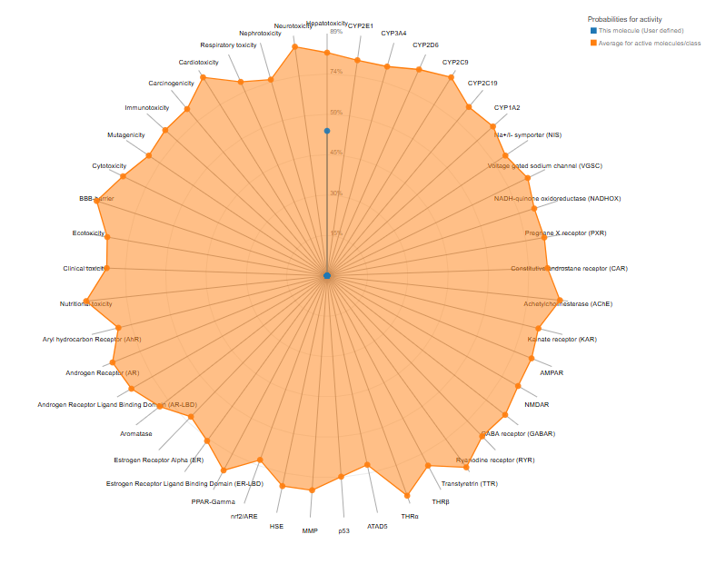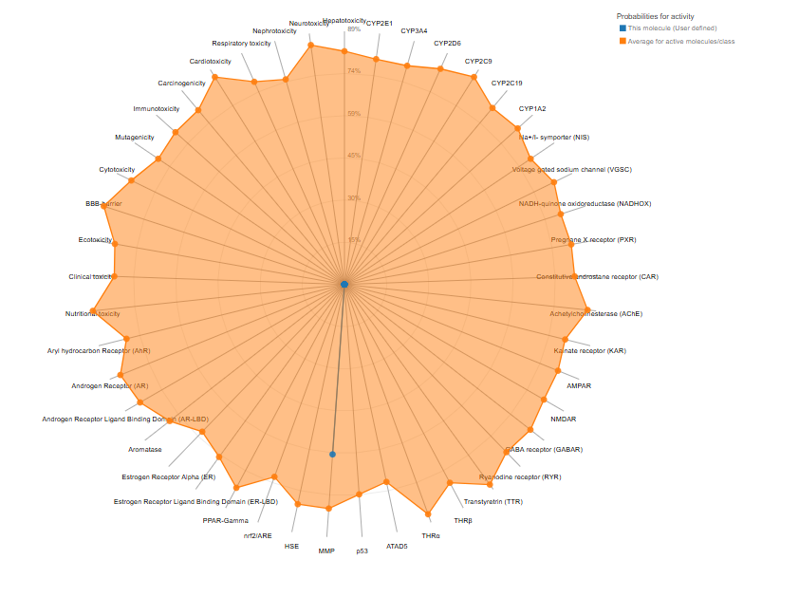
NPA020257
NPA004276
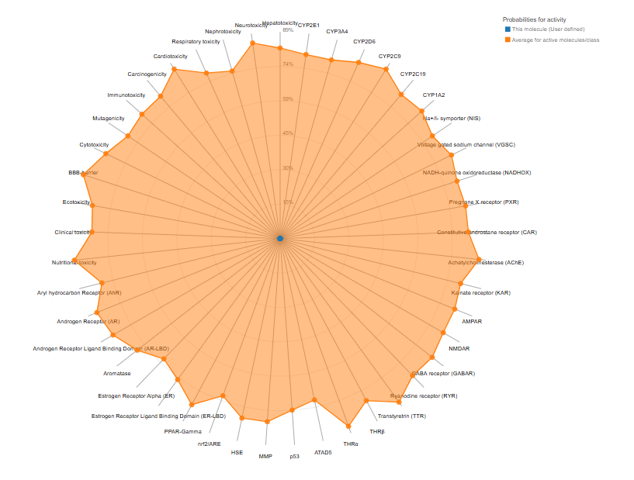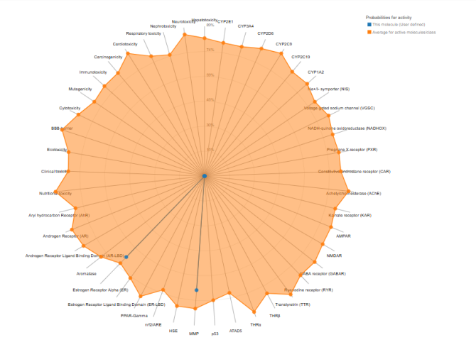

NPA036064
NPA034843

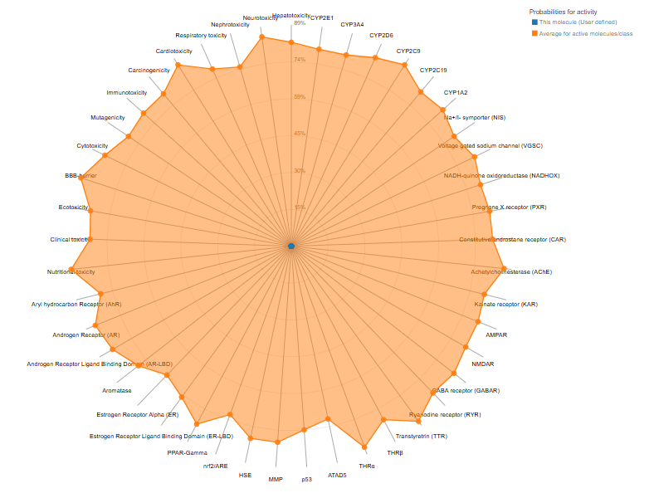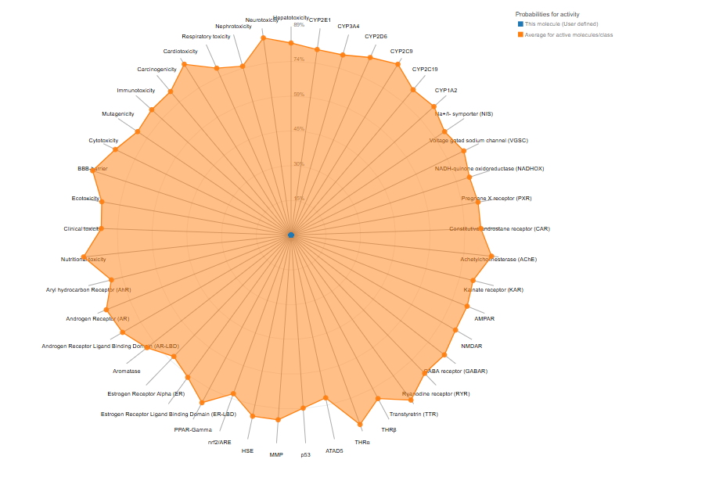
Reference
AR-A014418

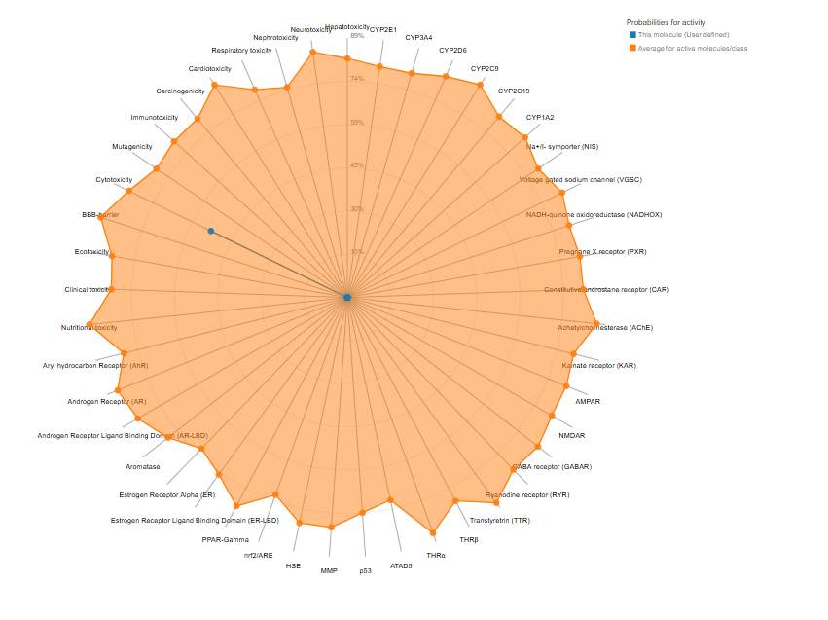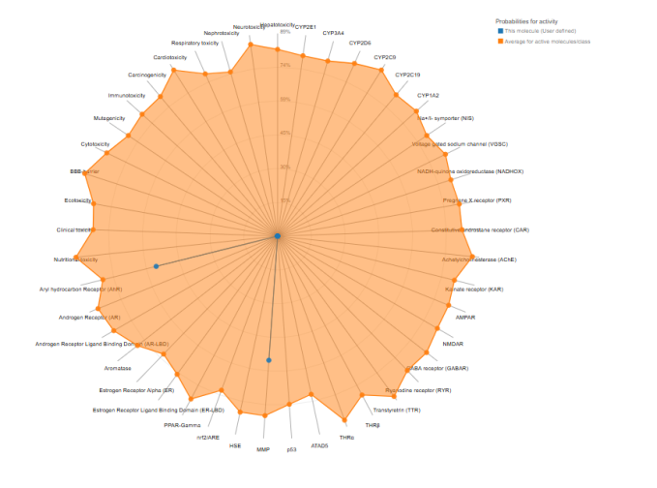
Tideglusib

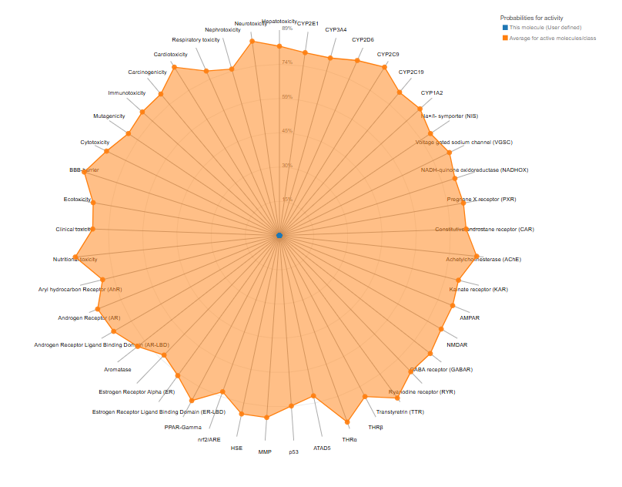
Figure 1: Radar for toxicity prediction by Protox-3

