Title: PEG-associated efficacy loss in lipid nanoparticles persists across formulation modifications for mRNA delivery

Author Line: Mariah L. Arral¹, Namit Chaudhary¹, Katherine C. Fein¹, Alexandra N. Newby¹, Saigopalakrishna S. Yerneni¹, Jilian R. Melamed¹, Samuel T. LoPresti¹, Daria M. Strelkova Petersen², Kathryn A. Whitehead^{1,2}*

¹ Department of Chemical Engineering, Carnegie Mellon University, Pittsburgh, PA, USA
² Department of Biomedical Engineering, Carnegie Mellon University, Pittsburgh, PA, USA
* Corresponding author: kawhite@cmu.edu

Fig S1 The ionizable lipidoid 304O_{i10} comprises an amine headgroup and an acrylate tail. The previously identified head group (304, red) and tail group (O_{i10}, blue) were reacted for 3 days at 90˚C, with purification by flash chromatography.

Fig S2 The three PEG-lipids used in this study share a common fatty acid tail structure but differ in their linker chemistry. The PEG-lipids used in this study each contain two fatty acid tails of 14 carbons (myristic acid, green). DMG-PEG2000 contains a glycerol linker between the fatty acid tails and the PEG chain, while PE-PEG750 and PE-PEG2000 contain a phosphoethanolamine linker. Each PEG-lipid ends with a methoxy group.

Fig S3 EPO expression correlated positively with PEG-lipid molar percentage. EPO concentrations were measured from blood collected 6 hours after the first dose across PEG-lipid concentrations from 0 to 2.5 mol%. N=3-4, error bars represent SEM. Pearson’s Correlation, R² = 0.9346, p < 0.05.

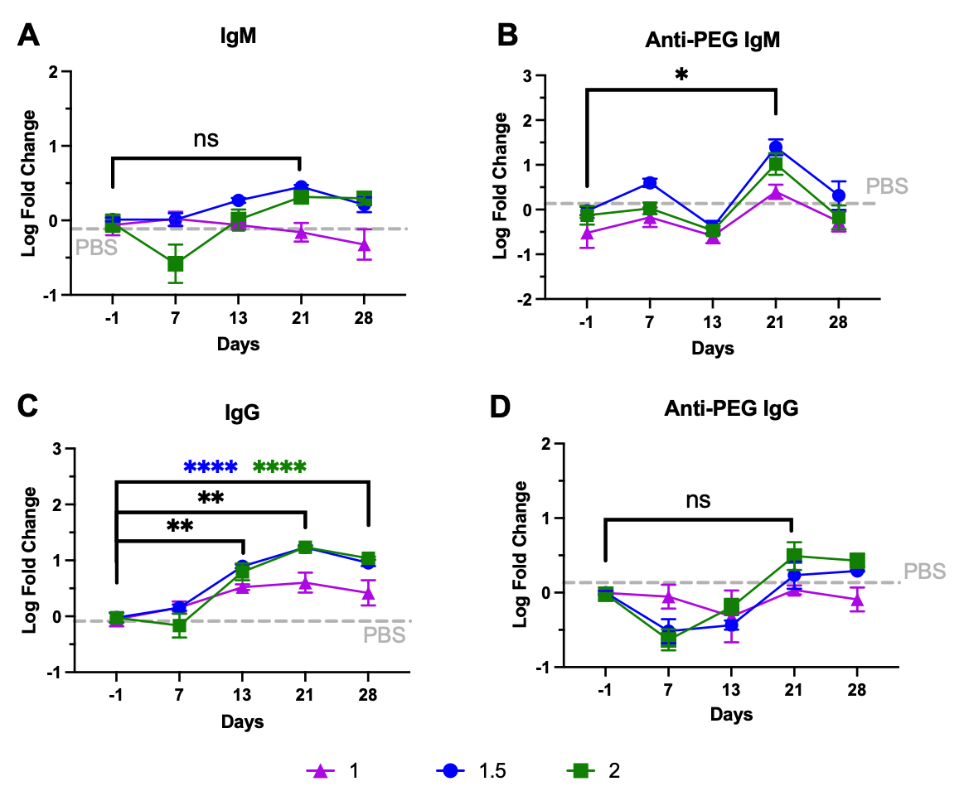
Fig S4 Anti-PEG IgM and total IgG increased significantly for PEG-lipid concentrations of 1-2 mol%. Lipid nanoparticles formulated with lipidoid 304O_{i10} and PE-PEG2000 were delivered intravenously to mice on Day 0 at 0.5 mg/kg with EPO mRNA for PEG molar concentrations of 1% (purple triangles), 1.5% (blue circles), and 2% (green squares). A) IgM, B) anti-PEG IgM, C) IgG, and D) anti-PEG IgG serum levels were quantified by ELISA. Anti-PEG IgM increased significantly for 1.5% and 2% PEG. Total IgG increased significantly for all groups, but anti-PEG IgG did not increase significantly. The gray dashed line indicates the serum PBS control value. N=3-4, error bars represent SEM, with * and **, **** indicating P < 0.05, P < 0.01, and P < 0.0001, respectively, by two-way ANOVA.

Fig S5 LNP_{MC3} maintains efficacy upon repeat administration. Lipid nanoparticles formulated with MC3 were delivered intravenously to mice at 0.5 mg/kg with EPO mRNA. Serum EPO concentrations were quantified by ELISA 6 hours after each dose. The gray dashed line indicates the PBS control serum level. N=3-4, error bars represent SEM, ns = not significant by Welch’s t-test.

