SUPPLEMENTARY DATA: TABLES & FIGURES

- SUPPLEMENTARY TABLES

Table S1. Clinical characteristics, comorbidities and TNM staging of included patients.

Variable | Value
Total number of patients | 71
General characteristics — median (IQR)
Age (years) | 75 (66.5–75.5)
Height (cm) | 174 (170–178)
Weight (kg) | 80 (75–90)
Body mass index (kg/m²) | 27 (24.5–29.5)
Comorbidities — n (%)
Active smoking | 32 (45)
Diabetes mellitus | 17 (24)
Anticoagulant therapy | 12 (17)
Antiplatelet therapy | 21 (30)
Previous urological surgery | 26 (37)
Oncological history — n (%)
Urological cancer | 16 (23)
Urological recurrence | 11 (15)
HPV-related cancer | 1 (1)
Other malignancy | 7 (10)
ASA score at admission — n (%)
ASA 1 | 7 (10)
ASA 2 | 38 (54)
ASA 3 | 24 (34)
ASA 4 | 2 (2)
ASA 5 | 0 (0)
Tumor location — n (%)
Glans | 49 (69)
Balanopreputial sulcus | 11 (16)
Foreskin | 5 (7)
Urethra | 3 (4)
Corpora cavernosa | 2 (3)
Scrotum | 1 (1)
Preoperative biopsy — n (%)
Yes | 38 (54)
No | 33 (46)
Histopathological biopsy results — n (%)
Squamous cell carcinoma | 32 (85)
PeIN 3 | 4 (10)
Verrucous carcinoma | 2 (5)
Preoperative decision – sentinel node laterality — n (%)
Right | 7 (10)
Left | 4 (5)
Bilateral | 60 (85)

Abbreviations: n = number of patients; IQR = interquartile range; BMI = body mass index; ASA = American Society of Anesthesiologists; PeIN = penile intraepithelial neoplasia.

Table S2. Success and failure rates of sentinel lymph node detection on scintigraphy

Variable | n | %
Per patient (n = 71)
Complete success | 58 | 81.7
Partial failure* | 12 | 16.9
Total failure** | 1 | 1.4
Per procedure (n = 131)
Complete success | 117 | 89.3
Right-sided failure | 10 | 7.6
Left-sided failure | 2 | 1.5
Bilateral failure | 1 | 0.8

*Partial failure: successful detection on only one side in patients scheduled for bilateral procedure.
**Total failure: absence of sentinel lymph node detection on both sides.
Abbreviations: n = number of patients; % = percentage.

Table S3. Failure of lymph node retrieval despite scintigraphic migration (n = 117 procedures)

Variable | n | %
Failure of lymph node retrieval
Right side | 1 | 0.9
Left side | 1 | 0.9
Bilateral | 0 | 0.0
Successful retrieval | 115 | 98.3

Abbreviations: n = number of patients; % = percentage.

Table S4. Diagnostic performance of sentinel lymph node biopsy on Intraoperative frozen section

Analysis | PPV | NPV | Sensitivity | Specificity | Accuracy
Per procedure | 1.00 | 0.942 | 0.647 | 1.00 | 0.948
Per patient | 1.00 | 0.902 | 0.600 | 1.00 | 0.914
Diagnostic performance of sentinel lymph node biopsy (SLNB) based on intraoperative frozen section, analyzed per procedure and per patient.
Abbreviations: PPV = positive predictive value; NPV = negative predictive value.

Table S5. Intraoperative frozen section analysis per procedure

 | Frozen section positive | Frozen section negative | Total
Lymph node involvement | 11 | 6 | 17
No lymph node involvement | 0 | 98 | 98
Total | 11 | 104 | 115
PPV = 1.00 – NPV = 0.942 – Sensitivity = 0.647 – Specificity = 1.00 – Accuracy = 0.948

Table S6. Intraoperative frozen section analysis per patient

 | Frozen section positive | Frozen section negative | Total
Lymph node involvement | 9 | 6 | 15
No lymph node involvement | 0 | 55 | 55
Total | 9 | 61 | 70
PPV = 1.00 – NPV = 0.902 – Sensitivity = 0.600 – Specificity = 1.00 – Accuracy = 0.914

Table S7. Diagnostic performance of sentinel lymph node biopsy on Final pathological analysis

Analysis | PPV | NPV | Sensitivity | Specificity | Accuracy
Per procedure | 1.00 | 0.990 | 0.941 | 1.00 | 0.991
Per patient | 1.00 | 0.982 | 0.933 | 1.00 | 0.986
Diagnostic performance of sentinel lymph node biopsy (SLNB) based on final pathological examination, analyzed per procedure and per patient.
Abbreviations: PPV = positive predictive value; NPV = negative predictive value.

Table S8. Final pathological analysis per procedure

 | Sentinel positive | Sentinel negative | Total
Lymph node involvement | 16 | 1 | 17
No lymph node involvement | 0 | 98 | 98
Total | 16 | 99 | 115
PPV = 1.00 – NPV = 0.990 – Sensitivity = 0.941 – Specificity = 1.00 – Accuracy = 0.991

Table S9. Final pathological analysis per patient

 | Sentinel positive | Sentinel negative | Total
Lymph node involvement | 14 | 1 | 15
No lymph node involvement | 0 | 55 | 55
Total | 14 | 56 | 70
PPV = 1.00 – NPV = 0.982 – Sensitivity = 0.933 – Specificity = 1.00 – Accuracy = 0.986

Table S10. Postoperative complications - comparison between SLNB alone and lymphadenectomy

Variable | All patients  (n = 71) | Lymphadenectomy (n = 21) | SLNB alone  (n = 50)
Patients with ≥1 complication | 20 (28.2%) | 15 (71.4%) | 5 (10.0%)
Type of complication
Lymphedema | 14 (19.7%) | 11 (52.4%) | 3 (6.0%)
Infection requiring antibiotics | 6 (8.5%) | 4 (19.0%) | 2 (4.0%)
Lymphocele (puncture or compression) | 3 (4.2%) | 3 (14.3%) | 0 (0.0%)
Maximum complication grade (Clavien–Dindo)
Grade 1 | 14 (19.7%) | 11 (52.4%) | 3 (6.0%)
Grade 2 | 6 (8.5%) | 4 (19.0%) | 2 (4.0%)
≥ Grade 3 | 0 (0.0%) | 0 (0.0%) | 0 (0.0%)
Abbreviations: % = percentage.

Table S11. Time interval between injection and procedure according to sentinel node biopsy outcome

Variable | Procedure failure (n = 15) | Successful procedure (n = 56)
Mean (min) | 646 | 468
Median (min) | 387 | 315
Q1 | 301.5 | 231
Q3 | 1110 | 458.5
IQR | 808.5 | 227.5
SD (min) | 460 | 352

Table S12. Correlation between vascular emboli and sentinel lymph node positivity

Vascular emboli | Sentinel node positive | Sentinel node negative | Total
Present (1) | 10 | 12 | 22
Absent (0) | 4 | 45 | 49
Total | 14 | 57 | 71
Statistics: OR = 12.71 (95% CI: 3.83–48.78), p < 0.001 (Fisher’s exact test).

Table S13. Correlation between perineural invasion and sentinel lymph node positivity

Perineural invasion | Sentinel node positive | Sentinel node negative | Total
Present (1) | 7 | 7 | 14
Absent (0) | 7 | 50 | 57
Total | 14 | 57 | 71
Statistics: OR = 15.31 (95% CI: 4.12–68.11), p < 0.001 (Fisher’s exact test).

Table S14. Association between lymph node dissection and postoperative complications

Lymph node dissection | No complication | Complication | Total
No (0) | 45 | 5 | 50
Yes (1) | 6 | 15 | 21
Total | 51 | 20 | 71

Statistics: OR = 22.5 (95% CI: 5.5–92.5), p < 0.001 (Fisher’s exact test). Complication rate with dissection: 71.4%. Complication rate without dissection: 10.0%.
This analyze includes patients with cN1 disease.

Table S15. Distribution of lymph node involvement

Type of involvement | Number of patients | %
Unilateral involvement | 11 | 61%
Bilateral involvement | 7 | 39%
Total | 18 | 100%

This analysis includes patients with cN1 disease.

Table S16. Association between right and left lymph node involvement

 | Left involvement + | Left involvement – | Total
Right involvement + | 7 | 4 | 11
Right involvement – | 7 | 53 | 60
Total | 14 | 57 | 71

Statistics: Left involvement when right positive: 63.6%. Right involvement when left positive: 50.0%. OR = 13.25 (95% CI: 3–57), p = 0.001 (two-sided test).
This analysis includes patients with cN1 disease.

- SUPPLEMENTARY FIGURES

Figure S1. Flow diagram of patient selection for final analysis

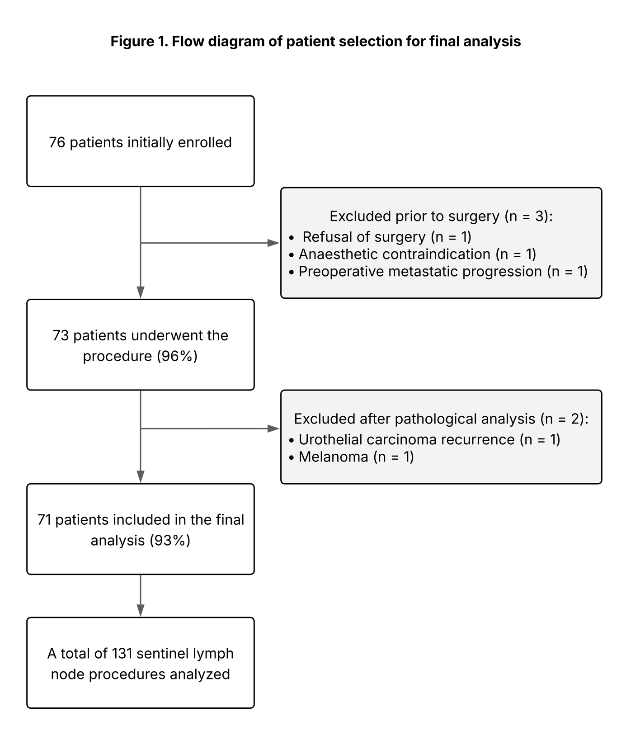

Figure S2. Postoperative complications according to the extent of lymphadenectomy.
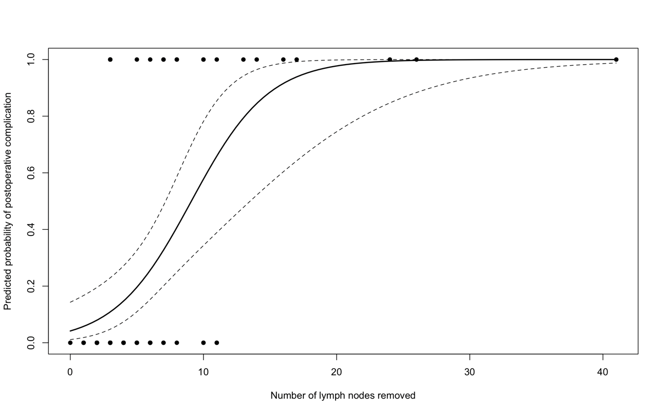
Predicted probability of postoperative complications derived from logistic regression. Solid line indicates the estimated probability and dashed lines the 95% confidence interval. Dots represent observed results.

