Appendix A

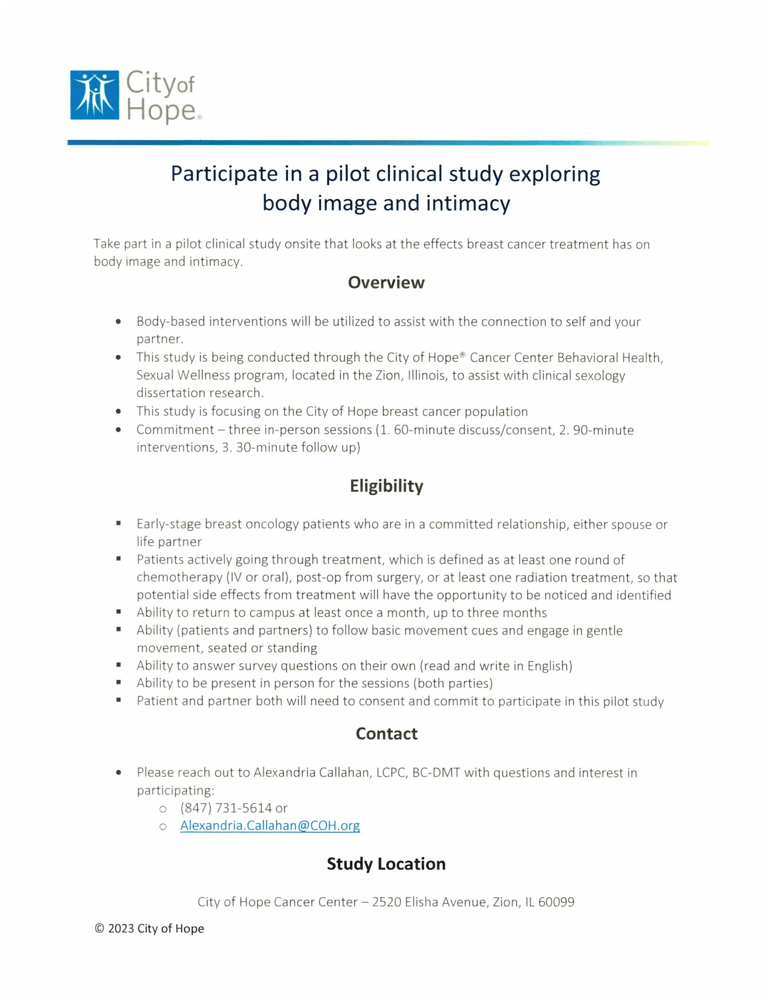

Appendix B

DEMOGRAPHICS SURVEY

- Age
- 18-24
- 25-34
- 35-44
- 45-54
- 55+

- Race
- White/ Caucasian
- Black / African American
- Hispanic / Latino
- Asian / Pacific Islander
- Other (please specify) ________________

- Sexual Orientation
- Heterosexual (cist)
- Lesbian
- Gay
- Bisexual
- Other (please specify) _________________
- Prefer not to answer

- Gender
- Male
- Female
- Transgender
- Other (please specify) __________________
- Prefer not to answer

- Length of Relationship
- Less than a year
- 1-4 years
- 5-10 years
- 10-15 years
- 15-24 years
- 25+ years

- Treatment Type (select all that apply)
- Surgery
- Chemotherapy
- Radiation
- Hormone treatment
- Other _____________
- Not Applicable (partner)

- Duration of treatment
- Less than a year
- 1-4 years
- 5-10 years
- More than 10 years
- Not Applicable (partner)

BODY IMAGE AND INTIMACY QUESTIONNAIRE (used pre- and post – intervention session)

