S1: Ethical consideration for Libya.
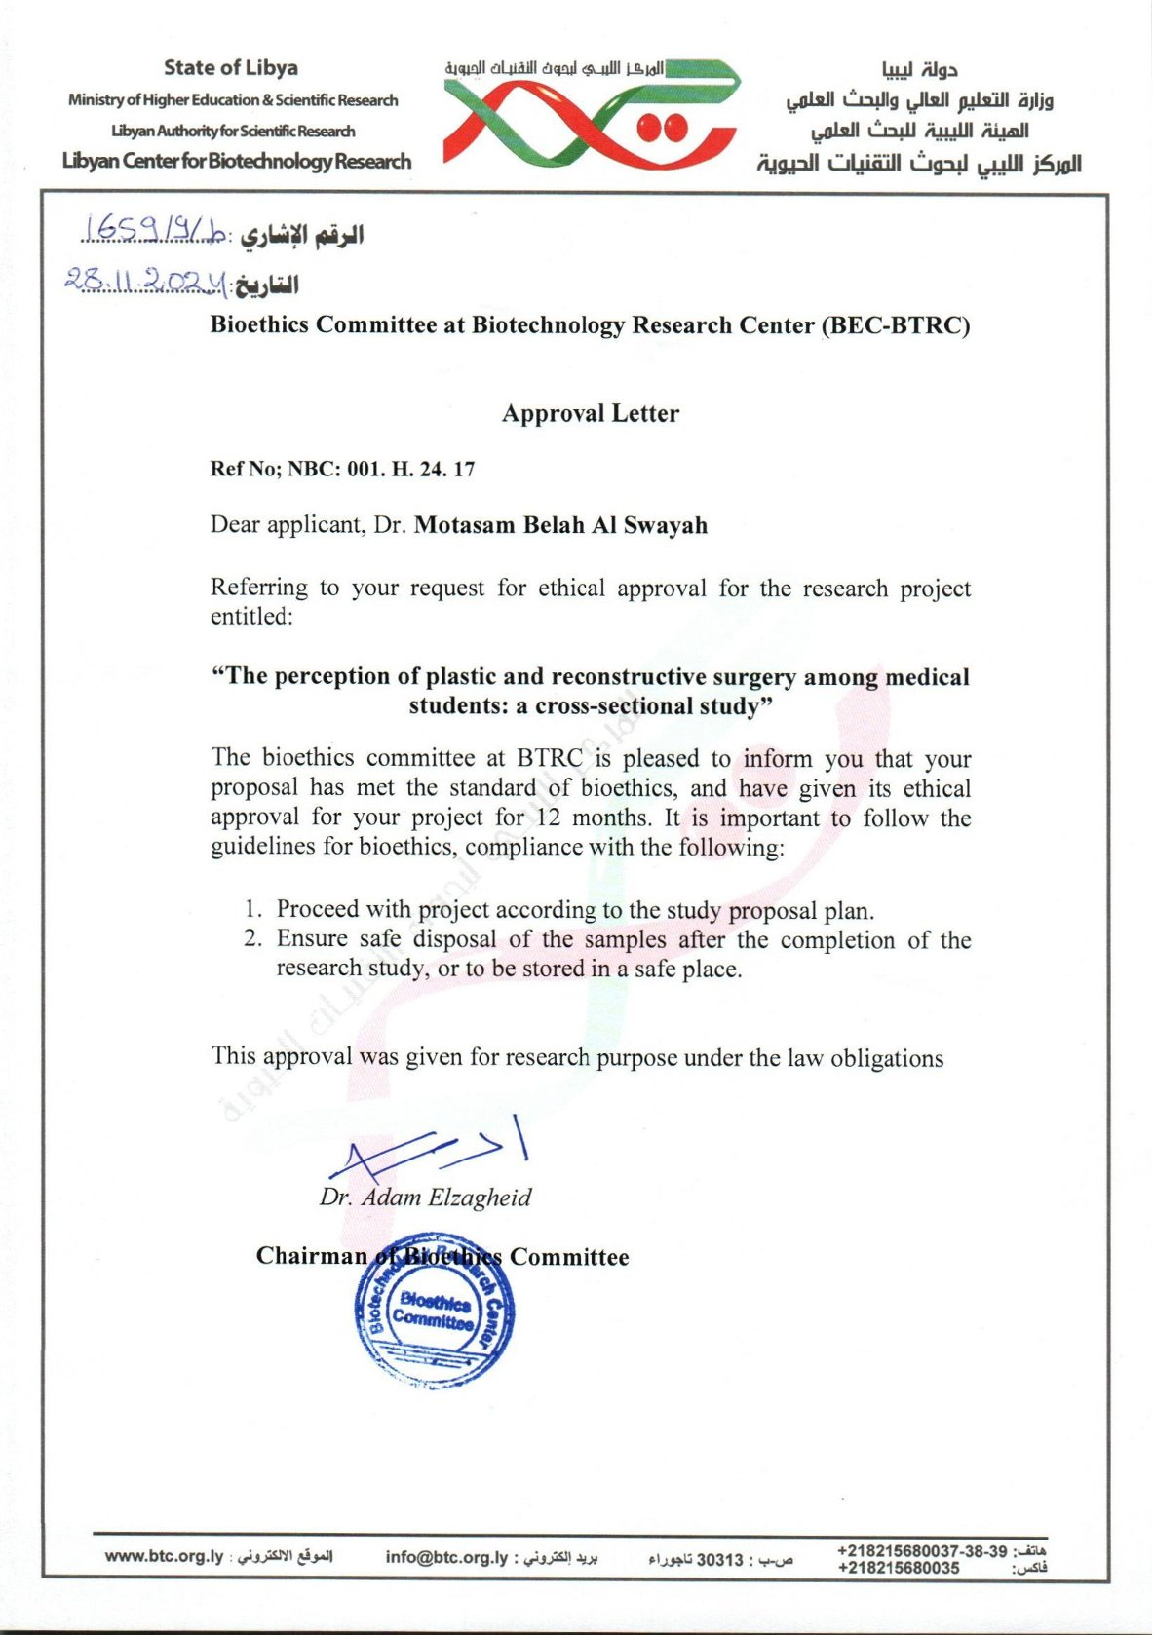

S2: Ethical consideration for Sudan.
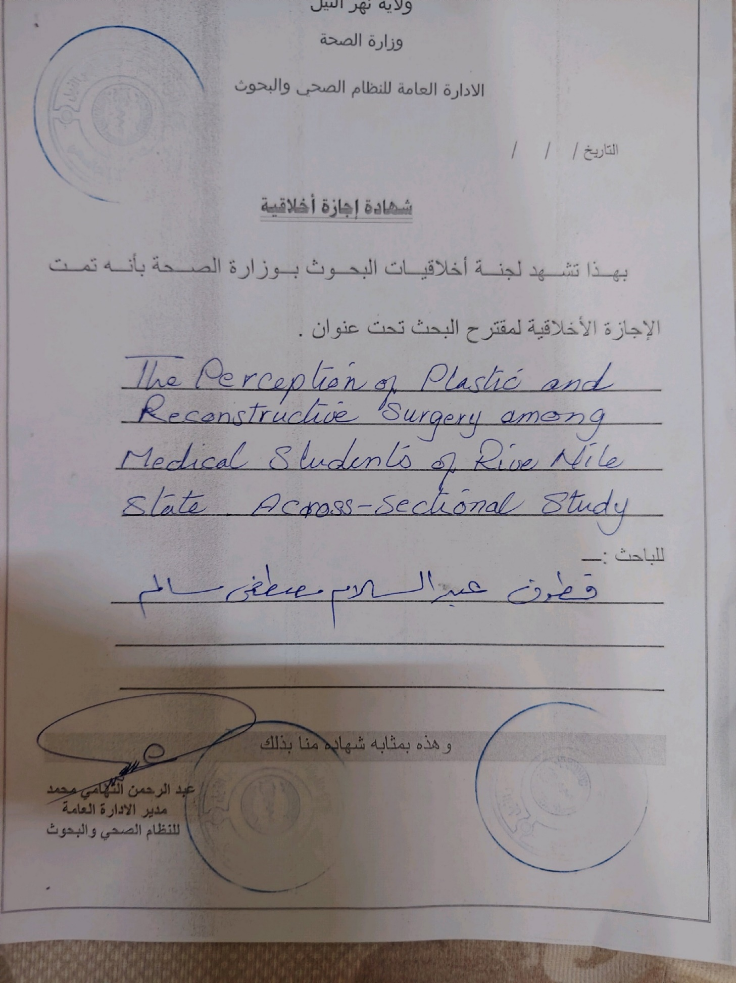

S3: Ethical consideration for Palestine.
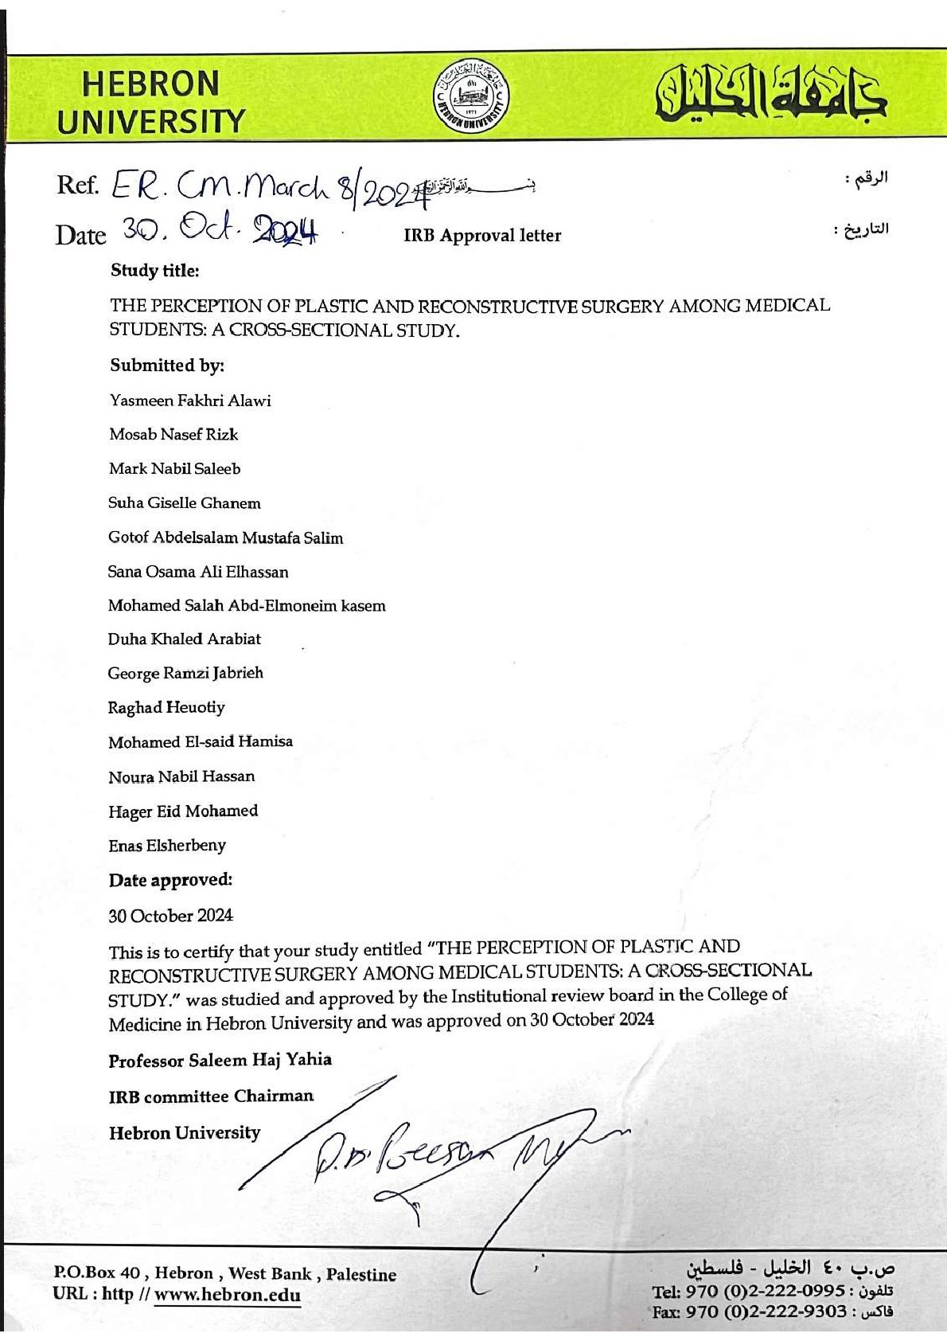
S4: Ethical consideration for Egypt.
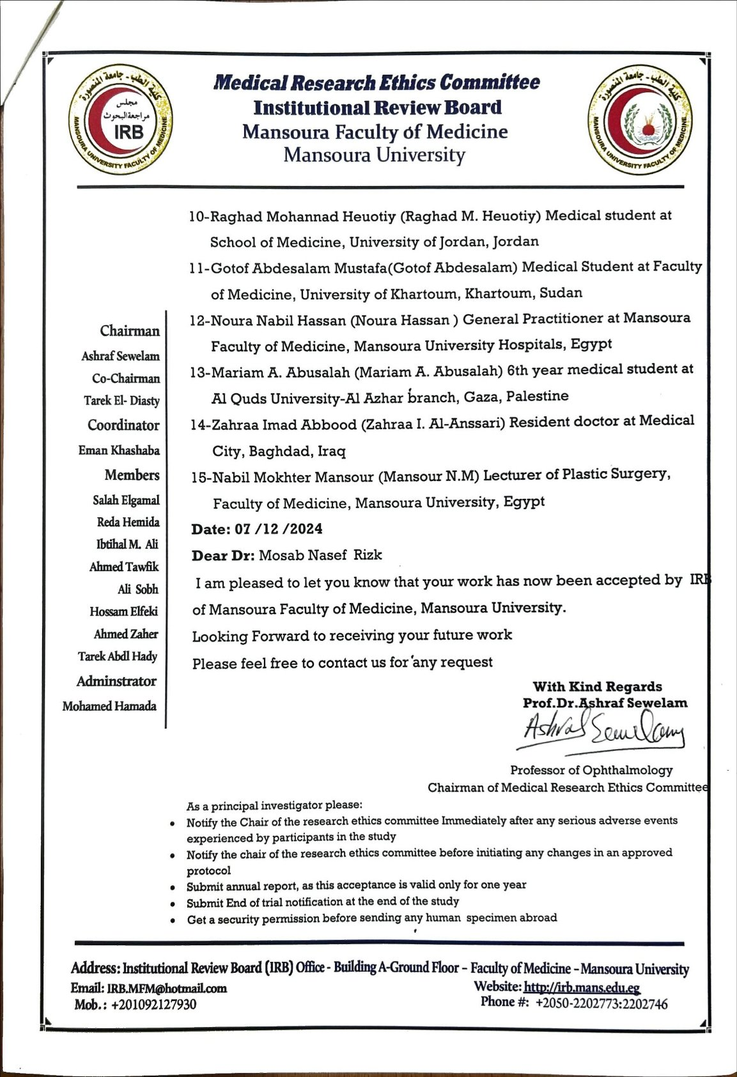

S5: Ethical consideration for Libya.
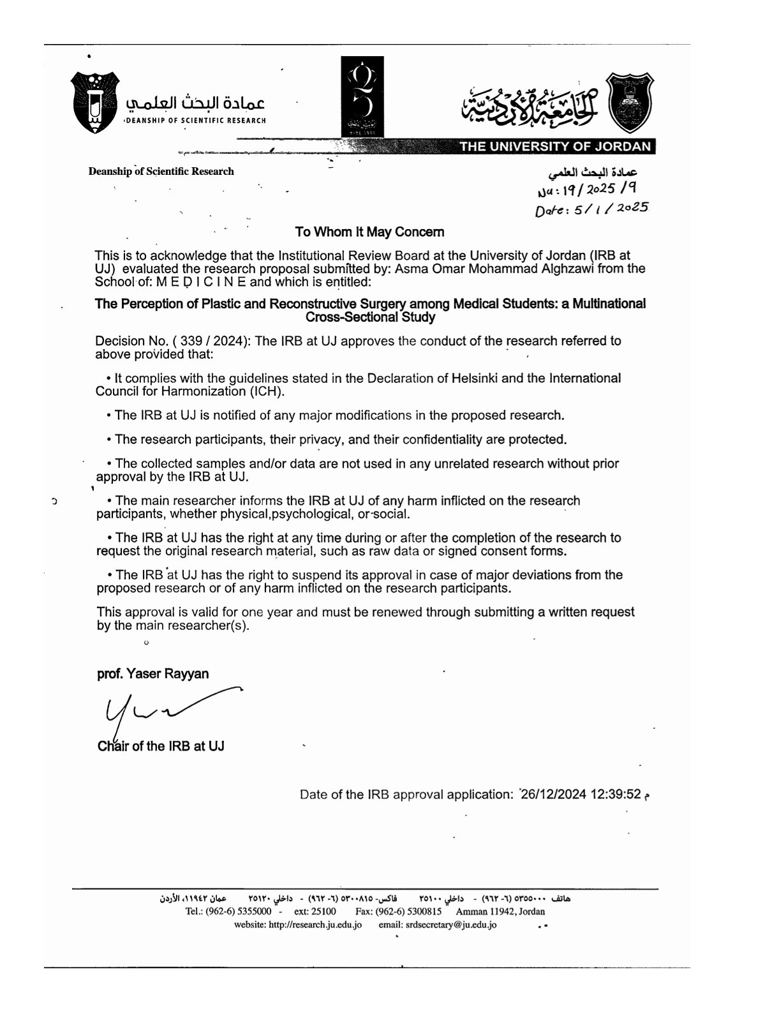

S6: Copy of the original questionnaire
The Perception of Plastic and Reconstructive Surgery among Medical Students.
Dear participant,
This questionnaire is part of a study that aims to explore the Perception of Medical Students of Plastic Surgery in developing countries. This study aims to gather information from medical students in the SWANA region regarding their attitudes and understanding of plastic surgery. Your participation in this study is entirely voluntary, and you were chosen at random to take part. There are no hazards involved in taking part in this research. We guarantee that your answers to the anonymous questionnaire will remain private and be utilized solely for research objectives. No identifiable personal information will be gathered and there is freedom to withdraw at any time.
- What is your gender?
- Male
- Female
- What is your age?
- What is your nationality?
- Country you are studying in
- Name of your university
- What is your medical educational level?
- Academic (Basic) years
- Clinical years
- Intern Year 1
- Intern Year 2
7-At which year of medical education?
8-Living status?
- Parents
- Alone
- University housing
- Spouse
- Other
9-Have you been previously exposed to Plastic Surgery clinically?
- Yes
- No
10-Have you studied plastic surgery in your medical curriculum?
- Yes
- No
11- Are you interested in Plastic Surgery procedure?
- Yes
- No
12- What surgical specialty have you been clinically exposed to previously? *
- General Surgery
- Orthopedic Surgery
- Plastic surgery
- ENT
- Neurosurgery
- Obstetrics/Gynecology
- Cardiac surgery
- Urology
- Dermatology
- Ophthalmology
- Vascular surgery
- Hand specialist
- None of the above
- What future specialty have you planned? *
- General Surgery
- Orthopedic Surgery
- Plastic surgery
- ENT
- Neurosurgery
- Obstetrics/Gynecology
- Cardiac surgery
- Urology
- Dermatology
- Ophthalmology
- Vascular surgery
- Hand specialist
- None of the above
14- Do you believe your knowledge in plastic and aesthetic surgery is enough or could be improved by adding further information to your curriculum
- Enough
- Needs further improvement
- I do not know
15- How likely are you to get more training in plastic surgery?
- Very unlikely
- 1
- 2
- 3
- 4
- 5
- Very likely
16-How important do you believe the role of Plastic Surgery is in improving patients' quality of life?
- Not Important
- 1
- 2
- 3
- 4
- 5
- Very Important
17-How can your interest in this specialty be increased during medical school?
- More lectures
- More extra-curricular work shops
- More clinical experiance during medical school
- Greater outreach from national plastic surgery associations
- More plastic surgeons within the medical school teaching
- Other

18-How interested are you in pursuing Plastic Surgery as a specialty?
- Highly unlikely
- 1
- 2
- 3
- 4
- 5
- Highly likely
19-Which of the following do you consider a barrier to pursuing Plastic Surgery as a specialty? (tick all that applies)
- Difficulty entering residency programs
- I do not feel it has enough impact on people's lives
- Religious reasons
- I do not have enough information about the topic
- Social stigma
- Verbal discouragement from peers, mentors or friends
- None of them

20-Please read the following cases and tick the most likely specialty that applies to manage each of them: (General Surgery - Orthopedics - Plastic surgery - ENT - Neurology/Neurosurgery - Obstetrics and Gynecology - Cardiac surgery - Urology - Dermatology - Ophthalmology - Vascular surgery - Hand specialist)
. A 35-year-old patient wants liposuction procedure to remove excess fat in certain areas for better body shape.
. A 45-year-old obese man with type 2 diabetes seeks sleeve gastrectomy.
. Repair of a severed extensor tendon of the index finger
. Third degree burn on the back of the hand.
. Cleft lip anomaly.
. Jaw fracture.
. Brachial plexus injury from motorcycle accident.
. Breast reconstruction after mastectomy.
. A child with partial facial paralysis since the birth.
. A 40-year-old woman went to a clinic for a facelift.
21-How often do you spend researching the topic online?
- Never
- Occasionally
- Sometimes
- Often
22-What influenced the majority of your impression of Plastic Surgery?
- Surfing the Internet
- Television/Series
- Personal encounter/experience
- Social media
- Clinical rotations
- Other

S7: Copy of the questionnaire after modification
The Perception of Plastic and Reconstructive Surgery among Medical Students.
Dear participant,
This questionnaire is part of a study that aims to explore the Perception of Medical Students of Plastic Surgery in developing countries. This study aims to gather information from medical students in the SWANA region regarding their attitudes and understanding of plastic surgery. Your participation in this study is entirely voluntary, and you were chosen at random to take part. There are no hazards involved in taking part in this research. We guarantee that your answers to the anonymous questionnaire will remain private and be utilized solely for research objectives. No identifiable personal information will be gathered and there is freedom to withdraw at any time.
- What is your gender?
- Male
- Female
- What is your age?
- What is your nationality?
- Country you are studying in
- Name of your university
- What is your medical educational level?
- Academic (Basic) years
- Clinical years
- Intern Year 1
- Intern Year 2
7-At which year of medical education?
8-Living status?
- Parents
- Alone
- University housing
- Spouse
- Other
9-Have you been previously exposed to Plastic Surgery clinically?
- Yes
- No
10-Have you studied plastic surgery in your medical curriculum?
- Yes
- No
11- Are you interested in Plastic Surgery procedure?
- Yes
- No
12- What surgical specialty have you been clinically exposed to previously? *
- General Surgery
- Orthopedic Surgery
- Plastic surgery
- ENT
- Neurosurgery
- Obstetrics/Gynecology
- Cardiac surgery
- Urology
- Dermatology
- Ophthalmology
- Vascular surgery
- Hand specialist
- None of the above
- What future specialty have you planned? *
- General Surgery
- Orthopedic Surgery
- Plastic surgery
- ENT
- Neurosurgery
- Obstetrics/Gynecology
- Cardiac surgery
- Urology
- Dermatology
- Ophthalmology
- Vascular surgery
- Hand specialist
- None of the above
14- Do you believe your knowledge in plastic and aesthetic surgery is enough or could be improved by adding further information to your curriculum
- Enough
- Needs further improvement
- I do not know
15- How likely are you to get more training in plastic surgery?
- Very unlikely
- 1
- 2
- 3
- 4
- 5
- Very likely
16-How important do you believe the role of Plastic Surgery is in improving patients' quality of life?
- Not Important
- 1
- 2
- 3
- 4
- 5
- Very Important
17-How can your interest in this specialty be increased during medical school?
- More lectures
- More extra-curricular work shops
- More clinical experiance during medical school
- Greater outreach from national plastic surgery associations
- More plastic surgeons within the medical school teaching
- Other

18-How interested are you in pursuing Plastic Surgery as a specialty?
- Highly unlikely
- 1
- 2
- 3
- 4
- 5
- Highly likely
19-Which of the following do you consider a barrier to pursuing Plastic Surgery as a specialty? (tick all that applies)
- Difficulty entering residency programs
- I do not feel it has enough impact on people's lives
- Religious reasons
- I do not have enough information about the topic
- Social stigma
- Verbal discouragement from peers, mentors or friends
- None of them

20-Please read the following cases and tick the most likely specialty that applies to manage each of them: (General Surgery - Orthopedics - Plastic surgery - ENT - Neurology/Neurosurgery - Obstetrics and Gynecology - Cardiac surgery - Urology - Dermatology - Ophthalmology - Vascular surgery - Hand specialist)
. A 35-year-old patient wants liposuction procedure to remove excess fat in certain areas for better body shape.
. A 45-year-old obese man with type 2 diabetes seeks sleeve gastrectomy.
. Repair of a severed extensor tendon of the index finger
. Third degree burn on the back of the hand.
. Cleft lip anomaly.
. Jaw fracture.
. Brachial plexus injury from motorcycle accident.
. Breast reconstruction after mastectomy.
. A child with partial facial paralysis since the birth.
. A 40-year-old woman went to a clinic for a facelift.
21-How often do you spend researching the topic online?
- Never
- Occasionally
- Sometimes
- Often
22-What influenced the majority of your impression of Plastic Surgery?
- Surfing the Internet
- Television/Series
- Personal encounter/experience
- Social media
- Clinical rotations
- Other

