Supplemental tables and figures
Table S1. Descriptive Statistics by Community Size in Urban Area, Chinese Family Panel Survey 2010-2014
 | Urban Overall | Small-sized | Moderate-sized | Large-sized
Dependent variables
Cognitive Skills Raw Score | 20.69 (15.43) | 15.36 (14.40) | 21.12 (15.15) | 24.54 (15.29)
Cognitive Skills Z-score | 0.32 (1.05) | -0.04 (0.98) | 0.35 (1.03) | 0.58 (1.04)
Key independent variables
Neighborhood typology
Growth with Aging | 1,755 (42.22%) | 546 (45.61%) | 552 (37.65%) | 657 (43.98%)
Growth and Rejuvenating | 1,109 (26.68%) | 384 (32.08%) | 418 (28.51%) | 307 (20.55%)
Depopulation with Aging | 957 (23.02%) | 169 (14.12%) | 397 (27.08%) | 391 (26.17%)
Depopulation and Rejuvenating | 336 (8.08%) | 98 (8.19%) | 99 (6.75%) | 139 (9.30%)
Individual-level variables
Age | 62.40 (9.12) | 62.12 (9.10) | 62.53 (8.79) | 62.50 (9.45)
Male | 2,006 (48.26%) | 567 (47.37%) | 724 (49.39%) | 715 (47.86%)
Self-rated Health | 2.62 (1.17) | 2.62 (1.27) | 2.60 (1.17) | 2.63 (1.08)
Married | 3,493 (84.03%) | 996 (83.21%) | 1,256 (85.68%) | 1,241 (83.07%)
Never married/Cohabitation/  Divorced/Widowed | 664 (15.97%) | 201 (16.79%) | 210 (14.32%) | 253 (16.93%)
Education
Illiterate | 1,081 (26.00%) | 469 (39.18%) | 373 (25.44%) | 239 (16.00%)
Primary School | 824 (19.82%) | 260 (21.72%) | 331 (22.58%) | 233 (15.60%)
Junior High School and above | 2,252 (54.17%) | 468 (39.10%) | 762 (51.98%) | 1,022 (68.41%)
Employed | 1,842 (44.31%) | 695 (58.06%) | 674 (45.98%) | 473 (31.66%)
Total family income
Low | 931 (22.40%) | 387 (32.33%) | 342 (23.33%) | 202 (13.52%)
Low-medium | 994 (23.91%) | 289 (24.14%) | 362 (24.69%) | 343 (22.96%)
Medium-high | 918 (22.08%) | 242 (20.22%) | 285 (19.44%) | 391 (26.17%)
High | 1,314 (31.61%) | 279 (23.31%) | 477 (32.54%) | 558 (37.35%)
Live with Children | 2,234 (53.74%) | 690 (57.64%) | 756 (51.57%) | 788 (52.74%)
Move | 25 (0.60%) | 7 (0.50%) | 7 (0.48%) | 12 (0.80%)
Not move | 3,653 (87.88%) | 1,057 (88.30%) | 1,296 (88.40%) | 1,300 (87.01%)
Unknown | 479 (11.52%) | 134 (11.19%) | 163 (11.12%) | 182 (12.18%)
Community-level variables
Welfare Coverage | 7.08 (10.67) | 11.39 (15.97) | 6.42 (7.73) | 4.28 (5.57)
Number of Health Facilities | 4.48 (4.44) | 2.86 (3.46) | 4.21 (4.13) | 6.04 (4.90)
Number of observations | 4,157 | 1,197 | 1,466 | 1,494

Table S2 Lagged DV: 2014 Cognitive Score with 2010 Score Controlled (Urban), Chinese Family Panel Survey 2010-2014
 | Model 1 |  | Model 2 |  | Model 3
 | Small-sized |  | Moderate-sized |  | Large-sized
 | β | (s.e) | β | (s.e) | β | (s.e)
Neighborhood typology
(Reference= Depopulation with aging)
Growth with aging | -0.29*** | (0.12) | -0.08 | (0.08) | 0.13 | (0.11)
Growth and rejuvenating | -0.28* | (0.12) | -0.07 | (0.08) | 0.18 | (0.12)
Depopulation and rejuvenating | -0.27 | (0.17) | -0.08 | (0.14) | 0.06 | (0.16)
Cognition in 2010 | 0.56*** | (0.04) | 0.57*** | (0.03) | 0.55*** | (0.04)
BIC fit statistics | 2263 |  | 2740 |  | 3027
Number of observations | 1,063 |  | 1,299 |  | 1,310
Note: * p < 0.05, ** p < 0.01, *** p < 0.001, Standard errors in parentheses. All models control for individual- and community-level covariates.

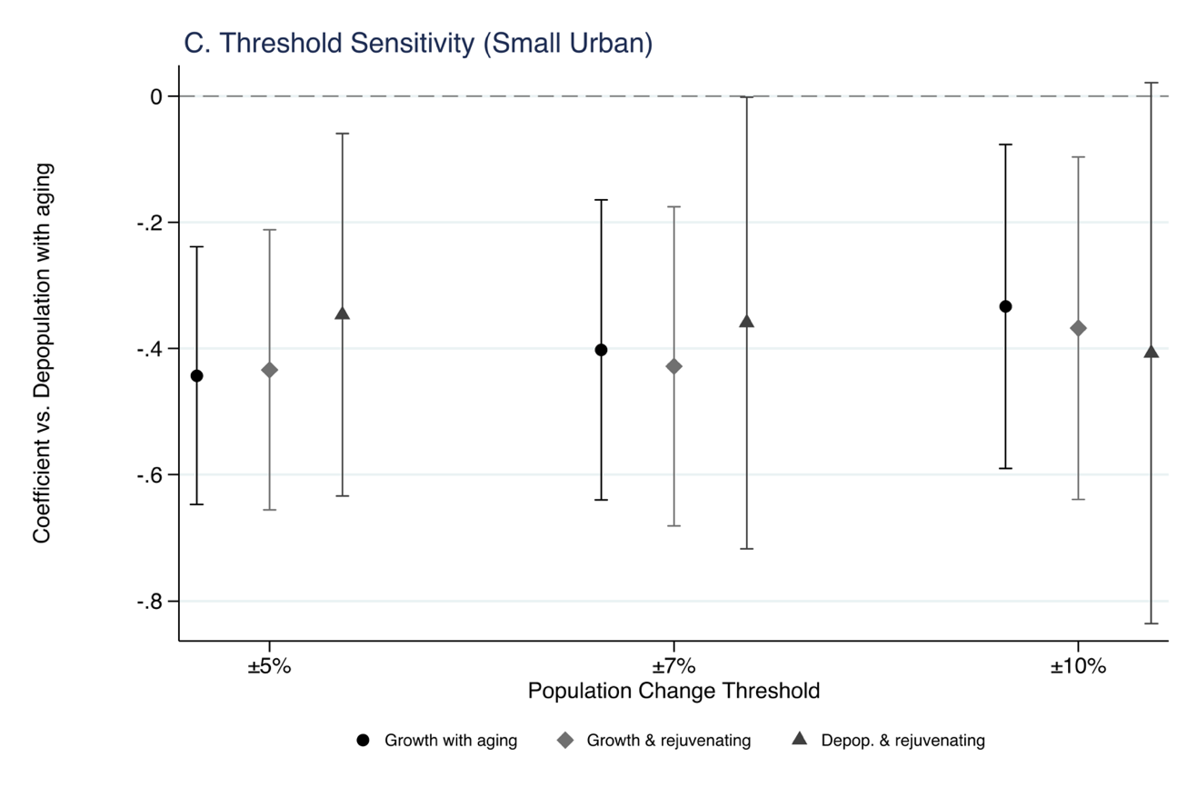
Figure S1 Threshold Sensitivity of Neighborhood Typology in Small Urban Areas

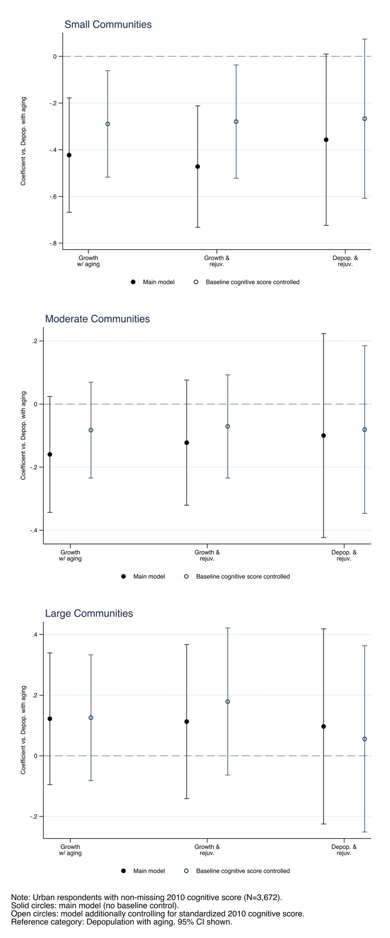

Figure S2 Threshold Sensitivity of Neighborhood Typology in Small Urban Areas

