Supplementary Appendix
Early prediction of 30-day mortality in critically ill patients with interstitial lung disease and acute hypoxemic respiratory failure: development and external validation of a clinically interpretable model
This appendix contains supplementary figures and tables referenced in the manuscript, together with supporting sensitivity and recalibration analyses.
Supplementary Figure S1. Training-set ROC curves of the primary and augmented models
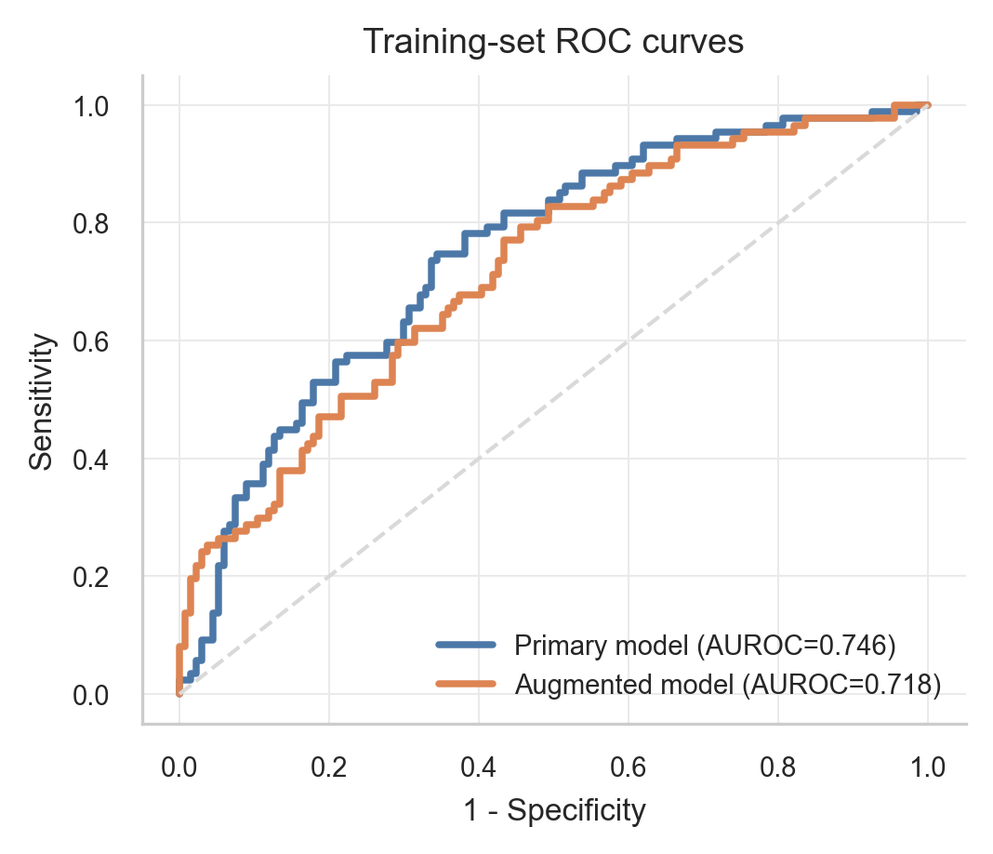
Receiver operating characteristic (ROC) curves of the primary and augmented models in the training set.
Supplementary Table S1. Missing data before imputation in the development and external validation cohorts
Variable | Development cohort missing n (%) | External validation cohort missing n (%)
Age | 0 (0.0%) | 3 (1.5%)
Male sex | 0 (0.0%) | 0 (0.0%)
ILD subtype | 0 (0.0%) | 0 (0.0%)
Malignant cancer | 0 (0.0%) | 5 (2.5%)
PAH | 0 (0.0%) | 6 (3.0%)
COPD | 0 (0.0%) | 5 (2.5%)
CAD | 0 (0.0%) | 4 (2.0%)
CHF | 0 (0.0%) | 5 (2.5%)
CKD | 0 (0.0%) | 3 (1.5%)
GERD | 0 (0.0%) | 2 (1.0%)
Asthma | 0 (0.0%) | 4 (2.0%)
Heart rate | 0 (0.0%) | 2 (1.0%)
Respiratory rate | 0 (0.0%) | 3 (1.5%)
MAP | 6 (1.9%) | 1 (0.5%)
SpO₂ | 0 (0.0%) | 30 (15.2%)
FiO₂ | 0 (0.0%) | 25 (12.6%)
pH | 0 (0.0%) | 4 (2.0%)
PaCO₂ | 0 (0.0%) | 6 (3.0%)
PaO₂/FiO₂ ratio | 0 (0.0%) | 0 (0.0%)
Lactate | 26 (8.2%) | 23 (11.6%)
White blood cell count | 0 (0.0%) | 3 (1.5%)
Hemoglobin | 0 (0.0%) | 2 (1.0%)
Platelet count | 0 (0.0%) | 2 (1.0%)
Albumin | 95 (30.0%) | 4 (2.0%)
LDH | 93 (29.3%) | 20 (10.1%)
Creatinine | 0 (0.0%) | 4 (2.0%)
Total bilirubin | 62 (19.6%) | 5 (2.5%)
GCS | 0 (0.0%) | 10 (5.1%)
SOFA | 18 (5.7%) | 4 (2.0%)
Invasive mechanical ventilation | 0 (0.0%) | 8 (4.0%)
Glucocorticoid use | 0 (0.0%) | 0 (0.0%)
Note: High missingness was observed for several laboratory variables, including albumin, LDH, and total bilirubin, and these patterns should be interpreted together with the imputation strategy described in Methods.
Note: High missingness was observed for several laboratory variables, including albumin, LDH, and total bilirubin, and these patterns should be interpreted together with the imputation strategy described in Methods.
Supplementary Table S2. Subgroup-specific discrimination of the primary model in the external validation cohort
Subgroup | n | Events | AUROC | 95% CI
Overall | 198 | 111 | 0.663 | 0.587–0.739
Male | 139 | 77 | 0.706 | 0.614–0.791
Female | 59 | 34 | 0.564 | 0.412–0.717
Age ≥70 years | 105 | 59 | 0.706 | 0.605–0.800
Age <70 years | 90 | 51 | 0.628 | 0.512–0.745
Malignant cancer | 52 | 33 | 0.589 | 0.419–0.743
No malignant cancer | 141 | 74 | 0.698 | 0.609–0.781
Albumin ≥3.0 g/dL | 110 | 56 | 0.712 | 0.608–0.810
Albumin <3.0 g/dL | 84 | 52 | 0.593 | 0.464–0.716
LDH ≥400 U/L | 94 | 65 | 0.708 | 0.599–0.812
LDH <400 U/L | 84 | 37 | 0.621 | 0.494–0.741
CTD-ILD | 56 | 39 | 0.621 | 0.449–0.774
Non-CTD-ILD | 142 | 72 | 0.698 | 0.611–0.781
Note: Sample sizes vary across subgroups because of missing values for some subgroup-defining variables.
Note: Sample sizes vary across subgroups because of missing values for some subgroup-defining variables.
Supplementary Figure S2. External recalibration of the primary model
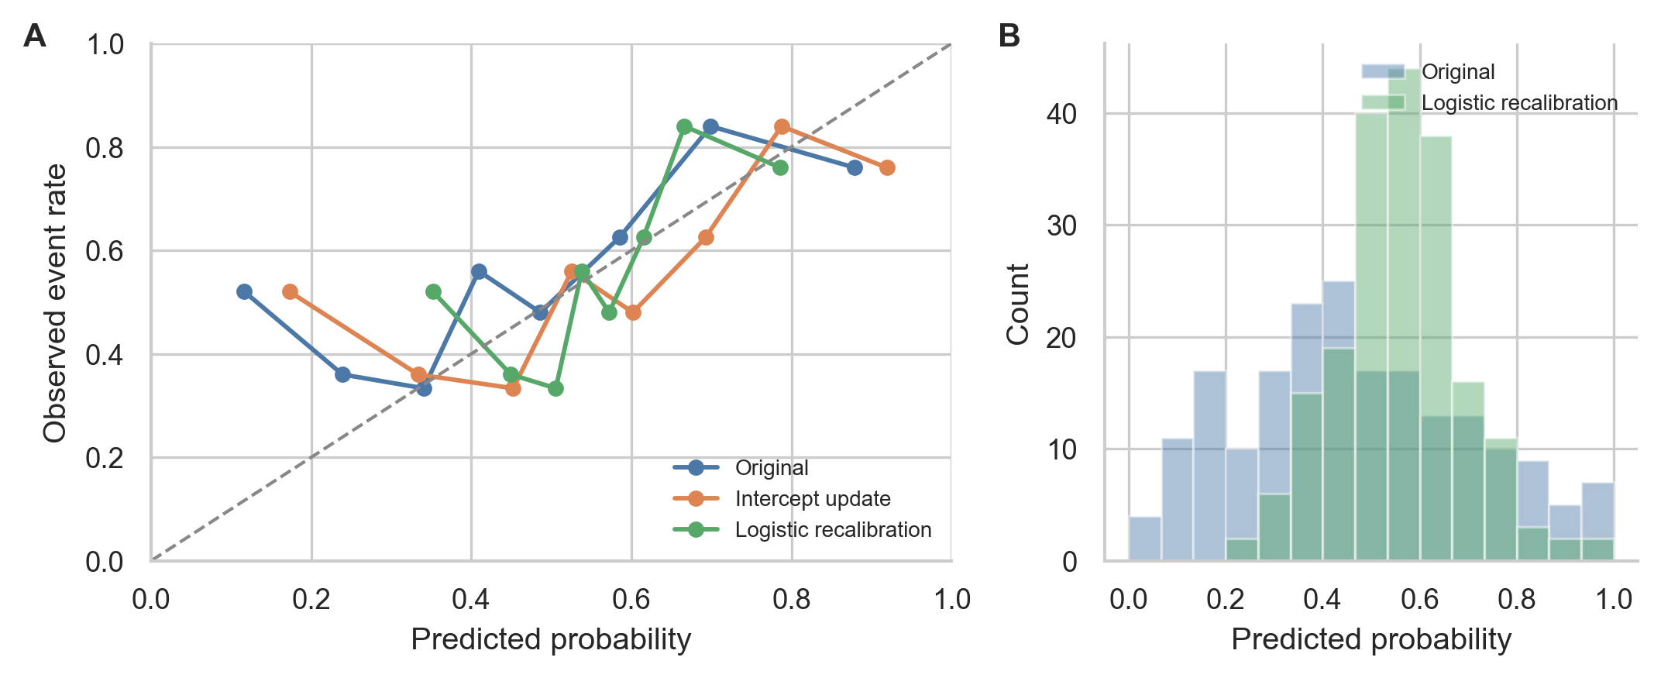
Panel A shows calibration curves for the original primary model, intercept-only recalibration, and logistic recalibration with updating of both intercept and slope in the external validation cohort. Panel B compares the distribution of predicted probabilities before and after logistic recalibration. The diagonal line indicates ideal calibration.
Supplementary Table S3. External recalibration metrics for the primary model
Analysis | AUROC | AUROC 95% CI | Brier score | Calibration intercept | Calibration slope
Original primary model | 0.663 | 0.589–0.736 | 0.246 | 0.47 | 0.443
Intercept-only recalibration | 0.663 | 0.585–0.743 | 0.239 | 0 | 0.443
Intercept + slope recalibration | 0.663 | 0.585–0.740 | 0.229 | 0 | 1
Note: Recalibration was assessed in the external validation cohort. Intercept + slope recalibration refers to logistic recalibration with updating of both parameters.
Supplementary Table S4. Missing-data sensitivity analyses for the primary model
Analysis | AUROC | AUROC 95% CI | Brier score | Calibration intercept | Calibration slope | Imputations
MICE sensitivity: training set | 0.758 | 0.688–0.821 | 0.191 | -0.011 | 1.155 | 20
MICE sensitivity: internal test set | 0.727 | 0.622–0.829 | 0.212 | -0.081 | 0.764 | 20
MICE sensitivity: external validation cohort | 0.654 | 0.574–0.726 | 0.249 | 0.541 | 0.481 | 20
Complete-case: training set | 0.751 |  | 0.202 |  | 1.052
Complete-case: internal test set | 0.701 |  | 0.214 |  | 0.882
Complete-case: external validation cohort | 0.65 |  | 0.255 |  | 0.547
Note: MICE indicates multiple imputation by chained equations. Complete-case values are provided as supplementary sensitivity analyses to show whether the main findings were materially altered by the handling of missing data.
Supplementary Figure S3. Quantified distribution shift between the development and external validation cohorts
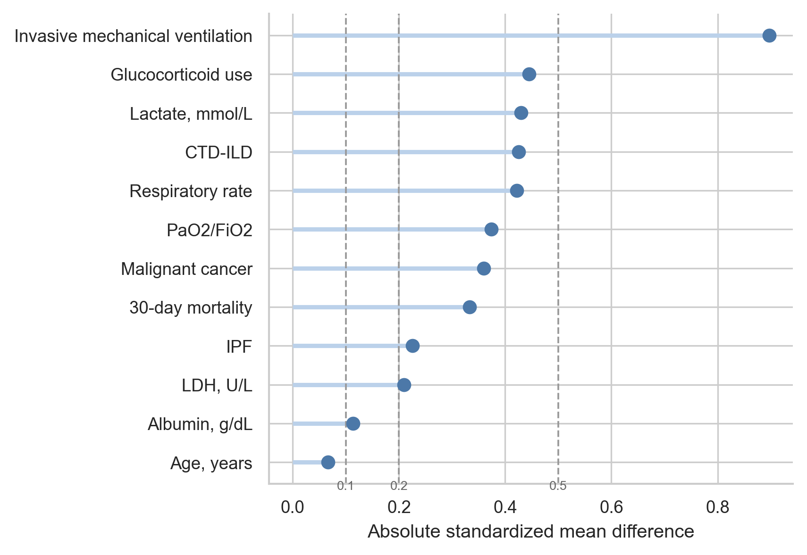
Points indicate absolute standardized mean differences for prespecified clinical characteristics. Dashed vertical reference lines at 0.1, 0.2, and 0.5 indicate small, moderate, and large between-cohort shifts, respectively.
Supplementary Table S5. Absolute standardized mean differences for selected characteristics across cohorts
Variable | Development cohort | External validation cohort | Absolute SMD
Invasive mechanical ventilation | 313/317 (98.7%) | 121/190 (63.7%) | 0.897
Glucocorticoid use | 206/317 (65.0%) | 167/198 (84.3%) | 0.445
Lactate, mmol/L | 1.3 (1.0–1.8) | 1.8 (1.1–2.6) | 0.43
CTD-ILD | 36/317 (11.4%) | 56/198 (28.3%) | 0.425
Respiratory rate | 22.0 (17.0–26.0) | 24.0 (21.0–29.0) | 0.422
PaO2/FiO2 | 107.5 (69.0–178.0) | 138.0 (101.2–197.8) | 0.374
Malignant cancer | 40/317 (12.6%) | 52/193 (26.9%) | 0.36
30-day mortality | 125/317 (39.4%) | 111/198 (56.1%) | 0.333
IPF | 26/317 (8.2%) | 6/198 (3.0%) | 0.225
LDH, U/L | 348.0 (246.0–503.0) | 412.5 (292.5–582.5) | 0.209
Albumin, g/dL | 3.2 (2.7–3.5) | 3.0 (2.7–3.3) | 0.113
Age, years | 71.0 (61.0–79.0) | 71.7 (63.2–79.8) | 0.066
Note: Absolute standardized mean differences were used to quantify between-cohort distribution shift. Larger values indicate greater differences between the development and external validation cohorts.

