Supporting Information
Supplemental Figure S1. Pedigree of Case 1.
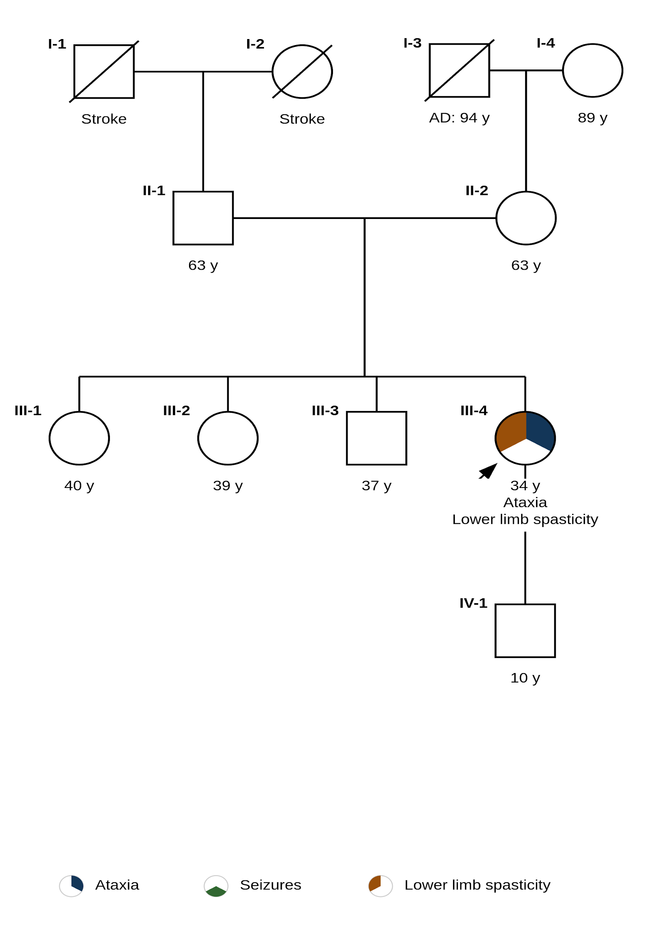

Supplemental Figure S2. Pedigree of Case 2.
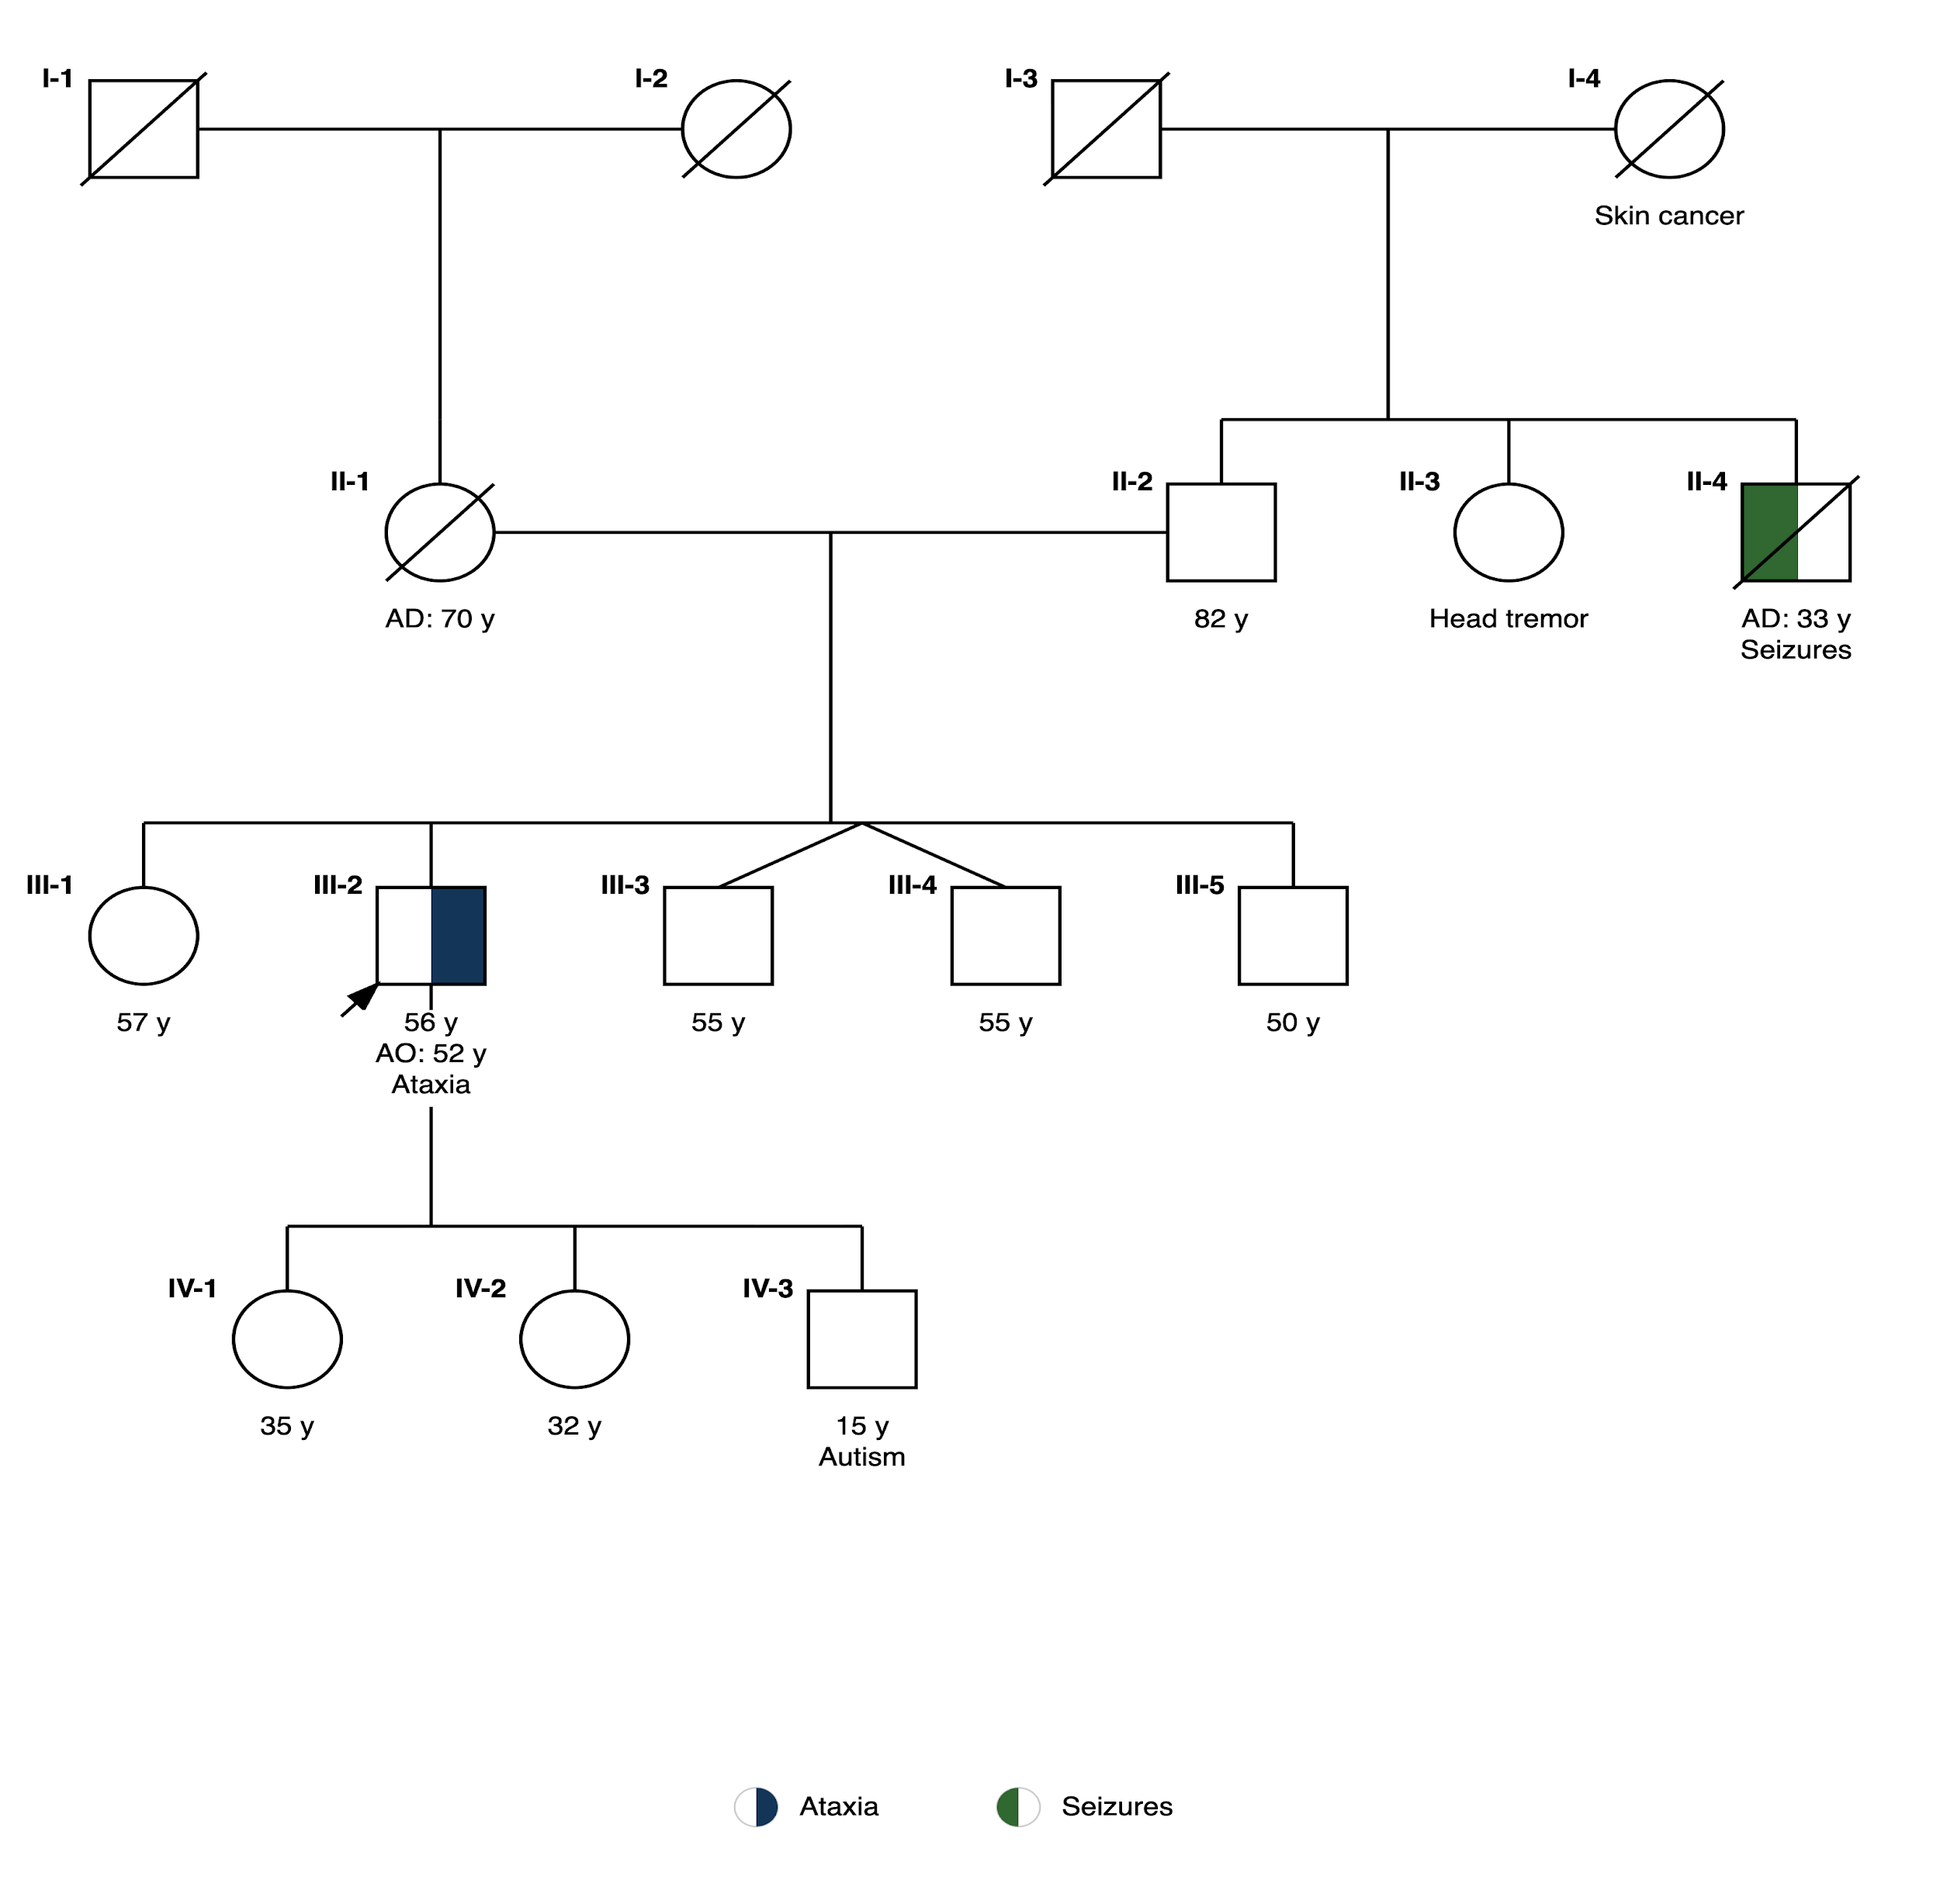

Supplemental Figure S3. Pedigree of Case 3.
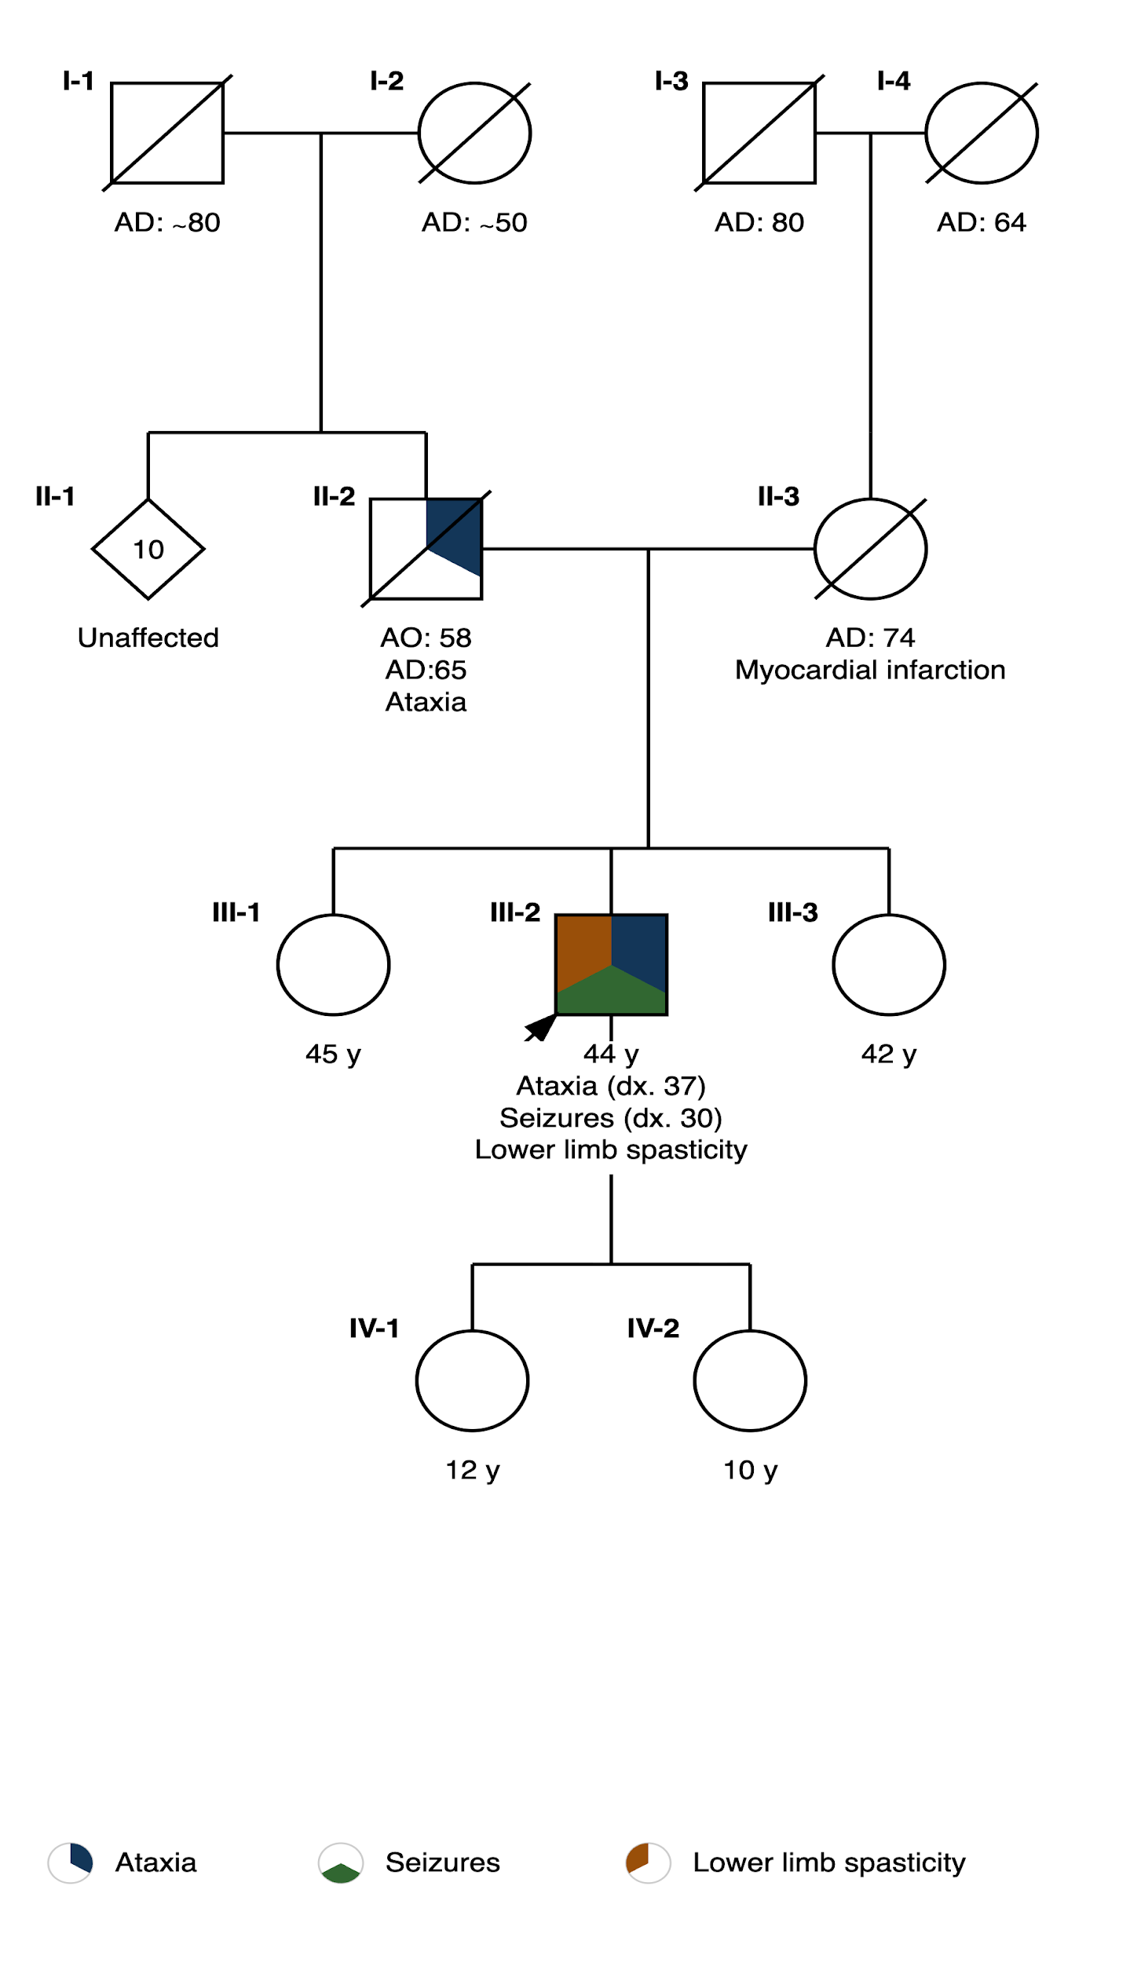

Supplementary document S4. PCR /RP-PCR Genotyping, WGS and long read sequencing procedures
PCR/RP-PCR Genotyping. CAG repeat expansion genotyping for SCA1, SCA2, MJD/SCA3, SCA6, was performed by PCR/TP-PCR. ATTCT repeat expansion genotyping for SCA10, was performed by PCR/RP-PCR, primers used for PCR SCA10-Forward: 5’-6-FAM- AGAAAACAGATGGCAGAATGA -3’ and SCA10-Reverse: 5’- GCCTGGGCAACATAGAGAGA -3’, for RP-PCR: SCA10-Forward: 5’-6-FAM- AGAAAACAGATGGCAGAATGA -3’, SCA10-2: 5’- TACGCATCCCAGTTTGAGACGGAATAGAATAGAATA GAATAGAATAGAATAGAATAGAATAG -3’ and SCA10-3: 5’- TACGCATCCCAGTTTGAGACG-3’.Sizing was estimated using GeneMapper™ Software 5 through capillary electrophoresis on SeqStudio Genetic Analyzer.
Whole-genome sequencing (WGS) was performed using KAPA library preparation with unique dual indexes and sequenced on an Illumina NovaSeq 6000 platform with 150-bp paired-end reads. FASTQ files were generated using Illumina bcl2fastq. Reads were aligned and analyzed using DRAGEN pipelines for detection of single nucleotide variants, small insertions/deletions, copy number variants, structural variants, and repeat expansions. Variant filtration and prioritization were performed using the Geneyx Analysis tool. Variants were classified according to ACMG/AMP guidelines and reported using HGVS nomenclature.
PureTarget long-read sequencing (LRS). DNA extraction for LRS was performed using the Nanobind PanDNA kit (PacBio,103-260-000) from saliva samples collected with Oragene Discover kits (DNA Genotek, OGR-500). DNA libraries were prepared following protocol PacBio, 103-329-400. Samples were digested with Cas9 and gRNA complex with the PureTarget 20- or 38-gene gRNA panel and further processed according to the protocol. Samples were barcoded, pooled, concentrated, and stored at -20C until Annealing, Binding, and SMRTbell Cleanup (ABC) for the Revio system at the Stanford Genomics Service Center. The repeat motifs were genotyped and visualized into waterfall plots by the Tandem Repeat Genotyping Tool (TRGT) developed by PacBio.

