KINEMATIC AND SPATIOTEMPORAL FEAURES RESULTS EXTRACTED FROM THE SINGLE WALKING TASK
Table S1. Kinematic variables of PD with and without FOG and PSP extracted from single walking task. Mean, standard deviation and p-values for each group were reported.
Joint | Kinematic Variables | PD-FOG | PD+FOG | PSP | p-value | PD-FOG vs  PD+FOG | PD-FOG vs  PSP | PD+FOG vs  PSP
Trunk | Anterior Tilt | 41.12 ± 8.81 | 42.68 ± 9.40 | 45.30 ± 12.44 | 0.364 | - | - | -
Trunk | Posterior Tilt | 38.16 ± 8.69 | 39.43 ± 9.78 | 42.40 ± 12.51 | 0.382 | - | - | -
Trunk | ROM Tilt | 2.96 ± 1.93 | 3.25 ± 1.51 | 2.90 ± 0.93 | 0.862 | - | - | -
Trunk | Internal Rotation | -3.00 ± 0.92 | -3.08 ± 1.04 | -4.26 ± 2.29 | 0.091 | - | - | -
Trunk | External Rotation | 2.88 ± 0.89 | 2.97 ± 0.90 | 4.24 ± 2.20 | 0.054 | - | - | -
Trunk | ROM Rotation | 5.88 ± 1.76 | 6.05 ± 1.79 | 8.50 ± 4.45 | 0.066 | - | - | -
Trunk | High Obliquity | 1.57 ± 0.91 | 2.30 ± 1.45 | 1.73 ± 0.99 | 0.047 | 0.128 | 0.710 | 0.710
Trunk | Low Obliquity | -1.58 ± 0.93 | -2.31 ± 1.60 | -1.73 ± 0.90 | 0.051 | - | - | -
Trunk | ROM Obliquity | 3.15 ± 1.82 | 4.62 ± 3.04 | 3.47 ± 1.89 | 0.047 | 0.137 | 0.691 | 0.691
Pelvis | Antiversum Tilt | 15.72 ± 6.91 | 8.96 ± 3.93 | 5.88 ± 6.04 | <0.001 | 0.001 | 0.000 | 0.000
Pelvis | Retroversum Tilt | 11.50 ± 5.01 | 4.19 ± 5.34 | 3.09 ± 5.92 | <0.001 | 0.000 | 0.000 | 0.000
Pelvis | ROM Tilt | 4.22 ± 4.63 | 4.77 ± 3.54 | 2.79 ± 0.77 | 0.720 | - | - | -
Pelvis | Internal Rotation | -3.37 ± 1.59 | -4.45 ± 1.85 | -3.79 ± 1.72 | 0.023 | 0.174 | 0.243 | 0.243
Pelvis | External Rotation | 3.30 ± 1.73 | 4.30 ± 2.14 | 4.01 ± 1.93 | 0.026 | 0.372 | 0.141 | 0.141
Pelvis | ROM Rotation | 6.67 ± 3.23 | 8.75 ± 3.86 | 7.80 ± 3.60 | 0.021 | 0.241 | 0.164 | 0.164
Pelvis | High Obliquity | 2.01 ± 0.92 | 2.42 ± 1.20 | 1.65 ± 0.57 | 0.771 | - | - | -
Pelvis | Low Obliquity | -2.38 ± 1.18 | -2.51 ± 1.23 | -1.65 ± 0.53 | 0.435 | - | - | -
Pelvis | ROM Obliquity | 4.39 ± 1.80 | 4.94 ± 2.41 | 3.29 ± 1.05 | 0.767 | - | - | -
Hip | Internal Rotation | 12.79 ± 14.63 | 9.76 ± 8.11 | 9.89 ± 14.50 | 0.470 | - | - | -
Hip | Extenal Rotation | -1.37 ± 14.97 | -5.15 ± 8.46 | -3.09 ± 14.70 | 0.461 | - | - | -
Hip | ROM Rotation | 14.16 ± 4.28 | 14.91 ± 3.24 | 12.98 ± 2.83 | 0.902 | - | - | -
Hip | Flexion | 32.34 ± 13.07 | 29.91 ± 8.47 | 24.94 ± 8.00 | 0.044 | 1.000 | 0.048 | 0.048
Hip | Extension | -5.81 ± 13.59 | -13.24 ± 10.44 | -12.55 ± 6.47 | 0.016 | 0.051 | 0.405 | 0.405
Hip | ROM Flexion/Extension | 38.15 ± 13.00 | 43.15 ± 8.48 | 37.49 ± 6.47 | 0.601 | - | - | -
Knee | Internal Rotation | -1.78 ± 6.37 | -0.80 ± 11.23 | 9.35 ± 17.51 | 0.041 | 1.000 | 0.048 | 0.048
Knee | External Rotation | -26.52 ± 9.85 | -15.90 ± 12.44 | -9.82 ± 14.83 | <0.001 | 0.014 | 0.000 | 0.000
Knee | ROM Rotation | 24.73 ± 10.21 | 15.10 ± 9.76 | 19.18 ± 10.23 | 0.003 | 0.005 | 0.247 | 0.247
Knee | Flexion | 56.22 ± 9.18 | 52.07 ± 7.79 | 48.22 ± 6.65 | 0.011 | 0.099 | 0.160 | 0.160
Knee | Extension | 3.47 ± 7.53 | 1.85 ± 3.36 | 5.12 ± 16.20 | 0.895 | - | - | -
Knee | ROM Flexion/Extension | 52.75 ± 7.97 | 50.22 ± 6.93 | 46.60 ± 6.98 | 0.052 | - | - | -
Ankle | Dorsiflexion | 12.28 ± 4.33 | 12.27 ± 4.51 | 12.15 ± 7.35 | 0.846 | - | - | -
Ankle | Plantarflexion | -17.06 ± 6.78 | -15.09 ± 5.52 | -10.58 ± 7.99 | 0.024 | 0.809 | 0.046 | 0.046
Ankle | ROM Dors-Plantarflexion | 29.34 ± 7.75 | 27.36 ± 5.08 | 22.73 ± 5.44 | 0.022 | 0.540 | 0.070 | 0.070

Table S2. Spatiotemporal variables of PD with and without FOG and PSP extracted from single walking task. Mean, standard deviation and p-values for each group were reported.
Spatiotemporal Variables | PD-FOG | PD+FOG | PSP | p-value | PD-FOG  vs  PD+FOG | PD-FOG vs  PSP | PD+FOG  vs  PSP
Cycle duration (s) | 1.09 ± 0.14 | 1.11 ± 0.12 | 1.31 ± 0.19 | 0.003 | 1.000 | 0.000 | 0.000
Stance duration (s) | 0.66 ± 0.10 | 0.67 ± 0.08 | 0.82 ± 0.14 | 0.004 | 1.000 | 0.000 | 0.000
Swing duration (s) | 0.43 ± 0.04 | 0.44 ± 0.05 | 0.48 ± 0.06 | 0.013 | 1.000 | 0.004 | 0.004
Stance phase (% gait cycle time) | 60.34 ± 2.79 | 60.59 ± 1.89 | 62.77 ± 2.62 | 0.047 | 1.000 | 0.025 | 0.025
Swing phase (% gait cycle time) | 39.11 ± 2.26 | 39.41 ± 1.88 | 37.18 ± 2.59 | 0.086 | - | - | -
Single support phase (%) | 38.91 ± 3.04 | 39.43 ± 1.90 | 37.22 ± 2.63 | 0.195 | - | - | -
Double support phase (%) | 10.58 ± 2.19 | 10.66 ± 2.18 | 12.73 ± 2.52 | 0.048 | 1.000 | 0.013 | 0.013
Speed (m/s) | 0.99 ± 0.18 | 0.99 ± 0.24 | 0.71 ± 0.24 | 0.010 | 1.000 | 0.000 | 0.000
Cadence (steps/minute) | 109.76 ± 14.17 | 109.65 ± 12.11 | 93.87 ± 13.76 | 0.012 | 1.000 | 0.001 | 0.001
Cycle length (% height) | 1.07 ± 0.16 | 1.06 ± 0.22 | 0.89 ± 0.18 | 0.036 | 1.000 | 0.009 | 0.009
Step length (m) | 0.50 ± 0.11 | 0.52 ± 0.12 | 0.42 ± 0.10 | 0.195 | - | - | -
Step width (m) | 0.09 ± 0.05 | 0.10 ± 0.04 | 0.12 ± 0.05 | 0.019 | 1.000 | 0.005 | 0.005

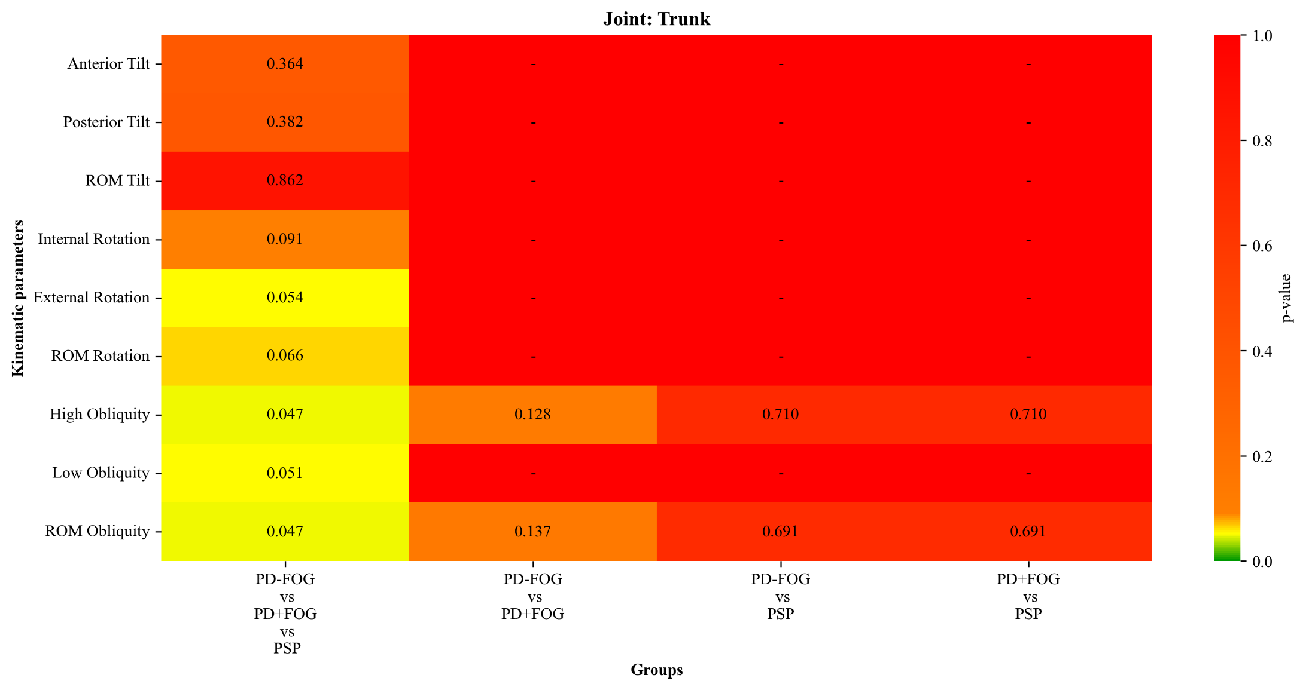
Figure S1. Heatmap of p-values for trunk kinematic parameters obtained from the comparison between three clinical groups during the single walking task (PD-FOG, PD+FOG, and PSP). The rows show the kinematic parameters, while the columns show the comparisons between groups and pairs. The colour scale indicates the level of statistical significance. For variables that did not show statistical significance between the three groups, no post hoc tests were performed.
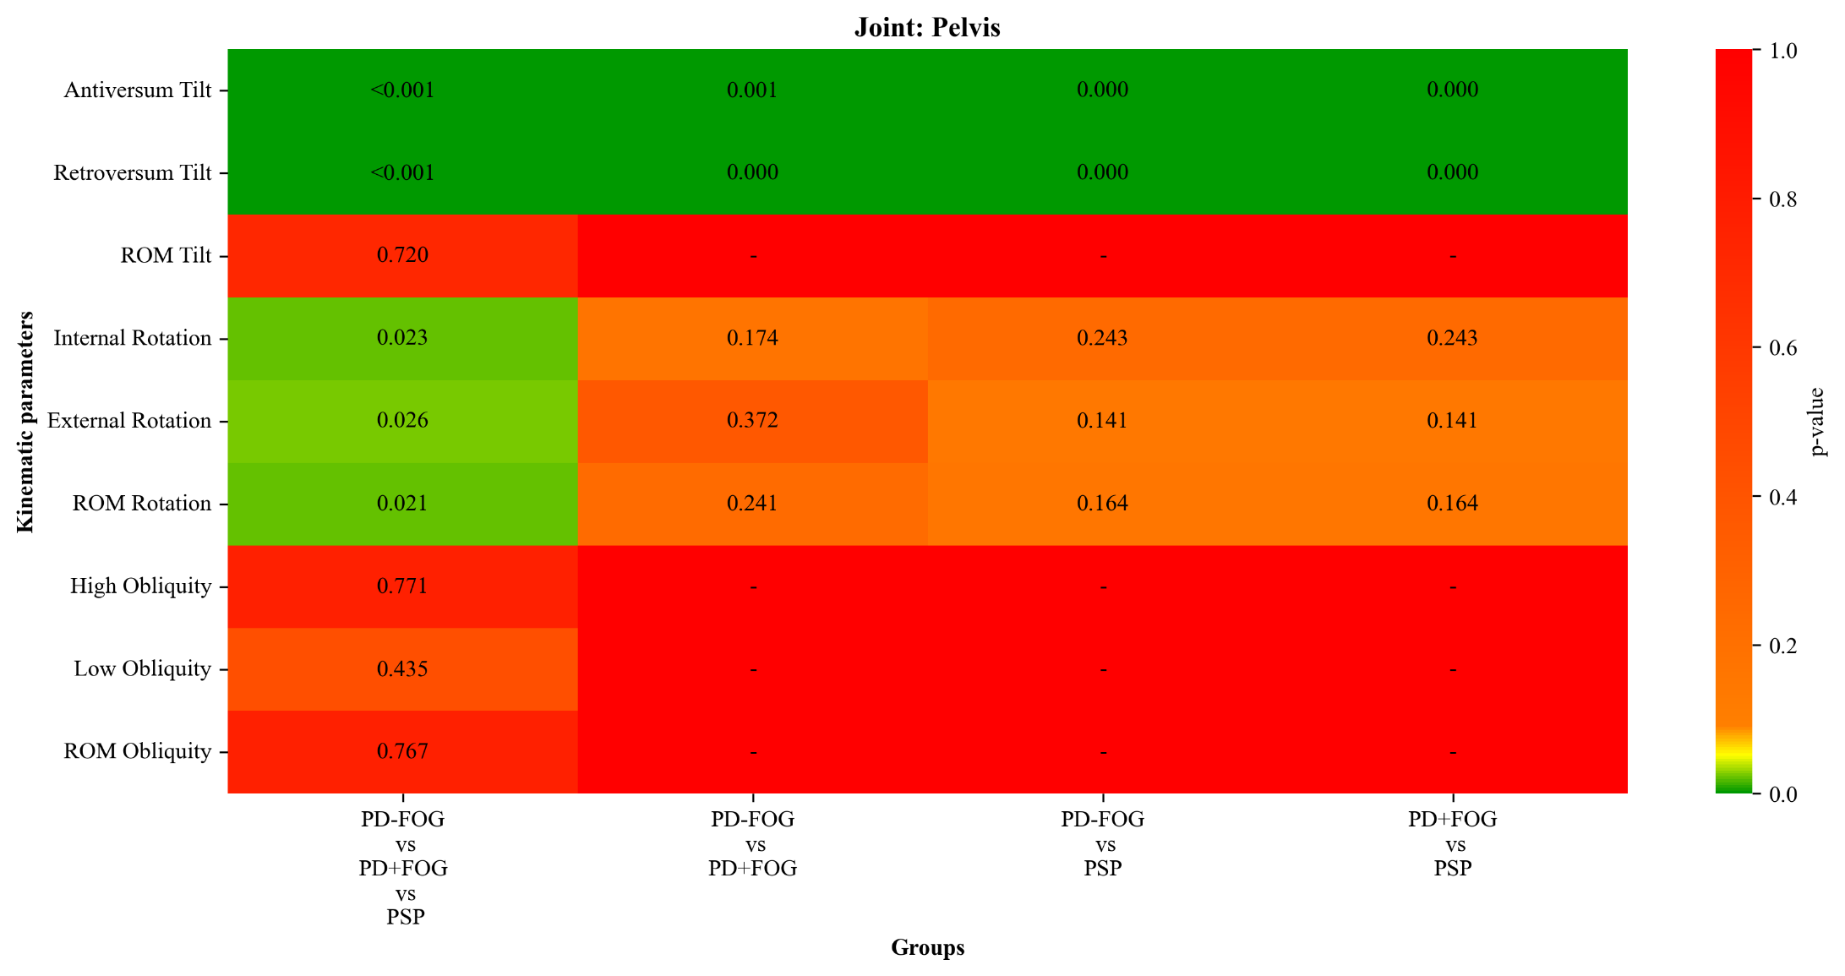
Figure S2. Heatmap of p-values for pelvis kinematic parameters obtained from the comparison between three clinical groups during the single walking task (PD-FOG, PD+FOG, and PSP). The rows show the kinematic parameters, while the columns show the comparisons between groups and pairs. The colour scale indicates the level of statistical significance. For variables that did not show statistical significance between the three groups, no post hoc tests were performed.

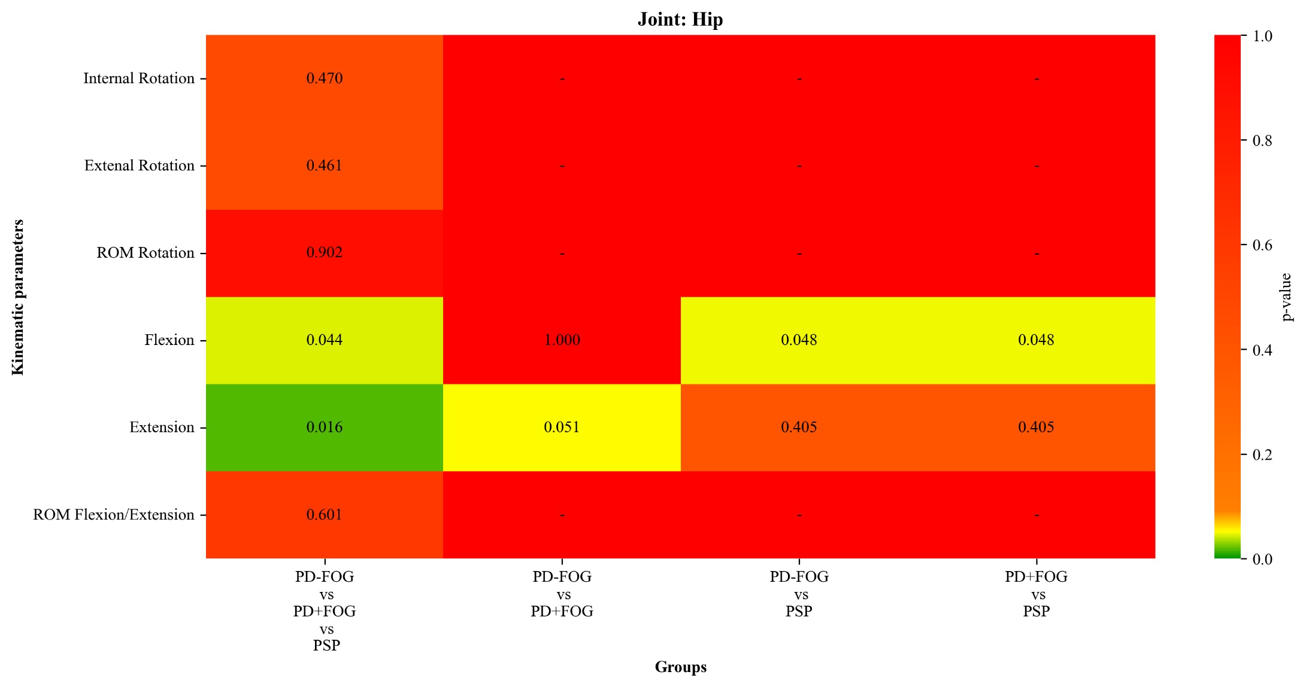
Figure S3. Heatmap of p-values for hip kinematic parameters obtained from the comparison between three clinical groups during the single walking task (PD-FOG, PD+FOG, and PSP). The rows show the kinematic parameters, while the columns show the comparisons between groups and pairs. The colour scale indicates the level of statistical significance. For variables that did not show statistical significance between the three groups, no post hoc tests were performed.

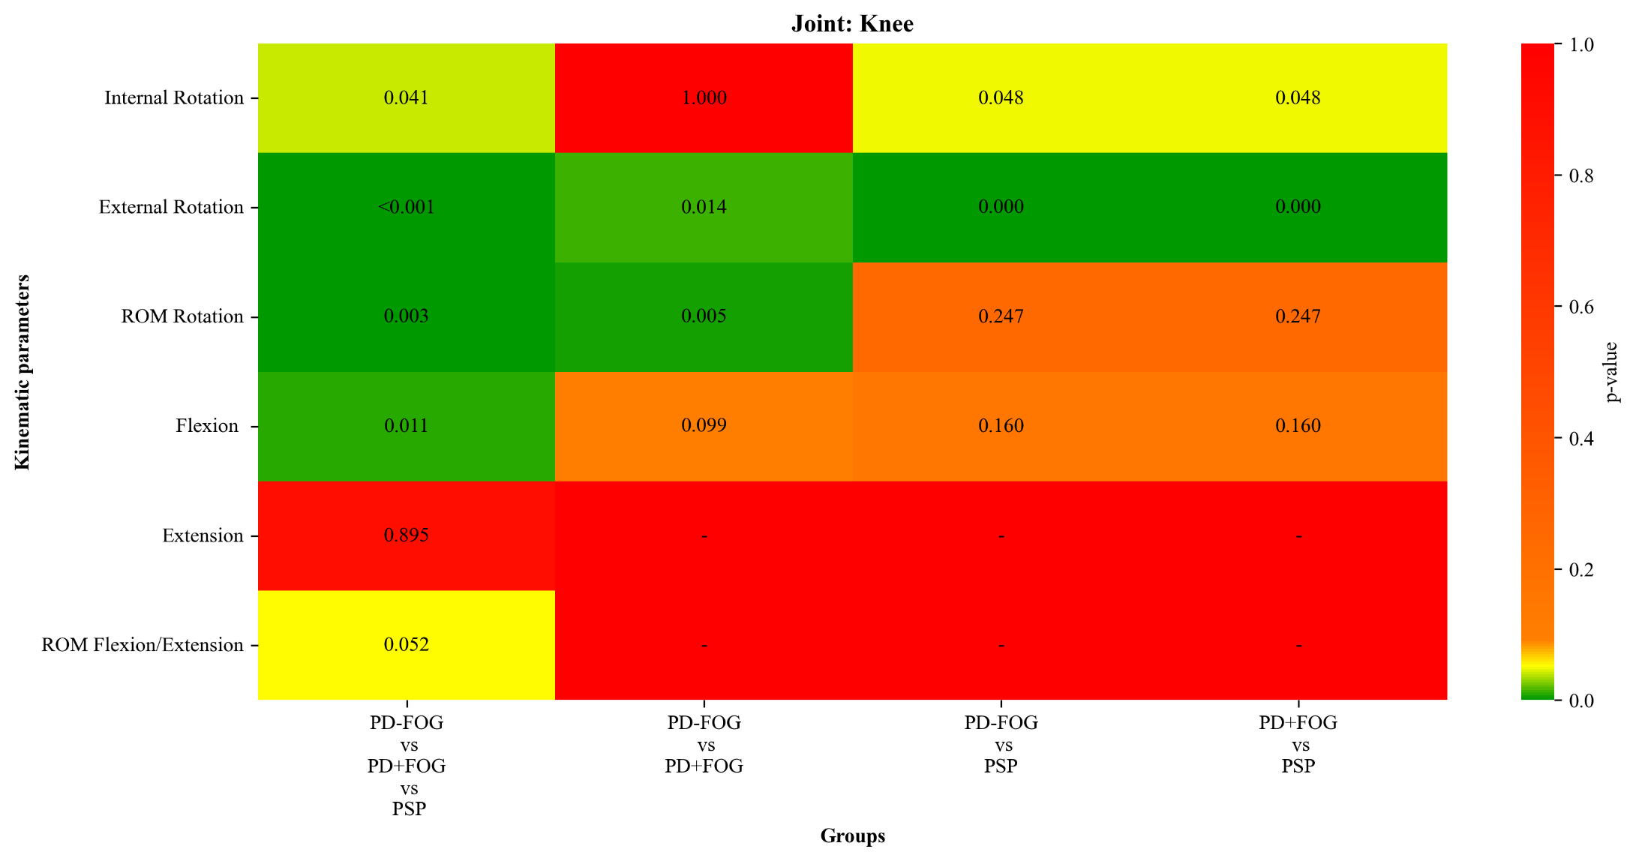
Figure S4. Heatmap of p-values for knee kinematic parameters obtained from the comparison between three clinical groups during the single walking task (PD-FOG, PD+FOG, and PSP). The rows show the kinematic parameters, while the columns show the comparisons between groups and pairs. The colour scale indicates the level of statistical significance. For variables that did not show statistical significance between the three groups, no post hoc tests were performed.

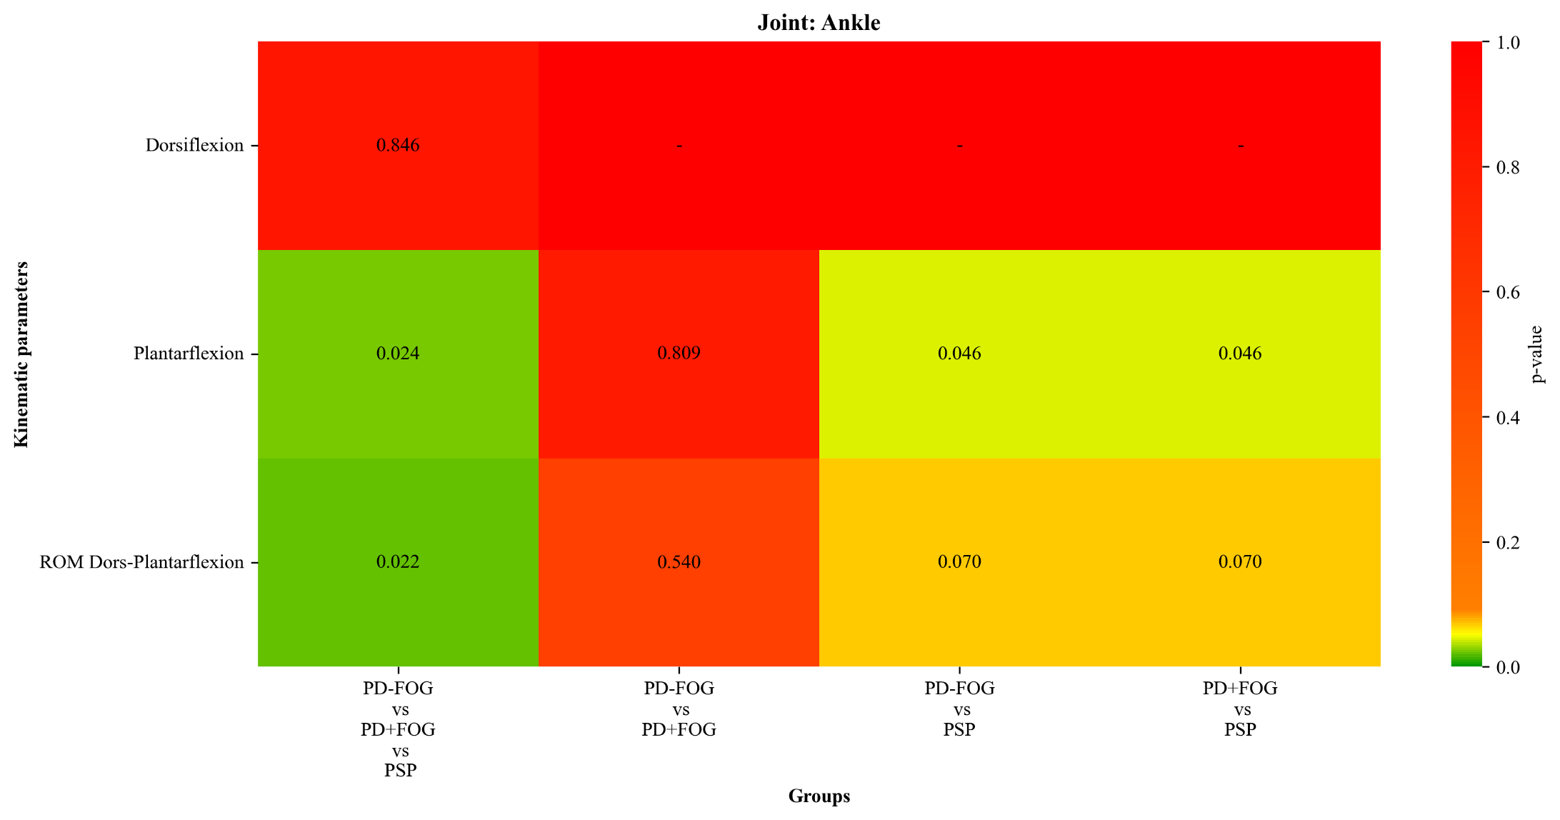
Figure S5. Heatmap of p-values for ankle kinematic parameters obtained from the comparison between three clinical groups during the single walking task (PD-FOG, PD+FOG, and PSP). The rows show the kinematic parameters, while the columns show the comparisons between groups and pairs. The colour scale indicates the level of statistical significance. For variables that did not show statistical significance between the three groups, no post hoc tests were performed.

KINEMATIC AND SPATIOTEMPORAL FEAURES RESULTS EXTRACTED FROM THE DUAL COGNITIVE TASK
Table S3. Kinematic variables of PD with and without FOG and PSP extracted from dual cognitive task. Mean, standard deviation and p-values for each group were reported.
Joint | Kinematic Variables | PD-FOG | PD+FOG | PSP | p-value | PD-FOG vs  PD+FOG | PD-FOG vs  PSP | PD+FOG vs  PSP
Trunk | Anterior Tilt | 39.83 ± 9.77 | 43.27 ± 10.99 | 45.98 ± 13.48 | 0.190 | - | - | -
Trunk | Posterior Tilt | 36.86 ± 10.05 | 40.27 ± 10.87 | 43.17 ± 13.54 | 0.180 | - | - | -
Trunk | ROM Tilt | 2.97 ± 1.13 | 3.00 ± 1.53 | 2.81 ± 1.36 | 0.712 | - | - | -
Trunk | Internal Rotation | -3.11 ± 1.12 | -3.63 ± 1.46 | -3.88 ± 2.41 | 0.164 | - | - | -
Trunk | External Rotation | 2.93 ± 1.25 | 3.50 ± 1.49 | 3.82 ± 2.25 | 0.085 | - | - | -
Trunk | ROM Rotation | 6.03 ± 2.31 | 7.13 ± 2.92 | 7.70 ± 4.38 | 0.105 | - | - | -
Trunk | High Obliquity | 1.81 ± 1.16 | 1.84 ± 1.15 | 1.62 ± 0.87 | 0.993 | - | - | -
Trunk | Low Obliquity | -1.83 ± 1.15 | -2.19 ± 1.74 | -1.65 ± 0.93 | 0.615 | - | - | -
Trunk | ROM Obliquity | 3.64 ± 2.31 | 4.03 ± 2.72 | 3.27 ± 1.79 | 0.781 | - | - | -
Pelvis | Antiversum Tilt | 12.24 ± 7.39 | 8.41 ± 8.00 | 6.65 ± 5.59 | 0.007 | 0.200 | 0.042 | 0.042
Pelvis | Retroversum Tilt | 9.29 ± 7.54 | 5.19 ± 7.92 | 3.59 ± 5.83 | 0.007 | 0.152 | 0.047 | 0.047
Pelvis | ROM Tilt | 2.95 ± 1.34 | 3.22 ± 1.39 | 3.07 ± 2.30 | 0.738 | - | - | -
Pelvis | Internal Rotation | -2.96 ± 1.23 | -3.27 ± 1.47 | -3.80 ± 1.50 | 0.105 | - | - | -
Pelvis | External Rotation | 2.96 ± 1.12 | 3.34 ± 1.82 | 4.07 ± 2.10 | 0.068 | - | - | -
Pelvis | ROM Rotation | 5.92 ± 2.30 | 6.61 ± 3.14 | 7.86 ± 3.29 | 0.066 | - | - | -
Pelvis | High Obliquity | 1.93 ± 0.88 | 2.36 ± 1.30 | 2.00 ± 1.14 | 0.561 | - | - | -
Pelvis | Low Obliquity | -1.87 ± 0.81 | -2.43 ± 1.44 | -1.84 ± 1.14 | 0.425 | - | - | -
Pelvis | ROM Obliquity | 3.80 ± 1.61 | 4.80 ± 2.67 | 3.84 ± 2.13 | 0.467 | - | - | -
Hip | Internal Rotation | 18.13 ± 24.21 | 9.14 ± 8.54 | 11.61 ± 17.76 | 0.258 | - | - | -
Hip | Extenal Rotation | -2.04 ± 20.67 | -4.40 ± 8.00 | -5.30 ± 19.48 | 0.427 | - | - | -
Hip | ROM Rotation | 20.18 ± 27.97 | 13.55 ± 3.58 | 16.90 ± 20.79 | 0.743 | - | - | -
Hip | Flexion | 34.38 ± 17.65 | 26.27 ± 11.16 | 24.74 ± 9.69 | 0.021 | 0.128 | 0.263 | 0.263
Hip | Extension | 1.99 ± 20.26 | -10.02 ± 13.02 | -9.86 ± 6.88 | 0.011 | 0.010 | 0.651 | 0.651
Hip | ROM Flexion/Extension | 32.40 ± 13.70 | 36.29 ± 9.18 | 34.60 ± 10.75 | 0.616 | - | - | -
Knee | Internal Rotation | 0.04 ± 22.51 | -2.68 ± 13.56 | 6.77 ± 16.16 | 0.256 | - | - | -
Knee | External Rotation | -24.56 ± 14.91 | -20.88 ± 15.53 | -9.91 ± 15.38 | 0.019 | 1.000 | 0.017 | 0.017
Knee | ROM Rotation | 24.61 ± 18.92 | 18.21 ± 6.60 | 16.68 ± 7.35 | 0.209 | - | - | -
Knee | Flexion | 51.95 ± 17.24 | 49.60 ± 6.39 | 47.04 ± 15.94 | 0.532 | - | - | -
Knee | Extension | 5.18 ± 12.89 | 0.26 ± 7.71 | 4.95 ± 16.08 | 0.826 | - | - | -
Knee | ROM Flexion/Extension | 46.77 ± 18.26 | 49.35 ± 6.45 | 42.09 ± 7.56 | 0.629 | - | - | -
Ankle | Dorsiflexion | 11.30 ± 4.52 | 11.07 ± 5.03 | 13.41 ± 4.35 | 0.400 | - | - | -
Ankle | Plantarflexion | -11.49 ± 5.61 | -11.52 ± 6.08 | -7.91 ± 7.54 | 0.196 | - | - | -
Ankle | ROM Dors-Plantarflexion | 22.79 ± 4.89 | 22.59 ± 6.01 | 21.31 ± 7.01 | 0.457 | - | - | -

Table S4. Spatiotemporal variables of PD with and without FOG and PSP extracted from dual cognitive task. Mean, standard deviation and p-values for each group were reported.
Spatiotemporal Variables | PD-FOG | PD+FOG | PSP | p-value | PD-FOG  vs  PD+FOG | PD-FOG vs  PSP | PD+FOG  vs  PSP
Cycle duration (s) | 1.17 ± 0.21 | 1.22 ± 0.22 | 1.44 ± 0.24 | 0.006 | 1.000 | 0.001 | 0.001
Stance duration (s) | 0.74 ± 0.16 | 0.76 ± 0.16 | 0.95 ± 0.20 | 0.008 | 1.000 | 0.001 | 0.001
Swing duration (s) | 0.44 ± 0.05 | 0.46 ± 0.07 | 0.49 ± 0.07 | 0.019 | 0.775 | 0.032 | 0.032
Stance phase (% gait cycle time) | 62.65 ± 2.85 | 62.25 ± 2.81 | 65.77 ± 3.70 | 0.092 | - | - | -
Swing phase (% gait cycle time) | 37.57 ± 2.76 | 39.22 ± 6.69 | 34.24 ± 3.71 | 0.542 | - | - | -
Single support phase (%) | 37.21 ± 3.43 | 37.76 ± 2.81 | 34.24 ± 3.71 | 0.231 | - | - | -
Double support phase (%) | 12.59 ± 2.55 | 13.79 ± 4.92 | 15.97 ± 3.74 | 0.021 | 0.695 | 0.042 | 0.042
Speed (m/s) | 0.84 ± 0.23 | 0.83 ± 0.26 | 0.53 ± 0.23 | 0.004 | 1.000 | 0.000 | 0.000
Cadence (steps/minute) | 105.07 ± 15.06 | 101.62 ± 17.98 | 85.88 ± 14.33 | 0.005 | 1.000 | 0.001 | 0.001
Cycle length (% height) | 0.96 ± 0.21 | 0.96 ± 0.21 | 0.73 ± 0.20 | 0.016 | 1.000 | 0.001 | 0.001
Step length (m) | 0.44 ± 0.12 | 0.46 ± 0.12 | 0.36 ± 0.11 | 0.213 | - | - | -
Step width (m) | 0.13 ± 0.13 | 0.10 ± 0.04 | 0.13 ± 0.05 | 0.408 | - | - | -

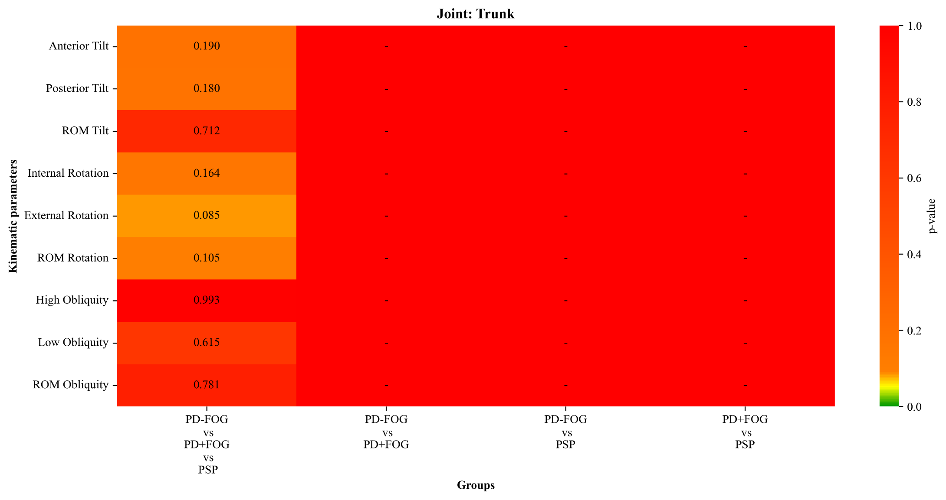
Figure S6. Heatmap of p-values for trunk kinematic parameters obtained from the comparison between three clinical groups during the dual cognitive task (PD-FOG, PD+FOG, and PSP). The rows show the kinematic parameters, while the columns show the comparisons between groups and pairs. The colour scale indicates the level of statistical significance. For variables that did not show statistical significance between the three groups, no post hoc tests were performed.

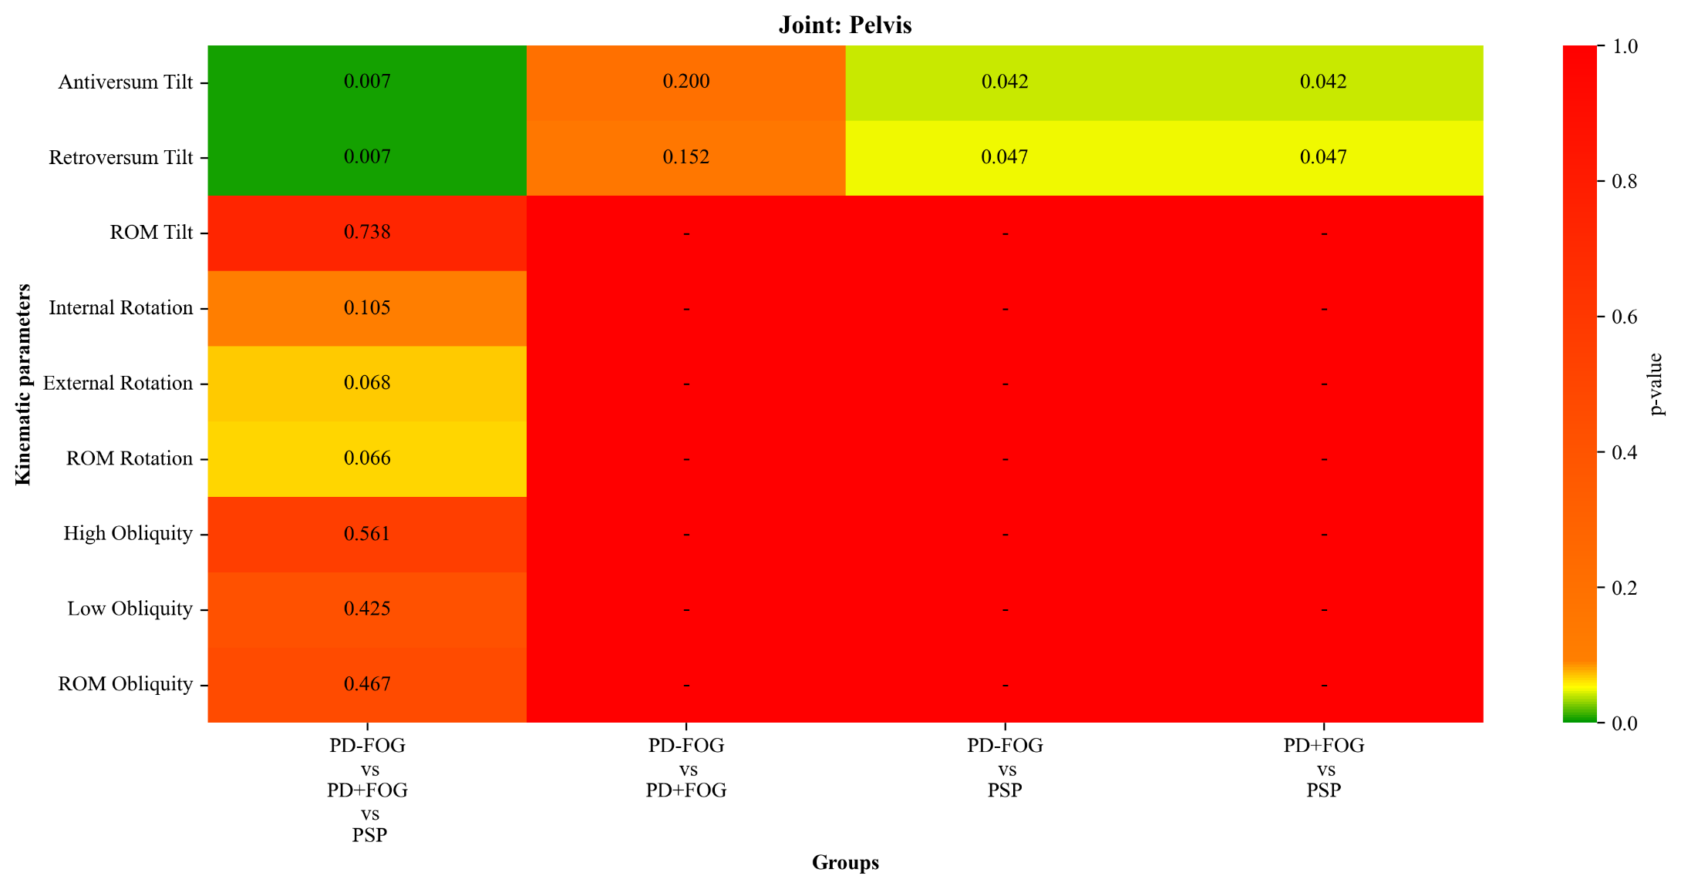
Figure S7. Heatmap of p-values for pelvis kinematic parameters obtained from the comparison between three clinical groups during the dual cognitive task (PD-FOG, PD+FOG, and PSP). The rows show the kinematic parameters, while the columns show the comparisons between groups and pairs. The colour scale indicates the level of statistical significance. For variables that did not show statistical significance between the three groups, no post hoc tests were performed.

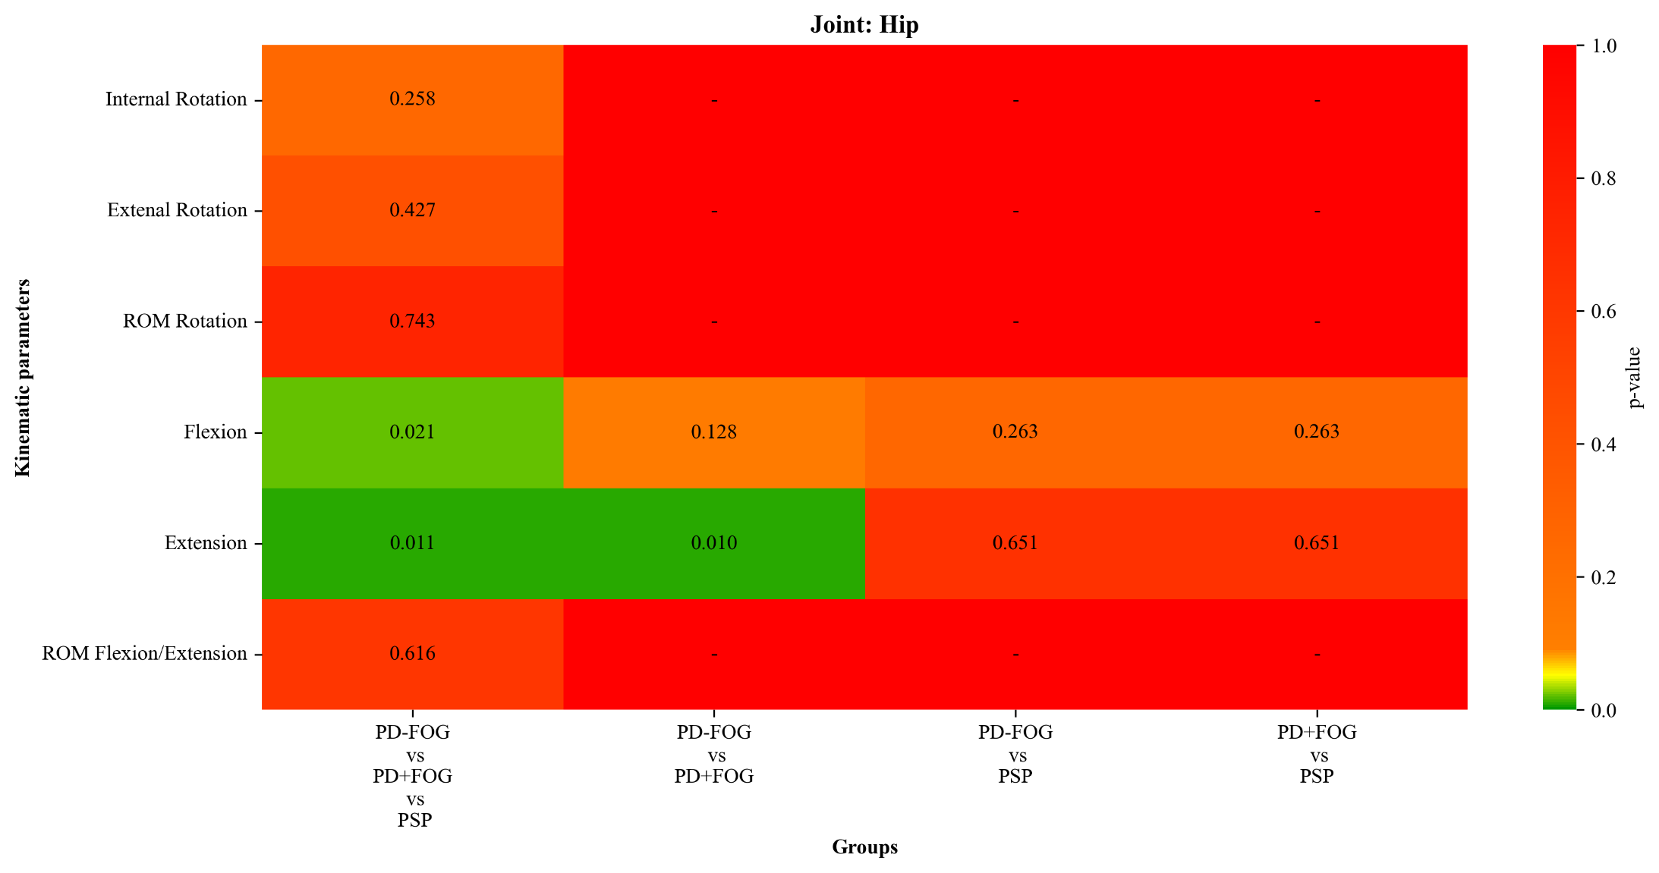
Figure S8. Heatmap of p-values for hip kinematic parameters obtained from the comparison between three clinical groups during the dual cognitive task (PD-FOG, PD+FOG, and PSP). The rows show the kinematic parameters, while the columns show the comparisons between groups and pairs. The colour scale indicates the level of statistical significance. For variables that did not show statistical significance between the three groups, no post hoc tests were performed.

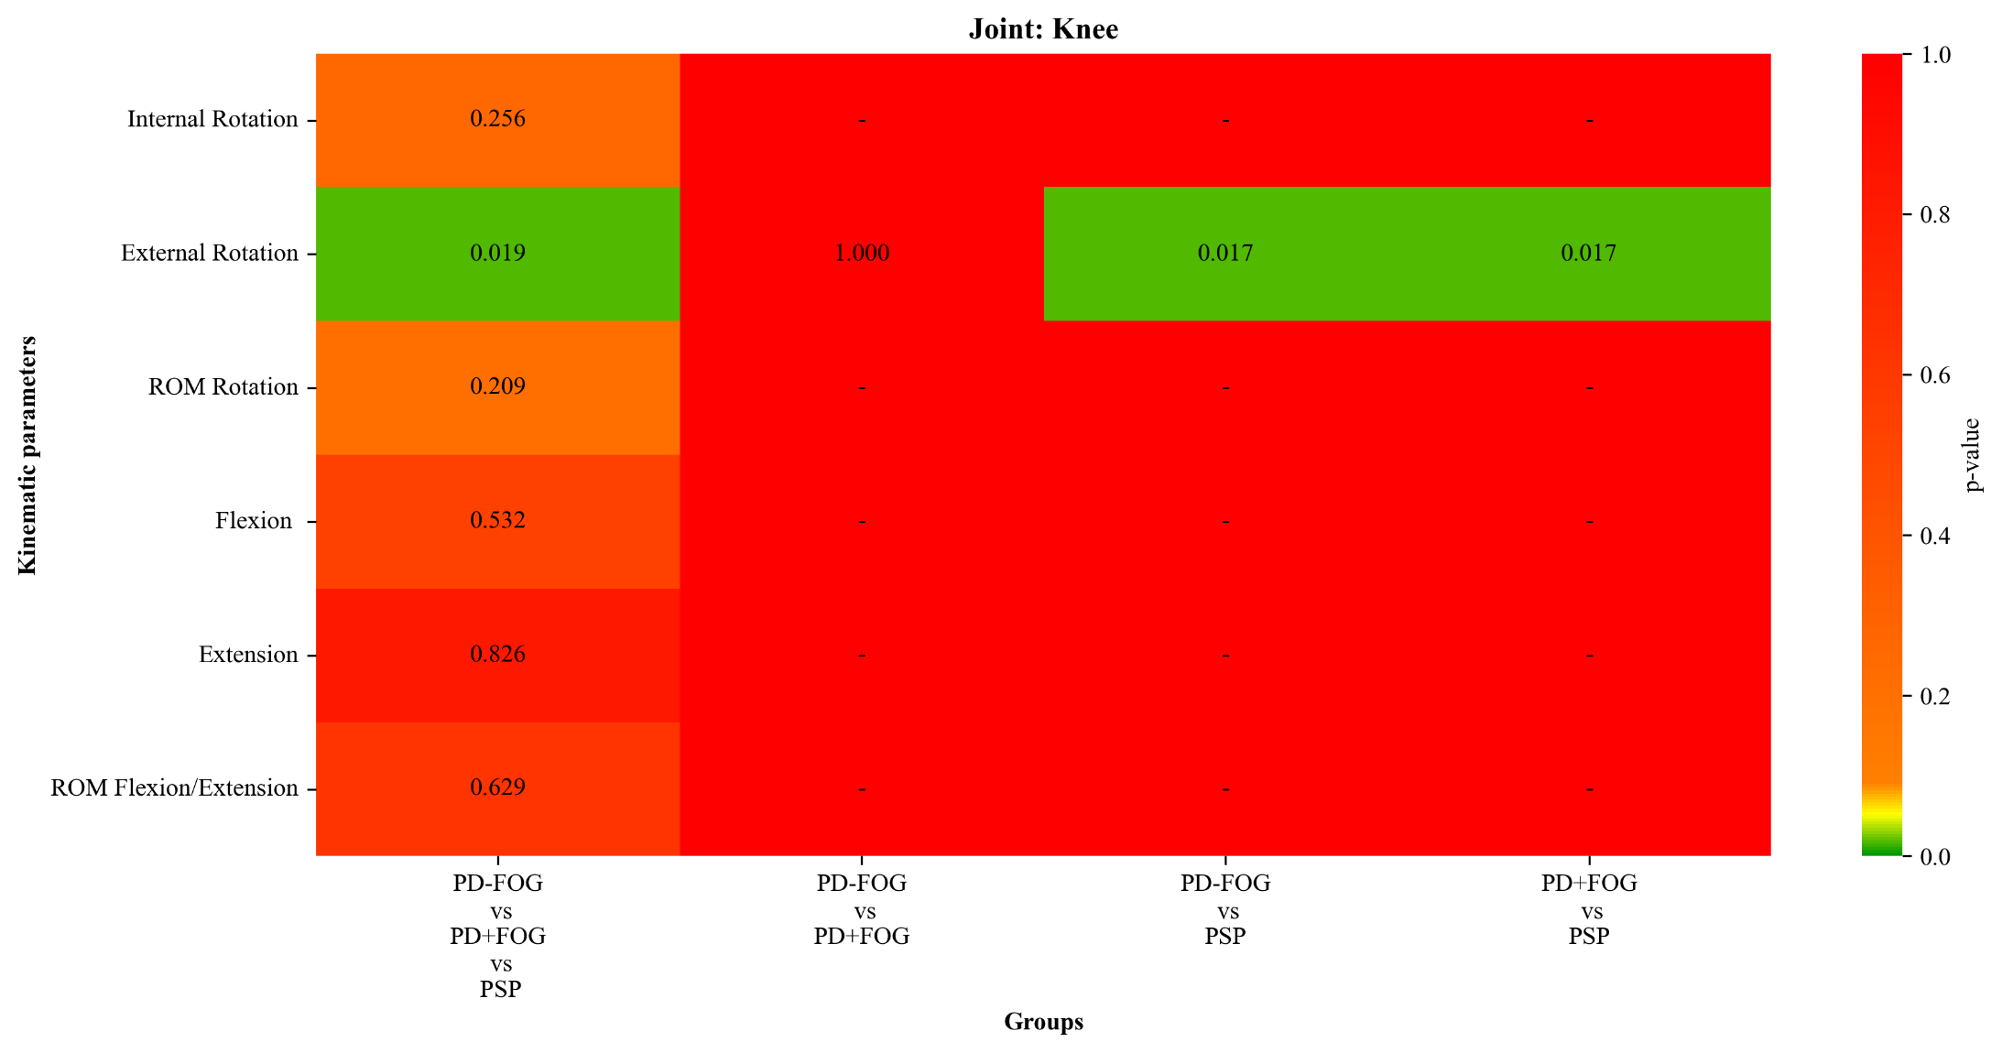
Figure S9. Heatmap of p-values for knee kinematic parameters obtained from the comparison between three clinical groups during the dual cognitive task (PD-FOG, PD+FOG, and PSP). The rows show the kinematic parameters, while the columns show the comparisons between groups and pairs. The colour scale indicates the level of statistical significance. For variables that did not show statistical significance between the three groups, no post hoc tests were performed.
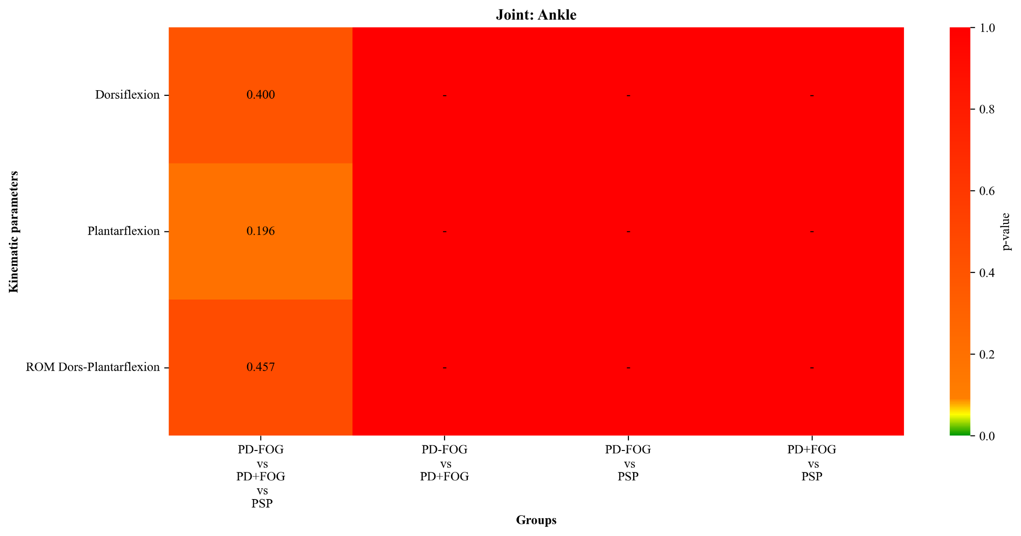
Figure S10. Heatmap of p-values for ankle kinematic parameters obtained from the comparison between three clinical groups during the dual cognitive task (PD-FOG, PD+FOG, and PSP). The rows show the kinematic parameters, while the columns show the comparisons between groups and pairs. The colour scale indicates the level of statistical significance. For variables that did not show statistical significance between the three groups, no post hoc tests were performed.

