Supplementary material
Table S1: Overview of organisms present in the studied seaweed cultivation site. Depending on which sampling method, organisms were divided into two columns. In the line samples, all sizes were counted; in the mobile samples, only the organisms bigger than 1 cm were considered and counted.
Taxonomic level | Name | Line samples  (mostly sessile) | Mobile samples (mostly mobile)
Species | Aequipecten opercularis | Present, quantified | Not considered
Species | Hyas coarctatus | Present, quantified | Present, quantified
Species | Caprella mutica | Present, quantified | Present, quantified
Species | Tectura virginea | Present, quantified | Not considered
Species | Idotea balthica | absent | Present, quantified
Species | Lacuna vincta | Present, quantified | Not considered
Species | Galathea nexa | Present, quantified | Present, quantified
Species | Hippolyte varians | absent | Present, quantified
Species | Ascidiella scabra | Present, quantified | Not considered
Species | Dendronotus frondosus | Present, quantified | Present, quantified
Genus | Mytilus sp. | Present, quantified | Not considered
Genus | Hiatella sp. | Present, quantified | Not considered
Genus | Ascidiella sp. | Present, quantified | Not considered
Genus | Balanus sp. | Present, quantified | Not considered
Genus | Idotea sp. | absent | Present, quantified
Family | Anomiidae | Present, quantified | Not considered
Order | Amphipoda | Present, quantified | Not considered
Class | Echinoidea | absent | Present, quantified
Class | Polychaeta | Present, quantified | Present, quantified
Class | Actinopterygii | absent | Present, quantified
Class | Hydrozoa | Present, not quantified | Absent
Phylum | Bryozoas | Present, not quantified | Absent
Phylum | Porifera | Present, not quantified | Absent
N.A. | Ichthyoplankton | absent | Present, not quantified

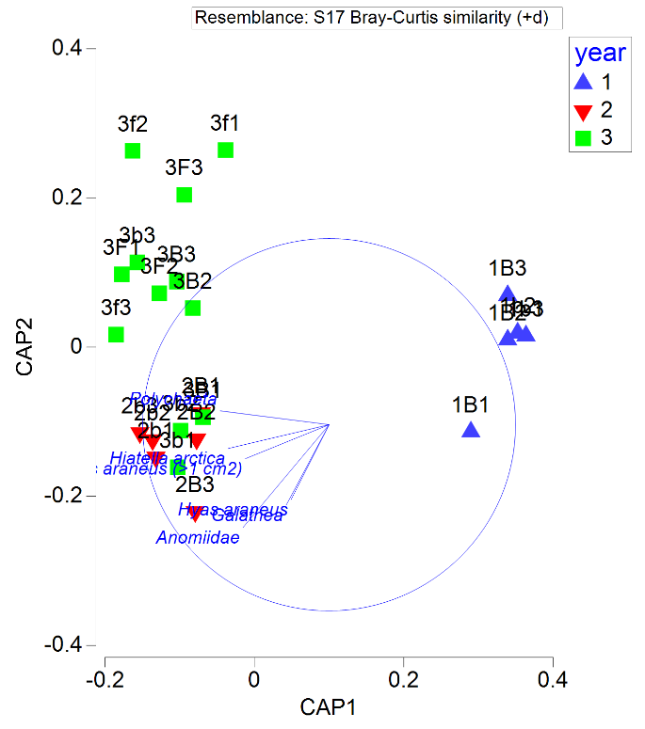
Figure S1: Cap graph of factor ‘year’ displaying loading vectors to organisms with R >= 0.45. Data does not include 1st year line April samples. PERMANOVA tests with Monte Carlo simulations based on D2 average distances for each organism until reaching a statistical significance threshold of p=0.05 were performed to identify which organisms contribute most to differences between samples.
Table S2: Organism richness of averages of replicates.
Sites | Exposed |  |  |  | Semi-exposed | Both sites
Month | All years | 1 | 2 | 3 | 3 | 3 | All years
April | 1.12 | 0 | 1.16 | 1.08 | 1.252 | 1.166 | 1.164
July | 1.195 | 0.89 | 1.496 | 1.199 | 1.663 | 1.431 | 1.312
Both seasons | 1.165 | 0.89 | 1.328 | 1.1397 | 1.4575 | 1.2986 | 1.249

