Supplementary information
High molar activity [¹¹C]phosgene from [¹¹C]CO₂
Edla Kerminen^{1,*}, Thomas Keller^{1,*}, Simo Salo¹, Johan Rajander², Olof Solin^{1,2,3}, Anna Krzyczmonik⁴, Anna K. Kirjavainen^{1,3}

¹Radiopharmaceutical Chemistry Laboratory, Turku PET Centre, University of Turku, Turku
² Accelerator Laboratory, Åbo Akademi University, Turku, Finland
³ Department of Chemistry, University of Turku, Turku, Finland
⁴ NOMATEN Centre of Excellence, National Centre for Nuclear Research, Świerk/Otwock, Poland
* These authors contributed equally to this work and share first authorship.

References
1. Jakobsson JE, Lu S, Telu S, Pike VW. [¹¹C]Carbonyl Difluoride—a New and Highly Efficient [¹¹C]Carbonyl Group Transfer Agent. Angew Chem. 2020;132(18):7323–7.
2. Jakobsson JE, Telu S, Lu S, Jana S, Pike VW. Broad Scope and High-Yield Access to Unsymmetrical Acyclic [¹¹C]Ureas for Biomedical Imaging from [¹¹C]Carbonyl Difluoride. Chem – Eur J. 2021;27(40):10369–76.
3. Seki, K. I. et al. New [¹¹C]phosgene based synthesis of [¹¹C]pyrimidines for positron emission tomography. Heterocycles 77, 1307–1321 (2009).

S1. Materials 2
S1.1 Device materials 2
S1.2 Precursors 3
S1.2.1 Thymine precursor 3
S1.3 Model molecule references 3
S1.3.1 1-benzyl-3-(4-fluorophenyl)urea 3
S1.3.2 1-benzyl-3-phenylurea 3
S.1.3.3 1-benzyl-3-(4-iodophenyl)urea 3
S.1.3.4 3,4-dihydroquinazolin-2(1H)-one 3
S2. Radiosyntheses 3
S2.1 [¹¹C]Phosgene synthesis 3
S2.2 Radiolabelling 4
2.2.1 Synthesis of [¹¹C]1 4
S2.2.2 Syntheses of [¹¹C]2-[¹¹C]4 5
S2.2.3 Synthesis of [¹¹C]5 5
S2.2.4 Synthesis of [¹¹C]Thymine 5
S2.2.5 Synthesis of [¹¹C]Sorafenib 5
S3. Calculations and definitions 5
S3.1 Determination of molar activity for [¹¹C]1 5
S3.2 Iodometric titration 5
S4. Analytical data 6
S4.1 GC analysis 6
S4.2 General HPLC methods and retention times 6
S4.3 Chromatograms from radiosyntheses 7
S4.3.1 [¹¹C]N,N’-diphenylurea ([¹¹C]1) 7
S4.3.2 [¹¹C]-1-benzyl-3-(4-fluorophenyl)urea ([¹¹C]2) 8
S4.3.3 [¹¹C]1-benzyl-3-phenylurea ([¹¹C]3) 9
S4.3.4 [¹¹C]-1-benzyl-3-(4-iodophenyl)urea ([¹¹C]4) 10
S4.3.4 [¹¹C]3,4-dihydroquinazolin-2(1H)-one ([¹¹C]5) 11
S4.3.5 [2-¹¹C]Thymine 12
S4.3.6 [¹¹C]Sorafenib 13
5. NMR-data 14

S1. Materials

S1.1 Device materials
Quartz chamber (Figure 1) and quartz tube with ground joints (length: 100mm, O.D: 10 mm, ID.: 4 mm, ground joints length: 1 mm, O.D: 6.35 mm) were purchased from Finnish Special Glass Oy.
Mass flow controller (type: F-201C) was purchased from Bronkhorst High-Tech. All lines used were PEEK tubing (O.D.: 1/16”, ID.: 0.75 mm) or stainless steel (length: O.D.: 1/16”, ID.: 0.75 mm). All nuts, ferrules and valves were purchased from Swagelok. The valves were two or three way 1/16 in., 316-SS Ball Valves (SS-41GS1, SS-41GXS1). The two way valves of the gas mixing system were 1/4 in., 316-SS bellows-sealed valves (SS-4BRW). The UV lamp was manufactured by Analytik Jena (Thuringia, Germany) and purchased from Fisher Scientific. The positioning of the UV-illumination chamber and the UV lamp is seen in image S1.

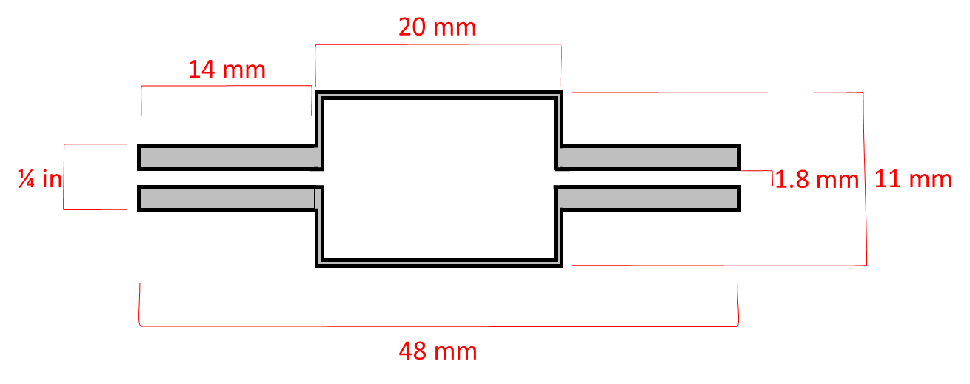
Figure S1. UV-illumination chamber

53.8 mm
20 mm
Image S1. Positioning of the UV pen lamp and the chamber

S1.2 Precursors
Precursors for compunds [¹¹C]1-5 and [¹¹C]sorafenib were purchased from Sigma-Aldrich.

S1.2.1 Thymine precursor
[2-¹¹C]Thymine precursor (Z)-β-(N-benzoylamino)methacrylamide (1) was synthesised and characterised according to a previously published method. (3) ¹H-NMR (500 MHz, CDCl₃) δ: 1,97 (3H, d, J =1,16 Hz), 5,65 (2H, br s), 7,48 (2H, t, J =7,83 Hz), 7,55 (1H, t, J =7,70 Hz), 7,58 (1H, d, J =7,70 Hz), 7,95 (2H, d, J =7,17 Hz), 12,2 (1H, br,d)

S1.3 Model molecule references
The references for labelled compounds [¹¹C]2-5 were synthesised. The syntheses and characterisations were done according to Jacobsen et al. (1-2). Reference for [¹¹C]sorafenib and [2-¹¹C]thymine were purchased from Sigma-Aldrich.

S1.3.1 1-benzyl-3-(4-fluorophenyl)urea
¹H-NMR (500 MHz, DMSO-d₆) δ: 4.30 (2H, d, J = 6.0 Hz), 6.62 (1H, t, 5.7 Hz), 7.22 - 7.26 (1H, m), 7.29 - 7.32 (2H, m), 7.39 - 7.43 (2H, m), 8.60 (1H,s)

S1.3.2 1-benzyl-3-phenylurea
¹H-NMR (500 MHz, DMSO-d₆) δ: 4.30 (2H, d, 6.0 Hz), 6.59 (1H t, J = 5.9 Hz), 6.89 (1H, t, J = 7.4 Hz), 7.26-7.20 (3H, m), 7.33-7.28 (4H, m), 7.41-7.39 (2H, m), 8.65 (1H, s)

S.1.3.3 1-benzyl-3-(4-iodophenyl)urea
¹H-NMR (500 MHz, DMSO-d₆) δ: 4.30 (2H, d, J = 5.9 Hz), 6.67 (1H, t, J = 5.8 Hz), 7.35 - 7.24 (7H, m), 7.54 (2H, d, J = 8.8 Hz), 8.68 (1H, s)

S.1.3.4 3,4-dihydroquinazolin-2(1H)-one
¹H-NMR (500 MHz, DMSO-d₆) δ: 4.30 (2H, s), 6.74-6.79 (2H, m), 6.85 (1H, ddd, J = 7.5 Hz), 7.07 (1H, d, J = 7.5 Hz), 7.10 (1H, dd, J = 7.5Hz), 8.99 (1H, s)

S2. Radiosyntheses

S2.1 [¹¹C]Phosgene synthesis
The synthesis steps are presented in Table S1.

Table S1. The synthesis steps.
Step | Synthesis step | Explanation
1 | [¹¹C]CO₂ collection | The collection is started by opening valves V1, V2 and opening the mass flow controller to 100%. The [¹¹C]CO₂ is collected into a stainless-steel loop submerged into a liquid nitrogen. The collection is followed from the trends of the yellow GM tube (Figure 1 B) and flow value from the mass flow controller. The collection is considered complete once the GM-tube trend is stabilised and flow value of the mass flow controller is < 10.
2 | Release of [¹¹C]CO₂ | By lifting the trap from the liquid nitrogen and letting it warm at room temperature the [¹¹C]CO₂ is released. Valve V3 is directed to reaction vial 1 and valve V4 is directed into the GC column.
3 | [¹¹C]CO formation | The reduction of the [¹¹C]CO₂ to [¹¹C]CO is conducted as previously described Taddei et al.^{[1]} The formation of [¹¹C]CO is followed from blue GM tube (Figure 1) next to the reaction vial 1. The produced [¹¹C]CO is loaded directly onto a GC column. The formation of [¹¹C]CO is completed once the blue GM-tube has peaked and stabilised.
4 | GC purification | GC purification of [¹¹C]CO is started by turning V4. The purification is performed at 100 °C with a flow of 120 ml/min. Purification is monitored by a GM tube (red) situated at the outlet of the GC column. At the start of the purification, the [¹¹C]CO collection trap is pre-cooled by lowering to it into liquid nitrogen to ensure efficient trapping
5 | Trapping the purified [¹¹C]CO | When the count rate of the red GM tube starts to increase after the first radioactivity peak has passed (Figure 1), the [¹¹C]CO is collected into a stainless-steel trap filled with silica by turning the valve V5. The collection is monitored from the black GM tube (Figure 1) placed next to the trap. When the black and red GM tubes (Figure 1) indicate that all the [¹¹C]CO is collected, the helium flow is directed to the waste from V5 ending the collection.
6 | Release of [¹¹C]CO | To release the [¹¹C]CO from the trap, the trap is heated for 1.5 min in a warm H₂O bath. The Cl₂ gas in Ne is released from the gas mixing system (V6), pushing the gas mixture into a UV-illumination chamber.
7 | [¹¹C]phosgene formation | The gas mixture of Cl₂ and [¹¹C]CO is illuminated with UV for 1-7 min forming [¹¹C]phosgene.
8 | Release of [¹¹C]phosgene | Valve V8 is directed towards the reaction vial 2. The [¹¹C]phosgene formed is released for further reactions by opening the valve V7. After the [¹¹C]phosgene bubbling, the He-flow is directed to the reaction vessel 2 by opening the V5.

S3. Calculations and definitions

S3.1 Determination of molar activity for [¹¹C]1
The molar activity of [¹¹C]1 was calculated by analytical HPLC. The calibrated UV absorbance response was used to quantify the injected amount of N,N’-diphenylurea in relation to its associated radioactivity. The molar activity value was decay-corrected to EOB.

S3.2 Iodometric titration
The gas mixing system was filled with a known pressure of 1% or 10 % chlorine in Neon gas. The mixing system was opened to the UV illumination chamber, and the pressure was allowed to equilibrate for 1 minute. Once equilibrated, the gas mixture from the illumination chamber was bubbled to a 1 mL of 1M KI solution turning the solution dark brown. The chamber was flushed for 30 seconds with helium. A solution of 0.01M Na₂S₂O₃ was added until the solution turned pale yellow. 0.5 mL of starch indicator was added and the mixture was further titrated with 0.01M Na₂S₂O₃. The amount of Cl₂ gas was calculated from the total amount of Na₂S₂O₃ used for titration.

S4. Analytical data

S4.1 GC analysis
The unpurified [¹¹C]CO was analysed (figure S2) using GOW-MAC gas chromatograph (69-152) equipped with a series 152 thermal conductivity detector and a 2 × 2-inch NaI radioactivity detector.
Figure S2. Chromatogram of two separate GC analysis. The thermal conductivity peak between 0-1 minute is air, The radioactivity peak 0-1 min is nitrogen-13 species and the peak 1-2.5 min is [¹¹C]CO. Radioactivity detector is saturated due to the high activity amount of the [¹¹C]CO.

S4.2 General HPLC methods and retention times

Column A: Phenomenex Luna C5, 5 μm, 4.6 x 150 mm
Column B: Waters SunFire C18, 5 μm, 4.6 × 150 mm
Column C: Waters SunFire C18, 5 μm, 4.6 × 250 mm
Column D: Waters Atlantis dC18, 5 μm, 3.9 x 150 mm

System A: 1.5 ml/min 50 % MeOH in H₂O
System B: 1.0 ml/min 70 % ACN in H₂O
System C: 1.0 ml/min. 50 % ACN in H₂O
System D: 1.0 ml/min 24% ACN in H₂O
System E: 1.0 ml/min 10 % ACN in H₂O (0-1 min); 10-70% (1-5 min); 70 % (5-10 min); 70-10 % (10-15 min)
System F: 1.0 ml/min 2% EtOH in H₂O
System G: 1.0 ml/min. 60/40 0.1% TFA ACN/0.1 % TFA in H₂O

Table S2. The used conditions for the HPLC analysis and the retention times (R_{t}) of the compounds.
Compound | Column | System | Rt (min)
N,N’-diphenylurea | A | A | 5.57
1-benzyl-3-(4-fluorophenyl)urea | D | B | 5.14
1-benzyl-3-phenylurea | D | E | 4.53
1-benzyl-3-(4-iodophenyl)urea | D | C | 11.26
3,4-dihydroquinazolin-2(1H)-one | B | D | 5.40
Thymine | D | F | 5.89
Sorafenib | B | G | 7.49

S4.3 Chromatograms from radiosyntheses

S4.3.1 [¹¹C]N,N’-diphenylurea ([¹¹C]1)

Detector 2
Rention Time | Area | Area%
1.96 | 2286824 | 1.72
2.97 | 6225513 | 4.68
5.51 | 124533237 | 93.60

Figure S3: Reaction scheme, HPLC chromatogram of the reaction mixture of the labelled product, R_{t} 5.57 min.

S4.3.2 [¹¹C]-1-benzyl-3-(4-fluorophenyl)urea ([¹¹C]2)

Detector 2
Rention Time | Area | Area%
2.16 | 5654353 | 7.47
5.27 | 68964285 | 91.15
6.82 | 1040692 | 1.38
Figure S4: Reaction scheme, HPLC chromatogram of the reaction mixture of the labelled product, R_{t} 5.14 min.

S4.3.3 [¹¹C]1-benzyl-3-phenylurea ([¹¹C]3)

Detector 2
Rention Time | Area | Area%
2.17 | 45397719 | 61.70
4.67 | 28182610 | 38.30
Figure S5: Reaction scheme, HPLC chromatogram of the reaction mixture of the labelled product, R_{t} 4.53 min.

S4.3.4 [¹¹C]-1-benzyl-3-(4-iodophenyl)urea ([¹¹C]4)

Detector 2
Rention Time | Area | Area%
2.16 | 25715533 | 40.24
11.28 | 38186755 | 59.76
Figure S6: Reaction scheme, HPLC chromatogram of the reaction mixture of the labelled product, R_{t} 11.26 min.

S4.3.4 [¹¹C]3,4-dihydroquinazolin-2(1H)-one ([¹¹C]5)

Detector 2
Rention Time | Area | Area%
2.56 | 59135463 | 61.94
5.56 | 36338000 | 38.06
Figure S7: Reaction scheme, HPLC chromatogram of the reaction mixture of the labelled product, R_{t} 5.40 min.

S4.3.5 [2-¹¹C]Thymine

Detector 2
Rention Time | Area | Area%
2.74 | 10141276 | 39.11
4.76 | 447305 | 1.73
5.82 | 11124411 | 42.90
6.29 | 1524582 | 5.88
6.74 | 755649 | 2.91
8.34 | 1493410 | 5.76
13.26 | 441822 | 1.70
Figure S8: Reaction scheme, HPLC chromatogram of the reaction mixture of the labelled product, R_{t} 5.89 min.

S4.3.6 [¹¹C]Sorafenib

Detector 2
Rention Time | Area | Area%
4.01 | 108733524 | 83.31
5.96 | 99196 | 0.08
7.56 | 21683164 | 16.61
Figure S9: Reaction scheme, HPLC chromatogram of the reaction mixture of the labelled product, R_{t} 7.49 min.

5. NMR-data

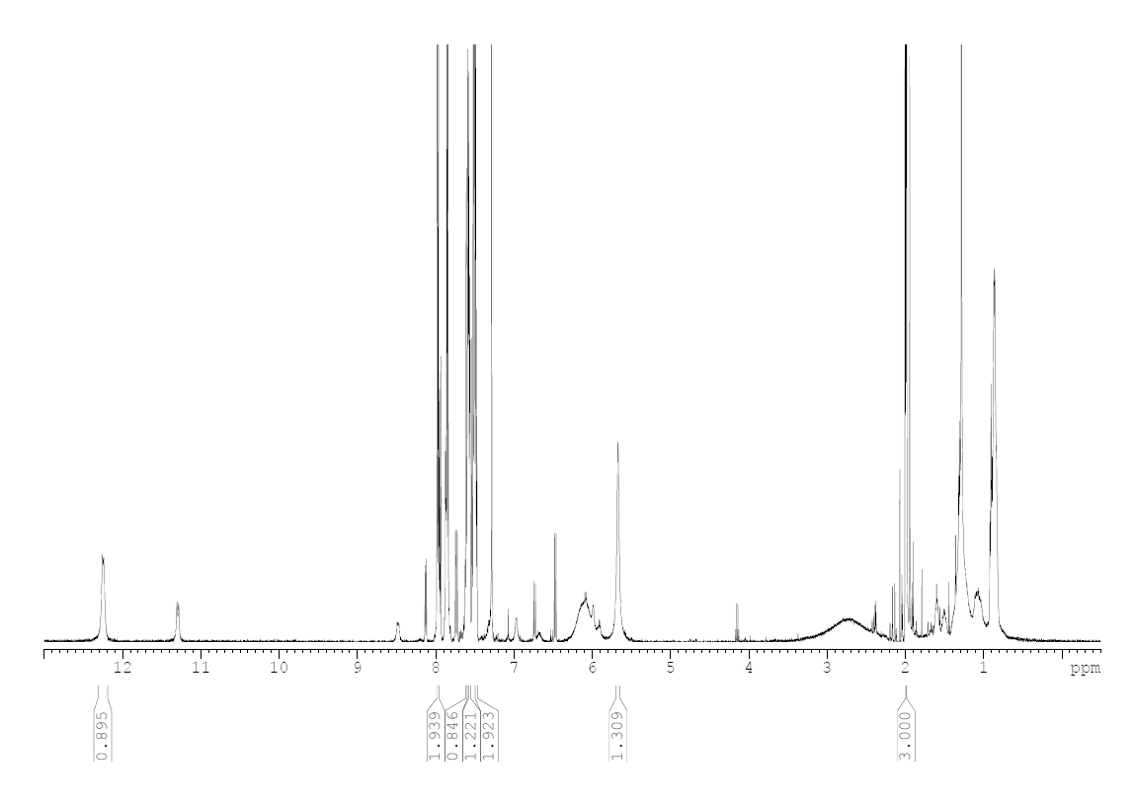
Figure S10. NMR-spectrum of (Z)-β-(N-benzoylamino)methacrylamide

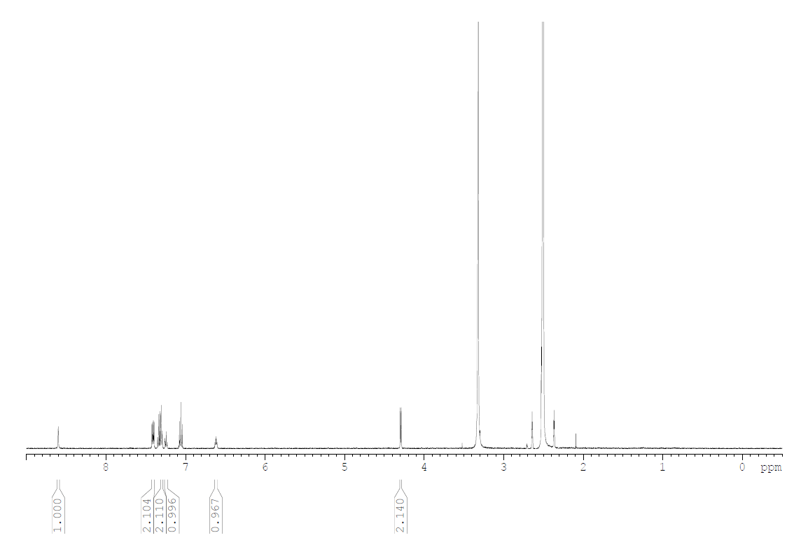
Figure S11. NMR-spectrum of 1-benzyl-3-(4-fluorophenyl)urea.

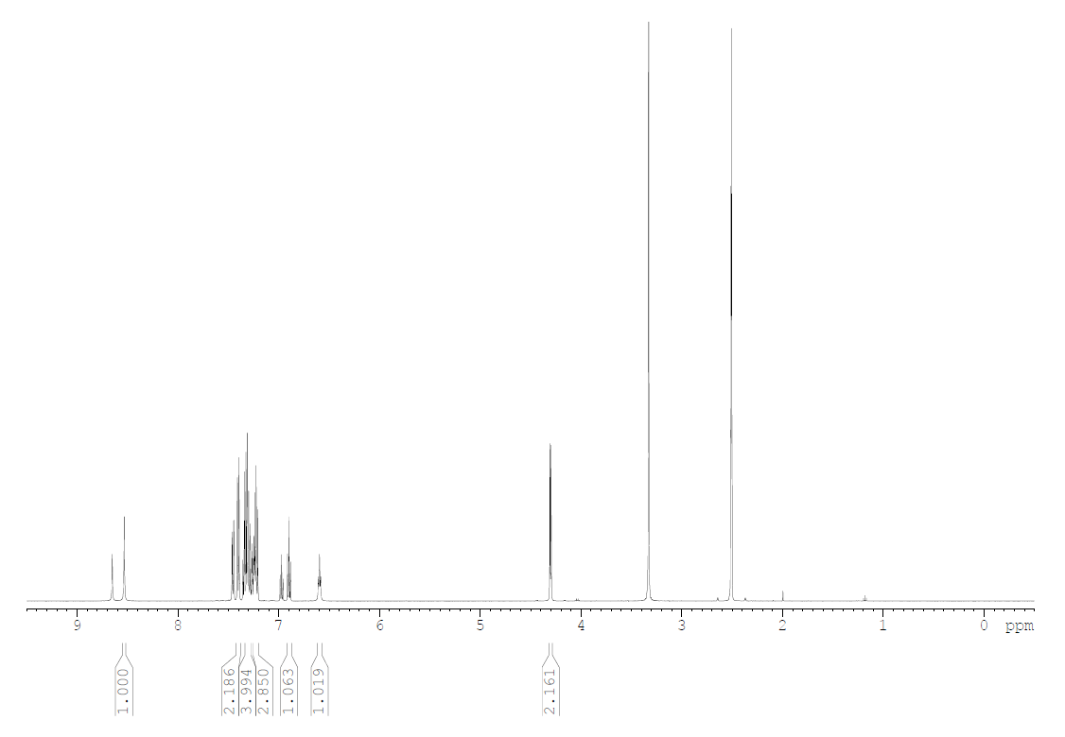
Figure S12. NMR-spectrum of 1-benzyl-3-phenylurea.
´

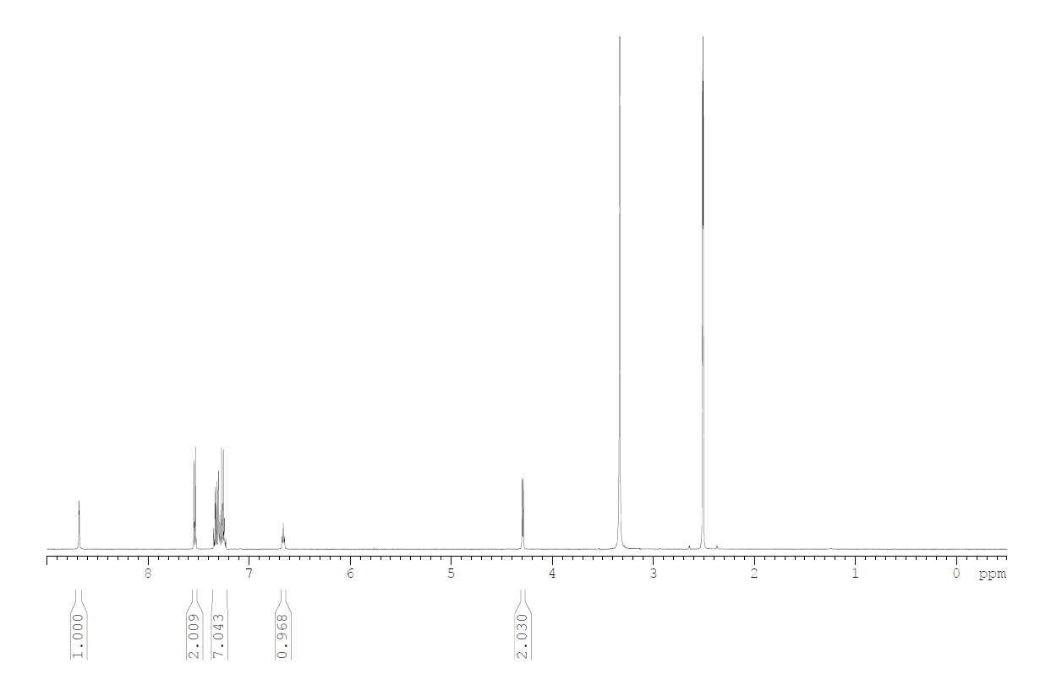
Figure S13. NMR-spectrum of 1-benzyl-3-(4-iodophenyl)urea.

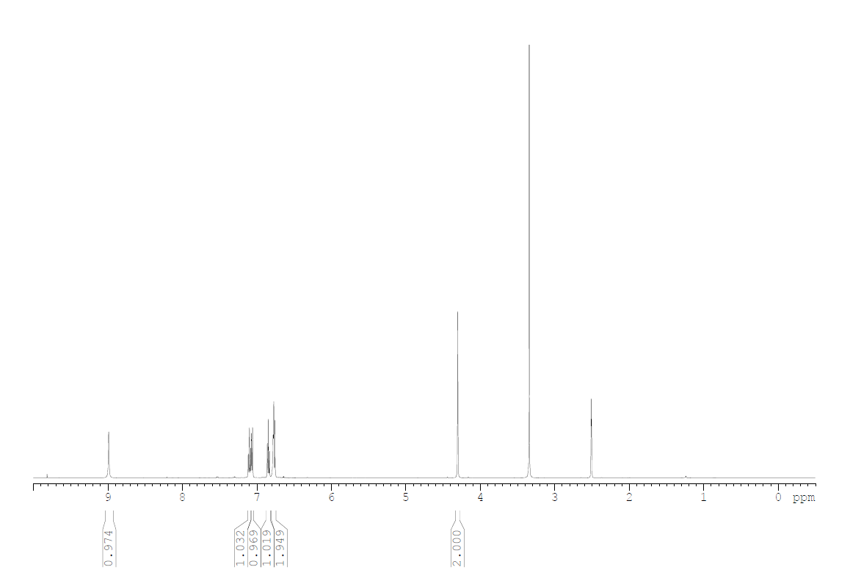
Figure S14. NMR-spectrum of 3,4-dihydroquinazolin-2(1H)-one

