Latent class analysis-derived classification improves the cancer-specific death Risk Stratification of Lung Cancer
Shangping Fang¹† , Xiaoyu Tang²† , Huan Li¹ , Xiaoying Wang¹ , Xiaolin Yang² , Jiameng Liu¹ , Miao Zhou⁴* , Yongquan Chen³*

Supplementary materials & methods
Text S1. Derivation of Classification Based on Potential Category Analysis of the Development Set .
Text S2. Clinical Utility of Latent Class Analysis Derived Categories Based on the Development Set in Patients with LC (Supplementary).
Text S3. Comparison of demographic and clinical pathological characteristics of lung cancer patients in the development set and the validation set (Supplementary).
Text S4. External validation of latent class Analysis derived classification based on validation set in LC patients.

Supplementary tables
Table S1. Demographic and clinicopathological characteristics of LC patients in the development set .
Table S2. Comparison of demographic and clinicopathological characteristics of LC patients between the development and validation sets.
Table S3. Latent class analysis model fit assessment in the development set.
Table S4. LCA-derived classifications of LC patients in the development set.
Table S5. Survival analyses in LCA-derived classifications under different treatment modalities based on development set.
Table S6. Latent class analysis model fit assessment in the validation set.
Table S7. LCA-derived classifications of LC patients in the validation set(SEER 17 database).

Supplementary figures
Figure S1. Based on age, race, tumor location, stage and pathological type, a forest plot was drawn to show the overall survival and cause-specific mortality risk ratios of the patients based on development set.
Figure S2. Trend of the proportion of cause of deaths in each class for age groups based on development set.
Figure S3. Trend of the proportion of cause of deaths in each class for stage I to stage IV based on development set.
Figure S4. Probabilities of indicator variables in each identified LCA-derived classifications based on validation set.
Figure S5. Survival analyses of LCA-Derived classifications in LC patients based on validation set.
Figure S6. Forest plots for survival analyses of different therapies (radiotherapy and/or chemotherapy) in LC patients, stratified by LCA-derived classifications on validation set.

Text S1. Derivation of Classification Based on Potential Category Analysis of the Development Set.
The specific composition of each category was as follows (Table S4) : LCA1 patients were mainly in early stage (stage I accounted for 51.89%), white (87.36%), and non-small cell lung cancer (99.04%). Late LCA2 (stage IV accounted for 82.52%), elderly (over 75 years old accounted for 72.75%) and Asian/Pacific Islander (49.57%) accounted for a relatively high proportion. In LCA3, there were no white patients, but the proportion of black patients was prominent (59.12%), and the tumors were more common in the upper lobe (74.26%). Patients with LCA4 had a higher proportion of small cell lung cancer (43.86%), primary tumors of the main bronchus (16.53%) and advanced stage (stage IV, 80.87%). These characteristic distributions suggest distinct patterns of risk. LCA2 patients with advanced stage, distant metastasis (M1 accounted for 82.53%) and advanced age had the highest risk of lung cancer specific death. On the contrary, LCA1 patients were mostly at early stage, without metastasis (M0 accounted for 81.91%), and received surgical treatment (98.27%), and the predicted risk of lung cancer related death was the lowest. In terms of non-lung cancer specific mortality, LCA1 and LCA4 may face higher risks of other mortality, especially the latter is associated with more aggressive small cell lung cancer and special tumor location. Although patients with LCA3 were at locally advanced stage (stage III-IV accounted for a high proportion), their risk of non-lung cancer mortality was relatively low.
Text S2. Clinical Utility of Latent Class Analysis Derived Categories Based on the Development Set in Patients with LC (Supplementary).
Preoperative systemic therapy significantly improved overall survival for all LCA subtypes. Preoperative radiotherapy increased the OS of LCA1 and LCA2 patients, but postoperative radiotherapy decreased the OS of LCA2 patients. In terms of cancer-specific mortality, surgery did not reduce the cancer-related and non-cancer-related mortality of LCA2, but the other subtypes had significant reductions in cancer-related and non-cancer-related mortality. Radiotherapy increases the risk of cancer-specific mortality in patients with LCA1 to LCA3, but has no significant effect on non-cancer-specific mortality. Chemotherapy was associated with a higher risk of cancer-specific death in LCA1 and LCA3, but was associated with a lower risk of non-cancer-specific death in LCA1 and LCA2. Preoperative systemic therapy generally reduced the risk of cancer-specific death in all patients with LCA, and the risk of non-cancer-specific death was also reduced in patients with LCA1. Postoperative systemic therapy may increase the risk of cancer-specific death, but reduce the risk of non-cancer-specific death in LCA3 patients. For patients with LCA2, preoperative and postoperative systemic therapy can reduce cancer-specific mortality, but significantly increase the risk of non-cancer-specific mortality. Preoperative radiotherapy can reduce the risk of cancer-specific death in patients with LCA2, while postoperative radiotherapy may increase the risk. In addition, preoperative radiotherapy also reduced the risk of non-tumor-specific death in patients with LCA1. (Table S5)
Text S3. Comparison of demographic and clinical pathological characteristics of lung cancer patients in the development set and the validation set (Supplementary).
The Development Set included 74107 patients with primary LC (Table S1). The patients with annual household income between 80 thousand and 99 thousand US dollars were relatively concentrated (47.28% in total), and 34.97% were in T1 stage, and 49.37% were in N0 lymph node metastasis. In terms of treatment options, most patients did not receive surgery (96.82%), while 38.92% and 39.45% of them received radiotherapy and chemotherapy, respectively. The A/B of the Breslow method was 1.187 (95%CI: 1.167-1.207), and the A/B of the Log-rank method was 1.182 (95%CI: 1.167-1.207). 1.163-1.202) showed that the overall mortality was 18%-19% higher than lung cancer specific mortality, and the 95% confidence interval did not include 1, the difference was statistically significant.
The external validation set included 112976 patients with primary LC, with a slightly higher proportion of T4 to N2 stages. Patients with annual household income less than US $70,000 accounted for 63.87%, indicating that the cohort was dominated by low-income groups. In terms of treatment, the proportion of patients receiving radiotherapy was slightly higher than that in the development dataset (41.00%), while the proportion of surgery and chemotherapy was 3.37% and 39.90%, respectively, which were similar to those in the development dataset. The A/B ratio calculated by the Breslow method was 1.194 (95%CI: 1.178-1.210), and the A/B ratio calculated by the Log-rank method was 1.188 (95%CI: 1.173-1.204), which indicated that the overall mortality was significantly higher than that of lung cancer specific mortality, and the 95% confidence interval did not include 1, the difference was statistically significant.
Comparing the two datasets, the proportion of white patients in the validation set was significantly higher, while the proportion of Asian or Pacific Islander patients was significantly lower. Patients with annual household income of less than $70,000 were more concentrated. In terms of clinical characteristics, the proportion of patients in stage III was higher and the proportion of patients in stage IV was slightly lower in the validation cohort. There was a slight increase in the proportion receiving radiotherapy. Other characteristics, including age distribution, partial T/N staging, and the proportion of surgery and chemotherapy, showed relatively small differences between the two groups, and the overall distribution was similar. (Table S2)

Text S4. External validation of latent class Analysis derived classification based on validation set in LC patients.
An external spatial validation set (SEER 17 database) was used to evaluate the latent class analysis-derived classification of the validation set. The results showed that the four-category model fitted the best, with BIC of 881079.546 and SaBIC of 880904.754, and the minimum sample ratio of 10.825%. Survival differences between derived categories were analyzed based on latent classes of the validation set(Figure. S4).
Kaplan-Meier survival curves derived from different latent class analysis showed that there were significant differences in overall survival between pairs of LCA1 and LCA3 (Figure. S5A), with a median survival of 7 for LCA1, 49 for LCA2, and 9 for LCA3, respectively. The median survival time of LCA4 patients was 23. Analysis with a Cox proportional-hazards model (Figure S5A-D) showed that LCA1 had the highest risk of death from any cause.The forest plot (Figure S5E) quantified the hazard ratio (HR) for each subtype using LCA1 as the reference group. In the overall survival analysis, LCA2 (HR=0.262, 95%CI: 0.256-0.267, P<0.001), LCA3 (HR=0.949, 95%CI: 0.929-0.970, P<0.001), LCA4 (HR=0.482, 95%CI: 0.468-0.497, P<0.001) were significantly lower than those in LCA1. For LC and nonLC endpoints, the HR of each subtype was also significantly less than 1 (P<0.001), which further confirmed that LCA1 was a high-risk subtype, while LCA2, LCA3 and LCA4 were low-risk subtypes.
The forest plots and summary tables further analyzed the prognostic effects of chemotherapy, radiotherapy, and chemoradiotherapy in different LCA subtypes (Figure S6). In the LCA1 subtype, all treatments significantly reduced the risks of OS, LC, and nonLC (HR<1, P<0.001), among which chemoradiotherapy had the greatest risk reduction (OS: HR=0.349, P<0.001). In patients with LCA2 subtype, chemotherapy and radiotherapy reduced the risk of LC, but the combination of radiotherapy and chemotherapy significantly increased the risk of OS (HR=1.503, 95%CI: 1.449-1.560, P<0.001). In the LCA3 subtype, all treatments could significantly reduce the risk of three types of endpoint events (HR<1, P<0.001). In the LCA4 subtype, the combination of chemotherapy and chemoradiotherapy reduced the risk of some endpoints, but the effect of radiotherapy on overall survival was only marginally significant (P=0.020).
These results suggest that LCA subtypes can be used as biomarkers to predict treatment response and provide more precise and individualized treatment for patients.

Table S1. Demographic and clinicopathological characteristics of LC patients in the development set (SEER 12 database).
Characteristics |  | Overall (%) | Death (%) | Death from  LC (%) | Death from  non-LC (%)
N |  | 74107(100.00) | 36713（49.54） | 27959（37.73） | 8754（11.82）
Age
 | 18to49 | 1923(2.60) | 642(1.75) | 539(1.93) | 103(1.18)
 | 50to74 | 44416(59.93) | 20096(54.74) | 15723(56.24) | 4373(49.95)
 | 75.and.above | 27768（37.47) | 15975(43.51) | 11697(41.83) | 4278（48.87)
Gender
 | Female | 38187(51.53) | 17036(46.40) | 13096(46.84) | 3940（45.01）
 | Male | 35920(48.47) | 19677(53.60) | 14863(53.16) | 4814（54.99）
Race
 | White | 56131(75.74) | 27883(75.95) | 21134(79.59) | 6749（77.10）
 | Black | 7154(9.65) | 3857(10.50) | 2837(10.15) | 1020（11.65）
 | American Indian/Alaska Native | 814(1.10) | 505(1.38) | 418(1.50) | 87（0.99）
 | Asian or Pacific Islander | 10008(13.51) | 4468(12.17) | 3570(12.76) | 898（10.26）
Cancer location
 | Main bronchi | 2806（3.80） | 2005（5.46） | 1679（6.01） | 326（3.72）
 | Up. lobe | 42502（57.35） | 20779（56.60） | 15756（56.35） | 5023（57.38）
 | Mid. lobe | 4027（5.43） | 1788（4.87） | 1330（4.76） | 458（5.23）
 | Low. lobe | 23984（32.36） | 11638（31.70） | 8786（31.42） | 2852（32.58）
 | Overlap. pulm. lesions | 788（1.06） | 503（1.37） | 408（1.46） | 95（1.09）
Stage
 | Stage.I | 23663(31.93) | 4878(13.29) | 2275(8.14) | 2603（29.74）
 | Stage.II | 6356(8.58) | 2174(5.92) | 1448(5.18) | 726(8.29)
 | Stage.III | 13277(17.91) | 6948(18.92) | 5327(19.05) | 1621(18.52)
 | Stage.IV | 30811(41.58) | 22713（61.87） | 18909(67.63) | 3804(43.45)
Classification
 | SCLC | 7089（9.57） | 5263（14.34） | 4427（15.83） | 836（9.55）
 | NSCLC | 67018（90.43） | 31450（85.66） | 23532（84.17） | 7918（90.45）
Martial
 | Married | 37260（50.28） | 17089（46.55） | 13121(46.93) | 3968（45.32）
 | Unmarried | 34596（46.68） | 18333（49.93） | 13859(49.47) | 4474（51.11）
 | Unknown | 2251（3.04） | 1291（3.52) | 979(3.50) | 312（3.67）
Household Income
 | < $70,000 | 31278（42.21） | 15176（41.34） | 11583(41.43) | 3593（41.04）
 | $70,000 - $79,999 | 7790（10.51） | 4137（11.26） | 3092(11.06) | 1045（11.94）
 | $80,000 - $89,999 | 24629（33.23) | 12372（33.70） | 9495(33.96) | 2877（32.87）
 | $90,000 - $99,999 | 10409(14.05) | 5028（13.70） | 3789(13.55) | 1239（14.15）
 | Unknown | 1(0.00) | 0（0.00） | 0(0.00) | 0（0.00）
Rural
 | ge1Mmetro | 46137（62.26） | 22272（60.68） | 17086(61.11) | 5186（59.24）
 | 250,000 to 1Mmetro | 14719（19.86） | 7156（19.50） | 5345(19.12) | 1811（20.69）
 | lt250,000Metro | 4086（5.51） | 2202（5.99） | 1678(6.00) | 524（5.99）
 | Nonmetropolitan counties | 8832（11.92） | 4868（13.26） | 3660(13.09) | 1208（13.80）
 | Unknown | 333（0.45） | 215（0.57） | 190(0.68) | 25（0.28）
T
 | T0 | 32（0.04） | 22（0.06） | 20(0.07) | 2(0.02)
 | T1 | 25913（34.97） | 7689（20.94） | 4637(16.58) | 3052(34.86)
 | T2 | 15922（21.48） | 7392（20.13） | 5498(19.66) | 1894(21.64)
 | T3 | 10631（14.35） | 6038（16.45） | 4832（17.29） | 1206(13.78)
 | T4 | 16532（22.31） | 11620（31.66） | 9701（34.70） | 1919(21.92)
 | TX | 5077（6.85） | 3952（10.76） | 3271（11.70） | 681(7.78)
N
 | N0 | 36585（49.37） | 12066（32.87） | 7702（27.55） | 4364(49.85)
 | N1 | 5730（7.73） | 2909（7.92） | 2275（8.14） | 634(7.24)
 | N2 | 18848（25.43） | 12454（33.92) | 10212（36.52） | 2242(25.61)
 | N3 | 9769（13.18） | 6693(18.23) | 5670（20.28） | 1023(11.69)
 | NX | 3175（4.29） | 2591(7.06) | 2100(7.51) | 491(5.61)
M
 | M0 | 43296（58.43） | 14000(38.13) | 9050(32.37) | 4950(56.55)
 | M1 | 30811（41.57） | 22713(61.87) | 18909(67.63) | 3804(43.45)
Surg_prim
 | No_surgery | 71753（96.82） | 35368(96.33) | 26864(96.08) | 8504(97.14)
 | Surgery | 2354（3.18） | 1345(3.67) | 1095(3.92) | 250(2.86)
Radiation
 | No_radiation | 67279（90.79） | 32909(89.64) | 24913(89.10) | 7996(91.35)
 | Radiation | 6828（9.21） | 3804(10.36) | 3046(10.89) | 758(8.65)
Chemotherapy
 | No_chemotherapy | 44870（60.55） | 21754(59.25) | 15526(55.53) | 6228(71.14)
 | Chemotherapy | 29237（39.45） | 14959(40.75) | 12433(44.47) | 2526(28.86)
Surg_sys
 | None | 62814（84.76) | 31741(86.47) | 23874(85.39) | 7867(89.87)
 | SysPri | 591(0.80) | 159(0.43) | 123(0.44) | 36(0.41)
 | SysIntra | 5（0.01） | 1(0.00) | 1(0.00) | 0(0.00)

Table S2. Comparison of demographic and clinicopathological characteristics of LC patients between the development and validation sets.
Characteristics |  | Development Set (%) | Validation Set ((%) | P value
N |  | 74107 | 112976
Age
 | 18to49 | 1923(2.60) | 2672(2.37) | <0.0001****
 | 50to74 | 44416(59.93) | 71402(63.20) | <0.0001****
 | 75.and.above | 27768（37.47) | 38902(34.43) | <0.0001****
Gender
 | Female | 38187(51.53) | 56545(50.05) | <0.0001****
 | Male | 35920(48.47) | 56431(49.95) | <0.0001****
Race
 | White | 56131(75.74) | 94266(83.44) | <0.0001****
 | Black | 7154(9.65) | 13053(11.55) | <0.0001****
 | American Indian/Alaska Native | 814(1.10) | 522(0.46) | <0.0001****
 | Asian or Pacific Islander | 10008(13.51) | 5135(4.55) | <0.0001****
Cancer location
 | Main bronchi | 2806（3.80） | 4900（4.34) | <0.0001****
 | Up. lobe | 42502（57.35） | 66286(58.67) | <0.0001****
 | Mid. lobe | 4027（5.43） | 5583(4.94) | <0.0001****
 | Low. lobe | 23984（32.36） | 34873(30.87) | <0.0001****
 | Overlap. pulm. lesions | 788（1.06） | 1334(1.18) | <0.0001****
Stage
 | Stage.I | 23663(31.93) | 33928(30.03) | <0.0001****
 | Stage.II | 6356(8.58) | 10178(9.01） | <0.0001****
 | Stage.III | 13277(17.91) | 22841（20.22） | <0.0001****
 | Stage.IV | 30811(41.58) | 46029（40.74） | <0.0001****
Classification
 | SCLC | 7089（9.57） | 13193(11.68) | <0.0001****
 | NSCLC | 67018（90.43） | 99783(88.32) | <0.0001****
Martial
 | Married | 37260（50.28） | 54803(58.51) | 0.007**
 | Unmarried | 34596（46.68） | 54329(48.09) | 0.007**
 | Unknown | 2251（3.04） | 3844(3.40) | 0.007**
Household Income
 | < $70,000 | 31278（42.21） | 72147(63.87) | <0.0001****
 | $70,000 - $79,999 | 7790（10.51） | 13073(11.58) | <0.0001****
 | $80,000 - $89,999 | 24629（33.23) | 18808(16.65) | <0.0001****
 | $90,000 - $99,999 | 10409(14.05) | 8947(7.90) | <0.0001****
 | Unknown | 1(0.00) | 1(0.00) | <0.0001****
Rural
 | ge1Mmetro | 46137（62.26） | 56899(50.37) | <0.0001****
 | 250,000 to 1Mmetro | 14719（19.86） | 24462(21.65) | <0.0001****
 | lt250,000Metro | 4086（5.51） | 11662(10.32) | <0.0001****
 | Nonmetropolitan counties | 8832（11.92） | 19952(17.66) | <0.0001****
 | Unknown | 333（0.45） | 1(0.00) | <0.0001****
T
 | T0 | 32（0.04） | 45（0.04） | <0.0001****
 | T1 | 25913（34.97） | 38088（33.72） | <0.0001****
 | T2 | 15922（21.48） | 24987(22.12) | <0.0001****
 | T3 | 10631（14.35） | 17241(15.26) | <0.0001****
 | T4 | 16532（22.31） | 26310(23.28) | <0.0001****
 | TX | 5077（6.85） | 6305(5.58) | <0.0001****
N
 | N0 | 36585（49.37） | 55129(48.80) | <0.0001****
 | N1 | 5730（7.73） | 9443（8.36） | <0.0001****
 | N2 | 18848（25.44） | 31405（27.80） | <0.0001****
 | N3 | 9769（13.18） | 13789（12.20） | <0.0001****
 | NX | 3175（4.28） | 3210（2.84） | <0.0001****
M
 | M0 | 43296（58.43） | 66947（45.26） | 0.0003***
 | M1 | 30811（41.57） | 46029（40.74） | 0.0003***
Surg_prim
 | No_surgery | 71753（96.82） | 109173(96.63) | 0.0245*
 | Surgery | 2354（3.18） | 3803（3.37） | 0.0245*
Radiation
 | No_radiation | 45265(61.08) | 66658（59.00） | <0.0001****
 | Radiation | 28842(38.92) | 46318（41.00） | <0.0001****

Table S3. Latent class analysis model fit assessment in the development set
 | AIC | BIC | SaBIC | Entrony | LMR（p） | Class Probability
1 | 608222.813 | 608342.586 | 608301.271 | 1 | - | 1
2 | 602112.808 | 602361.566 | 602275.759 | 0.484 | <0.0001 | 0.12580/0.87420
3 | 600881.168 | 601258.912 | 601128.613 | 0.461 | <0.0001 | 0.12073/0.12464/0.75463
4 | 600385.382 | 600892.112 | 600717.32 | 0.471 | <0.0001 | 0.60746/0.10270/0.08516/0.20468
5 | 600198.804 | 600834.519 | 600615.235 | 0.452 | 0.0078 | 0.40274/0.11741/0.07755/0.05685/0.34545
Note: AIC, Akaike Information Criterion; BIC, Bayesian Information Criterion; SaBIC, Sample size-adjusted BIC;Entrony,A physical quantity that measures the degree of disorder and chaos in a system;LMR (p), Lo–Mendell–Rubin likelihood ratio test (p-value); Class Probability, estimated class proportion for each subgroup.

Table S4. LCA-derived classifications of LC patients in the development set
Characteristics |  |  | overall | Latent Class 1 | Latent Class 2 | Latent Class 3 | Latent Class 4
N |  |  | 74107（100.0） | 45017(60.75) | 7611（10.27） | 6311(8.52) | 15168(20.47)
Age
 | 18to49 |  | 1923(2.60) | 308(0.68) | 1177（15.46） | 305(4.84) | 133(0.87)
 | 50to74 |  | 44416(59.93) | 25569（56.80） | 897（11.79） | 5483(86.88) | 12467(82.20)
 | 75+ |  | 27768（37.47) | 19140（42.52） | 5537（72.75） | 523(8.28) | 2568（16.93）
Gender
 | Female |  | 38187(51.53) | 24124（53.59） | 3774（49.59） | 2956（46.84） | 7333（48.35）
 | Male |  | 35920(48.47) | 20893（46.41） | 3837（50.41） | 3355（53.16） | 7835（51.65）
Race
 | White |  | 56131(75.74) | 39327（87.36） | 3570（46.90） | 0(0.00) | 13234（87.25）
 | Black |  | 7154(9.65) | 2409（5.35） | 266（3.50） | 3731(59.12) | 748（4.93）
 | American Indian/Alaska Native |  | 814(1.10) | 284（0.63） | 2（0.03） | 5(0.08) | 523（3.45）
 | Asian or Pacific Islander |  | 10008(13.51) | 2997（6.66） | 3773（49.57） | 2575(40.80) | 663（4.37）
Cancer location
 | Main bronchi |  | 2806（3.80） | 61（0.15） | 217(2.86) | 20(0.33) | 2508（16.53）
 | Up. lobe |  | 42502（57.35） | 25911（57.55） | 1926(25.30) | 4687(74.26) | 9978（65.79）
 | Mid. lobe |  | 4027（5.43） | 2948（6.55） | 204(2.68) | 534(8.47) | 341（2.25）
 | Low. lobe |  | 23984（32.36） | 16072（35.70） | 5015(65.89) | 1067(16.90) | 1830（12.06）
 | Overlap. pulm. lesions |  | 788（1.06） | 25（0.05） | 249(3.27) | 3(0.04) | 511（3.37）
stage
 | stageⅠ |  | 23663(31.93) | 23352（51.89） | 122(1.60) | 184(2，92) | 5（0.03）
 | stageⅡ |  | 6356(8.58) | 5194（11.54） | 459(6.03) | 273(4.33) | 430（2.83）
 | stageⅢ |  | 13277(17.91) | 8329（18.50） | 746(9.80) | 1731(27.42) | 2468（16.27）
 | stageⅣ |  | 30811(41.58) | 8142（18.07） | 6281(82.52) | 4123(65.33) | 12265（80.87）
Classification
 | SCLC |  | 7089（9.57） | 434（0.96） | 2(0.03) | 0(0.00) | 6653(43.86)
 | NSCLC |  | 67018（90.43） | 44583（99.04） | 7609(99.97) | 6133(100) | 8515(56.14)
Martial
 | Married |  | 37260（50.28） | 22895（50.86） | 4193(55.09) | 2877(45.59) | 7295(48.10)
 | Unmarried |  | 34596（46，68） | 20839（46.29） | 3186(41.86) | 3199(50.69) | 7372(48.60)
 | Unknown |  | 2251（3.04） | 1283（2.85） | 232(3.05) | 235(3.72) | 501(3.30)
Household Income
 | < $70,000 |  | 31278（42.21） | 18775（41.71） | 3866(50.79) | 2603(41.24) | 6034(39.78)
 | $70,000 - $79,999 |  | 7790（10.51） | 4782（10.62） | 551(7.24) | 553(8.76) | 1904(12.55)
 | $80,000 - $89,999 |  | 24629（33.23) | 14839（32.96） | 2430(31.93) | 2437(38.62) | 4923(32.46)
 | $90,000 - $99,999 |  | 10409(14.05) | 6620（14.71） | 764(10.04) | 718(11.38) | 2307(15.21)
 | Unknown |  | 1（0.00） | 0（0.00） | 0(0.00) | 0(0.00) | 0(0.00)
Rural
 | ge1Mmetro |  | 46137（62.26） | 26802（59.54） | 5728(75.26) | 5528(87.59) | 8079(53.26)
 | 250,000 to 1Mmetro |  | 14719（19.86） | 9841（21.86） | 953(12.52) | 453(7.18) | 3472(22.89)
 | lt250,000Metro |  | 4086（5.51） | 2652（5.89） | 317(4.17) | 110(1.74) | 1007(6.64)
 | Nonmetropolitan counties |  | 8832（11.92） | 5608（12.46） | 612(8.04) | 219(3.47) | 2393(15.78)
 | Unknown |  | 333（0.45） | 114（0.25） | 1(0.01) | 1(0.02) | 217(1.43)
T
 | T0 |  | 32（0.04） | 7（0.02） | 6(0.08) | 1(0.02) | 18(0.12)
 | T1 |  | 25913（34.97） | 21878（48.60） | 974(12.80) | 994(15.75) | 2067(13.63)
 | T2 |  | 15922（21.48） | 10201（22.66） | 1661(21.82) | 1267(20.08) | 2793(18.41)
 | T3 |  | 10631（14.35） | 5425（12.05） | 1493(19.62) | 1141(18.08) | 2572(16.96)
 | T4 |  | 16532（22.31） | 5955（13.23） | 2424(31.85) | 2324(36.82) | 5829(38.43)
 | TX |  | 5077（6.85） | 1551（3.44） | 1053(13.83) | 584(9.25) | 1889(12.45)
N
 | N0 |  | 36585（49.37） | 30386（67.50） | 2178(28.62) | 1580(25.03) | 2441(16.09)
 | N1 |  | 5730（7.73） | 3172（7.05） | 690(9.07) | 553(8.76) | 1315(8.67)
 | N2 |  | 18848（25.44） | 7517（16.70） | 2534(33.29) | 2514(39.84) | 6283(41.42)
 | N3 |  | 9769（13.18） | 2928（6.50） | 1519(19.96) | 1360(21.55) | 3962(26.12)
 | NX |  | 3175（4.28） | 1014（2.25） | 690(9.06) | 304(4.82) | 1167(7.10)
M
 | M0 |  | 43296（58.43） | 36874（81.91） | 1330(17.47) | 2188(34.67) | 2903(19.14)
 | M1 |  | 30811（41.57） | 8143（18.09） | 6281(82.53) | 4123(65.33) | 12265(80.86)
Surg_prim
 | No_surgery |  | 71753（96.82） | 44236（98.27） | 7264(95.44) | 5934(94.03) | 14319(94.40)
 | Surgery |  | 2354（3.18） | 781（1.73） | 347(4.56) | 377(5.97) | 849(5.60)
Radiation
 | No_radiation |  | 45265(61.08) | 41530（92.25） | 7053(92.67) | 5477(86.78) | 13219(87.15)
 | Radiation |  | 28842(38.92) | 3487（7.75） | 558(7.33) | 834(13.22) | 1949(12.85)
Chemotherapy
 | No_chemotherapy |  | 44870（60.55） | 32350（71.86） | 4095(53.80) | 2649(41.97) | 5776(38.08)
 | Chemotherapy |  | 29237（39.45） | 12667（28.14） | 3516(46.20) | 3662(58.03) | 9392(61.92)
Surg_sys
 | None |  | 62814（84.76) | 38735（86.05） | 6637(87.20) | 4997(79.18) | 12445(82.05)
 | SysPri |  | 591(0.80) | 388（0.85） | 51(0.67) | 89(1.41) | 63(0.42)
 | SysIntra |  | 5（0.01） | 1(0.00) | 1(0.01) | 2(0.03) | 1(0.01)
 | SysAfter |  | 10275（13.86） | 5634(12.52) | 879(11.55) | 1162(18.41) | 2660(17.54)
 | SysBoth |  | 352（0.47） | 232(0.52) | 37(0.49) | 49(0.78) | 34(0.22)
 | Unknown |  | 70（0.10） | 27(0.06) | 6(0.08) | 12(0.19) | 25(0.16)
Surg_rad
 | None |  | 67279（90.80） | 41530(92.25) | 7053(92.67) | 5477(86.78) | 13219(87.15)
 | RadPri |  | 314（0.42） | 141(0.31) | 41(0.54) | 61(0.97) | 71(0.47)
 | RadIntra |  | 104（0.14） | 64(0，15） | 7(0.09) | 14(0.22) | 19(0.13)
 | RadAfter |  | 6360（8.58) | 3256（7.83） | 506(6.65) | 752(11.92) | 1846(12.17)
 | Unknown |  | 50(0.06) | 26（0.06） | 4(0.05) | 7(0.11) | 13(0.08)
Cause of Death
 | Alive |  | 37394（50.46） | 28013（62.23) | 2583(33.94) | 2687(42.58) | 4111(27.10)
 | LC |  | 27959（37.73） | 11689(25.97) | 4115(54.07) | 2902(45.98) | 9253(61.00)
 | nonLC |  | 8754（11.81） | 5315(11.80) | 913(11.99) | 722(11.44) | 1804(11.90)

Table S5. Survival analyses in LCA-derived classifications under different treatment modalities based on development set.
LCAs |  | none | treat | HR.OS  (95%CI) | Pval.OS | HR.LC  (95%CI) | Pval. LC | HR.nonLC  (95%CI) | Pval.nonLC
Surgical
 | LCA1 | 44236 | 781 | 1.424（1.285-1.578） | <0.001 | 1.13（1.008-1.267） | 0.036 | 0.986(0.782-1.245) | 0.909
 | LCA2 | 7264 | 347 | 0.812（0.708=0.931） | 0.003 | 0.884(0.762-1.027) | 0.107 | 0.713(0.508-0.999) | 0.05
 | LCA3 | 5934 | 377 | 0.992（0.865-1.139） | 0.912 | 1.034(0.887-1.205) | 0.669 | 0.961(0.704-.313) | 0.803
 | LCA4 | 14319 | 849 | 0.708（0.650-0.772） | <0.001 | 0.858(0.780-0.945) | 0.002 | 0.696(0.570-0.851) | <0.001
Radiation(fang)
 | LCA1 | 41530 | 3487 | 1.176(1.141-1.213) | <0.001 | 0.686(0.661-0.712) | <0.001 | 1.412(1.337-1.491) | <0.001
 | LCA2 | 7053 | 558 | 1.775(0.730-0.822) | <0.001 | 0.735(0.689-0.785) | <0.001 | 0.646(0.557-0.748) | <0.001
 | LCA3 | 5477 | 834 | 1.771(0.722-0.823) | <0.001 | 0.786(0.730-0.846) | <0.001 | 0.645(0.555-0.751) | <0.001
 | LCA4 | 13219 | 1949 | 0.564(0.543-0.586) | <0.001 | 0.619(0.594-0.646) | <0.001 | 0.434(0.394-0.478) | <0.001
Chemotherapy
 | LCA1 | 32350 | 12667 | 1.177(1.140-1.216) | <0.001 | 0.717(0.691-0.745) | <0.001 | 0.811(0.759-0.866) | <0.001
 | LCA2 | 4095 | 3516 | 0.381(0.360-0.404) | <0.001 | 0.433(0.406-0.462) | <0.001 | 0.246(0.213-0.284) | <0.001
 | LCA3 | 2649 | 3662 | 0.406(0.380-0.433) | <0.001 | 0.451(0.418-0.485) | <0.001 | 0.282(0.243-0.327) | <0.001
 | LCA4 | 5776 | 9392 | 0.345(0.332-0.359) | <0.001 | 0.396(0.379-0.413) | 0 | 0.229(0.208-0.251) | <0.001
Radiation Surgical
Radiation Prior Surgical
 | LCA1 | 41556 | 141 | 0.861(0.657-1.127) | 0.276 | 0.725(0.529-0.993) | 0.045 | 0.737(0.436-1.245) | 0.254
 | LCA2 | 7357 | 41 | 0.417(0.255-0.681) | <0.001 | 0.829(0.507-1.354) | 0.453 | -
 | LCA3 | 5484 | 61 | 0.781(0.554-1.100) | 0.157 | 0.879(0.606-1.276) | 0.497 | 0.580(0.241-1.399) | 0.225
 | LCA4 | 13232 | 71 | 0.666(0.505-0.880) | 0.004 | 0.738(0.541-1.007) | 0.056 | 0.739(0.397-1.376) | 0.34
Radiation After Surgical
 | LCA1 | 41556 | 3256 | 1.138(1.082-1.198) | <0.001 | 0.689(0.649-0.731) | <0.001 | 1.080(0.978-1.192) | 0.127
 | LCA2 | 7357 | 506 | 0.666(0.594-0.747) | <0.001 | 0.684(0.604-0.744) | <0.001 | 0.529(0.392-0.715) | <0.001
 | LCA3 | 5484 | 752 | 0.623(0.560-0.692) | <0.001 | 0.73(0.650-0.820) | <0.001 | 0.481(0.371-0.624) | <0.001
 | LCA4 | 13232 | 1846 | 0.611(0.576-0.648) | <0.001 | 0.653(0.613-0.696) | <0.001 | 0.530(0.454-0.618) | <0.001
Systemic Surgical
Systemic Prior Surgical
 | LCA1 | 38762 | 338 | 0.555（0.451-0.683) | <0.001 | 0.604(0.473-0.771) | <0.001 | 0.464(0.313-0.687) | <0.001
 | LCA2 | 6643 | 51 | 0.224(0.127-0.394) | <0.001 | 0.627(0.356-1.105) | 0.107 | -
 | LCA3 | 5009 | 89 | 0.280(0.184-0.425) | <0.001 | 0.772(0.479-1.244) | 0.287 | 0.228(0.095-0.550) | <0.001
 | LCA4 | 12470 | 63 | 0.458(0.329-0.638) | <0.001 | 0.550(0.382-0.793) | 0.001 | 0.396(0.177-0.882) | 0.023
Systemic After Surgical
 | LCA1 | 38762 | 5634 | 0.781(0.745-0.818) | <0.001 | 0.657(0.623-0.693) | <0.001 | 0.546(0.495-0.602) | <0.001
 | LCA2 | 6643 | 879 | 0.443(0.401-0.489) | <0.001 | 0.548(0.491-0.611) | <0.001 | 0.374(0.296-0.473) | <0.001
 | LCA3 | 5009 | 1162 | 0.447(0.407-0.492) | <0.001 | 0.576(0.516-0.639) | <0.001 | 0.299(0.236-0.380) | <0.001
 | LCA4 | 12470 | 2600 | 0.555(0.527-0.584) | <0.001 | 0.586(0.554-0.619) | <0.001 | 0.454(0.396-0.521) | <0.001
Systemic Both P&A Surgical
 | LCA1 | 38762 | 232 | 0.367(0.270-0.499) | <0.001 | 0.627(0.435-0.902) | 0.012 | 0.300(0.170-0.529) | <0.001
 | LCA2 | 6643 | 37 | 0.208(0.108-0.399) | <0.001 | 0.540(0.243-1.204) | 0.132 | 0.254(0.082-0.789) | 0.018
 | LCA3 | 5009 | 49 | 0.218(0.117-0.405) | <0.001 | 0.434(0.195-0.968) | 0.041 | 0.311(0.116-0.830) | 0.02
 | LCA4 | 12470 | 34 | 0.395(0.248-0.627) | <0.001 | 0.693(0.417-1.150) | 0.156 | 0.300(0.097-0.932) | 0.037

Table S6. Latent class analysis model fit assessment in the validation set
 | AIC | BIC | aBIC | Entrony | LMR（p） | Class Probability
1 | 892947.115 | 893072.37 | 893031.055 | 1 | - | 1
2 | 882478.207 | 882738.35 | 882652.543 | 0.48 | <0.0001 | 0.14353/0.85647
3 | 881156.585 | 881551.617 | 881421.318 | 0.469 | <0.0001 | 0.72294/0.13031/0.14675
4 | 880549.625 | 881079.546 | 880904.754 | 0.388 | <0.0001 | 0.17102/0.48130/0.23943/0.10825
5 | 880243.617 | 880908.427 | 880689.142 | 0.416 | 0.0001 | 0.39061/0.11354/0.04534/0.12650/0.32401
Note: AIC, Akaike Information Criterion; BIC, Bayesian Information Criterion; SaBIC, Sample size-adjusted BIC;Entrony,A physical quantity that measures the degree of disorder and chaos in a system;LMR (p), Lo–Mendell–Rubin likelihood ratio test (p-value); Class Probability, estimated class proportion for each subgroup

Table S7. LCA-derived classifications of LC patients in the validation set(SEER 17 database).
Characteristics |  | overall | Latent Class 1 | Latent Class 2 | Latent Class 3 | Latent Class 4
N |  | 112976（1.00） | 19321（17.10） | 54375（48.13） | 27050（23.94） | 12230（10.83）
Age
 | 18to49 | 2672（2.37） | 971（5.02） | 479（0.88） | 318(1.18) | 904（7.39）
 | 50to74 | 71402（63.20） | 6221（32.20） | 32619（59.99） | 23034(85.15) | 9528（77.91）
 | 75+ | 38902（34.43） | 12129（62.78） | 21277（39.13） | 3698(13.67) | 1798(14.70)
Gender
 | Female | 56545（50.05） | 9352（48.40） | 28596（52.59） | 13007(48.09) | 5590(45.71)
 | Male | 56431（49.95） | 9969（51.60） | 25779（47.41） | 14043(51.91) | 6640(54.29)
Race
 | White | 94266（83.44） | 17271（89.39） | 51452（94.62） | 25259(93.38) | 284(2.32)
 | Black | 13053（11.55） | 0（0.00） | 1228（2.26） | 1559(5.76) | 10266(83.94)
 | American Indian/Alaska Native | 522（0.46） | 104（0.54） | 208（0.38） | 194(0.72) | 16(0.13)
 | Asian or Pacific Islander | 5135（4.55） | 1946（10.07） | 1487（2.74） | 38(0.14) | 1664(13.61)
Cancer location
 | Main bronchi | 4900（4.34） | 145（0.75） | 178（0.33） | 4454(16.47） | 123(1.01)
 | Up. lobe | 66286（58.67） | 7543（39.04） | 32921（60.54） | 17642（65.22） | 8180(66.88)
 | Mid. lobe | 5583（4.94） | 546（2.83） | 2957（5.44） | 1305（4.82） | 775(6.34)
 | Low. lobe | 34873（30.87） | 10702（55.39） | 18233（33.53） | 2949（10.90） | 2989(24.44)
 | Overlap. pulm. lesions | 1334（1.18） | 385（1.99） | 86（0.16） | 700（2，59） | 163(1.33)
stage
 | stageⅠ | 33928（30.03） | 0（0.00） | 31434（57.81） | 24（0.09） | 2470(20.20)
 | stageⅡ | 10178（9.01） | 422（2.18） | 8305（15.27） | 540（2.00） | 911(7.45)
 | stageⅢ | 22841（20.22) | 469（2.43） | 14636（26.92） | 4531(16.75) | 3205(26.21)
 | stageⅣ | 46029（40.74） | 18430（95.39） | 0（0.00） | 21955(81.16) | 5644(46.14)
Classification
 | SCLC | 13191（11.68） | 358(1.85) | 839(1.54) | 11994(44.35) | 2(0.02)
 | NSCLC | 99783（88.32） | 18963(98.15) | 53536(98.46) | 15056(55.65) | 12228(99.98)
Martial
 | Married | 54803（48.51） | 9682（50.11） | 27536（50.64） | 12919(47.76) | 4666(38.15)
 | Unmarried | 3844（3.40） | 605（3.13） | 1888（3.47） | 911(3.37) | 440(3.60)
 | Unknown | 54329（48.09） | 9034（46.76） | 2495（45.89） | 13220(48.87) | 7124(58.25)
Household Income
 | < $70,000 | 72147（63.86） | 11979（62.00） | 34191（62.88） | 17778(65.72) | 8199(67.04)
 | $70,000 - $79,999 | 13073（11.57） | 2132（11.03） | 6388（11.75） | 3208(11.86) | 1345(11.00)
 | $80,000 - $89,999 | 18808（16.65） | 3544（18.34） | 9224（16.96） | 4233(15.65) | 1807(14.78)
 | $90,000 - $99,999 | 8947（7.92） | 1666（8.63） | 4571（8.41） | 1831(6.77) | 879(7.18)
 | Unknown | 1（0.00） | 0（0.00） | 1（0.00） | 0(0.00) | 0(0.00)
Rural
 | ge1Mmetro | 56899（50.36） | 10777（55.78） | 28123（51.72） | 12020(44.44) | 5979(48.89)
 | 250,000 to 1Mmetro | 24462（21.65） | 3920（20.29） | 11294（20.77） | 5984(22.12) | 3264(26.69)
 | lt250,000Metro | 11662（10.32） | 1733（8.97） | 5408（9.95） | 3122(11.54) | 1399(11.44)
 | Nonmetropolitan counties | 19952（17.66） | 2891（14.96） | 9549（17.56） | 5924(21.90) | 1588(12.98)
 | Unknown | 1（0.01） | 0（0.00） | 1（0.00） | 0(0.00) | 0(0.00)
T
 | T0 | 45（0.04） | 19（0.10） | 5（0.01） | 19(0.07) | 2(0.02)
 | T1 | 38088（33.71） | 2753（14，25） | 28246（51.95） | 3851(14.24) | 3238(26.48)
 | T2 | 24987（22.12） | 4057（21.00） | 13066（24.03） | 5208(19.25) | 2656(21.72)
 | T3 | 17241（15.26） | 3663（18.96） | 6718（12.35） | 4756(17.58) | 2104(17.20)
 | T4 | 26310（23.29） | 6395（33.10） | 5894（10.84） | 10517(38.88) | 3504(28.65)
 | TX | 6305（5.58） | 2434（12.59） | 446（0.82） | 2699(9.98) | 726(5.93)
N
 | N0 | 55129（48.80） | 5572（28.84） | 39569（72.77） | 4973(18.38) | 5015(41.01)
 | N1 | 9443（8.36） | 1821（9.42） | 4116（7.57） | 2387(8.82) | 1119(9.15)
 | N2 | 31405（27.80） | 6871（35.56） | 8467（15.57) | 12081(44.66) | 3986(32.59)
 | N3 | 13789（12.20） | 3617（18.72） | 2144（3.94） | 6305(23.31) | 1723(14.09)
 | NX | 3210（2.84） | 1440（7.46） | 79（0.15） | 1304(4.83) | 387(3.16)
M
 | M0 | 66947（59.26） | 891（4.61） | 54375（1.00） | 5095(18.84) | 6586(53.85)
 | M1 | 46029（40.74） | 18430（95.39） | 0（0.00） | 21955(81.16) | 5644(46.15)
Surg_prim
 | No_surgery | 109173（96.63） | 18255（94.48） | 53773（98.89） | 25471(94.16) | 11674(95.45)
 | Surgery | 3803（3.37） | 1066（5.52） | 602（1.11） | 1579(5.84) | 556(4.55)
Radiation
 | No_radiation | 66658（59.00） | 12740（65.94） | 31996（58.84） | 14915(55.14) | 7007(57.29)
 | Radiation | 46318（41.00） | 6581（34，06） | 22379（41.16） | 12135（44.86） | 5223(42.71)
Chemotherapy
 | No_chemotherapy | 67903（60.10） | 11261（58.28） | 39263（72.21） | 10780（39.85） | 6599(53.96)
 | Chemotherapy | 45073（39.90） | 8060（41.72） | 15112（27.79） | 16270（60.15） | 5631(46.04)
Surg_rad
 | None | 102901(91.08） | 17930（92.80） | 50105（92.15） | 23842（88.14） | 11024(90.13)
 | RadPri | 504（0.45） | 93（0.48） | 232（0.43） | 104（0.38） | 75(0.61)
 | RadIntra | 160（0.14） | 24（0.12） | 64（0.12） | 55（0.20） | 17(0.14)
 | RadAfter | 9311（8.24） | 1260（6.52） | 3936（7.24） | 3017（11.15） | 1098(8.98)
 | Unknown | 100（0.09） | 14（0.08) | 38（0.06） | 32（0.13） | 16(0.14)
Cause of Death
 | Alive | 52013（46.04） | 4642（24.03） | 34961（64.30） | 6687（24.72） | 5723(46.79)
 | LC | 45296（40.09） | 11835（61.25） | 11858（21.81） | 16791（62.07） | 4812(39.35)
 | nonLC | 15667（13.87） | 2844（14.72） | 7556（13.89） | 3572（13.21） | 1695(13.86)

Figure S1. Based on age, race, tumor location, stage and pathological type, a forest plot was drawn to show the overall survival and cause-specific mortality risk ratios of the patients based on development set.

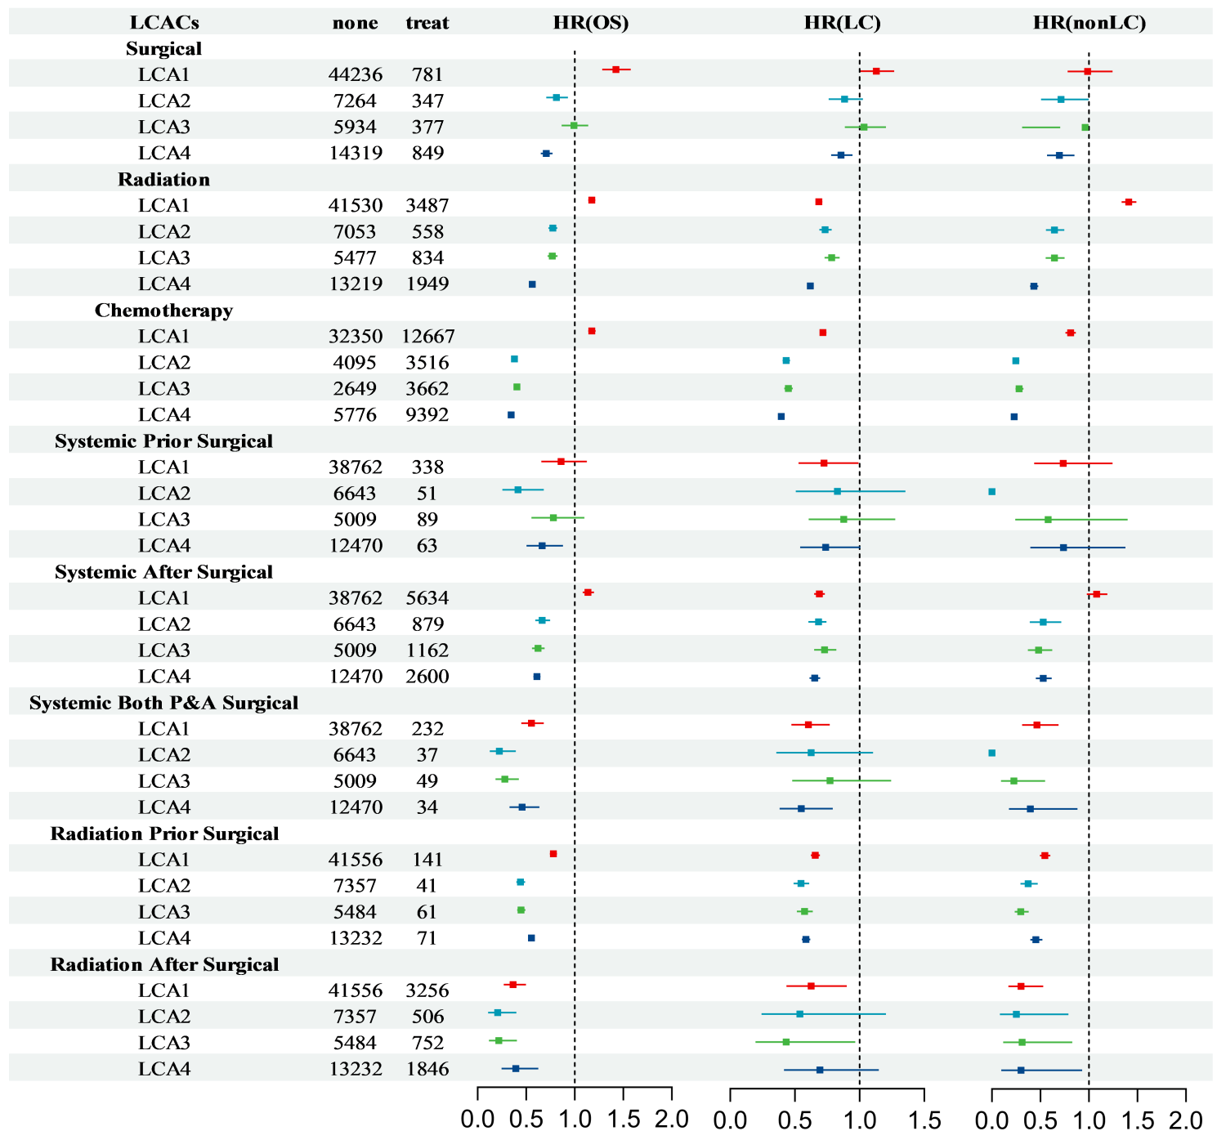
The analysis results show that the impact patterns of different indicator variables on prognosis vary. The influence of age is not linear. For the two age groups of 18-49 years old and 50-74 years old, the total mortality risk, lung cancer-related mortality risk, and other causes of mortality risk all show an increasing trend. However, the elderly group aged 75 and above presents different characteristics. The total mortality risk only shows a slight increase, the lung cancer-related mortality risk does not show a significant change, but the mortality risk caused by other reasons significantly increases. This indicates that the outcome of elderly patients is mainly related to non-lung cancer factors.
Among different racial groups, the death risks of white patients are generally higher. The risks of Asian and Pacific Islander, and black patients are significantly lower than those of white patients, indicating that race is a stable factor affecting prognosis. American Indian/Alaska Native patients only have an increase in total mortality risk, and there is no significant difference in specific mortality risk, which may reflect the differences in medical accessibility or comorbidity burden of this group. The primary site of the tumor also has prognostic significance. Patients with tumors located in the lower lobe of the lung or with overlapping lesions have lower risks of all types of death than white patients. Tumor stage shows a clear gradient association. From stage I to stage III, the risks of all types increase significantly in each stage, and reach a peak in stage III. It is notable that the risk ratio of stage IV patients is lower than that of stage III, which may be related to the extremely poor overall prognosis of this stage of patients and the dominance of competitive risk events (i.e., the high possibility of dying from lung cancer in the short term, masking other risks). In terms of histological type, the death risk of patients with small cell lung cancer is significantly higher than that of patients with non-small cell lung cancer.
In conclusion, compared with factors such as age and stage that mainly reflect the overall risk trend, or variables such as race and site that have relatively limited impact strength, the LCA classification system demonstrates more comprehensive discriminative efficacy. It is not only valuable in distinguishing overall survival risks, but also can effectively distinguish the risk differences between lung cancer-related deaths and non-lung cancer-related deaths (Figures S3 and S4). This characteristic makes it helpful in clinical practice for more accurately identifying high-risk patient groups and providing key evidence for formulating individualized treatment strategies.

Figure S2. Trend of the proportion of cause of deaths in each class for age groups based on development set.
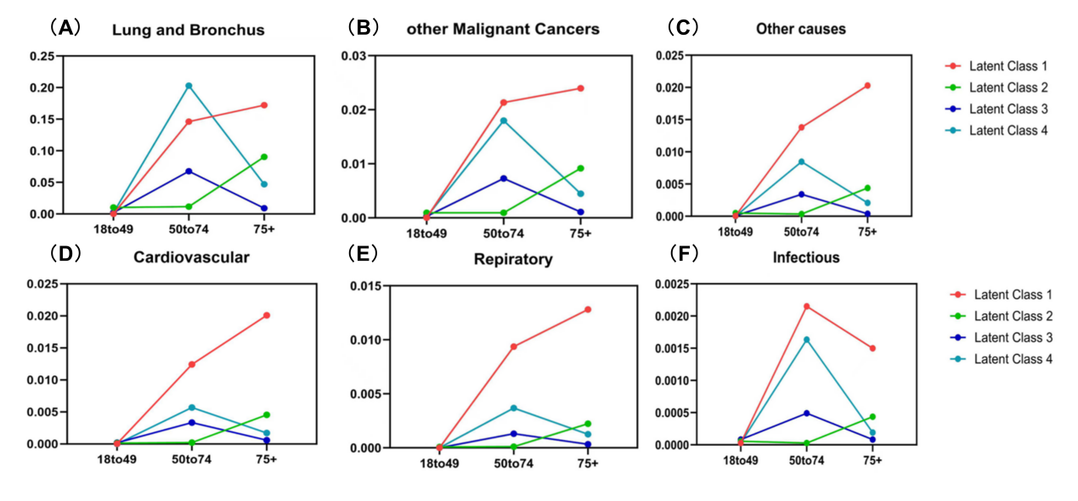
With increasing age, there were also significant differences in the causes of death among patients with different LCA categories. LCA1 patients had a higher proportion of deaths from cardiovascular and respiratory diseases than other categories, while LCA2 patients showed an upward trend in this proportion. Among LCA1 patients, the proportion of deaths from infectious diseases was the highest in the 50–70 age group, and that from other diseases was the highest in those over 75 years old; in LCA3 and LCA4 patients, the proportion of deaths from all diseases peaked in the 50–70 age group. For lung and bronchial diseases, LCA1 patients had the highest death proportion in all age groups except 50–70 years old where LCA4 patients had the highest. In patients aged 75 and above, LCA1 and LCA2 patients had the highest death proportion, mainly due to other causes, cardiovascular diseases and respiratory diseases.

Figure S3. Trend of the proportion of cause of deaths in each class for stage I to stage IV based on development set.
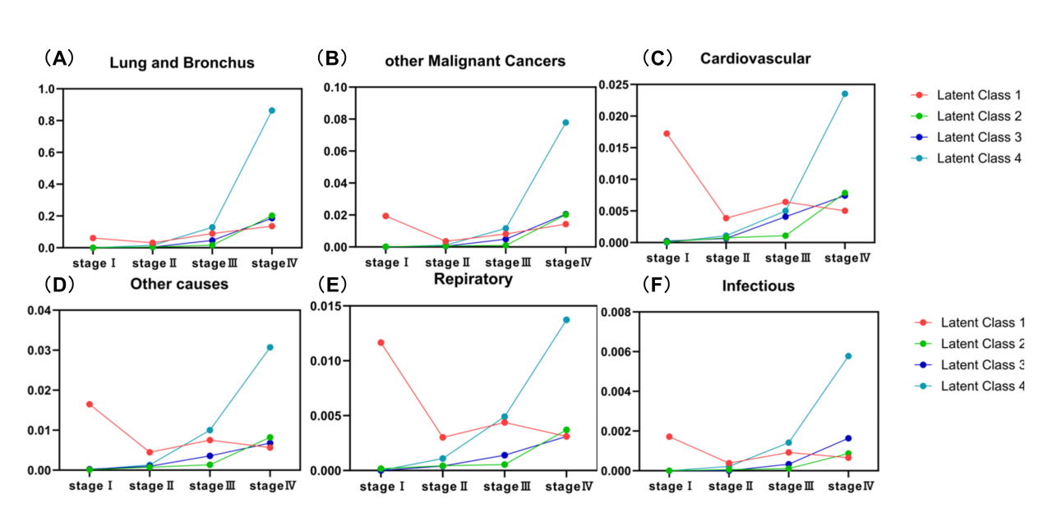
With the increase of tumor stage, the distribution of death causes among patients with different LCA categories shows differences. In all LCA categories, the proportion of deaths due to lung cancer (LC) in stage Ⅲ patients increased significantly, especially in LCA4 patients who also had a significant increase in the proportion of deaths from all types of diseases in stage Ⅲ. LCA1 patients had a general decrease in the proportion of deaths in stage Ⅱ with a stable trend in the later period, which was particularly significant in cardiovascular and respiratory diseases. LCA2 and LCA3 patients had similar trends in the proportion of deaths from various diseases, both showing a steady increase. The proportion of deaths caused by other cancers gradually increased in LCA2 to LCA4 patients with the elevation of tumor stage, and cardiovascular disease became the leading cause of death in LCA2 patients at stage Ⅲ. The proportion of deaths caused by infectious diseases remained low in LCA2 patients but maintained a high level in LCA4 patients.

Figure S4. Probabilities of indicator variables in each identified LCA-derived classifications based on validation set.

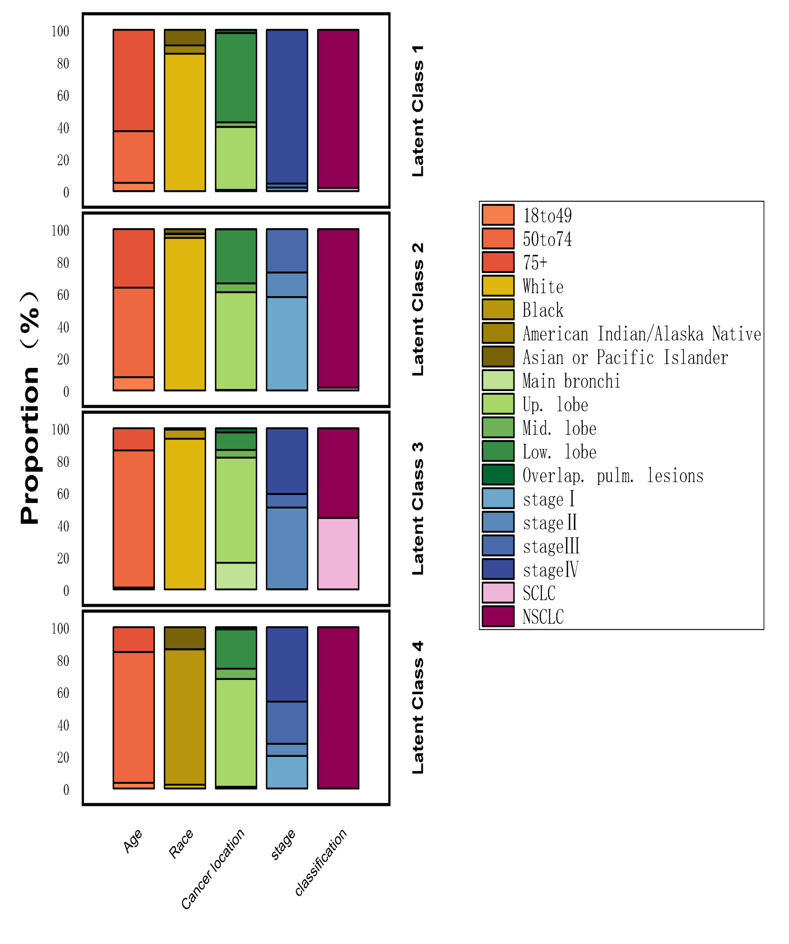
Figure S5. Survival analyses of LCA-Derived classifications in LC patients based on validation set.

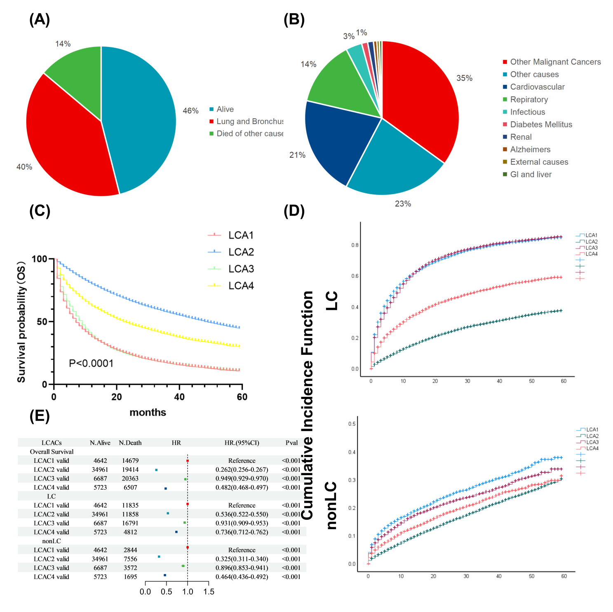

Figure S6. Forest plots for survival analyses of different therapies (radiotherapy and/or chemotherapy) in LC patients, stratified by LCA-derived classifications on validation set.
