SUPPLEMENTAL MATERIALS
Development of a G-Quadruplex-Forming DNA Aptamer Against EGFR-Driven Malignancies
Deepa Singh¹, Vikas Kumar¹, Akash Kumar², Tushar Kushwaha¹, Kamal Baswal¹, Rajkumar Kulandaisamy¹, Manoj Kumar¹, Saroj Kumar¹, Prabhat Singh Malik³, Tailor Prafullakumar⁴, Deepak Seghal², Tarun Kumar Sharma⁵, Mohan Babu Appaiahgari^{6*}, Krishna K. Inampudi^{1*}
¹ Department of Biophysics, All India Institute of Medical Sciences, New Delhi, Delhi 110029, India
² Virology Lab, Department of Life Sciences, Shiv Nadar University, Greater Noida, Uttar Pradesh 201314, India
³ Department of Medical Oncology, All India Institute of Medical Sciences, New Delhi 110029, India
⁴ Laboratory of Innate Immunity, National Institute of Immunology, New Delhi, India
⁵ Department of Medical Devices National Institute of Pharmaceutical Education and Research (NIPER), Mohali, Punjab 160062, India
⁶ Laboratory for Multidisciplinary Research in Virology, Yenepoya (deemed to be) University, Deralakatte, Mangaluru - 575018, Karnataka, India
*Corresponding Authors:
Dr. Krishna K Inampudi
Additional Professor
Department of Biophysics
All India Institute of Medical Sciences (AIIMS),
Ansari Nagar, New Delhi-110 029, India
Telephone: +91-11-2659 3834
Email id: krishna.inampudi@aiims.edu, kishorehcu@gmail.com
Dr. Mohan B Appaiahgari
Associate Professor,
Laboratory for Multidisciplinary Research in Virology,
Yenepoya (deemed to be) University,
Deralakatte, Mangaluru - 575018, Karnataka, India
Email: mohanviro@gmail.com, mohan.ba@yenepoya.edu.in

Supplemental Table 1. DNA Aptamer Library and Primers.
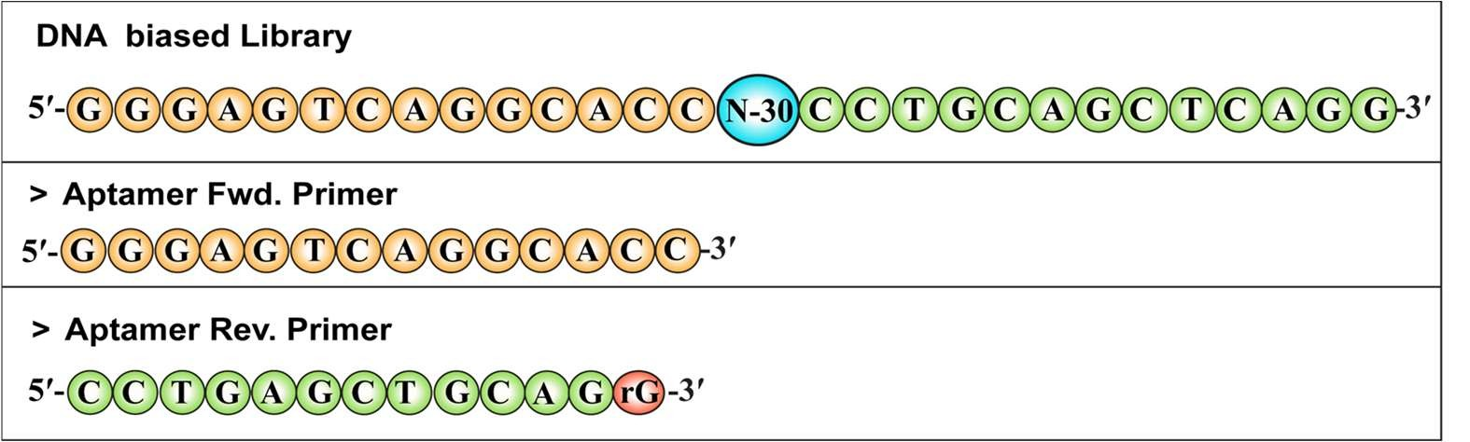

Supplemental Table 2. Next-generation sequencing (NGS) results

1. | Total Sequences | 25170392
2. | Unique Sequences | 22327197
3. | Correct sequences (30nt) | 19388565

Supplemental Figures

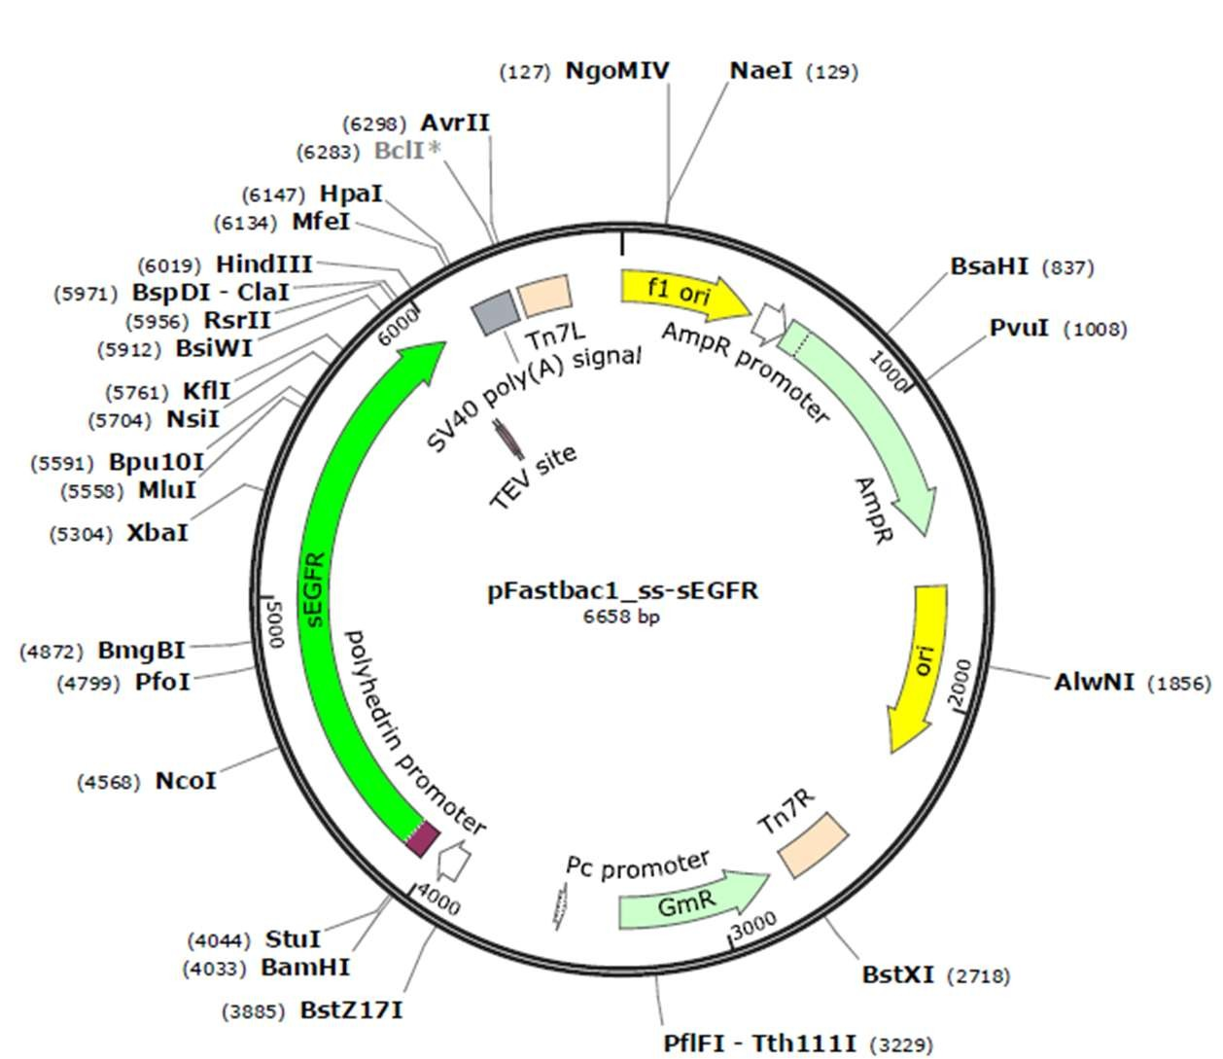

Supplemental Figure 1. Schematic representation of Plasmid construct of pFastBac1_ss-sEGFR (6658 bp). The sEGFR insert is cloned under the polyhedrin (polh) promoter for expression in insect cells. The plasmid map was created by using SnapGene software (GSL Biotech LLC)

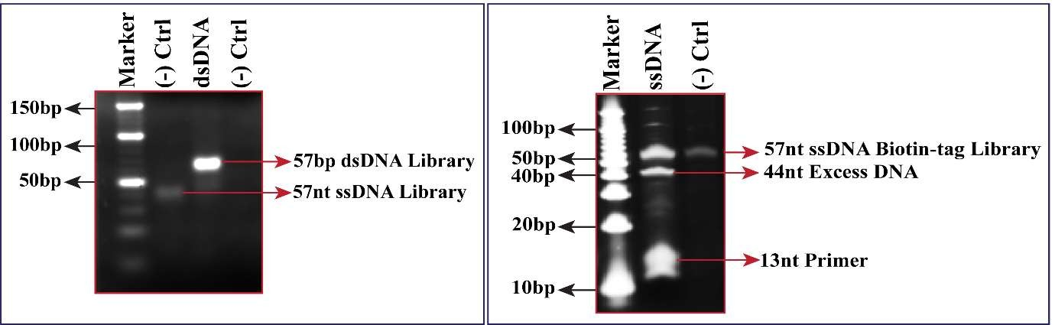

Supplemental Figure 2. PCR amplification and ssDNA regeneration of enriched aptamer pools from the 7th cycle of conventional SELEX against sEGFR. Representative 3% agarose gels (left panels) show PCR-amplified doublestranded DNA (dsDNA) aptamer libraries (~57 bp) generated after each SELEX round, alongside single-stranded DNA (ssDNA) products (~57 nt). Corresponding 10% urea–denaturing PAGE gels (right panels) display the separation of ssDNA from the ribo-linkage–containing strand, with distinct bands for the 57 nt ssDNA library and shorter excess DNA fragments (~44 nt), as well as the 13 nt reverse primer. Results are shown sequentially for rounds 1–7 of SELEX, demonstrating successful amplification and efficient ssDNA regeneration at each enrichment stage.

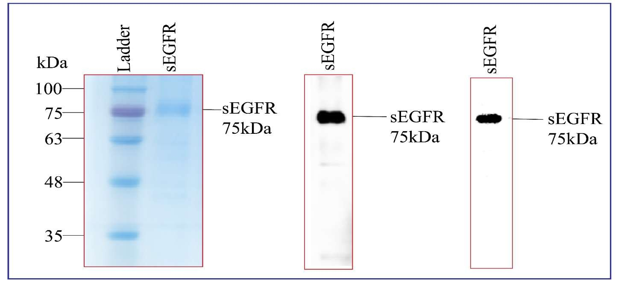
Supplemental Figure 3. Purification and analysis of recombinant sEGFR protein. The figure shows (A) a 12% SDS–PAGE gel of gel filtration chromatography (GFC) purified sEGFR protein, (B) western blot detection using an anti-His tag antibody (1:3000 dilution), and (C) western blot detection using an anti-sEGFR antibody (1:3000 dilution).
Supplemental Figure 4. Schematic of P-SELEX process to identify sEGFR-specific aptamers. Step A illustrates the negative selection, wherein the ssDNA library is incubated with Ni²⁺-Sepharose beads to remove Ni-NTA-binding sequences. In step B, the unbound library is incubated with sEGFR-bound Ni-NTA beads for positive selection. In Step C, the beads are washed and the bound library is eluted, followed by the amplification of the eluted library by PCR in Step D. Step E illustrates the preparation of the ssDNA library for the iterative-SELEX. In step F, the evolved ssDNA pool is subjected to NGS to identify the aptamers that are specific to sEGFR.
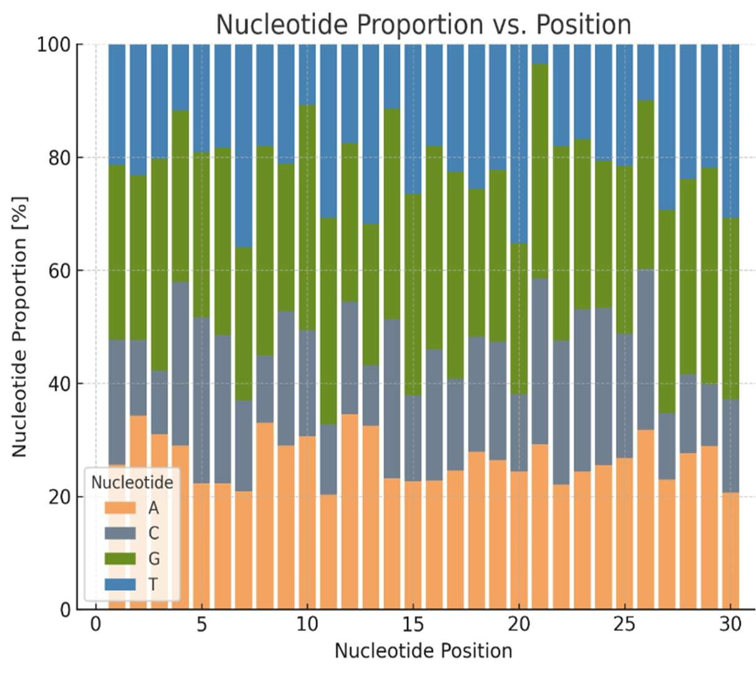
Supplemental Figure 5. Nucleotide distribution over the 30 positions of the central random region of the recovered 200 abundant aptamer
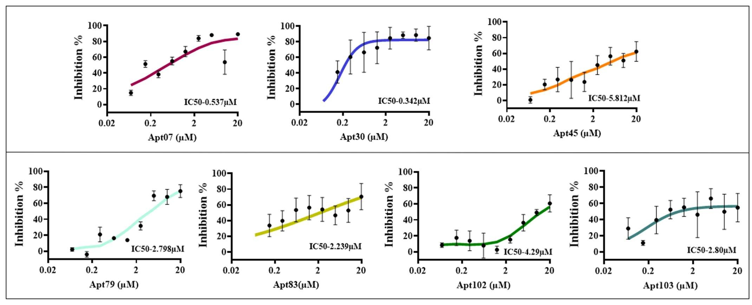Supplemental Figure 6. MTT assay-based cytotoxicity analysis of selected aptamers in A431 cells. Dose– response inhibition curves of ten enriched aptamer candidates (Apt07, Apt30, Apt45, Apt79, Apt83, Apt102, Apt103, and Apt109) in EGFR-overexpressing A431 cells.

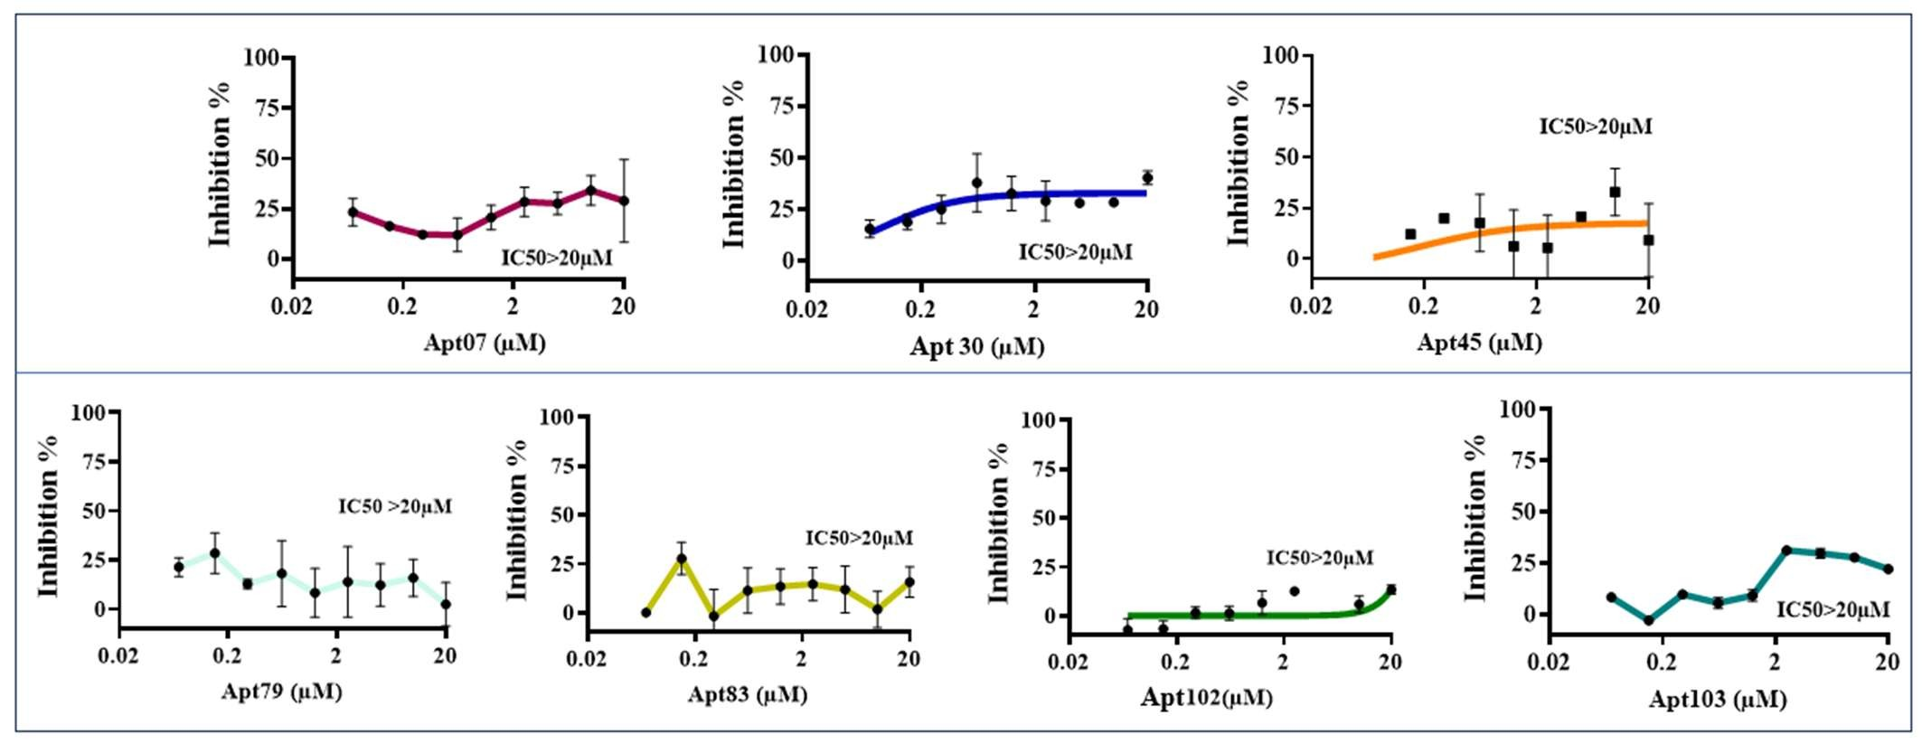
Supplemental Figure 7. MTT assay-based cytotoxicity analysis of selected aptamers in A549 cells. Dose– response inhibition curves of ten enriched aptamer candidates (Apt07, Apt30, Apt45, Apt79, Apt83, Apt102, Apt103, and Apt109) in EGFR-moderate expressing A549 cells.

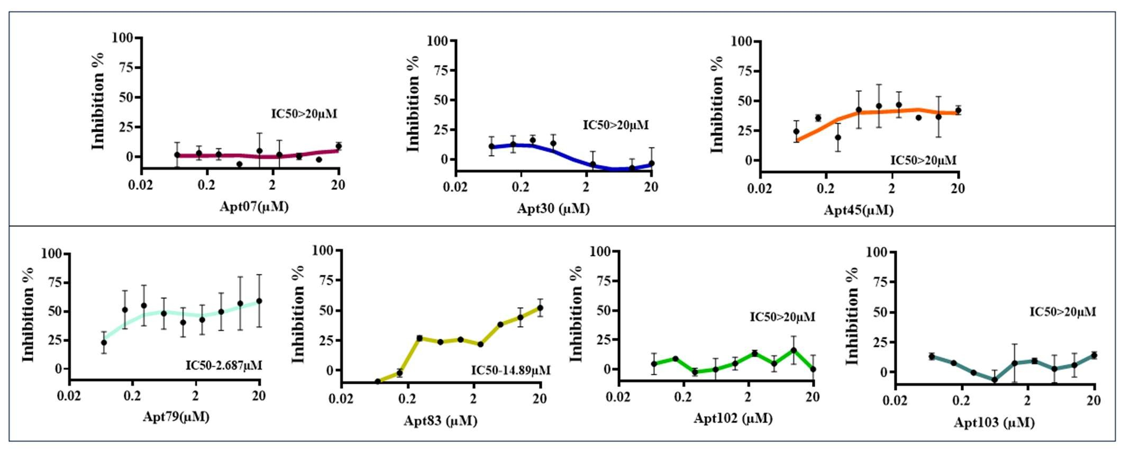
Supplemental Figure 8. MTT assay-based cytotoxicity analysis of selected aptamers in Jurkat cells. Doseresponse inhibition curves of ten enriched aptamer candidates (Apt07, Apt30, Apt45, Apt79, Apt83, Apt102, Apt103, and Apt109) in EGFR-negative Jurkat cells.
Supplemental Figure 9. Secondary structure analysis of selected aptamers. (A) The secondary structures of Apt27, Apt64, and Apt109, predicted using the NuPACK web server, showed stable stem-loop arrangements and G-rich sequences capable of forming G4 motifs (top panel). (B) CD spectroscopy was performed at two different concentrations (10 µM and 20 µM) (bottom panel). Apt27, Apt64, and Apt109 exhibited parallel G4 topology, with a strong positive peak at ~260 nm and a negative peak at ~240 nm. These CD signatures confirm that all selected aptamers fold into stable G4 structures. (C) Thermal stability assessment of Apt27, Apt64, & Apt109 was performed between 25°C and 95°C by CD spectroscopy and the melting curves were generated to evaluate thermal stability of their G4 conformations. Spectra were recorded in the 200-320 nm wavelength range.

Supplemental Figure 10. Binding affinities of the selected aptamers by MST. MST analysis of Apt27, Apt64 and Apt109 against sEGFR suggested that Apt64 exhibited the highest binding affinity for sEGFR (Kd = 25.77 nM), which is at par with that of Cetuximab (Kd = 8.98 nM). Shown are the binding affinities of A. Apt27, B. Apt64, C. Apt109, D. Cetuximab.
Supplemental Figure 11. Serum stability of Apt64. (A) Denaturing PAGE analysis of Apt64 (30-nt) incubated in 50% human AB serum at 37 °C for the indicated time points (0-216 h). The intact band corresponding to Apt64 remained clearly visible at least up to 144 h, but was barely visible starting from 168 h onwards. (B) Densitometric quantification of the full length Apt64, averaged from three independent experiments (mean ± SD), showing gradual degradation with a calculated half-life of ~129 h.

