Supporting material
- NMR
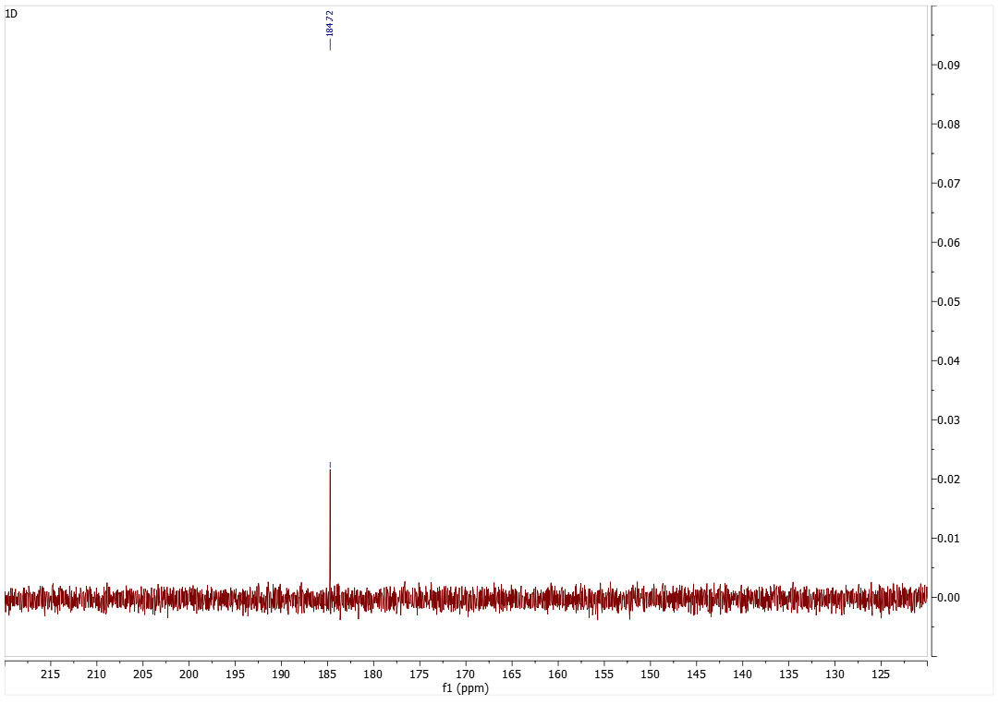
Figure 1: 13C NMR spectrum of 0.1 mol L-alanine and 1eq. NaOH prior to CO₂ treatment.
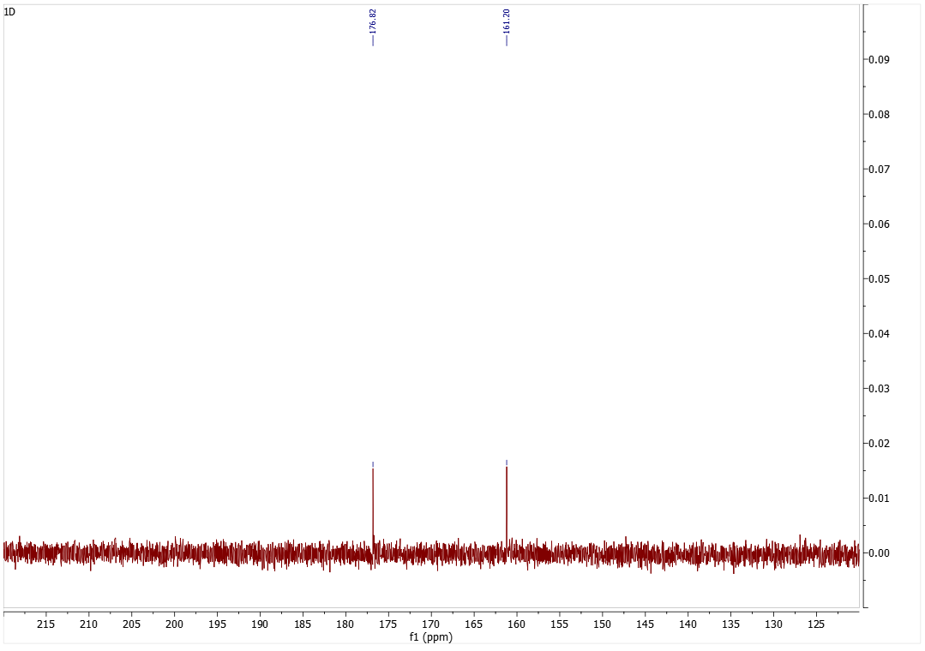
Figure 2: 13C NMR spectrum of 0.1 mol L-alanine and 1eq. NaOH after the CO₂ treatment.

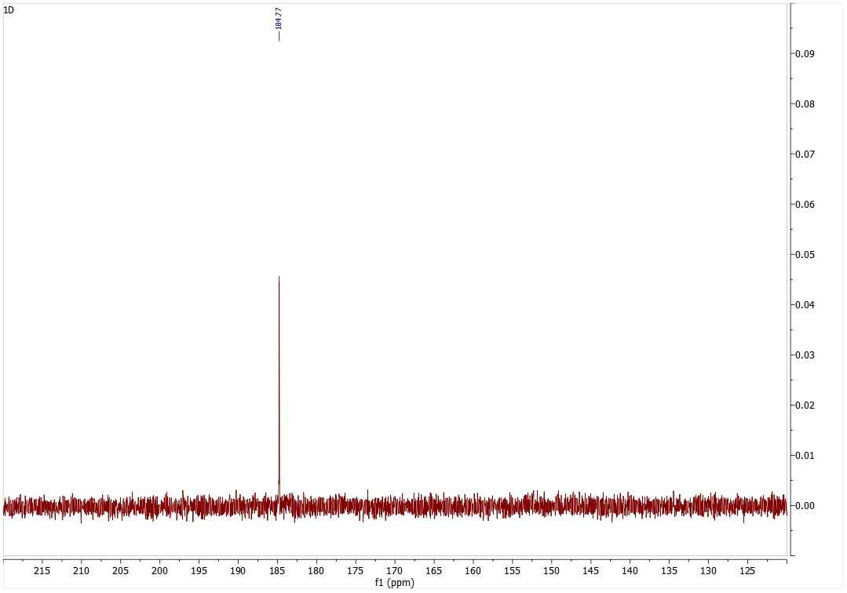
Figure 3: 13C NMR spectrum of 0.25 mol L-alanine and 1eq. NaOH prior to CO₂ treatment.
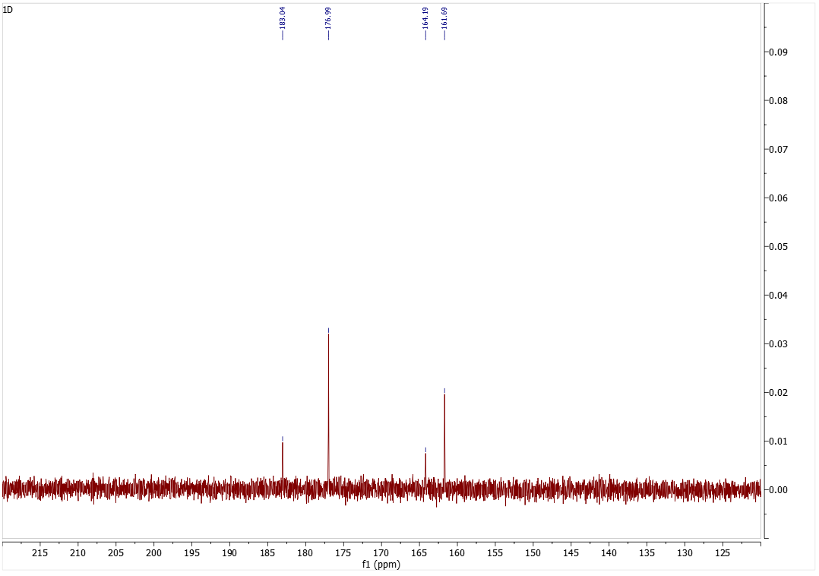
Figure 4: 13C NMR spectrum of 0.25 mol L-alanine and 1eq. NaOH after the CO₂ treatment.
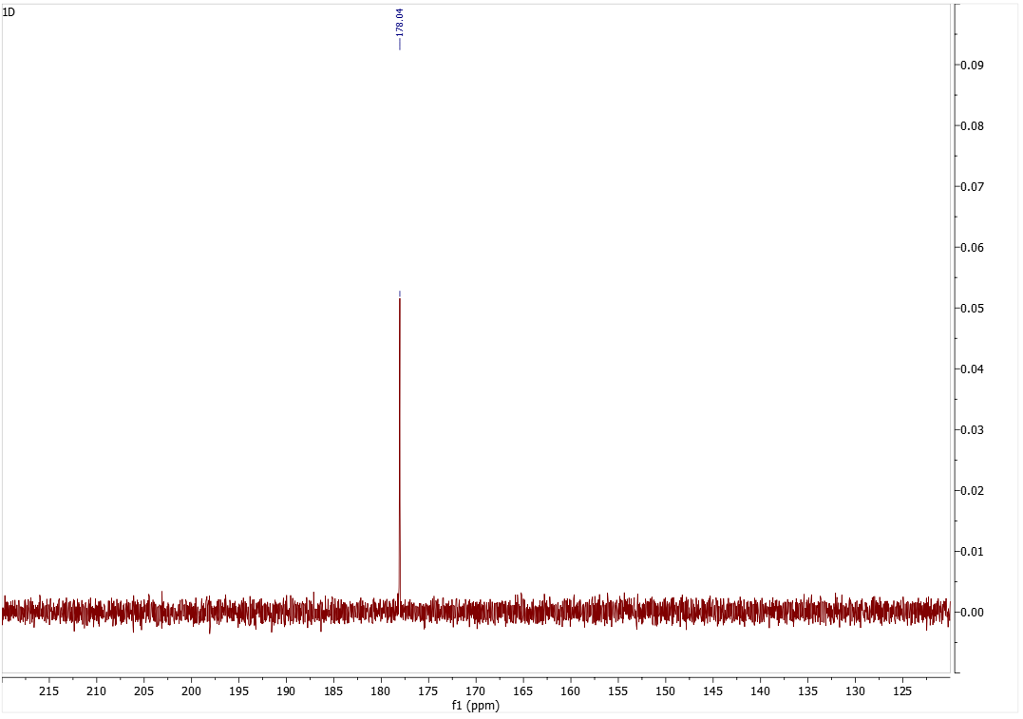
Figure 5: 13C NMR spectrum of 0.25 mol L-alanine and 0.2 eq. NaOH prior to CO₂ treatment.
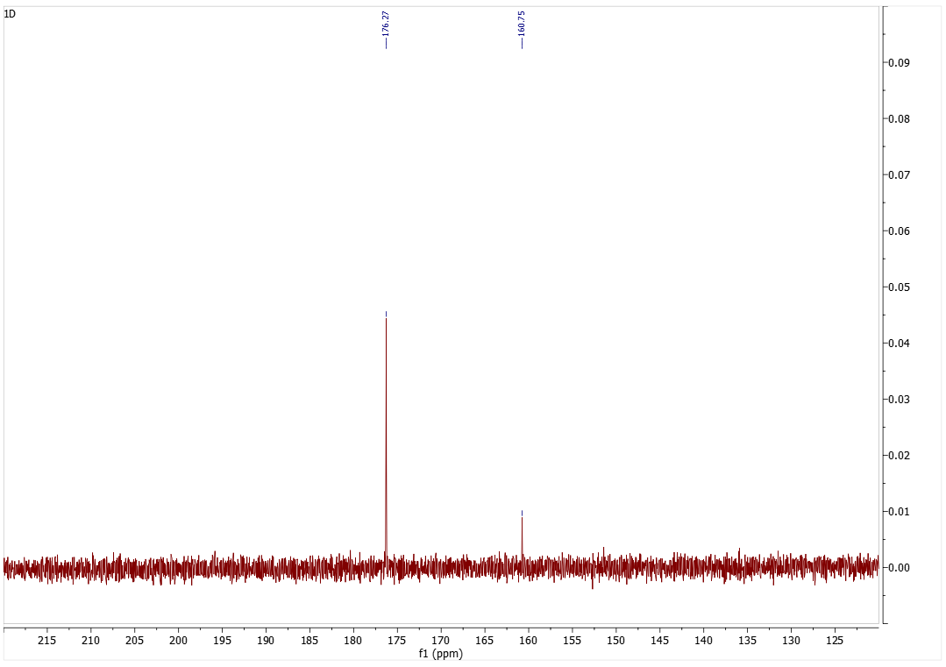
Figure 6: 13C NMR spectrum of 0.25 mol L-alanine and 0.2eq. NaOH after the CO₂ treatment.
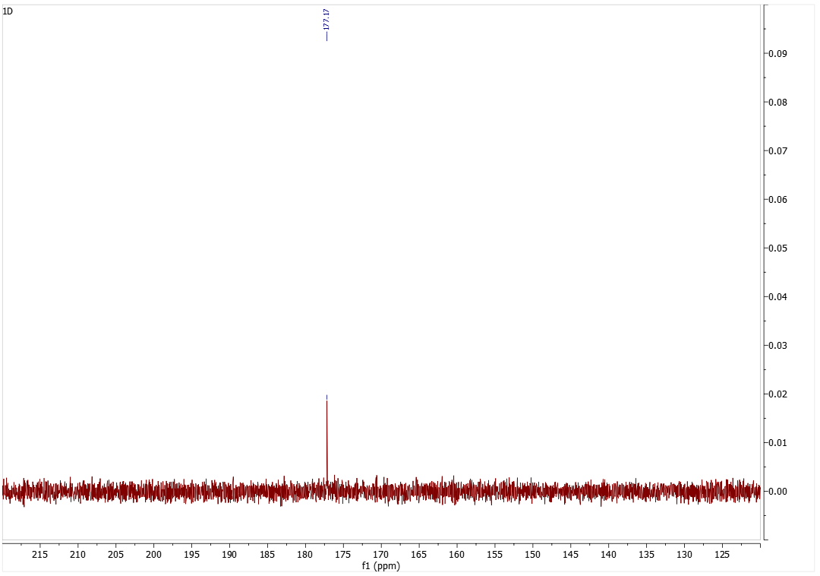
Figure 7: 13C NMR spectrum of 0.1 mol L-cysteine and 1eq. NaOH prior to CO₂ treatment.
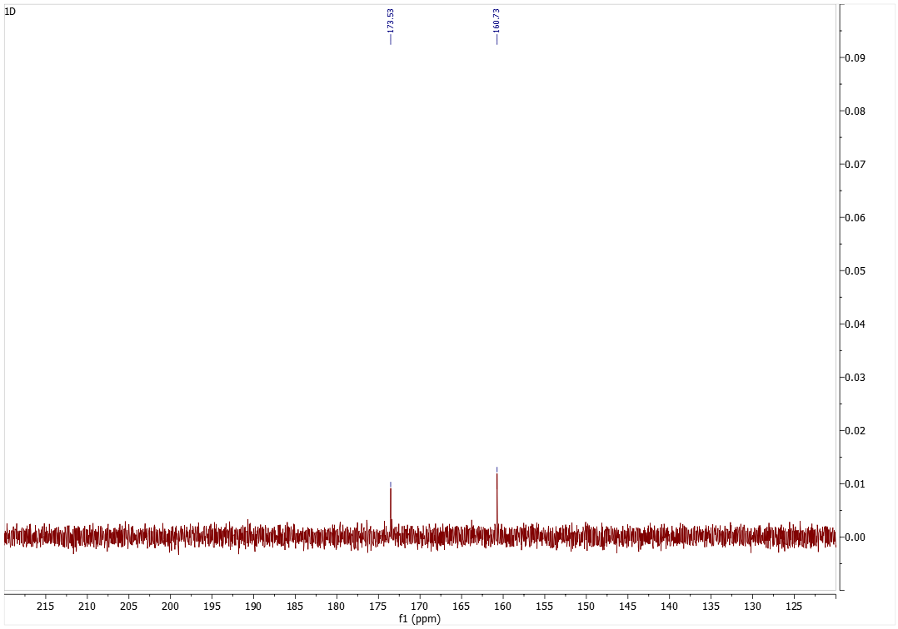
Figure 8: 13C NMR spectrum of 0.1 mol L-cysteine and 1eq. NaOH after the CO₂ treatment.

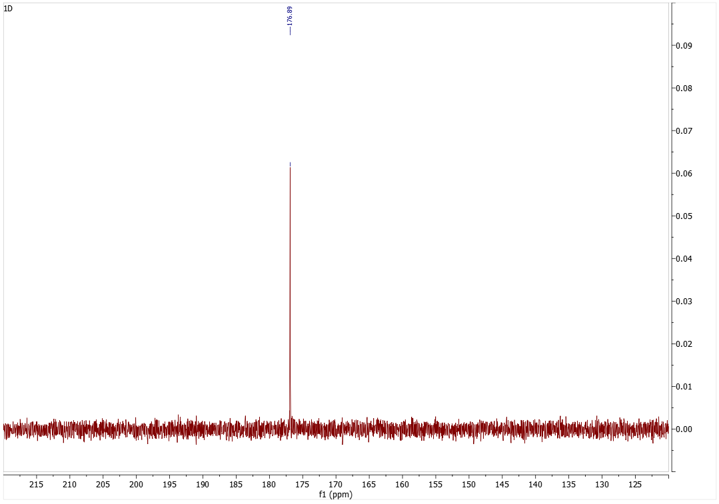
Figure 9: 13C NMR spectrum of 0.25 mol L-cysteine and 1eq. NaOH prior to CO₂ treatment.
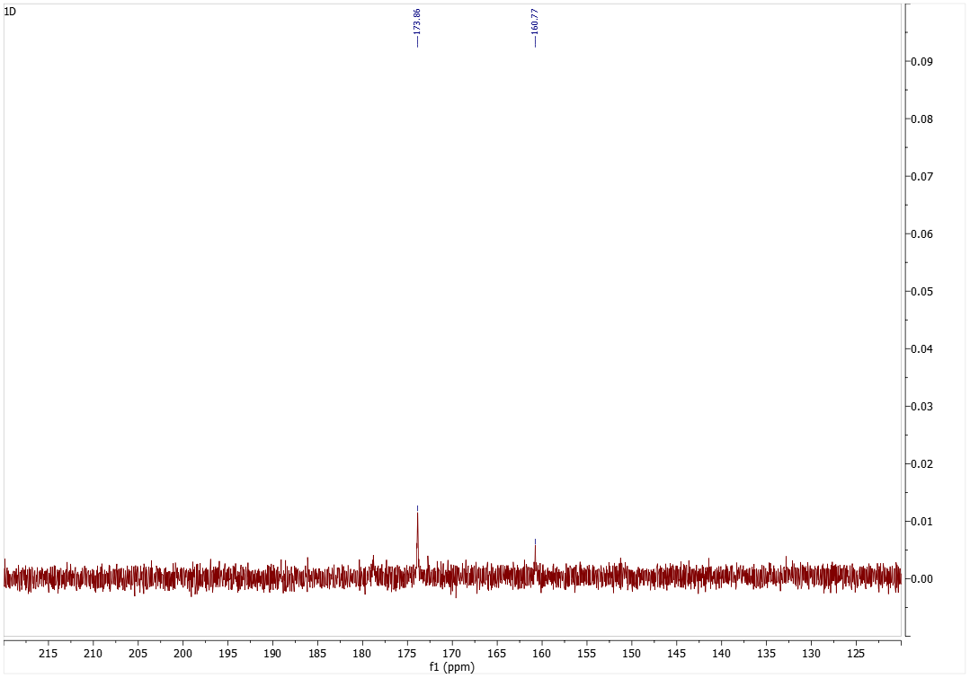
Figure 10: 13C NMR spectrum of 0.25 mol L-cysteine and 1eq. NaOH after the CO₂ treatment.
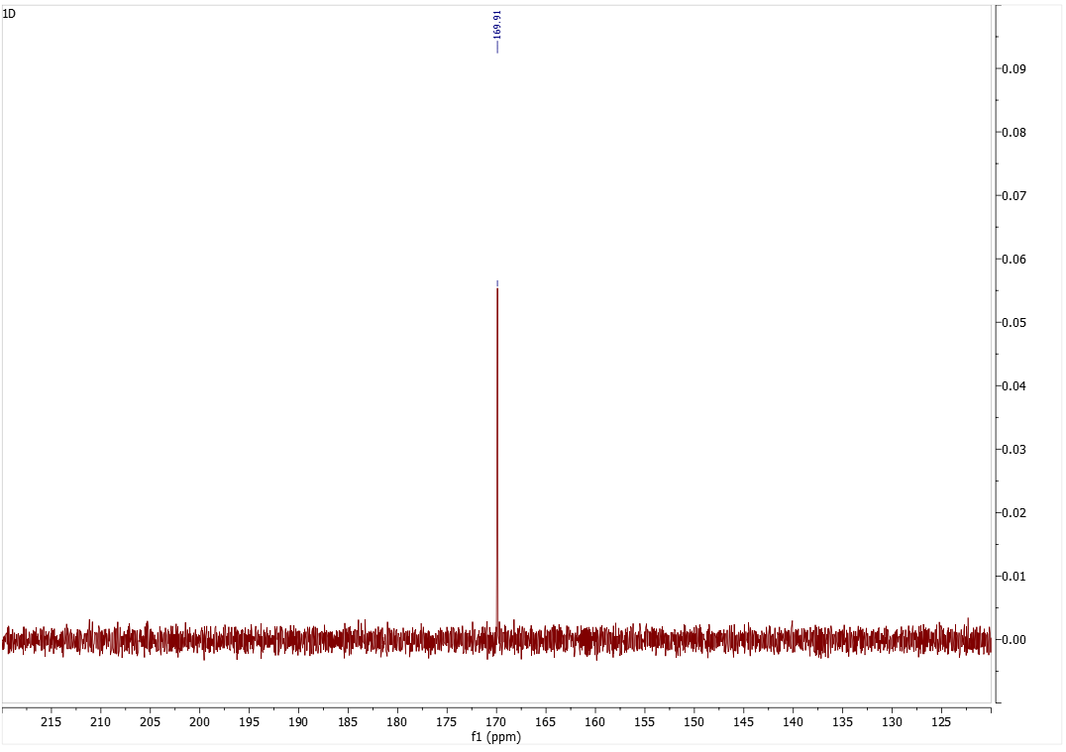
Figure 11: 13C NMR spectrum of 0.25 mol L-cysteine and 0.2 eq. NaOH prior to CO₂ treatment.
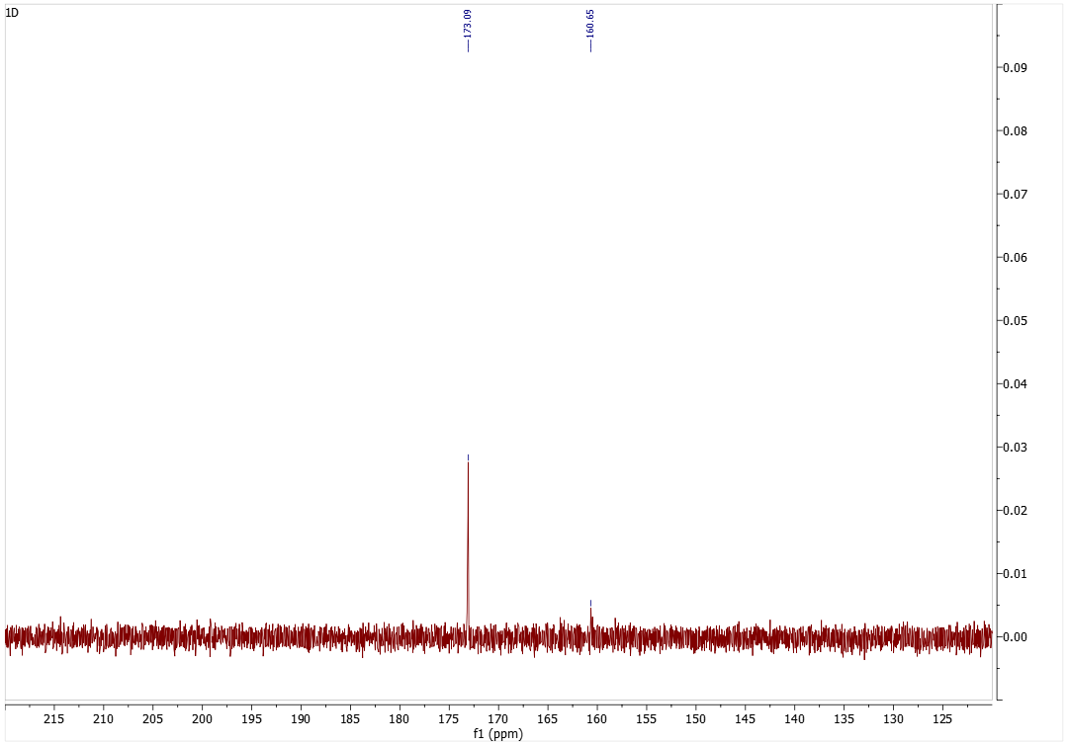
Figure 12: 13C NMR spectrum of 0.25 mol L-cysteine and 0.2 eq. NaOH after the CO₂ treatment.
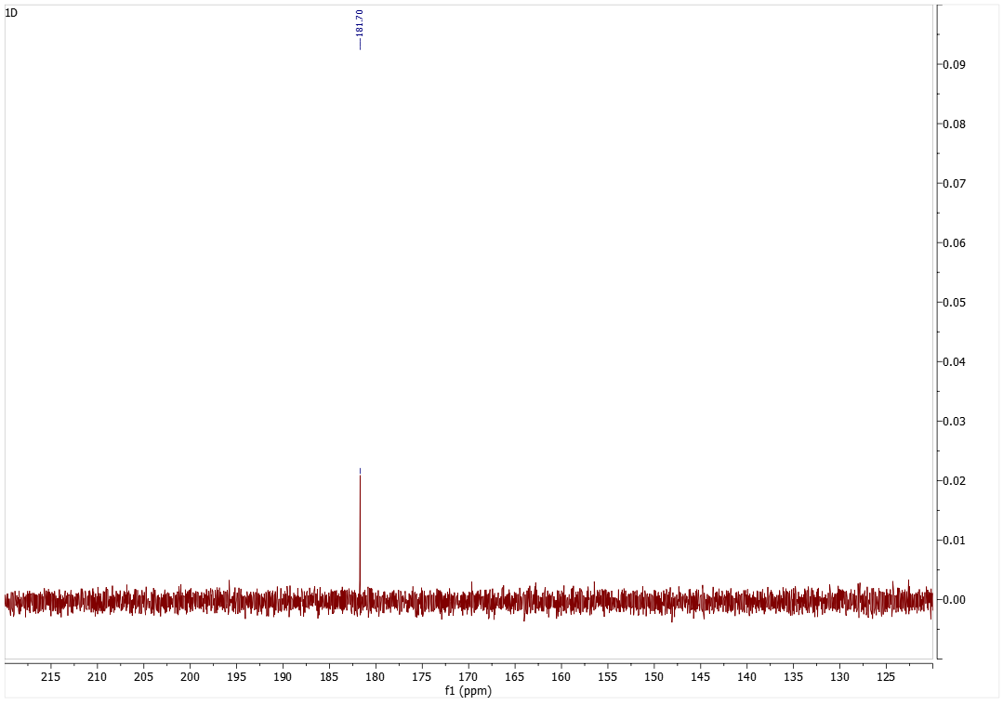
Figure 13: 13C NMR spectrum of 0.1 mol L-glycine and 1 eq. NaOH prior to CO₂ treatment.
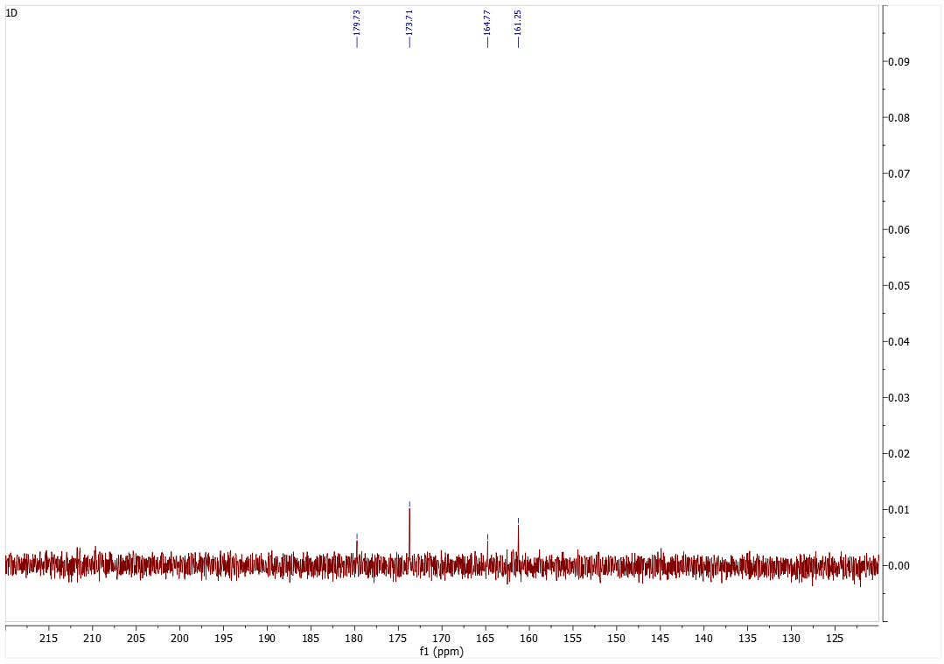
Figure 14: 13C NMR spectrum of 0.1 mol L-glycine and 1 eq. NaOH after the CO₂ treatment.
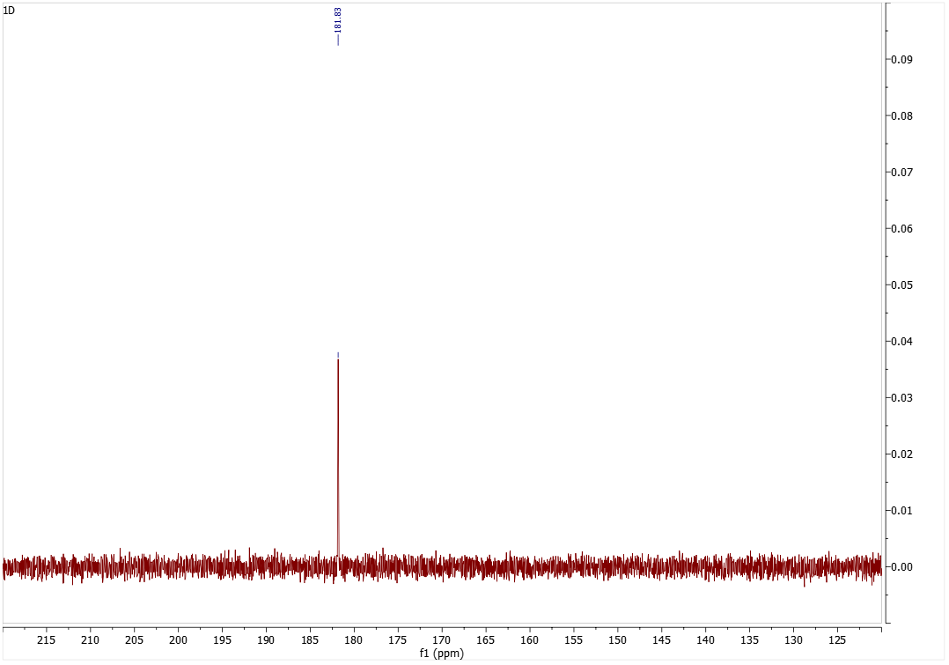
Figure 15: 13C NMR spectrum of 0.25 mol L-glycine and 1 eq. NaOH prior to CO₂ treatment.
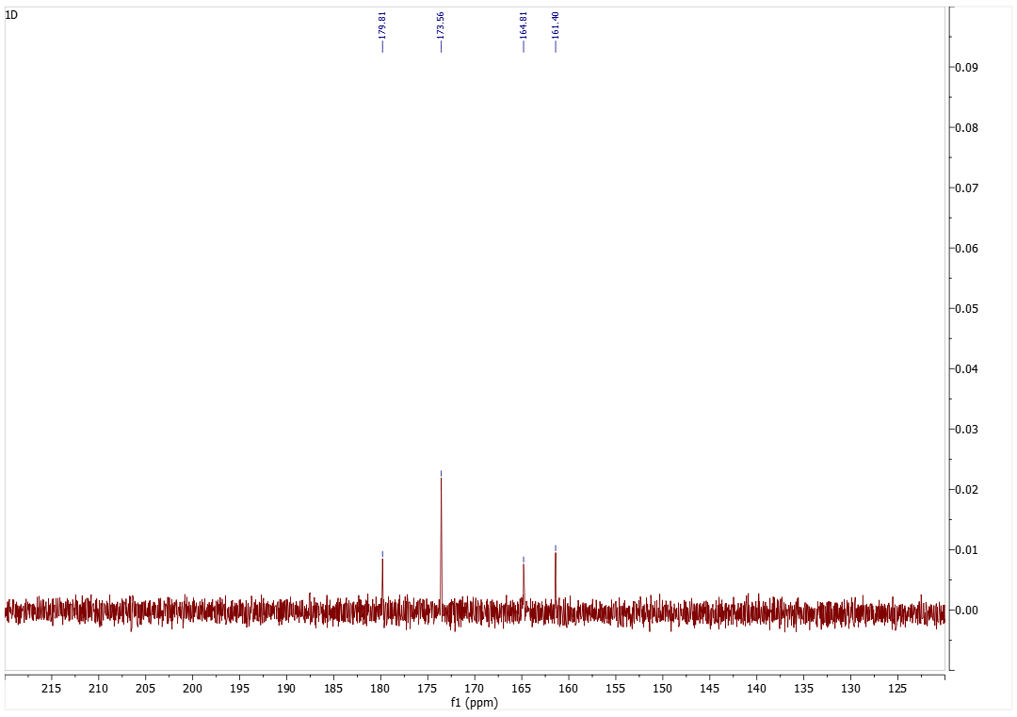
Figure 16: 13C NMR spectrum of 0.25 mol L-glycine and 1 eq. NaOH after the CO₂ treatment.
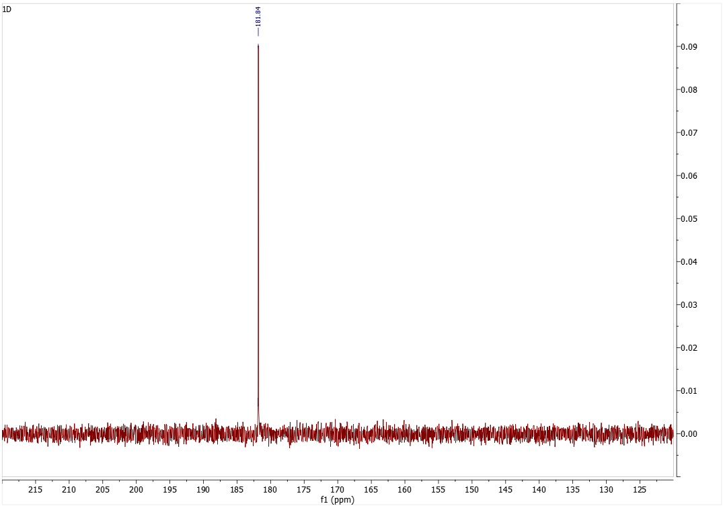
Figure 17: 13C NMR spectrum of 0.5 mol L-glycine and 1 eq. NaOH prior to CO₂ treatment.
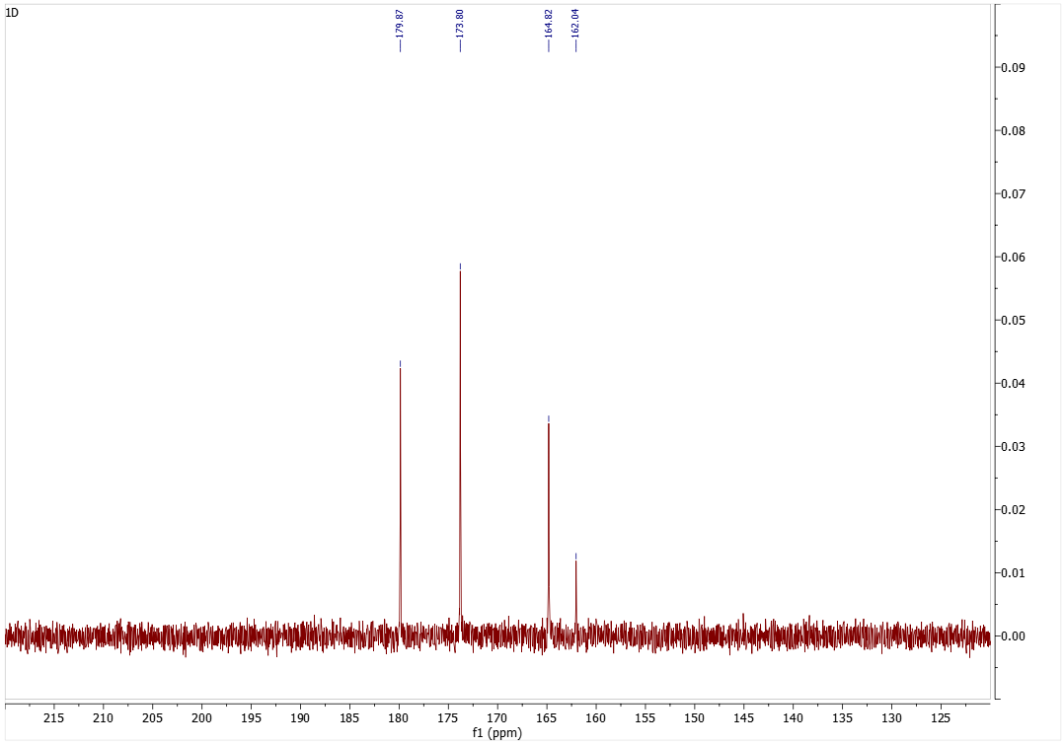
Figure 18: 13C NMR spectrum of 0.5 mol L-glycine and 1 eq. NaOH after the CO₂ treatment.
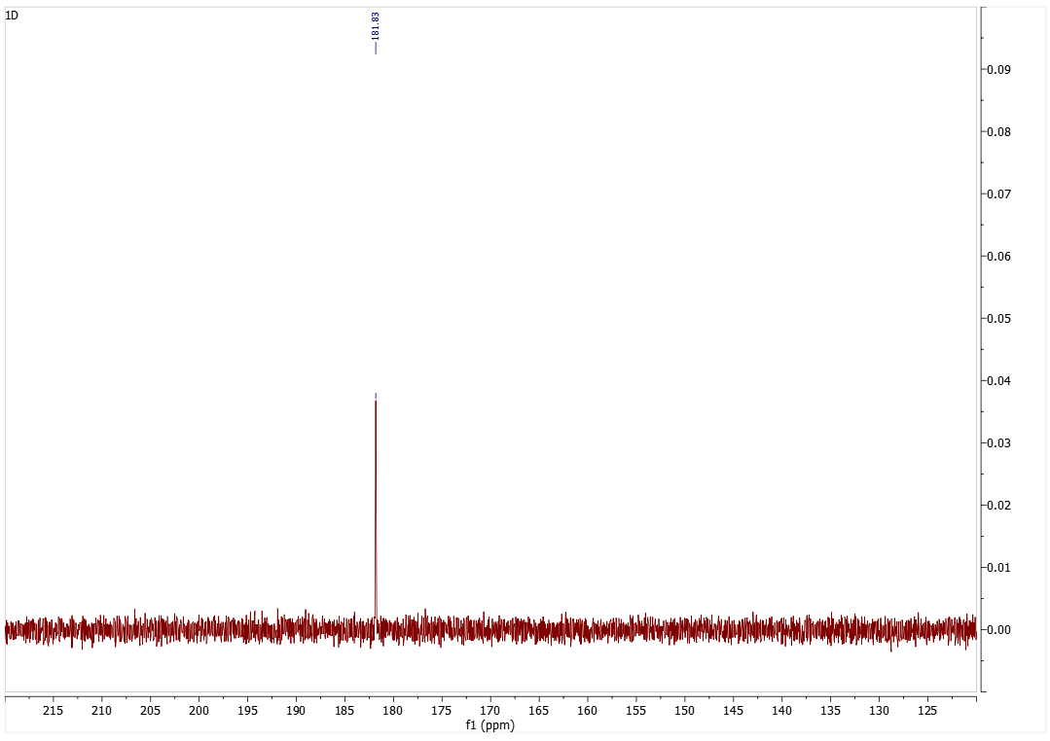
Figure 19: 13C NMR spectrum of 0.5 mol L-glycine and 0.2 eq. NaOH prior to CO₂ treatment.
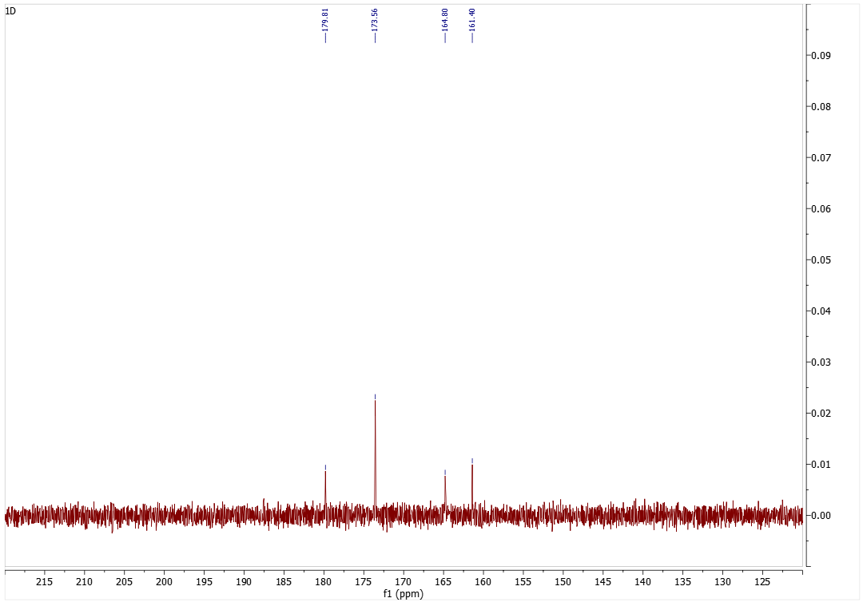
Figure 20: 13C NMR spectrum of 0.5 mol L-glycine and 0.2 eq. NaOH after the CO₂ treatment.
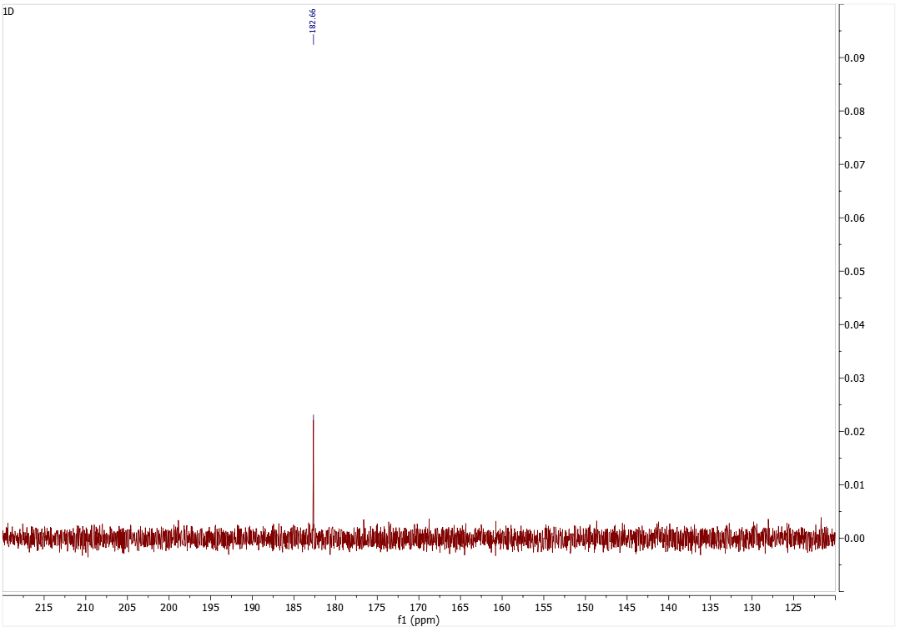
Figure 21: 13C NMR spectrum of 0.1 mol L-proline and 1 eq. NaOH prior to CO₂ treatment.
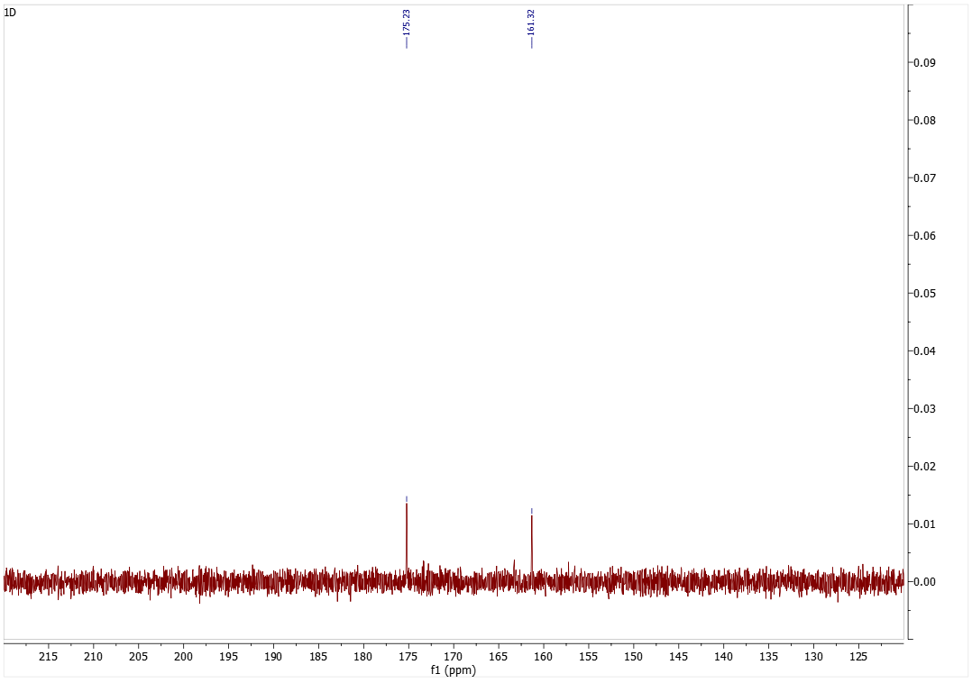
Figure 22: 13C NMR spectrum of 0.1 mol L-proline and 1 eq. NaOH after the CO₂ treatment.
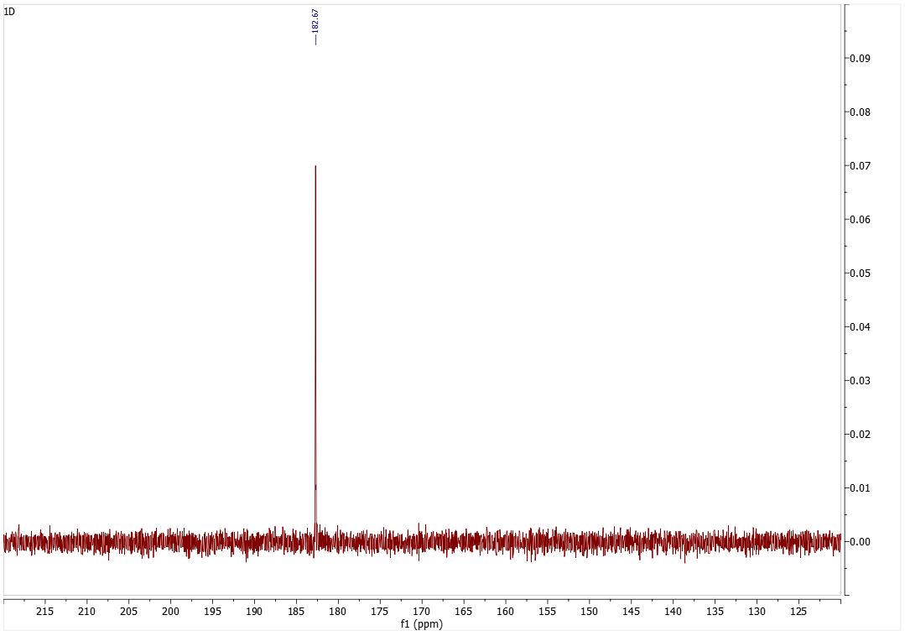
Figure 23: 13C NMR spectrum of 0.25 mol L-proline and 1 eq. NaOH prior to CO₂ treatment.
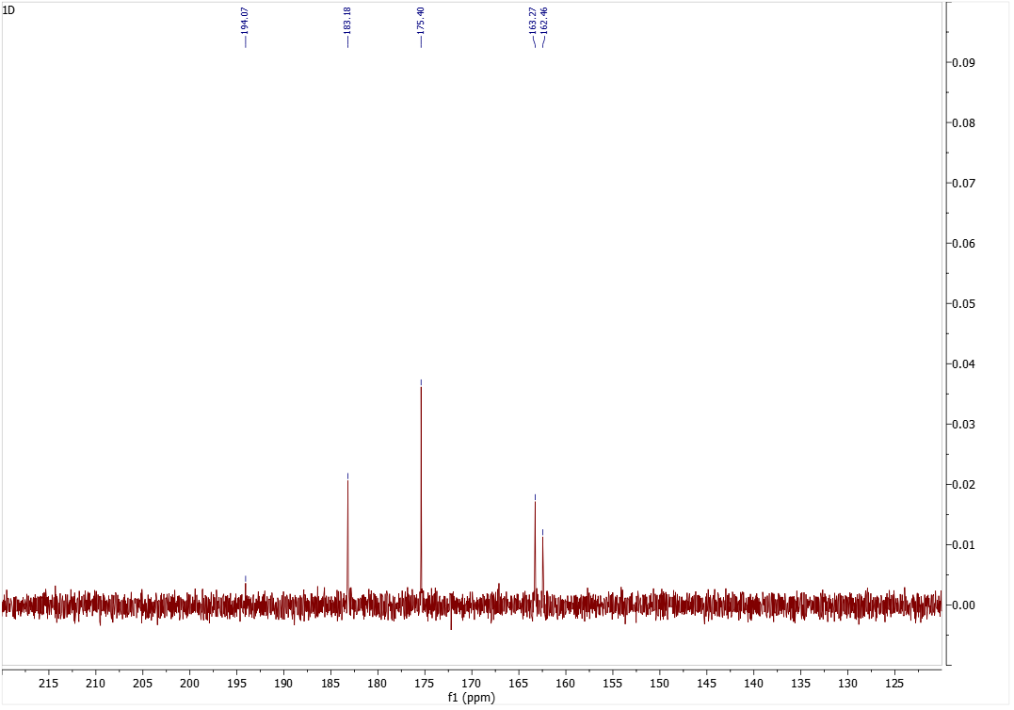
Figure 24: 13C NMR spectrum of 0.25 mol L-proline and 1 eq. NaOH after the CO₂ treatment.
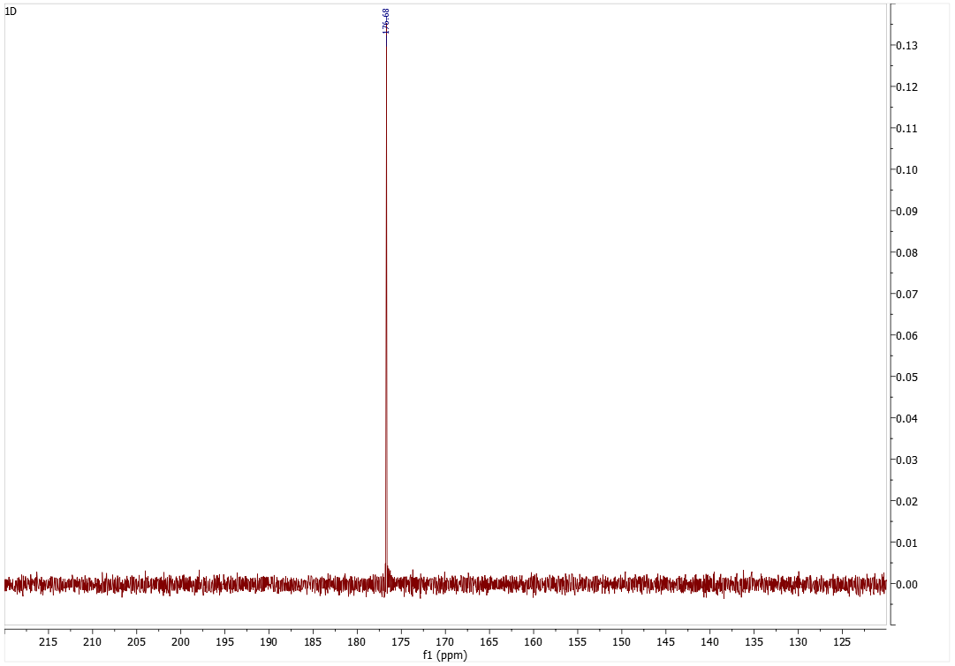
Figure 25: 13C NMR spectrum of 0.5 mol L-proline and 1 eq. NaOH prior to CO₂ treatment.
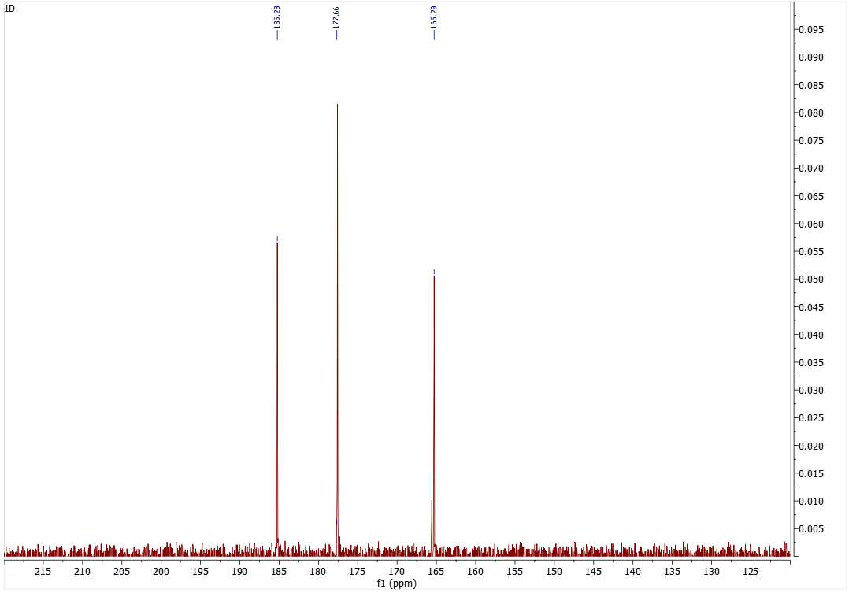
Figure 26: 13C NMR spectrum of 0.5 mol L-proline and 1 eq. NaOH after the CO₂ treatment.

Figure 27: 13C NMR spectrum of 0.5 mol L-proline and 0.2 eq. NaOH prior to CO₂ treatment.
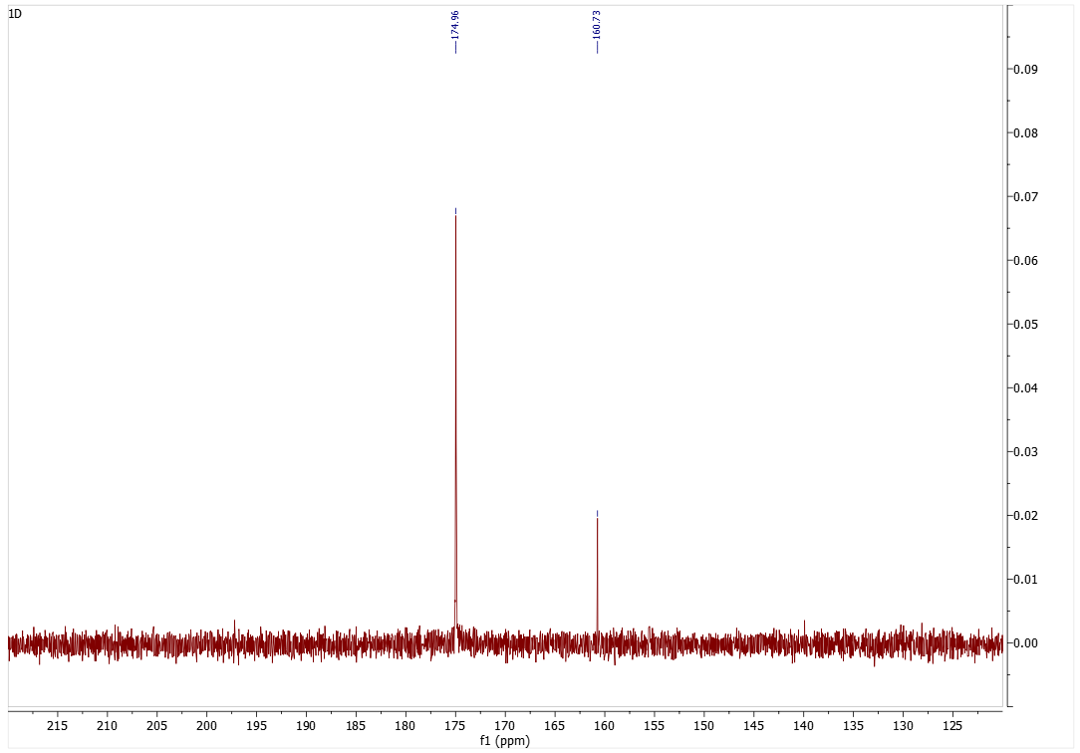
Figure 28: 13C NMR spectrum of 0.5 mol L-proline and 0.2 eq. NaOH after the CO₂ treatment.

