Design, synthesis and molecular docking studies of some new 1,3,4-oxadiazole linked benzimidazoles as anticancer agents
Ulviye ACAR ÇEVİK ^{1,2} *, İsmail Çelik³, Ayşen IŞIK⁴, Yusuf Özkay^{1,2}, Zafer Asım Kaplancıklı¹

¹ Department of Pharmaceutical Chemistry, Faculty of Pharmacy, Anadolu University, Eskişehir 26470, Turkey.
² Department of Pharmaceutical Chemistry, Faculty of Pharmacy, Doping and Narcotic Compounds Analysis Laboratory, Anadolu University, Eskişehir 26470, Turkey.
³ Department of Pharmaceutical Chemistry, Faculty of Pharmacy, Erciyes University, Kayseri 38039, Turkey.
⁴ Department of Biochemistry, Faculty of Science, Selçuk University, Konya, Turkey.
* Corresponding Author. E-mail: uacar@anadolu.edu.tr (U.A.Ç.); Tel. +90-222-335-0580/3775

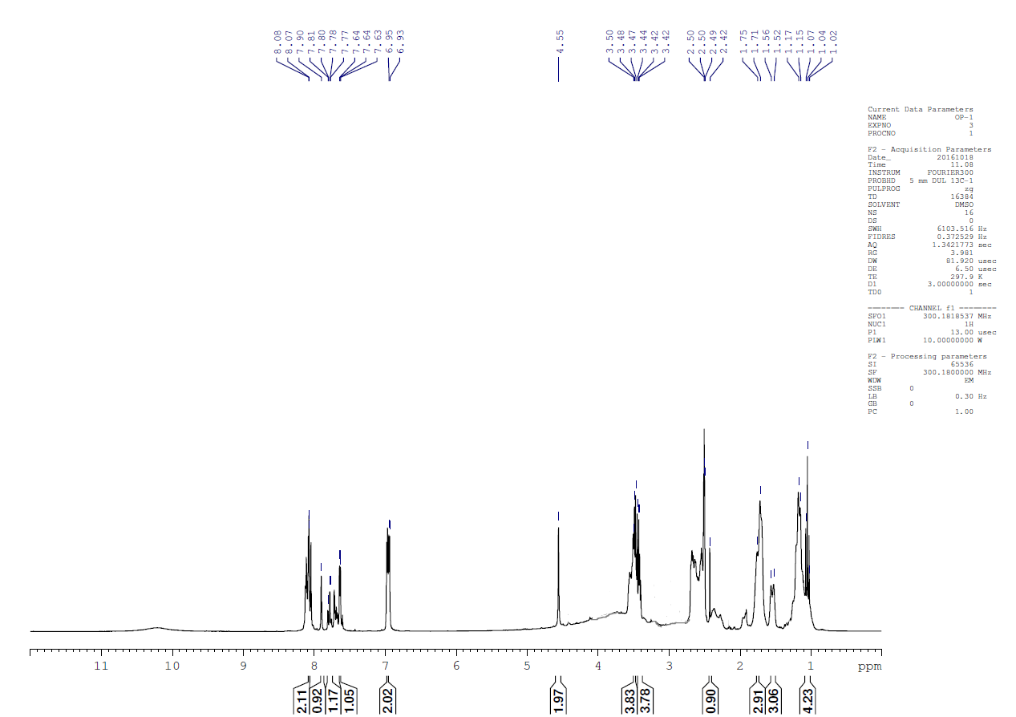
Figure 1. ¹H-NMR spectra of compound 5a
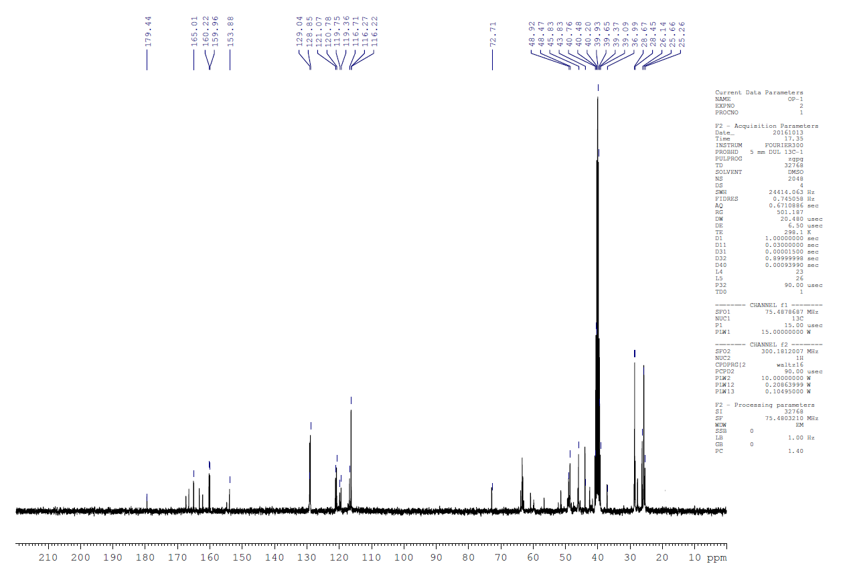
Figure 2. ¹³C-NMR spectra of compound 5a

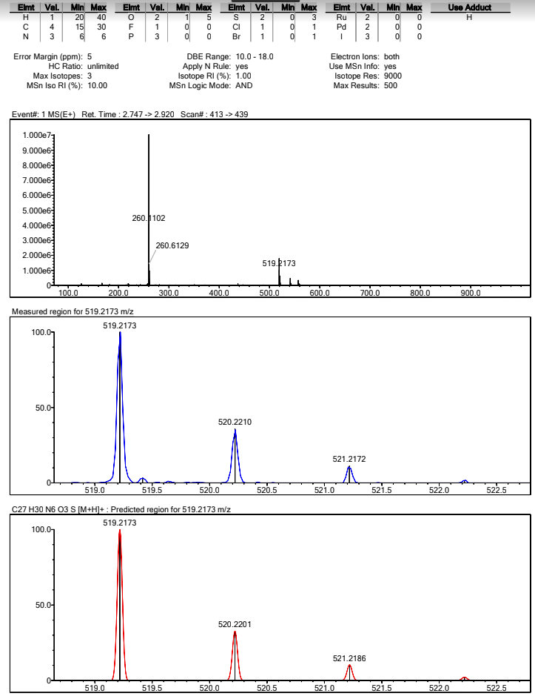
Figure 3. Mass spectrum of compound 5a
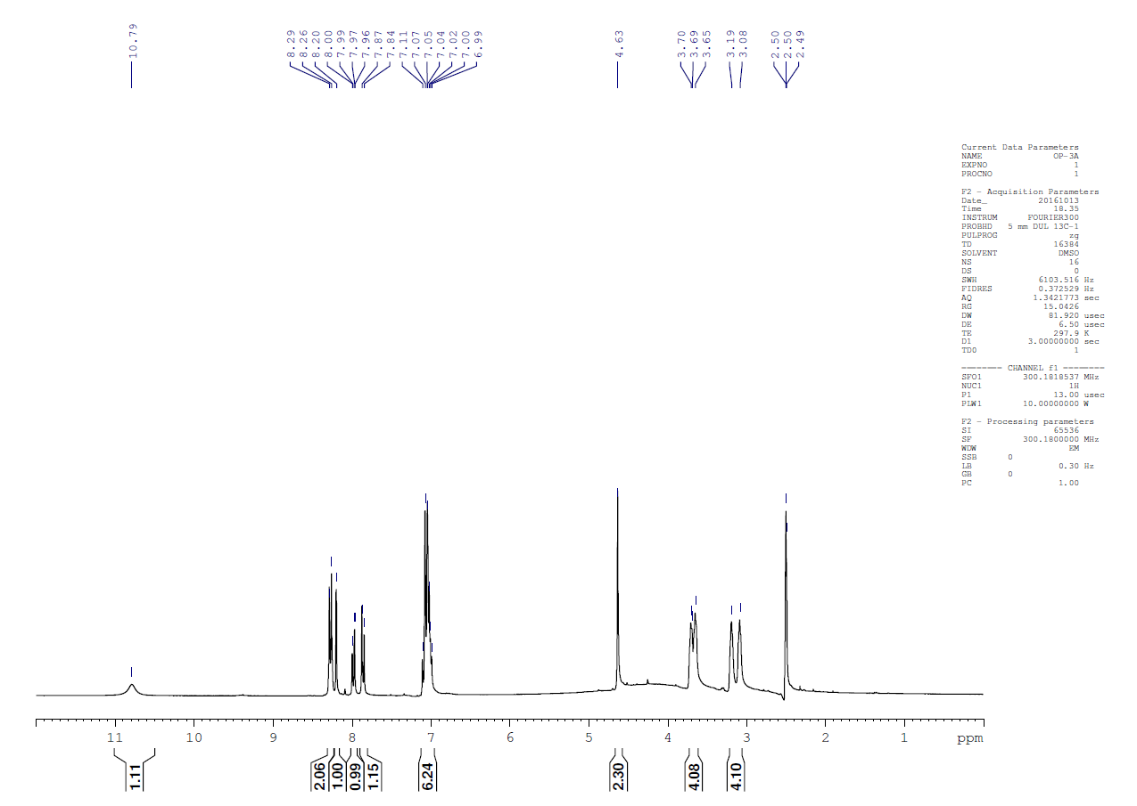
Figure 4. ¹H-NMR spectra of compound 5b
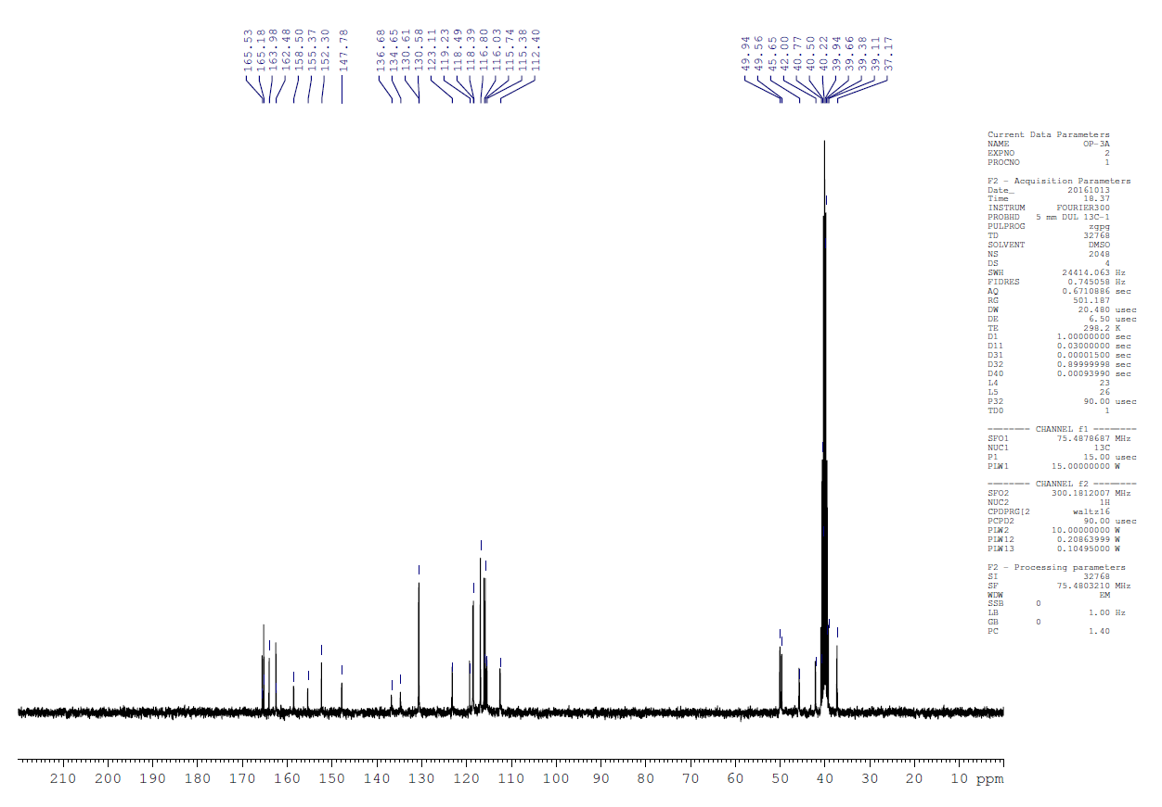
Figure 5. ¹³C-NMR spectra of compound 5b

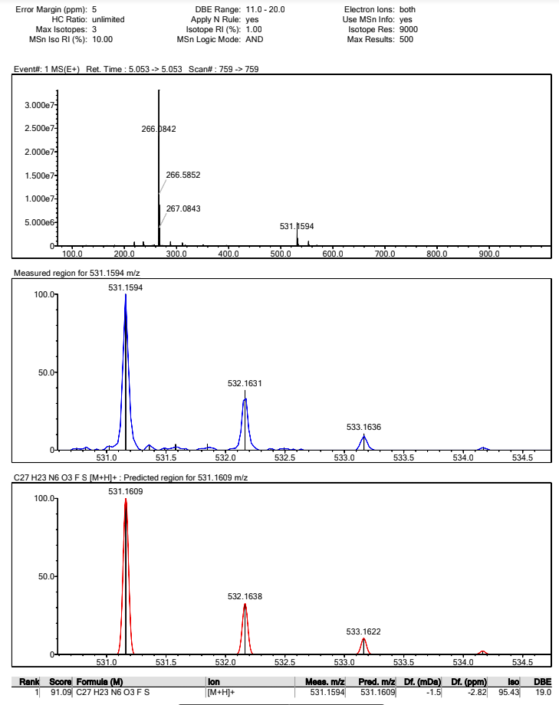
Figure 6. Mass spectrum of compound 5b
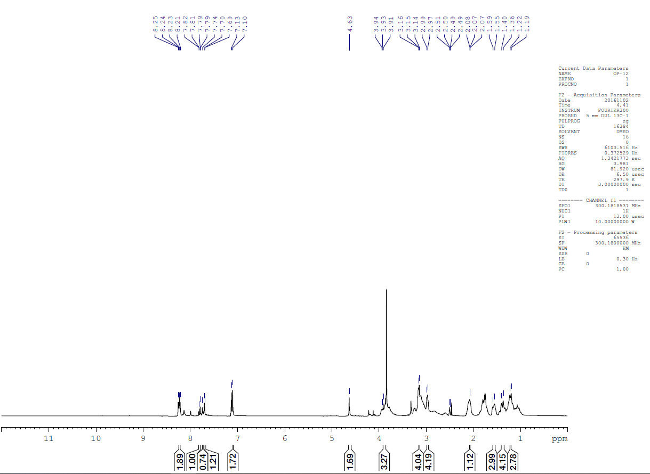
Figure 7. ¹H-NMR spectra of compound 5c
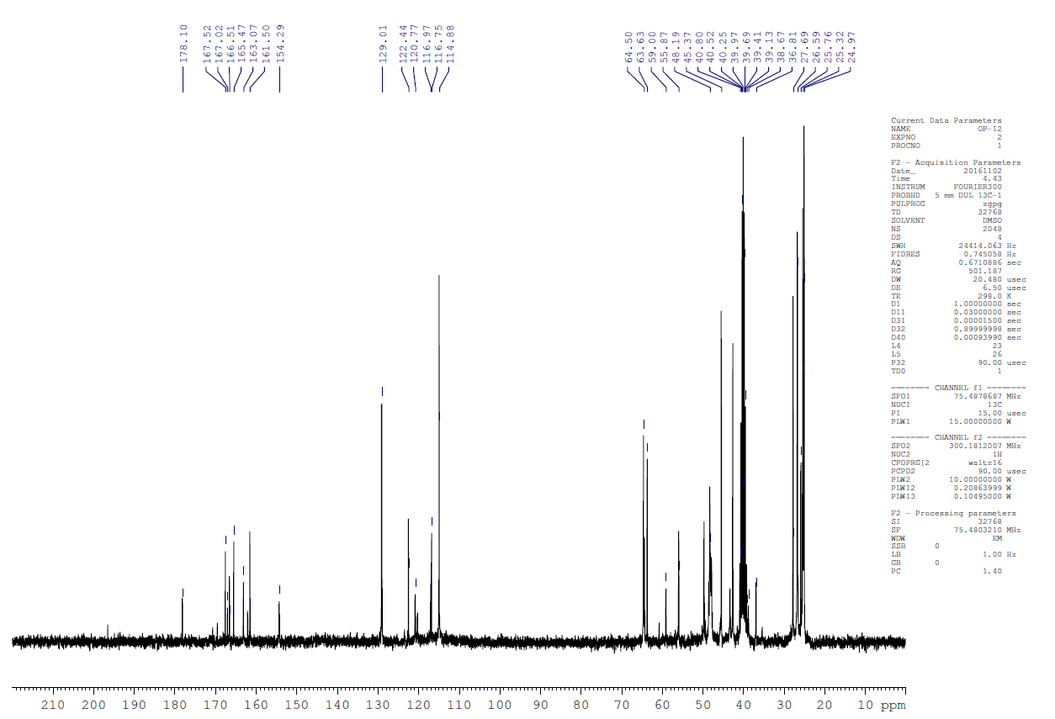
Figure 8. ¹³C-NMR spectra of compound 5c

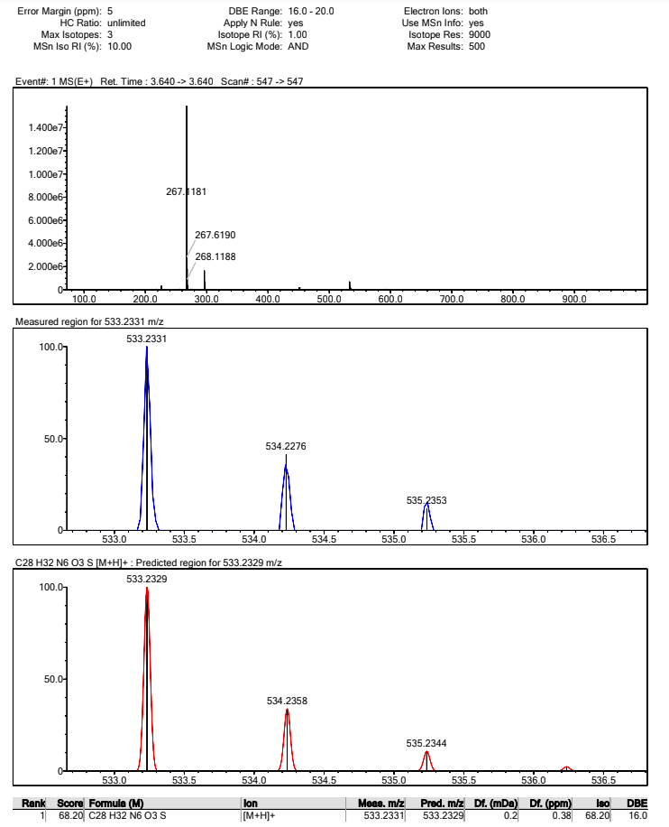
Figure 9. Mass spectrum of compound 5c
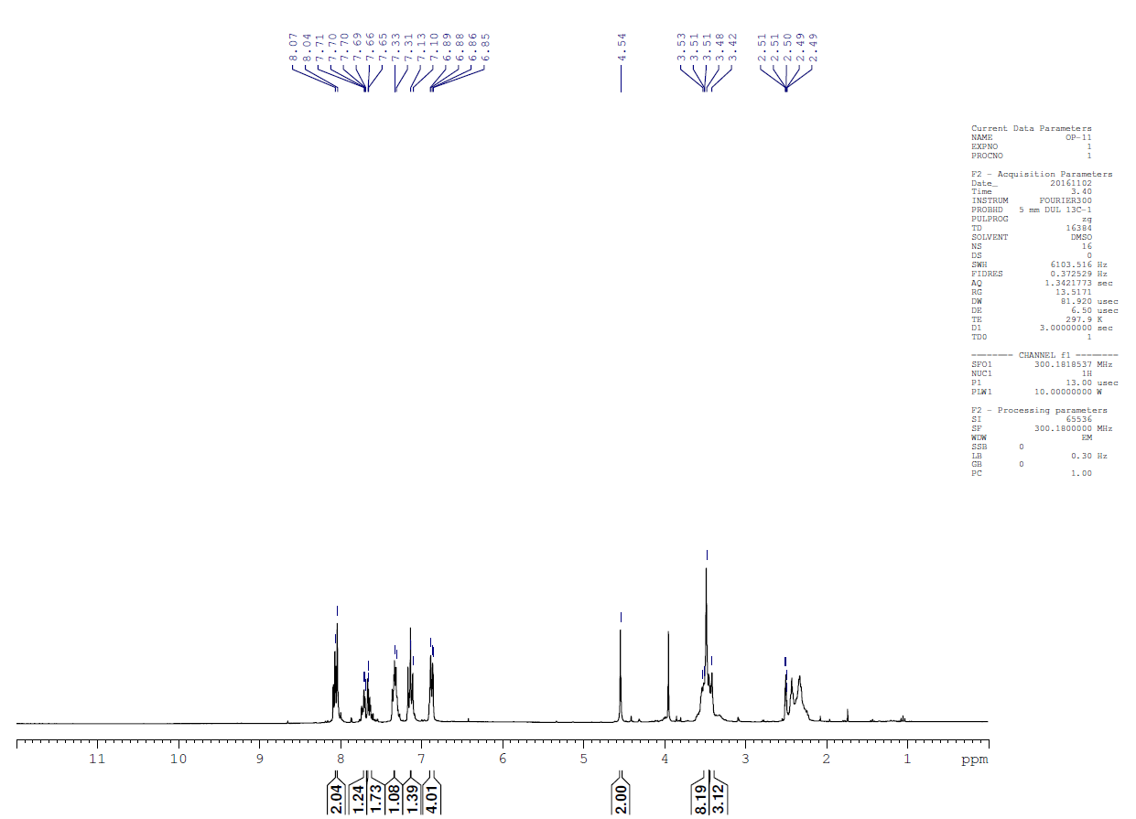
Figure 10. ¹H-NMR spectra of compound 5d
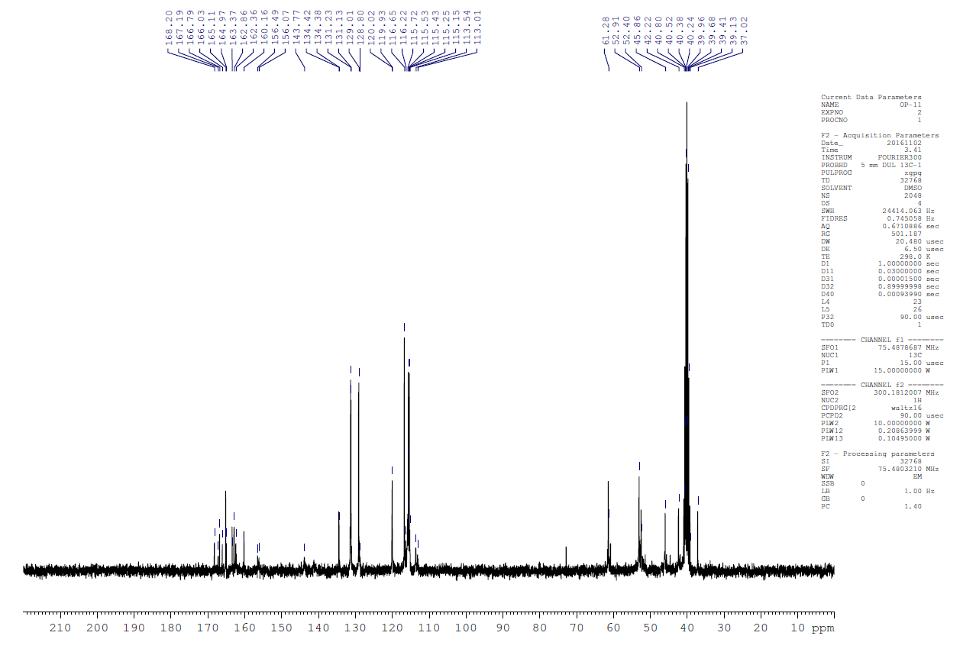
Figure 11. ¹³C-NMR spectra of compound 5d

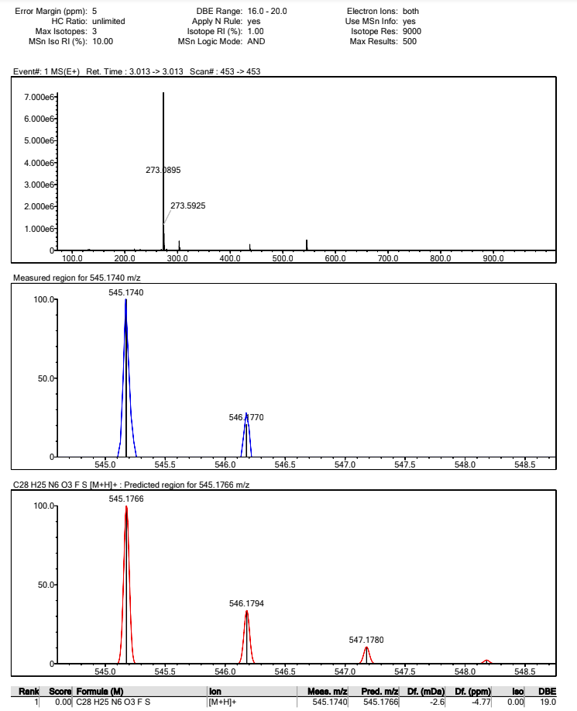
Figure 12. Mass spectrum of compound 5d
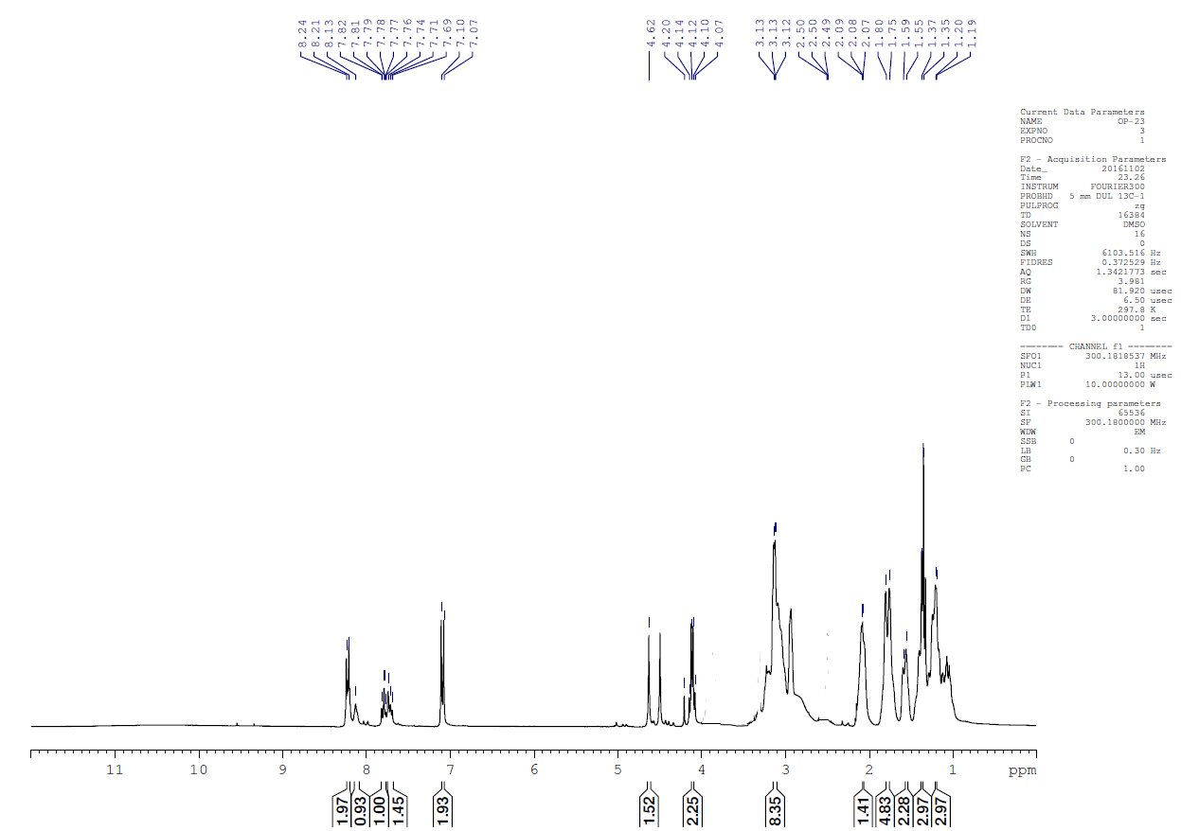
Figure 13. ¹H-NMR spectra of compound 5e
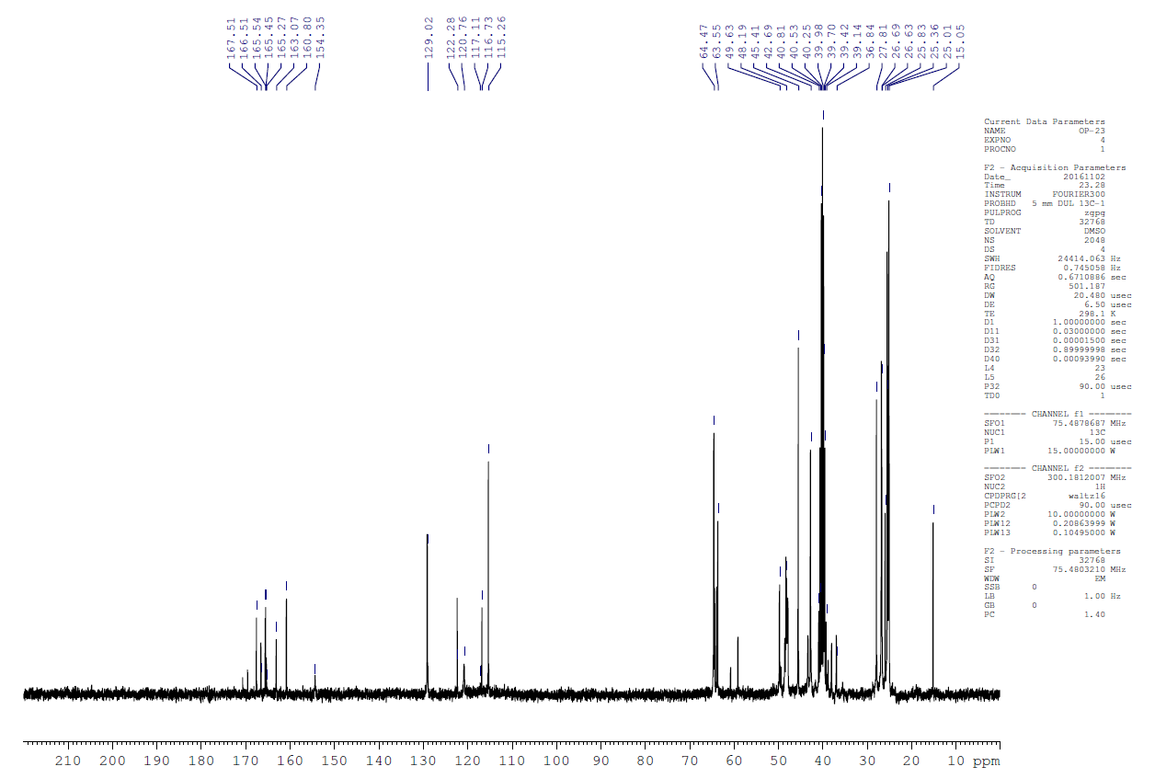
Figure 14. ¹³C-NMR spectra of compound 5e

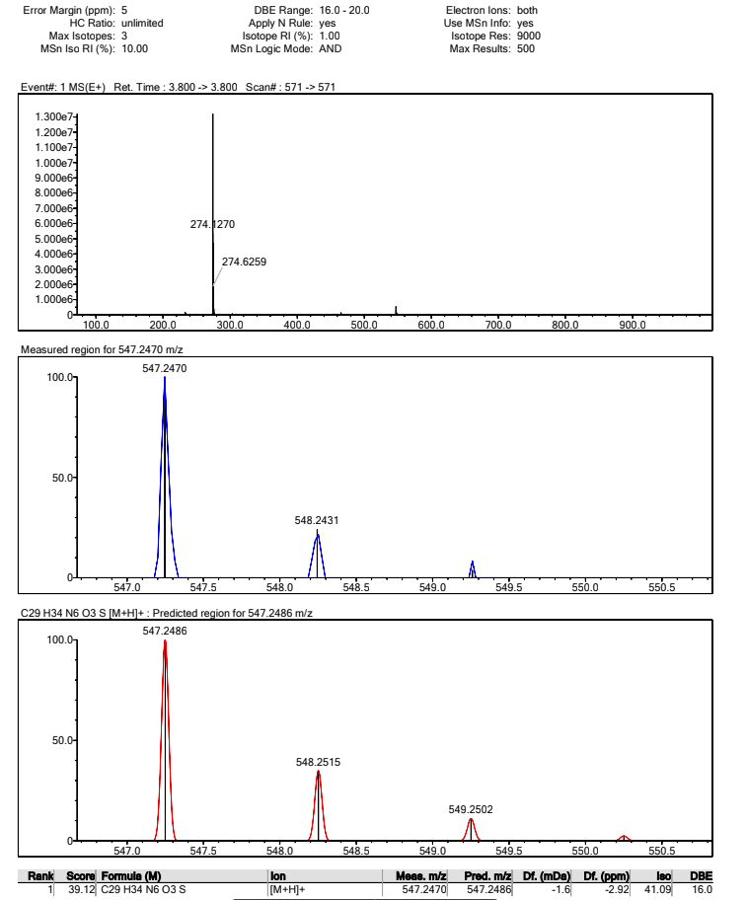
Figure 15. Mass spectrum of compound 5e
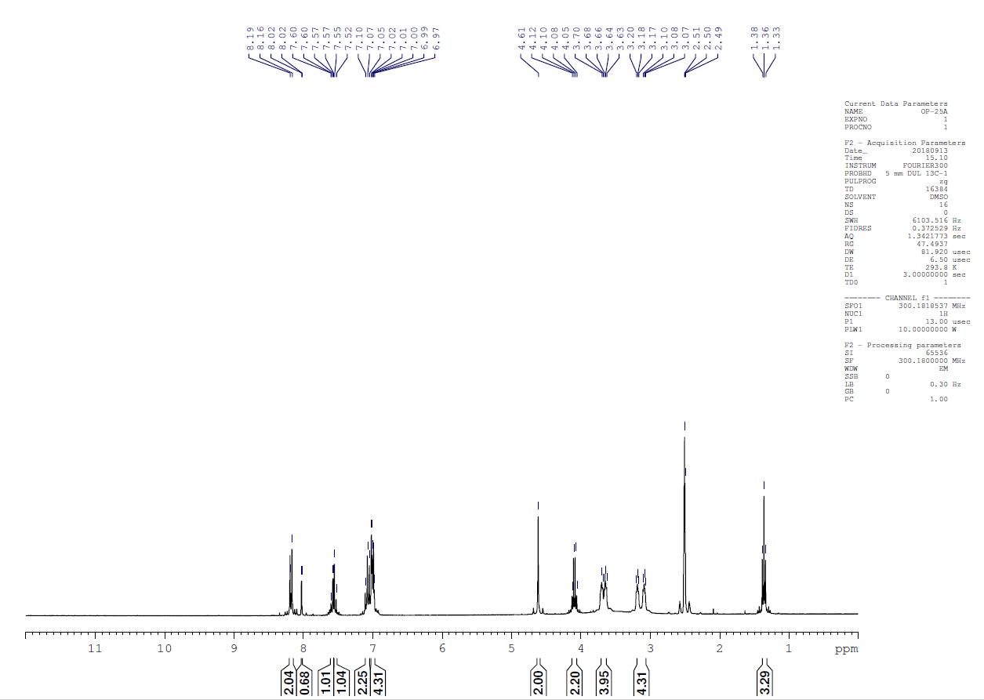
Figure 16. ¹H-NMR spectra of compound 5f
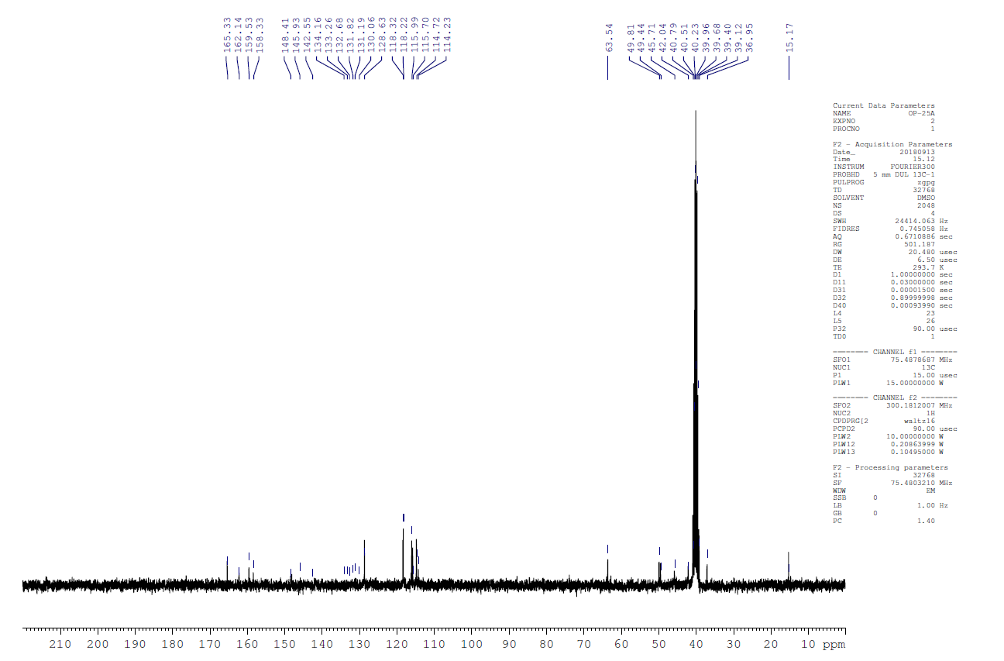
Figure 17. ¹³C-NMR spectra of compound 5e

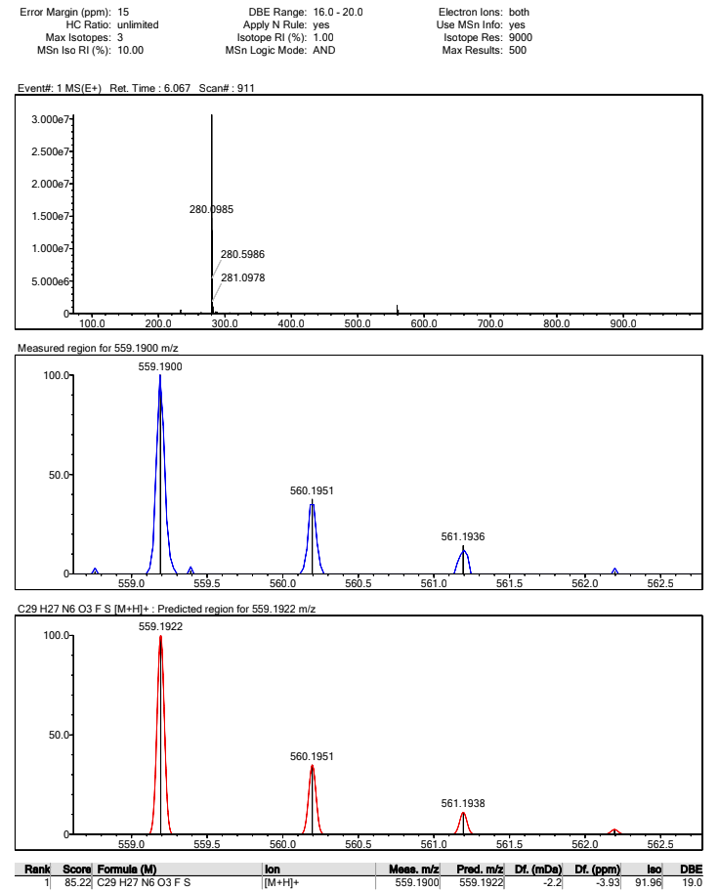
Figure 18. Mass spectrum of compound 5f

