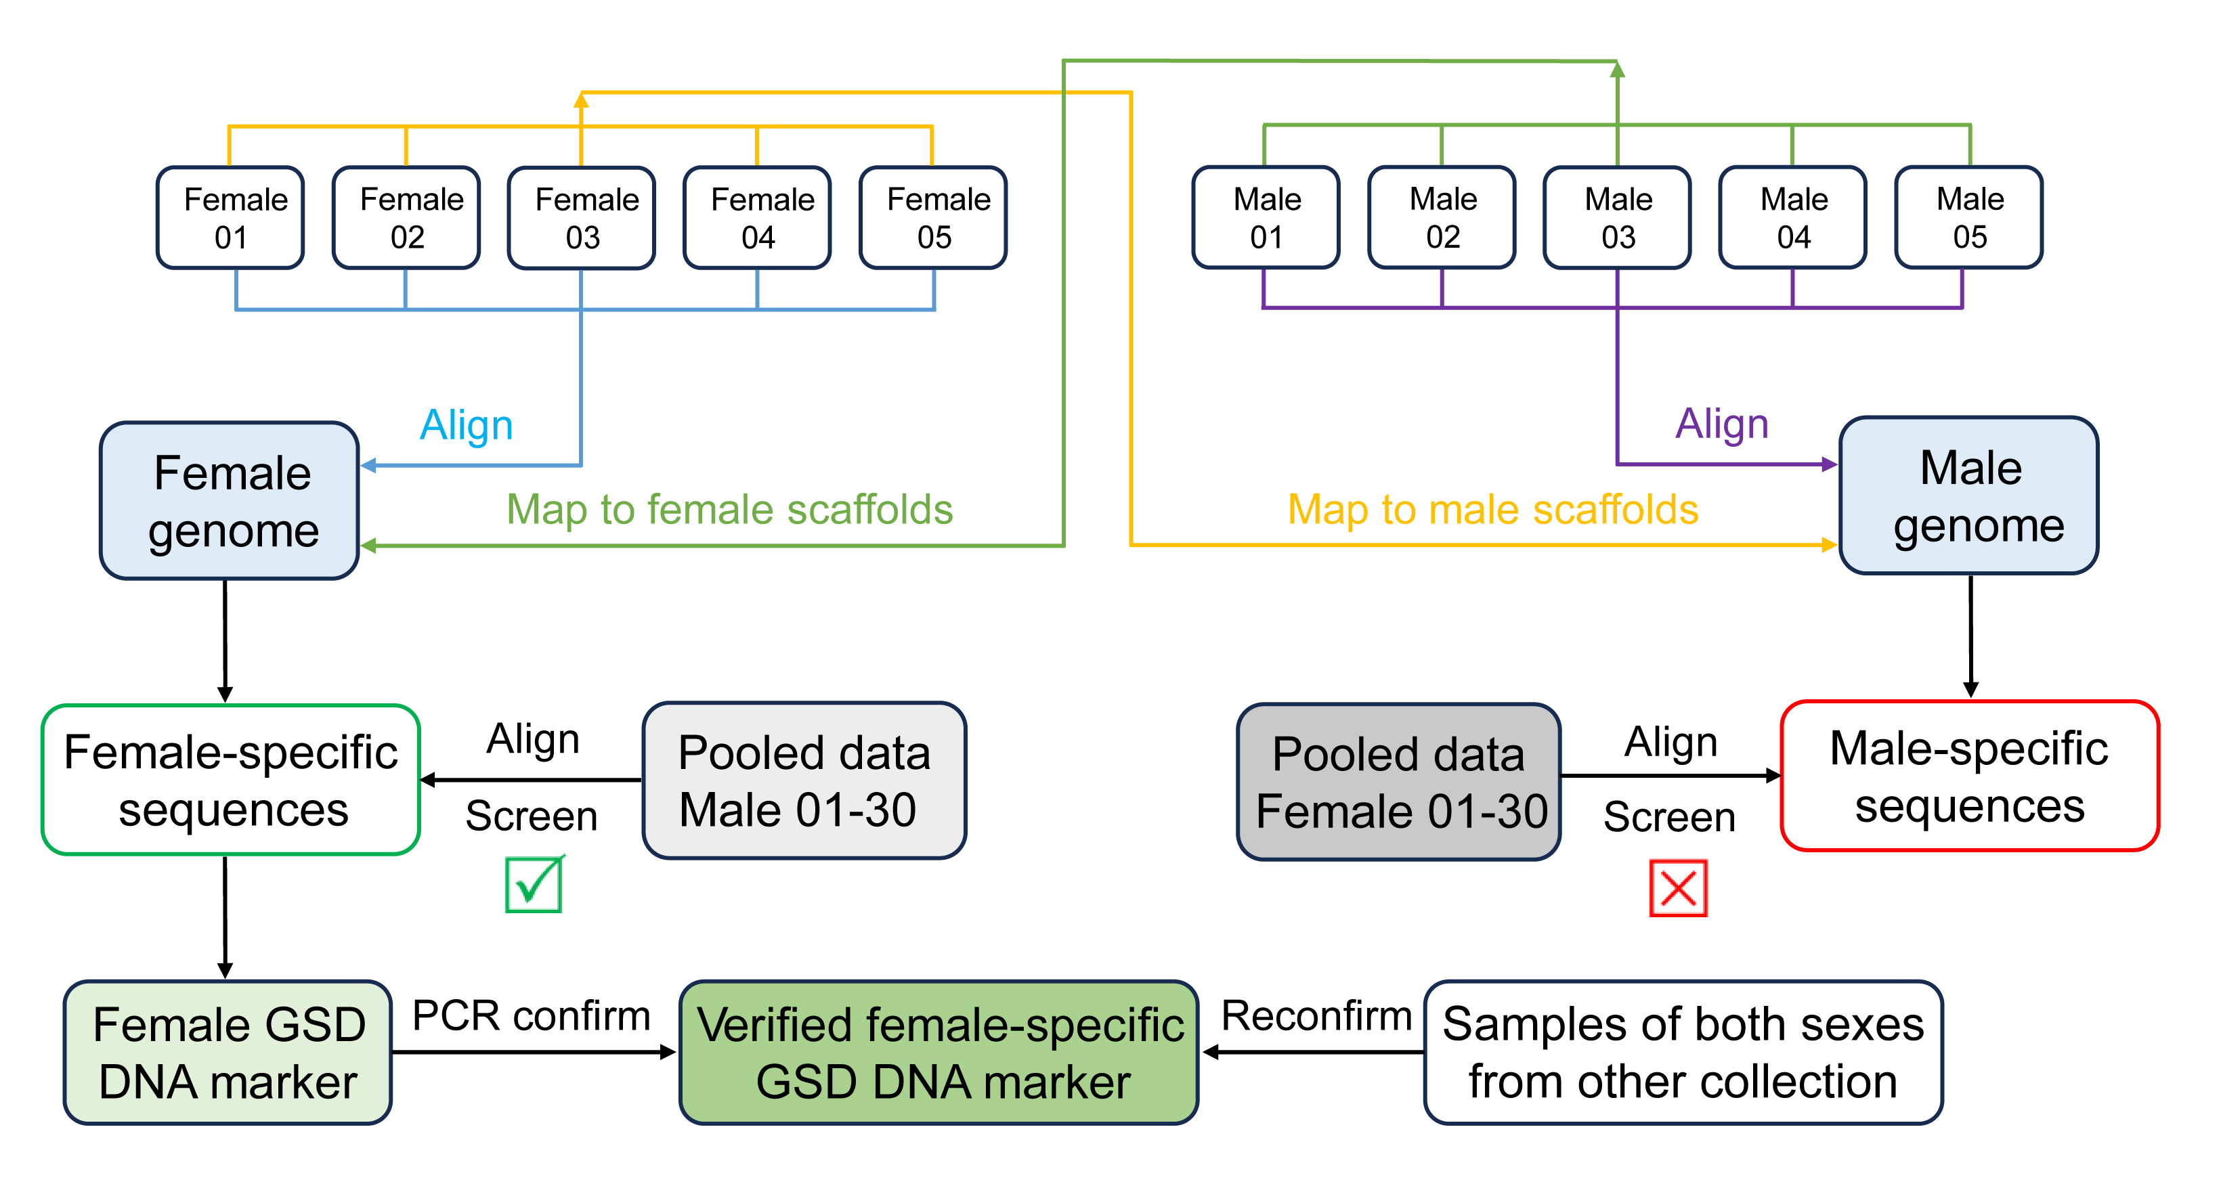
Fig. S1. The general pipeline for the screening and validation of the sex-specific molecular markers in COTS.

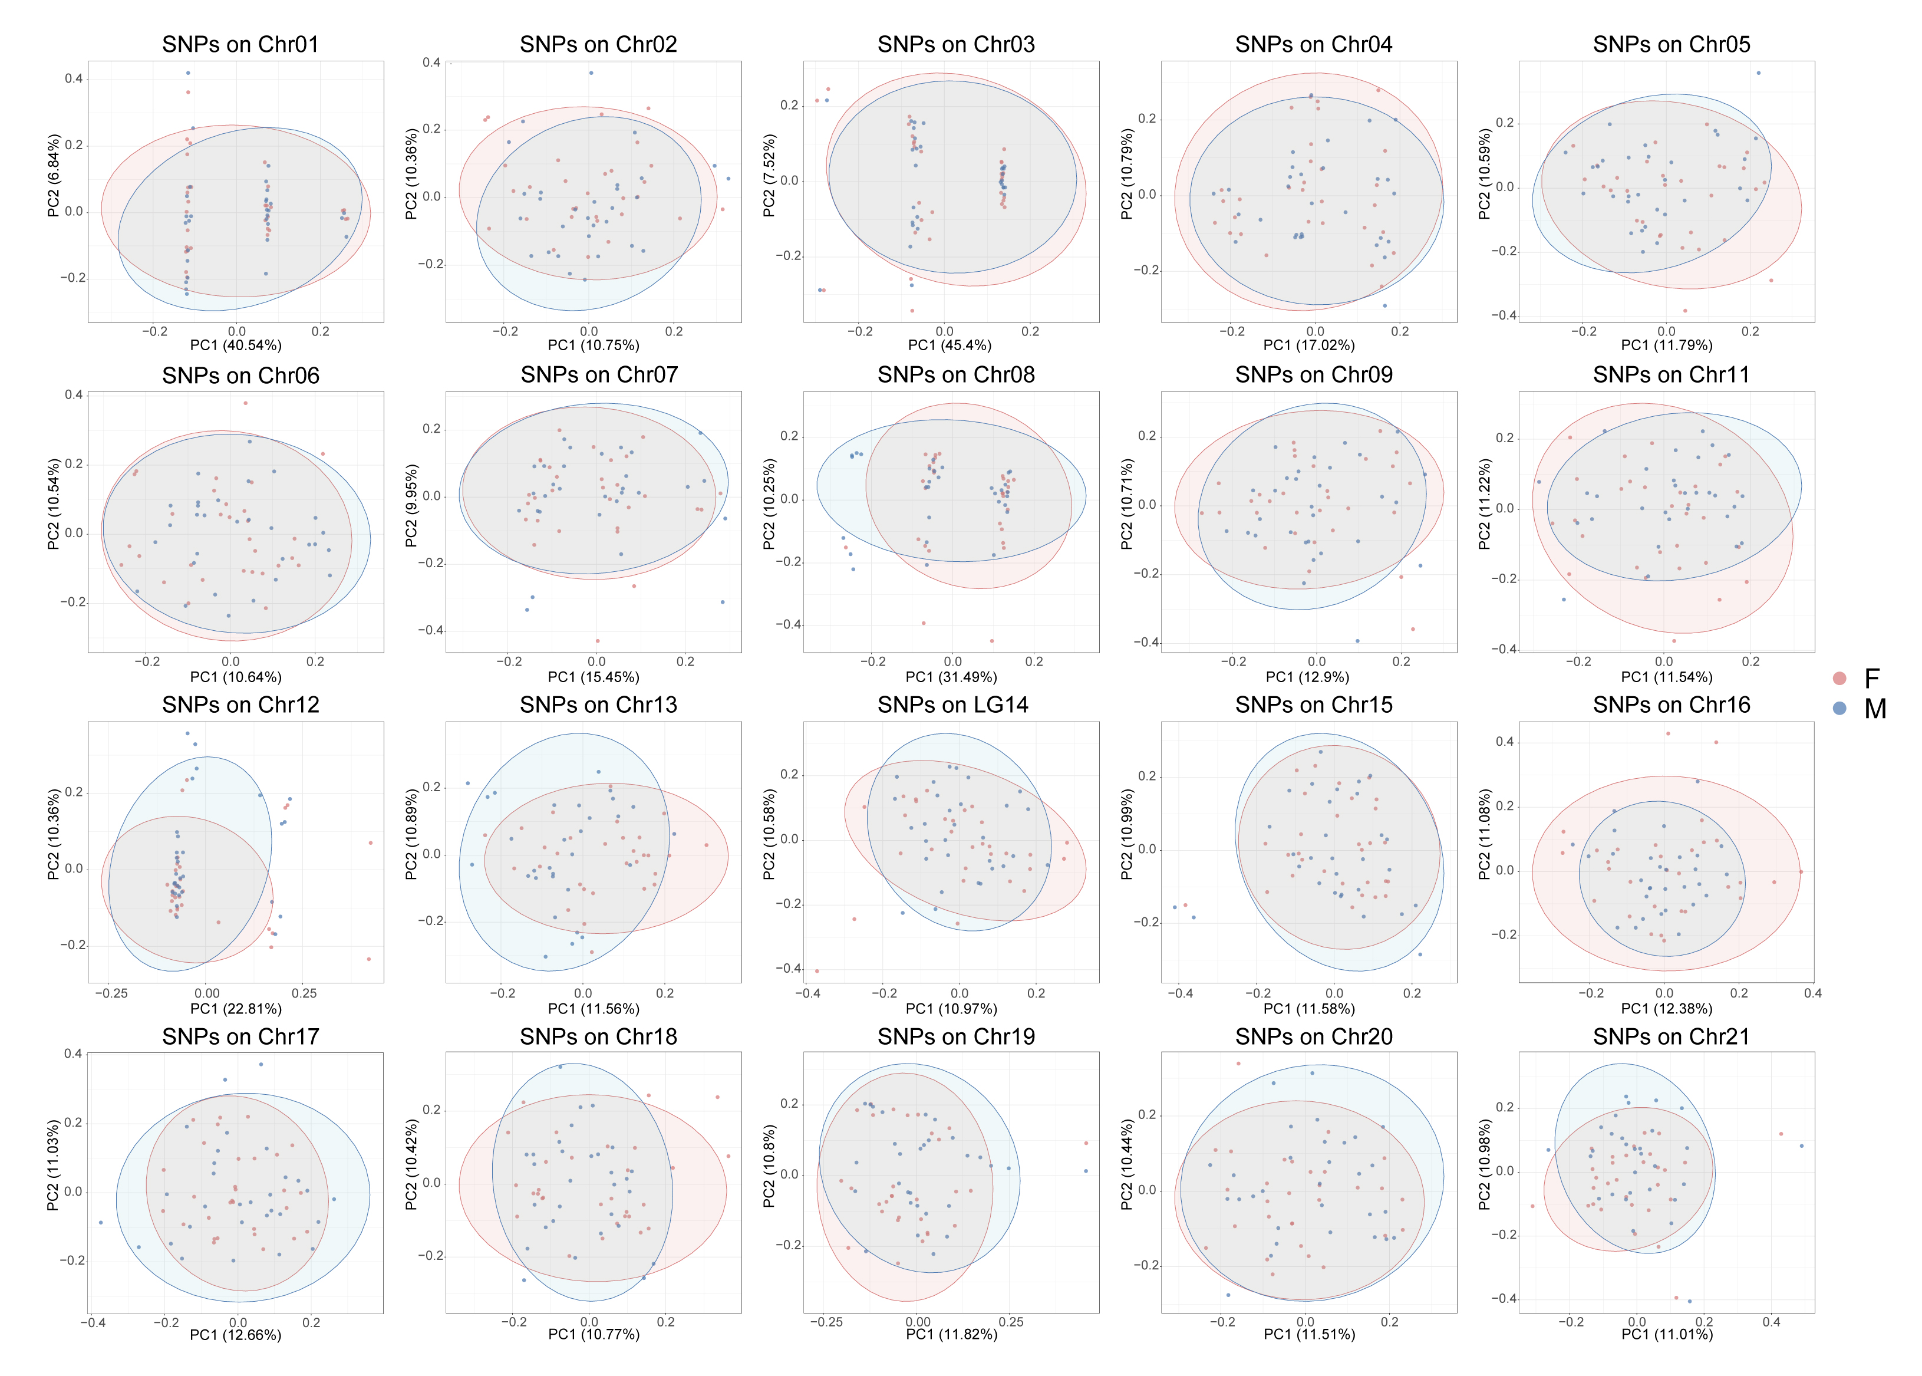
Fig. S2. PCA plot of 60 COTS individuals using SNPs on different chromosomes. Ellipses represent the 95% confidence region for each sex.

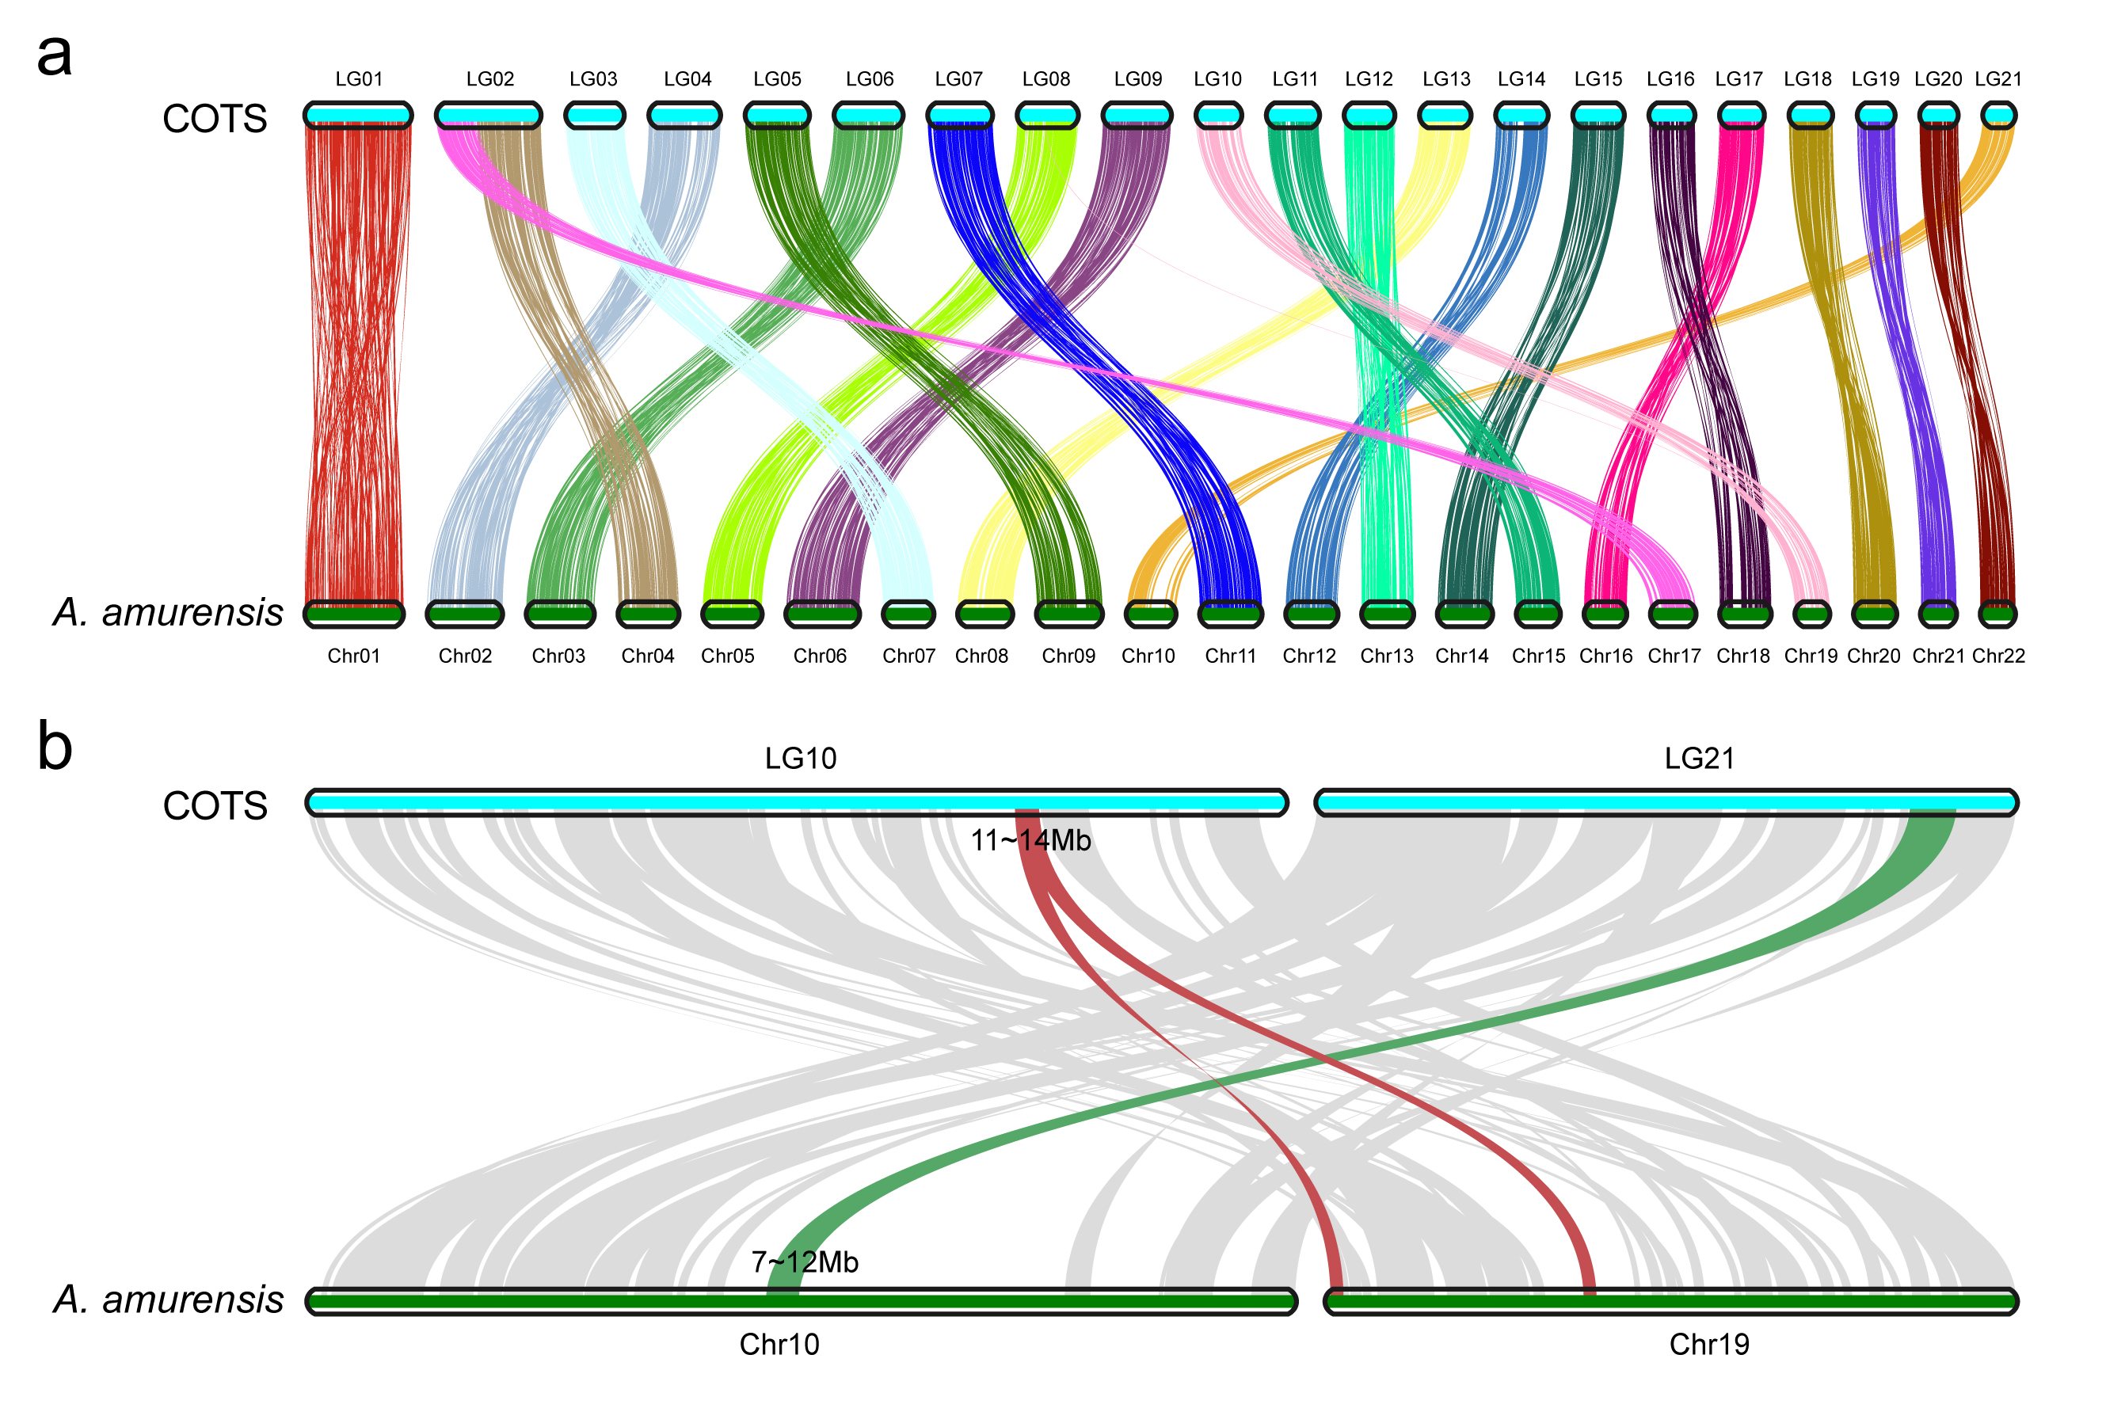
Fig. S3. Synteny comparison between COTS and A. amurensis. a Macro-synteny analysis between 21 chromosomes of COTS and 22 chromosomes of A. amurensis. Colored ribbons represent gene pairs within synteny blocks. b Micro-synteny analysis between LG10/LG21 of COTS and matching regions in A. amurensis. The ribbons show matching gene pairs: red for the candidate sex determination region of COTS; green for that of A. amurensis.

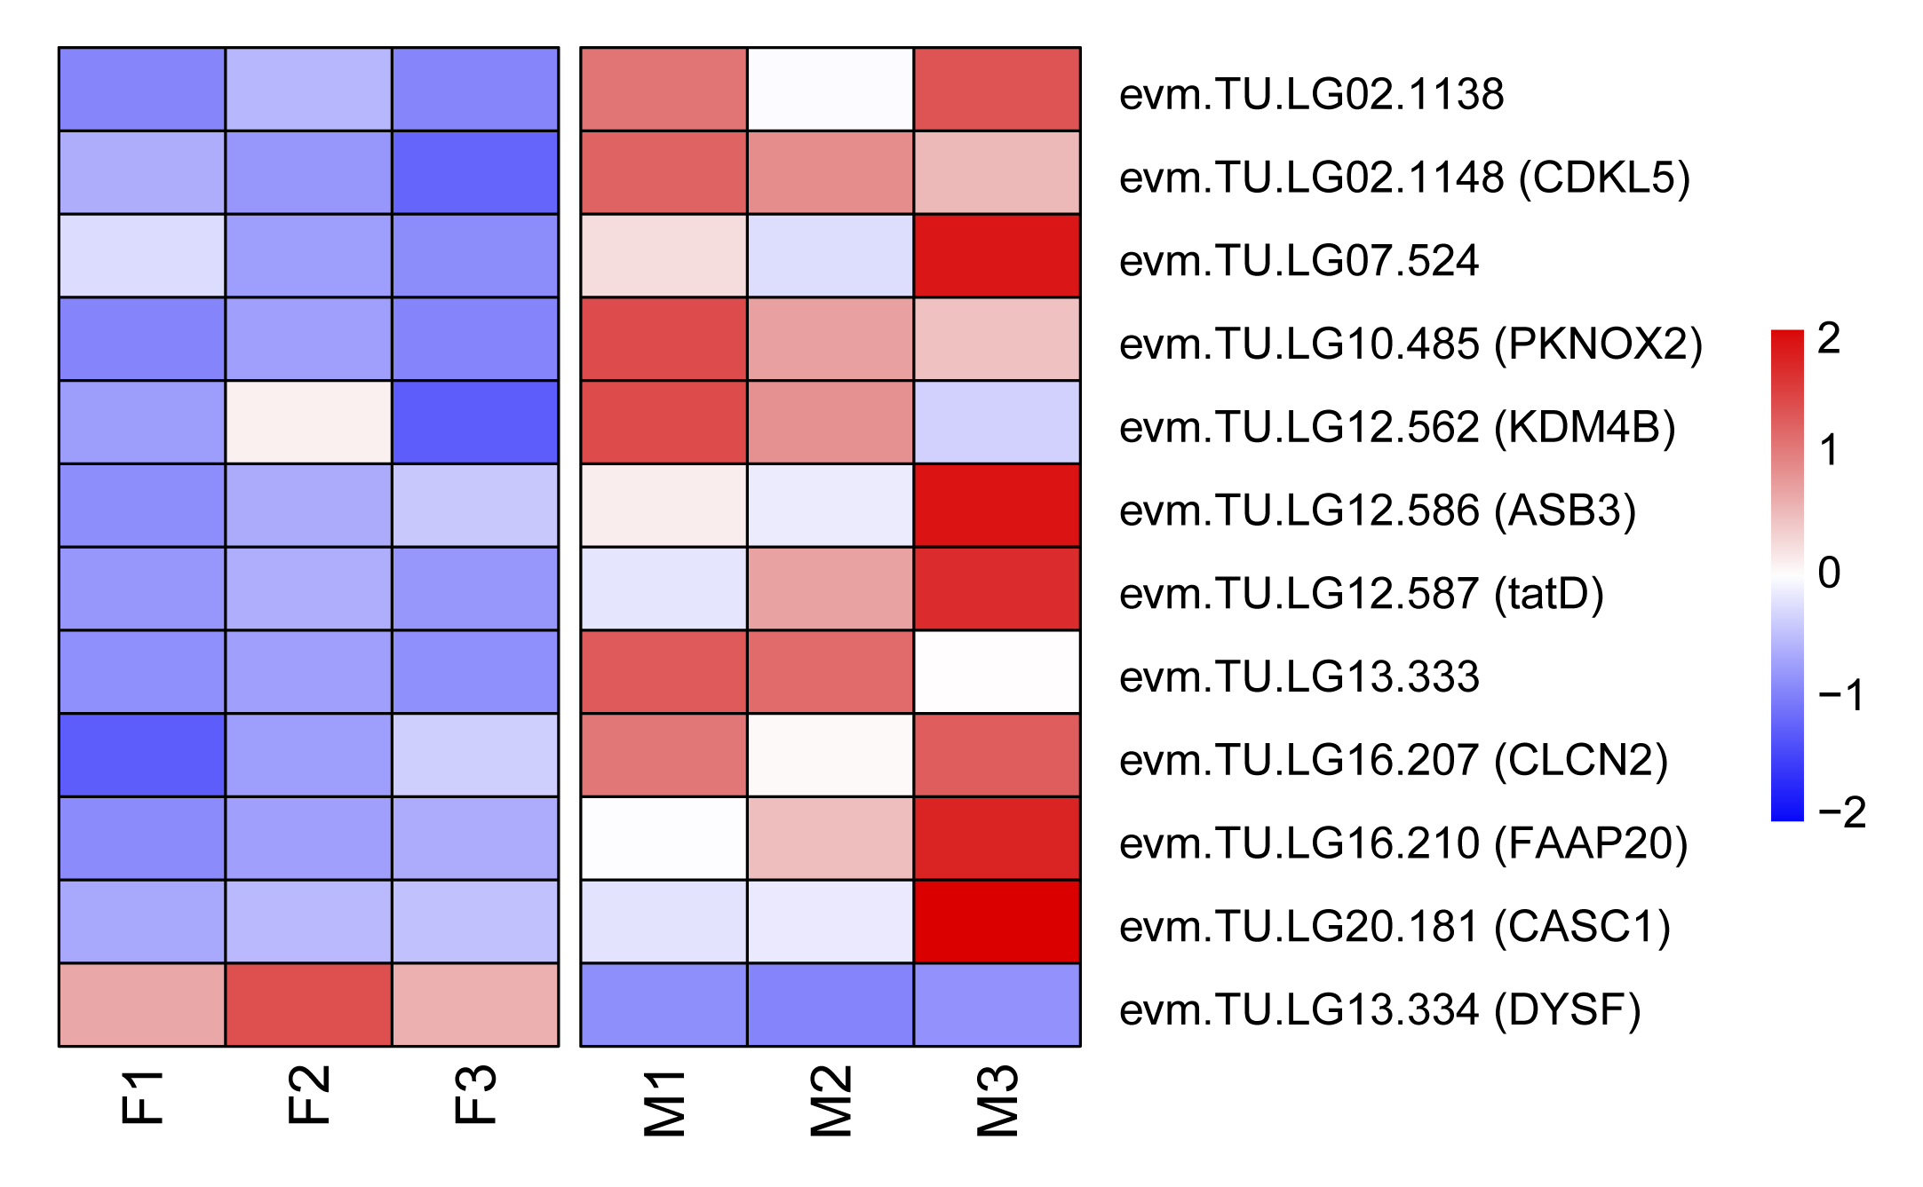
Fig. S4. Heatmap of differentially expressed genes between testes (M1, M2, M3) and ovaries (F1, F2, F3). These genes are located in genomic regions containing sex-associated SNPs. The expression values are z-score normalized across samples.

