Supplementary Figures
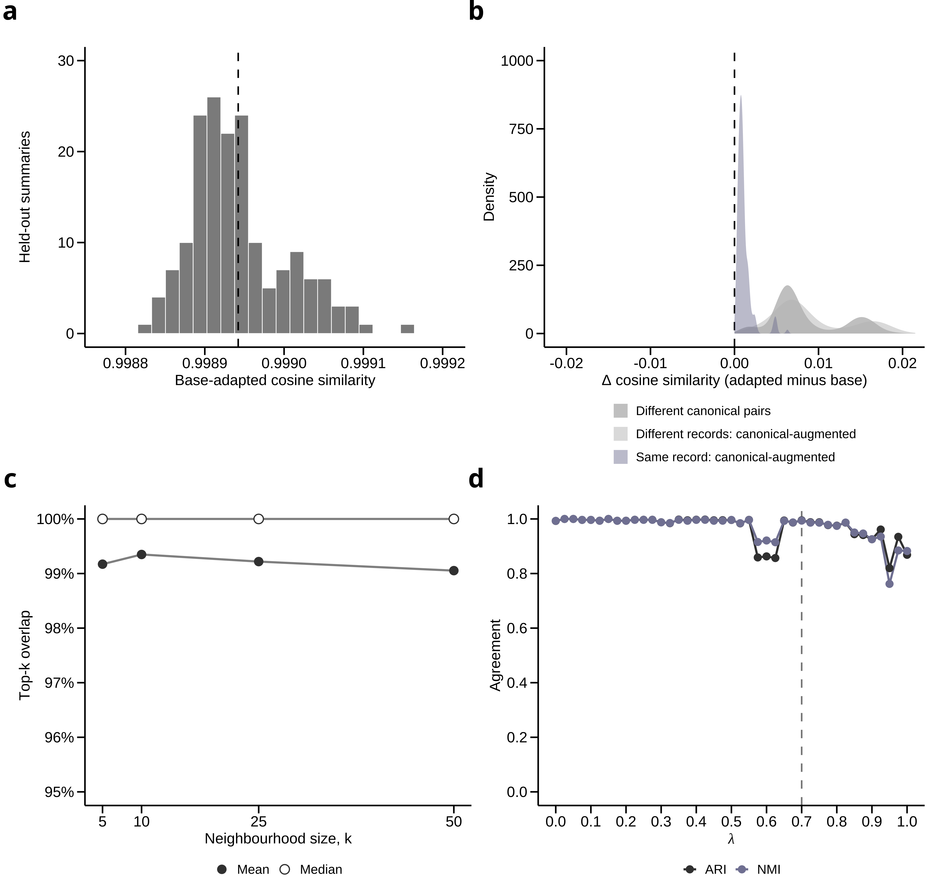
Supplementary Figure 1. Encoder adaptation diagnostics.
a, Base-versus-adapted cosine similarity for held-out canonical ACHD summaries. Mean similarity was 0.99894, with SD 0.00006, median 0.99893 and minimum 0.99883, indicating minimal embedding drift after schema adaptation. b, Change in pairwise cosine similarity after adaptation, calculated as adapted minus base similarity. Pairwise structure was preserved across held-out summaries, with Pearson r = 0.99992, Spearman ρ = 0.99986 and ΔAUROC = 0.00014 [−0.00018, 0.00054]. c, Nearest-neighbour preservation between base and adapted embedding spaces. Filled points show mean top-k overlap and open points show median overlap for k = 5, 10, 25 and 50; median overlap was 100% for all k. d, Base-versus-adapted clustering agreement across the λ sweep, measured using ARI and NMI. The dashed line marks the selected operating point, λ = 0.70, where agreement remained high (ARI = 0.995; NMI = 0.994). Together, these diagnostics show that schema adaptation preserved embedding geometry, local neighbourhood structure and clustering behaviour.
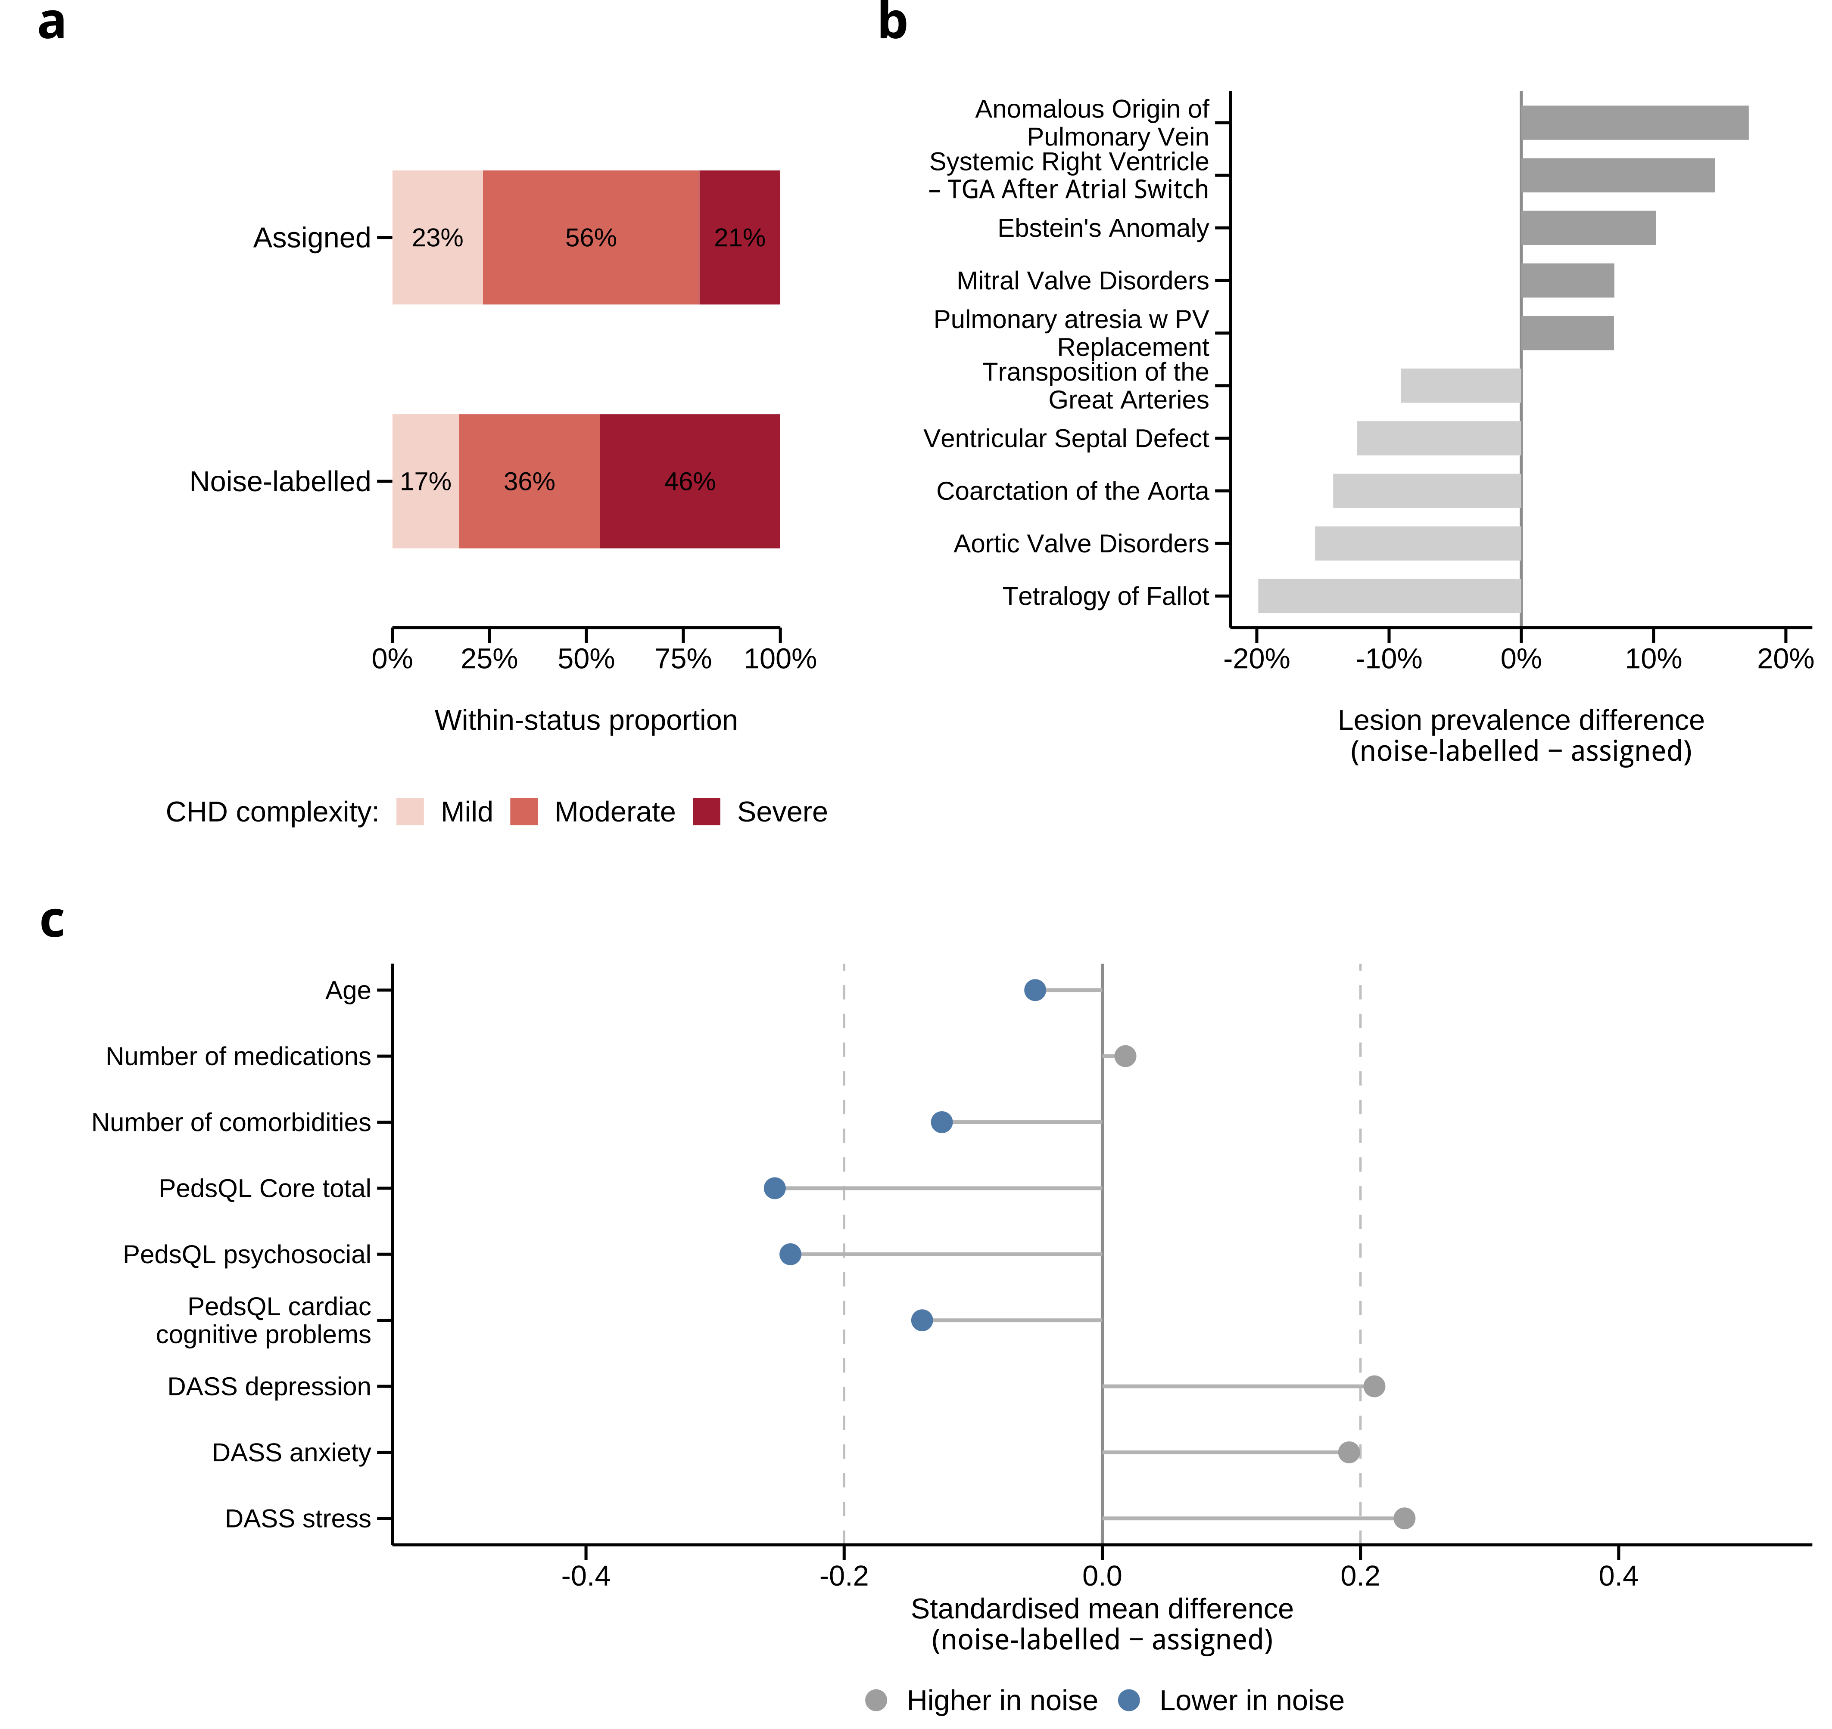
Supplementary Figure 2. Clinical profile of noise-labelled patients.
a, Distribution of CHD complexity among patients assigned to a primary semantic phenotype versus patients retained as noise by HDBSCAN. Assigned patients were pooled across all six non-noise primary phenotypes. Noise-labelled patients showed a higher proportion of severe CHD complexity than assigned patients, indicating that the noise group was not simply random residual variation. Colours indicate mild, moderate and severe CHD complexity. b, Lesion-category enrichment among noise-labelled patients, calculated as the lesion prevalence in noise-labelled patients minus the lesion prevalence in assigned patients. Positive values indicate lesion categories that were more common among noise-labelled patients, whereas negative values indicate lesion categories that were more common among assigned patients. Noise-labelled patients were enriched for several less densely represented or more heterogeneous lesion categories, including anomalous origin of pulmonary vein, systemic right ventricle/TGA after atrial switch, Ebstein’s anomaly, mitral valve disorders and pulmonary atresia with pulmonary valve replacement. c, Standardised mean differences comparing noise-labelled versus assigned patients across selected clinical and patient-reported variables. Values are calculated as noise-labelled minus assigned; positive values indicate higher mean values in noise-labelled patients, and negative values indicate lower mean values in noise-labelled patients. Grey points indicate variables higher in noise-labelled patients, while blue points indicate variables lower in noise-labelled patients. Noise-labelled patients showed higher distress scores and lower PedsQL functioning scores, supporting interpretation of the noise group as a clinically meaningful density-unstable subgroup rather than analytic failure.
Supplementary Tables
Supplementary Table 1. Encoder adaptation settings and stability diagnostics.
Item | Value
Encoder adaptation
Base encoder | BAAI/bge-large-en-v1.5
Adapted encoder | BAAI/bge-large-en-v1.5, schema-adapted
Adaptation summaries | 1,121 deterministic ACHD summaries
Train / validation / test split | 784 / 168 / 169
Training configuration | 1 epoch; batch size 32; learning rate 5 × 10⁻⁶; warm-up 0.05; max length 384; 1 augmented view per record; 6 anchor repeats; final encoder layer unfrozen
Training objective | Positive-pair cosine loss + MSE anchoring to frozen base embeddings
Parameter-change diagnostics
Largest relative L2 parameter change | ≈ 0.000888 (encoder layer 23)
Relative L2 change in most other encoder layers | ≈ 0.000016–0.000020
Embedding preservation
Base-adapted cosine similarity | Mean 0.998942; SD 0.000060; minimum 0.998828; 1st percentile 0.998842
Pairwise geometry preservation
Pairwise comparisons | 14,196 held-out canonical pairs
Base-vs-adapted pairwise similarity correlation | Pearson r = 0.999920; Spearman ρ = 0.999863 across 14,196 held-out canonical pairs
Same-vs-different discrimination
AUROC stability | Base 0.99352; adapted 0.99366; ΔAUROC +0.00014, 95% CI, -0.00018 to +0.00054
Nearest-neighbour preservation
Top-k neighbour overlap | Mean overlap 99.05–99.35%; median overlap 100% for k = 5, 10, 25 and 50
λ = 0.70 clustering stability
Phenotype solution | Base: 6 clusters, 726/155 clustered/noise; adapted: 6 clusters, 724/157 clustered/noise
Lesion coherence | Weighted dominant lesion share: base = 0.8209, adapted = 0.8218; adapted diagnosis fragmentation 0.000
Base-vs-adapted agreement | ARI 0.995; NMI 0.994; common non-noise ARI/NMI 1.000/1.000
ACHD, adult congenital heart disease; ARI, adjusted Rand index; AUROC, area under the receiver-operating-characteristic curve; NMI, normalised mutual information; SD, standard deviation. Δ values are calculated as adapted minus base. Weighted dominant lesion share operationalised lesion coherence.

Supplementary Table 2. Held-out validation variables used in Figure 6.
Characteristic | Overall cohort
Continuous held-out validators
Cardiac Anxiety Questionnaire score | 22.0 [15.0, 30.0]; n = 879
Connor-Davidson Resilience Scale score | 29.0 [23.0, 34.0]; n = 872
Impact of Event Scale-Revised score | 0.1 [0.0, 0.5]; n = 878
PROMIS Sleep Disturbance T-score | 50.2 [43.9, 55.3]; n = 875
6-minute walk distance | 557.0 [486.0, 621.0]; n = 547
Binary held-out clinical/burden validators
NYHA class II–IV | 549/846 (64.9%)
Employment impact | 192/852 (22.5%)
Employment changes | 232/834 (27.8%)
Education impact | 161/879 (18.3%)
Education changed | 184/879 (20.9%)
Learning difficulties | 263/879 (29.9%)
Fell behind in education | 305/878 (34.7%)
Assessment difficulties | 123/878 (14.0%)
Social involvement difficulties | 296/878 (33.7%)
ED use burden | 215/866 (24.8%)
Multiple specialist doctors | 259/869 (29.8%)
Values are median [IQR]; n, or n/N (%). These variables were held out from clinical-summary generation, encoder adaptation, λ selection, primary clustering, burden-axis construction and subphenotype assignment, and were used only for downstream validation in Figure 6. CAQ, Cardiac Anxiety Questionnaire; CD-RISC, Connor-Davidson Resilience Scale; ED, emergency department; IES-R, Impact of Event Scale-Revised; IQR, interquartile range; NYHA, New York Heart Association; PROMIS, Patient-Reported Outcomes Measurement Information System

Supplementary Table 3. λ-sweep sensitivity for primary phenotype discovery.
λ | Primary phenotypes | Assigned / noise-labelled patients | Lesion coherence | Diagnosis fragmentation
0.00 | 8 | 612 / 269 (30.5% noise) | 0.868 | 0.350
0.10 | 8 | 612 / 269 (30.5% noise) | 0.866 | 0.348
0.20 | 8 | 607 / 274 (31.1% noise) | 0.867 | 0.344
0.30 | 8 | 598 / 283 (32.1% noise) | 0.863 | 0.333
0.40 | 7 | 706 / 175 (19.9% noise) | 0.793 | 0.144
0.50 | 7 | 699 / 182 (20.7% noise) | 0.794 | 0.139
0.60 | 7 | 688 / 193 (21.9% noise) | 0.799 | 0.137
0.70 | 6 | 724 / 157 (17.8% noise) | 0.822 | 0.000
0.80 | 6 | 669 / 212 (24.1% noise) | 0.855 | 0.000
0.90 | 6 | 442 / 439 (49.8% noise) | 0.939 | 0.000
1.00 | 3 | 364 / 517 (58.7% noise) | 0.179 | 1.544
λ denotes the weighting of patient-reported outcome content in the semantic representation. The selected operating point was λ = 0.70. Assigned patients are those allocated to a primary HDBSCAN phenotype; noise-labelled patients were retained as density-unstable observations. Lesion coherence is reported as the weighted dominant lesion share. Diagnosis fragmentation quantifies whether the same lesion category was split across multiple dominant primary phenotypes.

Supplementary Table 4. Full held-out validation model estimates for Figure 6.
Supplementary Table 4a. Continuous held-out validation model estimates.
Outcome | n | ΔSD [95% CI] | p value | Adj. R² A / A+S
Cardiac anxiety | 722 | 0.96 [0.83, 1.08] | <0.001 | 0.072 / 0.296
Resilience | 717 | −0.87 [−1.01, −0.74] | <0.001 | 0.033 / 0.222
Trauma symptoms | 721 | 0.72 [0.58, 0.85] | <0.001 | 0.022 / 0.147
Sleep disturbance | 719 | 0.68 [0.54, 0.82] | <0.001 | 0.016 / 0.131
6-minute walk distance | 459 | −0.48 [−0.65, −0.30] | <0.001 | 0.080 / 0.133

Supplementary Table 4b. Binary held-out validation model estimates.
Outcome | n | Lower % | Higher % | RD, pp [95% CI] | AUC A / A+S
NYHA class II-IV | 695 | 45.7 | 81.1 | 35.3 [28.3, 41.0] | 0.735 / 0.822
Employment impact | 701 | 6.7 | 36.5 | 29.8 [24.6, 35.4] | 0.667 / 0.800
Employment changes | 686 | 14.1 | 37.5 | 23.5 [16.8, 29.6] | 0.671 / 0.746
Fell behind in education | 721 | 18.4 | 51.0 | 32.6 [25.4, 38.8] | 0.616 / 0.739
Learning difficulties | 722 | 16.0 | 43.0 | 27.0 [20.4, 32.9] | 0.638 / 0.734
Education impact | 722 | 7.9 | 28.0 | 20.1 [14.9, 25.7] | 0.655 / 0.751
Education changed | 722 | 10.9 | 29.1 | 18.2 [12.8, 23.7] | 0.669 / 0.730
Assessment difficulties | 722 | 7.5 | 20.3 | 12.7 [8.2, 17.9] | 0.743 / 0.787
Social involvement difficulties | 721 | 17.2 | 47.0 | 29.8 [23.6, 35.5] | 0.665 / 0.752
ED use burden | 714 | 20.6 | 29.3 | 8.7 [2.6, 14.9] | 0.596 / 0.612
Multiple specialist doctors | 713 | 24.5 | 34.7 | 10.2 [3.8, 16.6] | 0.623 / 0.642
ΔSD denotes the adjusted higher- versus lower-burden subphenotype difference in standard deviation units. Lower % and Higher % denote adjusted probabilities expressed as percentages. RD, pp denotes the marginal standardised risk difference expressed in percentage points, with simulation-based 95% confidence intervals; p-values were not separately reported for binary outcomes. Models were adjusted for age, sex, remoteness, CHD complexity and primary phenotype cluster. A denotes anatomy-based model; A+S denotes anatomy plus subphenotype model. Adj. R², adjusted coefficient of determination; AUC, area under the receiver-operating-characteristic curve; CHD, congenital heart disease; ED, emergency department; NYHA, New York Heart Association; RD, risk difference.

