Projected Amazon forest loss alters tropical Atlantic circulation and surface heat exchange through reduced freshwater input
Nelson de Almeida Gouveia^{1,2}, Sly Wongchuig³, Jhan-Carlo Espinoza^{4,5}, Luiz E. O. C. Aragão⁶, Eduardo Tavares Paes⁷, Ramon Batista Santos⁶, and Douglas F. M. Gherardi⁶
Author Information
Affiliations
¹ Spectral and Remote Sensing Lab, Department of Geography, University of Victoria, Victoria, BC, Canada
²Federal University of Pará, Perimetral Avenue, 2651 - Guama, Belém, PA 66077-830, Brazil
³ University of Toulouse, LEGOS (CNES/CNRS/IRD/UT3), Toulouse, France
⁴University of Grenoble Alpes, IRD, CNRS, Grenoble INP, Institute of Environmental Geosciences (IGE, UMR 5001), Grenoble, France
⁵ Institute for Research on Mathematics Education, Pontifical Catholic University of Peru, 15088 Lima, Peru
⁶ Laboratory of Ocean and Atmosphere Studies (LOA), Division of Earth Observation and Geoinformatics, National Institute for Space Research (INPE), São José dos Campos, SP, Brazil, e-mail: douglas.gherardi@inpe.br., orcid 0000-0003-3471-7213.
⁷Social-Environmental and Water Resources Institute, Federal Rural University of Amazon, Belém, Brazil
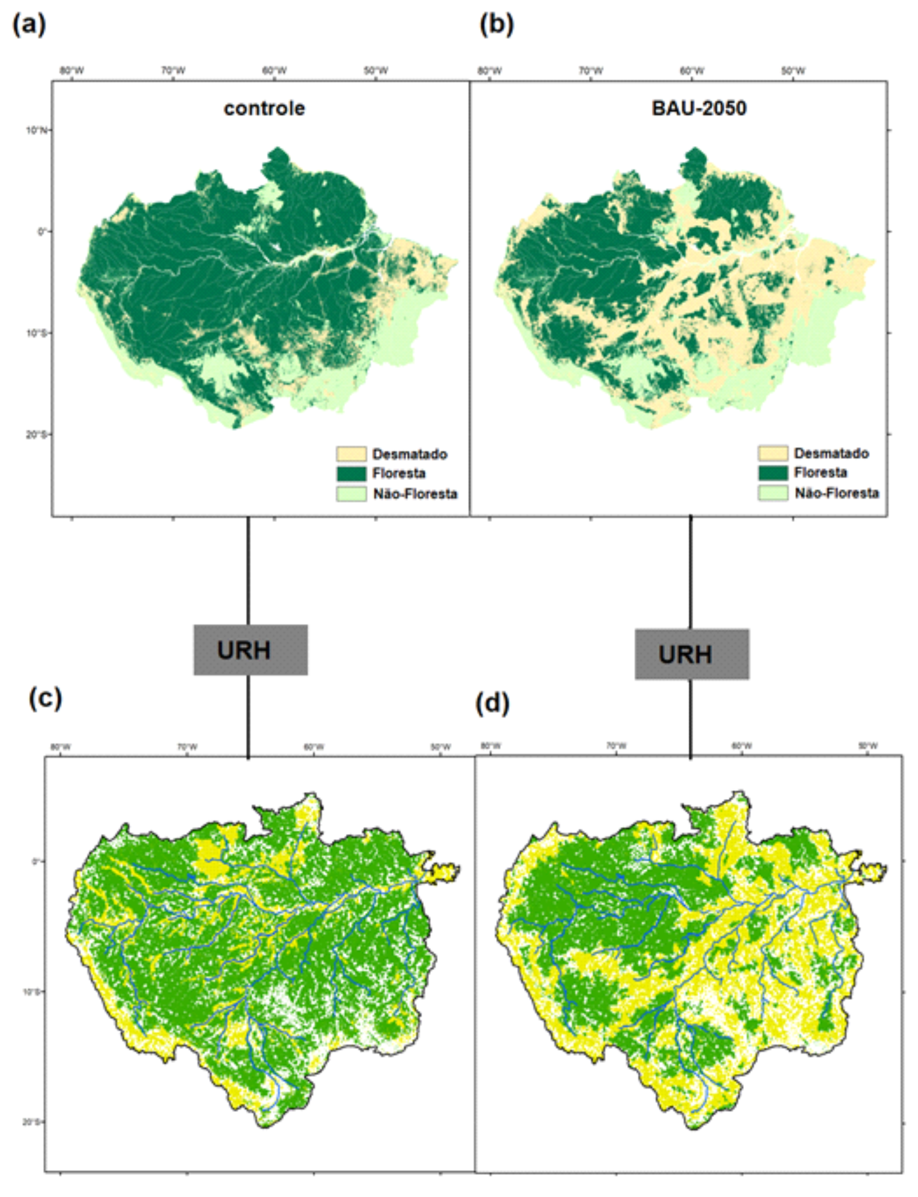
Fig. S1: Classification of land use and land cover for the control scenario (a) and considering the BAU 2050 (b) and the HRUs (c and d) obtained from each land use and land cover scenario, respectively..

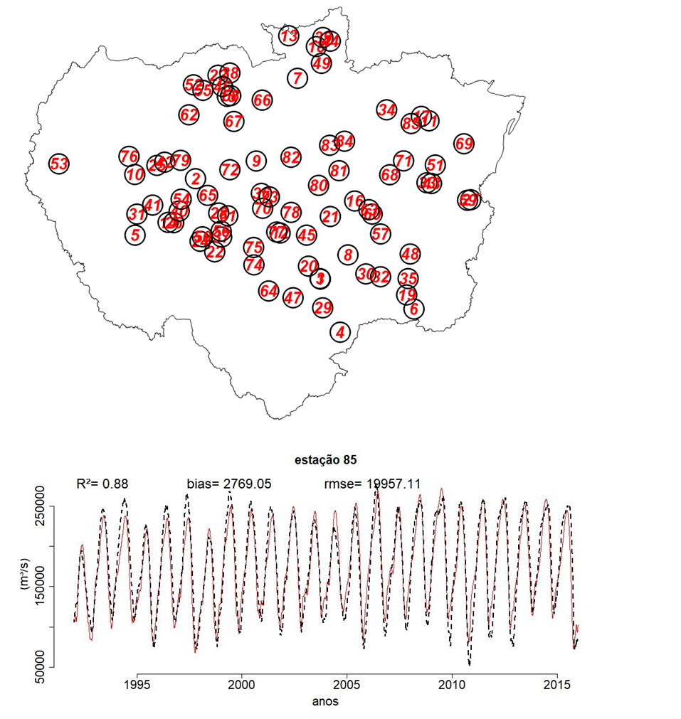

Fig. S2. Streamflow gauges used to compare observed (red line) and MGB-modeled discharges (black dashed line) from 1992 to 2015. The upper map displays station locations, while the plot below highlights results for the Óbidos station. Performance metrics (R², RMSE, and bias) are shown.

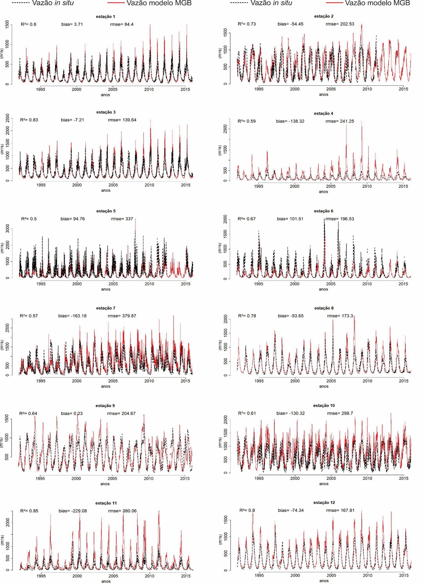
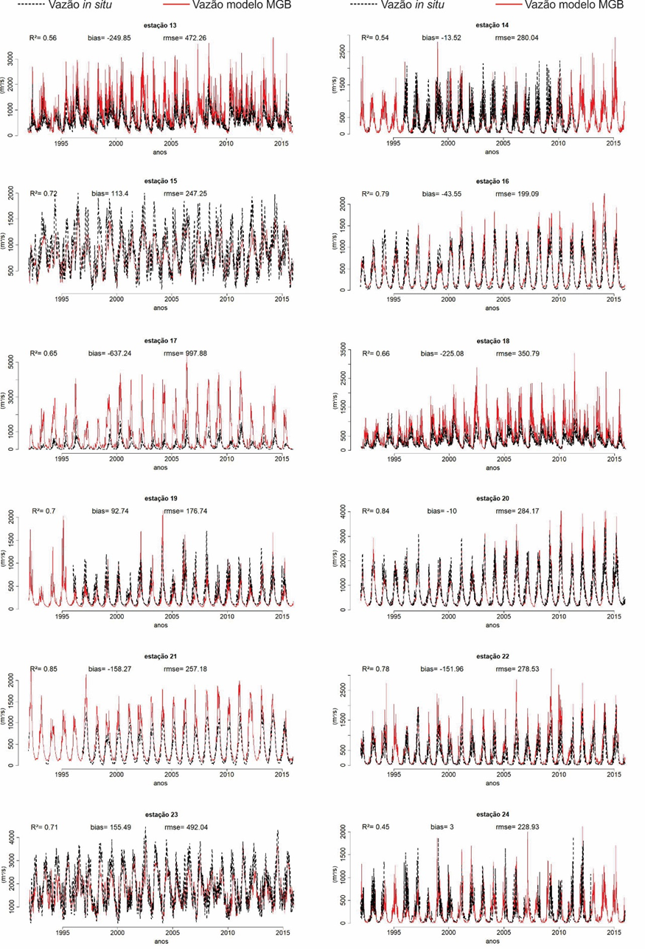

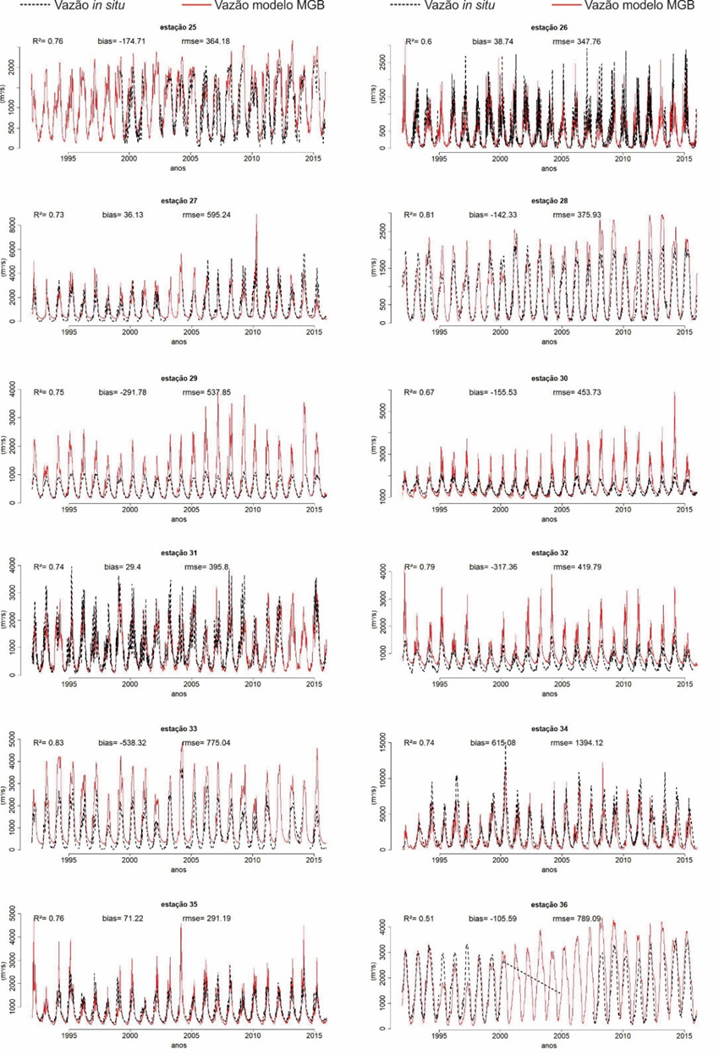

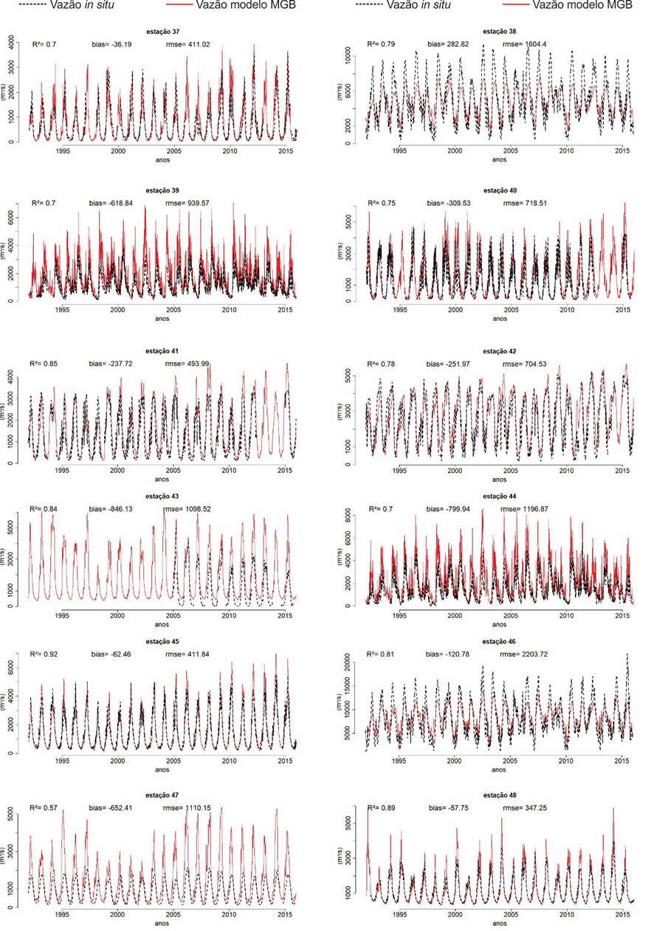

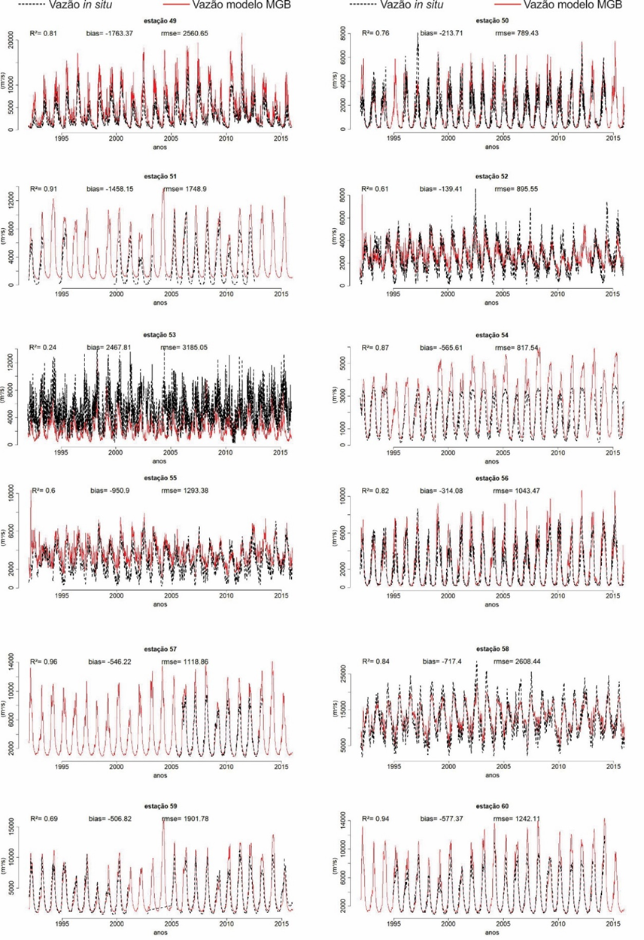

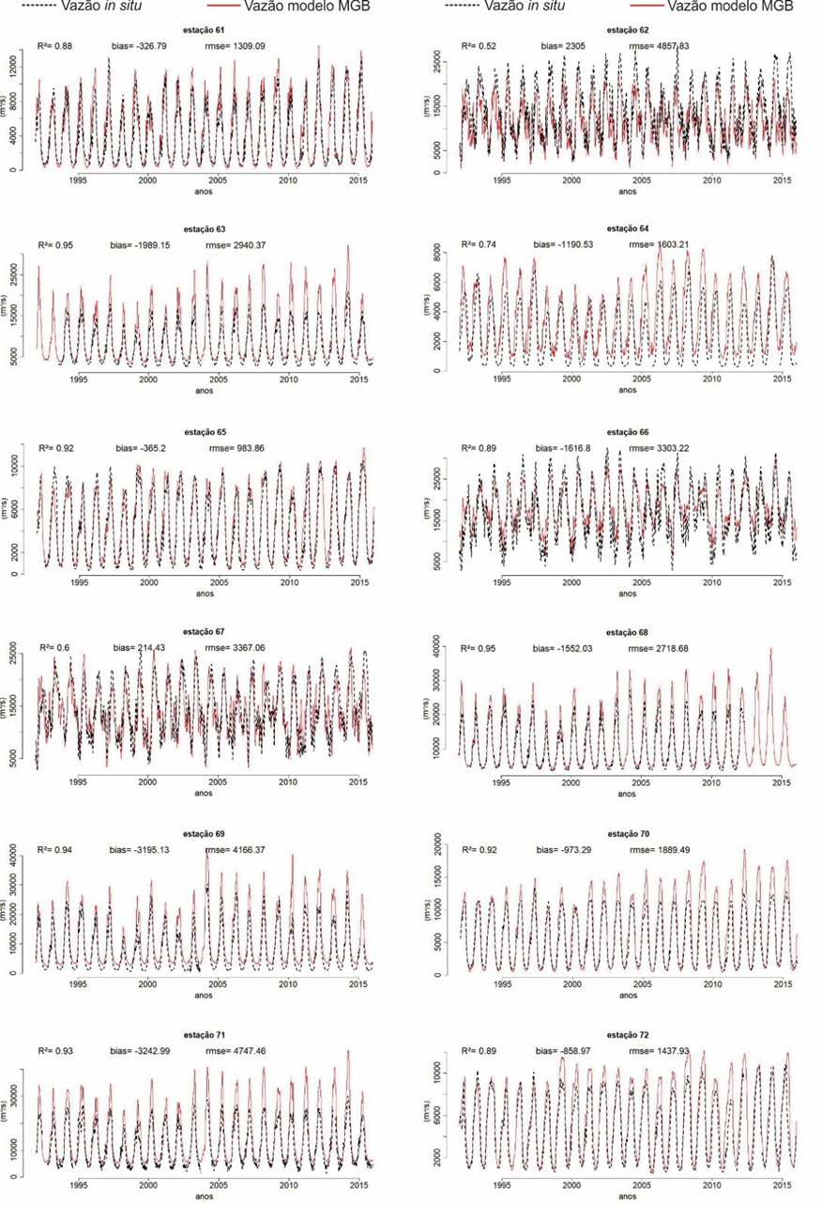

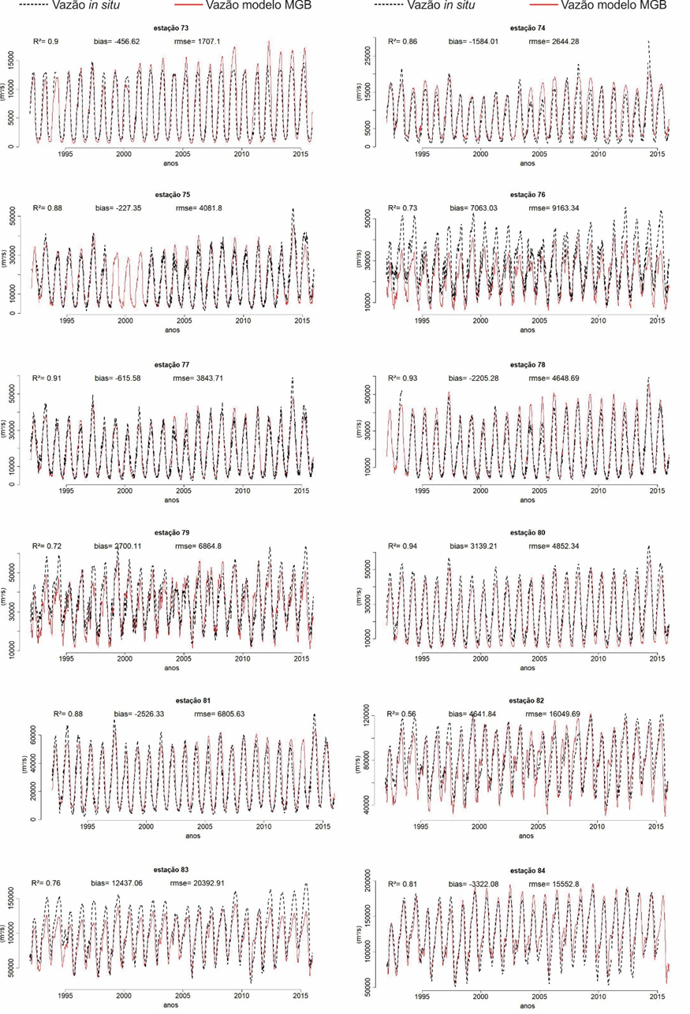

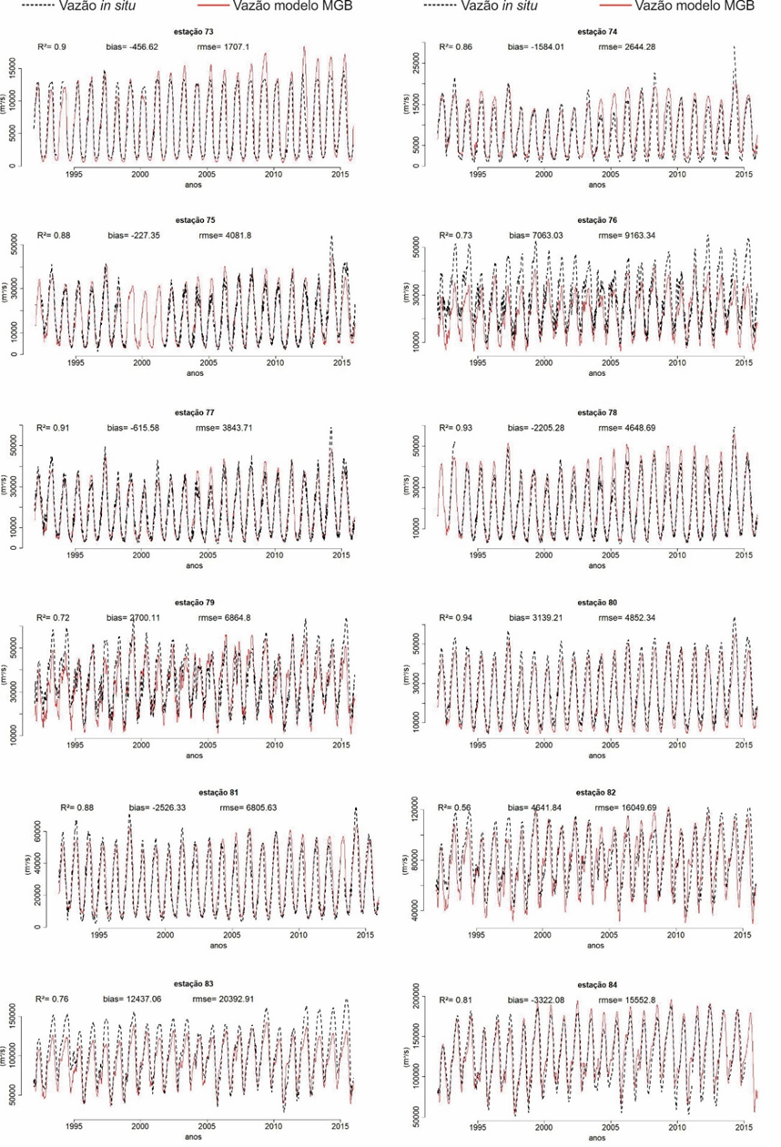

Fig. S2: Comparison between observed streamflow data and MGB-modeled simulations for stations 1 to 84 (Figur S2). Performance metrics (R², bias, and RMSE) are provided for each station.

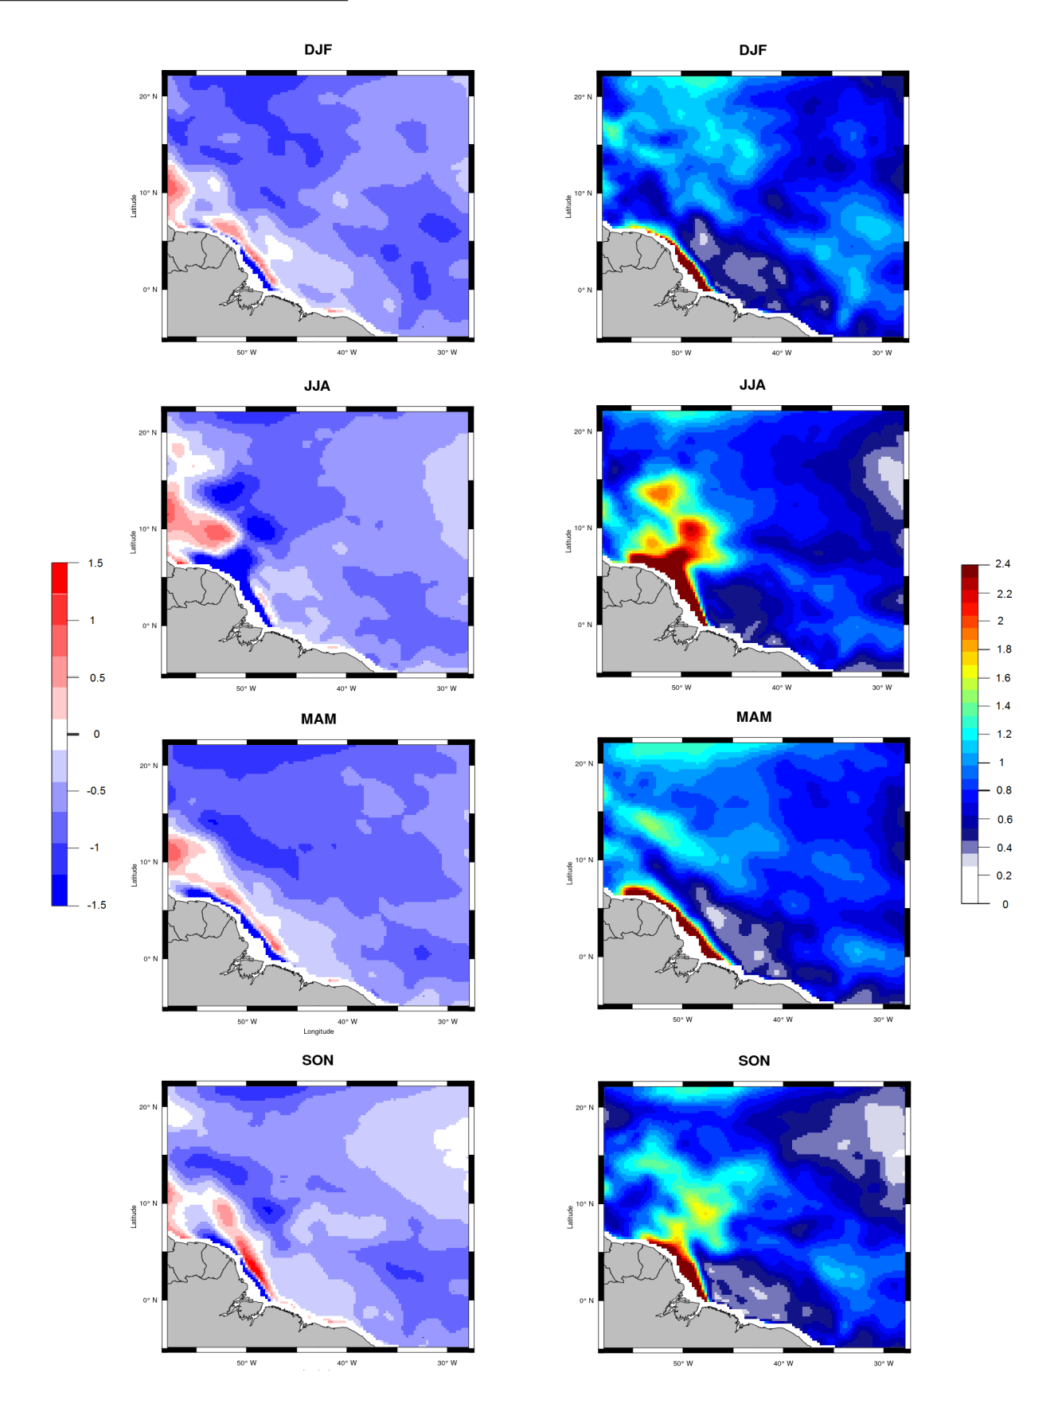
Fig. S3: Seasonal maps of bias (left column) and RMSE (right column) for SSM (2010–2015) between the control scenario and SMOS in the western portion of the tropical North Atlantic

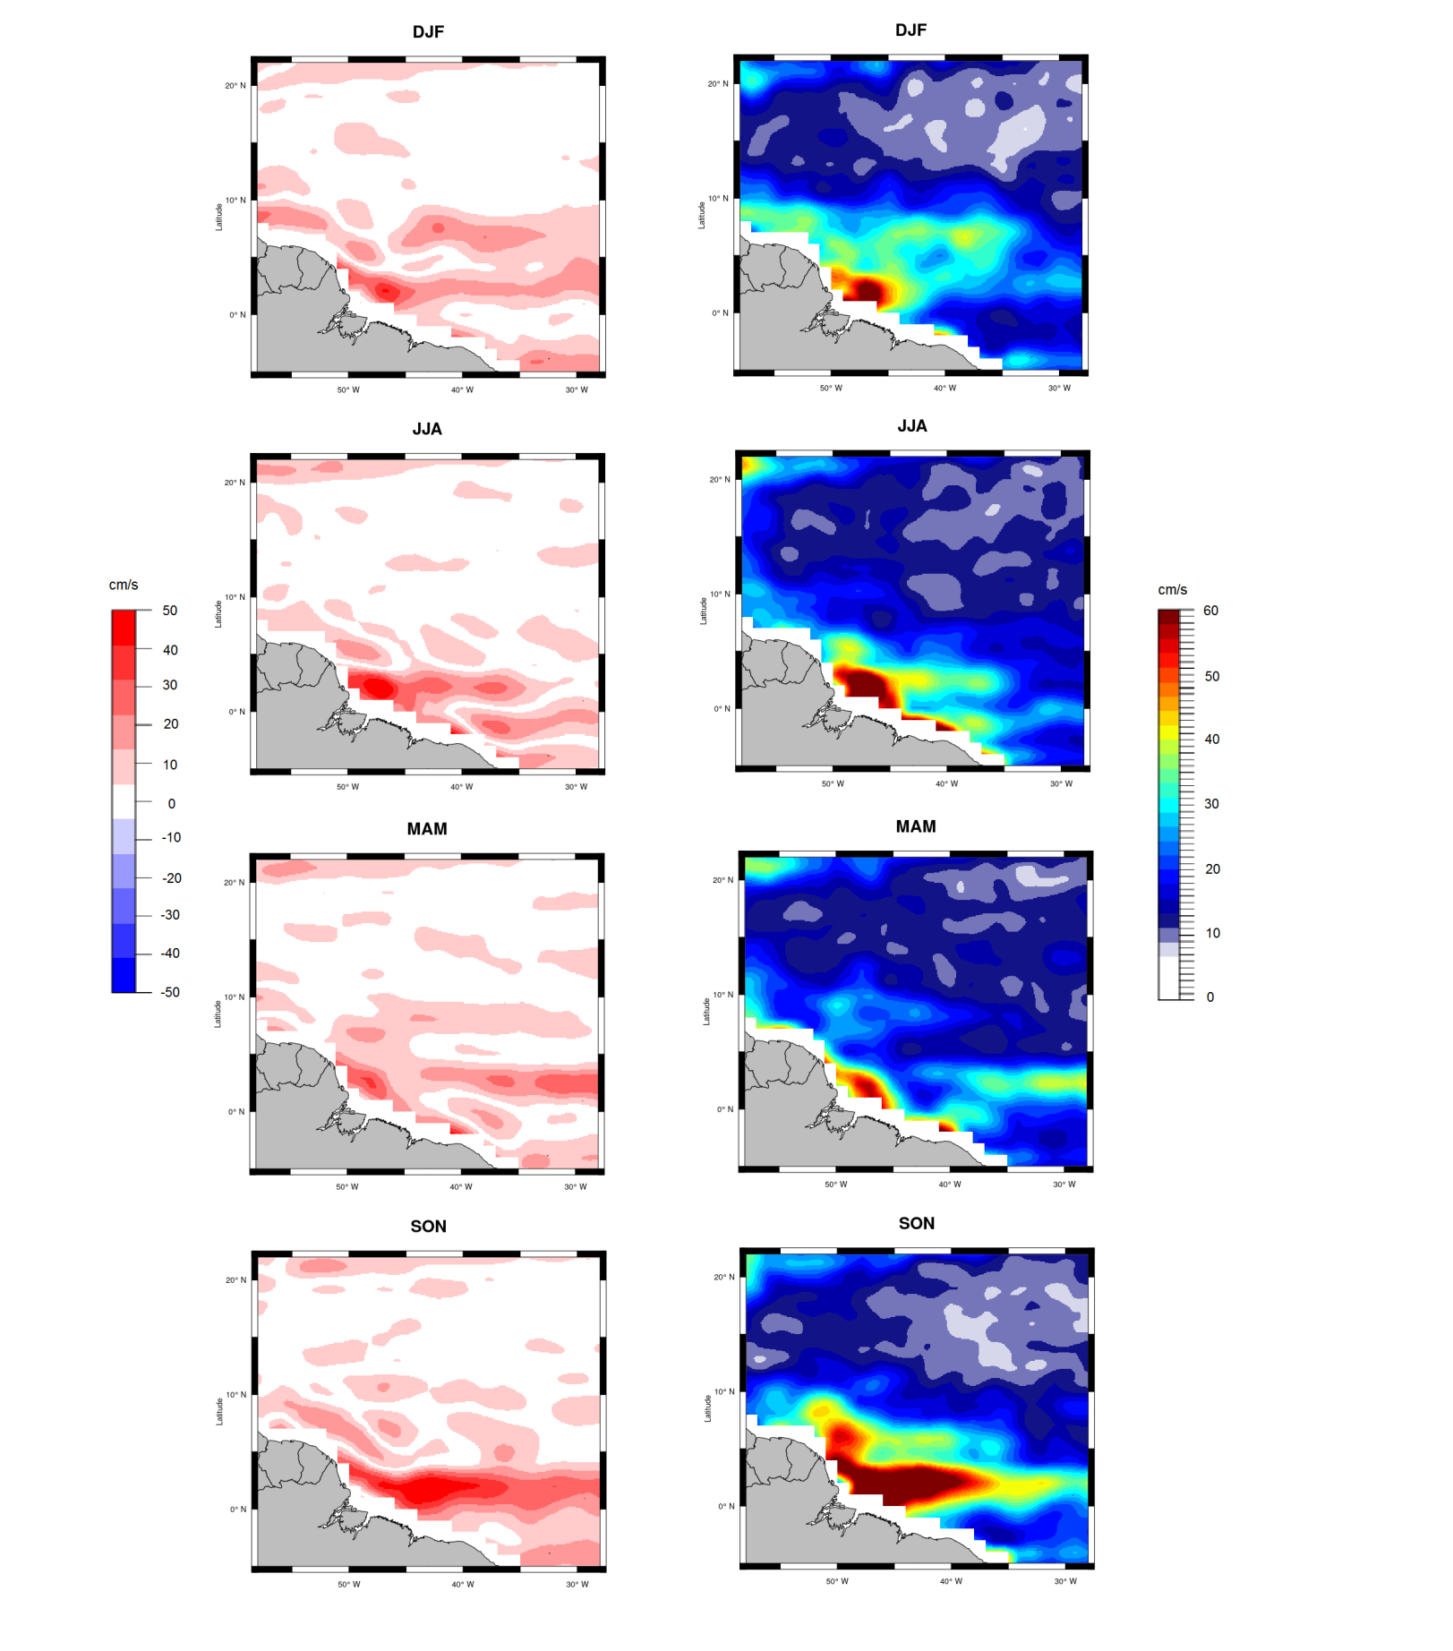
Fig.S4: Seasonal maps of bias (left column) and RMSE (right column) for the *u*-component (2010–2015) between the control scenario and OSCAR in the western tropical North Atlantic
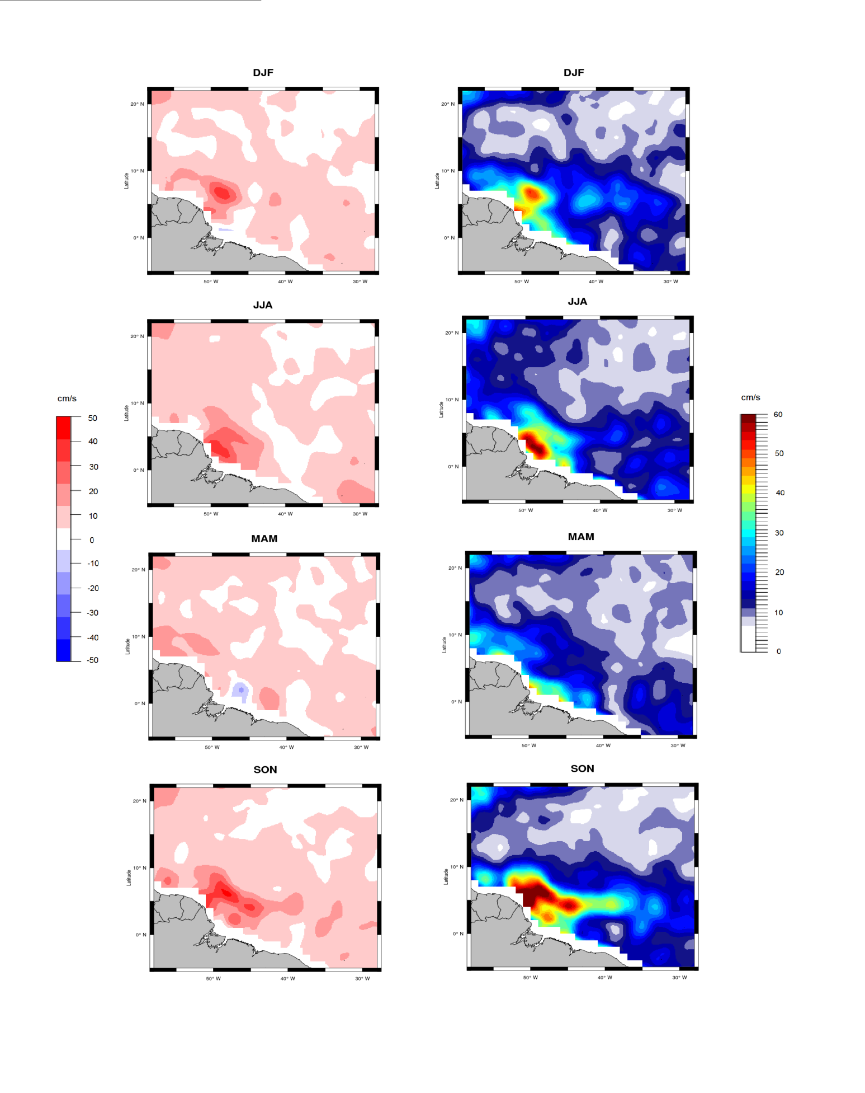
Fig. S5- Seasonal maps of bias (left column) and RMSE (right column) for the *v*-component (2010–2015) between the control scenario and OSCAR data in the western tropical North Atlantic

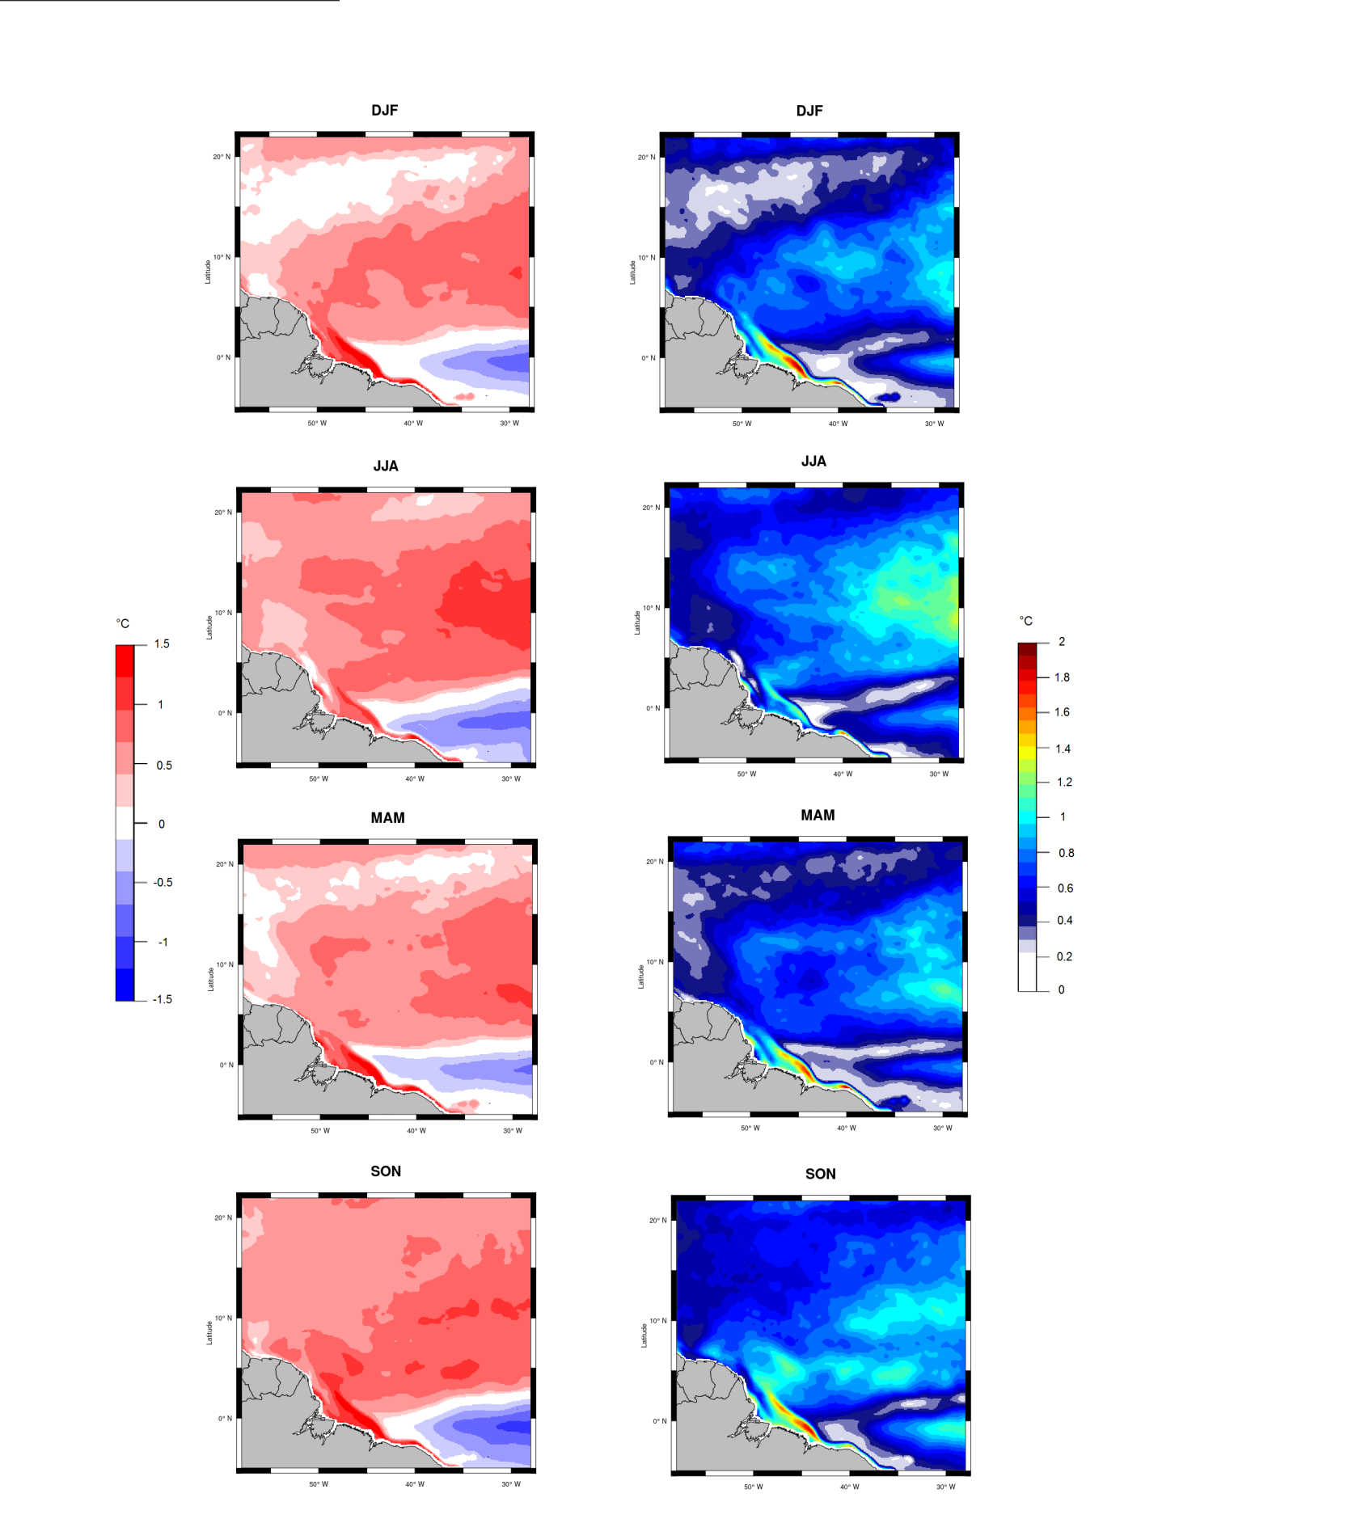.
Fig.S6 - Seasonal maps of bias (left column) and RMSE (right column) for SST (2010–2015) between the control scenario and OSTIA data in the western tropical North Atlantic.

