Online Archive
Table 1 - Telemedicine feasibility, supervised transport assessment, provider agreement, and critical interventions stratified by dispatch category and age group
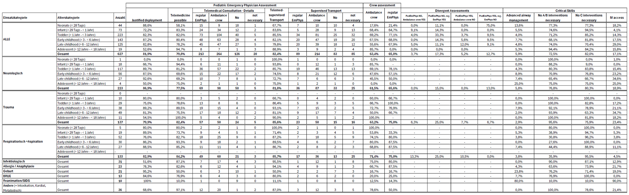

Table 2 - Distribution of emergency dispatch categories among 627 cases
Dispatch catgory | n | n (%)
Neurological | 223 | 35,57%
Trauma | 137 | 21,85%
Respiratory | 133 | 21,21%
Infectious diseases | 31 | 4,94%
Allergy / Anaphylaxis | 23 | 3,67%
Delivery / Childbirth | 21 | 3,35%
Other | 14 | 2,23%
BRUE | 13 | 2,07%
Intoxication | 8 | 1,28%
Resuscitation / SIDS | 10 | 1,59%
Cardiac | 6 | 0,96%
Metabolic | 4 | 0,64%
Psychiatric | 4 | 0,64%
TOTAL | 627 | 100,00%

Figure 1 – Temporal Trends in Questionnaire Capture Rate and Eligible Alarms

Figure 2 – Telemedicine Assessment Form for Pediatric Emergency Medical Services
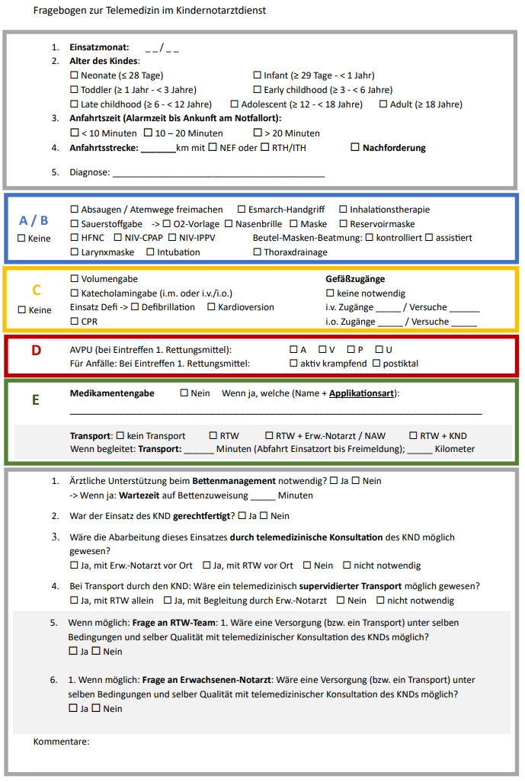
Plain Language Title: Can remote pediatric emergency specialists help ambulance teams care for children before hospital, and reduce the need for a specialist doctor to be physically present at every emergency?
Plain Language Summary: Children’s emergencies before arrival at hospital are uncommon, but they can be serious and stressful. Because these situations happen rarely, ambulance teams and general emergency doctors may have limited routine experience with very sick children. In some cities, a specialist pediatric emergency doctor can come to the scene, but this resource is limited and may not always be immediately available.
This study looked at whether telemedicine could help in these situations. Telemedicine means that a pediatric emergency specialist gives advice remotely, for example by phone or video, instead of being physically present at the scene. The study was carried out in Munich, Germany, between October 2024 and March 2026. After pediatric emergency missions, pediatric emergency doctors, ambulance crews, and regular emergency doctors were asked whether similar care could have been provided with remote specialist support.
Questionnaires were returned for 627 of 2733 eligible missions. The most common emergencies were neurological problems, trauma, and breathing problems. Pediatric emergency doctors thought their physical presence was needed in most cases, but they also judged that telemedicine would have been possible in many of them. Overall, 75.3% of cases were considered suitable for telemedical management. Among children who needed transport, remote supervision during transport was considered possible in 36.9% of transports. Ambulance crews and regular emergency doctors were somewhat less confident than pediatric emergency doctors about using telemedicine.
Serious procedures, such as intubation, resuscitation, or intraosseous access, were uncommon, while intravenous access was needed more often. This suggests that telemedicine may help extend pediatric specialist expertise and reduce unnecessary specialist deployment, while still keeping on-site specialists available for the sickest children.
However, the study did not test real telemedicine in practice. It was based on expert judgement after missions, so further studies are needed to assess safety, feasibility, workflow, and patient outcomes.

