Quorum Quenching Lactonase SsoPox Ameliorates DSS-Induced Colitis
Supplementary Figures
Matthew Dietz^{1,2,*}, Zachary Ziegert^{1,2,*}, Maria Martell^{1,2}, Marjais McBride^{1,2}, Rakesh Sikdar^{2,3}, Cyrus Jahansouz⁴, Subbaya Subramanian^{1,5,6}, Mikael Elias^{2,3}, Christopher Staley^{1,2,6,#}
¹ Division of Basic and Translational Research, Department of Surgery, University of Minnesota, Minneapolis, Minnesota, USA
² BioTechnology Institute, University of Minnesota, St. Paul, Minnesota, USA
³ Department of Biochemistry, Molecular Biology, and Biophysics, University of Minnesota, St. Paul, Minnesota, USA
⁴ Division of Colon and Rectal Surgery, Department of Surgery, University of Minnesota, Minneapolis, Minnesota, USA
⁵ Department of Pharmacology, University of Minnesota Medical School, Minneapolis, Minnesota,USA
⁶ Masonic Cancer Center, University of Minnesota, Minneapolis, Minnesota, USA
*Authors contributed equally to this work.
#Correspondence:
Christopher Staley, Ph.D.
Division of Basic & Translation Research
Department of Surgery
University of Minnesota
420 Delaware St, SE
Minneapolis, MN 55455
612-625-8831
cmstaley@umn.edu

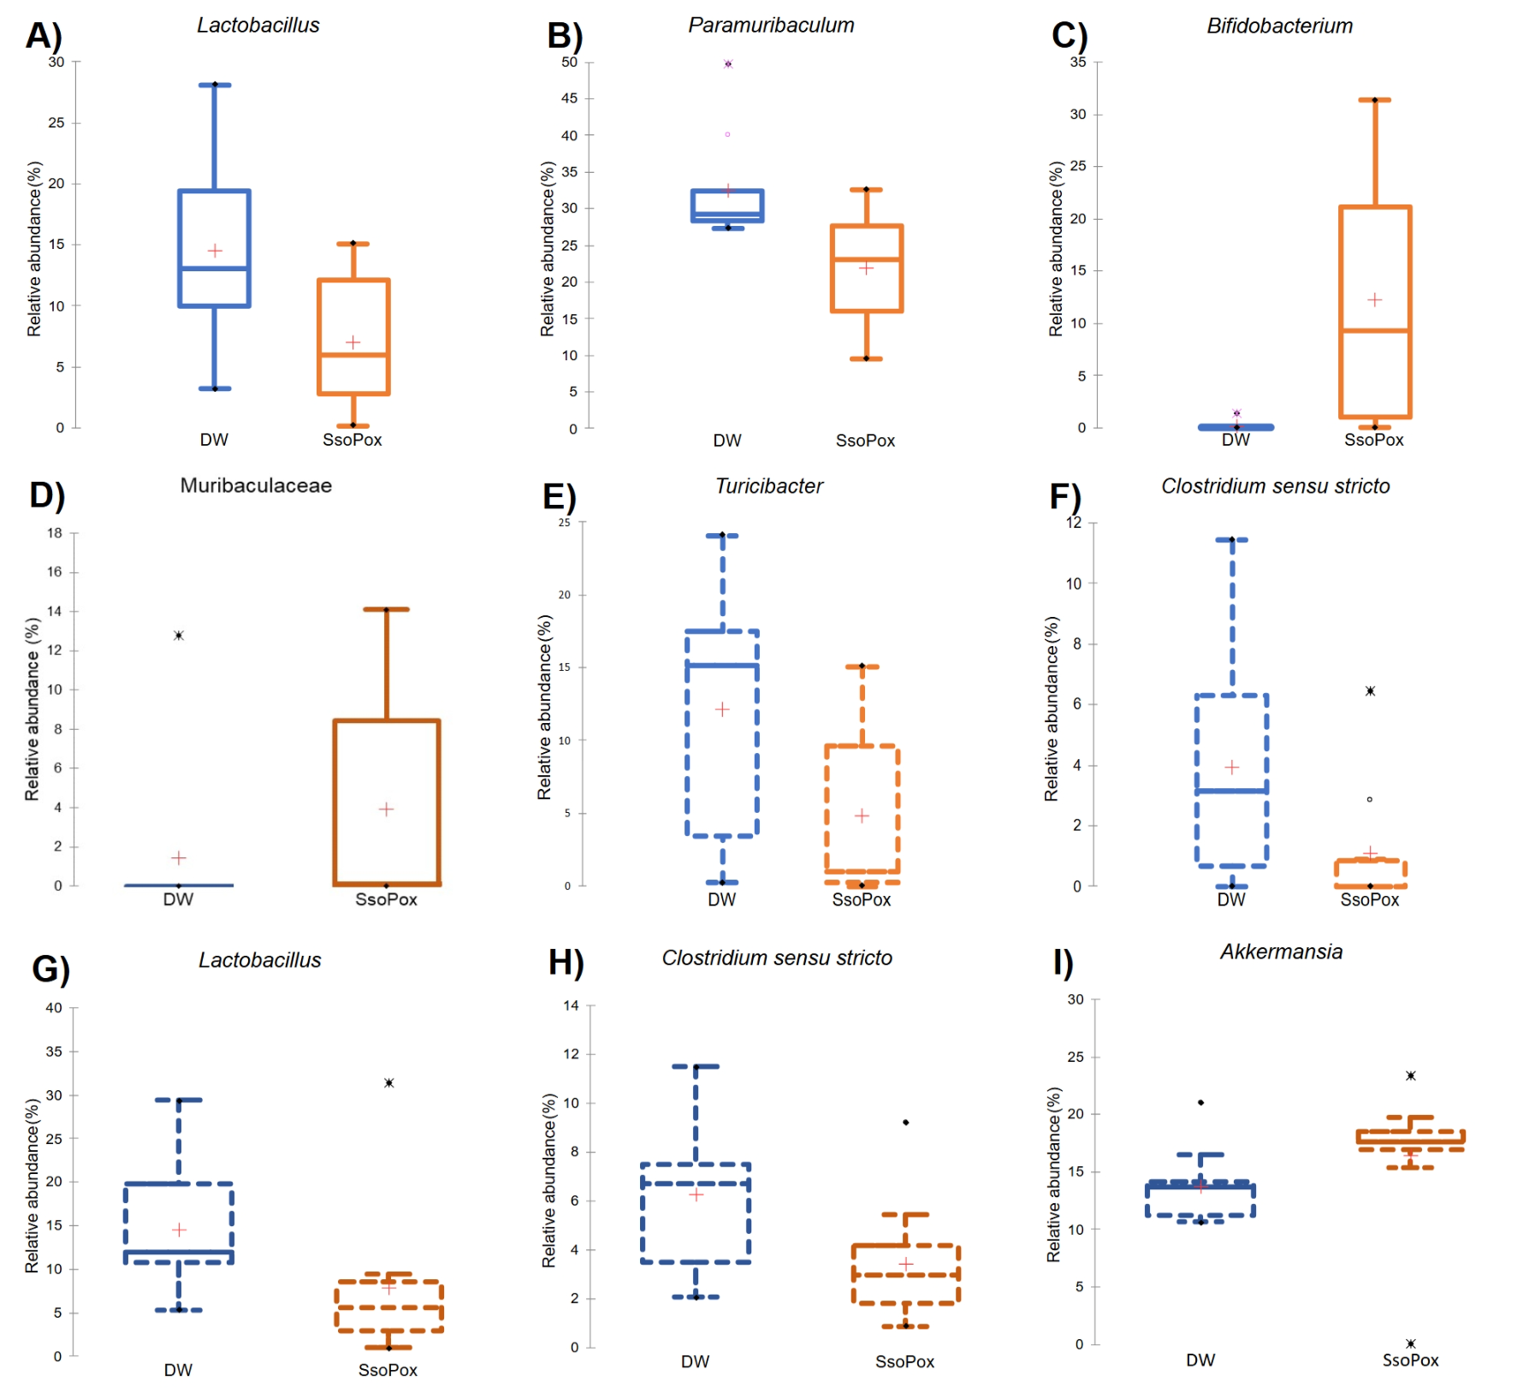Supplementary Figure S1. Box and whisker plots of predominant taxa whose relative abundances differed between 1mg/mL SsoPox-treated mice and their respective controls. Male mice are denoted with solid lines, female mice with dotted lines. (A-C) The relative abundances of Lactobacillus, Paramuribaculum, and Bifidobacterium differed between male SsoPox-treated mice and their controls after three weeks of treatment. (D) Muribaculaceae was more abundant in SsoPox-treated males at endpoint. (E-F) Turicibacter and Clostridium sensu stricto were less abundant in SsoPox-treated females compared to female controls at week 3. (G-I) The relative abundances of Lactobacillus, Clostridium sensu stricto, and Akkermansia differed between SsoPox-treated females and their respective controls at endpoint.

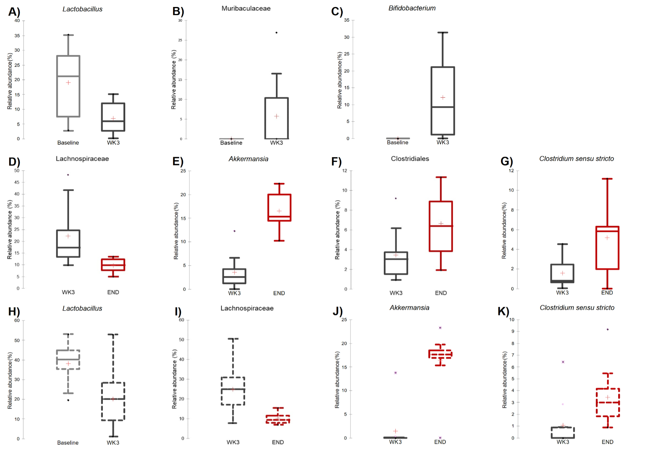Supplementary Figure S2. Box and whisker plots of predominant taxa whose relative abundances differed in 1mg/mL SsoPox-treated mice over time. Male mice are denoted with solid lines, female mice with dotted lines. (A-C) In male mice, the relative abundance of Lactobacillus decreased and the relative abundances of Muribaculaceae and Bifidobacterium increased between baseline and week 3. (D-G) In those same male mice, the relative abundance of Lachnospiraceae decreased, and the relative abundances of Akkermansia, Clostridiales, and Clostridium sensu stricto increased between week 3 and endpoint. (H) In female mice, the relative abundance of Lactobacillus decreased from baseline to week 3. (I-K) In those same female mice, the relative abundance of Lachnospiraceae decreased and the relative abundances of Akkermansia and Clostridium sensu stricto from week 3 and endpoint.

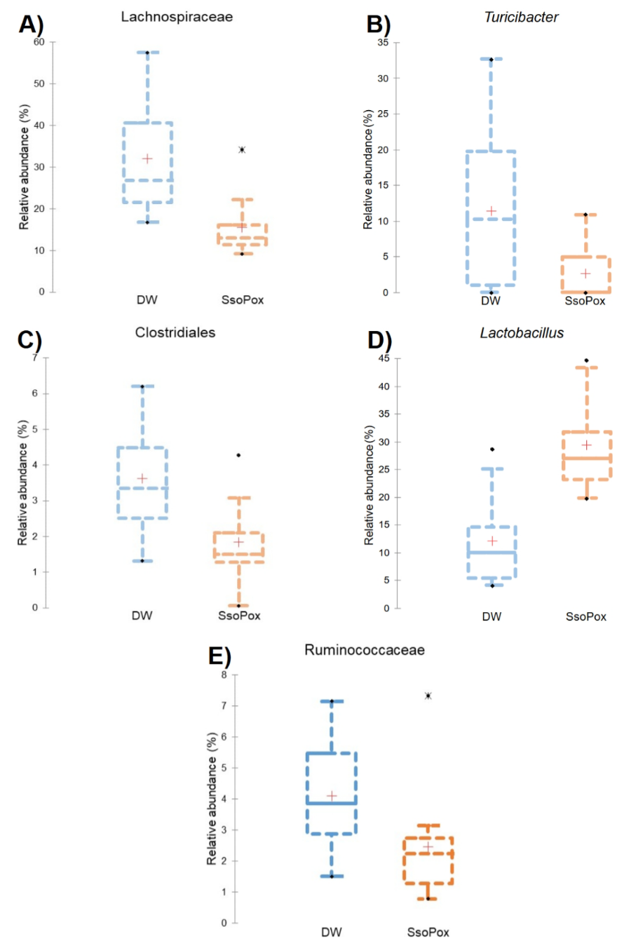
Supplementary Figure S3. Box and whisker plots of predominant taxa whose relative abundances differed between 2mg/mL SsoPox-treated mice and their respective controls. (A-C) In female mice, the relative abundances of Lachnospiraceae, Turicibacter, and Clostridiales were lower and (D) the relative abundance of Lactobacillus was greater in the mice assigned to the SsoPox group at baseline. (E) In female mice at week 3, the relative abundance of Ruminococcaceae was lower in SsoPox-treated females.

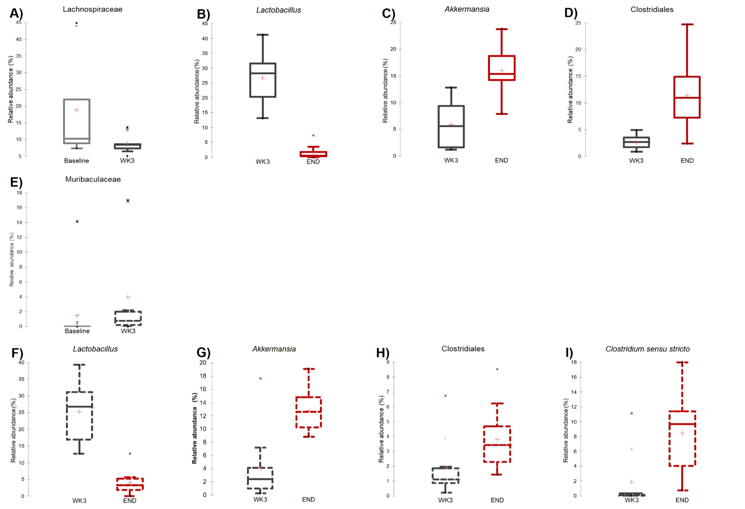
Supplementary Figure S4. Box and whisker plots of predominant taxa whose relative abundances differed in 2mg/mL SsoPox-treated mice over time. Male mice are denoted with solid lines, female mice with dotted lines. (A) In male SsoPox-treated mice, the relative abundance of Lachnospiraceae decreased from baseline to week 3. (B) In those same male mice, the relative abundance of Lactobacillus decreased and (C-D) the relative abundances of Akkermansia and Clostridiales increased from week 3 to endpoint. (E) In female SsoPox-treated mice, the relative abundance of Muribaculaceae increased from baseline to week 3. (F) In those same female mice, the relative abundance of Lactobacillus decreased and (G-I) the relative abundances of Akkermansia, Clostridiales, and Clostridium sensu stricto increased from week 3 to endpoint.

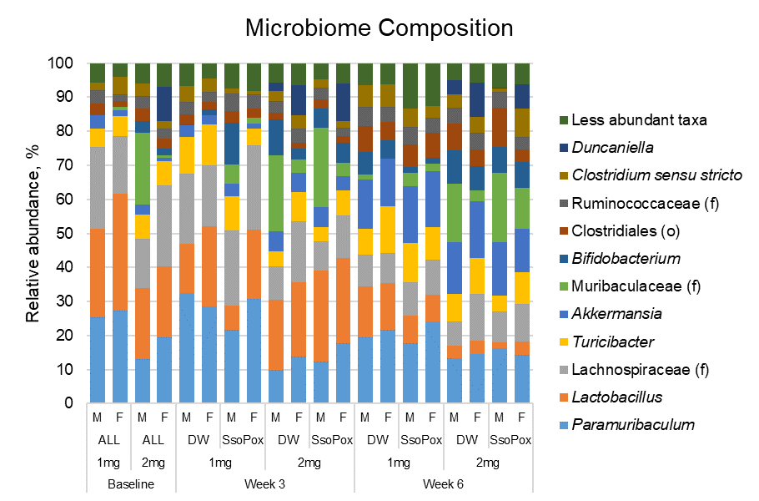
Supplementary Figure S5. The gut microbiome compositions of all DW control samples throughout both experiments.

