Supplementary

Table attached 1: Values of the Habitat Integrity Index (HII), observed richness, standard deviation, and land-use type for the sites located in the municipality of Barcarena, Pará, Brazil.
Sites | Treatment | IIH | Richness | Standard deviation
F3 | Forest fragment | 0.60 | 9 | 3.171
G3 | Forest fragment | 0.60 | 6 | 4.350
J2 | Peri-urban area | 0.36 | 1 | 0.164
J3 | Recreational area | 0.60 | 6 | 9.027
L3 | Forest fragment | 0.61 | 7 | 13.448
M3 | Recreational area | 0.60 | 3 | 12.372
P3 | Recreational area | 0.50 | 10 | 11.184
PB02 | Forest fragment | 0.65 | 4 | 0.501
PB18 | Forest fragment | 0.66 | 9 | 9.902
PB20 | Forest fragment | 0.67 | 6 | 4.349
PB22 | Agricultural area | 0.49 | 4 | 2.487
PB27 | Industrial | 0.55 | 7 | 4.369
PB5 | Forest fragment | 0.65 | 9 | 7.231
PB6 | Forest fragment | 0.69 | 8 | 4.964
PB8 | Recreational area | 0.26 | 1 | 0.164
PC02 | Peri-urban area | 0.52 | 5 | 13.288
PC06 | Floresta - Agrícola | 0.53 | 6 | 2.504
PC08 | Forest fragment | 0.63 | 9 | 4.828
PFM14 | Agricultural area | 0.46 | 4 | 7.678
PM02 | Industrial | 0.48 | 10 | 15.588
PM31 | Slurry pipeline | 0.57 | 1 | 5.468
PM32 | Slurry pipeline | 0.49 | 2 | 1.932
PM33 | Slurry pipeline | 0.51 | 8 | 3.643
PM35 | Slurry pipeline | 0.43 | 6 | 24.788
RQ3 | Forest fragment | 0.56 | 4 | 3.782
T3 | Forest fragment | 0.67 | 8 | 5.942
U3 | Forest fragment | 0.57 | 5 | 6.165
V1 | Industrial | 0.26 | 14 | 6.714
Z1 | Forest fragment | 0.62 | 8 | 5.107

Table attached 2. Predictor variables of habitat heterogeneity metrics at each site, selected using the BioEnv method.
Sites | CD (%) | OD (mg/L) | TA (°C) | PF (%)
F3 | 73.8 | 5.5 | 26.6 | 70.4
G3 | 73.0 | 4.3 | 27.6 | 43.6
J2 | 69.3 | 2.8 | 23.6 | 23.3
J3 | 66.8 | 5.6 | 25.6 | 13.4
L3 | 71.9 | 3.3 | 27.2 | 29.8
M3 | 46.5 | 4.8 | 28.1 | 36.4
P3 | 66.6 | 3.7 | 26.8 | 28.8
PB02 | 75.9 | 4.9 | 25.4 | 44.7
PB18 | 65.8 | 4.0 | 25.4 | 78.0
PB20 | 76.7 | 3.9 | 26.2 | 11.6
PB22 | 59.9 | 5.7 | 26.3 | 24.4
PB27 | 66.3 | 1.0 | 26.3 | 37.3
PB5 | 70.9 | 8.4 | 25.9 | 9.5
PB6 | 81.8 | 5.5 | 26.1 | 96.7
PB8 | 71.4 | 4.3 | 26.6 | 81.2
PC02 | 59.1 | 0.7 | 26.3 | 15.2
PC06 | 69.8 | 4.4 | 25.5 | 36.9
PC08 | 84.5 | 3.4 | 25.5 | 19.5
PFM14 | 40.1 | 3.7 | 26.4 | 18.9
PM02 | 73.0 | 2.0 | 25.9 | 37.8
PM31 | 66.3 | 5.1 | 25.9 | 30.6
PM32 | 65.0 | 4.7 | 25.1 | 23.3
PM33 | 69.8 | 6.2 | 26.6 | 19.2
PM35 | 75.9 | 4.8 | 27.2 | 25.6
RQ3 | 47.9 | 4.3 | 26.5 | 69.5
T3 | 73.3 | 4.3 | 26.3 | 46.0
U3 | 76.5 | 6.4 | 26.8 | 47.8
V1 | 2.1 | 1.1 | 26.9 | 22.8
Z1 | 72.2 | 3.8 | 26.9 | 8.4

Supplementary Figure 1. Variance partitioning analysis for total beta diversity (βT) and its components βsim (a), βsor (b), and βsne (c), showing the relationship with environmental and spatial variables, based on incidence data collected in the municipality of Barcarena, Pará state, Brazil. The values presented correspond to R² and adjusted R² from the dbRDA.
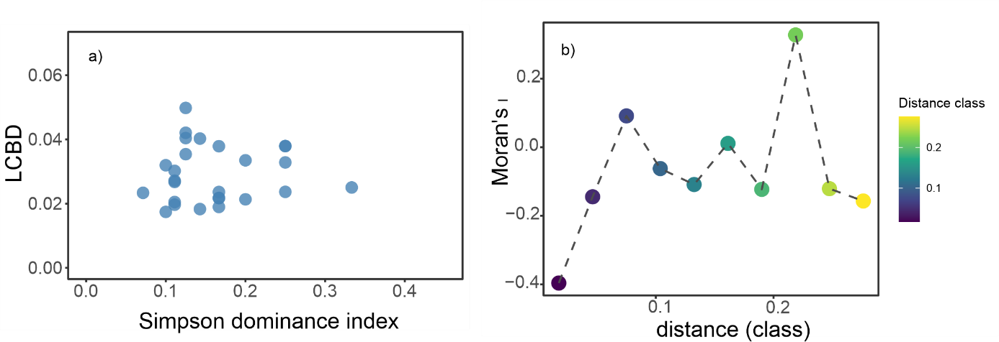

Supplementary Figure 2. Relationship between LCBD and Simpson dominance index, and spatial class distance from Moran’s I spatial correlation (right panels a, b).

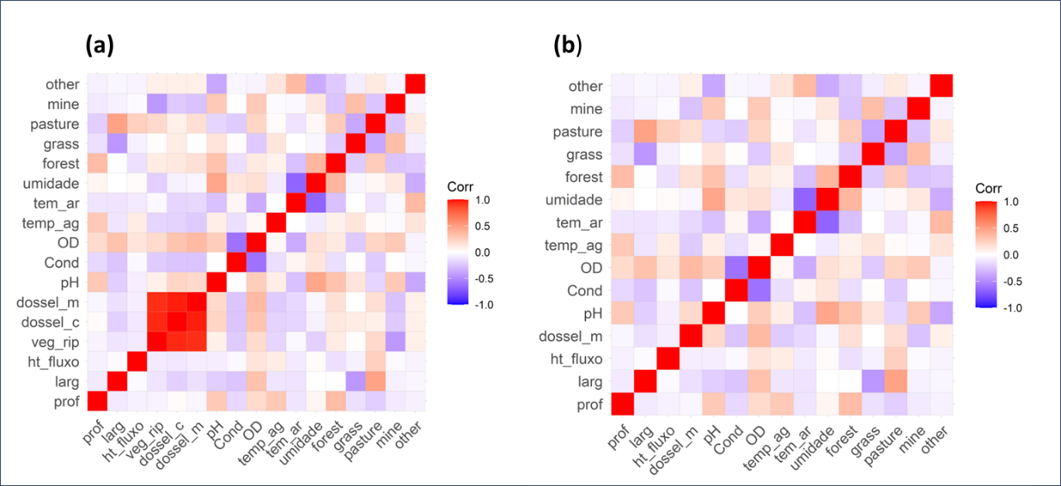
Supplementary Figure 3. Details of the Pearson correlation, (a) correlated variables, and (b) removal of variables (riparian vegetation and canopy cover of the channel).

Table attached 4. Set of environmental variables identified for the taxonomic group by BIO-ENV analysis and the overall correlation (Pearson) for the group.

Predictores | Correlation
CD | 0.407
OD
TA
PF

Table attached 5: Stream code, variables used for selection using BioEnv: depth, width, flow heterogeneity, riparian vegetation, channel canopy, bank canopy, pH, conductivity, temperature, dissolved oxygen, humidity, and percentage of forest, grass, pasture, and mining.
Sites | Channel Morphology variables |  |  |  |  |  | Physicohemical variables |  |  |  |  |  | Land use variables
 | Prof. (m) | Larg. (m) | ht_fluxo | veg_rip | dossel_c (%) | dossel_m (%) | pH | Cond. (S/m) | OD (mg/L) | temp_ag (C°) | temp_ar (C°) | umid(%) | forest (%) | grass(%) | pasture(%) | mine(%)
F3 | 1.315 | 2.836 | 0.034 | 69.920 | 69.920 | 73.797 | 4.5 | 16.8 | 5.5 | 27 | 27 | 83 | 70.437 | 0 | 29.563 | 0
G3 | 0.425 | 3.660 | 0.000 | 75.000 | 75.000 | 72.995 | 6.9 | 0.0 | 4.3 | 28 | 28 | 83 | 43.573 | 0 | 34.190 | 0
J2 | 0.742 | 2.164 | 0.195 | 67.513 | 67.513 | 69.251 | 5.5 | 37.3 | 2.8 | 24 | 32 | 80 | 23.265 | 0 | 10.026 | 0
J3 | 0.764 | 3.918 | 0.000 | 72.059 | 72.059 | 66.845 | 5.1 | 14.2 | 5.6 | 26 | 30 | 77 | 13.368 | 0 | 2.314 | 0
L3 | 0.428 | 1.428 | 0.000 | 72.059 | 75.267 | 71.925 | 5.4 | 8.8 | 3.3 | 27 | 29 | 71 | 29.820 | 12.082 | 0.643 | 0
M3 | 17.345 | 2.745 | 0.060 | 72.059 | 53.877 | 46.524 | 5.7 | 12.6 | 4.8 | 28 | 29 | 70 | 36.375 | 0 | 0.000 | 0
P3 | 0.284 | 3.191 | 0.000 | 72.059 | 70.321 | 66.578 | 4.3 | 15.0 | 3.7 | 27 | 30 | 52 | 28.792 | 0 | 24.807 | 0
PB02 | 1.085 | 5.155 | 0.000 | 72.059 | 71.925 | 75.936 | 5.3 | 16.6 | 4.9 | 25 | 28 | 76 | 44.730 | 0 | 26.864 | 0
PB18 | 0.279 | 3.909 | 0.000 | 72.059 | 68.449 | 65.775 | 5.8 | 13.2 | 4.0 | 25 | 29 | 75 | 78.021 | 0 | 45.758 | 0
PB20 | 0.284 | 2.645 | 0.000 | 72.059 | 74.733 | 76.738 | 5.2 | 15.1 | 3.9 | 26 | 35 | 60 | 11.568 | 0 | 18.766 | 0
PB22 | 2.522 | 4.327 | 0.000 | 72.059 | 56.150 | 59.893 | 5.0 | 14.9 | 5.7 | 26 | 35 | 51 | 24.422 | 0 | 28.920 | 0
PB27 | 0.203 | 2.326 | 22.000 | 72.059 | 70.455 | 66.310 | 4.8 | 23.4 | 1.0 | 26 | 35 | 51 | 37.275 | 5.656 | 0.000 | 0.386
PB5 | 0.226 | 2.627 | 0.034 | 72.059 | 75.000 | 70.856 | 7.1 | 0.0 | 8.4 | 26 | 28 | 80 | 9.512 | 6.812 | 0.000 | 10.668
PB6 | 15.836 | 2.095 | 0.000 | 72.059 | 83.824 | 81.818 | 7.3 | 0.0 | 5.5 | 26 | 28 | 81 | 96.658 | 0 | 1.671 | 0
PB8 | 0.217 | 2.309 | 0.000 | 72.059 | 70.187 | 71.390 | 6.7 | 15.7 | 4.3 | 27 | 33 | 76 | 81.234 | 0 | 7.198 | 0
PC02 | 0.147 | 1.754 | 0.000 | 72.059 | 67.380 | 59.091 | 6.1 | 59.0 | 0.7 | 26 | 29 | 78 | 15.167 | 8.098 | 0.000 | 0
PC06 | 0.917 | 2.155 | 0.000 | 72.059 | 72.594 | 69.786 | 5.2 | 13.6 | 4.4 | 26 | 33 | 54 | 36.889 | 0.514 | 0.000 | 0
PC08 | 0.211 | 2.600 | 0.201 | 72.059 | 86.230 | 84.492 | 4.9 | 25.5 | 3.4 | 26 | 30 | 75 | 19.537 | 0 | 17.352 | 0
PFM14 | 0.242 | 3.791 | 11.000 | 72.059 | 42.246 | 40.107 | 5.3 | 15.6 | 3.7 | 26 | 30 | 81 | 18.895 | 0 | 3.599 | 0
PM02 | 0.381 | 2.100 | 0.000 | 72.059 | 72.594 | 72.995 | 6.3 | 146.0 | 2.0 | 26 | 28 | 81 | 37.789 | 0 | 5.913 | 0
PM31 | 0.371 | 3.709 | 0.000 | 72.059 | 59.492 | 66.310 | 5.0 | 14.3 | 5.1 | 26 | 27 | 76 | 30.591 | 0 | 0.000 | 0
PM32 | 0.207 | 2.791 | 0.082 | 72.059 | 70.187 | 64.973 | 5.1 | 13.4 | 4.7 | 25 | 27 | 65 | 23.265 | 0 | 8.997 | 0
PM33 | 0.769 | 2.792 | 193.000 | 72.059 | 68.583 | 69.786 | 5.4 | 13.7 | 6.2 | 27 | 28 | 73 | 19.152 | 0 | 32.391 | 0
PM35 | 0.264 | 2.270 | 0.000 | 72.059 | 73.128 | 75.936 | 6.0 | 20.5 | 4.8 | 27 | 29 | 66 | 25.578 | 0 | 6.812 | 0
RQ3 | 0.223 | 2.867 | 19.000 | 72.059 | 45.856 | 47.861 | 4.6 | 17.0 | 4.3 | 27 | 28 | 90 | 69.537 | 0 | 36.375 | 0
T3 | 0.134 | 2.500 | 0.221 | 72.059 | 79.947 | 73.262 | 5.0 | 25.0 | 4.3 | 26 | 28 | 81 | 46.015 | 0 | 0.000 | 0
U3 | 0.256 | 2.600 | 0.000 | 72.059 | 75.802 | 76.471 | 7.2 | 0.0 | 6.4 | 27 | 30 | 80 | 47.815 | 0 | 19.666 | 0
V1 | 0.237 | 2.825 | 19.000 | 72.059 | 2.139 | 2.139 | 5.1 | 69.8 | 1.1 | 27 | 33 | 73 | 22.751 | 0.771 | 0.000 | 4.6272
Z1 | 0.263 | 2.697 | 0.000 | 72.059 | 73.663 | 72.193 | 3.8 | 16.5 | 3.8 | 27 | 35 | 51 | 8.355 | 0 | 21.465 | 0

Table attached 6: LCBD values and their components (LCBDtot), local contribution to habitat heterogeneity (LCEHtot) for incidence data, S – richness values, Domi – Simpson dominance values, and geographic coordinates for the 32 streams sampled in Barcarena, Pará state, Brazil.
Sites | LCBD | LCEH | S | Domi | Latitude | Longitude
F3 | 0.020 | 0.029 | 9 | 0.111 | -1.597 | -48.579
G3 | 0.019 | 0.024 | 6 | 0.167 | -1.6619 | -48.618
J2 | 0.082 | 0.094 | 1 | 1.000 | -1.5046 | -48.678
J3 | 0.024 | 0.021 | 6 | 0.167 | -1.6425 | -48.65
L3 | 0.018 | 0.016 | 7 | 0.143 | -1.6491 | -48.773
M3 | 0.025 | 0.056 | 3 | 0.333 | -1.6743 | -48.762
P3 | 0.017 | 0.006 | 10 | 0.100 | -1.6345 | -48.558
PB02 | 0.038 | 0.016 | 4 | 0.250 | -1.5563 | -48.618
PB18 | 0.027 | 0.038 | 9 | 0.111 | -1.762 | -48.728
PB20 | 0.022 | 0.015 | 6 | 0.167 | -1.5799 | -48.674
PB22 | 0.033 | 0.011 | 4 | 0.250 | -1.6063 | -48.659
PB27 | 0.040 | 0.033 | 7 | 0.143 | -1.5685 | -48.72
PB5 | 0.027 | 0.070 | 9 | 0.111 | -1.6909 | -48.51
PB6 | 0.035 | 0.076 | 8 | 0.125 | -1.687 | -48.532
PB8 | 0.082 | 0.036 | 1 | 1.000 | -1.7023 | -48.8
PC02 | 0.033 | 0.049 | 5 | 0.200 | -1.5421 | -48.696
PC06 | 0.038 | 0.007 | 6 | 0.167 | -1.6373 | -48.669
PC08 | 0.030 | 0.026 | 9 | 0.111 | -1.6176 | -48.697
PFM14 | 0.024 | 0.030 | 10 | 0.100 | -1.5947 | -48.72
PM02 | 0.032 | 0.020 | 1 | 1.000 | -1.5424 | -48.725
PM31 | 0.042 | 0.005 | 2 | 0.500 | -1.7266 | -48.722
PM32 | 0.022 | 0.021 | 8 | 0.125 | -1.7077 | -48.722
PM33 | 0.038 | 0.019 | 6 | 0.167 | -1.637 | -48.723
PM35 | 0.040 | 0.017 | 4 | 0.250 | -1.6152 | -48.735
RQ3 | 0.021 | 0.031 | 5 | 0.200 | -1.6152 | -48.596
T3 | 0.023 | 0.004 | 14 | 0.071 | -1.6152 | -48.65
U3 | 0.050 | 0.025 | 8 | 0.125 | -1.6152 | -48.61
V1 | 0.077 | 0.187 | 9 | 0.111 | -1.6152 | -48.748
Z1 | 0.020 | 0.020 | 9 | 0.111 | -1.6152 | -48.656

Table attached 7: Table with species contribution values and occupancy values per site.
Taxon | SCBD | abundance | site occupancy | ocup_prop
Rhagovelia brunae | 0.133 | 624 | 23 | 0.793
Cylindrostethus palmares | 0.093 | 250 | 21 | 0.724
Rhagovelia elegans | 0.139 | 453 | 21 | 0.724
Euvelia lata | 0.066 | 101 | 14 | 0.483
Brachymetra lata | 0.057 | 107 | 12 | 0.414
Rhagovelia evidis | 0.118 | 133 | 12 | 0.414
Stridulivelia tersa | 0.036 | 58 | 12 | 0.414
Stridulivelia alia | 0.046 | 104 | 11 | 0.379
Stridulivelia strigosa | 0.036 | 63 | 11 | 0.379
Limnogonus recurvus | 0.016 | 28 | 7 | 0.241
Neogerris magnus | 0.004 | 7 | 5 | 0.172
Paravelia bullialata | 0.004 | 5 | 5 | 0.172
Microvelia hambletoni | 0.023 | 28 | 4 | 0.138
Strudulivelia transversa | 0.010 | 12 | 4 | 0.138
Tachygerris adamsoni | 0.007 | 19 | 4 | 0.138
Microvelia belterrensis | 0.007 | 21 | 3 | 0.103
Microvelia cf sp nov. 6 | 0.006 | 7 | 3 | 0.103
Neogerris lotuss | 0.003 | 7 | 3 | 0.103
Mesovelia mulsanti | 0.005 | 5 | 2 | 0.069
Microvelia cf venustatis | 0.003 | 2 | 2 | 0.069
Callivelia conata | 0.000 | 1 | 1 | 0.034
Euvelia discala | 0.061 | 1 | 1 | 0.034
Hebrus sp | 0.010 | 1 | 1 | 0.034
Mesovelia amoena | 0.001 | 1 | 1 | 0.034
Microvelia cf belterrensis | 0.001 | 1 | 1 | 0.034
Microvelia cf mimula | 0.001 | 1 | 1 | 0.034
Microvelia longipes | 0.019 | 24 | 1 | 0.034
Microvelia pulchela | 0.025 | 32 | 1 | 0.034
Microvelia sousorum | 0.002 | 3 | 1 | 0.034
Microvelia sp fm 1 | 0.001 | 1 | 1 | 0.034
Neogerris celeris | 0.002 | 7 | 1 | 0.034
Neogerris visendus | 0.000 | 1 | 1 | 0.034
Rhagovelia hambletoni | 0.001 | 1 | 1 | 0.034
Rheumatobates tritiatis | 0.061 | 1 | 1 | 0.034
Tachygerris celosis | 0.001 | 1 | 1 | 0.034
Tachygerris opacus | 0.001 | 1 | 1 | 0.034

Table attached 8: Abundance of genera and species of Gerromorpha from the 32 streams sampled, based on data collected in Barcarena, Pará state, Brazil.
Taxon | Author | N° | %
Gerridae |  | 963 | 0.44
Brachymetra |  | 107 | 0.05
Brachymetra lata | Shaw, 1933 | 107
Cylindrostethus |  | 317
Cylindrostethus palmares | Drake & Harris, 1934 | 317 | 0.05
Euvelia |  | 102 | 0.14
Euvelia discala | Polhemus & Polhemus, 1984 | 1 | 0.14
Euvelia lata | Polhemus & Polhemus, 1984 | 101 | 0.05
Limnogonus |  | 30 | 0.00
Limnogonus recurvus | Drake & Harris, 1930 | 30 | 0.05
Microvelia |  | 120 | 0.01
Microvelia belterrensis | dos Santos, Rodrigues, Couceiro & Moreira, 2021 | 21 | 0.01
Microvelia cf. belterrensis | dos Santos, Rodrigues, Couceiro & Moreira, 2022 | 1 | 0.05
Microvelia cf. mimula | White, 1879 | 1 | 0.01
Microvelia cf. sp. nov. 6* |  | 7 | 0.00
Microvelia cf. venustatis | Drake & Harris, 1933 | 2 | 0.00
Microvelia hambletoni | Drake, 1951 | 28 | 0.00
Microvelia longipes | Uhler, 1894 | 24 | 0.00
Microvelia pulchela | Westwood, 1834 | 32 | 0.01
Microvelia sousorum | dos Santos, Rodrigues, Couceiro & Moreira, 2021 | 3 | 0.01
Microvelia sp.fm.1* |  | 1 | 0.01
Neogerris |  | 22 | 0.00
Neogerris celeris | Drake & Harris, 1934 | 7 | 0.00
Neogerris lotuss | White, 1879 | 7 | 0.01
Neogerris magnus | Kuitert, 1942 | 7 | 0.00
Neogerris visendus | Drake & Harris, 1934 | 1 | 0.00
Rheumatobates |  | 1 | 0.00
Rheumatobates tritiatis | China, 1943 | 1 | 0.00
Tachygerris |  | 21 | 0.00
Tachygerris adamsoni | Drake, 1942 | 19 | 0.00
Tachygerris celosis | Drake & Harris, 1931 | 1 | 0.01
Tachygerris opacus | Champion, 1898 | 1 | 0.01
Hebridae |  | 1 | 0.00
Hebrus | Curtis, 1833 | 1 | 0.00
Hebrus sp. |  | 1 | 0.00
Mesoveliidae |  | 11 | 0.00
Mesovelia |  | 11 | 0.00
Mesovelia amoena | Uhler, 1894 | 6 | 0.00
Mesovelia mulsanti | White, 1879 | 5 | 0.00
Veliidae |  | 1231 | 0.00
Callivelia |  | 2 | 0.00
Callivelia conata | Hungerford, 1929 | 2 | 0.56
Paravelia |  | 7 | 0.00
Paravelia bullialata | Polhemus & Polhemus, 1984 | 7 | 0.00
Platyvelia |  | 1 | 0.00
Platyvelia brachialis | Stål, 1860 | 1 | 0.00
Rhagovelia |  | 1221 | 0.00
Rhagovelia brunae | Magalhães & Moreira, 2016 | 624 | 0.00
Rhagovelia elegans | Uhler, 1894 | 463 | 0.55
Rhagovelia evidis | Bacon, 1948 | 133 | 0.28
Rhagovelia hambletoni | Drake & Harris, 1933 | 1 | 0.21
Stridulivelia |  | 243 | 0.06
Stridulivelia alia | Drake, 1957 | 104 | 0.00
Stridulivelia strigosa | Hungerford, 1929 | 63 | 0.11
Stridulivelia tersa | Drake & Harris, 1941 | 64 | 0.05
Strudulivelia transversa | Hungerford, 1929 | 12 | 0.03

Table attached 9: Values of the correlogram based on the model's autocorrelation using Moran's I distance classes.
Moran’s I – Beta model
 | dist.class | coef | p.value | n
[1,] | 0.018 | 0.051 | 0.662 | 46
[2,] | 0.046 | -0.059 | 0.852 | 120
[3,] | 0.075 | -0.046 | 0.919 | 152
[4,] | 0.104 | 0.048 | 0.409 | 170
[5,] | 0.133 | -0.062 | 0.788 | 152
[6,] | 0.161 | -0.320 | 0.024 | 116
[7,] | 0.190 | -0.100 | 0.689 | 84
[8,] | 0.219 | -0.055 | 0.989 | 48
[9,] | 0.248 | 0.205 | 0.220 | 32
[10,] | 0.276 | -0.375 | 0.639 | 10

