Title: Supplementary figures for "Spatial prediction of cassava seed market performance in Tanzania's Lake Zone"
Description: Five supplementary figures (S1–S5) supporting the methods, results, and discussion of the main manuscript.
File format: DOCX

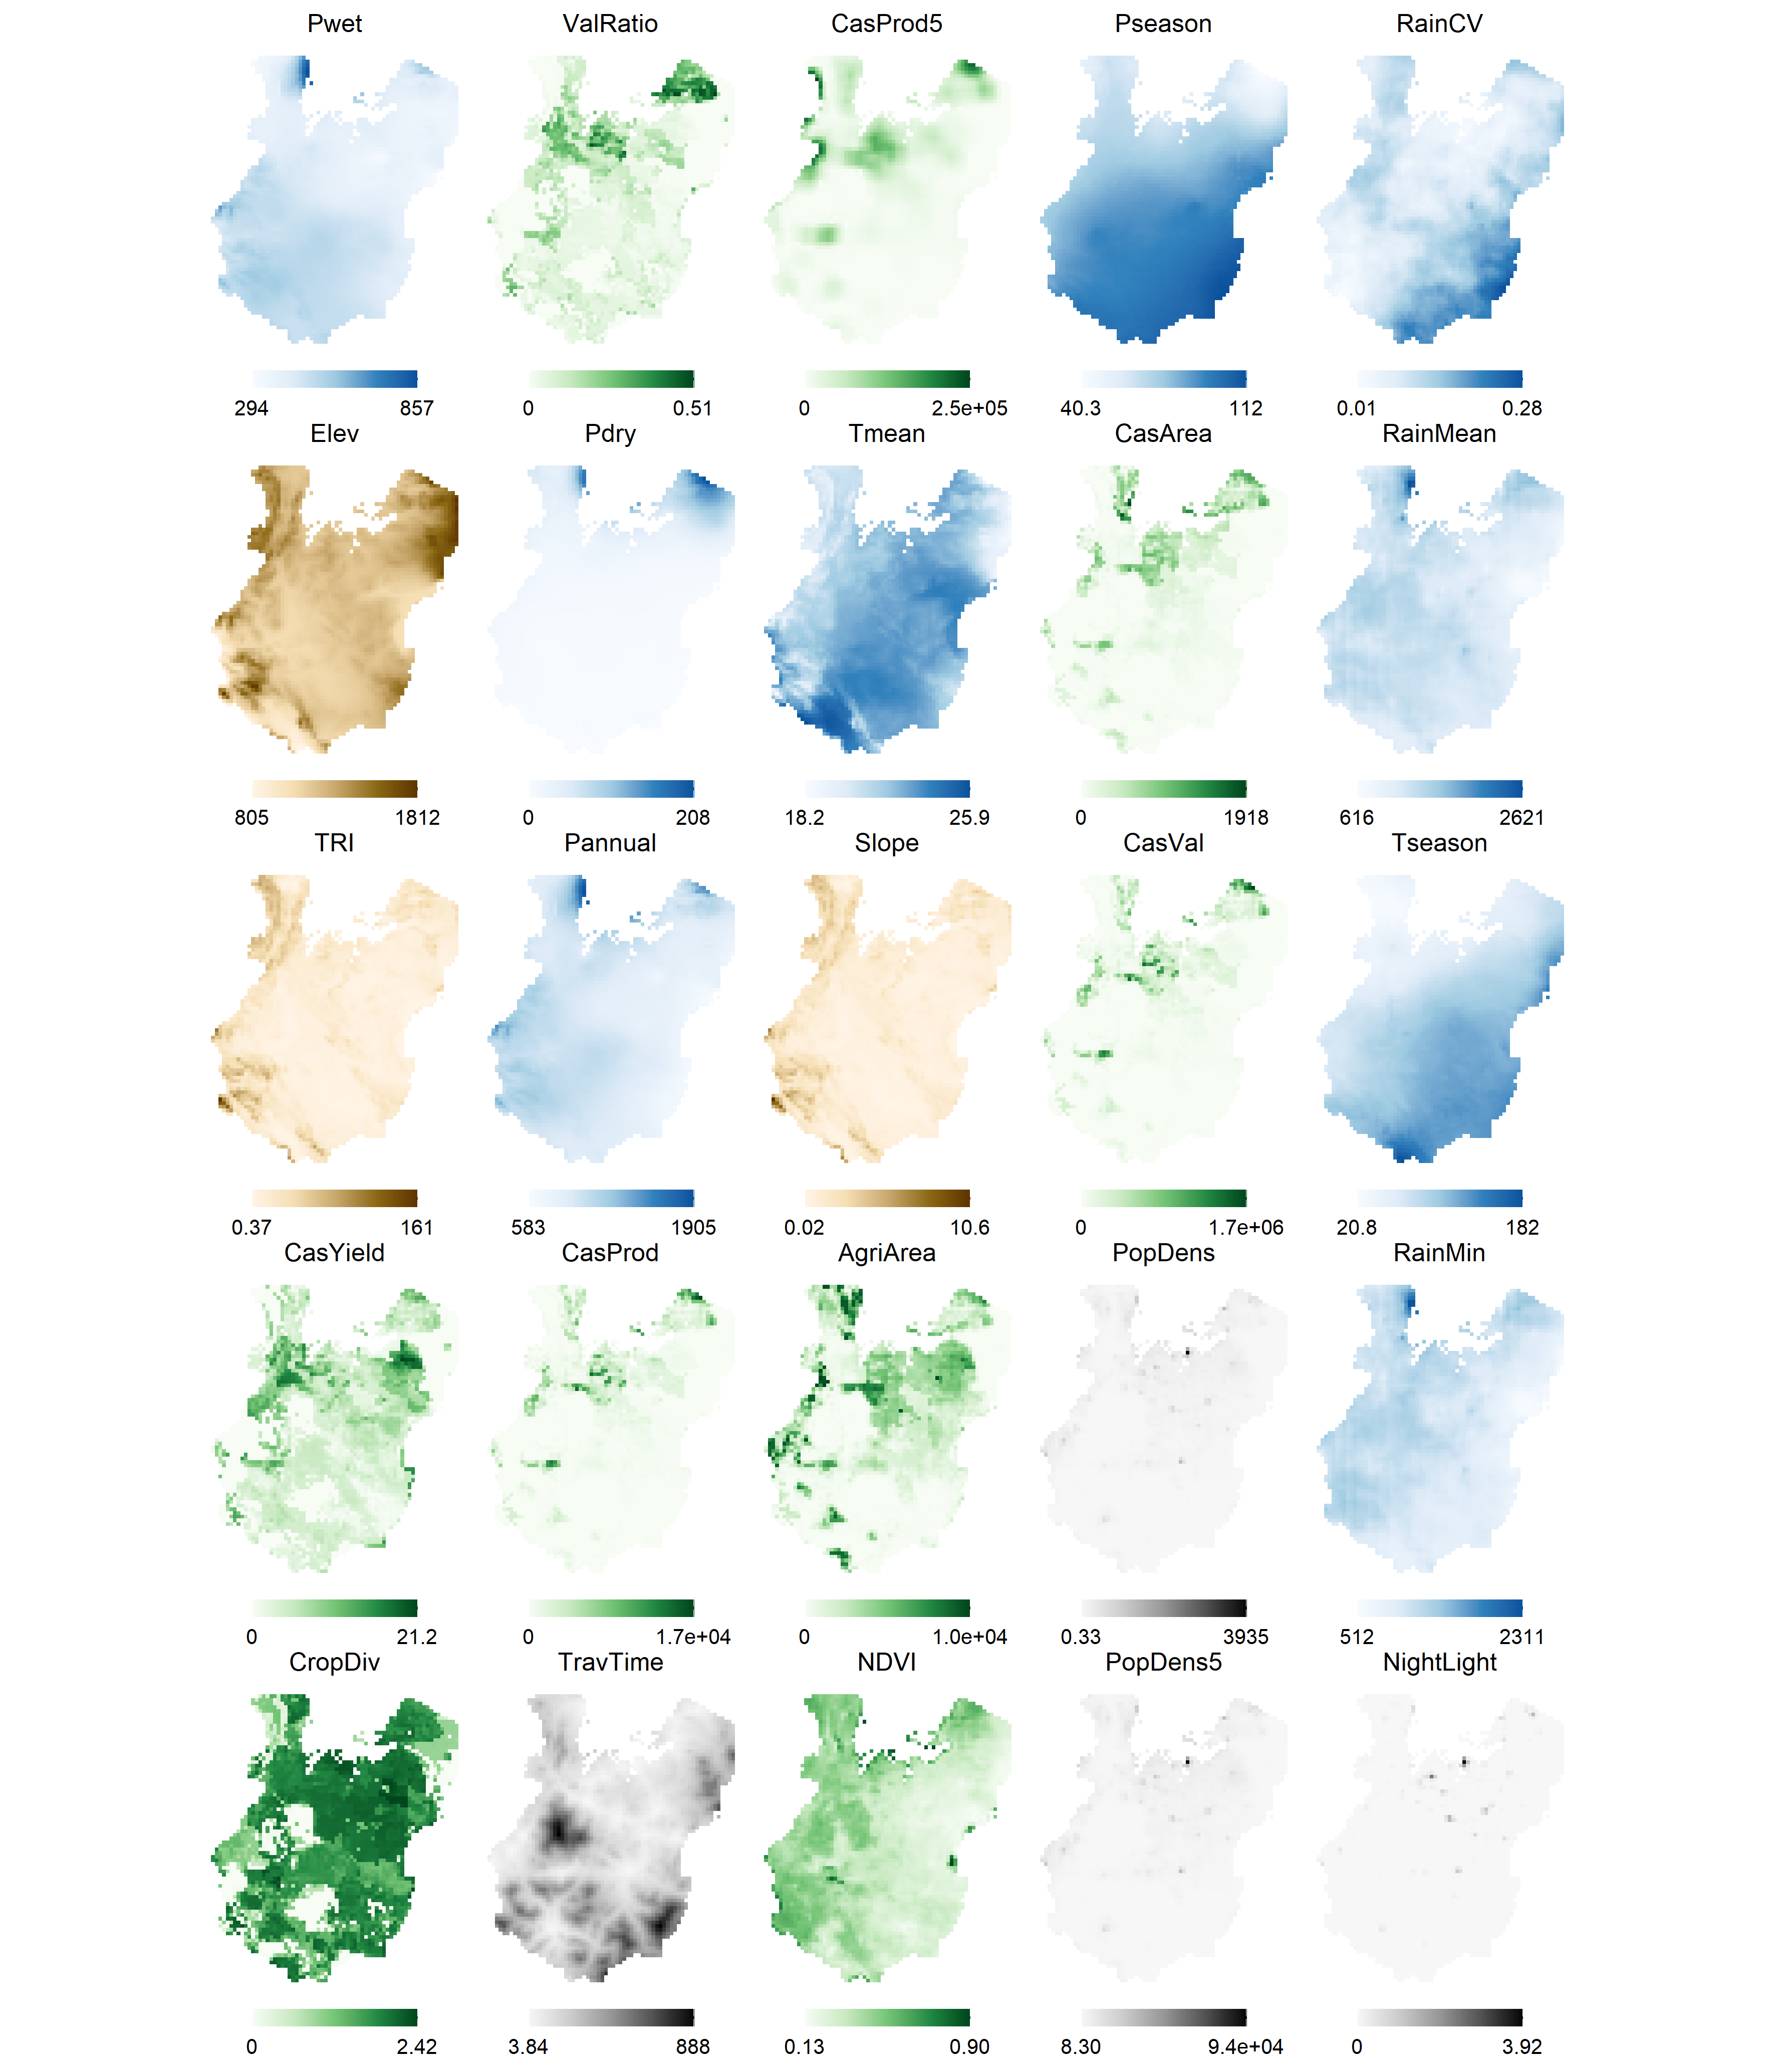
Figure S1 Spatial distribution of all 25 predictor variables used in the RF model across the Lake Zone at 5-arcminute (~10 km) resolution. Predictors are ordered by permutation importance (highest to lowest, left to right, top to bottom). Colour palettes are grouped thematically: green for agricultural and vegetation metrics, blue for climate variables, brown for terrain, and grey for human activity indicators. Legends show value ranges in original units (see Table 2 in main text for units). Value Ratio represents cassava's economic value as a proportion of total crop value across all 42 SPAM crops. Cassava Prod. (5×5) and Pop. Density (5×5) are focal means calculated over a 5×5-pixel neighbourhood (~50×50 km), capturing regional context. Rainfall CV is the coefficient of variation of annual rainfall (2018–2022), indicating inter-annual variability. Terrain Roughness quantifies local elevation variability. Travel Time measures minutes to the nearest city with population exceeding 50,000.
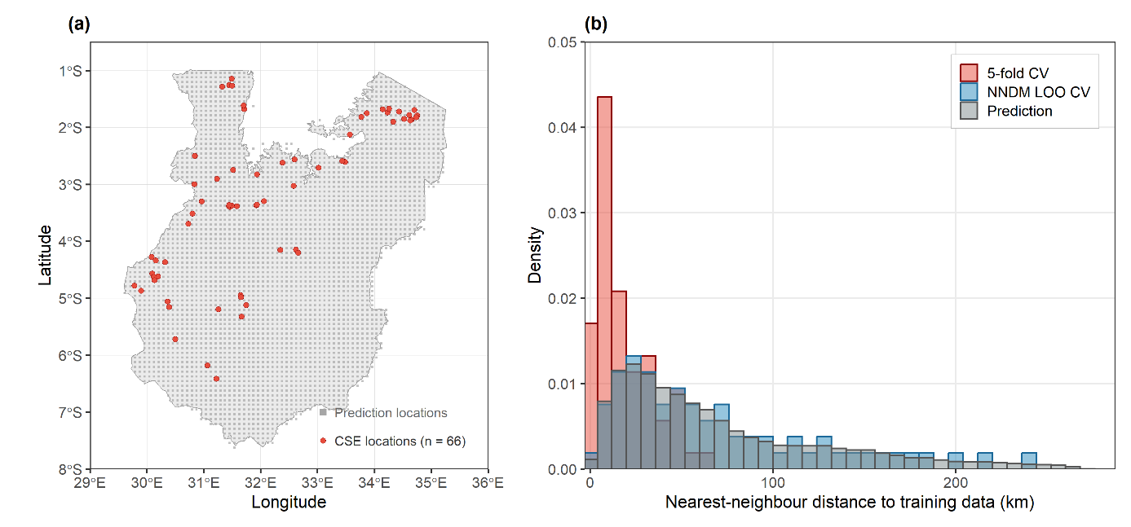
Figure S2 Spatial distribution of CSE and prediction locations (a) and nearest-neighbour distance distributions under three cross-validation strategies (b). Red: random 5-fold CV, where each test point's nearest-neighbour distance is computed to the training set of its assigned fold. Blue: NNDM LOO CV, where some nearby training points are excluded to match the prediction distance distribution. Grey: prediction distances from each grid cell to the nearest CSE. The 5-fold CV distribution is concentrated at short distances, indicating that test points typically have nearby training data — inflating apparent prediction accuracy. NNDM LOO CV shifts the distribution toward the prediction distances, providing more realistic performance estimates.
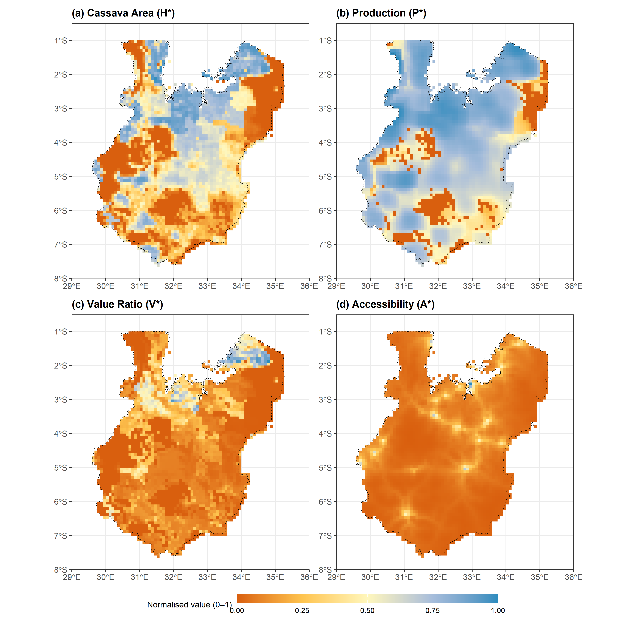
Figure S3 Spatial distribution of the four normalised components used in the Structural Potential Index (SPI). (a) Harvested cassava area (H*), log-transformed before scaling, shows concentrated production around Lake Victoria. (b) Regional cassava production (P*), computed as a 5×5 neighbourhood mean, highlights large production belts extending west and east of the lake. (c) Value ratio (V*), cassava’s share of total crop value, shows low relative economic importance across most of the Lake Zone. (d) Accessibility (A*), the inverse-transformed travel time to cities >50,000 population, is highest only around a few urban centres. Together these components illustrate why the SPI shows modest values across large areas despite high cassava production in specific zones.
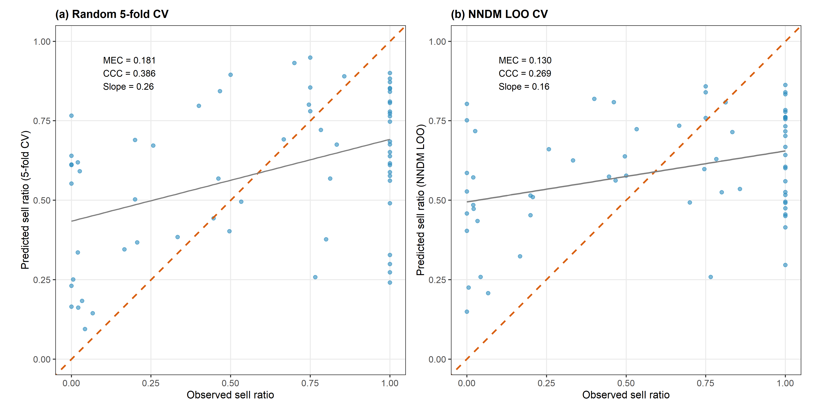
Figure S4 Observed versus predicted sell ratios from two cross-validation strategies. (a) Random 5-fold CV shows moderate agreement (MEC = 0.181, CCC = 0.386), with regression toward the mean (slope = 0.26). (b) NNDM leave-one-out CV shows reduced agreement (MEC = 0.130, CCC = 0.269) and further regression toward the mean (slope = 0.16), reflecting more realistic prediction performance evaluation under spatial clustering. Red dashed line: 1:1 reference. Grey line: fitted regression. Both panels show systematic underprediction of high sell ratios and overprediction of low sell ratios, consistent with the U-shaped response distribution.
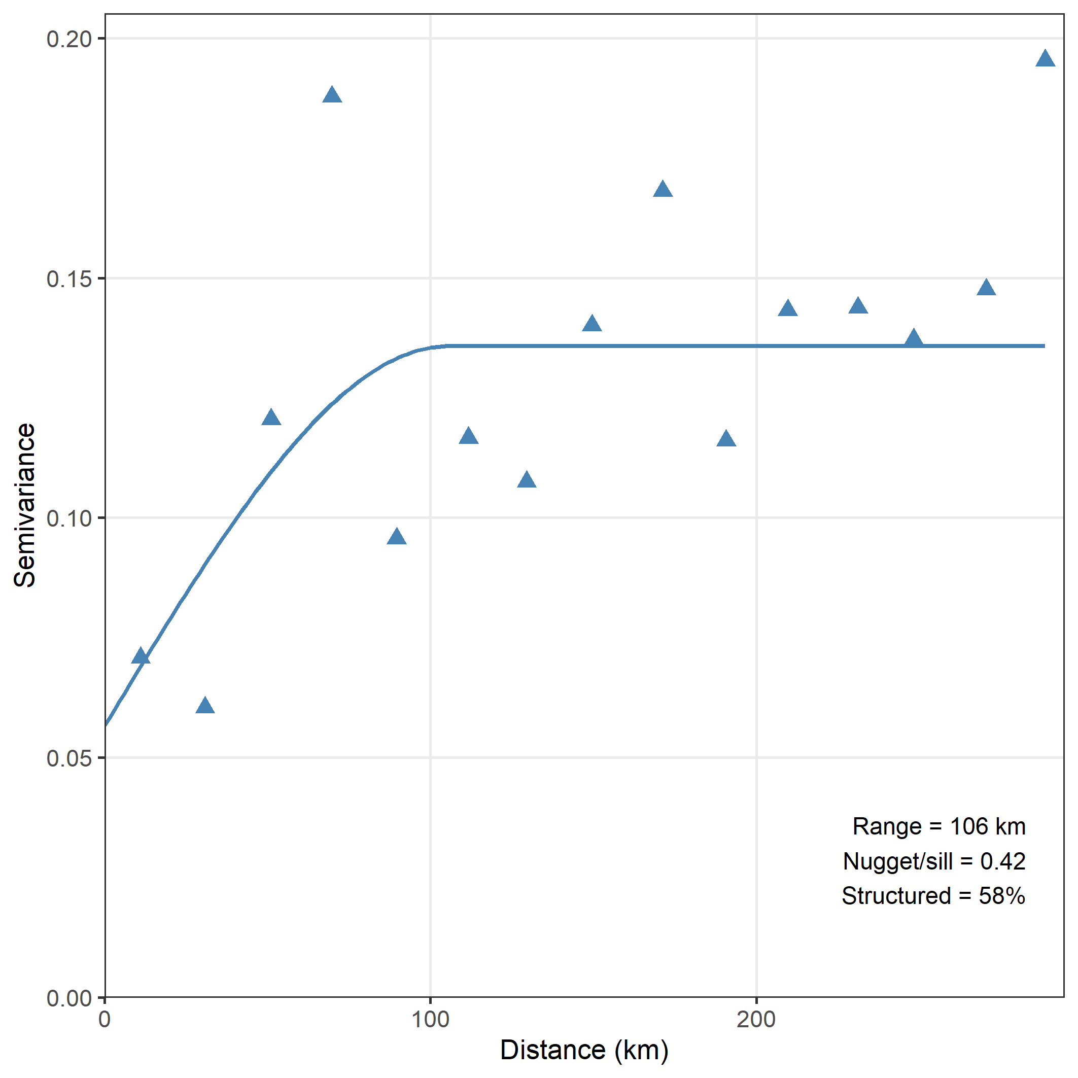
Figure S5 Empirical semivariogram of observed sell ratios (n = 66) with fitted spherical model. The y-intercept of the fitted curve (~0.06) represents the nugget, which corresponds to 42% of the total sill, indicating that a substantial fraction of variance occurs at distances shorter than the sampling resolution. The estimated range (~106 km) indicates moderate spatial autocorrelation. This justifies the use of NNDM cross-validation to obtain realistic spatial prediction error estimates.

