Supporting Information for:
Community context, resource dynamics, and body size differences shape multidimensional niche overlap among avian frugivores of south Asian tropics

Table of contents:
Content | Page no.
Table S1. Bird species information | 2–3
Table S2. GLMM results summary: fruit crop size vs. overlap | 3–4
Table S3. Variation explained by random effects in the above GLMM models | 4–5
Table S4. GLMM results summary: overlap vs. body mass difference | 5–7
Fig. S1. Comparison between original overlaps and overlaps after controlled effort | 8
Fig. S2. Fruit crop size comparison between different tree categories | 9
Fig S3. Mean visit duration of frugivores on focal trees | 10–11
Fig. S4. Relationship between arrival and foraging heights of avian frugivores | 12–13

Table S1. Avian frugivore species included in the analyses across the two study sites. For each study site, we provide the bird species code, common name, scientific name following Clement’s taxonomy, and bird family.
Study site | Bird family | Species code | Common name | Scientific name (Clement’s taxonomy)
Anamalai | Bucerotidae | GRHO | Great Hornbill | Buceros bicornis
Anamalai | Bucerotidae | MGHO | Malabar Grey Hornbill | Ocyceros griseus
Anamalai | Columbidae | GFGP | Grey-fronted Green-Pigeon | Treron affinis
Anamalai | Irenidae | AFBL | Asian Fairy-bluebird | Irena puella
Anamalai | Megalaimidae | MABA | Malabar Barbet | Psilopogon malabaricus
Anamalai | Megalaimidae | WCBA | White-cheeked Barbet | Psilopogon viridis
Anamalai | Pycnonotidae | FTBU | Flame-throated Bulbul | Rubigula gularis
Anamalai | Pycnonotidae | YBBU | Yellow-browed Bulbul | Acritillas indica
Anamalai | Sturnidae | SHMY | Southern Hill Myna | Gracula indica
Namdapha | Bucerotidae | GRHO | Great Hornbill | Buceros bicornis
Namdapha | Bucerotidae | RNHO | Rufous-necked Hornbill | Aceros nipalensis
Namdapha | Bucerotidae | WRHO | Wreathed Hornbill | Rhyticeros undulatus
Namdapha | Columbidae | AHGP | Ashy-headed Green-Pigeon | Treron phayrei
Namdapha | Columbidae | MIPI | Mountain Imperial-Pigeon | Ducula badia
Namdapha | Columbidae | PTGP | Pin-tailed Green-Pigeon | Treron apicauda
Namdapha | Irenidae | AFBL | Asian Fairy-bluebird | Irena puella
Namdapha | Leiothrichidae | BWMI | Blue-winged Minla | Actinodura cyanouroptera
Namdapha | Leiothrichidae | GNLA | Greater Necklaced Laughingthrush | Pterorhinus pectoralis
Namdapha | Leiothrichidae | LTSI | Long-tailed Sibia | Heterophasia picaoides
Namdapha | Leiothrichidae | RBSI | Rufous-backed Sibia | Leioptila annectens
Namdapha | Leiothrichidae | SEME | Silver-eared Mesia | Leiothrix argentauris
Namdapha | Megalaimidae | BTBA | Blue-throated Barbet | Psilopogon asiaticus
Namdapha | Megalaimidae | GRBA | Great Barbet | Psilopogon virens
Namdapha | Pycnonotidae | ASBU | Ashy Bulbul | Hemixos flavala
Namdapha | Pycnonotidae | WTBU | White-throated Bulbul | Alophoixus flaveolus
Namdapha | Sturnidae | CHMY | Common Hill Myna | Gracula religiosa
Namdapha | Zosteropidae | WHYU | Whiskered Yuhina | Yuhina flavicollis

Table S2. Results of the binomial generalised linear mixed-effects models (GLMMs) examining the effect of log-transformed ripe fruit availability at the level of focal tree individuals on the probability of pairwise frugivore niche overlap in vertical and temporal axes in both our study sites, Anamalai and Namdapha. Fixed-effect estimates are presented on the logit scale with standard errors (SE), z-scores, and p-values.
Site | Overlap type | Predictor | Estimate (logit) | SE | z-score | p-value
Anamalai | Vertical | (Intercept) | –5.758 | 0.973 | –5.92 | <0.001
Anamalai | Vertical | log FCS | 0.463 | 0.102 | –4.53 | <0.001
Namdapha | Vertical | (Intercept) | –6.284 | 0.590 | –10.65 | <0.001
Namdapha | Vertical | log FCS | 0.328 | 0.055 | 5.97 | <0.001
Anamalai | Temporal | (Intercept) | –7.718 | 1.062 | –7.27 | <0.001
Anamalai | Temporal | log FCS | 0.604 | 0.115 | 5.27 | <0.001
Namdapha | Temporal | (Intercept) | –7.209 | 0.676 | –10.66 | <0.001
Namdapha | Temporal | log FCS | 0.351 | 0.062 | 5.63 | <0.001

Table S3. Random-effect variance components from the binomial generalised linear mixed-effects models (GLMMs) assessing the influence of log-transformed ripe fruit availability at the level of focal tree individuals on the probability of pairwise frugivore niche overlap in vertical and temporal axes in both our study sites, Anamalai and Namdapha. Variance and standard deviation (SD) are reported for random intercepts associated with tree identity (Tree ID) and the two species identities within each frugivore pair (Frugivore 1 and Frugivore 2).
Site | Overlap type | Group | Predictor | Variance | SD
Anamalai | Vertical | Tree ID. | Intercept | 1.589 | 1.260
Anamalai | Vertical | Frugivore 1 | Intercept | 1.108 | 1.053
Anamalai | Vertical | Frugivore 2 | Intercept | 0.722 | 0.850
Namdapha | Vertical | Tree ID. | Intercept | 0.698 | 0.835
Namdapha | Vertical | Frugivore 1 | Intercept | 0.356 | 0.596
Namdapha | Vertical | Frugivore 2 | Intercept | 0.442 | 0.665
Anamalai | Temporal | Tree ID. | Intercept | 2.545 | 1.595
Anamalai | Temporal | Frugivore 1 | Intercept | 1.116 | 1.057
Anamalai | Temporal | Frugivore 2 | Intercept | 0.800 | 0.894
Namdapha | Temporal | Tree ID. | Intercept | 0.939 | 0.969
Namdapha | Temporal | Frugivore 1 | Intercept | 0.553 | 0.744
Namdapha | Temporal | Frugivore 2 | Intercept | 0.607 | 0.779

Table S4. Results of separate beta GLMMs (logit link) testing the effect of log-transformed body mass difference on dietary, temporal, and vertical niche overlap among frugivore species in Anamalai and Namdapha, including fixed‐effect estimates (intercept and log bodyMassDifference), standard errors (SE), z-scores, p-values, and marginal R-square values.
Site | Overlap type | Predictor | Estimate (logit) | SE | z-score | p-value | R²_{marginal}
Anamalai | Dietary | (Intercept) | 0.151 | 0.241 | 0.63 | 0.532 | 0.68
Anamalai | Dietary | log bodyMassDifference | –0.198 | 0.113 | –1.75 | 0.081
Namdapha | Dietary | (Intercept) | –0.757 | 0.232 | –3.26 | 0.001 | 0.32
Namdapha | Dietary | log bodyMassDifference | –0.371 | 0.065 | –5.71 | <0.001
Anamalai | Vertical | (Intercept) | –0.81 | 0.211 | –3.83 | <0.001 | 0.89
Anamalai | Vertical | log bodyMassDifference | –0.347 | 0.109 | –3.19 | 0.001
Namdapha | Vertical | (Intercept) | –1.387 | 0.218 | –6.37 | <0.001 | 0.39
Namdapha | Vertical | log bodyMassDifference | –0.378 | 0.064 | –5.93 | <0.001
Anamalai | Temporal | (Intercept) | –1.787 | 0.262 | –6.82 | <0.001 | 0.35
Anamalai | Temporal | log bodyMassDifference | –0.254 | 0.103 | –2.48 | 0.013
Namdapha | Temporal | (Intercept) | –2.525 | 0.184 | –13.71 | <0.001 | 0.51
Namdapha | Temporal | log bodyMassDifference | –0.348 | 0.062 | –5.57 | <0.001

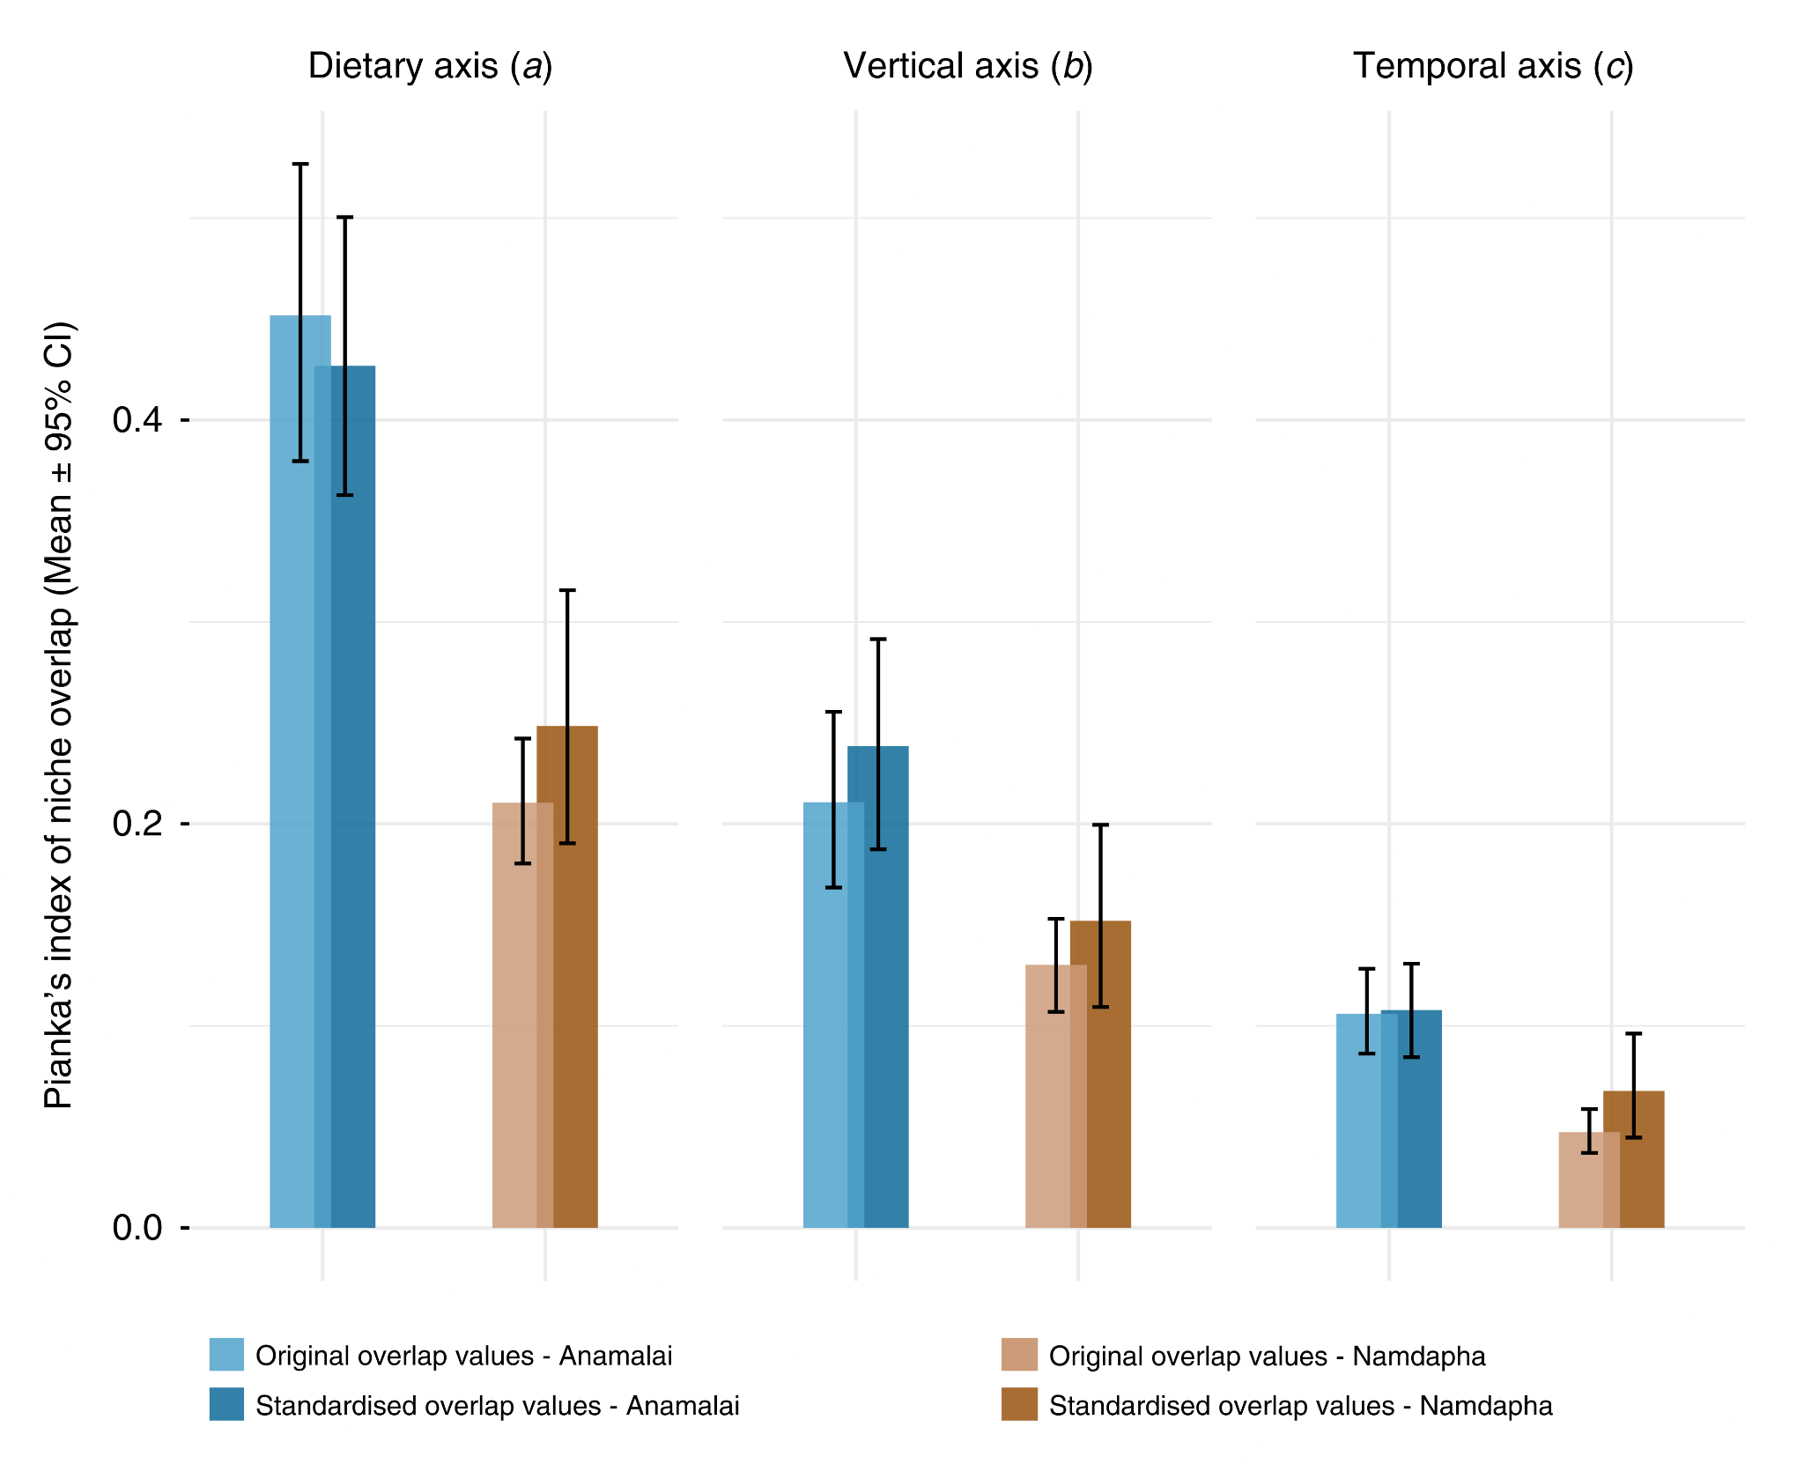
Figure S1. Comparison of pairwise frugivore overlap between sites after standardising sampling effort (67 focal tree individuals randomly chosen from the Anamalai data to match with the number of focal tree individuals sampled in Namdapha), total frugivore and tree species richness (nine and twenty-eight species, respectively), and representation within frugivore groups (Irena puella; Gracula – one species; Treron – one species; Bucerotidae – two species; Megalaimidae – two species; and Pycnonotidae – two species). Mean (± 95% CI) pairwise frugivore niche overlap is shown for the three niche dimensions examined in this study: dietary (a), vertical (b), and temporal (c). This standardisation ensures that differences in overlap patterns between sites are not artefacts of unequal sampling effort or data structure.

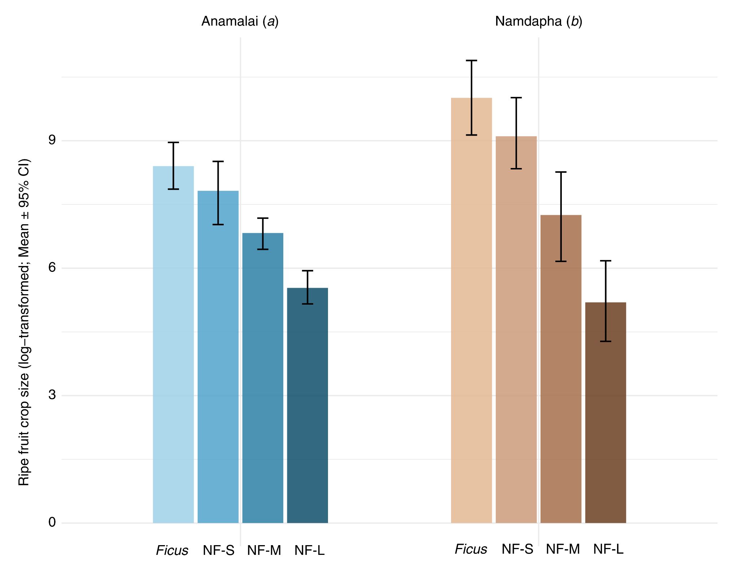
Figure S2. Comparing log-transformed ripe fruit crop size at the level of individual focal tree between different tree types: Ficus, non-Ficus small-seeded (NF-S), non-Ficus medium-seeded (NF-M), and non-Ficus large-seeded (NF-L) in two study sites - Anamalai (a) and Namdapha (b). The y-axis represents means and bootstrapped 95% confidence intervals (CIs) with 1000 iterations.
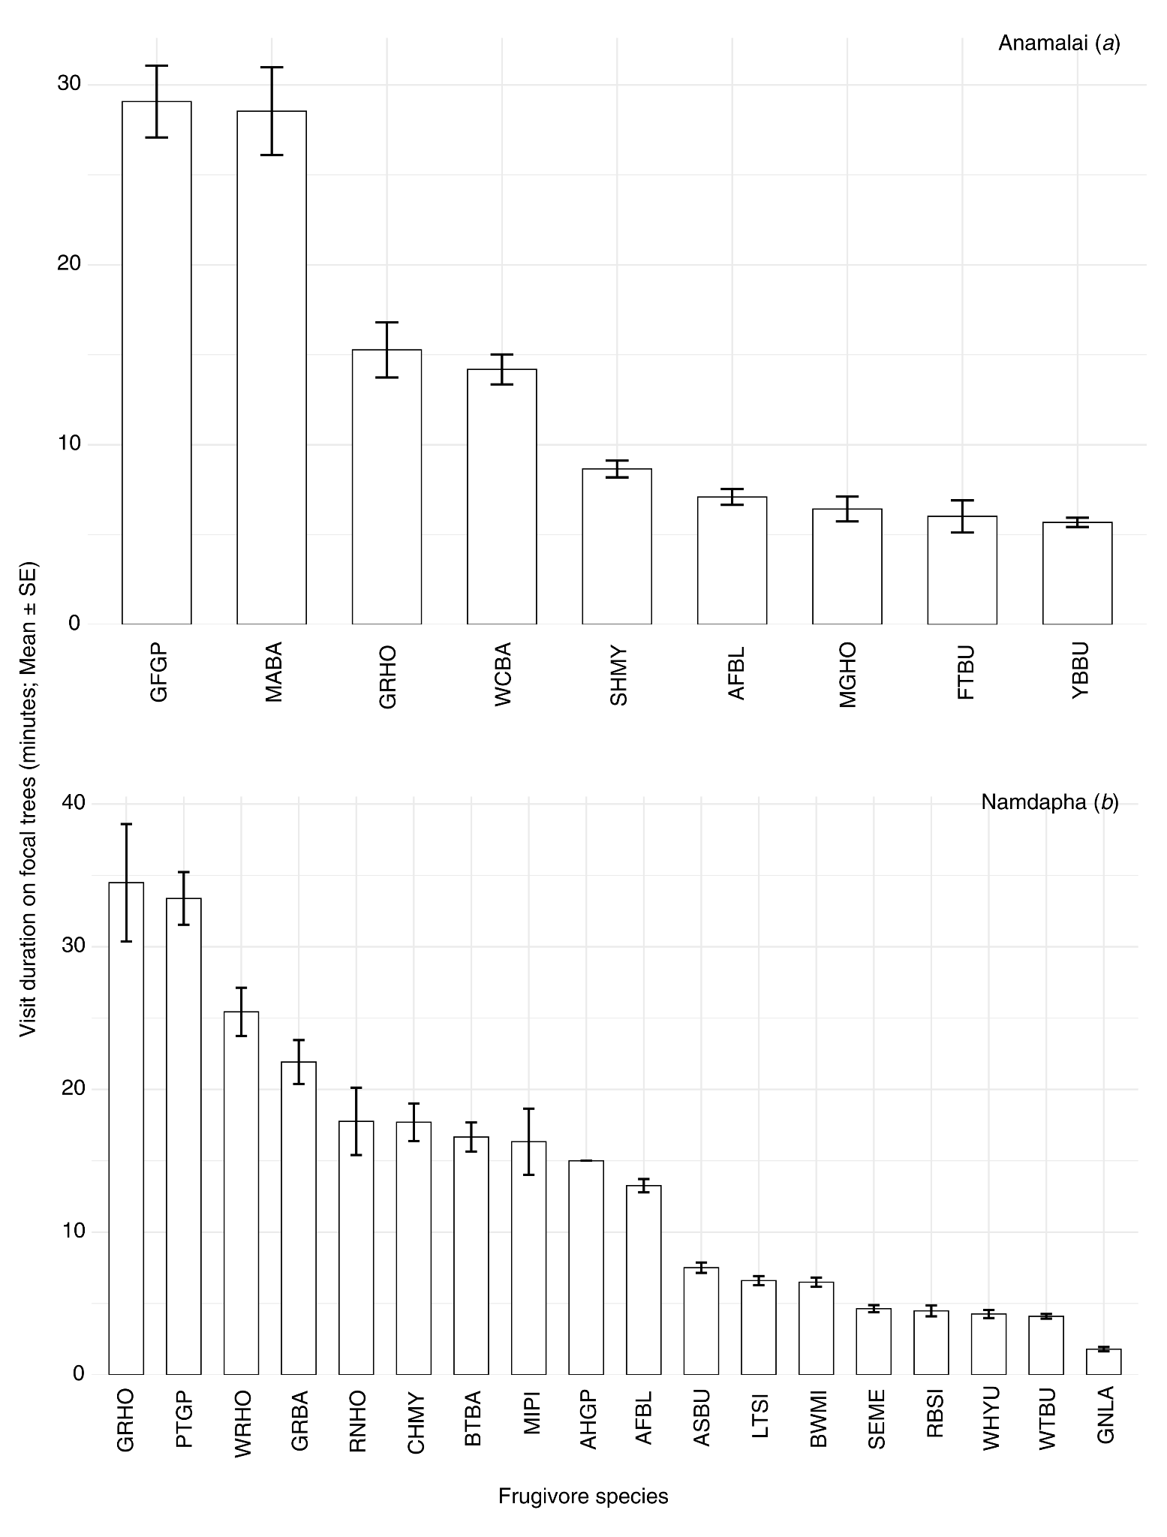
Figure S3. Bar plots representing the mean (± SE) visit duration (in minutes) of each frugivore species recorded on focal trees in Anamalai (a) and Namdapha (b). Avian frugivore species are shown along the x-axis, and values on the y-axis represent the average duration of individual visits per frugivore species at each site. Scientific names corresponding to each bird code are provided in Table S1.

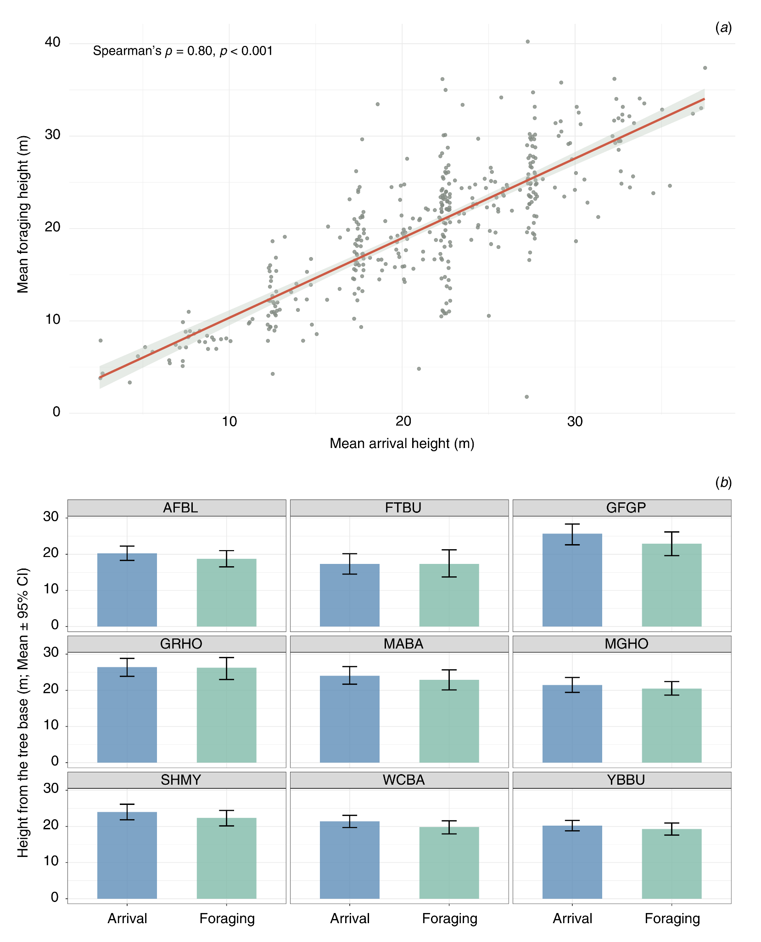
Figure S4. Relationship between arrival and foraging heights of avian frugivores in Anamalai. a – Scatterplot showing the relationship between mean arrival height and mean foraging height of frugivores on focal trees. Each point represents an individual observation of a bird species on a focal tree, with the fitted line indicating the overall trend (Spearman’s ρ = 0.80, p < 0.001). b – Species-wise comparisons of arrival and foraging heights for the nine frugivore species included in the analysis. Bars represent mean height (m) from the tree base, and error bars indicate bootstrapped 95% confidence intervals (with 1000 iterations). Arrival height corresponds to the vertical position at which a frugivore first lands on a focal tree (recorded once per visit for an individual frugivore visitation), measured in 5-m height bins. Foraging height represents the vertical position of the frugivore during feeding, estimated at 5-minute intervals from the start of each tree watch using a laser range finder. Scientific names corresponding to each bird code are provided in Table S1.

