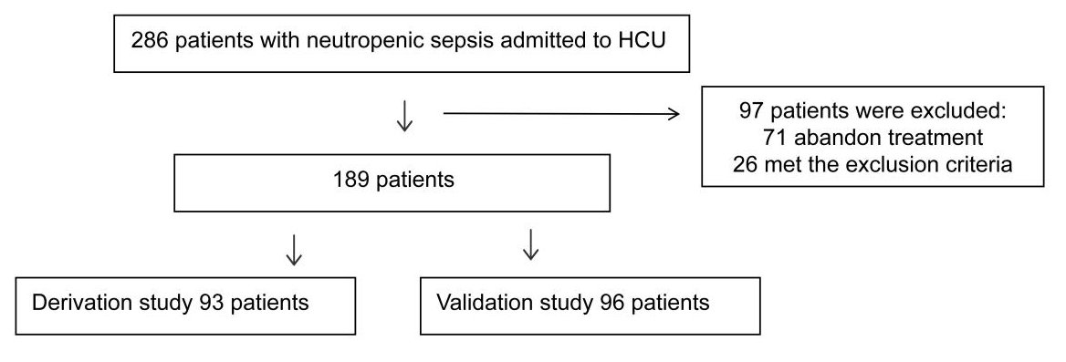
Figures S1. Flow diagram illustrating selection of patients.

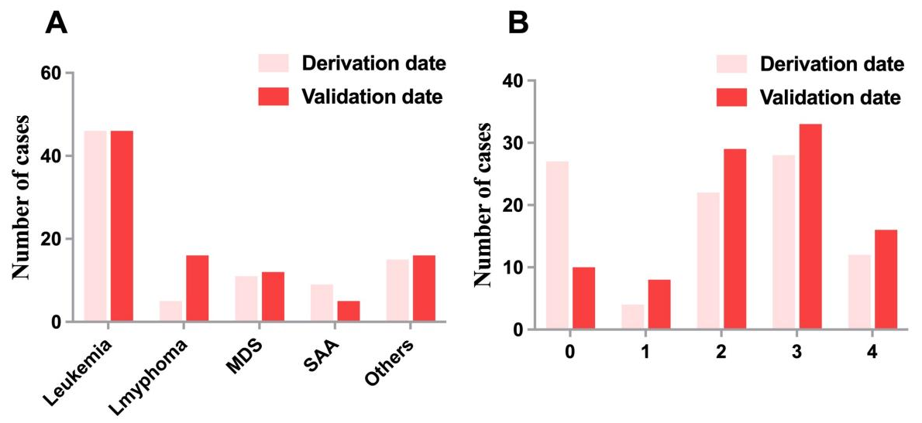
Figures S2. Distribution of the illness source (A) and prognosis score (B) in the derivation and validation samples
Abbreviations: MDS, myelodysplastic syndrome; SAA, severe aplastic anemia

