Supplementary materials
Night work and breast cancer risk: umbrella review of evidence and evaluation of bias
Alizée Lorenz, BMed¹, Joy Sudan, MMed¹, Drinbardha Elshani, MSc¹, Stéphane Cullati, PhD^{1,2,3}, Bernadette W.A. van der Linden, PhD^{1,3}

¹ Population Health Laboratory (#PopHealthLab), University of Fribourg, Switzerland
² Institute of Sociological Research, University of Geneva, Switzerland
³ Swiss Center of Expertise in Life Course Research LIVES, Switzerland

Corresponding author: Dr. Bernadette van der Linden, Population Health Laboratory (#PopHealthLab), University of Fribourg, Route des Arsenaux 41, CH-1700 Fribourg, Switzerland, Phone +41 26 300 94 93, bernadette.vanderlinden@unifr.ch, ORCID Number : 0000-0002-4815-2121

Table of contents
Table S1. PRISMA 2020 Checklist
Table S2. Search strategy in databases
Text S1. Strategy for data synthesis and analysis
Table S3. Results of quality assessment according to the Risk Of Bias In Systematic reviews tool (ROBIS) and the Critical Appraisal Tool from the Center for Evidence-Based Medicine (CEBM)
Table S4. Synthesis of night work pooled effects sizes from systematic reviews and meta-analyses, by shift domains of the IARC Working Group
Table S5. Detailed results examining the association between duration of exposure to night work and breast cancer risk
Table S6. Detailed summary of results of qualitative systematic reviews
Table S7. Synthesis of night work pooled effects by shift domains of IARC Working Group and by menopausal status, all primary study designs combined

Table S1. PRISMA 2020 Checklist
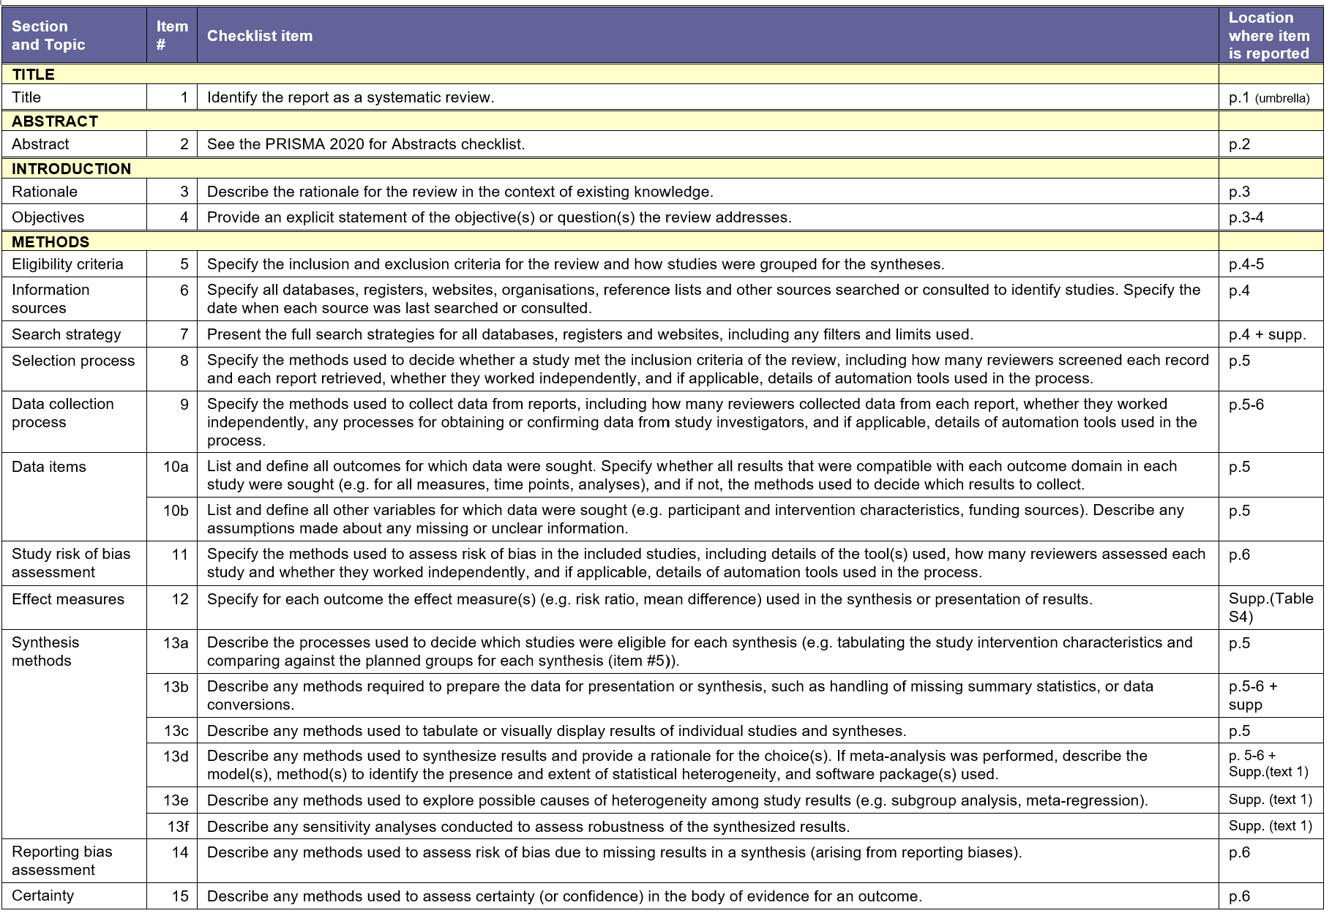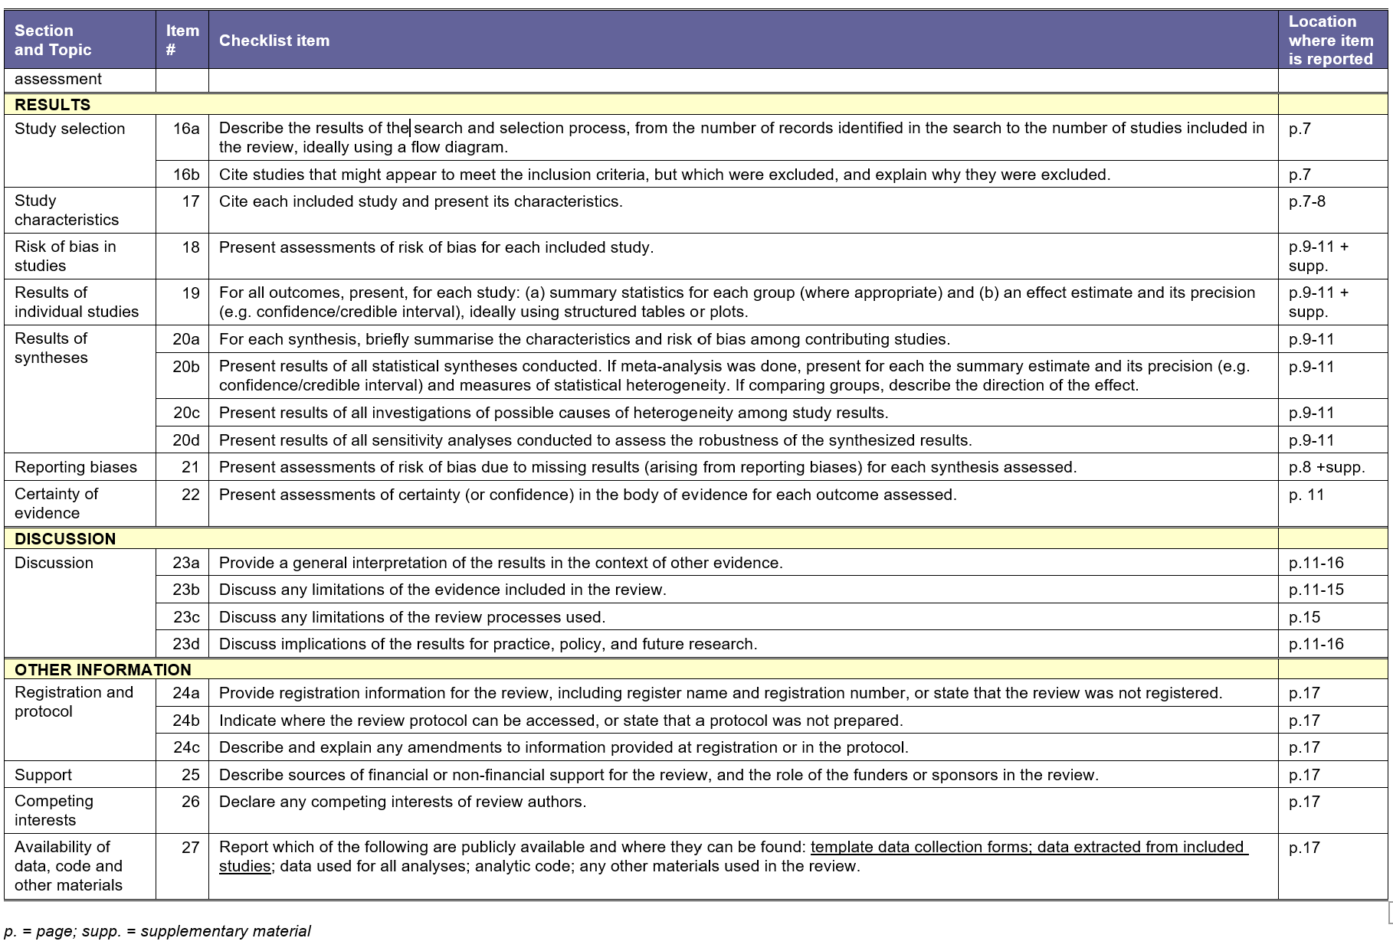
Table S2. Search strategy in databases
Database (Date) | Search number | Query | Results
PubMed (25.02.2024) | 1 | ("Shift Work Schedule"[Mesh] OR "Work Schedule Tolerance"[Mesh] OR "Night Shift Work" OR "Night Shifts" OR "Light At Night") | 10739
PubMed (25.02.2024) | 2 | ("Breast Neoplasms"[Mesh] OR "Breast Cancer" OR Carcinogenesis) | 652600
PubMed (25.02.2024) | 3 | #1 AND #2 | 396
PubMed (25.02.2024) | 4 (final) | #3 AND (meta-analysis[Filter] OR review[Filter] OR systematicreview[Filter]) | 124
PsycINFO (25.02.2024) | 1 | night work OR sleep deprivation OR light at night OR night shift OR shift patterns OR working night shifts OR night shift work OR workday shifts OR work schedule tolerance OR shift work OR rotating shift work OR human biological rhythms | 23065
PsycINFO (25.02.2024) | 2 | breast cancer OR mammary cancer OR mammary carcinoma OR mammary neoplasms OR mammary tumo?r OR breast neoplasms OR breast tumo?r | 17460
PsycINFO (25.02.2024) | 3 | #1 AND #2 | 140
PsycINFO (25.02.2024) | 4 (final) | #3 with filters « literature review », « systematic review » and «meta-analysis» | 12
Web of Science (25.02.2024) | 1 | ALL=(Breast Neoplasms OR Carcinogenesis) | 176325
Web of Science (25.02.2024) | 2 | ALL=((Mammary OR Breast) AND (Cancer OR Neoplasms OR Tumo?r OR Carcinoma OR Carcinogenesis)) | 766556
Web of Science (25.02.2024) | 3 | #1 OR #2 | 894921
Web of Science (25.02.2024) | 4 | ALL=(Work Schedule Tolerance OR Shift Work Schedule) | 6336
Web of Science (25.02.2024) | 5 | ALL=(Night Shift Work OR Night Shift* OR Work Schedule Tolerance OR Shift Work Schedule OR Working At Night OR Rotating Shift Work OR Light At Night) | 37667
Web of Science (25.02.2024) | 6 | #4 OR #5 | 37667
Web of Science (25.02.2024) | 7 | #3 AND #6 | 1033
Web of Science (25.02.2024) | 8 | ALL=(meta-analy*) OR ALL=(systematic review) | 645013
Web of Science (25.02.2024) | 9 (final) | #7 AND #8 | 88
Cochrane Library (25.02.2024) | 1 | MeSH descriptor: [Breast Neoplasms] explode all trees | 19974
Cochrane Library (25.02.2024) | 2 | Title Abstract Keyword : ((mammary or breast*) NEXT (cancer* or neoplasm* or tumo?r* or carcinoma*)):ti,ab,kw | 45101
Cochrane Library (25.02.2024) | 3 | #1 OR #2 | 45130
Cochrane Library (25.02.2024) | 4 | MeSH descriptor: [Work Schedule Tolerance] explode all trees | 232
Cochrane Library (25.02.2024) | 5 | MeSH descriptor: [Shift Work Schedule] explode all trees | 54
Cochrane Library (25.02.2024) | 6 | Title Abstract Keyword : ((night-shift* or shift* or night or night shift* or rotating shift* or rotating night shift* or nocturnal) NEXT work*):ti,ab,kw OR (working at night):ti,ab,kw OR (night-work exposure):ti,ab,kw OR (shift pattern*):ti,ab,kw | 3299
Cochrane Library (25.02.2024) | 7 | #4 OR #5 OR #6 | 3365
Cochrane Library (25.02.2024) | 8 | #3 AND #7 | 49 (2 reviews and 47 trials)

Text S1. Strategy for data synthesis and analysis
Results from the included reviews were presented in tables and synthetized narratively. To clarify the association between night work and breast cancer risk, the relationship was analysed across several exposure categories. To define these categories, we relied on the shift work domains described by the IARC Working Group (1). However, since included reviews did not report results for all IARC-defined shift domains, some domains were excluded. Additionally, some reviews presented results for exposure categories not covered by the IARC domains; therefore, we incorporated these night work categories into our tables and results, based on the analyses available in the reviews. Most meta-analyses reported results based on a combination of all study designs, integrating findings from cohort studies, case-control studies, and/or nested case-control studies. Some reviews reported the overall effect of night work, while others examined the impact of ever versus never exposure. To simplify synthesis and analysis, ever versus never exposure was considered as representing an overall effect, as both exposure categories assessed the general impact of night work. To synthesize the results based on the duration of night work exposure, we divided the exposure duration into five groups: ≤ 5 years, ≤ 10 years, ≥ 10 years, ≥ 20 years, and ≥ 30 years.
Heterogeneity of results was classified as low when I² was approximately 25%, moderate at 50%, and high at 75% or above, in accordance with the criteria proposed by Higgins et al. (2). A p-value for heterogeneity of 0.10 or lower was considered indicative of statistically significant heterogeneity. In this umbrella review, heterogeneity was systematically reported when it was assessed as moderate or high.
Reviews were grouped based on the ROBIS risk of bias levels to explore potential result variations across these categories. Subgroup analyses were performed by menopausal status.

Table S3. Results of quality assessment according to the Risk Of Bias In Systematic reviews tool (ROBIS) and the Critical Appraisal Tool from the Center for Evidence-Based Medicine (CEBM)
First Author | ROBIS | CEBM | CEBM score*
Megdal (3) | HIGH | yes/no/yes/unclear/yes | 2
Erren (4) | HIGH | unclear/unclear/yes/unclear/yes | 2
Kolstad (5) | HIGH | no/unclear/unclear/unclear/unclear | -1
Wang (6) | HIGH | yes/no/unclear/unclear/unclear | 0
Jia (7) | HIGH | yes/no/yes/yes/unclear | 2
Ijaz (8) | LOW | yes/yes/yes/yes/unclear | 4
Kamdar (9) | LOW | yes/yes/yes/yes/unclear | 4
He (10) | HIGH | yes/no/yes/yes/unclear | 2
Benabu (11) | HIGH | no/no/unclear/yes/unclear | -1
Lin (12) | HIGH | yes/yes/yes/yes/unclear | 4
Nikpour (13) | HIGH | unclear/no/yes/unclear/yes | 1
Travis (14) | HIGH | unclear/no/yes/yes/unclear | 1
McElvenny (15) | HIGH | no/no/unclear/yes/no | -2
Salamanca-Fernández (16) | HIGH | no/yes/yes/yes/unclear | 2
Liu (17) | HIGH | unclear/yes/yes/yes/unclear | 3
Dun (18) | HIGH | yes/no/yes/yes/unclear | 2
Fagundo-Rivera (19) | HIGH | yes/no/yes/yes/unclear | 2
Schwarz (20) | LOW | yes/yes/yes/yes/unclear | 4
Van (21) | HIGH | yes/yes/yes/yes/no | 3
Manouchehri (22) | LOW | yes/yes/yes/yes/unclear | 4
Wei (23) | HIGH | no/yes/yes/yes/unclear | 2
Hong (24) | HIGH | yes/yes/yes/yes/no | 3
Moon (25) | HIGH | yes/yes/yes/yes/yes | 5
*CEBM scoring: one point awarded for “yes”, zero for “unclear”, and minus one for “no”, yielding a maximum possible score of five. Studies were categorized into three quality levels based on their total score: low (≤ 2 points), moderate (3 points), and high quality (≥ 4 points).
Table S4. Synthesis of night work pooled effects sizes from systematic reviews and meta-analyses, by shift domains of the IARC Working Group*
Shift domains* | NW category (Review’s ID)  [Risk of bias**] | Study design | Pooled ES | 95% CI | Heterogeneity***
NW | Ever versus never (9) [LOW] | ASC | RR = 1.21 | 1.00-1.47 | X² p=0.000, I²=75.8
NW | Overall effect (3) [HIGH] | ASC | CE = 1.48 | 1.36-1.61 | p=0.62
NW | Ever versus never (6) [HIGH] | ASC | RR = 1.19 | 1.05-1.35 | p=0.000, I²=75.2
NW | Overall effect (7) [HIGH] | ASC | RR = 1.20 | 1.08-1.33 | Q p=0.000, I²=63.4
NW | Ever versus never (7) [HIGH] | ASC | RR = 1.16 | 1.06-1.27 | Q p=0.005
NW | Overall effect (10) [HIGH] | ASC | RR = 1.23 | 1.11-1.36 | Q p<0.001, I²=76.9
NW | Ever versus never (14) [HIGH] | ASC | RR = 0.99 | 0.95-1.03 | X² p=0.052
NW | Overall effect (17) [HIGH] | ASC | OR = 1.22 | 1.08-1.38 | p<0.001, I²=81.2
NW | Overall effect (18) [HIGH] | ASC | OR = 1.01 | 0.98-1.03 | I²=45.7
NW | Overall effect (21) [HIGH] | ASC | CE = 1.11 | 1.04-1.20 | I²=72.4
NW | Overall effect (24) [HIGH] | ASC | HR = 1.20 | 1.10-1.31 | Q p=0.000, I²=76.3
NW | Ever versus never (9) [LOW] | CC | RR = 1.28 | 1.03-1.60 | X² p<0.01, I² = 52
NW | Ever versus never (6) [HIGH] | CC | RR = 1.30 | 1.04-1.64 | p=0.000, I²=79.5
NW | Overall effect (7) [HIGH] | CC | RR = 1.32 | 1.17-1.50 | Q p=0.137, I²=32.7
NW | Overall effect (21) [HIGH] | CC | OR = 1.34 | 1.17-1.53 | I²=63.8
NW | Overall effect (21) [HIGH] | NCC | OR = 1.14 | 0.98-1.46 | I²=65.8
NW | Ever versus never (9) [LOW] | CS | RR = 1.14 | 0.85-1.53 | I² = 76
NW | Ever versus never (6) [HIGH] | CS | RR = 1.06 | 0.98-1.16 | p=0.204, I²=37.1
NW | Overall effect (7) [HIGH] | CS | RR = 1.08 | 0.97-1.21 | Q p=0.019, I²=51.8
NW | Overall effect (12) [HIGH] | CS | RR = 1.06 | 1.01-1.10 | Q p = 0.358, I²=9.2
NW | Overall effect (21) [HIGH] | CS | CE =0.98 | 0.93-1.03 | I²=25.3
NW | Overall effect (23) [HIGH] | CS | RR = 1.03 | 1.00-1.05 | X² p=0.115, I²=30.3
Duration < 5 years | 1 year (25) [HIGH] | CS | RR = 1.00 | 1.00-1.01 | N/A
Duration < 5 years | 1 year (25) [HIGH] | CC | OR = 1.02 | 1.01-1.03 | N/A
Duration < 5 years | < 5 years (12) [HIGH] | CS | RR = 1.03 | 0.97-1.09 | Q p=0.223, I²=31.6
Duration < 5 years | 5 years (12) [HIGH] | CS | RR= 1.02 | 1.00-1.04 | Q p=0.302, I²=17.7
Duration ≤ 10 years | < 8 years (9) [LOW] | ASC | RR = 1.13 | 0.97-1.32 | X² p=0.000, I²=78.5
Duration ≤ 10 years | < 8 years (9) [LOW] | CS | RR = 1.05 | 0.98-1.12 | I² =0
Duration ≤ 10 years | < 8 years (9) [LOW] | CC | RR = 1.17 | 0.92-1.49 | X² p<0.01, I² =75
Duration ≤ 10 years | ≤ 10 years (21) [HIGH] | ASC | CE= 1.02 | 0.98-1.05 | I²=2.0
Duration ≤ 10 years | < 10 years¹ (22) [LOW] | ASC | RR = 1.13 | 1.03-1.24 | X²p=0.008, I²=71.3
Duration ≤ 10 years | < 10 years¹ (22) [LOW] | CS | RR = 1.02 | 0.97-1.06 | X²p=0.806, I²=0
Duration ≤ 10 years | < 10 years¹ (22) [LOW] | NCC | RR = 1.40 | 0.90-2.19 | X²p= 0.011, I²=66.2
Duration ≤ 10 years | < 10 years¹ (22) [LOW] | CC | RR = 1.25 | 1.08-1.44 | X²p=0.003, I²=59.8
Duration ≤ 10 years | 0-10 years (23) [HIGH] | CS | RR = 1.01 | 0.99-1.05 | X²p=0.668, I²=0
Duration ≤ 10 years | 1-10 years (24) [HIGH] | ASC | HR = 1.09 | 1.01-1.18 | I²=78.9
Duration ≤ 10 years | 5-10 years (12) [HIGH] | CS | RR = 1.02 | 1.01-1.04 | Q p=0.149, I²=43.7
Duration ≤ 10 years | 10 years (25) [HIGH] | CS | RR = 1.04 | 1.01-1.07 | N/A
Duration ≤ 10 years | 10 years (25) [HIGH] | CC | OR = 1.24 | 1.11-1.37 | N/A
 | ≥ 8 years (9) [LOW] | ASC | RR = 1.04 | 0.92-1.18 | X² p=0.023, I²=55
 | ≥ 8 years (9) [LOW] | CS | RR = 1.05 | 0.92-1.19 | I² = 40
 | ≥ 8 years (9) [LOW] | CC | RR = 1.06 | 0.82-1.37 | X² p=0.25, I² = 62
Duration ≥10 years | ≥ 10 years (22) [LOW] | ASC | RR = 1.08 | 0.99-1.17 | X²p=0.09, I²=42.2
Duration ≥10 years | ≥ 10 years (22) [LOW] | CS | RR = 1.01 | 0.95-1.07 | X²p=0.706, I²=0
Duration ≥10 years | ≥ 10 years (22) [LOW] | NCC | RR = 1.5 | 0.86-2.66 | X²p=0.001, I²=84.7
Duration ≥10 years | ≥ 10 years (22) [LOW] | CC | RR = 1.22 | 1.02-1.46 | X²p=0.819, I²=0
Duration ≥10 years | > 10 years (23) [HIGH] | CS | RR = 1.09 | 1.03-1.14 | X²p=0.959, I²=0
Duration ≥10 years | ≥ 15 years (7) [HIGH] | ASC | RR = 1.15 | 1.03-1.29 | Q p=0.115, I²= 39.6

Table S4 (Continued)
Shift domains* | NW category (Review’s ID)  [Risk of bias**] | Study design | Pooled ES | 95% CI | Heterogeneity***
Duration ≥10 years | ≥ 15 years (20) [LOW] | ASC | RR = 1.13 | 1.01-1.27 | X²p=0.002 I²=56.8
Duration ≥10 years | ≥ 15 years (20) [LOW] | CS | RR = 1.04 | 0.91-1.18 | X²p=0.139, I²=36.3
Duration ≥10 years | ≥ 15 years (20) [LOW] | NCC | RR = 1.34 | 0.96-1.88 | X²p<0.001, I²=82.2
Duration ≥10 years | ≥ 15 years (20) [LOW] | CC | RR = 1.22 | 1.01-1.48 | X²p=0.613, I²=0.0
Duration ≥10 years | 10-20 years (12) [HIGH] | CS | RR = 1.07 | 1.01-1.14 | Q p=0.531, I²=0.0
Duration ≥10 years | > 10-20 years (21) [HIGH] | ASC | CE = 0.99 | 0.91-1.07 | I²=13.1
Duration ≥10 years | 11-29 years (24) [HIGH] | ASC | HR = 1.12 | 1.01-1.23 | I²=69.9
Duration ≥20 years | 20 years (25) [HIGH] | CS | RR = 1.09 | 1.03-1.15 | N/A
Duration ≥20 years | 20 years (25) [HIGH] | CC | OR = 1.53 | 1.24-1.88 | N/A
Duration ≥20 years | ≥ 20 years (14) [HIGH] | ASC | RR = 1.01 | 0.93-1.10 | X² p=0.011
Duration ≥20 years | > 20 years (12) [HIGH] | CS | RR = 1.09 | 1.01-1.17 | Q p=0.185, I²=37.8
Duration ≥20 years | > 20 years (21) [HIGH] | ASC | CE = 1.03 | 0.95-1.11 | I²=36.6
Duration ≥ 30 years | 30 years (25) [HIGH] | CS | RR = 1.13 | 1.04-1.23 | N/A
Duration ≥ 30 years | 30 years (25) [HIGH] | CC | OR = 1.88 | 1.38-2.57 | N/A
Duration ≥ 30 years | ≥ 30 years (14) [HIGH] | ASC | RR = 1.00 | 0.87-1.14 | X² p=0.067
Duration ≥ 30 years | > 30 years (24) [HIGH] | ASC | HR = 1.18 | 1.02-1.36 | I²=74.4
Duration (each duration in years) | each 1-year (21) [HIGH] | ASC | CE = 1.007 | 1.002-1.011 | N/A
Duration (each duration in years) | each 1-year (21) [HIGH] | CS | CE = 1.001 | 0.997-1.006 | N/A
Duration (each duration in years) | each 5-year (6) [HIGH] | ASC | RR = 1.03 | 1.01-1.05 | p=0.000, I²=70.0
Duration (each duration in years) | each 5-year (6) [HIGH] | CS | RR = 1.02 | 1.00-1.04 | p=0.218, I²=34.3
Duration (each duration in years) | each 5-year (6) [HIGH] | CC | RR = 1.06 | 1.02-1.09 | p=0.001, I²=74.6
Duration (each duration in years) | each 5-year (8) [LOW] | ASC | RR = 1.05 | 1.01-1.10 | I²= 55
Duration (each duration in years) | each 5-year (8) [LOW] | CS | RR = 1.01 | 0.97-1.05 | I² = 34
Duration (each duration in years) | each 5-year (8) [LOW] | CC | RR = 1.09 | 1.02-1.20 | I² = 45
Duration (each duration in years) | each 10-years (10) [HIGH] | ASC | RR = 1.06 | 0.98-1.15 | N/A
Duration (each duration in years) | each 10-years (10) [HIGH] | CS | RR = 1.03 | 0.95-1.11 | N/A
Duration (each duration in years) | each 10-years (10) [HIGH] | CC | RR = 1.16 | 1.06-1.27 | N/A
Duration (each duration in years) | each 10-years (20) [LOW] | ASC | RR = 1.05 | 0.94-1.09 | X²p=0.008, I²=33.4
Duration (with increasing number of night shifts) | Each 300 night shifts (8) [LOW] | ASC | RR = 1.04 | 1.00-1.10 | I²= 58
Duration (with increasing number of night shifts) | Each 300 night shifts (8) [LOW] | CS | RR = 1.00 | 0.97-1.04 | I² = 53
Duration (with increasing number of night shifts) | Each 300 night shifts (8) [LOW] | CC | RR = 1.07 | 1.00-1.10 | I²= 37
Duration (with increasing number of night shifts) | Each 500 night shifts (6) [HIGH] | ASC | RR = 1.13 | 1.07-1.21 | p=0.060, I²=59.6
Duration (with increasing number of night shifts) | < 500 night shifts (24) [HIGH] | ASC | HR = 1.00 | 0.75-1.34 | I²=46.0
Duration (with increasing number of night shifts) | 500-1000 night shifts (24) [HIGH] | ASC | HR = 1.15 | 0.83-1.61 | I²=74.1
Duration (with increasing number of night shifts) | > 1000 night shifts (24) [HIGH] | ASC | HR = 1.39 | 0.99-1.95 | I²=70.0
Intensity | 3 night shifts per month (6) [HIGH] | ASC | RR = 1.02 | 0.97-1.09 | p=0.072, I²=62.0
Intensity | 1-5 times per week (24) [HIGH] | ASC | HR = 1.08 | 0.94-1.24 | Q p=0.000, I²=78.6
Intensity | > 5 times per week (24) [HIGH] | ASC | HR = 1.50 | 1.02-2.20 | Q p=0.000, I²=95.0
ASC = all studies combined, CC = case-control studies, CE = combined effect, CI = confidence interval, CS = cohort studies, ES = effect size, HR = hazard ratio, IARC = International Agency for Research on Cancer, N/A = not available, NCC = nested case-control studies, NW = night work, OR = odds ratio, RR = relative risk; *Stevens et al. (1); **according to the ROBIS; ***p value for heterogeneity (X² or Q) and I² [%]
Table S5. Detailed results examining the association between duration of exposure to night work and breast cancer risk
Less than five years | Participants who worked night shifts for five years or less showed an increased risk of breast cancer according to one meta-analysis of case-control studies (Moon et al.: for one year of night work: OR = 1.02; 95% CI: 1.01–1.03) (25). Three meta-analyses of cohort studies examined the impact of night work exposure for five years or less and found no effect (e.g., Lin et al.: RR = 1.02; 95% CI: 1.00–1.04) (12).
Less than ten years | For women who worked night shifts for ten years or less, the increase in risk was unclear. The analyses of all study designs combined (N = 4) were contradictory: two meta-analyses reported no significant effect (Kamdar et al. (9) and Van et al. (21)), while two others (Manouchehri et al. (22) and Hong et al. (24)) showed an association, though with high heterogeneity (e.g., (22): RR = 1.13; 95% CI: 1.03–1.24; I² = 71.3%; p = 0.008). In subgroup analyses of case-control studies (N = 3), two meta-analyses reported an elevated risk of breast cancer associated with ten years or less of night work (e.g., (25): OR = 1.24; 95% CI: 1.11–1.37), whereas another reported no association (9), with considerable heterogeneity (for <8 years: RR = 1.17; 95% CI: 0.92–1.49; I² = 75%; p < 0.01). Among meta-analyses of cohort studies (N = 5), two reported significant relative risks (e.g. (12): RR = 1.02; 95% CI = 1.01-1.04; I² = 43.7%; p = 0.149), though three results were not significant. The only meta-analysis of nested case-control studies found an almost significant association with a relatively large effect of 40%, with moderate heterogeneity (RR = 1.40; 95% CI: 0.90–2.19; I² = 66.2%; p = 0.011) (22).
More than ten years | Meta-analyses combining all study designs provided conflicting results regarding the effect of at least ten years of night work on breast cancer risk (N = 5). Reported relative risks ranged from 0.99 (95% CI: 0.91–1.07) (21) to 1.15 (≥15 years of NW: 95% CI: 1.03–1.29; p = 0.115) (7), and three of these effects were statistically significant. In the subgroup of case-control studies (N = 2), meta-analyses consistently reported a 22% increased risk of breast cancer among women who worked night shifts for ten years or more (e.g. (22): RR = 1.22; 95% CI: 1.02–1.46). The meta-analyses of cohort studies (N = 4) were contradictory: two reported an effect (e.g. (23): RR = 1.09; 95% CI: 1.03–1.14), while two others found no association. Finally, two meta-analyses of nested case-control studies (N = 2) reported almost significant effects with high increases in risk of 34% and 50% (e.g. (20): RR = 1.34; 95% CI: 0.96–1.88; I² = 82.2%; p < 0.001), with high heterogeneity.
More than twenty years | For ≥20 years of exposure to night work, meta-analyses combining all study designs (N = 2) reported no significant association. The only meta-analysis of case-control studies reported a strong association between night work exposure for 20 years and increased breast cancer risk (OR = 1.53; 95% CI: 1.24–1.88) (25). Meta-analyses of cohort studies (N = 2) consistently indicated a 9% increase in breast cancer risk in women who worked night shifts for 20 years or more (e.g., (12): RR = 1.09; 95% CI: 1.01–1.17).
More than 30 years | For ≥30 years of exposure, meta-analyses combining all study designs (N = 2) reported conflicting findings: one found no association (RR = 1.00; 95% CI: 0.87–1.14; p = 0.067) (14), while another reported an increase in risk (HR = 1.18; 95% CI: 1.02–1.36; I² = 74.4%) (24), both with high heterogeneity. The only meta-analysis of cohort studies reported a 13% increase in risk (RR = 1.13; 95% CI: 1.04–1.23), while the same meta-analysis showed an even stronger association in case-control studies (OR = 1.88; 95% CI: 1.38–2.57), though heterogeneity was not reported (25).
High quality reviews | Three high‑quality reviews, examined the association between night work and breast cancer risk according to duration of exposure (N = 3) (9,20,22). The review by Kamdar et al. divided participants into two categories: women who worked night shifts for fewer than eight years and those who worked for more than eight years. In both groups, the meta‑analyses showed no significant association, regardless of study design. Review by Manouchehri et al. reported a significant effect for night work lasting fewer than 10 years when all study designs were pooled and within case–control studies (RR = 1.25; 95 % CI 1.08–1.44; I² = 59.8 %; p = 0.003), with moderate to high heterogeneity. For exposure of 10 years or more, a significant association emerged only in the case–control subgroup (RR = 1.22; 95 % CI 1.02–1.46), and the effect size was smaller than that observed for shorter exposure. All studies combined as well as only cohort studies showed no effect, and nested case–control studies showed an effect that approached statistical significance. Review by Schwarz et al. found a significant association when all study designs were combined (moderate heterogeneity, I² = 56.8 %) and within case–control studies (RR = 1.22; 95% CI 1.01–1.48) for exposure of 15 years or longer. Cohort studies did not demonstrate a link between ≥15 years of night work and breast cancer risk. Nested case-control studies showed an increase in risk of 34% that was almost significant ((20): RR = 1.34; 95% CI: 0.96–1.88; I² = 82.2%; p < 0.001), with high heterogeneity. In summary, reviews by Kamdar et al. and by Manouchehri et al. did not observe a progressive increase in risk with longer exposure. Significant effects were detected in two of the three reviews when analyses were restricted to case–control studies, in all duration groups.

Table S6. Detailed summary of results of qualitative systematic reviews
Kolstad, 2008 (5) | There were indications of a long-term effect of night work (over 20–30 years) on breast cancer risk, but evidence was limited to a small number of studies (n = 8) conducted exclusively among nurses. The risk estimates increased only moderately, making the findings susceptible to bias, chance, and confounding. There was limited evidence for a causal association between night work and breast cancer.
Benabu, 2015 (11) | Night work was associated with a small to moderate increase in breast cancer risk, particularly after more than 20 years of exposure. Four out of seven cohort studies reported an association with an elevated relative risk of breast cancer among women working at night. Similarly, seven of twelve case–control studies demonstrated a significant effect. When an association between night work and breast cancer was identified, it was often accompanied by evidence of a dose–response relationship with increasing number of years of exposition. Circadian rhythm disruption, responsible for dysregulation of melatonin synthesis, hormonal status, geographical origin and lifestyle, and vitamin D deficiency appear to be mechanisms potentially responsible for the increased risk of cancer in this occupational population.
Nikpour, 2015 (13) | Among five prospective cohort studies, only two reported an increased risk of breast cancer associated with night work, while the others found no association. Similarly, four of eleven case–control studies identified an association. However, four of the remaining seven case–control studies suggested that breast cancer risk increases with the number of night shifts per month and the duration of night work. In conclusion, long-term night work (>5 years) might be associated with an increased risk of breast cancer.
McElvenny, 2017 (15) | McElvenny et al. noted that the individual epidemiological primary studies published recently (between 2013 and 2015) were generally of higher methodological quality than earlier studies, particularly in terms of study design and adjustment for confounding factors. The ten included studies suggested a relative risk associated with night work of approximately 1.2 or lower, with none providing robust evidence to support this association. Some studies offered weak evidence for an exposure–response relationship, indicating a potential increase in risk with a greater number of years of night work (20 or 30 years or more).
Salamanca-Fernández, 2018 (16) | The included primary studies (n = 26) varied in population and exposure measurement (ever vs. never, short vs. long-term, rotating vs. permanent shifts), leading to diverse outcomes. Overall, 76% of the included studies reported some type (ever vs. never exposure, short vs. long-term, rotating vs. permanent) of significant association between night work and breast cancer risk, especially for exposure of more than 20-30 years. However, the evidence for this association remained uncertain due to inherent limitations in the studies.
Fagundo-Rivera, 2020 (19) | Most of the primary studies (n = 10) reported a significant association between breast cancer and prolonged rotating night shifts. The risk of breast cancer in nurses increased if they worked during early adulthood and after five or more years of working six or more consecutive nights, especially when shifts were long (12h).

Table S7 Synthesis of night work pooled effects by shift domains of IARC Working Group* and by menopausal status, all primary study designs combined
Shift domains* | Menopausal status | NW category (Review’s ID) | Risk of bias** | Pooled ES | 95% CI | Heterogeneity***
NW | Premenopausal | Overall effect (21) | HIGH | CE =1.16 | 0.98-1.37 | I²=0
NW | Postmenopausal | Overall effect (21) | HIGH | CE = 1.12 | 1.00-1.25 | I²=0
Menopausal status at onset of NW**** | Premenopausal status at initiation of NW | Overall effect (24) | HIGH | HR = 1.17 | 1.02-1.33 | Q p=0.188, I²=30.1
Menopausal status at onset of NW**** | Premenopausal status at initiation of NW | 1-9 years (24) | HIGH | HR = 1.13 | 1.02-1.24 | I²=38.7
Menopausal status at onset of NW**** | Premenopausal status at initiation of NW | >10 years (24) | HIGH | HR = 1.13 | 0.95-1.36 | I²=42.8
Menopausal status at onset of NW**** | Postmenopausal status at initiation of NW | Overall effect (24) | HIGH | HR = 1.04 | 0.97-1.11 | Q p=0.930, I²=0
Menopausal status at onset of NW**** | Postmenopausal status at initiation of NW | 1-9 years (24) | HIGH | HR = 1.03 | 0.96-1.09 | I²=12.4
Menopausal status at onset of NW**** | Postmenopausal status at initiation of NW | >10 years (24) | HIGH | HR = 1.19 | 1.02-1.39 | I²=48.3
Menopausal status at BC diagnosis**** | Pre-/perimenopausal | ≥15 years (20) | LOW | RR = 1.27 | 0.96-1.68 | X²p=0.196, I²=32
Menopausal status at BC diagnosis**** | Postmenopausal | ≥15 years (20) | LOW | RR = 1.05 | 0.90-1.24 | X²p=0.050, I²=52.4
BC = breast cancer, CE = combined effect, CI = confidence interval, ES = effect size, HR = hazard ratio, NW = night work, RR = relative risk; *Stevens et al 2010 (1); **according to the ROBIS; ***p value for heterogeneity (X² or Q) and I² [%]; ****Not a shift domain from the IARC Working Group

References
1. Stevens RG, Hansen J, Costa G, Haus E, Kauppinen T, Aronson KJ, et al. Considerations of circadianimpact for defining “shift work” in cancer studies: IARC Working Group Report. Occup EnvironMed. 2011;68(2):154–62.
2. Higgins JPT, Thompson SG, Deeks JJ, Altman DG. Measuring inconsistency in meta-analyses.BMJ. 2003;327(7414):557–60.
3. Megdal SP, Kroenke CH, Laden F, Pukkala E, Schernhammer ES. Night work and breast cancerrisk: a systematic review and meta-analysis. Eur J Cancer. 2005;41(13):2023–32.
4. Erren TC, Pape HG, Reiter RJ, Piekarski C. Chronodisruption and cancer. Naturwissenschaften.2008;95(5):367–82.
5. Kolstad HA. Nightshift work and risk of breast cancer and other cancers--a critical review of theepidemiologic evidence. Scand J Work Environ Health. 2008;34(1):5–22.
6. Wang F, Yeung KL, Chan WC, Kwok CCH, Leung SL, Wu C, et al. A meta-analysis on doseresponse relationship between night shift work and the risk of breast cancer. Ann Oncol.2013;24(11):2724–32.
7. Jia Y, Lu Y, Wu K, Lin Q, Shen W, Zhu M, et al. Does night work increase the risk of breast cancer?A systematic review and meta-analysis of epidemiological studies. Cancer Epidemiol.2013;37(3):197–206.
8. Ijaz S, Verbeek J, Seidler A, Lindbohm ML, Ojajärvi A, Orsini N, et al. Night-shift work and breastcancer--a systematic review and meta-analysis. Scand J Work Environ Health. 2013;39(5):431–47.
9. Kamdar BB, Tergas AI, Mateen FJ, Bhayani NH, Oh J. Night-shift work and risk of breast cancer:a systematic review and meta-analysis. Breast Cancer Res Treat. 2013;138(1):291–301.
10. He C, Anand ST, Ebell MH, Vena JE, Robb SW. Circadian disrupting exposures and breast cancerrisk: a meta-analysis. Int Arch Occup Environ Health. 2015;88(5):533–47.
11. Benabu JC, Stoll F, Gonzalez M, Mathelin C. [Night work, shift work: Breast cancer risk factor?].Gynecol Obstet Fertil. 2015;43(12):791–9.
12. Lin X, Chen W, Wei F, Ying M, Wei W, Xie X. Night-shift work increases morbidity of breastcancer and all-cause mortality: a meta-analysis of 16 prospective cohort studies. Sleep Med.2015;16(11):1381–7.
13. Nikpour M, Firouzbakht M, Tirgar A. Risk of breast cancer among female shift workers (systematicreview). Caspian J Soc Med. 2015;1(1): 17-2.
14. Travis RC, Balkwill A, Fensom GK, Appleby PN, Reeves GK, Wang XS, et al. Night Shift Workand Breast Cancer Incidence: Three Prospective Studies and Meta-analysis of Published Studies. JNatl Cancer Inst. 2016;108(12):djw169.
15. McElvenny DM, Crawford JO, Davis A, Dixon K, Alexander C, Cowie H, et al. A review of theimpact of shift-work on occupational cancer: part 1 – epidemiological research. Policy and Practicein Health and Safety. 2017;16(1):71–108.
16. Salamanca-Fernández E, Rodríguez-Barranco M, Guevara M, Ardanaz E, Olry de Labry Lima A,Sánchez MJ. Night-shift work and breast and prostate cancer risk: updating the evidence fromepidemiological studies. An Sist Sanit Navar. 2018;41(2):211–26.
17. Liu W, Zhou Z, Dong D, Sun L, Zhang G. Sex Differences in the Association between Night ShiftWork and the Risk of Cancers: A Meta-Analysis of 57 Articles. Dis Markers. 2018;2018:7925219.
18. Dun A, Zhao X, Jin X, Wei T, Gao X, Wang Y, et al. Association Between Night-Shift Work andCancer Risk: Updated Systematic Review and Meta-Analysis. Front Oncol. 2020;10:1006.
19. Fagundo-Rivera J, Gómez-Salgado J, García-Iglesias JJ, Gómez-Salgado C, Camacho-Martín S,Ruiz-Frutos C. Relationship between Night Shifts and Risk of Breast Cancer among Nurses: ASystematic Review. Medicina (Kaunas). 2020;56(12):680.
20. Schwarz C, Pedraza-Flechas AM, Pastor-Barriuso R, Lope V, de Larrea NF, Jiménez-Moleón JJ, etal. Long-Term Nightshift Work and Breast Cancer Risk: An Updated Systematic Review and MetaAnalysis with Special Attention to Menopausal Status and to Recent Nightshift Work. Cancers(Basel). 2021;13(23):5952.
21. Van NTH, Hoang T, Myung SK. Night shift work and breast cancer risk: a meta-analysis ofobservational epidemiological studies. Carcinogenesis. 2021;42(10):1260–9.
22. Manouchehri E, Taghipour A, Ghavami V, Ebadi A, Homaei F, Latifnejad Roudsari R. Night-shiftwork duration and breast cancer risk: an updated systematic review and meta-analysis. BMCWomens Health. 2021;21(1):89.
23. Wei F, Chen W, Lin X. Night-shift work, breast cancer incidence, and all-cause mortality: an updatedmeta-analysis of prospective cohort studies. Sleep Breath. 2022;26(4):1509–26.
24. Hong J, He Y, Fu R, Si Y, Xu B, Xu J, et al. The relationship between night shift work and breastcancer incidence: A systematic review and meta-analysis of observational studies. Open Med (Wars).2022;17(1):712–31.
25. Moon J, Ikeda-Araki A, Mun Y. Night shift work and female breast cancer: a two-stage dose-response meta-analysis for the correct risk definition. BMC Public Health. 2024;24(1):2065.

