Figure 1. Patient acceptance outcomes following unsedated EGD
Proportion of patients reporting willingness to repeat EGD and achieving a favorable procedural outcome (defined as a discomfort score ≤3 together with willingness to repeat). Both outcomes were significantly more frequent in the gastric WE group compared with the air group.
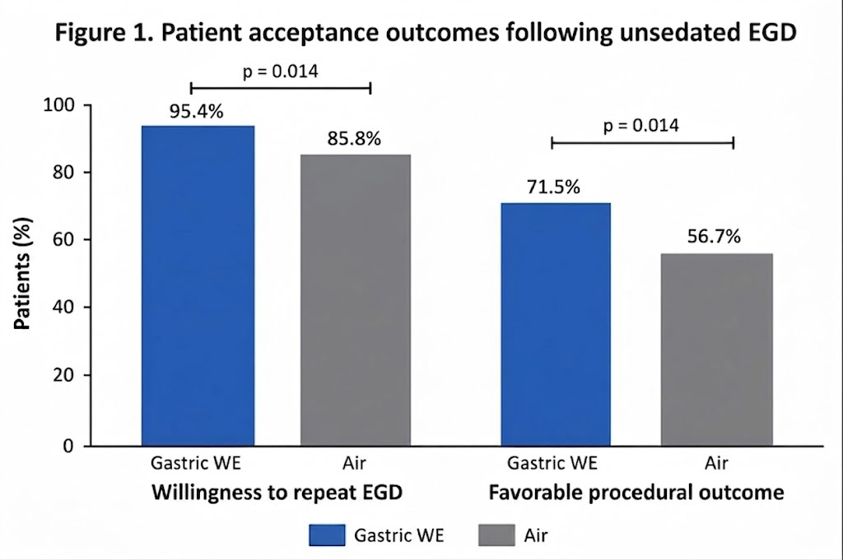

Supplementary Table S1. Additional procedural and physiological parameters

Variable | WE (n = 130) | Air (n = 120) | p value
Number of coughing during exam | 0 (0–1) | 0 (0–1) | 0.776
Number of belches during recovery | 0 (0–1) | 0 (0–2) | 0.149
Number of episodes of flatus during recovery | 0 (0–0) | 0 (0–0) | 0.443
Oxygen saturation (%)
Before exam | 97 (96–99) | 97 (96–99) | 0.710
Lowest during exam | 97 (95–98) | 96 (95–98) | 0.749
Heart rate (bpm)
Before exam | 81 (71–92) | 85 (73–95) | 0.263
Lowest during exam | 87 (74–97) | 89 (76–100) | 0.164
Highest during exam | 99 (87–114) | 105 (92–118) | 0.069
Blood pressure (mmHg)
Before exam | 130 (117–144) | 122 (113–138) | 0.076
Lowest during exam | 128 (113–141) | 120 (110–136) | 0.099
Highest during exam | 143 (127–161) | 139 (120–163) | 0.233

