A randomized parallel-group intervention in controlled office environments
Bilge Kobas^{1,2}*, Sebastian C. Koth¹, Amelie Reitmayer³, Thomas Auer¹
¹ Chair of Building Technology and Climate Responsive Design, TUM School of Engineering and Design, Technical University of Munich, Arcisstraße 21, 80333 Munich, Germany
² TUM Institute for Advanced Study, Technical University of Munich, Lichtenbergstraße 2a, 85748 Garching
³ School of the Environment, The University of Queensland, St Lucia, Queensland 4072, Australia
* bilge.kobas@tum.de

- Anthropomorphic data of participants
- Description of sensors
  - Specifications for physical sensors and location of the sensing equipment
  - Specifications for physiological sensors and body sites for the sensors
- Administered questionnaires
- Model outputs
  - CBT
  - Skin temperature
  - HRV
  - BP
  - Thermal perception
- Additional model results
  - DPG

Anthropomorphic data of participants
Table 1. Characteristics of participants.
Part. ID | Condition | Age | Sex | Mens Date-1 | Mens Date-2 | Height (cm) | Weight (kg) | BMI | Body fat (%) | Muscle (%) | BMR
P01 | AC | 26 | M | n/a | n/a | 188.5 | 99.68 | 28 | 24.94 | 71.2 | 2408
P16 | AC | 31 | F | 27-05-23 | 23-06-23 | 158.3 | 52.9 | 21.1 | 21.8 | 74.2 | 1202
P17 | AC | 25 | F | 22-05-23 | 23-06-23 | 167.8 | 53.9 | 19.1 | 26.58 | 72.65 | 1302
P19 | AC | 25 | M | n/a | n/a | 176.3 | 64.65 | 20.8 | 12.13 | 83.00 | 1628
P22 | AC | 25 | M | n/a | n/a | 174 | 54.9 | 18.1 | 17.2 | 78.6 | 1517
P24 | AC | 24 | F | 29-05-23 | 29-05-23 | 165 | 54.2 | 19.9 | 21 | 74.9 | 1292
P04 | FR | 24 | F | 15-05-23 | 19-06-23 | 159.4 | 47.97 | 18.9 | 15.2 | 80.5 | 1195
P08 | FR | 25 | F | 19-05-23 | 17-06-23 | 156 | 50.1 | 20.6 | 20.3 | 75.7 | 1190
P09 | FR | 26 | M | n/a | n/a | 169.5 | 67.05 | 23.3 | 18.1 | 77.8 | 1605
P11 | FR | 29 | M | n/a | n/a | 170.1 | 78.7 | 27.2 | 21.7 | 74.4 | 1710
P12 | FR | 34 | F | 15-05-23 | 13-06-23 | 164.2 | 60.5 | 22.4 | 21.1 | 74.5 | 1300
P13 | FR | 26 | F | 21-05-23 | 21-06-23 | 168 | 54 | 19.1 | 19.3 | 76 | 1299
P14 | FR | 26 | F | 28-05-23 | 28-05-23 | 170.3 | 60.2 | 20.8 | 22.9 | 72 | 1375
P15 | FR | 26 | M | n/a | n/a | 188.5 | 87.9 | 24.7 | 19.7 | 76.2 | 1932

Table 2. Summary statistics of participant baseline characteristics by condition arm.
Variable | FR (n=8) | AC (n=6)
Age (y) | 27.0 ± 3.2 | 26.0 ± 2.5
Height (cm) | 168.2 ± 9.7 | 171.7 ± 10.5
Weight (kg) | 63.3 ± 14.0 | 63.4 ± 18.3
BMI | 22.1 ± 2.9 | 21.2 ± 3.5
Fat (%) | 19.8 ± 2.4 | 20.6 ± 5.3
Muscle (%) | 75.9 ± 2.5 | 75.8 ± 4.3
BMR | 1451 ± 269 | 1558 ± 445

We examined potential baseline differences between the three experimental groups (FR = control, AC and Mix) using one-way ANOVA followed by Tukey’s Honest Significant Difference (HSD) tests. The variables included age, height, weight, body mass index (BMI), body fat percentage, muscle percentage, and basal metabolic rate (BMR). No statistically significant differences were detected across groups for any parameter (all adjusted p > 0.1). All other anthropometric and demographic variables showed small mean differences with overlapping confidence intervals. These results suggest that the condition groups were well balanced at baseline, minimizing the risk of bias in subsequent physiological analyses.
Table 3. Pairwise Tukey’s Honest Significant Difference (HSD) post-hoc comparisons across condition arms.
Variable | Group 1 | Group 2 | Mean difference | Adjusted p-value | Lower CI | Upper CI | Significant
Age | CC | FR | 1 | 0.88 | -4.279 | 6.279 | FALSE
Height (cm) | CC | FR | -3.4 | 0.787 | -16.479 | 9.679 | FALSE
Weight (kg | CC | FR | -0.069 | 1 | -25.416 | 25.277 | FALSE
BMI | CC | FR | 0.958 | 0.901 | -4.645 | 6.562 | FALSE
Body fat (%) | CC | FR | -0.821 | 0.97 | -9.653 | 8.012 | FALSE
Muscle (%) | CC | FR | 0.129 | 0.999 | -8.151 | 8.409 | FALSE
BMR | CC | FR | -107.417 | 0.836 | -586.358 | 371.525 | FALSE

Description of sensors

Specifications for physical sensors and location of the sensing equipment
SenseLab utilizes a sensor kit including air temperature, globe thermometer, relative humidity, air velocity and CO₂ concentration sensors that log the data at a minute interval. Table 4 shows the technical specifications of these instruments.
Table 4. Specifications of physical sensors
 | Data | Unit | Brand | Model | Sensor / Setup | Resolution | Accuracy | Range | Sampling Rate
1 | Air temp. | °C | Tinkerforge | Thermocouple Bricklet 2.0 | MAX31856-based thermocouple, radiation-shielded | 0.01 °C | ±0.15% FS; ±0.7 °C CJC | −210 to +1800 °C | 1 min
2 | Globe temp. | °C | Tinkerforge | Thermocouple Bricklet 2.0 | MAX31856 thermocouple in blackened PVC globe (Ø120 mm) | 0.01 °C | ±0.15% FS; ±0.7 °C CJC | −210 to +1800 °C | 1 min
3 | Relative humidity | %RH | Tinkerforge | Humidity Bricklet 2.0 | HDC1080 capacitive RH/T sensor | 0.01 %RH | ±2 %RH (20–60) | 0–100 %RH | 1 min
4 | Air velocity | m·s⁻¹ | Modern Device | Wind Sensor Rev. P | Hot-wire anemometer | – | ±0.5 m·s⁻¹ | 0–6 m·s⁻¹ | 1 min
5 | CO₂ concentration | ppm | Tinkerforge | CO₂ Bricklet 2.0 | NDIR SCD30 | 1 ppm | ±30 ppm ±3% | 400–10,000 ppm | 1 min

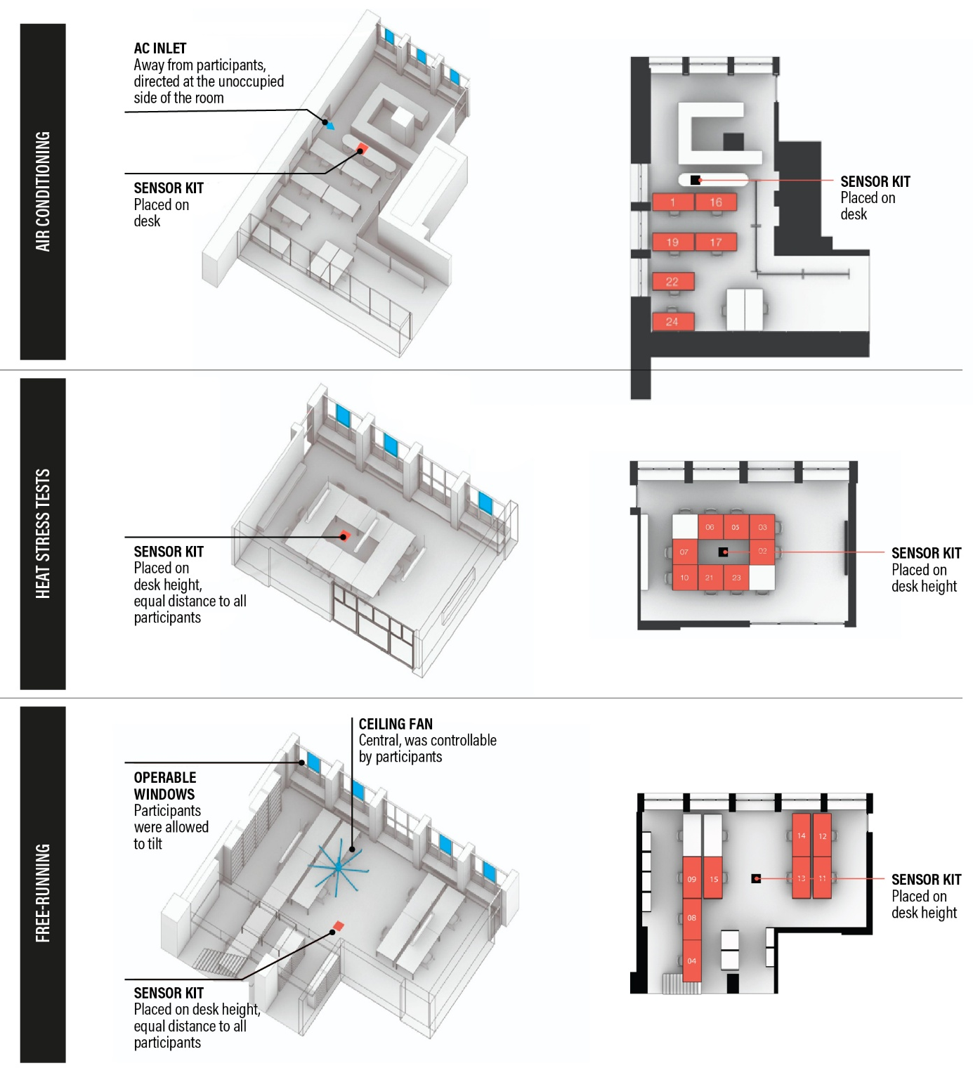
Figure 1. Layout of test rooms and sensor locations per room.

Specifications for physiological sensors and body sites for the sensors
Table 5 summarises the specifications, sensor types, and sampling characteristics of physiological instruments used in this study. Figure 2 illustrates sensor placement on the body.
Table 5. Specifications of physiological sensors
 | Data | Unit | Brand | Model | Sensor | Position | Resolution | Accuracy | Range | Sampling Rate
1 | Core body temperature | °C | BodyCAP | eCelsius Performance | Ingestible telemetry pill | Pill swallowed – receiver within 3 m | 0.01 °C | ±0.2 °C | 25–45 °C | 1 min
2 | Electrocardiogram | mV | Shimmer | EXG | 4‑channel ECG | Chest-worn; RA, LA, RL, LL, V6 | 1 mV | ±800 mV (gain=6) | 125–8000 SPS | 128Hz
5 | Blood pressure | mmHg | Withings | BPM Connect | Oscillometric | Left arm, brachial level | 0.1 mmHg | ±3 mmHg | 0–285 mmHg | Discrete
6 | Skin temperature | °C | iButton | DS1922L-F5 Thermochron | Thermistor | Neck & ankle, right side, exposed skin | 0.5 °C | ±0.5 °C | 10–65 °C | 1 min
9 | Movement | g | Shimmer | EXG | Triaxial accelerometer | Chest-worn | – | 1000 LSB/g at ±2g | ±16 g | 128Hz
16 | Weight | kg | Withings | BodyComp | Load cells + BIA | Stepped barefoot, in underwear | 50 g | – | – | Discrete
17 | Body composition | % | Withings | BodyComp | Multi-frequency bioelectrical impedance | Stepped barefoot, in underwear |  | ~1–2% repeatability | Fat % ~5–60% | Discrete

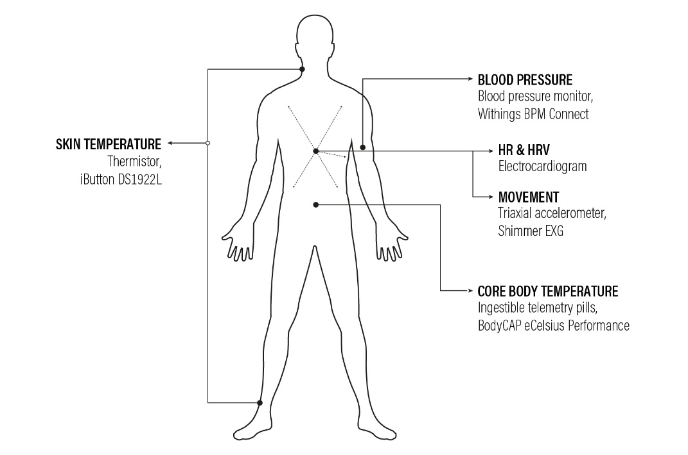
Figure 2. Body sites of physiological sensors.

Administered questionnaires
Thermal perception questionnaires were administered using printed paper forms placed on each participant’s assigned desk prior to the start of the experimental day. Each sheet contained four repeated sets of the same questions corresponding to the four scheduled assessment timepoints throughout the day. Participants were instructed to complete the questionnaires only at the predefined measurement intervals indicated by the researchers.
Questionnaires were available in both English and German, and participants selected their preferred language prior to the beginning of the intervention period. During the first experimental morning, participants received standardised verbal instructions on how to complete the scales and were instructed to select the single response option that best represented their current perception at each assessment.
The questionnaire structure and response scales were adapted from DIN EN ISO 10551:2019 and included assessments of thermal sensation, thermal comfort, and thermal preference using categorical ordinal scales. Thermal sensation was assessed using a seven-point scale ranging from “very cold” to “very hot,” thermal comfort using a five-point scale ranging from “comfortable” to “extremely uncomfortable,” and thermal preference using a seven-point scale ranging from “much cooler” to “much warmer.” Representative English and German versions of the administered questionnaires are shown below.
- How do you feel at this precise moment? (mark appropriate box): I am…
Very cold | Cold |  | Slightly cool |  | Neither hot nor cold | Slightly warm |  | Hot |  | Very hot
- Do you find this … ?
Comfortable |  | Slightly uncomfortable |  | Uncomfortable |  |  | Very uncomfortable |  | Extremely uncomfortable
- At this moment, would you prefer to be...?
Much cooler | Cooler |  | Slightly cooler |  | Without change | Slightly warmer |  | Warmer |  | Much warmer
Figure 3. English version.
- Wie fühlen Sie sich genau in diesem Moment? (Kreuzen Sie das zutreffende Kästchen an): Mir ist…
Kalt | Kühl |  | Etwas kühl |  | Weder heiß noch kalt | Etwas warm |  | Warm |  | Heiß
- Finden Sie dies … ?
Angenehm |  | Etwas unangenehm |  | Unangenehm |  |  | Sehr unangenehm |  | Äußerst unangenehm
- Wie würden Sie sich in diesem Moment lieber fühlen?
Viel kälter | Kälter |  | Etwas kälter |  | Ohne Änderung | Etwas wärmer |  | Wärmer |  | Viel wärmer
Figure 4. German version.

Model outputs

CBT
Unless otherwise specified, physiological outcomes were analysed using linear mixed-effects models with participant included as a random intercept. Fixed effects included intervention arm (FR vs CC), testing scenario (HS1 vs HS2), their interaction, and centered sex coding (sex_c). Additional exploratory models including body fat percentage (fat_pct_c) were evaluated using AIC/BIC-based model comparison. Final model structures were selected based on physiological interpretability and model parsimony.
Menstrual timing was additionally evaluated in exploratory sensitivity models but was not retained because it worsened model fit and reduced analytical parsimony.

Afternoon drift

Model selection
Table 6 summarises candidate models for afternoon CBT drift. The sex-adjusted base model demonstrated the lowest AIC and BIC values and was retained for final inference. The final model was: $drift∼arm*scenario+sex_c$.
Table 6. Candidate model comparison for afternoon CBT drift
Model | Formula | AIC | BIC | ΔAIC | ΔBIC
M0 (base) | drift ~ arm * scenario + sex_c | −9.832 | −1.025 | 0.000 | 0.000
M1 (+fat %) | drift ~ arm * scenario + sex_c + fat_pct_c | −8.694 | 1.371 | 1.137 | 2.395

Model outputs
Table 7. Linear mixed-effects model output for afternoon CBT drift
Predictor | Coefficient (β) | Standard Error | z-value | p-value | 95% CI
Intercept | 0.253 | 0.078 | 3.259 | 0.001 | 0.101 to 0.405
AC arm | −0.340 | 0.096 | −3.548 | <0.001 | −0.528 to −0.152
HS2 scenario | −0.212 | 0.082 | −2.581 | 0.010 | −0.374 to −0.051
AC × HS2 interaction | 0.323 | 0.121 | 2.665 | 0.008 | 0.085 to 0.560
Sex (centered) | 0.125 | 0.074 | 1.676 | 0.094 | −0.021 to 0.270
Random intercept variance (participant) | 0.006 | 0.071

Model characteristics
Table 8. Linear mixed-effects model predicting afternoon core body temperature (CBT) drift during the heat-stress protocol.
Parameter | Value
Model type | Linear mixed-effects model
Estimation method | REML
Number of observations | 26
Number of participants | 13
Residual variance (scale) | 0.0237
Log-likelihood | 2.803
Minimum group size | 2
Maximum group size | 2
Mean group size | 2.0
Model convergence | Yes

Area Under the Curve (AUC)

Model selection
Table 9 summarises candidate models for CBT area under the curve (AUC). The sex-adjusted base model demonstrated the lowest AIC and BIC values and was retained for final inference. The final model was: $auc_delta_h∼arm*scenario+sex_c$.
Table 9. Candidate model comparison for CBT AUC
Model | Formula | AIC | BIC | ΔAIC | ΔBIC
M0 (base) | auc_delta_h ~ arm * scenario + sex_c | 69.398 | 78.204 | 0.000 | 0.000
M1 (+fat %) | auc_delta_h ~ arm * scenario + sex_c + fat_pct_c | 71.127 | 81.192 | 1.730 | 2.988

Model outputs
Table 10. Linear mixed-effects model output for CBT AUC
Predictor | Coefficient (β) | Standard Error | z-value | p-value | 95% CI
Intercept | 1.211 | 0.344 | 3.523 | <0.001 | 0.537 to 1.885
AC arm | −1.336 | 0.435 | −3.070 | 0.002 | −2.189 to −0.483
HS2 scenario | −0.712 | 0.418 | −1.705 | 0.088 | −1.530 to 0.107
AC × HS2 interaction | 1.164 | 0.615 | 1.894 | 0.058 | −0.041 to 2.369
Sex (centered) | 0.444 | 0.308 | 1.441 | 0.149 | −0.160 to 1.048
Random intercept variance (participant) | 0.000 | 0.278

Model characteristics
Table 11. Linear mixed-effects model predicting core body temperature (CBT) area under the curve (AUC) during the heat-stress protocol.
Parameter | Value
Model type | Linear mixed-effects model
Estimation method | REML
Number of observations | 26
Number of participants | 13
Residual variance (scale) | 0.6104
Log-likelihood | −29.283
Minimum group size | 2
Maximum group size | 2
Mean group size | 2.0
Model convergence | Yes

Skin temperature

Neck Skin Temperature Drift

Model selection
Table 12 summarises candidate models for neck skin temperature drift. The sex-adjusted base model demonstrated the best balance between physiological interpretability and model parsimony and was retained for final inference. The final model was: drift∼arm*scenario+sex_c.
Table 12. Candidate model comparison for neck skin temperature drift
Model | Formula | AIC | BIC | ΔAIC | ΔBIC
M0 (base) | drift ~ arm * scenario + sex_c | 15.777 | 25.102 | 0.000 | 0.000
M1 (+fat %) | drift ~ arm * scenario + sex_c + fat_pct | 16.143 | 26.801 | 0.366 | 1.698

Model outputs
Table 13. Linear mixed-effects model output for neck skin temperature drift
Predictor | Coefficient (β) | Standard Error | z-value | p-value | 95% CI
Intercept | 0.047 | 0.118 | 0.403 | 0.687 | −0.184 to 0.278
AC arm | −0.135 | 0.149 | −0.901 | 0.368 | −0.427 to 0.158
HS2 scenario | −0.204 | 0.138 | −1.480 | 0.139 | −0.474 to 0.066
AC × HS2 interaction | 0.284 | 0.210 | 1.348 | 0.178 | −0.129 to 0.696
Sex (centered) | 0.070 | 0.106 | 0.664 | 0.507 | −0.137 to 0.278
Random intercept variance (participant) | 0.000 | 0.092

Model characteristics
Table 14. Linear mixed-effects model predicting neck skin temperature drift during the heat-stress protocol.
Parameter | Value
Model type | Linear mixed-effects model
Estimation method | REML
Number of observations | 28
Number of participants | 14
Residual variance (scale) | 0.0759
Log-likelihood | −7.818
Minimum group size | 2
Maximum group size | 2
Mean group size | 2.0
Model convergence | Yes

Ankle Skin Temperature Drift

Model selection
Table 15 summarises candidate models for ankle skin temperature drift. The sex-adjusted base model demonstrated the best balance between physiological interpretability and model parsimony and was retained for final inference. The final model was: drift∼arm*scenario+sex_c.
Table 15. Candidate model comparison for ankle skin temperature drift
Model | Formula | AIC | BIC | ΔAIC | ΔBIC
M0 (base) | drift ~ arm * scenario + sex_c | 37.021 | 45.827 | 0.000 | 0.000
M1 (+fat %) | drift ~ arm * scenario + sex_c + fat_pct | 38.067 | 48.131 | 1.046 | 2.304

Model outputs
Table 16. Linear mixed-effects model output for ankle skin temperature drift
Predictor | Coefficient (β) | Standard Error | z-value | p-value | 95% CI
Intercept | 0.653 | 0.186 | 3.517 | <0.001 | 0.289 to 1.017
AC arm | −0.414 | 0.240 | −1.725 | 0.085 | −0.884 to 0.056
HS2 scenario | −0.774 | 0.199 | −3.888 | <0.001 | −1.164 to −0.384
AC × HS2 interaction | 0.994 | 0.321 | 3.098 | 0.002 | 0.365 to 1.624
Sex (centered) | −0.034 | 0.178 | −0.188 | 0.851 | −0.383 to 0.316
Random intercept variance (participant) | 0.018 | 0.151

Model characteristics
Table 17. Linear mixed-effects model predicting ankle skin temperature drift during the heat-stress protocol.
Parameter | Value
Model type | Linear mixed-effects model
Estimation method | REML
Number of observations | 26
Number of participants | 13
Residual variance (scale) | 0.1585
Log-likelihood | −16.096
Minimum group size | 2
Maximum group size | 2
Mean group size | 2.0
Model convergence | Yes

Distal–Proximal Gradient (DPG) Drift

Model selection
Table 18 summarises candidate models for distal–proximal gradient (DPG) drift. The sex-adjusted base model demonstrated the best balance between physiological interpretability and model parsimony and was retained for final inference. The final model was: drift∼arm*scenario+sex_c.
Table 18. Candidate model comparison for DPG drift
Model | Formula | AIC | BIC | ΔAIC | ΔBIC
M0 (base) | drift ~ arm * scenario + sex_c | 50.569 | 59.376 | 0.000 | 0.000
M1 (+fat %) | drift ~ arm * scenario + sex_c + fat_pct | 51.205 | 61.269 | 0.635 | 1.894

Model outputs
Table 19. Linear mixed-effects model output for DPG drift
Predictor | Coefficient (β) | Standard Error | z-value | p-value | 95% CI
Intercept | 0.583 | 0.236 | 2.470 | 0.014 | 0.120 to 1.046
AC arm | −0.374 | 0.310 | −1.205 | 0.228 | −0.982 to 0.234
HS2 scenario | −0.570 | 0.272 | −2.096 | 0.036 | −1.103 to −0.037
AC × HS2 interaction | 0.828 | 0.439 | 1.888 | 0.059 | −0.032 to 1.687
Sex (centered) | −0.068 | 0.219 | −0.309 | 0.757 | −0.498 to 0.362
Random intercept variance (participant) | 0.000 | 0.173

Model characteristics
Table 20. Linear mixed-effects model predicting distal–proximal gradient (DPG) drift during the heat-stress protocol.
Parameter | Value
Model type | Linear mixed-effects model
Estimation method | REML
Number of observations | 26
Number of participants | 13
Residual variance (scale) | 0.2959
Log-likelihood | −21.608
Minimum group size | 2
Maximum group size | 2
Mean group size | 2.0
Model convergence | Yes

HRV

Heart Rate (HR)

Model selection
Table 21 summarises candidate models for HR drift. The sex-adjusted base model was retained for final inference. The final model was: $drift∼arm*scenario+sex_c$.
Table 21. Candidate model comparison for heart rate (HR)
Model | Formula | AIC | BIC | ΔAIC
M0 (base) | drift ~ arm * scenario + sex_c | 159.107 | 168.432 | 0.000
M1 (+fat %) | drift ~ arm * scenario + sex_c + fat_pct_c | 160.867 | 171.525 | 1.761

Model outputs
Table 22. Linear mixed-effects model output for HR drift
Predictor | Coefficient (β) | Standard Error | z-value | p-value | 95% CI
Intercept | 0.154 | 1.560 | 0.099 | 0.921 | −2.903 to 3.211
AC arm | −2.066 | 1.941 | −1.064 | 0.287 | −5.870 to 1.738
HS2 scenario | −1.771 | 1.674 | −1.058 | 0.290 | −5.052 to 1.510
AC × HS2 interaction | 6.995 | 2.557 | 2.736 | 0.006 | 1.983 to 12.006
Sex (centered) | −0.664 | 1.460 | −0.455 | 0.649 | −3.527 to 2.198
Random intercept variance (participant) | 1.595 | 1.269 | — | — | —

Model characteristics
Table 23. Linear mixed-effects model predicting heart rate (HR) drift during the heat-stress protocol
Parameter | Value
Model type | Linear mixed-effects model
Estimation method | REML
Number of observations | 28
Number of participants | 14
Residual variance (scale) | 11.2073
Log-likelihood | −66.630
Minimum group size | 2
Maximum group size | 2
Mean group size | 2.0
Model convergence | Yes

lnRMSSD

Model selection
Table 24 summarises candidate models for lnRMSSD drift. The sex-adjusted base model was retained for final inference. The final model was: $drift∼arm*scenario+sex_c$.
Table 24. Candidate model comparison for lnRMSSD
Model | Formula | AIC | BIC | ΔAIC
M0 (base) | drift ~ arm * scenario + sex_c | 1.534 | 10.860 | 0.000
M1 (+fat %) | drift ~ arm * scenario + sex_c + fat_pct_c | 3.168 | 13.826 | 1.634

Model outputs
Table 25. Linear mixed-effects model output for lnRMSSD drift
Predictor | Coefficient (β) | Standard Error | z-value | p-value | 95% CI
Intercept | 0.026 | 0.093 | 0.282 | 0.778 | −0.156 to 0.209
AC arm | −0.058 | 0.116 | −0.499 | 0.617 | −0.286 to 0.170
HS2 scenario | 0.158 | 0.101 | 1.559 | 0.119 | −0.041 to 0.356
AC × HS2 interaction | −0.195 | 0.155 | −1.258 | 0.208 | −0.498 to 0.109
Sex (centered) | −0.107 | 0.087 | −1.227 | 0.220 | −0.277 to 0.064
Random intercept variance (participant) | 0.005 | 0.074 | — | — | —

Model characteristics
Table 26. Linear mixed-effects model predicting lnRMSSD drift during the heat-stress protocol.
Parameter | Value
Model type | Linear mixed-effects model
Estimation method | REML
Number of observations | 28
Number of participants | 14
Residual variance (scale) | 0.0410
Log-likelihood | −1.927
Minimum group size | 2
Maximum group size | 2
Mean group size | 2.0
Model convergence | Yes

lnHF

Model selection
Table 27 summarises candidate models for lnHF drift. The sex-adjusted base model demonstrated the lowest AIC and BIC values and was retained for final inference. The final model was: $drift∼arm*scenario+sex_c$.
Table 27. Candidate model comparison for lnHF
Model | Formula | AIC | BIC | ΔAIC
M0 (base) | drift ~ arm * scenario + sex_c | 45.210 | 54.535 | 0.000
M1 (+fat %) | drift ~ arm * scenario + sex_c + fat_pct_c | 45.708 | 56.366 | 0.498

Final model specification
Table 28. Linear mixed-effects model output for lnHF drift
Predictor | Coefficient (β) | Standard Error | z-value | p-value | 95% CI
Intercept | 0.044 | 0.211 | 0.210 | 0.834 | −0.369 to 0.458
AC arm | 0.195 | 0.258 | 0.757 | 0.449 | −0.310 to 0.700
HS2 scenario | 0.379 | 0.204 | 1.856 | 0.063 | −0.021 to 0.779
AC × HS2 interaction | −0.765 | 0.312 | −2.451 | 0.014 | −1.376 to −0.153
Sex (centered) | −0.320 | 0.205 | −1.561 | 0.118 | −0.722 to 0.082
Random intercept variance (participant) | 0.058 | 0.205 | — | — | —

Model characteristics
Table 29. Linear mixed-effects model predicting lnHF drift during the heat-stress protocol
Parameter | Value
Model type | Linear mixed-effects model
Estimation method | REML
Number of observations | 28
Number of participants | 14
Residual variance (scale) | 0.1668
Log-likelihood | −19.783
Minimum group size | 2
Maximum group size | 2
Mean group size | 2.0
Model convergence | Yes

BP

Systolic Blood Pressure (SBP)

Model selection
Table 30 summarises candidate models for systolic blood pressure (SBP) drift. The sex-adjusted base model demonstrated the lowest AIC and BIC values and was retained for final inference. The final model was: drift∼arm*scenario+sex_c.
Table 30. Candidate model comparison for SBP drift
Model | Formula | AIC | BIC | ΔAIC | ΔBIC
M0 (base) | drift ~ arm * scenario + sex_c | 198.279 | 207.605 | 0.000 | 0.000
M1 (+fat %) | drift ~ arm * scenario + sex_c + fat_pct | 198.670 | 209.328 | 0.391 | 1.723

Model outputs
Table 31. Linear mixed-effects model output for SBP drift
Predictor | Coefficient (β) | Standard Error | z-value | p-value | 95% CI
Intercept | 4.993 | 3.075 | 1.624 | 0.104 | −1.033 to 11.019
AC arm | 0.868 | 3.887 | 0.223 | 0.823 | −6.750 to 8.486
HS2 scenario | 0.875 | 3.550 | 0.247 | 0.805 | −6.082 to 7.832
AC × HS2 interaction | −2.958 | 5.422 | −0.546 | 0.585 | −13.585 to 7.669
Sex (centered) | −5.389 | 2.786 | −1.935 | 0.053 | −10.848 to 0.071
Random intercept variance (participant) | 0.987 | 2.178

Model characteristics
Table 32. Linear mixed-effects model predicting systolic blood pressure (SBP) drift during the heat-stress protocol
Parameter | Value
Model type | Linear mixed-effects model
Estimation method | REML
Number of observations | 28
Number of participants | 14
Residual variance (scale) | 50.3990
Log-likelihood | −82.753
Minimum group size | 2
Maximum group size | 2
Mean group size | 2.0
Model convergence | Yes

Diastolic Blood Pressure (DBP)

Model selection
Table 33 summarises candidate models for diastolic blood pressure (DBP) drift. The sex-adjusted base model demonstrated the lowest AIC and BIC values and was retained for final inference. The final model was: drift∼arm*scenario+sex_c.
Table 33. Candidate model comparison for DBP drift
Model | Formula | AIC | BIC | ΔAIC | ΔBIC
M0 (base) | drift ~ arm * scenario + sex_c | 166.657 | 175.983 | 0.000 | 0.000
M1 (+fat %) | drift ~ arm * scenario + sex_c + fat_pct_c | 167.776 | 178.433 | 1.118 | 2.451

Model outputs
Table 34. Linear mixed-effects model output for DBP drift
Predictor | Coefficient (β) | Standard Error | z-value | p-value | 95% CI
Intercept | 2.912 | 1.997 | 1.458 | 0.145 | −1.001 to 6.825
AC arm | 0.218 | 2.364 | 0.092 | 0.927 | −4.416 to 4.851
HS2 scenario | 1.750 | 1.573 | 1.113 | 0.266 | −1.333 to 4.833
AC × HS2 interaction | −3.250 | 2.403 | −1.353 | 0.176 | −7.959 to 1.459
Sex (centered) | −4.259 | 2.036 | −2.092 | 0.036 | −8.250 to −0.269
Random intercept variance (participant) | 9.042 | 2.625

Model characteristics
Table 35. Linear mixed-effects model predicting diastolic blood pressure (DBP) drift during the heat-stress protocol.
Parameter | Value
Model type | Linear mixed-effects model
Estimation method | REML
Number of observations | 28
Number of participants | 14
Residual variance (scale) | 9.8964
Log-likelihood | −69.538
Minimum group size | 2
Maximum group size | 2
Mean group size | 2.0
Model convergence | Yes

Mean Arterial Pressure (MAP)

Model selection
Table 36 summarises candidate models for mean arterial pressure (MAP) drift. The sex-adjusted base model demonstrated the lowest AIC and BIC values and was retained for final inference. The final model was: drift∼arm*scenario+sex_c.
Table 36. Candidate model comparison for MAP drift
Model | Formula | AIC | BIC | ΔAIC | ΔBIC
M0 (base) | drift ~ arm * scenario + sex_c | 172.989 | 182.314 | 0.000 | 0.000
M1 (+fat %) | drift ~ arm * scenario + sex_c + fat_pct_c | 173.683 | 184.341 | 0.695 | 2.027

Model outputs
Table 37. Linear mixed-effects model output for MAP drift
Predictor | Coefficient (β) | Standard Error | z-value | p-value | 95% CI
Intercept | 3.606 | 2.158 | 1.671 | 0.095 | −0.624 to 7.836
AC arm | 0.434 | 2.585 | 0.168 | 0.867 | −4.633 to 5.502
HS2 scenario | 1.458 | 1.858 | 0.785 | 0.432 | −2.183 to 5.099
AC × HS2 interaction | −3.153 | 2.838 | −1.111 | 0.267 | −8.714 to 2.409
Sex (centered) | −4.636 | 2.161 | −2.145 | 0.032 | −8.872 to −0.400
Random intercept variance (participant) | 8.864 | 2.505

Model characteristics
Table 38. Linear mixed-effects model predicting mean arterial pressure (MAP) drift during the heat-stress protocol.
Parameter | Value
Model type | Linear mixed-effects model
Estimation method | REML
Number of observations | 28
Number of participants | 14
Residual variance (scale) | 13.8036
Log-likelihood | −72.192
Minimum group size | 2
Maximum group size | 2
Mean group size | 2.0
Model convergence | Yes

Pulse Pressure (PP)

Model selection
Table 39 summarises candidate models for pulse pressure (PP) drift. The sex-adjusted base model demonstrated the lowest AIC and BIC values and was retained for final inference. The final model was: drift∼arm*scenario+sex_c.
Table 39. Candidate model comparison for PP drift
Model | Formula | AIC | BIC | ΔAIC | ΔBIC
M0 (base) | drift ~ arm * scenario + sex_c | 188.694 | 198.020 | 0.000 | 0.000
M1 (+fat %) | drift ~ arm * scenario + sex_c + fat_pct_c | 186.816 | 197.473 | 0.121 | 2.786

Model outputs
Table 40. Linear mixed-effects model output for PP drift
Predictor | Coefficient (β) | Standard Error | z-value | p-value | 95% CI
Intercept | 2.081 | 2.433 | 0.855 | 0.392 | −2.689 to 6.851
AC arm | 0.650 | 3.085 | 0.211 | 0.833 | −5.397 to 6.698
HS2 scenario | −0.875 | 2.845 | −0.308 | 0.758 | −6.452 to 4.702
AC × HS2 interaction | 0.292 | 4.346 | 0.067 | 0.946 | −8.227 to 8.810
Sex (centered) | −1.130 | 2.190 | −0.516 | 0.606 | −5.423 to 3.163
Random intercept variance (participant) | 0.000 | 4.306

Model characteristics
Table 41. Linear mixed-effects model predicting pulse pressure (PP) drift during the heat-stress protocol.
Parameter | Value
Model type | Linear mixed-effects model
Estimation method | REML
Number of observations | 28
Number of participants | 14
Residual variance (scale) | 32.3827
Log-likelihood | −77.454
Minimum group size | 2
Maximum group size | 2
Mean group size | 2.0
Model convergence | Yes

Additional model results

Distal–proximal temperature gradient (DPG)
To further interrogate peripheral thermoregulatory control, we analysed late-phase drift in the distal–proximal temperature gradient (DPG), an established index of cutaneous vasomotor balance. DPG drift was defined using the same 15-minute reference windows as CBT and ankle skin temperature.
In the FR arm, DPG drift decreased from PRE to POST, indicating a shift toward a reduced distal–proximal gradient consistent with enhanced late-day heat dissipation. The within-arm PRE–POST contrast approached statistical significance (p = 0.053) with a moderate-to-large paired effect size (dz = −0.82), and most participants exhibited downward PRE–POST trajectories (Figure 5).
In contrast, the AC arm showed no systematic change in DPG drift from PRE to POST (p = 0.654; dz = −0.19), with individual responses remaining heterogeneous. Mixed-effects modelling did not identify a significant arm × scenario interaction for DPG, indicating greater variability and lower sensitivity of this composite measure relative to distal skin temperature alone.
Taken together, the DPG results qualitatively corroborate the ankle skin temperature findings, supporting the interpretation that free-running exposure promotes adaptive peripheral vasomotor adjustment. However, the weaker statistical signal relative to ankle temperature suggests that distal skin temperature provides a more sensitive marker of late-day peripheral adaptation in this experimental context.
Table 42. Late-phase distal–proximal gradient (DPG) drift before and after the intervention.
Arm / Contrast | PRE drift (°C) | POST drift (°C) | Δ POST–PRE (°C) | 95% CI of Δ | p (paired) | Effect size (d_{z})
FR (n = 8) | +0.62 | −0.05 | −0.67 | [−1.36, 0.02] | 0.053 | −0.82
AC (n = 6) | +0.61 | +0.42 | −0.19 | [−0.91, 0.53] | 0.654 | −0.19
FR – AC (ΔΔ) | − | − | −0.48 | [−1.29, 0.33] | 0.24 | −0.70
Late-phase DPG drift was defined as the change in distal–proximal skin temperature gradient from the pre-lunch reference window (12:15–12:30) to the end of the experimental session (16:15–16:30). Positive values indicate a warmer distal relative to proximal skin temperature (greater peripheral heat dissipation). Values are model-adjusted means with 95% confidence intervals. Within-arm p-values are derived from model-based paired contrasts; the between-arm contrast represents a model-estimated difference-in-differences. Effect sizes are reported as Cohen’s d_{z} (within-arm) or Cohen’s d (between-arm).
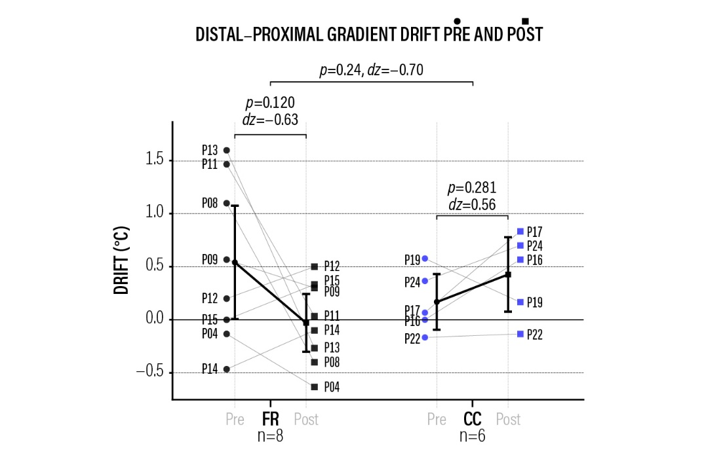
Figure 5. Late-phase DPG drift from the pre-lunch reference window (12:15–12:30) to the end of the session (16:15–16:30), shown for PRE and POST measurements in the FR and AC arms. Points represent individual participants; black markers and error bars denote model-adjusted means ± 95% confidence intervals. Lines connect paired PRE–POST observations.

