Supplementary Table 1. Overall survival and event-free survival outcomes in the study cohort
Total N | Alive
Total N | Alive | Median FU
64 | 44 | 173.0 (141.6–204.4)
Total N | Death
Total N | Death | Median overall survival
64 | 20 | Not reached
Total N | EFS
Total N | EFS | Median EFS
64 | 24 | Not reached
Event-free survival was defined as the time from diagnosis to relapse, progression, or death, whichever occurred first.
FU, follow-up; N, total number of included cases EFS, event-free survival.

Supplementary Table 2. Association between histological classification and clinicopathological characteristics
 |  | Histology
Variables | Categories | MBEN  (N = 7) | Classic (N = 32) | LC/A (N = 1) | D/N  (N = 28) | P value
Tumor stage | T1 | 2 (28.6) | 16 (50) | 1 (100) | 14 (50) | 0.526
Tumor stage | T2–T4 | 5 (71.4) | 16 (50) | 0 (0) | 14 (50)
Metastatic stage | M0 | 6 (85.7) | 22 (68.8) | 1 (100) | 23 (82.1) | 0.702
Metastatic stage | M1 | 0 (0) | 2 (6.3) | 0 (0) | 0 (0)
Metastatic stage | M2 | 0 (0) | 3 (9.4) | 0 (0) | 0 (0)
Metastatic stage | M3 | 1 (14.3) | 5 (15.6) | 0 (0) | 5 (17.9)
Metastasis status | Non-metastatic | 6 (85.7) | 22 (68.8) | 1 (100) | 23 (82.1) | 0.532
Metastasis status | Metastatic | 1 (14.3) | 10 (31.3) | 0 (0) | 5 (17.9)
Surgical resection grade | S1 | 1 (14.3) | 13 (40.6) | 0 (0) | 13 (46.4) | 0.219
Surgical resection grade | S2 | 5 (71.4) | 11 (34.4) | 0 (0) | 9 (32.1)
Surgical resection grade | S3 | 1 (14.3) | 5 (15.6) | 1 (100) | 6 (21.4)
Surgical resection grade | S4 | 0 (0) | 3 (9.4) | 0 (0) | 0 (0)
Residual tumor status | R1 | 2 (28.6) | 13 (40.6) | 0 (0) | 13 (46.4) | 0.712
Residual tumor status | R2 | 3 (42.9) | 9 (28.1) | 0 (0) | 9 (32.1)
Residual tumor status | R3 | 2 (28.6) | 8 (25) | 1 (100) | 6 (21.4)
Residual tumor status | R4 | 0 (0) | 2 (6.3) | 0 (0) | 0 (0)
Therapy outcome | Total response | 2 (28.6) | 9 (28.1) | 0 (0) | 14 (50) | 0.065
Therapy outcome | Partial response | 1 (14.3) | 6 (18.8) | 0 (0) | 3 (10.7)
Therapy outcome | Process stabilization | 2 (28.6) | 7 (21.9) | 0 (0) | 5 (17.9)
Therapy outcome | Progression | 0 (0) | 2 (6.3) | 1 (100) | 3 (10.7)
Therapy outcome | Relapse | 0 (0) | 6 (18.8) | 0 (0) | 3 (10.7)
Therapy outcome | Death | 2 (28.6) | 2 (6.3) | 0 (0) | 0 (0)
Outcome | Alive | 5 (71.4) | 19 (59.4) | 0 (0) | 20 (71.4) | 0.403
Outcome | Death | 2 (28.6) | 13 (40.6) | 1 (100) | 8 (28.6)
MBEN, medulloblastoma with extensive nodularity; D/N, desmoplastic/nodular; LC/A, large cell/anaplastic; OS, overall survival; FU, follow-up; T, tumor stage; M, metastatic stage; S, surgical resection grade; R, residual tumor status; outcome, survival at last follow-up; dead, mortality. P-values were calculated using Pearson’s χ² or Fisher’s exact test, as appropriate.
Supplementary figure 1
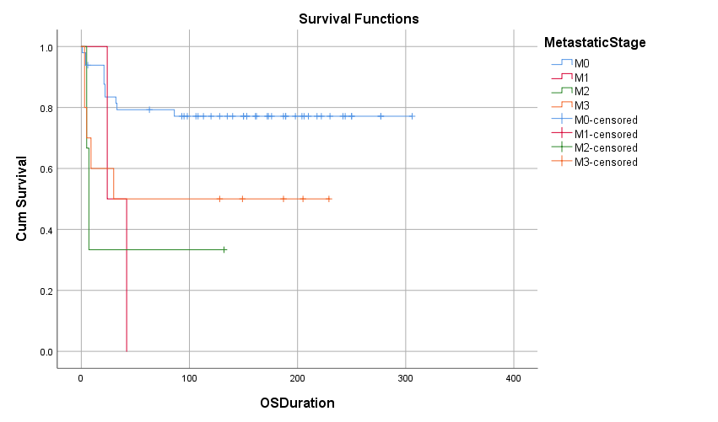
Kaplan–Meier overall survival (OS) curves stratified according to metastatic stage (M0–M3). Tick marks indicate censored observations.

Supplementary figure 1A
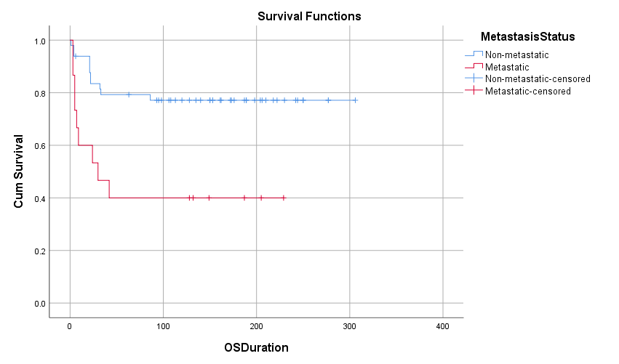
Kaplan–Meier overall survival (OS) curves comparing patients with non-metastatic and metastatic disease at diagnosis. Tick marks indicate censored observations.

Supplementary figure 1B
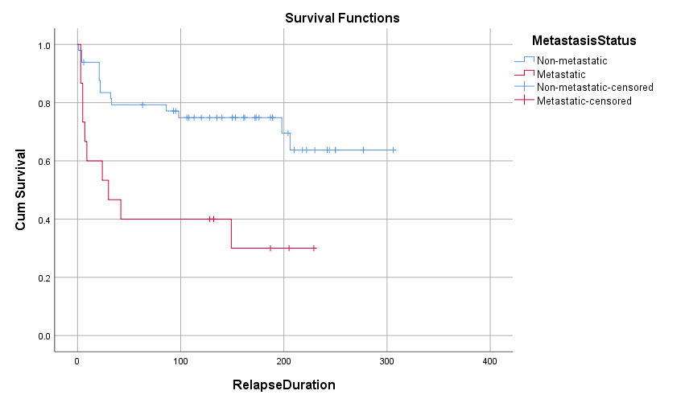
Kaplan–Meier relapse-free survival (RFS) curves comparing patients with non-metastatic and metastatic disease at diagnosis. Tick marks indicate censored observations.

Supplementary figure 2
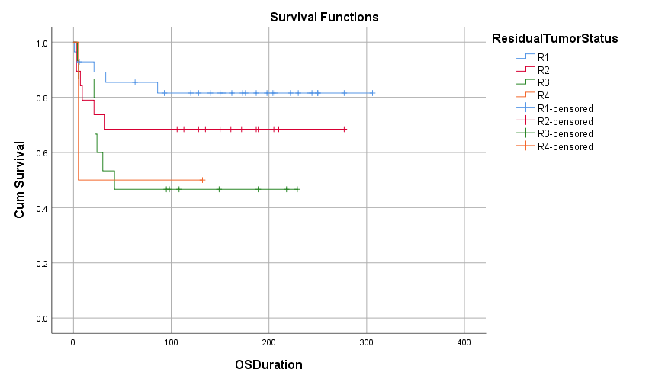
Kaplan–Meier overall survival (OS) curves according to residual tumor status (R1–R4), demonstrating the association between extent of residual disease after surgery and survival outcome. Tick marks indicate censored observations.

Supplementary figure 3
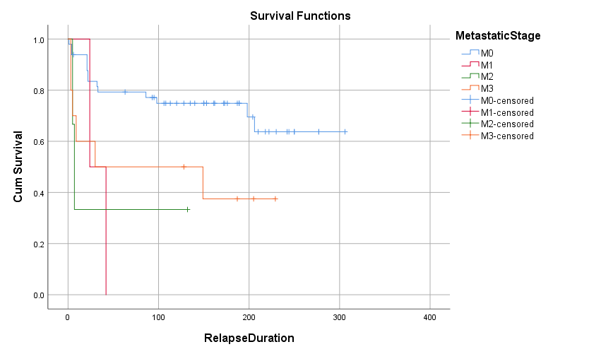
Kaplan–Meier relapse-free survival (RFS) curves stratified according to metastatic stage (M0–M3). Tick marks indicate censored observations.

Supplementary figure 4
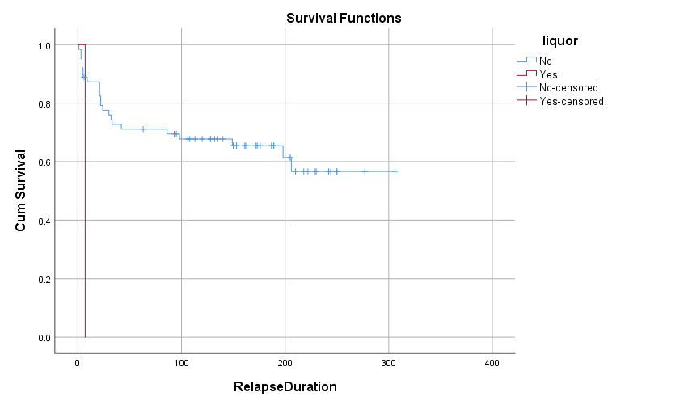
Kaplan–Meier relapse-free survival (RFS) curves according to cerebrospinal fluid involvement status at diagnosis (positive vs negative). Tick marks indicate censored observations.

