Supplemental Material

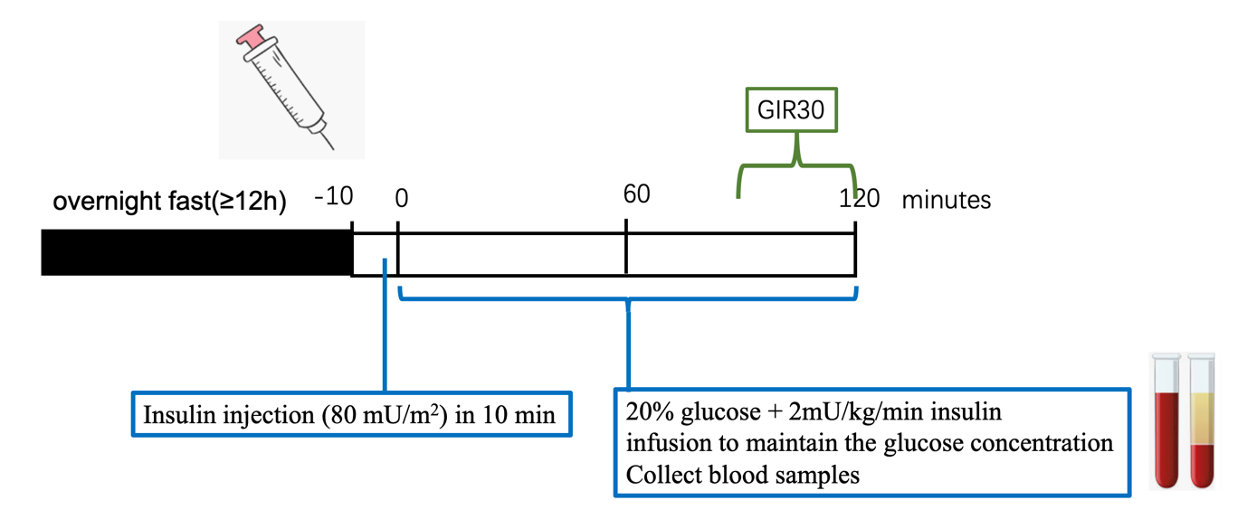
Supplementary Figure 1. Flow chart of the hyperinsulinemic euglycemic clamp.

Supplementary Table 1 Gender differences in individual lipid species

Supplementary Table 2 Age differences in individual lipid species

Supplementary Table 3. BMI differences in individual lipid species

Supplementary Table 4. GIR differences in individual lipid species

Supplementary Table 5 FPIR differences in individual lipid species

Supplementary Table 6 Pearson’s relationship between lipids and clinical characteristics adjusted by age, sex, BMI, TG, TC, HDLc, LDLc, ALT and AST.

Supplementary Table 7 ROC curve for insulin sensitivity.

