Table 1: Phytochemical profiling via GC/MS of fraction 1
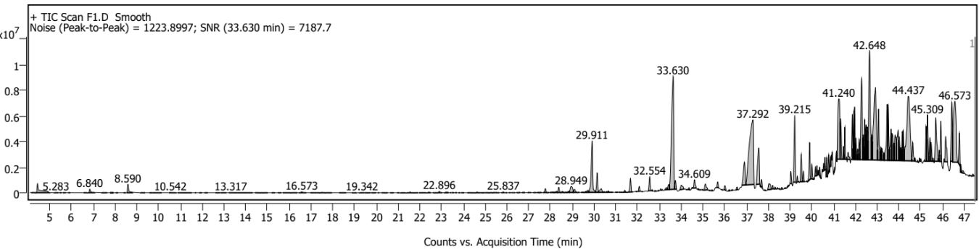
Compound’s name | Retention time | Peak area (%)
2,4-Di-tert-butylphenol (C14H22O) | 33.63 | 93.30%
trans-2-methyl-4-n-pentylthiane, S, S-dioxide (C11H22O2S) | 37.292 | 100%
Triethyl citrate (C12H20O7) | 39.215 | 27.49%
Smo 1-Heneicosyl formate (C22H44O2) | 41.24 | 46.65%
Smo Phthalic acid, butyl dec-2-yl ester (C22H34O4) | 42.648 | 66.51%
Smo Behenyl acrylate (C25H48O2) | 44.437 | 82.07%
Smo Trihexadecyl borate (C48H99BO3) | 46.573 | 65%

Table_2: Glide emodel, Docking scores, and free energy calculation by MM-GBSA of compounds with Co-crystal ligand (3BMP)
Compound ID | Docking Score | Glide emodel | MM-GBSA
2,4-Di-tert-butylphenol | -4.06493 | -20.561 | -21.7593
trans-2-methyl-4-n-pentylthiane, S, S-dioxide | -0.989286 | -22.7553 | -21.1121
Triethyl citrate | -3.27952 | -33.2657 | -32.6594
Phthalic acid, butyl dec-2-yl ester | -2.5367 | -41.7884 | -33.3395

Table_3: Glide emodel, Docking scores, and free energy calculation by MM-GBSA of compounds with Co-crystal ligand (5T1A)
Compound ID | Docking Score | Glide emodel | MM-GBSA
2,4-Di-tert-butylphenol | -5.95322 | -0.331486 | -19.85
trans-2-methyl-4-n-pentylthiane, S, S-dioxide | -6.06848 | 0 | -26.2846
Triethyl citrate | -5.11695 | -0.587885 | -35.8566
1-Heneicosyl formate | -0.383419 | -0.304461 | -28.6559
Phthalic acid, butyl dec-2-yl ester | -7.00954 | -0.264872 | -36.8528

Table_4: ADME&T analysis of identified compounds
Ligands/ Molecules | QPlogPo/w | QPlogS | QPPCaco | QPlogBB | QPPMDCK | Rule Of Five
2,4-Di-tert-butylphenol | 3.836 | -3.942 | 4986.828 | 0.124 | 2809.413 | 0
trans-2-methyl-4-n-pentylthiane, S,S-dioxide | 2.179 | -2.763 | 1812.465 | -0.366 | 950.989 | 0
Triethyl citrate | 2.133 | -3.008 | 520.165 | -1.313 | 244.08 | 0
1-Heneicosyl formate | 7.521 | -8.873 | 1036.898 | -1.992 | 514.469 | 1
Phthalic acid, butyl dec-2-yl ester | 5.566 | -5.294 | 2215.243 | -0.894 | 1168.718 | 1
Behenyl acrylate | 8.909 | -10.059 | 2896.337 | -1.53 | 1561.544 | 1
Trihexadecylborate | Not Satisfied ADMET

Table_5: Solvent accessible surface area (SASA) 500-800 Å², hydrophobic surface area (FOSA) 100-350 Å², hydrophillic surface area (FISA) 50-200 Å², pi-conjugated surface area (PISA) 200-400 Å², weakly polar surface area (WPSA) 0-150 Å², polar surface area (PSA) >140 Å² calculated for identified compounds in the fraction
Ligands/Molecules | SASA | FOSA | FISA | PISA | WPSA | PSA
2,4-Di-tert-butylphenol | 469.662 | 370.705 | 31.433 | 67.524 | 0 | 17.558
trans-2-methyl-4-n-pentylthiane, S,S-dioxide | 490.113 | 411.477 | 77.785 | 0 | 0.852 | 38.996
Triethyl citrate | 590.907 | 455.954 | 134.953 | 0 | 0 | 117.644
1-Heneicosyl formate | 894.916 | 791.556 | 103.36 | 0 | 0 | 48.915
Phthalic acid, butyl dec-2-yl ester | 794.466 | 563.38 | 83.281 | 147.804 | 0 | 62.883
Behenyl acrylate | 974.696 | 868.05 | 56.317 | 50.33 | 0 | 36.51
Trihexadecylborate | Not satisfied with ADMET

