Supplemental Material
Pilot multi-matrix geochemical and biomonitoring assessment of mixed mercury exposure pathways among e-waste dismantling workers in Qingyuan, South China
Qiyuan Lu
This supplemental material contains:
2 Supplemental Figures
4 Supplemental Tables
Supplemental Figure S1. Participant-level isotope-speciation map.
Supplemental Figure S2. Literature range comparison for hair Δ¹⁹⁹Hg and MeHg fraction. Literature ranges were compiled from studies cited in the main manuscript.

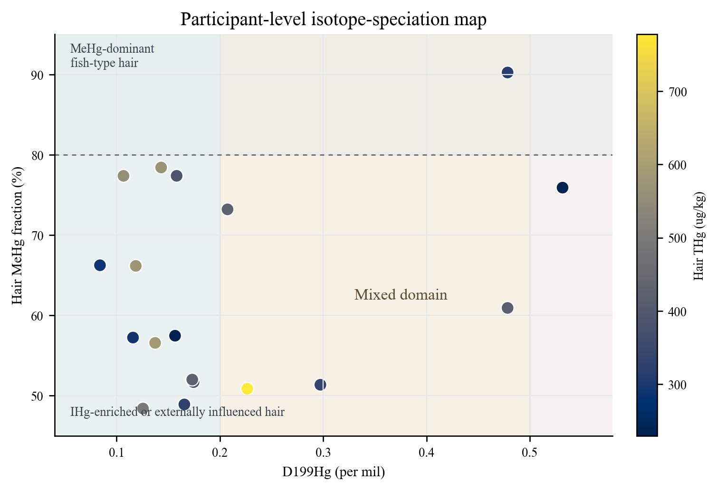
Figure S1. Participant-level isotope-speciation map used for discussion. Shaded fields show interpretive domains derived from the literature: high MeHg fraction with stronger odd-MIF is more consistent with fish-type MeHg exposure, whereas lower MeHg fractions and weak-to-moderate odd-MIF indicate possible inorganic or external particulate Hg contributions. The classification is qualitative.

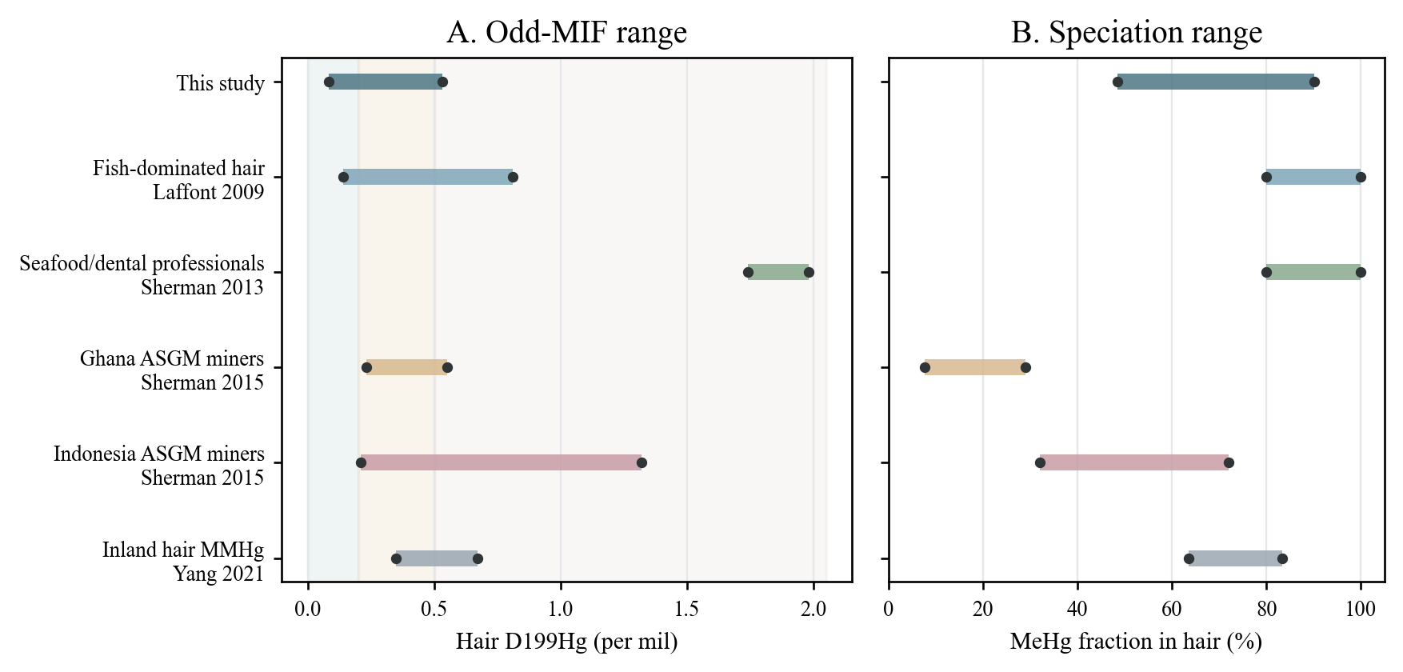
Figure S2. Literature ranges used to contextualize the present hair isotope and speciation results. The Qingyuan workers overlap partly with mixed occupational or inland exposure settings but have lower Δ¹⁹⁹Hg than strongly seafood-dominated populations.

Table S1. Individual-level Hg concentration, speciation, isotope and paired matrix dataset.
ID | Hair THg | MeHg | IHg | MeHg% | Blood THg | Urine THg | Work dust THg | Indoor dust THg | δ²⁰²Hg | Δ¹⁹⁹Hg | Δ²⁰¹Hg
H4 | 229.272 | 131.734 | 97.538 | 57.457 | 1.526 | 0.543 | - | - | 1.607 | 0.157 | 0.118
H15 | 232.847 | 176.724 | 56.123 | 75.897 | 1.377 | 0.438 | - | - | 2.580 | 0.532 | 0.461
H10 | 286.122 | 189.505 | 96.617 | 66.232 | 2.110 | 0.455 | - | 600.557 | 1.082 | 0.084 | 0.060
H13 | 290.678 | 166.347 | 124.331 | 57.227 | 1.419 | 0.169 | - | 538.212 | 1.535 | 0.116 | 0.056
H2 | 314.165 | 283.481 | 30.685 | 90.233 | 1.313 | 0.479 | - | 334.615 | 1.977 | 0.478 | 0.278
H14 | 329.156 | 160.953 | 168.203 | 48.899 | 1.261 | 0.377 | - | 754.523 | 0.402 | 0.166 | 0.123
H1 | 336.181 | 172.619 | 163.562 | 51.347 | 2.489 | 0.244 | 7221.515 | 2118.549 | 1.652 | 0.297 | 0.149
H11 | 386.577 | 299.084 | 87.492 | 77.367 | 1.601 | 0.176 | - | 400.264 | 1.450 | 0.158 | 0.100
H5 | 387.687 | 200.352 | 187.335 | 51.679 | - | - | - | - | 2.393 | 0.174 | 0.066
H3 | 418.888 | 255.168 | 163.721 | 60.915 | 2.383 | - | - | - | 1.511 | 0.478 | 0.278
H12 | 422.780 | 309.447 | 113.333 | 73.193 | 1.806 | 0.912 | 566.069 | - | 1.747 | 0.207 | 0.115
H6 | 426.353 | 221.681 | 204.673 | 51.995 | - | 0.146 | 4440.139 | - | 0.515 | 0.173 | 0.021
H7 | 496.360 | 240.188 | 256.173 | 48.390 | 3.082 | 0.639 | - | 828.591 | 1.216 | 0.125 | 0.023
H18 | 559.371 | 432.747 | 126.623 | 77.363 | - | - | - | - | 0.874 | 0.107 | 0.035
H17 | 571.598 | 448.157 | 123.441 | 78.404 | 2.466 | - | - | - | 0.682 | 0.143 | 0.097
H9 | 575.156 | 380.480 | 194.676 | 66.153 | 2.193 | 0.161 | 776.426 | 1436.197 | 0.522 | 0.119 | 0.025
H8 | 589.975 | 333.709 | 256.265 | 56.563 | 1.017 | 0.526 | 1604.681 | 2274.719 | 0.576 | 0.137 | −0.012
H16 | 777.994 | 395.618 | 382.376 | 50.851 | 1.503 | - | - | - | 0.406 | 0.227 | 0.181
Note: - indicates unavailable measurements.

Table S2. Method-performance parameters and quality-control information for mercury analyses.
Parameter | Matrix / material | Value
THg LOD | Hair / fish | 0.07 ng/g
THg LOD | Rice | 0.03 ng/g
THg LOD | Comparable biological/food protocol | 0.02 ng/g
MeHg LOD | Hair / fish / rice and related matrices | 0.003–0.004 ng/g
Urine THg LOD | Human urine | 0.1 ng/mL
Estimated THg LOQ | Solid matrices, based on 10/3 × LOD | 0.067–0.233 ng/g
Estimated MeHg LOQ | Based on 10/3 × LOD | 0.010–0.013 ng/g
Estimated urine THg LOQ | Human urine, based on 10/3 × LOD | 0.33 ng/mL
MeHg recovery | CRMs, rice, fish, hair | 93 ± 8%
MeHg extract purity | Digested solutions | 94 ± 7%
THg / MeHg duplicate precision | Duplicate solid samples | RPD <10%
THg / MeHg CRM recovery | CRMs | >90%
Urine THg CRM recovery | ZK020-1, human urine, China CDC | 94 ± 9%
Urine THg CRM recovery | ZK020-2, human urine, China CDC | 95 ± 7%
Urine THg duplicate precision | Duplicate urine samples | RPD <10%
THg isotope digestion recovery | Digested samples | 80–120%
δ²⁰²Hg uncertainty | Reference standards | ±0.08–0.10‰
Δ¹⁹⁹Hg uncertainty | Reference standards | ±0.04–0.08‰
Δ²⁰¹Hg uncertainty | Reference standards | ±0.06–0.12‰
Reference materials | CRMs / standards | TORT-2, ERM-CE464, BCR-482, NIES-13, ZK020-1, ZK020-2, UM-Almadén, NIST-3177

Table S3. Exploratory Spearman correlation matrix among THg concentrations in paired matrices.
Matrix pair | Paired n | Spearman rho
Hair vs Blood | 15 | 0.21
Hair vs Urine | 13 | -0.08
Hair vs Work dust | 5 | -0.30
Hair vs Indoor dust | 9 | 0.65
Hair vs Meat | 15 | 0.01
Hair vs Vegetables | 16 | -0.24
Hair vs Rice | 17 | -0.20
Hair vs Fish | 12 | -0.45
Blood vs Urine | 12 | -0.03
Blood vs Work dust | 4 | 0.40
Blood vs Indoor dust | 9 | 0.17
Blood vs Meat | 14 | 0.38
Blood vs Vegetables | 15 | 0.21
Blood vs Rice | 15 | -0.50
Blood vs Fish | 10 | 0.15
Urine vs Work dust | 5 | -0.50
Urine vs Indoor dust | 9 | 0.13
Urine vs Meat | 12 | 0.29
Urine vs Vegetables | 13 | -0.19
Urine vs Rice | 13 | 0.25
Urine vs Fish | 10 | 0.16
Work dust vs Meat | 4 | 0.40
Work dust vs Vegetables | 5 | 0.60
Work dust vs Rice | 5 | -0.30
Work dust vs Fish | 5 | 0.70
Indoor dust vs Meat | 8 | 0.62
Indoor dust vs Vegetables | 9 | 0.13
Indoor dust vs Rice | 9 | 0.22
Indoor dust vs Fish | 7 | -0.14
Meat vs Vegetables | 15 | 0.49
Meat vs Rice | 15 | 0.14
Meat vs Fish | 10 | 0.45
Vegetables vs Rice | 16 | 0.36
Vegetables vs Fish | 11 | 0.18
Rice vs Fish | 11 | -0.46

Table S4. Summary of hair Hg isotope and speciation data for primary hair samples (n = 18).
Variable | n | Mean | SD | Min | Median | Max
THg (μg/kg) | 18 | 423.953 | 146.292 | 229.272 | 403.288 | 777.994
MeHg (μg/kg) | 18 | 266.555 | 99.218 | 131.734 | 247.678 | 448.157
IHg (μg/kg) | 18 | 157.398 | 83.481 | 30.685 | 145.093 | 382.376
MeHg % | 18 | 63.343 | 12.684 | 48.390 | 59.186 | 90.233
IHg % | 18 | 36.657 | 12.684 | 9.767 | 40.814 | 51.610
δ²⁰²Hg | 18 | 1.263 | 0.676 | 0.402 | 1.333 | 2.580
Δ¹⁹⁹Hg | 18 | 0.215 | 0.138 | 0.084 | 0.162 | 0.532
Δ²⁰¹Hg | 18 | 0.121 | 0.118 | −0.012 | 0.098 | 0.461

