Supplementary Information for

Rapid and Accurate Microseismic Source Location in 3D Heterogeneous Media with Precomputed Travel-Time Grid interpolation and Stochastic Regularization

Ruo Jia^{1,2}, Hao Qiu^{1,2}*, Wen Li¹*, Dapeng Zhao³, Yuguang Lian¹, Kai Qin¹, Yang Xu¹

¹CCTEG China Coal Research Institute, Beijing 100013, China.
²State Key Laboratory of Digital Intelligent Technology for Unmanned Coal Mining, Beijing 100013, China.
³Department of Geophysics, Graduate School of Science, Tohoku University, Sendai 980-8578, Japan.

Figures S1 – S16.

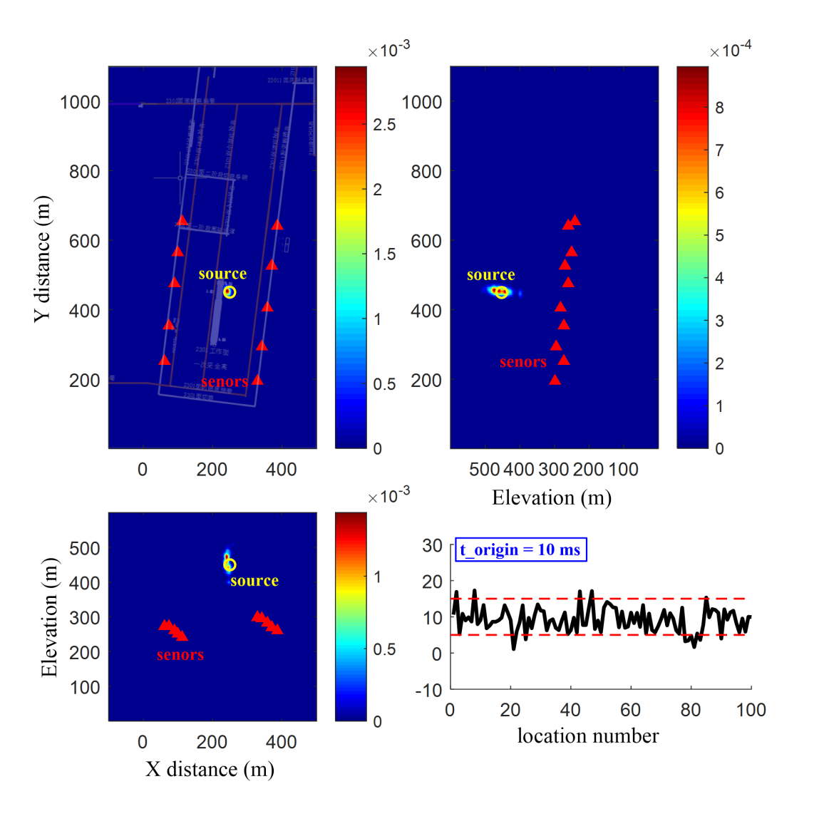
Figure S1. Same as figure 4 but with random error perturbations within [-2, 2] ms.
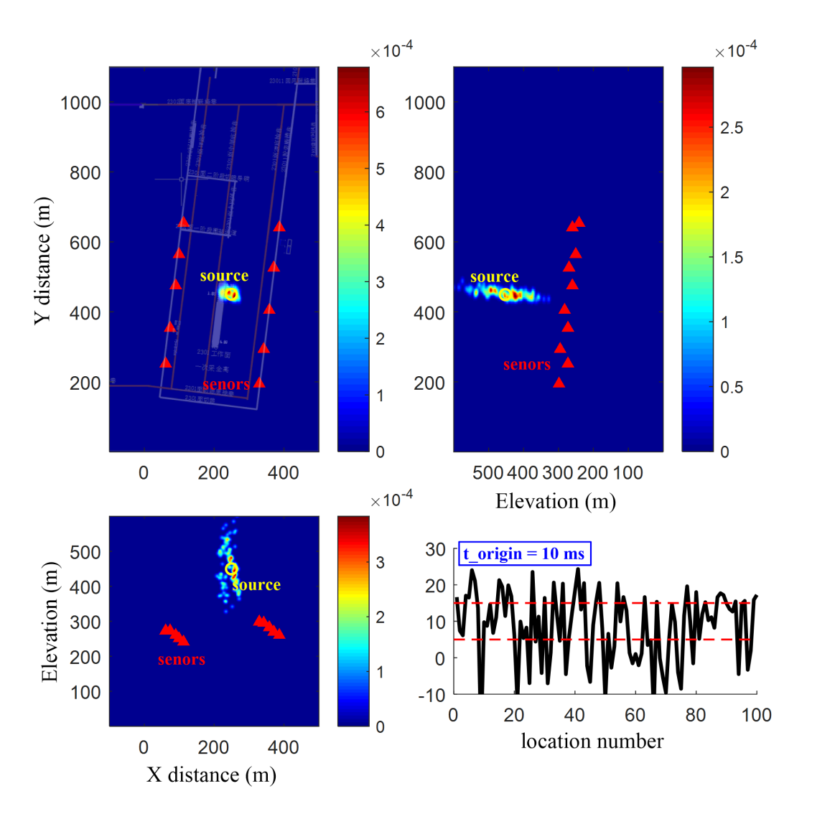
Figure S2. Same as figure 4 but with random error perturbations within [-6, 6] ms.
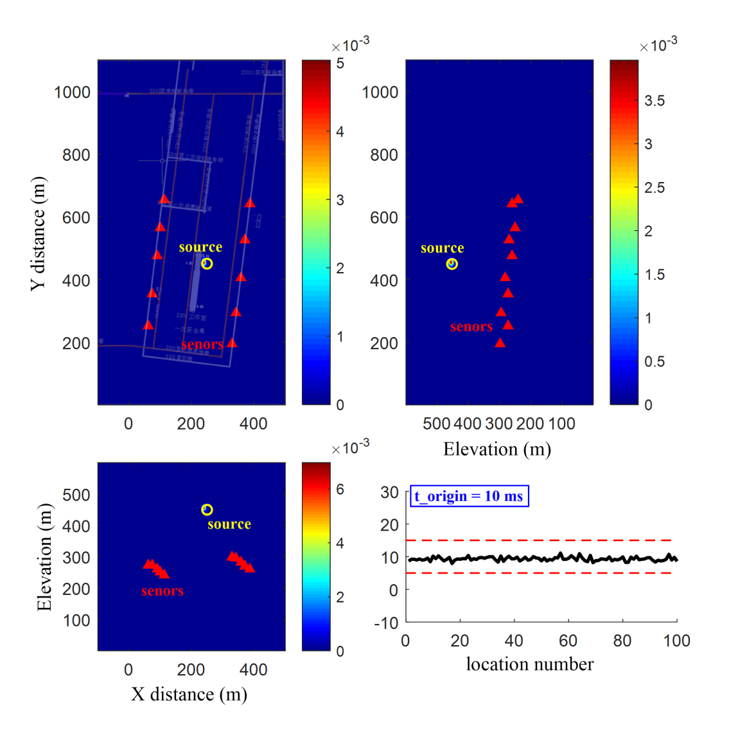
Figure S3. Same as figure 5 but with random error perturbations within [-2, 2] ms.
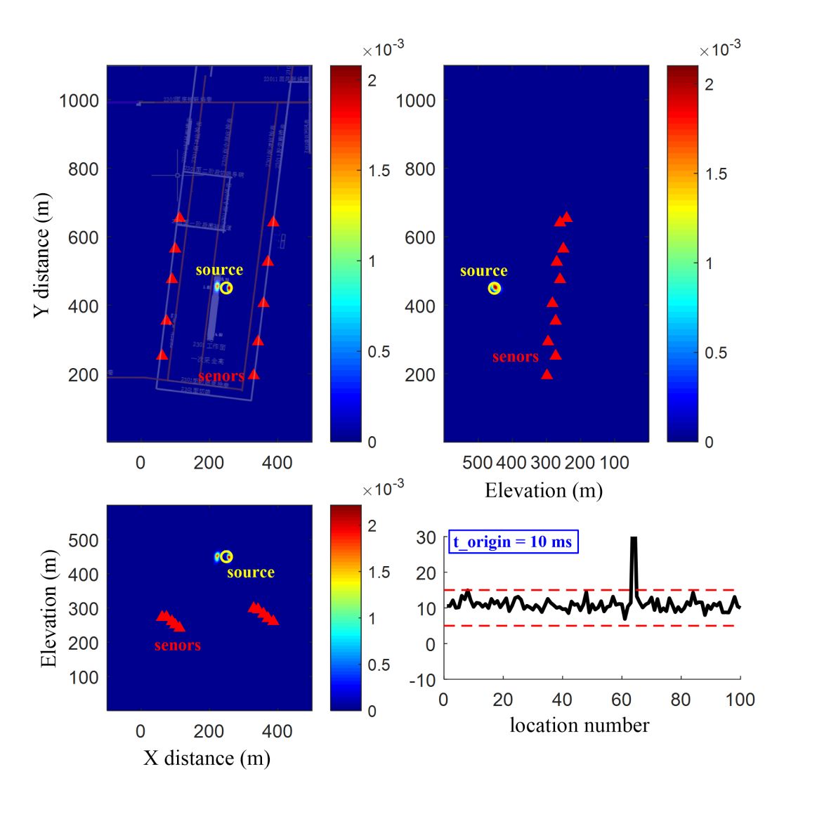
Figure S4. Same as figure 5 but with random error perturbations within [-6, 6] ms.
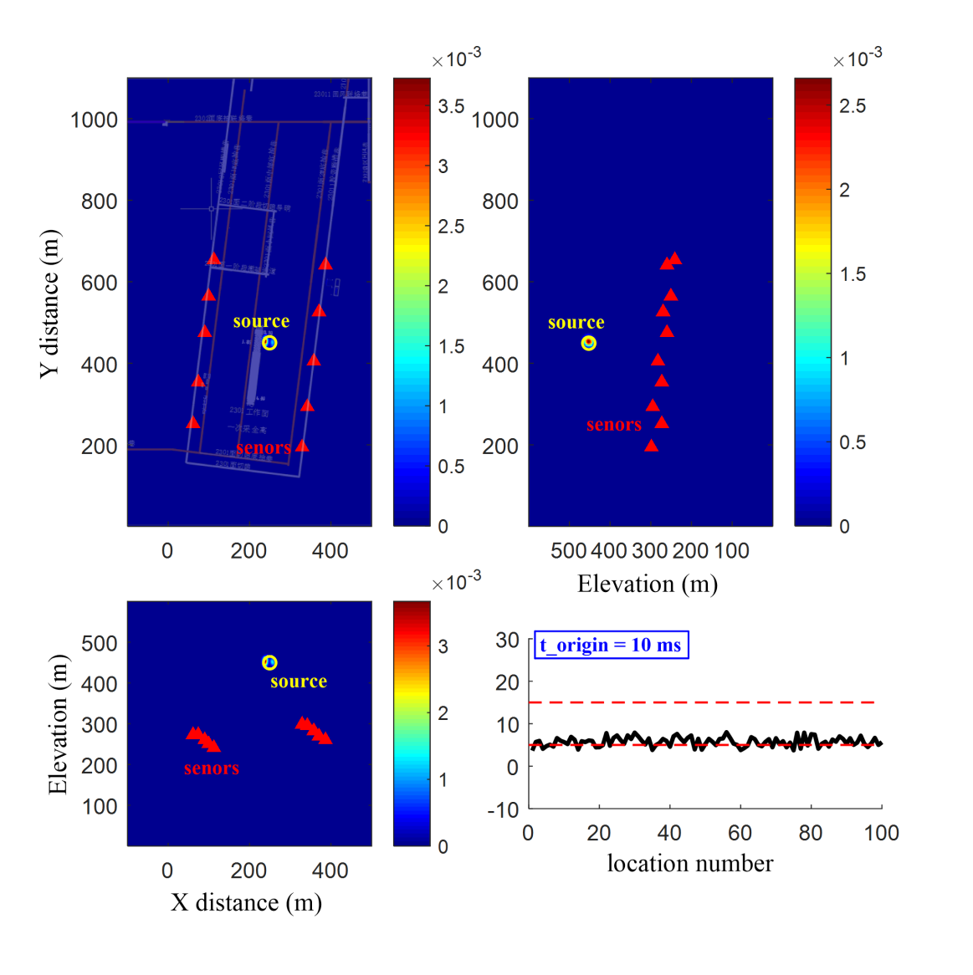
Figure S5. Same as figure 5 but with random error perturbations within [-8, 0] ms.

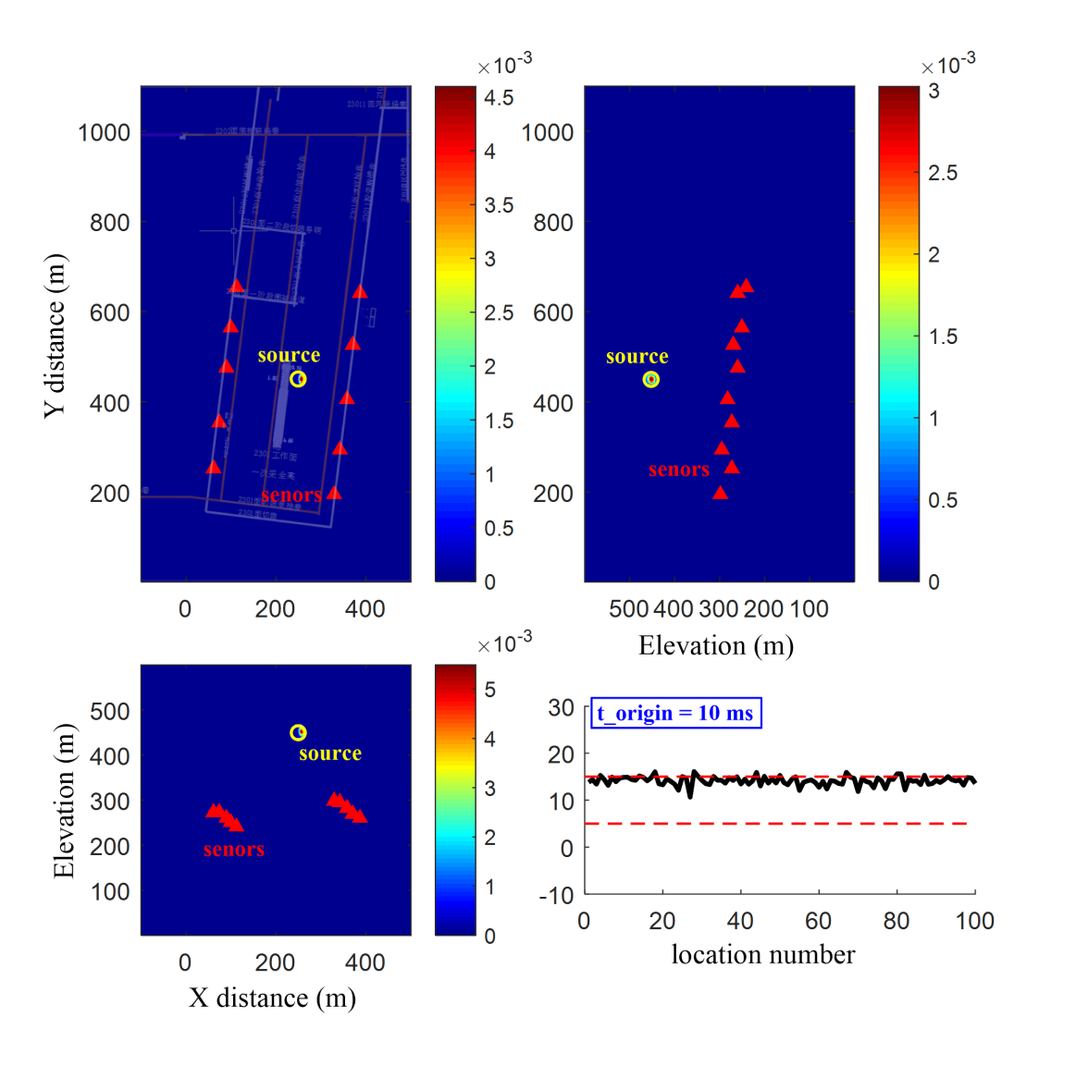
Figure S6. Same as figure 5 but with random error perturbations within [0, 8] ms.

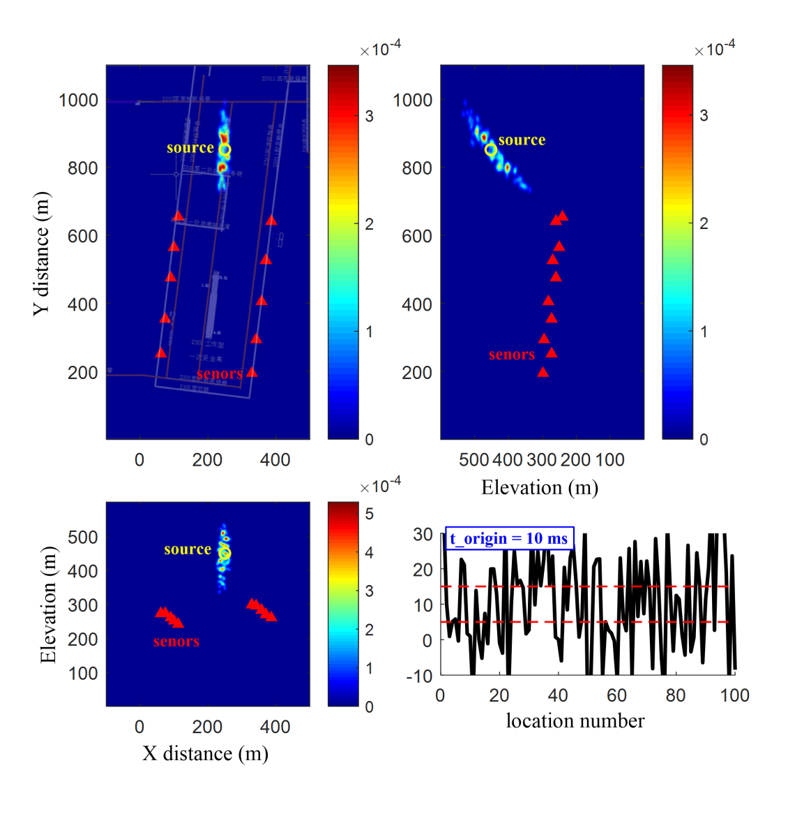
Figure S7. Same as figure 4 but with the synthetic event located outside the network coverage and random error perturbations within [-2, 2] ms.

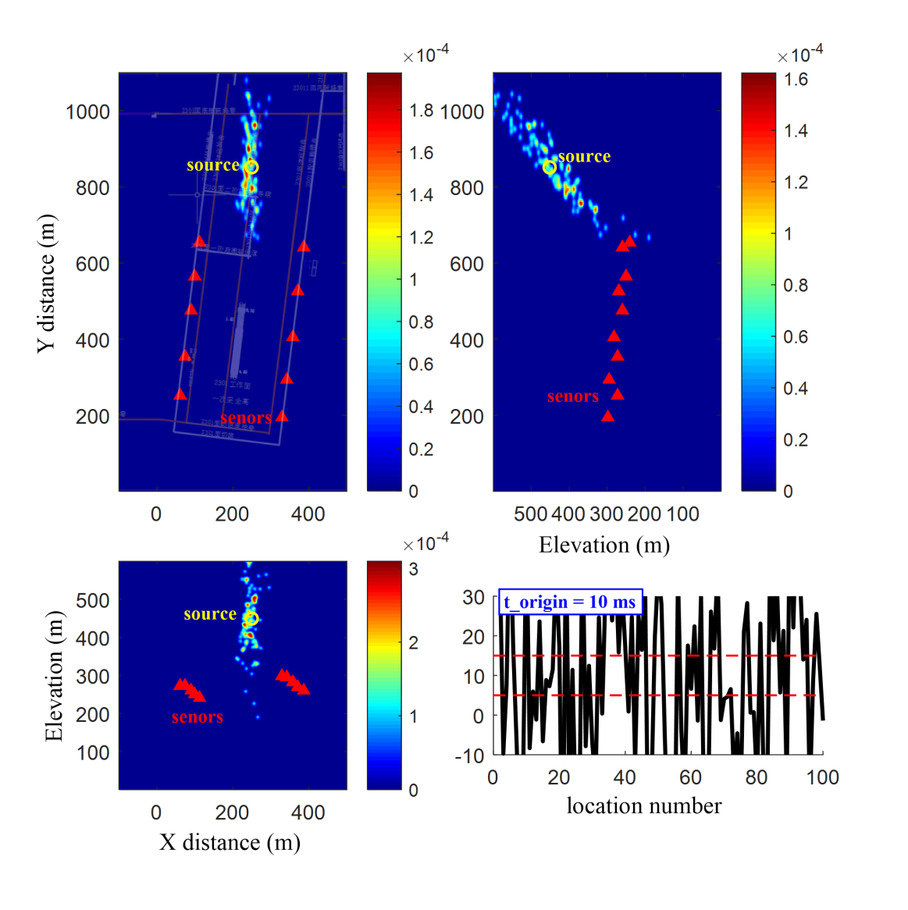
Figure S8. Same as figure 4 but with the synthetic event located outside the network coverage and random error perturbations within [-4, 4] ms.

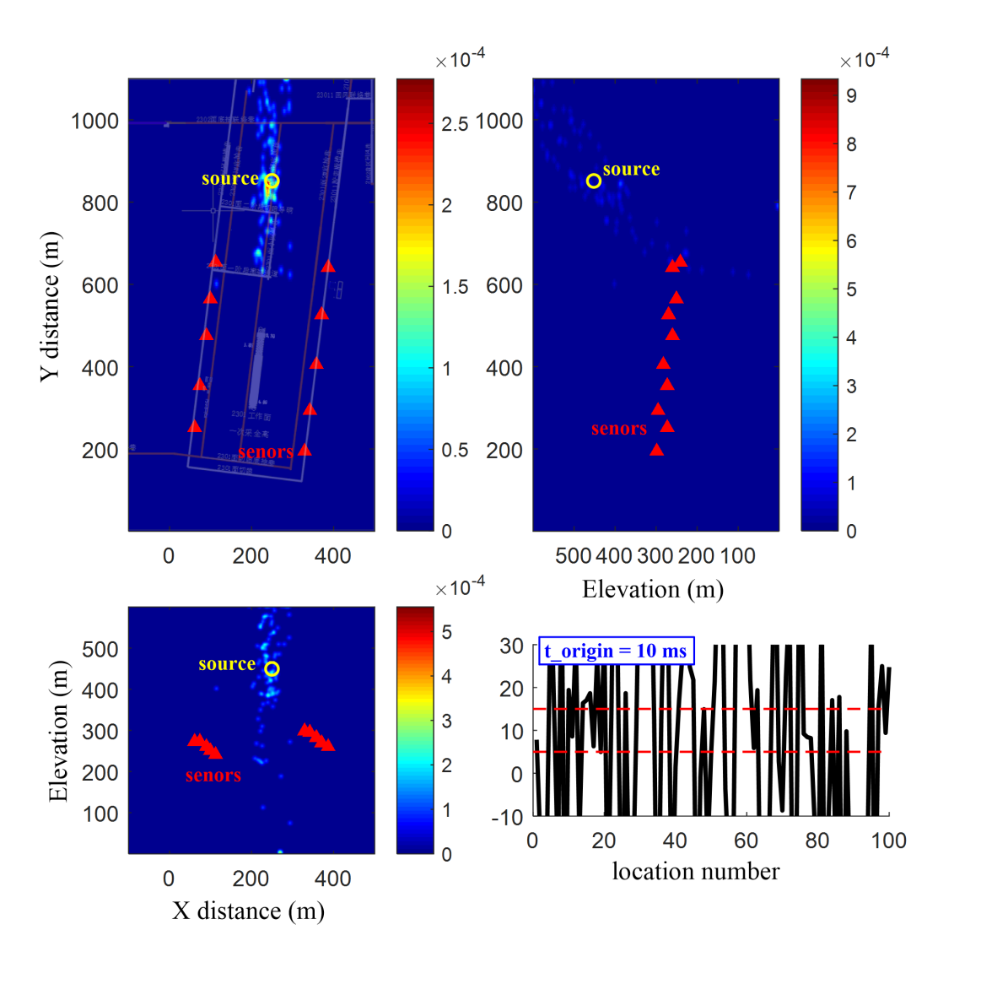
Figure S9. Same as figure 4 but with the synthetic event located outside the network coverage and random error perturbations within [-6, 6] ms.

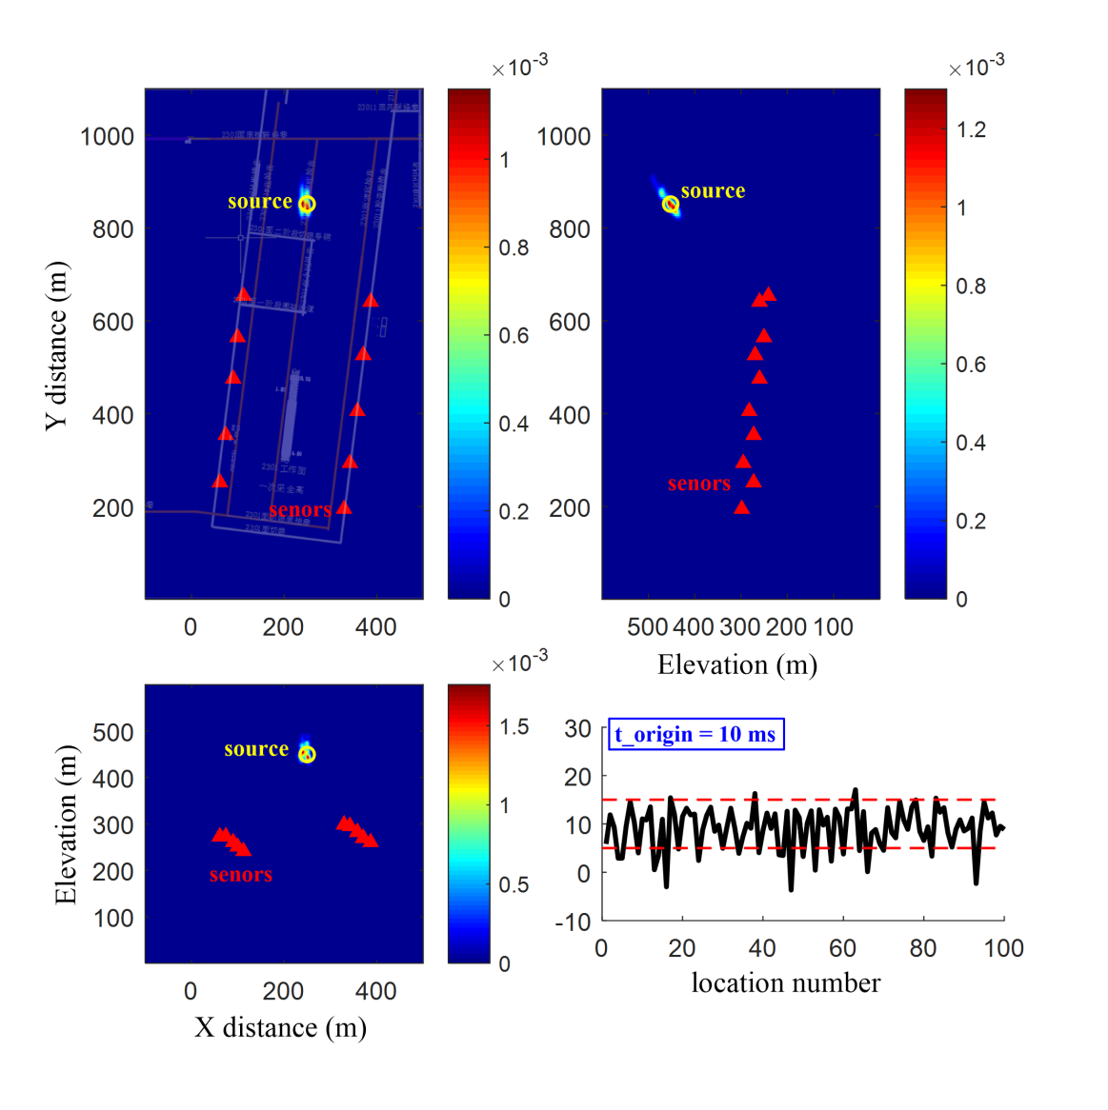
Figure S10. Same as figure 5 but with the synthetic event located outside the network coverage and random error perturbations within [-2, 2] ms.

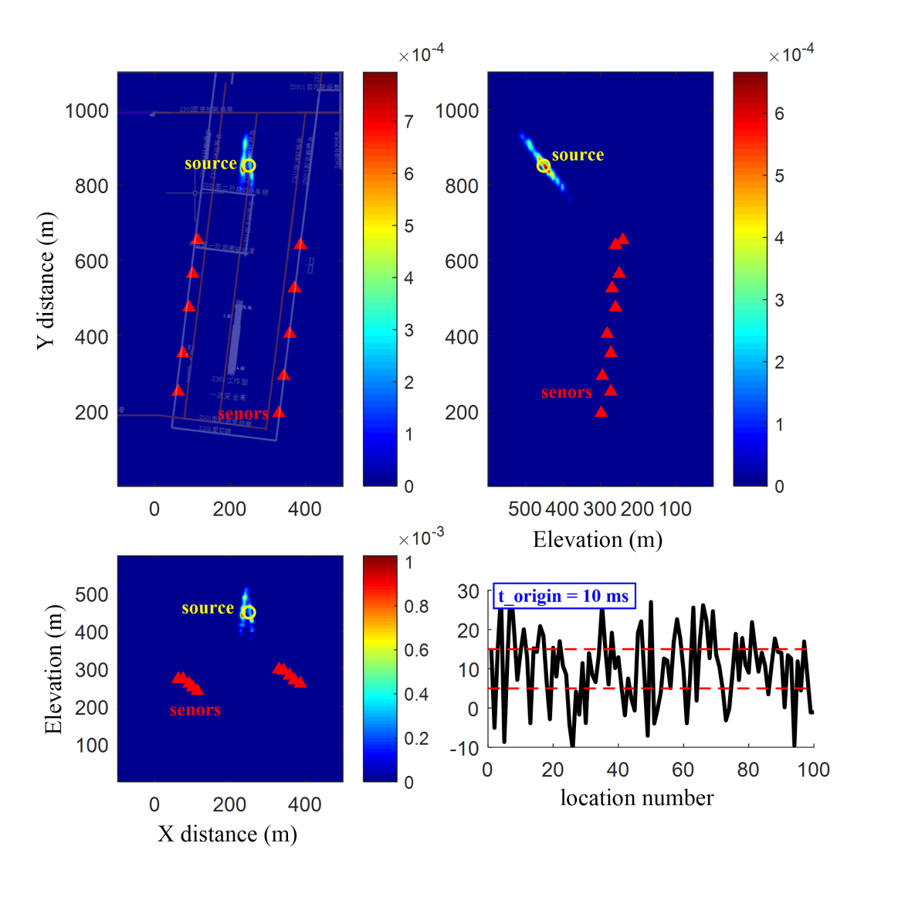
Figure S11. Same as figure 5 but with the synthetic event located outside the network coverage and random error perturbations within [-4, 4] ms.

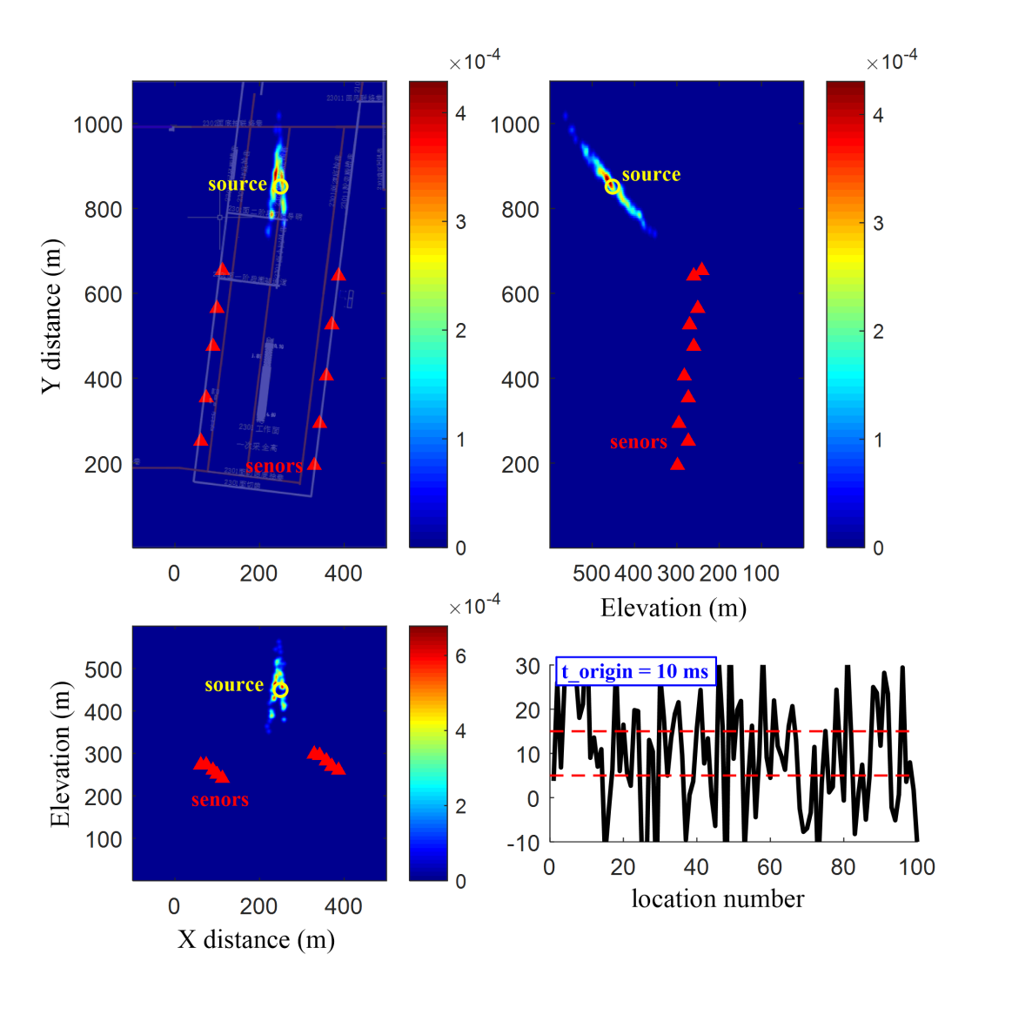
Figure S12. Same as figure 5 but with the synthetic event located outside the network coverage and random error perturbations within [-6, 6] ms.

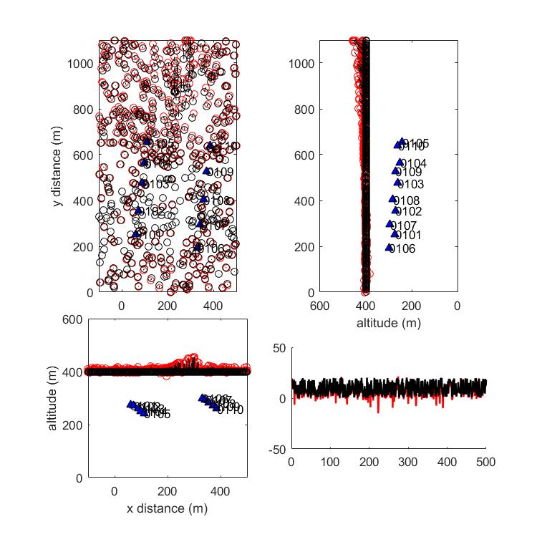
Figure S13. The location results of 500 synthetic microseismic events at elevation of 400 m. The SDPR inversion is conducted for the source location. The microseismic array was deployed on 27 July 2024 at the No. 2301 working face of the Zhaozhuang Coal Mine. The lower and upper bound parameters (l and u in equation 6) are set to -5 and 5 ms, respectively. The black open circles denote true hypocenters. The red open circles are the location results. The short black lines represent deviations of the located hypocenters relative to the true hypocenters. The black and red lines in the lower-right inset denote true and inverted origin times of the 500 events, respectively.

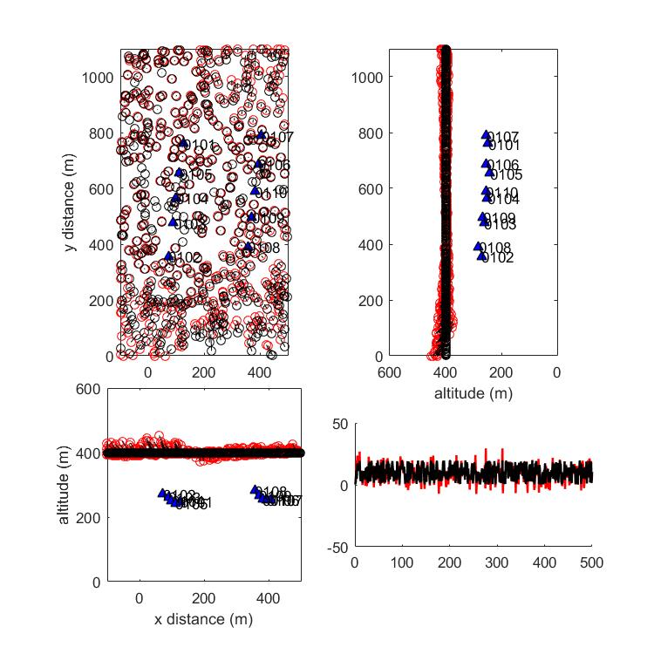
Figure S14. Same as figure S13 but with a microseismic array deployed on 24 August, 2024.

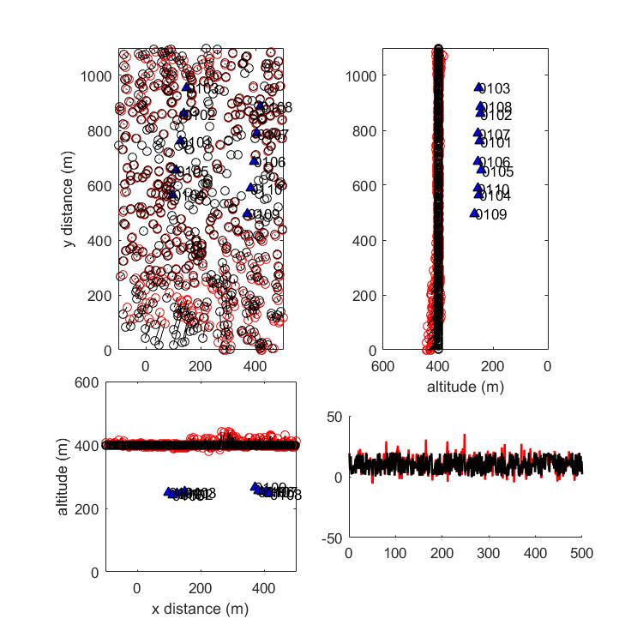
Figure S15. Same as figure S13 but with a microseismic array deployed on 9 October, 2024.

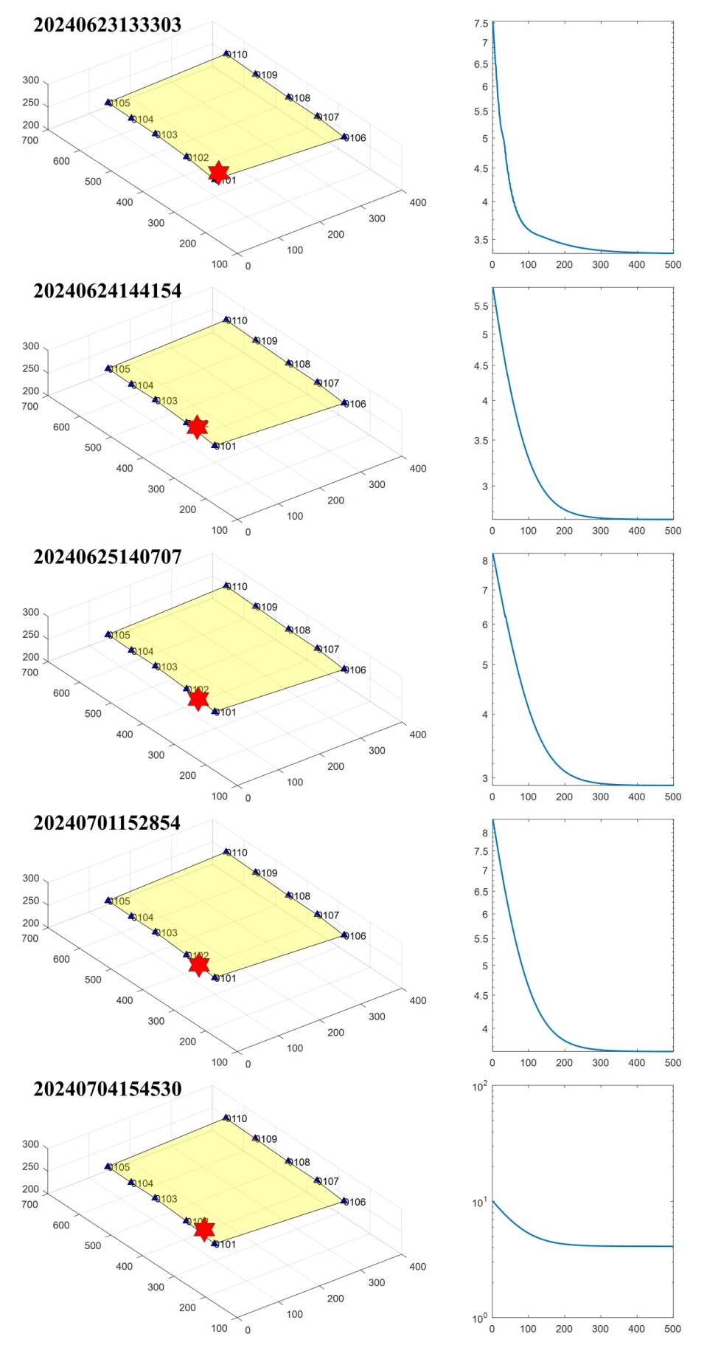
Figure S16. Location results of five blasting events (left) and the convergence curves of the least-squares misfit with iteration (right).

