Supplementary Material

Supplementary Table 1. Breast cancer clinical features
Characteristics | Training (n = 5965) | Internal test (n = 1492) | External validation  （n = 1125）
Weight (kg), mean±SD | 57.37±8.06 | 57.09±7,96 | 59.66±8.22
Height (cm), mean±SD | 157.49±4.91 | 157.41±4.93 | 159.25±5.44
Body surface area (m²), mean±SD | 1.54±0.12 | 1.54±0.12 | 1.59±0.08
Reimbursement ratio, mean±SD | 66.07±22.24 | 67.12±21.55 | /
ER percentage, mean±SD | 74.66±26.10 | 74.37±26.60 | 21.96±38.07
PR percentage, mean±SD | 56.17±32.19 | 54.52±32.82 | 16.16±33.53
Ki67, mean±SD | 34.23±21.53 | 34.78±21.32 | 31.08±22.08
Education level, n(%)
/ | 0(0) | 0(0) | 444(39.47)
Junior High School | 2098(35.17) | 553(37.06) | 253(22.49)
Elementary School | 911(15.27) | 194(13.00) | 104(9.24)
High School | 860(14.42) | 225(15.08) | 201(17.87)
Junior College | 854(14.32) | 224(15.01) | 19(1.69)
Undergraduate | 614(10.29) | 153(10.25) | 50(4.44)
Vocational School | 391(6.55) | 92(6.17) | 0(0)
Illiterate | 153(2.56) | 31(2.08) | 54(4.80)
Master's Degree | 56(0.94) | 13(0.87) | 0(0)
Doctorate | 9(0.15) | 2(0.13) | 0(0)
Others | 19(0.32) | 5(0.34) | 0(0)
Marital status, n(%)
Married | 5781(96.92) | 1453(97.39) | 1091(96.98)
Unmarried | 90(1.51) | 15(1.01) | 9(0.80)
Divorced | 91(1.53) | 24(1.61) | 9(0.80)
Remarried | 3(0.04) | 0(0) | 0(0)
Widowed | 0(0) | 0(0) | 16(1.42)
Menopausal status at diagnosis, n(%)
Yes | 2731(62.55) | 913(61.19) | 691(61.42)
No | 2234(37.45) | 579(38.81) | 434(38.58)
Primary or recurrent status, n(%)
Initial onset | 5922(99.28) | 1483(99.40) | 1125(100)
Recurrence | 43(0.72) | 9(0.60) | 0(0)
ER, n(%)
/ | 572(9.59) | 102(6.84) | 17(1.51)
- | 1608(26.96) | 437(29.29) | 265(23.56)
± | 3(0.05) | 0(0) | 3(0.27)
+ | 3652(61.22) | 921(61.73) | 88(7.82)
++ | 27(0.45) | 8(0.54) | 156(13.87)
+++ | 103(1.73) | 24(1.61) | 596(52.98)
PR, n(%)
/ | 573(9.61) | 103(6.90) | 22(1.96)
- | 1798(30.14) | 474(31.77) | 350(31.11)
± | 6(0.10) | 0(0) | 1(0.08)
+ | 3480(58.34) | 891(59.72) | 137(12.18)
++ | 35(0.59) | 10(0.67) | 155(13.78)
+++ | 73(1.22) | 14(0.94) | 460(40.89)
CK5/6, n(%)
/ | 1208(20.25) | 272(18.23) | 175(15.56)
- | 3924(65.78) | 1002(67.16) | 774(68.80)
± | 14(0.23) | 1(0.07) | 26(2.31)
+ | 817(13.70) | 217(14.54) | 149(13.24)
++ | 2(0.04) | 0(0) | 1(0.09)
HER2 FISH, n(%)
/ | 3258(54.62) | 809(54.22) | 785(69.78)
- | 1674(28.06) | 399(26.74) | 271(24.09)
± | 185(3.10) | 31(2.08) | 4(0.36)
+ | 848(14.22) | 253(16.96) | 65(5.78)
HER2, n(%)
/ | 588(9.86) | 108(7.24) | 22(1.96)
- | 1162(19.48) | 316(21.18) | 235(20.89)
± | 9(0.15) | 1(0.07) | 1(0.07)
+ | 1425(23.89) | 369(24.73) | 292(25.96)
++ | 1592(26.69) | 372(24.93) | 409(36.36)
+++ | 1189(19.93) | 326(21.85) | 166(14.76)
WHO grade, n(%)
/ | 1541(25.83) | 377(25.24) | 428(38.04)
I | 103(1.73) | 29(1.94) | 70(6.22)
II | 1956(32.79) | 449(30.09) | 465(41.33)
III | 2365(39.65) | 637(42.29) | 162(14.40)
T, n(%)
/ | 37(0.62) | 5(0.34) | 0(0)
0 | 13(0.22) | 3(0.20) | 74(6.58)
1 | 2037(34.15) | 519(34.79) | 563(50.04)
2 | 3029(50.78) | 767(51.41) | 449(39.91)
3 | 245(4.11) | 60(4.02) | 33(2.93)
4 | 321(5.38) | 72(4.83) | 6(0.53)
5 | 283(4.74) | 66(4.42) | 0(0)
N, n(%)
/ | 5155(86.42) | 1286(86.19) | 0(0)
0 | 95(1.59) | 32(2.14) | 665(59.11)
1 | 322(5.40) | 78(5.23) | 426(37.87)
2 | 154(2.58) | 37(2.48) | 14(1.24)
3 | 227(3.81) | 56(3.75) | 20(1.78)
5 | 12(0.20) | 3(0.20) | 0(0)
pN, n(%)
/ | 825(13.83) | 212(14.21) | 0(0)
0 | 2670(44.76) | 674(45.17) | 676(60.09)
1 | 1564(26.22) | 390(26.14) | 300(26.67)
2 | 533(8.94) | 131(8.78) | 99(8.80)
3 | 368(6.17) | 82(5.50) | 50(4.44)
5 | 5(0.08) | 3(0.20) | 0(0)
M, n(%)
/ | 5(0.08) | 3(0.20) | 0(0)
0 | 5960(99.92) | 1488(99.73) | 1125(100)
1 | 0(0) | 1(0.07) | 0(0)
Clinical stage, n(%)
/ | 419(7.02) | 98(6.57) | 71(6.31)
0 | 27(0.45) | 3(0.20) | 374(33.24)
I | 1212(20.32) | 322(21.58) | 420(37.33)
IIA | 1798(30.14) | 455(30.50) | 209(18.58)
IIB | 1044(17.50) | 266(17.83) | 27(2.40)
IIIA | 671(11.25) | 161(10.79) | 4(0.36)
IIIB | 229(3.84) | 47(3.15) | 20(1.78)
IIIC | 565(9.47) | 138(9.25) | 0(0)
IV | 0(0) | 2(0.13) | 0(0)

Supplementary Table 2. Imbalance level changes after applying MLSMOTE.
 | MeanIR | MaxIR
Before | 1.46 | 2.03
After | 1.07 | 1.21

Supplementary Table 3 Results before and after applying MLSMOTE.
Dataset |  | MacroFM | MicroFM
Internal test | Before | 0.03 | 0.04
Internal test | After | 0.30 | 0.31
External validation | Before | 0.01 | 0.01
External validation | After | 0.16 | 0.16
Best values are highlighted in bold.

Supplementary Table 4 Comparison of EMR-BCEP and single prediction model application MLSMOTE results on internal test set.
 | MacroFM | MicroFM
Multi | 0.30 | 0.31
Single | 0.23 | 0.24
Best values are highlighted in bold.

Supplementary Table 5. Accuracy of the EMR-BCEP model in predicting BCSS, iDFS, D-DFS, L-RFS, and OS on internal test set.
 | BCSS | iDFS | D-DFS | L-RFS | OS
Accuracy | 91.43 | 87.26 | 86.86 | 90.02 | 89.96

Supplementary Table 6. Comparison of EMR-BCEP and single prediction model application MLSMOTE results on external validation set.
 | MacroFM | MicroFM
Multi | 0.30 | 0.31
Single | 0.23 | 0.24
Best values are highlighted in bold.

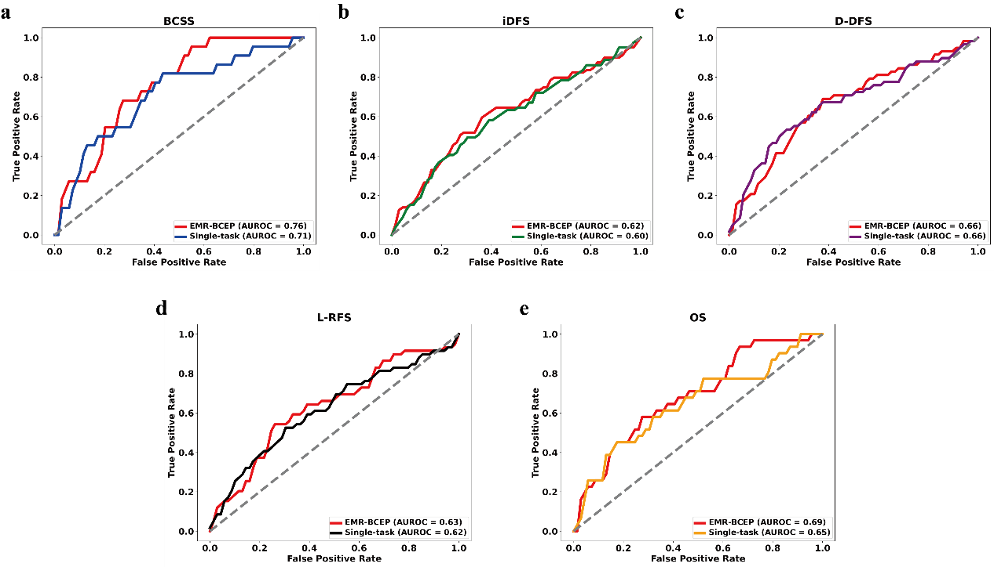
Supplementary Fig. 1: Receiver operating characteristic (ROC) curves for the EMR-BCEP model and single prediction model on the external validation set.
a ROC curve for BCSS. b ROC curve for iDFS. c ROC curve for D-DFS. d ROC curve for L-RFS. e ROC curve for OS.

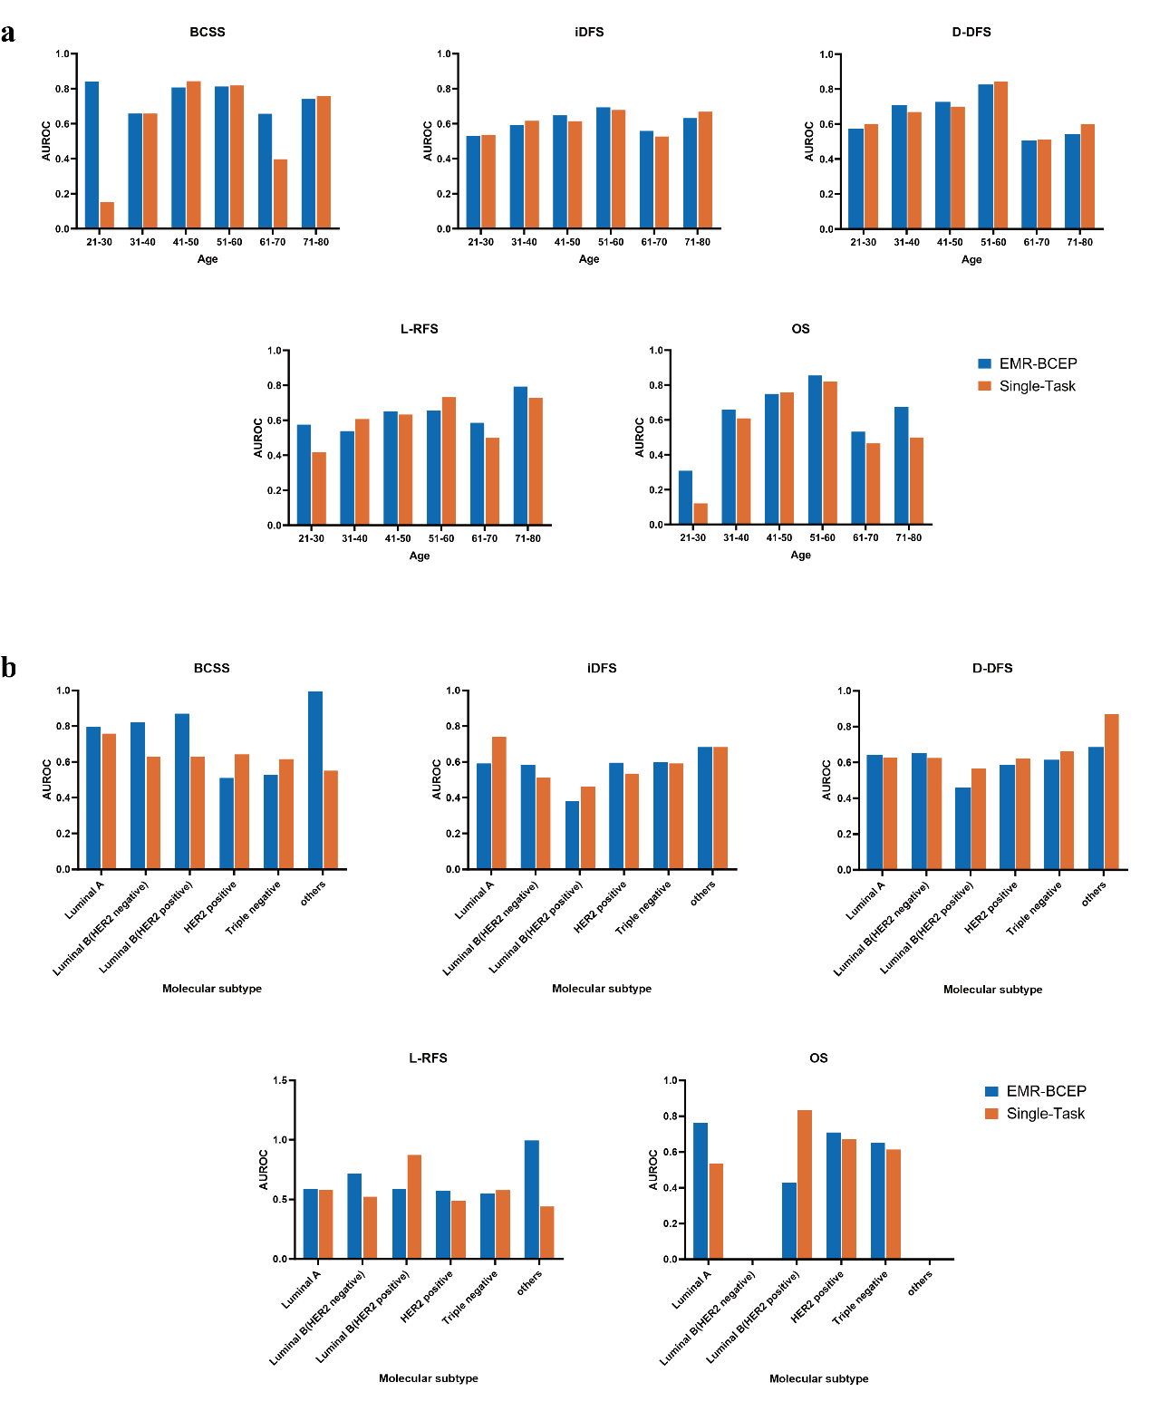
Supplementary Fig. 2: Comparison of age stratification and molecular subtype stratification between the EMR-BCEP model and the single prediction model on the external validation set
a Age-stratified comparison results between EMR-BCEP and single-task models for BCSS, iDFS, D-DFS, L-RFS, and OS. b Molecular subtype-stratified comparison results between EMR-BCEP and single-task models for BCSS, iDFS, D-DFS, L-RFS, and OS.

