Table 1. The sample sizes of the surveys (1995, 2005, 2015 and 2025)

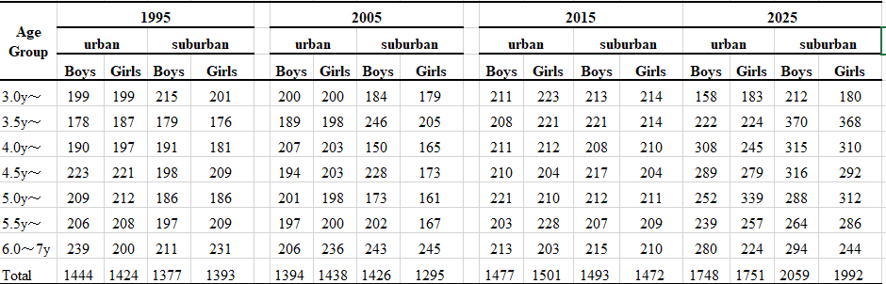
Table 2. Body weight of boys and girls in 1995, 2005, 2015 and 2025, and long-term changes from 1995 to 2025
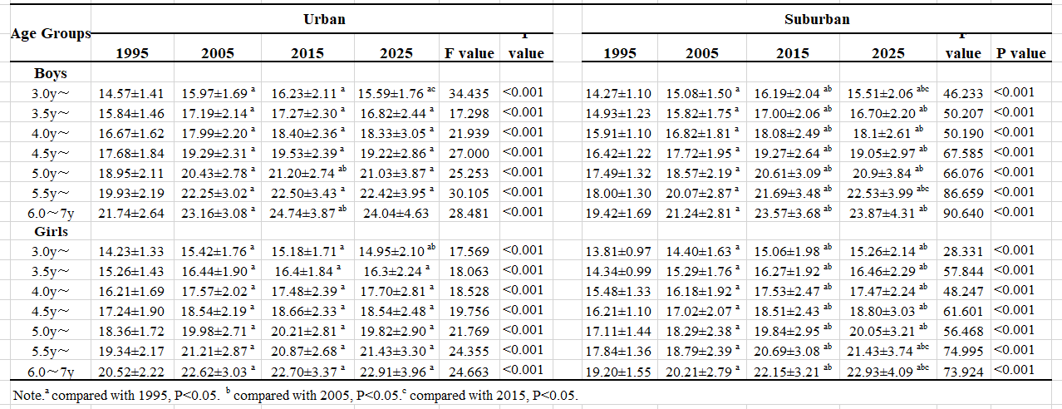
Table 3. Body height of boys and girls in 1995, 2005, 2015 and 2025, and long-term changes from 1995 to 2025
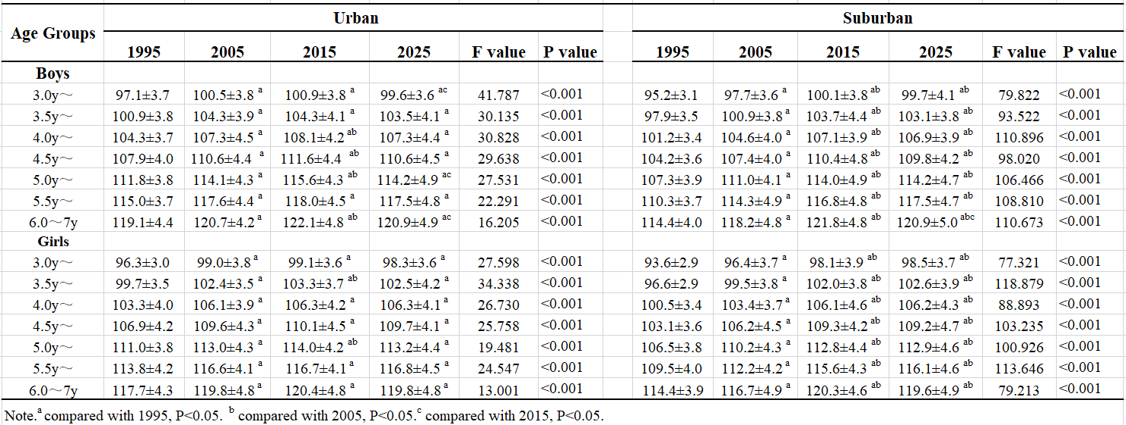
Table 4. The urban-suburban difference in body weight and height of boys and girls in 1995, 2005, 2015 and 2025
