DFT study of Pt/TiO₂ single atom catalyst with oxygen vacancy rich surface

Yongkang Zhang, Yuhang Wang, and Fengping Wang*

School of Mathematics and Physics, University of Science and Technology Beijing, Beijing 100083, P.R. China

*Corresponding authors: Fengping Wang (fpwang@ustb.edu.cn).

Table S1. Cohesive energy of Pt. E(coh)=(E(bulk)-N(E(Pt)))/N. Unit is eV.
E(bulk) | E(Pt) | N | E(coh)
-24.457 | -0.617 | 4 | -5.48

Table S2. The adsorption energy of all TiO₂ surface loaded Pt atom models in the article, E(ads) = E(Pt+TiO₂)-E(TiO₂)-E(Pt). The red value indicates the model with the largest adsorption energy. Unit is eV.

Model | E(TiO2+Pt) | E(TiO2) | E(Pt) | E(ads)
Anatase(001) (a) | -421.803 | -420.065 | -0.617 | -1.12
Anatase(001) (b) | -423.363 | -420.065 | -0.617 | -2.68
Anatase(001) (c) | -421.569 | -420.065 | -0.617 | -0.87
Anatase(001)+Vo (a) | -415.638 | -409.602 | -0.617 | -5.42
Anatase(001)+Vo (b) | -411.704 | -409.602 | -0.617 | -1.89
Anatase(101) (a) | -422.481 | -420.255 | -0.617 | -1.61
Anatase(101) (b) | -422.706 | -420.255 | -0.617 | -1.83
Anatase(101) (c) | -423.554 | -420.255 | -0.617 | -2.68
Anatase(101)+Vo (a) | -412.991 | -410.487 | -0.617 | -1.89
Anatase(101)+Vo (b) | -416.189 | -410.487 | -0.617 | -5.08
Rutile(100) (a) | -211.182 | -208.902 | -0.617 | -1.66
Rutile(100) (b) | -211.543 | -208.902 | -0.617 | -2.02
Rutile(100)+Vo (a) | -205.342 | -199.436 | -0.617 | -5.29
Rutile(011) (a) | -209.237 | -206.513 | -0.617 | -2.11
Rutile(011) (b) | -208.920 | -206.513 | -0.617 | -1.79
Rutile(011) (c) | -210.226 | -206.513 | -0.617 | -3.09
Rutile(011)+Vo (a) | -202.649 | -195.896 | -0.617 | -6.14
Rutile(110) (a) | -206.551 | -204.181 | -0.617 | -1.75
Rutile(110) (b) | -210.163 | -204.181 | -0.617 | -5.36
Rutile(110)+Vo (a) | -200.432 | -193.188 | -0.617 | -6.63
Rutile(110)+Vo (b) | -200.856 | -193.188 | -0.617 | -7.05
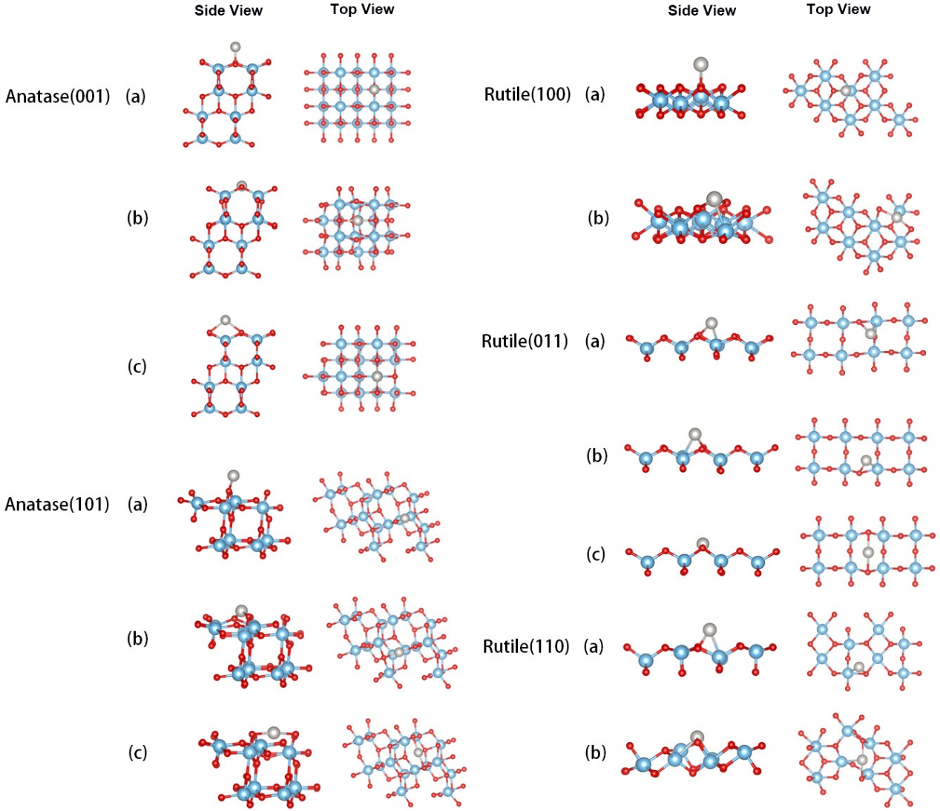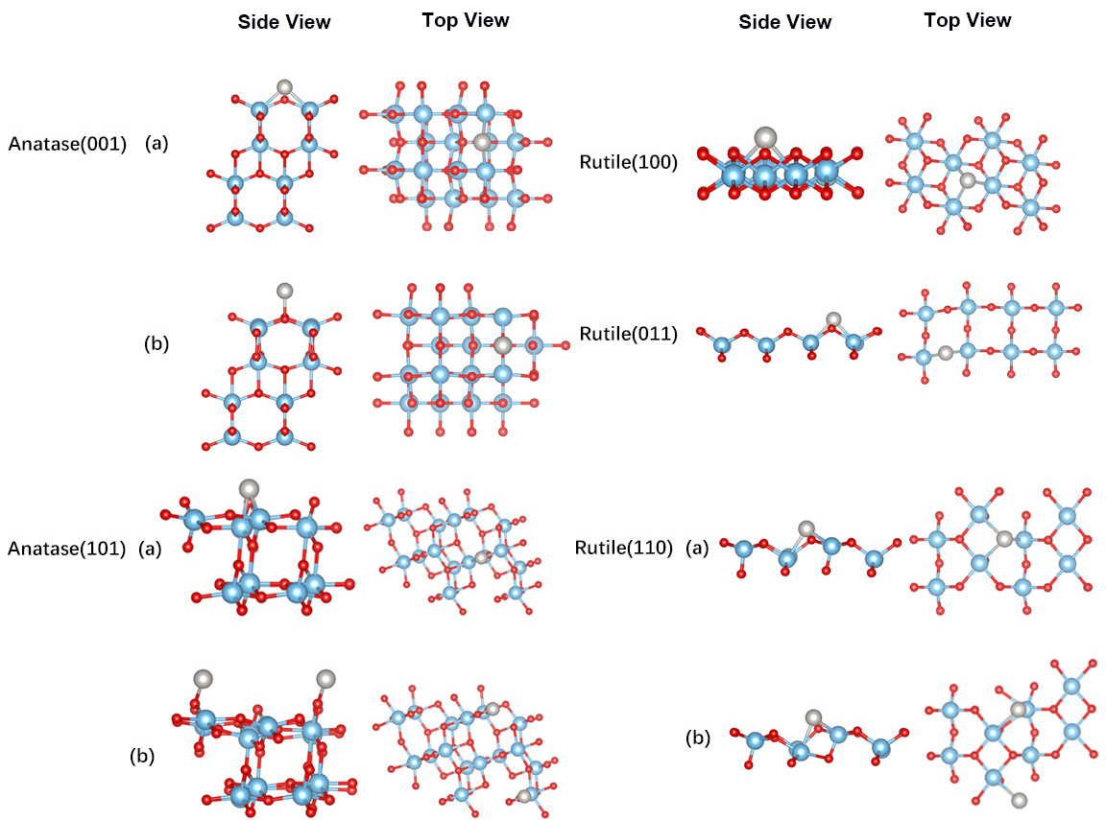
Table S3. D-band center energy of different adsorption model. Surfaces containing oxygen vacancies are represented by Vo. Unit is eV. The energy has subtracted the Fermi level.

Model | E(ads)/eV | d-band center/eV | Model | E(ads)/eV | d-band center/eV
Anatase(001) (a) | -1.12 | -1.02 | Rutile(100) (a) | -1.66 | -1.21
Anatase(001) (b) | -2.68 | -1.43 | Rutile(100) (b) | -2.02 | -1.52
Anatase(001) (c) | -0.87 | -1.15 | Rutile(100)+Vo (a) | -5.29 | -0.87
Anatase(001)+Vo (a) | -5.42 | -1.17 | Rutile(011) (a) | -2.11 | -1.59
Anatase(001)+Vo (b) | -1.89 | -2.07 | Rutile(011) (b) | -1.79 | -1.20
Anatase(101) (a) | -1.61 | -0.86 | Rutile(011) (c) | -3.09 | -1.93
Anatase(101) (b) | -1.83 | -2.01 | Rutile(011)+Vo (a) | -6.14 | -1.40
Anatase(101) (c) | -2.68 | -1.41 | Rutile(110) (a) | -1.75 | -1.12
Anatase(101)+Vo (a) | -1.89 | -2.20 | Rutile(110) (b) | -5.36 | -1.84
Anatase(101)+Vo (b) | -5.08 | -1.17 | Rutile(110)+Vo (a) | -6.63 | -0.77
 |  |  | Rutile(110)+Vo (b) | -7.05 | -0.68

