Figure Legends and Table Notes
Dynamic lactate trajectories within 48 hours of ICU admission predict mortality in severe pneumonia: a retrospective cohort study with external validation
Journal: Journal of Intensive Care

Supplementary Figures
Figure S1
Figure S1. Latent growth mixture model selection criteria for k = 1–5 trajectory classes. (A) Bayesian information criterion (BIC) plotted against the number of classes. Lower BIC indicates better fit. (B) Relative entropy plotted against the number of classes. Values ≥ 0.60 indicate acceptable class separation. The four-class solution (k = 4: BIC = 14,050, entropy = 0.680) was selected.
BIC, Bayesian information criterion; k, number of trajectory classes; LGMM, latent growth mixture model.
Figure S2
Figure S2. Lactate trajectory phenotypes in the external validation cohort (SGH, n = 289). Mean lactate with 95% confidence intervals (shaded ribbons) at 0, 12, 24, 36, and 48 hours. The dashed line at 2.0 mmol/L indicates the upper limit of normal. The trajectory patterns are consistent with the derivation cohort (Fig. 2). Sample sizes are shown in the panel headers.
CI, confidence interval; mmol/L, millimoles per litre; SGH, Shanghai General Hospital; T1–T4, trajectory phenotypes 1–4.
Figure S3
Figure S3. Schoenfeld residual plots for the 90-day multivariable Cox model (MIMIC-IV, n = 870). Scaled Schoenfeld residuals are plotted against follow-up time for each covariate. A smoothed spline with 95% confidence bands is overlaid. The global Grambsch–Therneau test indicated departure from proportional hazards (p < 0.001); hazard ratios should therefore be interpreted as average effects over the follow-up period.
APS III, Acute Physiology Score III; COPD, chronic obstructive pulmonary disease; PH, proportional hazards; SOFA, Sequential Organ Failure Assessment.
Figure S4
Figure S4. Forest plot of 90-day mortality hazard ratios for T2 versus T1 across pre-specified clinical subgroups (MIMIC-IV). Unadjusted hazard ratios with 95% confidence intervals from separate Cox models within each subgroup. The vertical dashed line at HR = 1.0 represents no difference. Red squares indicate p < 0.05; blue squares indicate p ≥ 0.05. This analysis was exploratory and not powered for formal interaction testing.
CI, confidence interval; COPD, chronic obstructive pulmonary disease; HR, hazard ratio; T1, Stable-normal; T2, Fluctuating-worsening.
Figure S5
Figure S5. Time-dependent AUC for mortality prediction: SOFA alone versus lactate trajectory-augmented model (MIMIC-IV, n = 870). The blue solid line represents the trajectory-augmented model (adjusted for age, sex, COPD, SOFA, and APS III); the red dashed line represents the SOFA-only model. AUC values at 28, 60, and 90 days are annotated. The trajectory-augmented model showed significantly higher AUC at all time points (28-day: 0.696 vs. 0.624, p = 0.007; 60-day: 0.696 vs. 0.608, p < 0.001; 90-day: 0.694 vs. 0.621, p = 0.004).
APS III, Acute Physiology Score III; AUC, area under the receiver operating characteristic curve; COPD, chronic obstructive pulmonary disease; SOFA, Sequential Organ Failure Assessment.

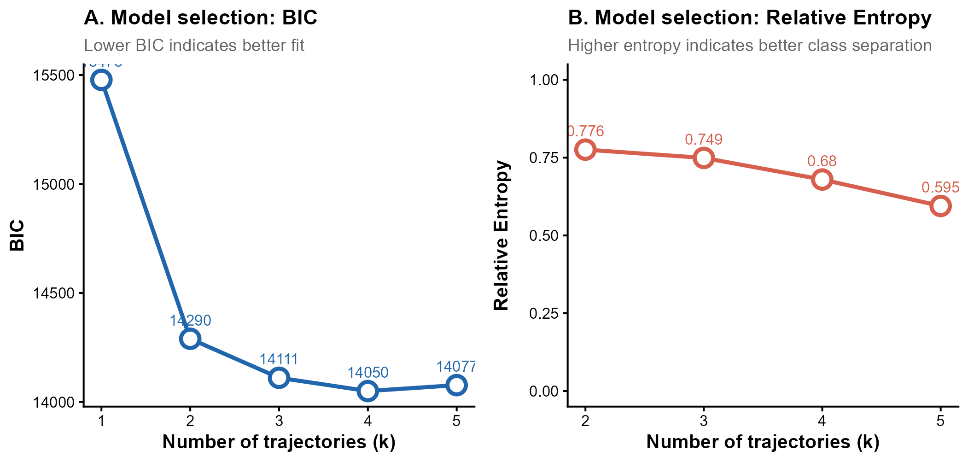
Figure S1. Latent growth mixture model selection criteria for k = 1–5 trajectory classes.
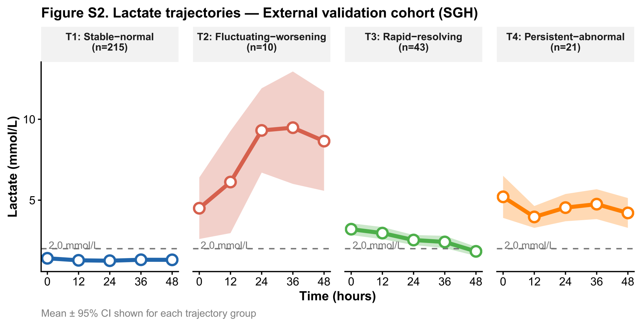
Figure S2. Lactate trajectory phenotypes in the external validation cohort (SGH, n = 289).
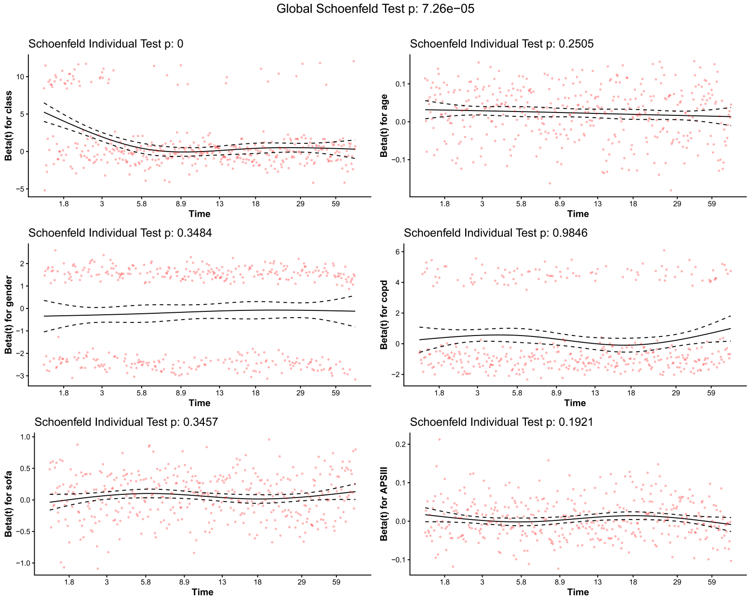
Figure S3. Schoenfeld residual plots for the 90-day multivariable Cox model (MIMIC-IV, n = 870).
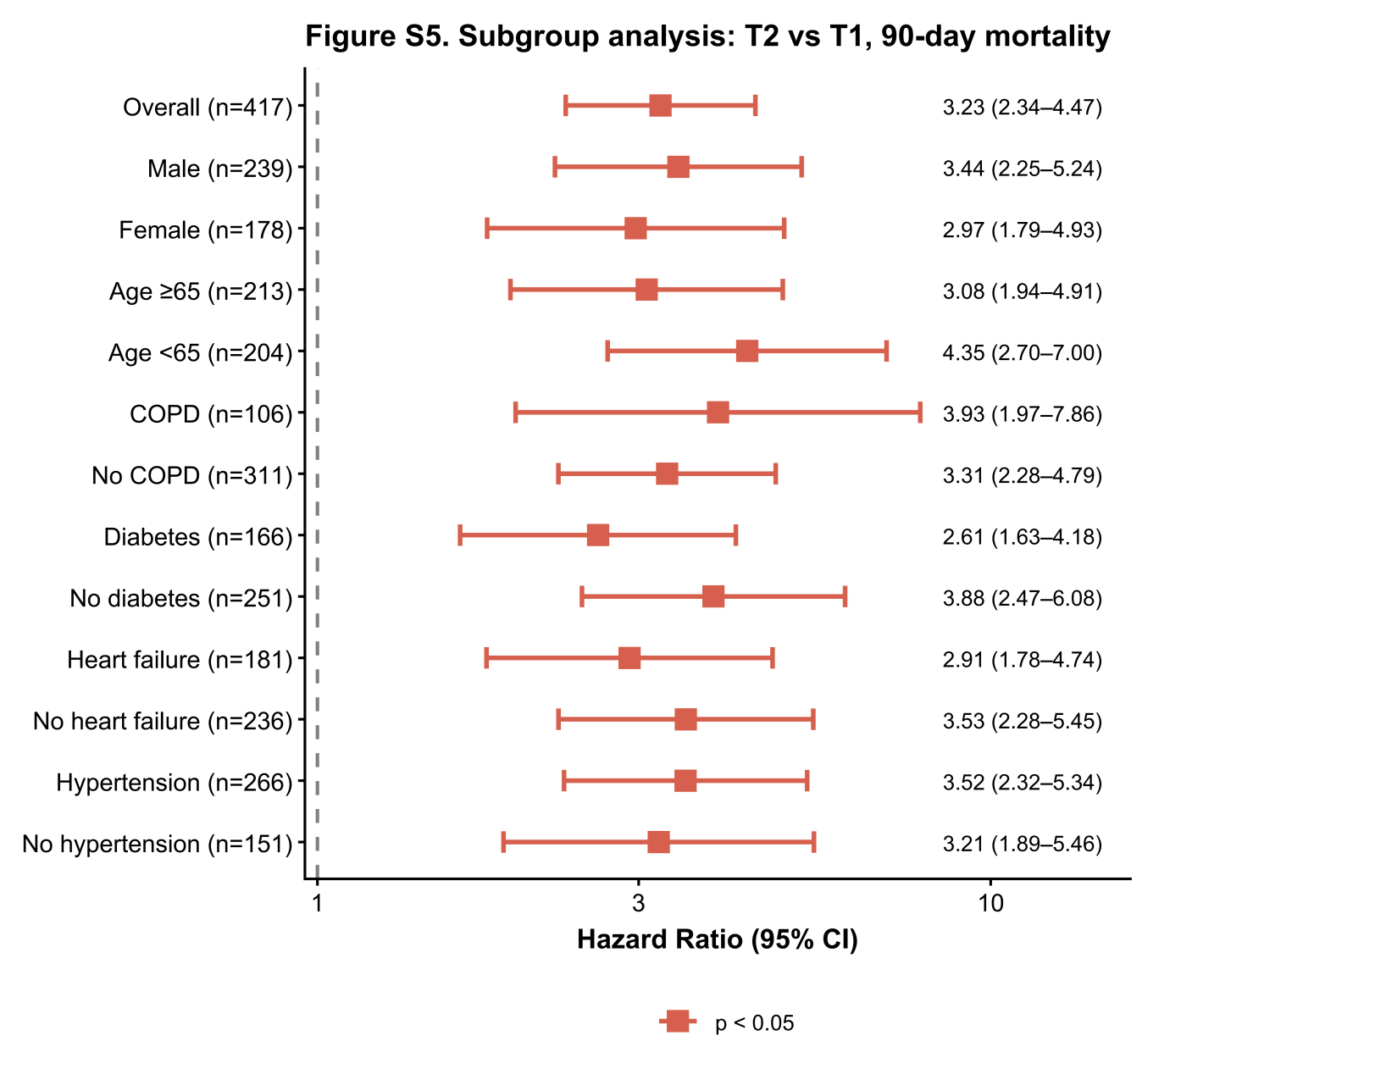
Figure S4. Forest plot of 90-day mortality hazard ratios for T2 versus T1 across pre-specified clinical subgroups (MIMIC-IV).
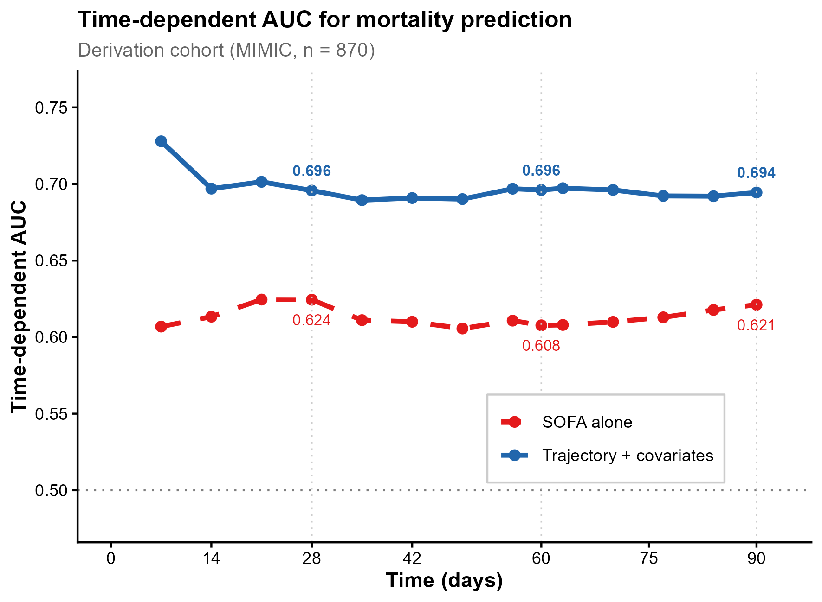
Figure S5. Time-dependent AUC for mortality prediction: SOFA alone versus lactate trajectory-augmented model (MIMIC-IV, n = 870).

