Supplementary Materials
- Additional preprocessing procedures for heat-related variables

A total of 18 heat-related variables were compiled to investigate spatial heterogeneity in the relationship between heat-related illness (HRI) incidence and its associated factors across 219 administrative districts in the Republic of Korea. The variables were classified into four categories: thermal environment, social vulnerability, healthcare accessibility and energy use, and land use. Several variables required additional preprocessing to construct district-level annual values. The preprocessing procedures are described below.

Meteorological variables (thermal environment category)
Meteorological data were collected from 547 automated weather stations operated by the Korea Meteorological Administration (KMA). We restricted the data to the summer surveillance period from May 15 to September 30 and excluded data from stations above 800m, because high-altitude measurements may not reflect heat exposure in populated areas. Hourly observations were aggregated into daily means at each station. District-level daily values were derived by averaging data within each district or using data from the nearest station when no station was available. Finally, district-level daily values were averaged within each year to obtain annual district-level values.

Pharmacy and hospital access variables (healthcare accessibility and energy use category)
The pharmacy and hospital access variables were constructed from information on pharmacies and medical and public health institutions in the Republic of Korea. Medical and public health institutions are organized into tertiary general hospitals, general hospitals, hospitals, long-term care hospitals, clinics, public health and medical centers, public health centers, and public health subcenters. The total number of these institutions was summed within each district to construct the hospital access variables. Pharmacy and hospital access data were collected quarterly, and these quarterly values were averaged by year.

Electricity consumption (healthcare accessibility and energy use category)
The electricity consumption variable was constructed using electricity usage data in the Republic of Korea, which are reported separately for the residential, general, educational, and agricultural sectors. These data were aggregated to obtain the total usage from May to September of each year.

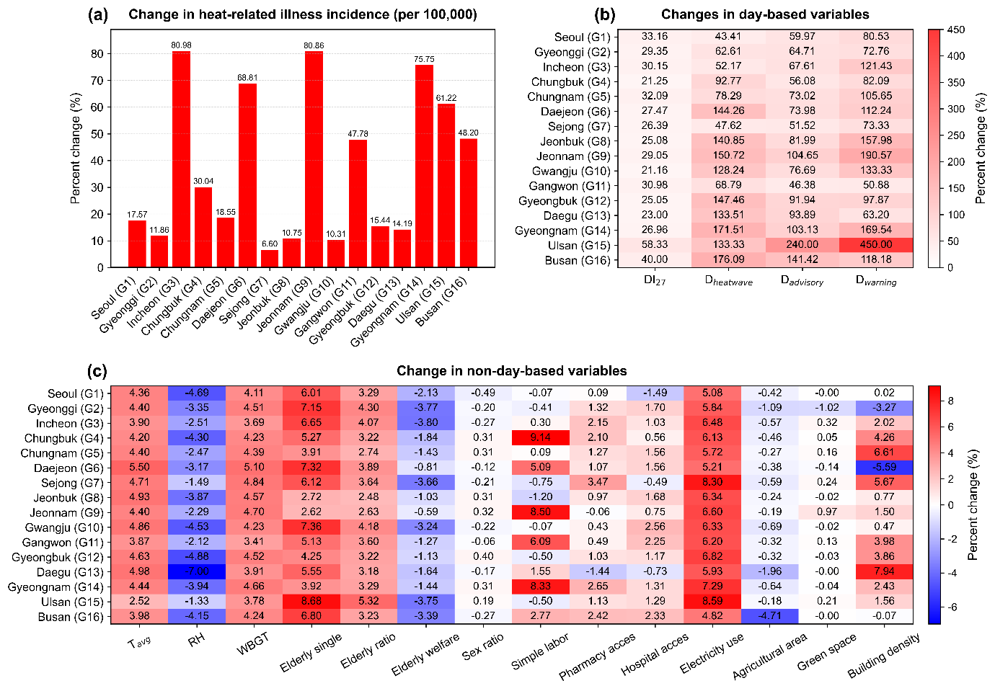
Supplementary Fig. S1 Regional variation in the relative changes of HRI incidence and heat-related variables from 2023 to 2024. (a) Relative change in HRI incidence by city. (b)–(c) Relative changes in 18 heat-related variables representing thermal exposure and vulnerability indicators. The values represent percentage changes relative to 2023

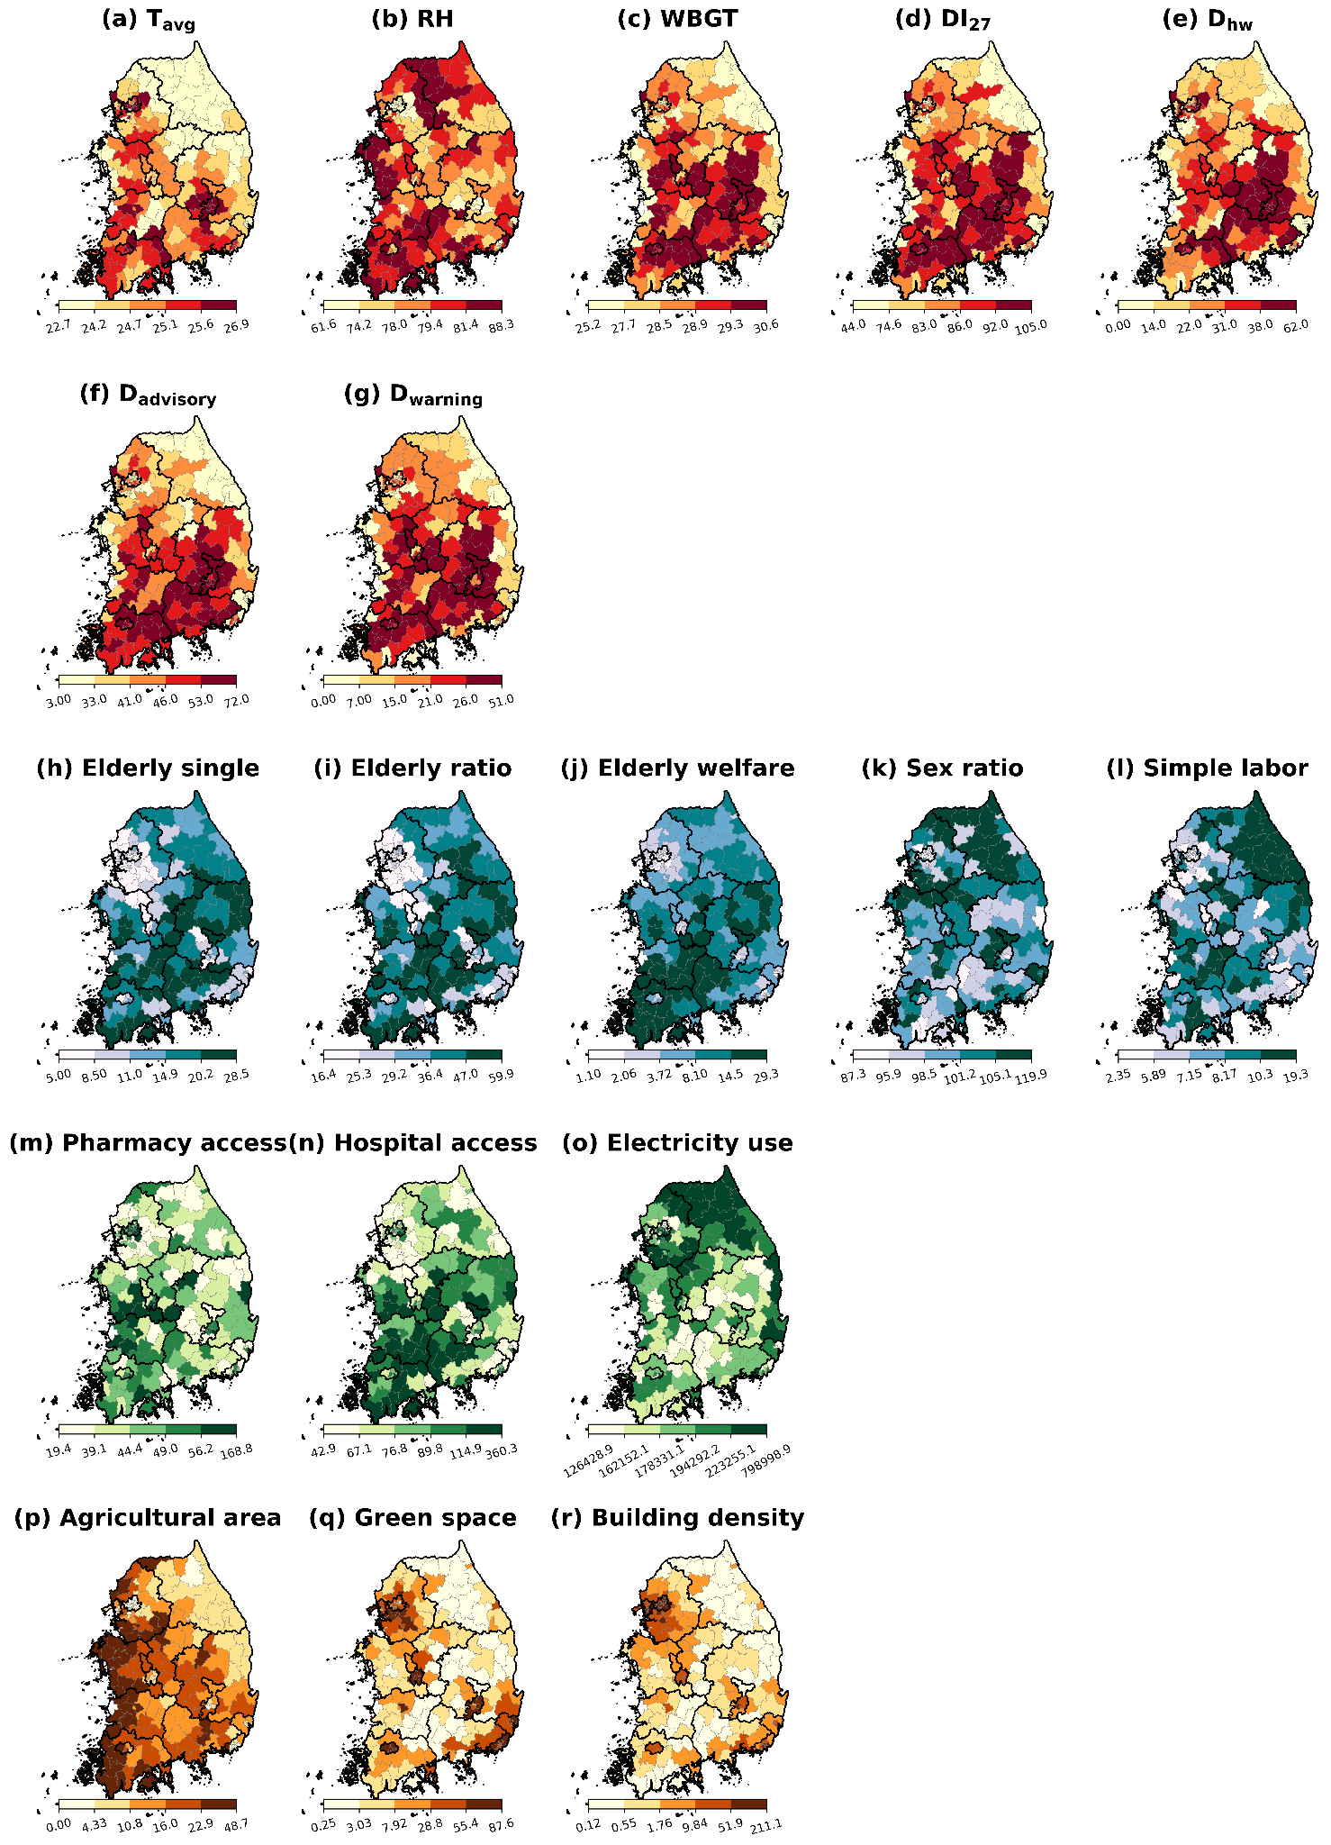
Supplementary Fig. S2 District-level distribution of the heat-related variables used in this study. Heat-related variables are classified into four categories: thermal environment (red), social vulnerability (blue), healthcare accessibility and energy use (green), and land use (brown)
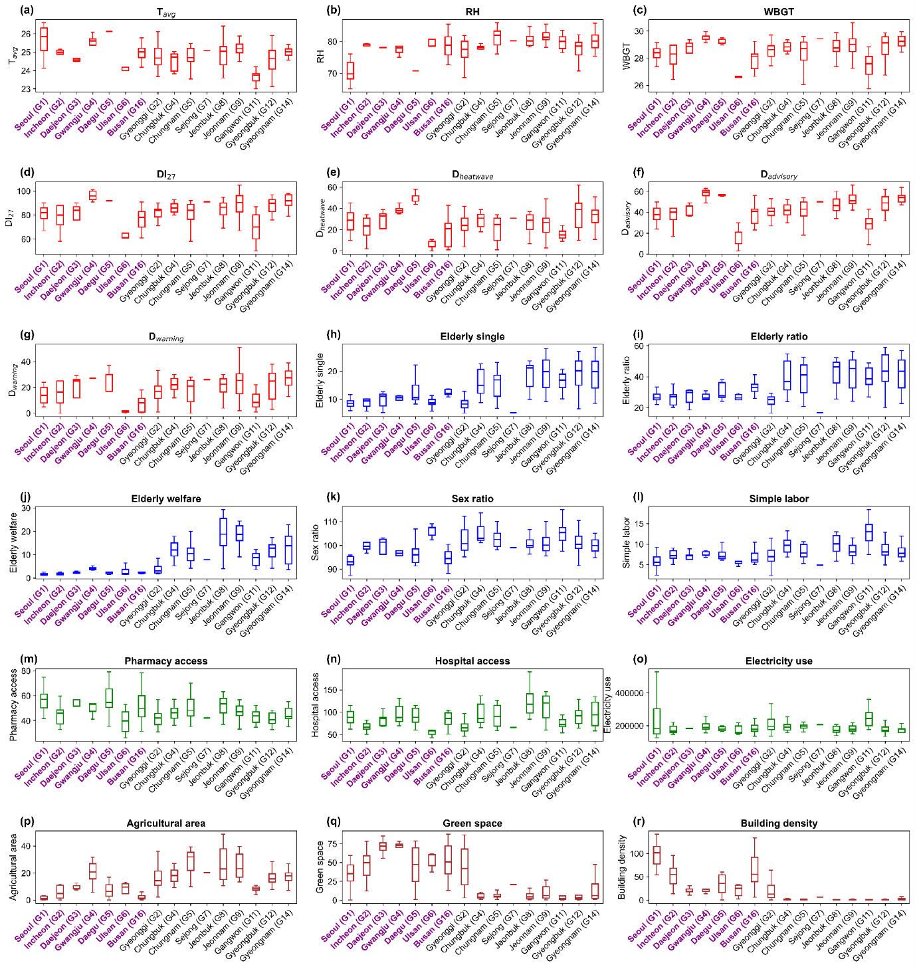
Supplementary Fig. S3 Regional distribution of heat-related variables by administrative district in 2024. The boxplots show regional differences in variables grouped into four categories: thermal environment (red), social vulnerability (blue), healthcare accessibility and energy use (green), and land use (brown). The purple x-axis labels indicate Seoul (G1), the capital of the Republic of Korea, and other metropolitan cities. The black x-axis labels indicate cities corresponding to provinces
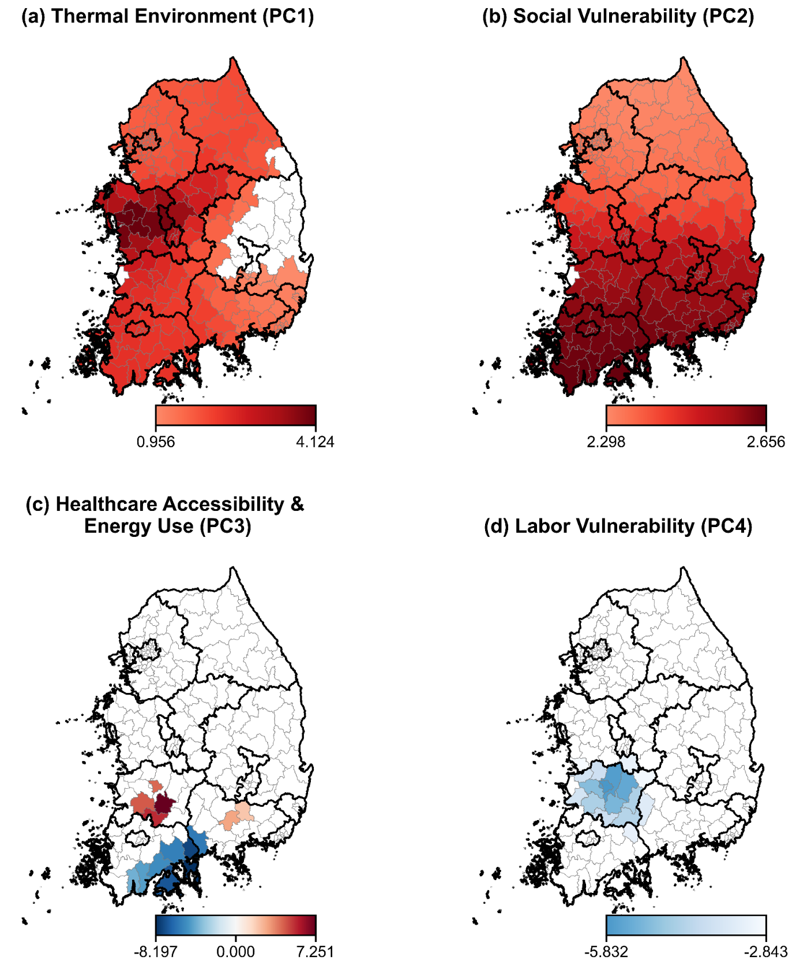
Supplementary Fig. S4 Spatial distribution of statistically significant local regression coefficients from the MGWR model. Red and blue indicate positive and negative regression coefficients, respectively
Supplementary Table S1. Count of hotspots and coldspots identified using Getis-Ord Gi* statistic by city. “Total number of districts” indicates the number of districts within each city
City | Number of hotspots | Number of coldspots | Total number of districts
Seoul (G1) | 0 | 25 | 25
Gyeonggi (G2) | 0 | 23 | 31
Incheon (G3) | 0 | 8 | 8
Chungbuk (G4) | 0 | 0 | 11
Chungnam (G5) | 5 | 2 | 15
Daejeon (G6) | 0 | 0 | 5
Sejong (G7) | 0 | 1 | 1
Jeonbuk (G8) | 9 | 0 | 14
Jeonnam (G9) | 9 | 0 | 20
Gwangju (G10) | 0 | 0 | 5
Gangwon (G11) | 1 | 0 | 18
Gyeongbuk (G12) | 1 | 6 | 21
Daegu (G13) | 0 | 9 | 9
Gyeongnam (G14) | 7 | 2 | 16
Ulsan (G15) | 0 | 1 | 5
Busan (G16) | 0 | 15 | 15

