Supplementary Material
Supplementary Table 1: Dose–Response Relationship Between PSQI Quartile and Psychiatric Morbidity (MMS ≥ 6)
PSQI Quartile | PSQI Score Range | n (%) | Adjusted OR | 95% CI | p value
Q1 (Reference) | 1-3 | 253 (29.2%) | 1.00 | - | -
Q2 | 4-5 | 286 (33.1%) | 2.33 | 1.40–3.88 | .001
Q3 | 6-7 | 191 (22.1%) | 6.08 | 3.64–10.14 | <.001
Q4 | 8-19 | 135 (15.6%) | 13.06 | 7.58–22.50 | <.001
Adjusted for age, gender, and academic stream. Nagelkerke R² = 0.223. Per-quartile trend OR = 2.39 (95% CI: 2.02–2.82, p < .001)

Supplementary Figure 1. Adjusted odds ratios (95% CI) for individual PSQI components as predictors of psychiatric morbidity (MMS ≥ 6).
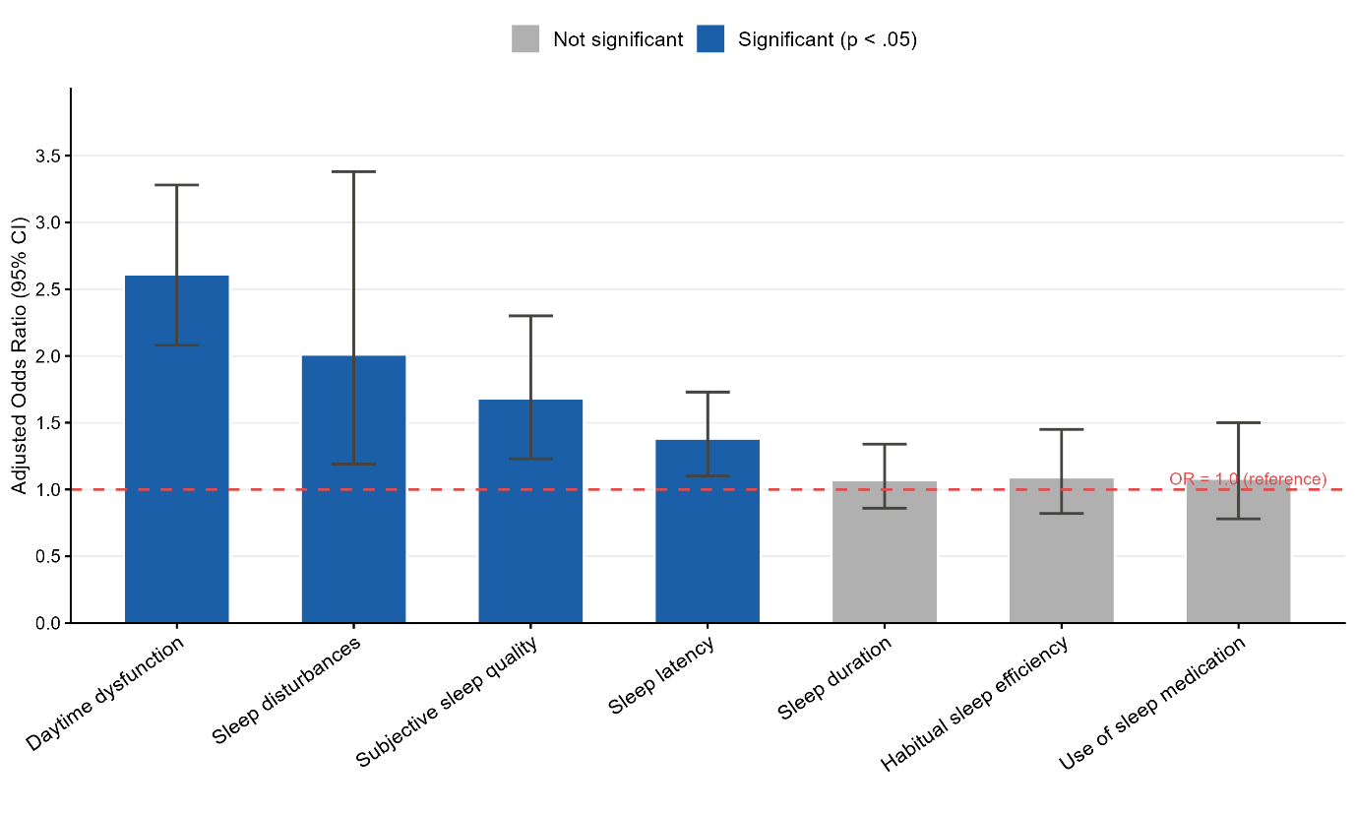
Blue bars indicate statistically significant associations (p < .05); gray bars indicate non-significant associations. Error bars represent 95% confidence intervals. The red dashed line indicates OR = 1.0 (reference). Adjusted for age, gender, and academic stream.

