Figure S1. Funnel Plot
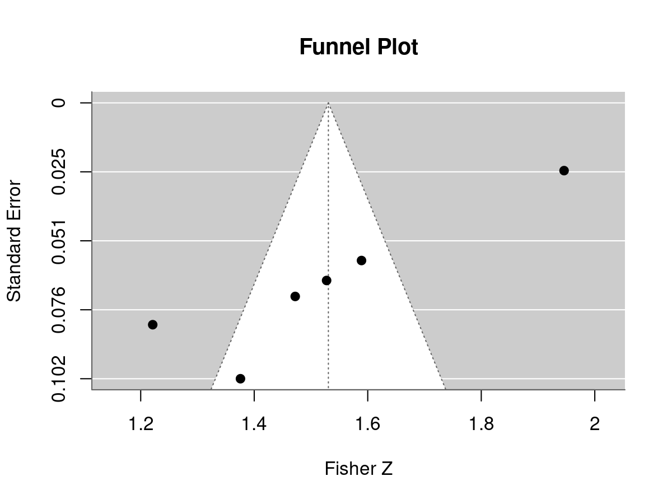 Funnel plot evaluating potential small-study effects and publication bias across included studies in the meta-analysis. Visual asymmetry was observed; however, interpretation is limited by the small number of included studies and substantial between-study heterogeneity.

Figure S2. Forest plot of IVUS-only subgroup analysis
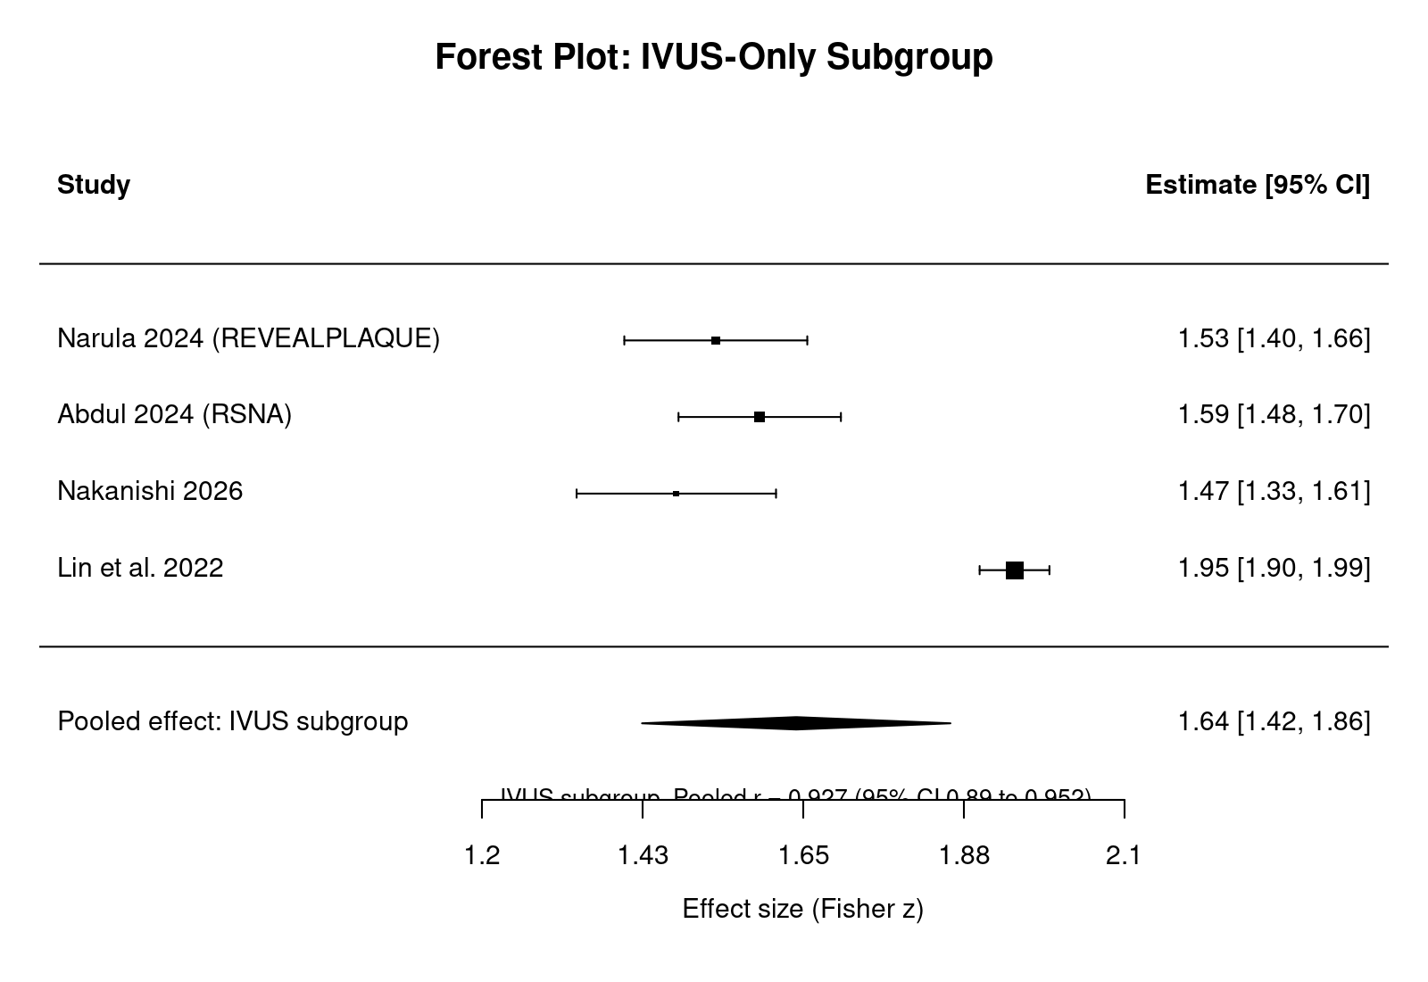Forest plot of IVUS-only subgroup analysis demonstrating pooled correlation between AI-enabled CCTA and intravascular ultrasound-based plaque quantification.

Figure S3. QUADAS-2 Summary Risk-of-Bias Assessment Across Included Studies
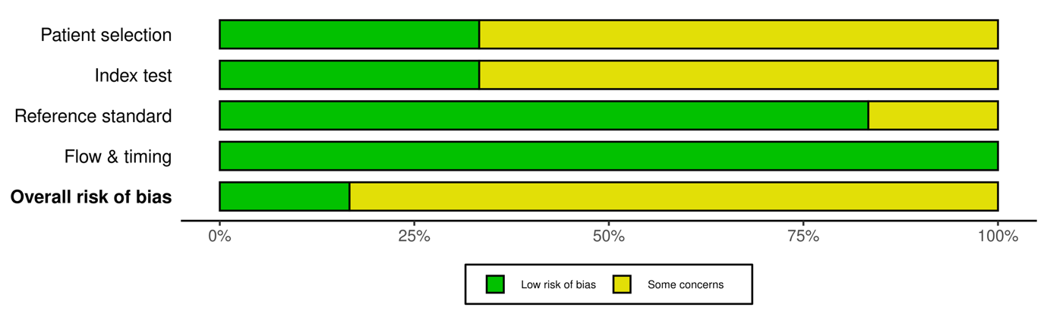
Summary plot demonstrating the proportion of studies rated as low risk or having some concerns across each QUADAS-2 domain, including patient selection, index test, reference standard, and flow and timing.

Figure S4. QUADAS-2 Traffic-Light Plot for Individual Study Risk-of-Bias Assessment
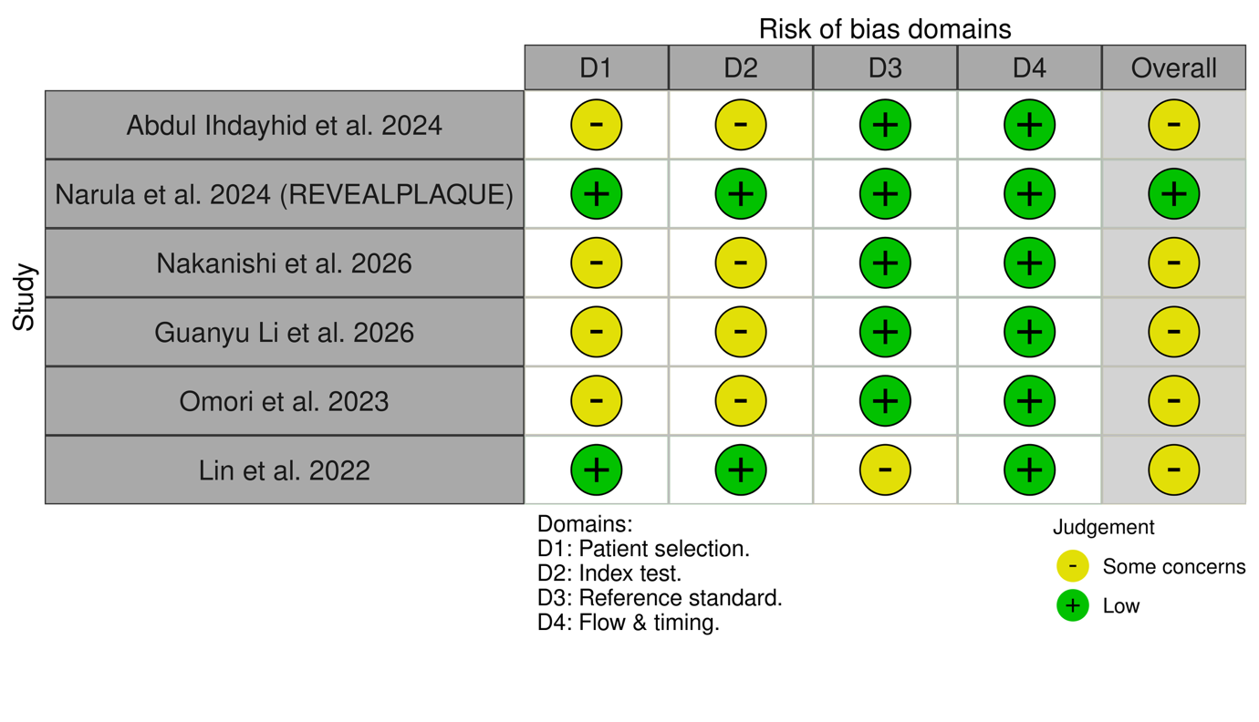
Traffic-light plot demonstrating domain-level QUADAS-2 assessments for each included study. Green indicates low risk of bias, whereas yellow indicates some concerns across the domains of patient selection, index test, reference standard, and flow and timing.

Table S1. Search Strategy
Database | Search Strategy
PubMed | ("artificial intelligence" OR "deep learning" OR "machine learning") AND ("coronary CT angiography" OR "CCTA" OR "CTA") AND ("plaque" OR "atheroma" OR "coronary stenosis") AND ("intravascular ultrasound" OR "IVUS" OR "optical coherence tomography" OR "OCT" OR "intravascular imaging")
Embase | ('artificial intelligence'/exp OR 'deep learning' OR 'machine learning') AND ('coronary computed tomography angiography'/exp OR 'CCTA' OR 'CTA') AND ('plaque' OR 'atheroma' OR 'coronary stenosis') AND ('intravascular ultrasound'/exp OR 'IVUS' OR 'optical coherence tomography' OR 'OCT')
Cochrane Library | ("artificial intelligence" OR "machine learning") AND ("coronary CT angiography" OR "CCTA") AND ("plaque" OR "atheroma") AND ("IVUS" OR "OCT" OR "intravascular imaging")
Additional sources | Manual screening of reference lists and relevant studies (n = 4)
Artificial intelligence-related and coronary imaging terms were combined using Boolean operators. Searches were conducted from database inception through March 2026. English language restriction was applied.

Table S2. Risk of Bias Assessment Using QUADAS-2
Study | Patient Selection | Index Test | Reference Standard | Flow and Timing | Overall
Abdul Ihdayhid 2024 | Some concerns | Some concerns | Low | Low | Some concerns
Narula 2024 (REVEALPLAQUE) | Low | Low | Low | Low | Low
Nakanishi 2026 | Some concerns | Some concerns | Low | Low | Some concerns
Guanyu Li 2026 | Some concerns | Some concerns | Low | Low | Some concerns
Omori 2023 | Some concerns | Some concerns | Low | Low | Some concerns
Lin et al. 2022 | Low | Low | Some concerns | Low | Some concerns

Risk of bias was assessed using the QUADAS-2 (Quality Assessment of Diagnostic Accuracy Studies-2) tool. Domains included patient selection, index test, reference standard, and flow and timing. Each domain was categorised as low risk or some concerns based on QUADAS-2 guidance and study reporting quality.

