Fig.1 Pair-wise meta-analysis of all endpoints
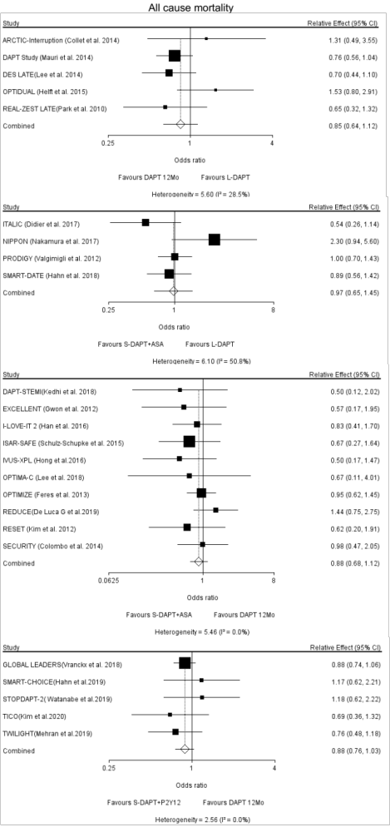
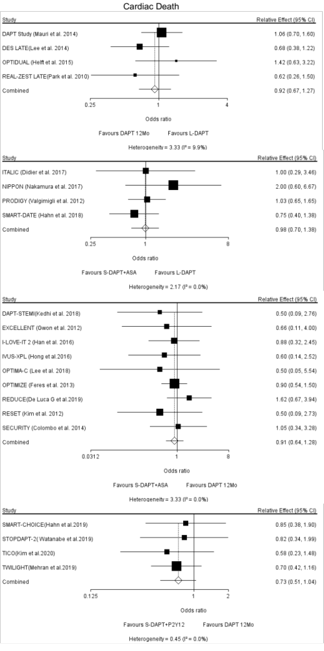
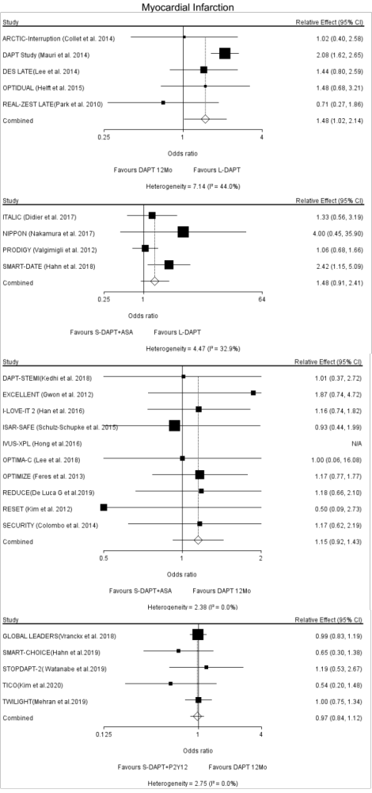
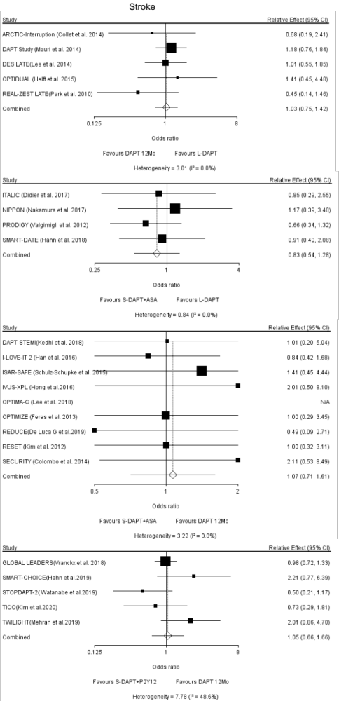
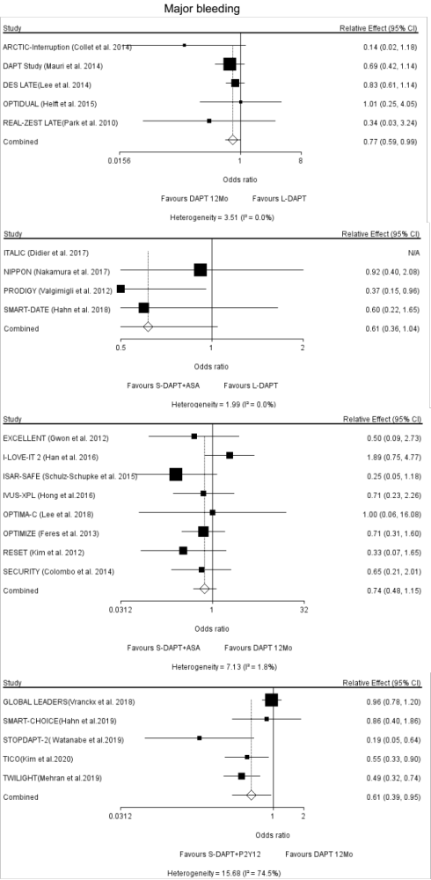
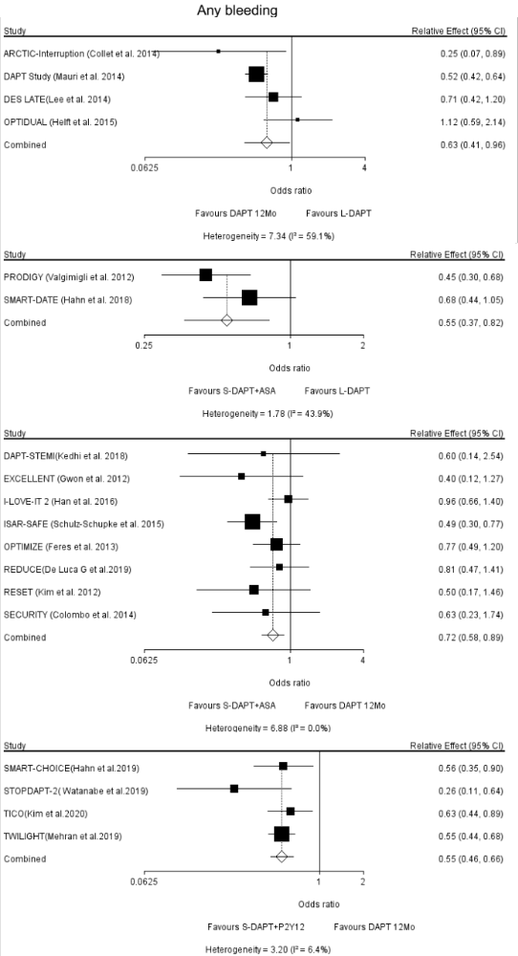
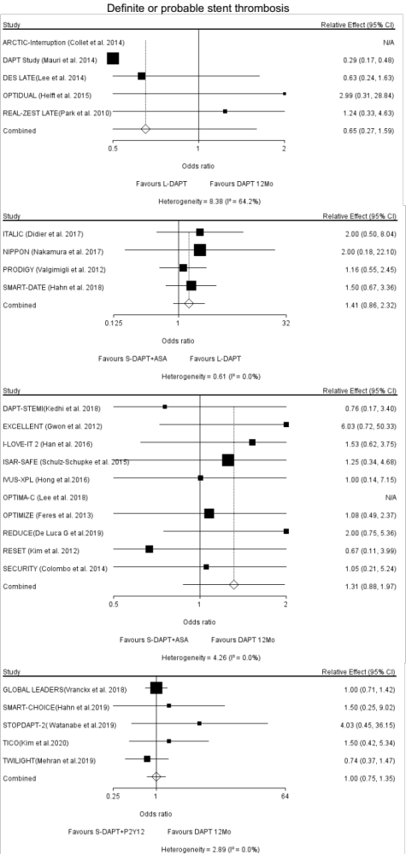
Trials | Randomization | Stent type | Follow-up | Primary endpoint | Treatment strategy
TICO [1] | At index PCI | BP-SES | 12months | Composite of major bleeding and adverse cardiac and cerebrovascular events | S-DAPT+P2Y12: ticagrelor (90 mg twice daily,12months) + aspirin (100 mg daily,3months);  DAPT 12Mo: ticagrelor (90 mg twice daily,12months) + aspirin (100 mg daily,12months)
STOPDAPT-2 [2] | At index PCI | EES | 12months | Composite of cardiovascular death, MI, definite ST, ischemic or hemorrhagic stroke, or TIMI major or minor bleeding | S-DAPT+P2Y12: aspirin (81-200mg daily dose,1months) + clopidogrel (75mg daily dose,1months) or prasugrel (3.75mg daily dose,1months) and followed by clopido-grel monotherapy for up to 5 years;  DAPT 12Mo: aspirin (81-200mg daily dose,12 months) + clopidogrel (75 mg daily dose,12months) or prasugrel (3.75 mg daily dose,12months) and followed by aspirin monotherapy for up to 5 years
TWILIGHT [3] | At 3 months after PCI | DES | 12months | The first occurrence of BARC type 2, 3, or 5 bleeding | S-DAPT+P2Y12: ticagrelor (90 mg twice daily) and aspirin (81-100 mg daily) for 3 months. Then switched saspirin to placebo for an additional 12 months along with continuation ticagrelor treatment;  DAPT 12Mo: ticagrelor (90 mg twice daily,15months) + aspirin (81-100 mg daily,15 months)
SMART-CHOICE [4] | At the index or within 3 months after the index PCI | EES/BP-SES/ZES | 12months | Composite of all-cause death, MI, or stroke | S-DAPT+P2Y12: aspirin (100mg daily dose, 3months) + clopidogrel (75 mg daily dose, indefinitely) or prasugrel (10 mg daily dose, indefinitely) or ticagrelor (90 mg twice daily, indefinitely);  DAPT 12Mo: Aspirin (100mg daily dose, indefinitely) + clopidogrel (75 mg daily dose, indefinitely) or prasugrel (10 mg daily dose, indefinitely) or ticagrelor (90 mg twice daily, indefinitely)

Table 1 Baseline characteristics of Included Trials

Trials | Randomization | Stent type | Follow-up | Primary endpoint | Treatment strategy
REDUCE [5] | At index PCI | MASCOT | 24months | Composite occurrence of all-cause death, MI, ST, stroke, TVR and bleeding | S-DAPT+ASA：Aspirin (indefinitely)+Pras-ugrel (10 mg daily dose,3months) or Ticagrelor (180 mg daily dose,3months) or Clopidogrel (75mg daily dose,3months);  DAPT 12Mo: Aspirin (indefinitely)+Prasu-grel (10 mg daily dose,12months) or Ticagrelor (180 mg daily dose,12months) or Clopidogrel (75mg daily dose,12m-onths)
GLOBAL LEADERS [6] | At index PCI | BES | 24months | Composite of all-cause death or new Q-wave MI | S-DAPT+P2Y12:75-100 mg aspirin daily in combination with 90 mg ticagrelor twice daily for 1 month, followed by 90 mg ticagrelor twice daily for 23 months;  DAPT 12Mo:75-100 mg aspirin daily in combination with either 75 mg clopidogrel daily (for patients with stable coronary artery disease) or 90 mg ticagrelor twice daily (for patients with acute coronary syndromes), followed by 75-100 mg aspirin daily for 12 months
OPTIMA-C [7] | At index PCI | BES/ZES | 12months | Composite of cardiac death, target vessel-related MI, ischemia-driven TLR | S-DAPT+ASA: aspirin (100 mg daily dose, indefinitely) + clopidogrel (75 mg daily dose, 6 months) ;  DAPT 12Mo: aspirin (100 mg daily dose, indefinitely) + clopidogrel (75 mg daily dose, 12 months)
DAPT-STEMI [8] | At 6 months after PCI | BES/EES/ZES | 24months | Composite of all-cause mortality, any MI, any revascularization, stroke, major bleeding | S-DAPT+ASA: aspirin (75-100mg daily dose, indefinitely) +Prasugrel (10 mg daily dose,6months) or Ticagrelor (90 mg twice daily,6months) or Clopidogrel (75mg daily dose,6months);  DAPT 12Mo: aspirin (75-100mg daily dose, indefinitely) + Prasugrel (10 mg daily dose,12months) or Ticagrelor (90 mg twice daily,12months) or Clopidogrel (75mg daily dose,12months)

Trials | Randomization | Stent type | Follow-up | Primary endpoint | Treatment strategy
SMART-DATE [9] | At index PCI | EES/ZES/BES | 18months | Composite of all-cause mortality, MI or stroke | S-DAPT+ASA: aspirin (100mg daily dose, indefinitely) + clopidogrel (75mg daily dose ,6months) or prasugrel (10 mg daily dose ,6months) or ticagrelor (90mg twice per day,6months);  L-DAPT: aspirin (100mg daily dose, indefinitely) + clopidogrel (75mg daily dose ,12 months or longer) or prasugrel (10 mg daily dose ,12 months or longer) or ticagrelor (90mg twice per day,12 months or longer)
NIPPON [10] | At index PCI | BES | 18months | Composite of all cause death, Q-wave or non-Q-wave MI, cerebrovascular events, and major bleeding events | L-DAPT: aspirin (81-162mg daily dose, indefinitely) + clopidogrel (75mg daily dose,18 months) /ticlopidine (200mg daily dose,18months);  S-DAPT+ASA: aspirin (81-162mg daily dose, indefinitely) + clopidogrel (75mg daily dose,6 months) /ticlopidine (200mg daily dose,6 months).
IVUS-XPL [11] | At index PCI | EES | 12months | Composite of cardiac death, MI, stroke, or TIMI major bleeding | S-DAPT+ASA: aspirin (100 mg daily dose, indefinitely) + clopidogrel (75 mg daily dose, 6 months);  DAPT 12Mo: aspirin (100 mg daily dose, indefinitely) + clopidogrel (75 mg daily dose, 12 months)
OPTIDUAL[12] | 12±3 months after PCI | SES/PES/ZES/ EES | 36months | Composite of all-cause mortality, non-fatal MI, stroke, or major bleeding | L-DAPT: aspirin (75-160mg daily dose, indefinitely) + clopidogrel (75mg daily dose,48 months);  DAPT 12Mo: aspirin (75-160mg daily dose, indefinitely) + clopidogrel (75mg daily dose,12months)
I-LOVE-IT 2 [13] | At index PCI | BP-SES | 18months | Composite of cardiac death, target vessel MI, or clinically indicated TLV | S-DAPT+ASA: aspirin (100 mg daily dose, indefinitely) + clopidogrel (75 mg daily dose, 6 months);  DAPT 12Mo: aspirin (100 mg daily dose, indefinitely) + clopidogrel (75 mg daily dose, 12 months)

Trials | Randomization | Stent type | Follow-up | Primary endpoint | Treatment strategy
ISAR-SAFE [14] | At 6 (-1/+2) months after DES implantation | PES/SES/EES/ ZES/BES/BMS | 15months | Composite of death, myocardial infarction, ST (definite or probable), stroke, or thrombolysis in MI major bleeding | S-DAPT+ASA: aspirin (81-200mg daily dose, indefinitely) +clopidogrel (75 mg daily dose, 6 months) and clopidogrel was swithched to placebo after 6 months;  DAPT 12Mo: aspirin (81-200 mg daily dose, indefinitely) + clopidogrel (75 mg daily dose, 12months)
ITALIC [15] | 6 months after PCI | EES | 24months | Composite of all-cause mortality, MI, TVR, stroke, or major bleeding according to the TIMI criteria | S-DAPT+ASA: aspirin (indefinitely) + clopidogrel (75mg daily dose, 6 months) or prasugrel (10mg daily dose, 6 months) or ticagrelor (90mg twice per day, 6months);  L-DAPT: aspirin (indefinitely) + clopid-ogrel (75mg daily dose,24 months) or prasugrel (10mg daily dose,24months) or ticagrelor (90mg twice per day,24 months)
DAPT Study [16] | 12 months after PCI | EES/PES/ZES/ SES | 33months | Composite of definite or probable ST and of major adverse cardiovascular and cerebrovascular events | L-DAPT: aspirin (75-162mg daily dose, indefinitely) + clopidogrel (75mg daily dose, 30months) or prasugrel (10 or 5 mg daily dose,30months);  DAPT 12Mo: Aspirin (75-162mg daily dose, indefinitely) + clopidogrel (75 mg daily dose, 12 months) or prasugrel (10 or 5mg daily dose, 12 months) continued by placebo
DES LATE [17] | 12 to 18 months after PCI | SES/PES/ZES/ EES/others | Median length of follow-up was 42.0 months (interquartile range, 24.7-50.7 months) | Composite of death resulting from cardiac causes, MI, or stroke 24 months after randomization. | DAPT 12Mo: aspirin (100-200mg daily dose, indefinitely) + clopidogrel (75mg daily dose,12 months);  L-DAPT: aspirin (100-200mg daily dose, indefinitely) + clopidogrel (75mg daily dose, 36 months)

Trials | Randomization | Stent type | Follow-up | Primary endpoint | Treatment strategy
SECURITY [18] | At index PCI | BES/EES/ZES | 24months | Composite of cardiac death, MI, stroke, definite or probable stent thrombosis, or BARC criteria type 3 or 5 bleeding | S-DAPT+ASA: aspirin (indefinitely) + clopidogrel (75 mg daily dose, 6 months);  DAPT 12Mo: aspirin (indefinitely) +clopidogrel (75 mg daily dose, 12 months)
ARCTIC-Interruption [19] | 12 months after PCI | First or second-generation DES | Median duration of follow-up was 17 months (interquartile range,15 to 18) | Composite of death, myocardial infarction, stent thrombosis, stroke, or urgent revascularisation | L-DAPT: aspirin (indefinitely) + clopidogrel (75-150mg daily dose, 18-30months) or purasugrel (10 mg daily dose, 18-30months);  DAPT12Mo: aspirin (indefinitely) + clopidogrel (75-150mg daily dose, 12months) or purasugrel (10 mg daily dose, 12months)
OPTIMIZE [20] | At index PCI | ZES | 12months | Composite of all-cause mortality, MI, stroke, or major bleeding | S-DAPT+ASA: aspirin (100-200mg daily dose, indefinitely) + clopidogrel (75 mg daily dose,3 months);  DAPT 12Mo: aspirin (100-200mg daily dose,indefinitely) + clopidogrel (75 mg daily dose, 12 months)
PRODIGY [21] | 30±􏰃5 days after PCI | EES/PES/ZES/ BMS | 24months | Composite of death of any cause, MI, or cerebrovascular accident | L-DAPT: aspirin (80-160mg daily dose, indefinitely) + clopidogrel (75 mg daily dose, 24 months);  S-DAPT+ASA: aspirin (80-160mg daily dose, indefinitely) + clopidogrel (75 mg daily dose, 6 months)
RESET [22] | At index PCI | ZES/SES/EES | 12months | Composite of death from cardiovascular cause, MI, ST, ischemia-driven TVR, or bleeding | S-DAPT+ASA: aspirin (100mg daily dose, indefinitely) + clopidogrel (75 mg daily dose,3months);  DAPT 12Mo: aspirin (100mg daily dose, indefinitely) + clopidogrel (75 mg daily dose,12months)

Trials | Randomization | Stent type | Follow-up | Primary endpoint | Treatment strategy
EXCELLENT [23] | At index PCI | EES/SES | 12months | Composite of cardiac death, MI, or TVR | S-DAPT+ASA: aspirin (100-200mg daily dose, 12months) + clopidogrel (75 mg daily dose,6 months);  DAPT12Mo: aspirin (100-200mg daily dose, 12months) + clopidogrel (75 mg daily dose, 12 months)
REAL-ZEST LATE [24] | 12 months after PCI | SES/PES/ZES/ other | Median duration of follow-up was 19.2 months (interquartile range, 13.2 to 24.1) | The first occurrence of MI or death from cardiac causes after assignment to a treatment group | L-DAPT: aspirin (100-200mg daily dose, indefinitely) + clopidogrel (75 mg daily dose, 36months);  DAPT 12Mo: aspirin (100-200mg daily dose, indefinitely) + clopidogrel (75 mg daily dose,12 months)

PCI, percutaneous coronary intervention; MI, myocardial infarction; ST, stent thrombosis; DAPT, dual antiplatelet therapy; L-DAPT, longer than 12 months DAPT; DAPT 12Mo,12 months DAPT; S-DAPT+ASA, shorter than 6-month DAPT followed by aspirin monotherapy; S-DAPT+P2Y12, shorter than 6-month DAPT followed by a P2Y12 receptor inhibitor monotherapy; TIMI, thrombolysis in MI; BARC, Bleeding Academic Research Consortium; BES, biolimus-eluting stent ; ZES, zotarolimus-eluting stent; BP-SES, biodegradable polymer sirolimus-eluting stent; EES, everolimus-eluting stent; PES, paclitaxel-eluting stent; SES, sirolimus-eluting stent; MASCOT, The Multinational Abluminal Sirolimus Coated Bio-engineered Stent ;TLR, target lesion revascularization; TVR, target vessel revascularization; NSTEMI, non-ST elevation myocardial infarction; STEMI, ST elevation myocardial infarction;

Characteristics | TICO [1] |  | STOPDAPT-2 [2] |  | TWILIGHT [3] |  | SMART-CHOICE [4]
Characteristics | S-DAPT+  P2Y12 | DAPT 12Mo | S-DAPT+  P2Y12 | DAPT 12Mo | S-DAPT+  P2Y12 | DAPT 12Mo | S-DAPT+  P2Y12 | DAPT 12Mo
No. of participants | 1527 | 1529 | 1500 | 1509 | 3555 | 3564 | 1495 | 1498
Age, mean(SD), years | 61 (11) | 61 (11) | 68.1 (10.9) | 69.1 (10.4) | 65.2±10.3 | 65.1±10.4 | 64.6 (10.7) | 64.4 (10.7)
Male, n/ total (%) | 1204(79) | 1224(80) | 1183 (78.9) | 1154 (76.5) | 2709(76.2) | 2712(76.1) | 1087 (72.7) | 1111 (74.2)
BMI, mean(SD), kg/m² | 24.9 (3.2) | 24.9 (3.3) | 24.4 (3.5) | 24.2 (3.5) | 28.6±5.5 | 28.5±5.6 | 24.5 (3.1) | 24.7 (3.2)
Cardiovascular risk factors, n/total (%)
Hypertension | 760 (50) | 781 (51) | 1105 (73.7) | 1116 (74.0) | 2580 (72.6) | 2574 (72.2) | 921 (61.6) | 919 (61.3)
Diabetes | 418 (27) | 417 (27) | 585 (39.0) | 574 (38.0) | 1319(37.1) | 1301(36.5) | 570 (38.2) | 552 (36.8)
Dyslipidemia | 924 (61) | 922 (60) | 1116 (74.4) | 1128 (74.8) | 2157 (60.7) | 2146 (60.2) | 673 (45.1) | 679 (45.5)
Current smoker | 555 (36) | 587 (38) | 399 (26.6) | 311 (20.6) | 726 (20.4) | 822 (23.1) | 424 (28.4) | 367 (24.5)
History, n/ total (%)
MI | 64 (4) | 49 (3) | 207 (13.8) | 199 (13.2) | 1020(28.7) | 1020(28.6) | 62 (4.1) | 65 (4.3)
PCI | 135 (9) | 127 (8) | 503 (33.5) | 529 (35.1) | 1502 (42.3) | 1496 (42.0) | 172 (11.5) | 177 (11.8)
Coronary artery bypass graft | 8 (1) | 10 (1) | 17 (1.1) | 42 (2.8) | 362 (10.2) | 348 (9.8) | NA | NA
Stroke | 60 (4) | 66 (4) | 81 (5.4) | 105 (7.0) | NA | NA | 99 (6.6) | 102 (6.8)
Clinical presenta-tion, n/ total (%)
Stable angina | NA | NA | 935 (62.3) | 926 (61.4) | 1047 (29.5) | 999 (28.0) | 625 (41.8) | 625 (41.8)
UA | 442 (29) | 484 (32) | 193 (12.9) | 214 (14.2) | 1249 (35.1) | 1245(34.9) | 467 (31.2) | 491 (32.8)
NSTEMA | 539 (35) | 488 (32) | 81 (5.4) | 99 (6.6) | 1024 (28.8) | 1096 (30.8) | 239 (16.0) | 230 (15.4)
STEMA | 546 (36) | 557 (36) | 291 (19.4) | 270 (17.9) | NA | NA | 164 (11.0) | 150 (10.0)
Target lesion site, n (%)
Left main | 49 (3) | 45 (2) | 43 (2.9) | 37 (2.5) | 166 (4.7) | 187 (5.2) | 23 (1.2) | 35 (1.9)
Left anterior des-cending artery | 912 (48) | 909 (48) | 828 (55.2) | 854 (56.6) | 1993 (56.1) | 2010 (56.4) | 903 (48.8) | 950 (50.4)
Left circumflex artery | 358 (19) | 353 (19) | 268 (17.9) | 305 (20.2) | 1151 (32.4) | 1146 (32.2) | 399 (21.6) | 376 (19.9)
Right coronary artery | 565 (30) | 588 (31) | 436 (29.1) | 410 (27.2) | 1243 (35.0) | 1257 (35.3) | 524 (28.3) | 524 (27.8)
Table 2 Baseline characteristics of participants

Characteristics |  | REDUCE [5] |  | GLOBAL LEADERS [6] |  | OPTIMA-C [7] |  | DAPT-STEMI [8]
 |  | S-DAPT+  ASA | DAPT 12Mo | S-DAPT+  P2Y12 | DAPT 12Mo | S-DAPT+  ASA | DAPT 12Mo | S-DAPT+  ASA | DAPT 12Mo
 | No. of participants | 751 | 745 | 7980 | 7988 | 683 | 684 | 433 | 437
 | Age, mean(SD), years | 61.0 | 60.0 | 64.5(10.3) | 64.6(10.3) | 62.8±10.8 | 64.4±10.3 | 59.8±10.7 | 60.2±10.3
 | Male, n/ total (%) | 620(82.6) | 576(77.3) | 6115 (76.6) | 6139(76.9) | 478 (70.0) | 464 (67.8) | 337 (78) | 332 (76)
 | BMI, mean(SD), kg/m² | 26.6 | 26.6 | 28.2 (4.6) | 28.2 (4.6) | NA | NA | 27.8±4.3 | 27.9±4.5
 | Cardiovascular risk factors, n/total (%)
 | Hypertension | 379(50.7) | 375(50.7) | 5882(74.0) | 5833(73.3) | 426 (62.4) | 437 (63.9) | 193 (45) | 195(45)
 | Diabetes | 162(21.6) | 145(19.5) | 2049(25.7) | 1989(24.9) | 199 (29.1) | 203 (29.7) | 54 (13) | 61(14)
 | Dyslipidemia | 346(46.3) | 333(44.9) | 5345(69.3) | 5423(70.0) | 204 (29.9) | 195 (28.5) | 120 (28) | 125(29)
 | Current smoker | 313(42.1) | 314(42.7) | 2066(25.9) | 2103(26.3) | 184 (26.9) | 184 (26.9) | 218(51) | 205(47)
 | History, n/ total (%)
 | MI | NA | NA | 1831(23.0) | 1879(23.6) | 18 (2.6) | 25 (3.7) | 26 (6) | 20(5)
 | PCI | 88(11.7) | 73(9.8) | 2609 (32.7) | 2612(32.7) | 59 (8.6) | 71 (10.4) | 29 (7) | 18(4)
 | Coronary artery bypass graft | 21(2.8) | 21(2.8) | 448(5.6) | 495(6.2) | NA | NA | 8 (2) | 2(0.5)
 | Stroke | 11(1.5) | 15(2.0) | 210(2.6) | 211(2.6) | NA | NA | 14 (3) | 8(2)
 | Clinical presenta-tion, n/ total (%)
 | Stable angina | NA | NA | 4230(53.0) | 4251(53.2) | 339 (49.6) | 336 (49.1) | NA | NA
 | UA | 114(15.2) | 103(13.8) | 1004(12.6) | 1018(12.7) | 254 (37.2) | 253 (37.0) | NA | NA
 | NSTEMA | 267(35.6) | 305(41.0) | 1684(21.1) | 1689(21.1) | 90 (13.2) | 95 (13.9) | NA | NA
 | STEMA | 370 (49.3) | 336(45.2) | 1062(13.3) | 1030(12.9) | NA | NA | NA | NA
 | Target lesion site, n (%)
 | Left main | NA | NA | 197(1.9) | 190 (1.8) | NA | NA | NA | NA
 | Left anterior des-cending artery | 360(48) | 329(44.2) | 4283(41.2) | 4383 (42.0) | 394(57.7) | 353(51.6) | 169 (39) | 188(43)
 | Left circumflex artery | 146 (19.5) | 164(22.0) | 2524(24.3) | 2553 (24.5) | 134(19.6) | 165(24.1) | 89 (21) | 70(16)
 | Right coronary artery | 234(31.2) | 246(33.0) | 3284 (31.6) | 3206 (30.7) | 155(22.7) | 166(24.3) | 175 (41) | 179(41)

Characteristics |  | SMART-DATE [9] |  | NIPPON [10] |  | IVUS-XPL [11] |  | OPTIDUAL [12]
 |  | S-DAPT+  ASA | L-  DAPT | L-DAPT | S-DAPT+  ASA | S-DAPT+  ASA | DAPT 12Mo | L-DAPT | DAPT 12Mo
 | No. of participants | 1357 | 1355 | 1653 | 1654 | 699 | 701 | 695 | 690
 | Age, mean(SD), years | 62(54-71) | 63(53-71) | 67.2±9.9 | 67.4±9.6 | 63±9 | 64±9 | 64.1±10.8 | 64.2 ±11.5
 | Male, n/ total (%) | 1016(74.9) | 1028 (75.9) | 1312(79.4) | 1,304(78.8) | 470(67) | 494(70) | 568(81.7) | 547(79.3)
 | BMI, mean(SD), kg/m² | 24.3(3.2) | 24.5(3.1) | 24.3±3.5 | 24.5±3.5 | 24.8±3.1 | 24.6±3.0 | NA | NA
 | Cardiovascular risk factors, n/total (%)
 | Hypertension | 669(49.9) | 654(48.7) | 1209 (73.1) | 1177(71.2) | 443(63) | 455(65) | 396(57.0) | 417(60.4)
 | Diabetes | 365(26.9) | 379(28.1) | 635(38.4) | 619(37.4) | 249(36) | 257(37) | 213(30.6) | 222(32.2)
 | Dyslipidemia | 322(24.2) | 336(25.2) | 1132(68.5) | 1130(68.3) | 473(68) | 456(65) | NA | NA
 | Current smoker | 506(38.0) | 536(40.1) | 997(60.3) | 960(58.0) | 171(25) | 165(24) | 425(61.2) | 399(57.8)
 | History, n/ total (%)
 | MI | 30(2.3) | 23(1.7) | 195(11.8) | 201(12.2) | 34(5) | 29(4) | 119(17.1) | 122(17.7)
 | PCI | 65(4.9) | 73(9.8) | 432(26.1) | 413(25.0) | 72(10) | 73(10) | 180(25.9) | 186(27.0)
 | Coronary artery bypass graft | NA | NA | 29(1.8) | 22(1.3) | 22(3) | 14(2) | 37(5.3) | 35(5.1)
 | Stroke | 52(3.9) | 58(4.4) | 41(2.5) | 48(2.9) | NA | NA | 29(4.2) | 25(3.6)
 | Clinical presenta-tion, n/ total (%)
 | Stable angina | NA | NA | 734(44.4) | 805(48.7) | 356(51) | 358(51) | 240(34.5) | 207(30.0)
 | UA | 420 (31.0) | 416(30.7) | 330(20.0) | 296(17.9) | 237(34) | 231(31) | 66(9.5) | 63(9.1)
 | NSTEMA | 428 (31.5) | 425(31.4) | 26(1.6) | 33(2.0) | NA | NA | 99(14.2) | 117(17.0)
 | STEMA | 509 (37.5) | 514(37.9) | 196(11.9) | 198(12.0) | NA | NA | 74(10.7) | 82(11.9)
 | Target lesion site, n (%)
 | Left main | 29(2.1) | 17(1.3) | 16(0.8) | 7(0.4) | NA | NA | 4(<1) | 2(<1)
 | Left anterior des-cending artery | 767(56.6) | 826(61.0) | 998(52.4) | 981(51.8) | 518(55) | 530(56) | 397(57) | 443(64)
 | Left circumflex artery | 331(24.4) | 340(25.1) | 374(19.7) | 381(20.1) | 187(20) | 175(18) | 225(32) | 214(31)
 | Right coronary artery | 504(37.2) | 490(36.2) | 515(27.1) | 524(27.7) | 239(25) | 245(26) | 280 (40) | 268(39)

Characteristics |  | I-LOVE-IT 2 [13] |  | ISAR-SAFE [14] |  | ITALIC [15] |  | DAPT Study [16]
 |  | S-DAPT+  ASA | DAPT 12Mo | S-DAPT+  ASA | DAPT 12Mo | S-DAPT+  ASA | L-DAPT | L-DAPT | DAPT 12Mo
 | No. of participants | 909 | 920 | 1997 | 2003 | 926 | 924 | 5020 | 4941
 | Age, mean(SD), years | 60.4±10.2 | 60.0±10.0 | 67.2(59.3–73.3) | 67.2(59.1–73.7) | 61.6±10.9 | 61.5±11.2 | 61.8±10.2 | 61.6±10.1
 | Male, n/ total (%) | 611(67.2) | 632(68.7) | 1611(80.7) | 1612(80.5) | 750(81.0) | 733(79.3) | 3778(75.3) | 3657(74.0)
 | BMI, mean(SD), kg/m² | 25.1±3.1 | 25.1±3.1 | 27.2(24.9–30.1) | 27.5(24.9–30.4) | 27.0±4.6 | 227.1±4.7 | 30.5±5.8 | 30.6±5.8
 | Cardiovascular risk factors, n/total (%)
 | Hypertension | 554(61.0) | 596(64.8) | 1797(90.1) | 1830(91.5) | 603(65.1) | 594(64.3) | 3796(75.8) | 3649(74.0)
 | Diabetes | 211(23.2) | 203(22.1) | 495(24.8) | 484(24.2) | 336(36.3) | 349(37.8) | 1556(31.1) | 1481(30.1)
 | Dyslipidemia | 230(25.3) | 215(23.4) | 1747(87.5) | 1748(87.4) | 625(67.5) | 618(66.9) | NA | NA
 | Current smoker | 333(36.6) | 5352(38.3) | 292(14.6) | 306(15.3) | 473(51.1) | 487(52.7) | 1222(24.62) | 1210(24.7)
 | History, n/ total (%)
 | MI | 156(17.2) | 145(15.8) | 516(25.9) | 491(24.5) | 144(15.6) | 138(14.9) | 1092(22.0) | 1026(21.1)
 | PCI | 77(8.5) | 60(6.5) | NA | NA | 226(24.4) | 209(22.6) | 1518(30.4) | 1529(31.0)
 | Coronary artery bypass graft | 4(0.4) | 4(0.4) | 152(7.7) | 149(7.5) | 61(6.6) | 45(4.9) | 568(11.3) | 581(11.8)
 | Stroke | 84(9.2) | 87(9.5) | NA | NA | 28(3.0) | 26(2.8) | 155(3.1) | 169(3.4)
 | Clinical presenta-tion, n/ total (%)
 | Stable angina | 130(14.3) | 139(15.1) | 969(48.6) | 956(47.8) | 382(41.3) | 383(41.5) | 1882(37.5) | 1870(37.8)
 | UA | 527(58.0) | 520(56.5) | 429(21.5) | 438(21.9) | 188(20.3) | 186(20.1) | 838(16.7) | 825(16.7)
 | NSTEMA | 103(11.3) | 98(10.7) | 207(10.4) | 203(10.1) | 145(15.7) | 152(16.5) | 776(15.5) | 767(15.5)
 | STEMA | 122(13.4) | 126(13.7) | 158(7.9) | 166(8.3) | 67(7.2) | 68(7.4) | 534(10.6) | 511(10.3)
 | Target lesion site, n (%)
 | Left main | 23(1.9) | 21(1.7) | 9(0.5) | 3(0.2) | 14(1.5) | 8(0.9) | 55(0.8) | 55(0.9)
 | Left anterior des-cending artery | 569(45.9) | 569(45.3) | 794(39.8) | 812(40.6) | 669(73.4) | 658(72.3) | 2715(41.2) | 2586(40.4)
 | Left circumflex artery | 284(22.9) | 279(22.2) | 528(26.4) | 480(24.0) | 456(50.0) | 436(47.9) | 1473(22.4) | 1506(23.5)
 | Right coronary artery | 364(29.4) | 386(30.8) | 636(31.8) | 682(34.0) | 489(53.6) | 474(52.1) | 2153(32.7) | 2057(32.1)

Characteristics |  | DES LATE [17] |  | SECURITY [18] |  | ARCTIC-Interruption[19] |  | OPTIMIZE [20]
 |  | DAPT 12Mo | L-DAPT | S-DAPT+  ASA | DAPT 12Mo | L-DAPT | DAPT 12Mo | S-DAPT+  ASA | DAPT 12Mo
 | No. of participants | 2514 | 2531 | 682 | 717 | 636 | 624 | 1563 | 1556
 | Age, mean(SD), years | 62.3±10.1 | 62.5±10.0 | 64.9±10.2 | 65.5±10.1 | 64(57–73) | 64(57–73) | 61.3(10.4) | 61.9(10.6)
 | Male, n/ total (%) | 1749(69.6) | 1749(69.1) | 529(77.6) | 551(76.8) | 508(80) | 503(81) | 992(63.5) | 982(63.1)
 | BMI, mean(SD), kg/m² | NA | NA | NA | NA | 27(25-29) | 27(25-30) | NA | NA
 | Cardiovascular risk factors, n/total (%)
 | Hypertension | 1423(56.6) | 1479(58.4) | 508(74.5) | 510(71.1) | 376(59) | 388(62) | 1350(86.4) | 1371(88.2)
 | Diabetes | 709(28.2) | 709(28.0) | 206(30.4) | 223(31.7) | 222(36) | 349(37.8) | 554(35.4) | 549(35.3)
 | Dyslipidemia | NA | NA | 446(65.4) | 436(60.8) | 428(67) | 426(68) | 953(63.2) | 952(63.7)
 | Current smoker | 722(28.7) | 693(27.4) | 139(20.5) | 172(24.4) | 147(23) | 152(24) | 290(18.6) | 269(17.3)
 | History, n/ total (%)
 | MI | 92(3.7) | 103(4.1) | 145(21.2) | 144(20.1) | 197(31) | 186(30) | 541(34.6) | 542(34.8)
 | PCI | 276(11.0) | 313(12.4) | 132(19.4) | 116(16.2) | 273(43) | 249(40) | 327(20.9) | 297(19.1)
 | Coronary artery bypass graft | NA | NA | 38(5.6) | 39(5.4) | 47(7) | 35(6) | 111(7.1) | 128(8.2)
 | Stroke | 89(3.5) | 15(4.5) | NA | NA | 28(4) | 38(6) | NA | NA
 | Clinical presenta-tion, n/ total (%)
 | Stable angina | 956(38.0) | 1011(39.9) | 341(61.6) | 368(61.6) | NA | NA | 935(59.8) | 911(58.6)
 | UA | 971(38.6) | 930(36.7) | 213(38.4) | 229(38.4) | NA | NA | NA | NA
 | NSTEMA | 266(10.6) | 268(10.6) | NA | NA | NA | NA | 84(5.4) | 84(5.4)
 | STEMA | 314(12.5) | 314(12.4) | NA | NA | NA | NA | NA | NA
 | Target lesion site, n (%)
 | Left main | 90(2.6) | 112(3.1) | NA | NA | 18(3) | 23(4) | 24(1.2) | 30(1.5)
 | Left anterior des-cending artery | 1768(50.6) | 1781(49.5) | 402(43) | 423(44) | 342(54) | 325(52) | 986(47.9) | 960(46.6)
 | Left circumflex artery | 651(18.6) | 715(19.9) | 133(14.3) | 137(14.2) | 209(33) | 181(29) | 481(23.4) | 501(24.3)
 | Right coronary artery | 972(27.8) | 976(27.1) | 206(22) | 207(21.6) | 191(30) | 222(36) | 567(27.6) | 571(27.7)

Characteristics |  | PRODIGY [21] |  | RESET [22] |  | EXCELLENT [23] |  | REAL-ZEST LATE [24]
 |  | L-DAPT | S-DAPT+  ASA | S-DAPT+  ASA | DAPT 12Mo | S-DAPT+  ASA | DAPT 12Mo | L-DAPT | DAPT 12Mo
 | No. of participants | 987 | 983 | 1059 | 1058 | 722 | 721 | 1357 | 1344
 | Age, mean(SD), years | 67.8±11 | 67.9±11 | 62.4±9.4 | 62.4±9.8 | 63.0±9.6 | 62.4±10.4 | 62.0±9.8 | 61.9±9.9
 | Male, n/ total (%) | 764(77.4) | 747(76.0) | 682(64.4) | 665(62.9) | 470(65.1) | 461(63.9) | 950(70.0) | 933(69.4)
 | BMI, mean(SD), kg/m² | 26.6 | 26.7 | 25.0±3.2 | 24.9±3.1 | 24.9±3.1 | 25.1±3.0 | NA | NA
 | Cardiovascular risk factors, n/total (%)
 | Hypertension | 721(73.0) | 693(70.4) | 660(62.3) | 650(61.4) | 525(72.7) | 532(73.8) | 775(57.1) | 765(56.9)
 | Diabetes | 244(24.7) | 233(23.7) | 316(29.8) | 305(28.8) | 272(37.7) | 278(38.6) | 340(25.1) | 364(27.1)
 | Dyslipidemia | 553(56.0) | 525(53.4) | 611(57.7) | 634(59.9) | 543(75.2) | 550(76.3) | 586(43.2) | 584(43.5)
 | Current smoker | 222(22.5) | 247(25.1) | 267(25.2) | 241(22.8) | 198(27.4) | 186(25.8) | 404(29.8) | 431(32.1)
 | History, n/ total (%)
 | MI | 270(27.3) | 258(26.2) | 19(1.8) | 17(1.6) | 47(6.5) | 27(3.7) | 51(3.8) | 45(3.3)
 | PCI | 184(18.6) | 174(17.7) | 37(3.5) | 32(3.0) | 67(9.3) | 62(8.6) | 177(13.0) | 159(11.8)
 | Coronary artery bypass graft | 110(11.1) | 105(10.7) | 2(0.2) | 6(0.6) | 11(1.5) | 7(1.0) | NA | NA
 | Stroke | 37(3.7) | 39(4.0) | NA | NA | NA | NA | 57(4.2) | 45(3.3)
 | Clinical presenta-tion, n/ total (%)
 | Stable angina | 257(26.0) | 250(25.4) | 471(44.5) | 490(46.3) | 353(48.9) | 346(48.0) | 514(37.9) | 514(37.9)
 | UA | 183(18.5) | 182(18.5) | 432(40.8) | 422(39.9) | NA | NA | 514(37.9) | 514(37.9)
 | NSTEMA | 226(22.9) | 224(22.8) | NA | NA | NA | NA | 514(37.9) | 144(10.7)
 | STEMA | 321(32.5) | 327(33.3) | NA | NA | 19(2.6) | 26(3.6) | 155(11.4) | 141(10.5)
 | Target lesion site, n (%)
 | Left main | 55(5.6) | 56(5.7) | NA | NA | NA | NA | 55(2.9) | 44(2.4)
 | Left anterior des-cending artery | 518(52.5) | 518 (52.7) | 707(52.7) | 722(53.6) | 452(63.0) | 447(62.2) | 912(48.7) | 921(49.9)
 | Left circumflex artery | 321(32.5) | 318(32.4) | 281(21.0) | 259(19.2) | NA | NA | 921(49.9) | 334(18.1)
 | Right coronary artery | 346(35.1) | 363(36.9) | 353(26.3) | 365(27.1) | NA | NA | 334(18.1) | 546(29.6)
NA, the concrete information was not available; PCI, percutaneous coronary intervention; MI, myocardial infarction; ST, stent thrombosis; DAPT, dual antiplatelet therapy; L-DAPT, longer than 12 months DAPT; DAPT 12Mo,12 months DAPT; S-DAPT+ASA, shorter than 6-month DAPT followed by aspirin monotherapy; S-DAPT+P2Y12, shorter than 6-month DAPT followed by a P2Y12 receptor inhibitor monotherapy; BMI, body mass index (calculated as the weight in kilograms divided by height in meters); NSTEMI, non-ST elevation myocardial infarction; STEMI, ST elevation myocardial infarction; UA, unstable angina; SD, standard deviation.
Table 3 Definitions of clinical endpoints of the included RCTs
Trials | Cardiac death | MI | Definite or probable ST | Major Bleeding | Any Bleeding | Stroke
TICO [1] | Death due to MI, cardiac perforation or pericardial tamponade, an arrhythmia or conduction abnormality, stroke within 30 days of the procedure or related to the procedure, death due to a procedural. | Symptoms, electrocardiographic changes, or abnormal imaging findings, combined with a CK-MB fraction above the upper normal limits or a troponin T or troponin I level greater than the 99th percentile of the upper normal limit. | ARC criteria | TIMI major bleeding | TIMI minor or major | An acute cerebrovascular event that caused death, a neurological deficit lasting more than 24 hours, or an acute infarction shown by imaging studies.
STOPDAPT-2 [2] | All deaths are considered cardiovascular deaths unless a definite non-cardiovascular cause can be established. | ARC criteria | ARC criteria | TIMI major bleeding | TIMI major or minor bleeding | Acute onset of a neurological deficit that persists for at least 24 hours and is the result of a disturbance of the cerebral circulation due to ischemia or hemorrhage.
TWILIGHT [3] | Any death due to proximate cardiac cause, unwitnessed death and death of unknown cause, all procedure-related deaths including those related to concomitant treatment. | Third universal definition | ARC criteria | BARC criteria type 3 or 5 | BARC criteria type 2, 3 or 5 | Acute symptomatic episode of neurological dysfunction, more than 24 hours in duration in the absence of therapeutic intervention or death, due to cerebral, spinal or retinal tissue injury as evidenced by neuroimaging or lumbar puncture.
SMART-CHOICE [4] | All deaths were considered cardiac unless a definite non-cardiac cause could be established. | Elevated cardiac enzyme levels above the upper reference limit with ischemic symptoms or electrocardiographic findings indicative of ischemia. | ARC criteria | BARC criteria type 3,4 or 5 bleeding | BARC criteria type 2 to 5 bleeding | any nonconvulsive focal or global neurologic deficit of abrupt onset lasting for more than 24 hours or leading to death, which was caused by ischemia or hemorrhage within the brain.
REDUCE [5] | All deaths are considered cardiovascular deaths unless a definite non-cardiovascular cause can be established. | Third universal definition of MI | ARC Criteria | NA | BARC criteria type 2, 3 or 5 | NA
GLOBAL LEADERS [6] | All deaths were considered cardiac unless a definite non-cardiac cause could be established. | Third universal MI definition | ARC criteria | BARC criteria type 3 or 5 | BARC criteria type 2, 3 or 5 | Non-convulsive focal or global neurologic deficit of abrupt onset lasting for more than 24 hours or leading to death, which was caused by ischemia or hemorrhage within the brain.
OPTIMA-C [7] | ARC criteria | ARC criteria | ARC criteria | TIMI major bleeding | NA | ARC criteria
DAPT-STEMI [8] | All deaths are considered cardiac unless an unequivocal non-cardiac cause can be established. | ARC criteria | ARC criteria | TIMI major bleeding | TIMI criteria | Acute neurological event of at least 24 hours of duration, with focal signs and symptoms and without evidence supporting any alternative explanation. Diagnosis of stroke requires confirmation by CT or MRI or pathological confirmation.
SMART-DATE [9] | All deaths were considered cardiac unless a definite non-cardiac cause could be established. | Elevated cardiac enzymes above the upper reference limit with ischaemic symptoms or electrocardiography findings indicative of ischaemia that was not related to the index procedure. | ARC criteria | BARC type 3-5 bleeding | BARC type 2-5 bleeding | Any non-convulsive focal or global neurological deficit of abrupt onset lasting more than 24h or leading to death, which was caused by ischemia or hemorrhage within the brain.
NIPPON [10] | All deaths are considered to be cardiac deaths unless an unequivocal non-cardiac cause can be established. | (1)Per-procedural: A serum CK-MB level exceeding the ULN should not be considered as new MI, but as MI at registration; a serum troponin or serum CK-MB level exceeding 3 times the ULN within 48 hours after PCI; a serum troponin or serum CK-MB level exceeding 5 times the ULN within 72 hours after CABG; and a new Q-wave, left bundle block, new occlusion of the native vessel or graft, or reduction of viable myocardium on diagnostic imagi-ng.(2)Spontaneous: When myocardial en-zymes are at or above the ULN, it should be considered as MI at registration, and when the serum level of troponin or CK-MB exceeds ULN more than 48 hours after PCI or within 72 hours after CABG.(3)Re-infarction: Blood levels of biomarkers measured twice after the onset of MI are stable or decrease and the values at 3 to 6 hours after PCI show a > 20% increase compared with those obtained at index PCI. | ARC criteria | BARC 3 and 5 type bleeding | NA | Stroke was defined as the sudden onset of vertigo, numbness, dysphasia, weakness, visual field defects, dysarthria or other focal neurological deficits due to vascular lesions of the brain such as hemorrhage, embolism, thrombosis, or ruptured aneurysm.
ITALIC [15] | All deaths unless an unequivocal non-cardiac cause could be established. | Q-wave MI was defined by recurrence of symptoms and/or development of new pathological Q waves in 2 or more contiguous leads with elevated CK, CK-MB, or troponin levels. Non–Q-wave MI was defined by >2-fold CK elevation with elevated CK-MB or troponin without new pathological Q waves. | ARC criteria | TIMI major bleeding | NA | Acute new neurological deficit ending in death or lasting longer than 24 h, diagnosed as stroke by a physician.
IVUS-XPL [11,25] | All deaths were considered cardiac deaths unless a definite noncardiac cause could be established. | The presence of consistent clinical symptoms, electrocardiographic changes, or abnormal imaging findings, combined with a CK-MB fraction increase greater than the upper normal limit or an increase in troponin T or troponin I to >99th percentile of the upper normal limit. | ARC criteria | TIMI major bleeding | NA | Detected by the occurrence of a new neurological deficit, was confirmed using a neurological examination and imaging studies.
I-LOVE-IT 2 [13] | Any death due to an evident cardiac cause, any death related to PCI, unwitnessed death or death of unknown causes. | Typical rise and fall of troponin or CK-MB fraction with at least one of the following: ischemic symptoms, development of pathol-ogical Q waves, ischemic electrocard-iographic changes, or pathological findings of an acute MI. | ARC criteria | BARC type≥3 bleeding | BARC criteria | NA
OPTIDUAL [12] | NA | The presence of clinical or electrocardiographic changes consistent with myocardial ischemia in the setting of increased cardiac biomarkers above the upper incorporates confounders to account for potential imbalances due to limit of normal in accordance with the universal definition. | ARC criteria | TIMI major bleeding | TIMI criteria | Stroke is defined as an acute episode of neurologic dysfunction attributed to a central nervous system vascular cause. Stroke should be documented by imaging.
ISAR-SAFE [14] | NA | TIMI Criteria | ARC criteria | TIMI major bleeding | BARC criteria | Acute neurological event of at least 24 hours of duration, with focal signs and symptoms and without evidence supporting any alternative explanation. Diagnosis of stroke requires confirmation by computed tomography or magnetic resonance imaging or pathological confirmation.
DAPT Study [16] | Any death due to immediate cardiac cause. Unwitnessed death and death of unknown cause will be classified as cardiac death. | The categories includes per-procedual PCI, per-procedual CABG, spontaneous, silent, sudden death, and reinfarction, more details were provided in the online appendix of the original article. | ARC criteria | GUSTO severe bleeding | BARC criteria | Sudden onset of vertigo, numbness, dysphasia, weakness, visual field defects, dysarthria or other focal neurological deficits due to vascular lesions of the brain such as hemorrhage, embolism, thrombosis, or rupturing aneurysm that either:(1) persists more than 24 hours or results in death in less than 24 hours; (2)persists <24 hours duration if the following treatments were used:a. pharmacologic, or b. non-pharmacologic;(3)persists <24 hours but has neuro-radiological diagnostic changes suggestive of acute tissue injury.
DES LATE [17] | All deaths were considered to have resulted from cardiac causes unless an unequivocal non-cardiac cause could be established. | Universal definition of myocardial infarction | ARC criteria | TIMI major bleeding | NA | Detected by the occurrence of a new neurological deficit, was confirmed by a neurologist and imaging.
SECURITY [18] | Any death without a non-cardiac cause. | Cardiac enzyme elevation above the upper normal limit associated with at least one ischemic symptom; development of Q waves on the electrocardiogram; electrocardiogram changes indicative of ischemia or coronary artery intervention | ARC criteria | BARC 3 or 5 type bleeding | BARC criteria | New neurological deficit lasting >24 h associated with neuroimaging evidence.
ARCTIC-Interruption [19] | NA | In patients with elevated biomarkers before PCI, positive diagnosis of reinfarction is made when all of the following criteria are present: (1) documentation that troponin level was decreasing; (2) troponin measured 6 hours after PCI is N3×ULN; (3) peak troponin level measured within 24 hours after the event is elevated by at least 50% above the previous level. In patients in whom biomarkers are normal or have returned to normal prior to PCI, periprocedural MI is defined when troponin measured 6 hours after PCI is N3×ULN. Measurements of biomarkers are requested before and 6 hours after PCI and at discharge. | ARC criteria | STEEPLE major bleeding | STEEPLE criteria | NA
OPTIMIZE [20,26] | Any unknown causes of death or death that cannot be clearly attributed to a non-cardiac cause will be considered cardiac. | Classified as Q wave or non-Q wave; Periprocedural—within 48 hours post-PCI with baseline biomarker <ULN, rise in CKMB or troponin >3 times ULN; Spontaneous—CK-MB or troponin >ULN; Re-infarction—stable or decreasing biomarker values on 2 samples and >20% increase 3 to 6 hours post-intervention as compared to baseline samples. | ARC criteria | Intracranial, intraocu-lar, or retroperitoneal hemorrhage; Clinica-lly overt blood loss resulting in a decree-se in hemoglobin of more than 3g/d;Any decrease in hemoglo-bin of more than 4 g/dL;Transfusion of 1 or more units of pack-ed red blood cells or whole blood;Bleeding causes hemodynam-ic compromise and requires intervention. | Major bleeding plus bleeding events that did not meet criteria for either major or severe or life-threatening bleeding. | Acute neurological event with duration ≥24 hours with confirmation by either computed tomography or magnetic resonance imaging or pathological confirmation.
PRODIGY [21] | All deaths were considered to be of cardiovascular causes unless an unequivocal noncardiovascular cause could be established. | Universal definition of myocardial infarction | ARC criteria | TIMI Major bleeding | BARC criteria | Detected by the occurrence of a new neurological deficit, was confirmed by a neurologist and on imaging, whereas the occurrence of a transient ischemic attack required hospitalization and clinical confirmation by a neurologist.
RESET [22] | All deaths are considered cardiovascular deaths unless a definite non-cardiovascular cause can be established. | Presence of clinical symptoms, electrocardiographic change or abnormal imaging findings of myocardial infarction combined with an increase in creatine kinase myocardial band fraction to greater than three times the upper limit of the normal range or troponin-T/troponin-I more than the 99th percentile of the upper normal limit, unrelated to an interventional procedure. | ARC criteria | TIMI major bleeding | TIMI criteria | A sudden onset of vertigo, numbness, aphasia, or dysarthria resulting from vascular lesions of the brain, including hemorrhage, embolism, thrombosis, or rupturing aneurysm.
EXCELLENT [23] | All deaths were considered cardiac unless a definite non-cardiac cause could be established. | During the first 48 hours after PCI, defined as an increase of cardiac enzyme 3 times above the upper limit of normal in stable patients; In patients with elevated baseline levels of cardiac enzyme, myocardial infarction was defined as a subsequent increase of >2-fold from baseline values; After the first 48hours, myocardial infarction was defined as the presence of clinical signs of MI combined with a CK-MB fraction or troponin T/troponin I increase higher than upper limit of normal. | ARC criteria | TIMI major bleeding | TIMI criteria | Detected by the occurrence of a new neurological deficit, was confirmed by a neurologist and on imaging.
REAL-ZEST LATE [24] | All deaths were considered cardiac unless a definite non-cardiac cause could be established. | Universal definition of myocardial infarction | ARC criteria | TIMI major bleeding | NA | Detected by the occurrence of a new neurologic deficit, was confirmed by a neurologist and on imaging.
NA,the concrete definition was not available; MI, myocardial infarction; ARC, Academic Research Consortium; TIMI, thrombolysis in myocardial Infarction; BARC,Bleeding Academic Research Consortium; CK-MB, creatine kinase-myocardial band; GUSTO, The Global Use of Strategies to Open Occluded Arteries; STEEPLE, Enoxaparin versus Unfractionated Heparin in Elective Percutaneous Coronary Intervention; REPLACE, Randomized Evaluation of PCI Linking Angiomax to Reduced Clinical Events; ISTH, International Society on Thrombosis and Haemostasis.

Fig. 2 Network plot of treatment comparisons (Network diagrams nodes represent individual interventions and nodes connected by lines indicate that these two interventions have been directly compared in a randomized trial. The nodes are weighted by the number of randomized trials evaluating this treatment and lines are weighted by the number of randomized trials evaluating this treatment comparison.)

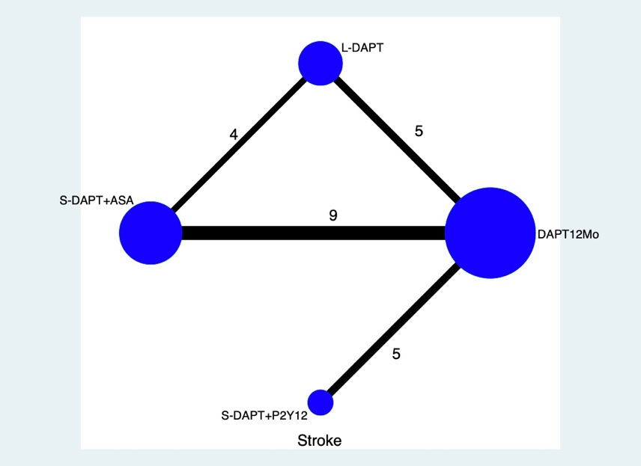
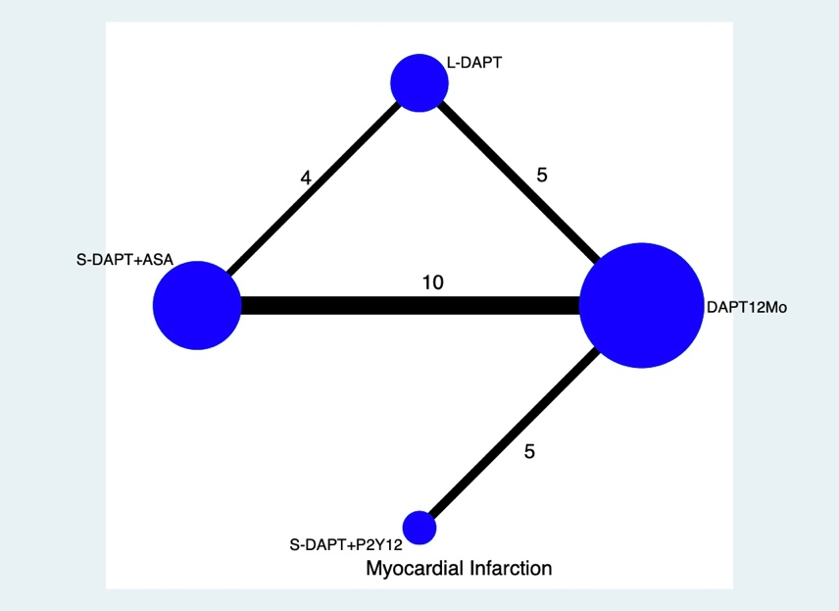
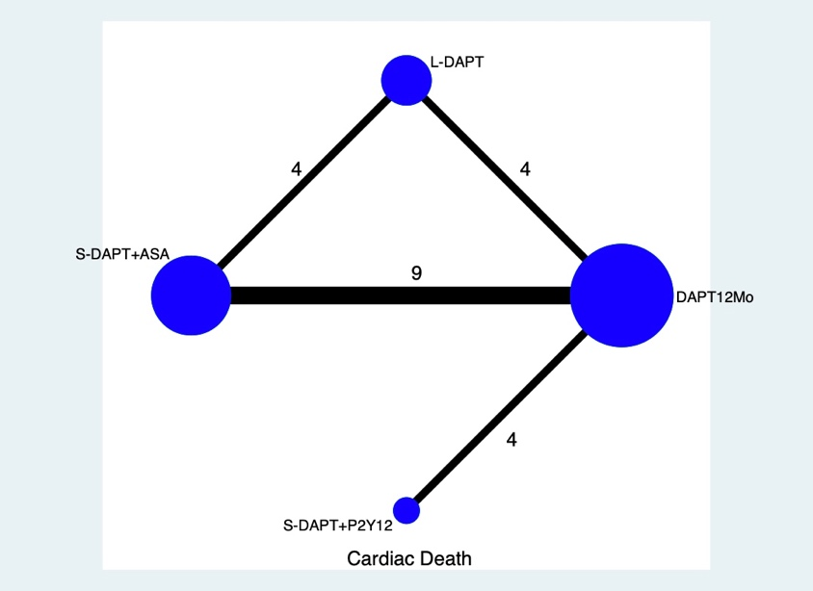
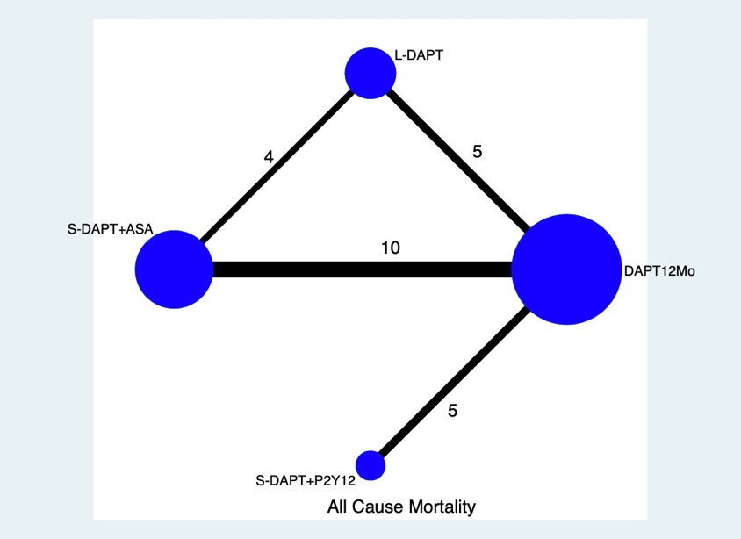

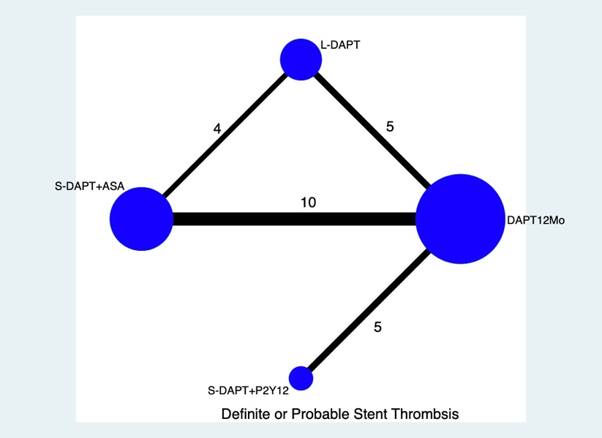
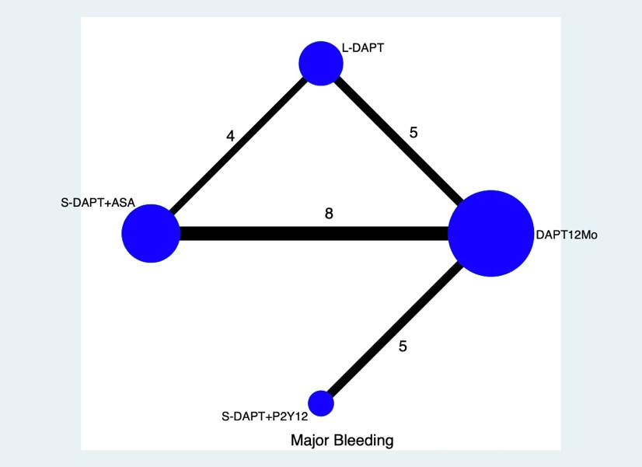
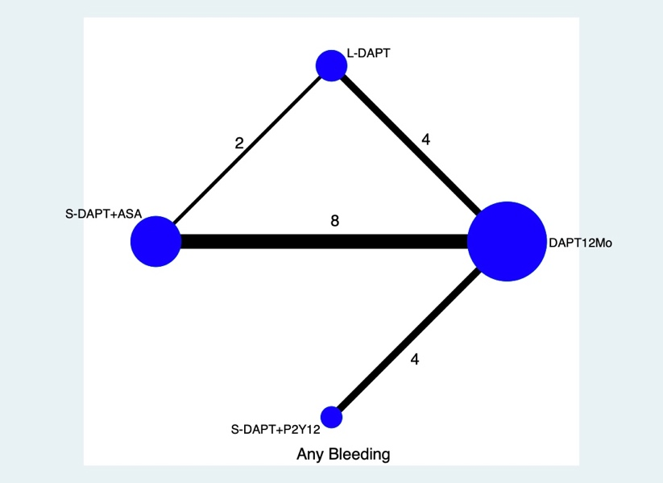

Table 4 The number of participants who had each outcome in each study
Trial | Treatment | All-cause  mortality | Cardiac death | MI | Stroke | Major bleeding | Any bleeding | Definite or probable ST
TICO [1] | S-DAPT+P2Y12 | 16 | 7 | 6 | 8 | 25 | 53 | 6
TICO [1] | DAPT 12Mo | 23 | 12 | 11 | 11 | 45 | 83 | 4
STOPDAPT-2 [2] | S-DAPT+P2Y12 | 21 | 9 | 13 | 8 | 3 | 6 | 4
STOPDAPT-2 [2] | DAPT 12Mo | 18 | 11 | 11 | 16 | 16 | 23 | 1
TWILIGHT [3] | S-DAPT+P2Y12 | 34 | 26 | 95 | 16 | 34 | 141 | 14
TWILIGHT [3] | DAPT 12Mo | 45 | 37 | 95 | 8 | 69 | 250 | 19
SMART-CHOICE [4] | S-DAPT+P2Y12 | 21 | 11 | 11 | 11 | 12 | 28 | 3
SMART-CHOICE [4] | DAPT 12Mo | 18 | 13 | 17 | 5 | 14 | 49 | 2
REDUCE [5] | S-DAPT+ASA | 23 | 13 | 26 | 2 | NA | 24 | 12
REDUCE [5] | DAPT 12Mo | 16 | 8 | 22 | 4 | NA | 29 | 6
GLOBAL LEADERS [6] | S-DAPT+P2Y12 | 224 | NA | 248 | 80 | 163 | NA | 64
GLOBAL LEADERS [6] | DAPT 12Mo | 253 | NA | 250 | 82 | 169 | NA | 64
OPTIMA-C [7] | S-DAPT+ASA | 2 | 1 | 1 | 0 | 1 | NA | 0
OPTIMA-C [7] | DAPT 12Mo | 3 | 2 | 1 | 2 | 1 | NA | 1
DAPT-STEMI [8] | S-DAPT+ASA | 3 | 2 | 8 | 3 | NA | 3 | 3
DAPT-STEMI [8] | DAPT 12Mo | 6 | 4 | 8 | 3 | NA | 5 | 4
SMART-DATE [9] | S-DAPT+ASA | 35 | 18 | 24 | 11 | 6 | 35 | 15
SMART-DATE [9] | L-DAPT | 39 | 24 | 10 | 12 | 10 | 51 | 10
NIPPON [10] | L-DAPT | 7 | 4 | 1 | 6 | 12 | NA | 1
NIPPON [10] | S-DAPT+ASA | 16 | 8 | 4 | 7 | 11 | NA | 2
ITALIC [15] | S-DAPT+ASA | 11 | 5 | 12 | 6 | 0 | NA | 6
ITALIC [15] | L-DAPT | 20 | 5 | 9 | 7 | 4 | NA | 3
IVUS-XPL study [11] | S-DAPT+ASA | 5 | 3 | 1 | 6 | 5 | NA | 2
IVUS-XPL study [11] | DAPT 12Mo | 10 | 5 | 0 | 3 | 7 | NA | 2
I-LOVE-IT 2 [13] | S-DAPT+ASA | 14 | 7 | 42 | 15 | 13 | 57 | 12
I-LOVE-IT 2 [13] | DAPT 12Mo | 17 | 8 | 37 | 18 | 7 | 60 | 8
OPTIDUAL [12] | L-DAPT | 16 | 10 | 11 | 5 | 4 | 18 | 3
OPTIDUAL [12] | DAPT 12Mo | 24 | 14 | 16 | 7 | 4 | 20 | 1
ISAR-SAFE [14] | S-DAPT+ASA | 8 | NA | 13 | 7 | 2 | 27 | 5
ISAR-SAFE [14] | DAPT 12Mo | 12 | NA | 14 | 5 | 8 | 55 | 4
DAPT Study [16] | L-DAPT | 98 | 45 | 99 | 37 | 38 | 263 | 19
DAPT Study [16] | DAPT 12Mo | 74 | 47 | 198 | 43 | 26 | 137 | 65
DES LATE [17] | DAPT 12Mo | 32 | 19 | 27 | 21 | 74 | 24 | 11
DES LATE [17] | L-DAPT | 46 | 28 | 19 | 21 | 89 | 34 | 7

SECURITY [18] | S-DAPT+ASA | 14 | 6 | 21 | 6 | 5 | 6 | 3
SECURITY [18] | DAPT 12Mo | 15 | 6 | 19 | 3 | 8 | 10 | 3
ARCTIC-Interruption [19] | L-DAPT | 7 | NA | 9 | 6 | 7 | 12 | 0
ARCTIC-Interruption [19] | DAPT 12Mo | 9 | NA | 9 | 4 | 1 | 3 | 3
OPTIMIZE [20] | S-DAPT+ASA | 43 | 29 | 49 | 5 | 10 | 35 | 13
OPTIMIZE [20] | DAPT 12Mo | 45 | 32 | 42 | 5 | 14 | 45 | 12
PRODIGY [21] | L-DAPT | 65 | 36 | 39 | 21 | 16 | 73 | 13
PRODIGY [21] | S-DAPT+ASA | 65 | 37 | 41 | 14 | 6 | 34 | 15
RESET [22] | S-DAPT+ASA | 5 | 2 | 2 | 6 | 2 | 5 | 2
RESET [22] | DAPT 12Mo | 8 | 4 | 4 | 6 | 6 | 10 | 3
EXCELLENT [23] | S-DAPT+ASA | 4 | 2 | 13 | NA | 2 | 4 | 6
EXCELLENT [23] | DAPT 12Mo | 7 | 3 | 7 | NA | 4 | 10 | 1
REAL-ZEST LATE [24] | L-DAPT | 20 | 13 | 10 | 9 | 3 | NA | 5
REAL-ZEST LATE [24] | DAPT 12Mo | 13 | 8 | 7 | 4 | 1 | NA | 4
NA, the concrete outcomes was not available; MI, myocardial infarction; ST, stent thrombosis

Table 5 Risk of bias of included trials using the Cochrane Risk Assessment Tool
Trial | Random sequence generation  (selection bias) | Allocation concealment  (selection bias) | Blinding of participants and personnel*  (performance bias) | Blinding of outcome assessment (detection bias) | Incomplete outcome data**  (attrition bias) | Selective reporting  (reporting bias) | Other sources of bias
TICO | + | + | ? | + | + | + | ?
STOPDAPT-2 | + | ? | ? | + | + | + | ?
TWILIGHT | + | + | + | + | + | + | ?
SMART-CHOICE | + | + | ? | + | + | + | ?
REDUCE | + | + | - | ? | + | + | -
GLOBAL LEADERS | + | + | + | ? | + | + | ?
OPTIMA-C | + | + | + | + | + | + | ?
DAPT-STEMI | + | ? | ? | + | + | + | ?
SMART-DATE | + | + | + | ? | + | + | ?
NIPPON | + | + | ? | + | + | + | ?
ITALIC | + | ? | ? | + | + | + | ?
IVUS-XPL study | + | + | ? | + | + | + | -
I-LOVE-IT 2 | + | - | ? | ? | + | + | ?
OPTIDUAL | + | ? | + | + | + | + | ?
ISAR-SAFE | + | + | + | + | + | + | ?
DAPT Study | ? | ? | + | - | + | + | ?
DES LATE | + | + | - | - | + | + | -
SECURITY | + | + | ? | ? | ? | + | -
ARCTIC-Interruption | + | + | + | ? | + | + | ?
OPTIMIZE | + | + | + | + | + | + | ?
PRODIGY | + | + | ? | ? | + | + | ?
RESET | + | + | ? | ? | + | + | -
EXCELLENT | + | + | ? | ? | + | + | -
REAL-ZEST LATE | + | + | - | - | + | + | -
*Despite that the trials used an open label trial design, the outcome assessment was blinded, and therefore the study design did not influence reported outcomes and hereby negatively effecting the quality of evidence.
**All trials reported minimal loss to follow-up.
Green refers to a low risk of bias; yellow refers to the uncertain risk of bias; red refers to a high risk of bias.

Table 6 Pooled estimates of the network meta-analysis of each endpoint. Results in the upper triangle are odds ratios (95% confidence intervals) from the network meta-analysis between the column defining intervention and row defining intervention. Significant results are in bold.
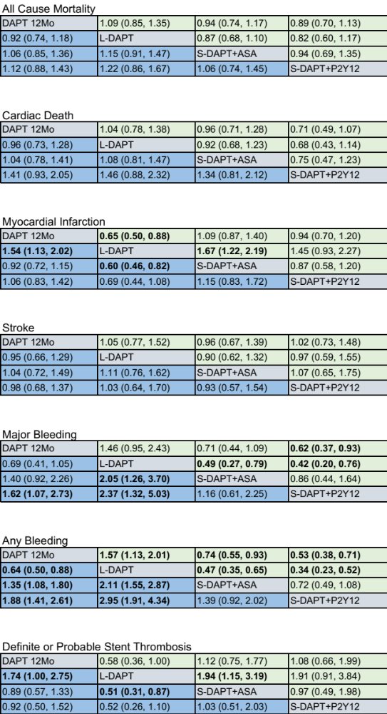
Table 7 Node-splitting analysis of Inconsistency for all endpoints
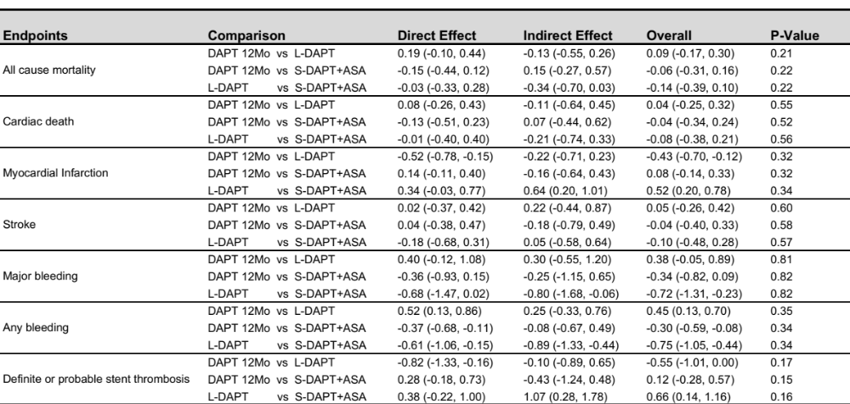

Table 8 Pooled estimates of the network meta-analysis of sensitivity analysis
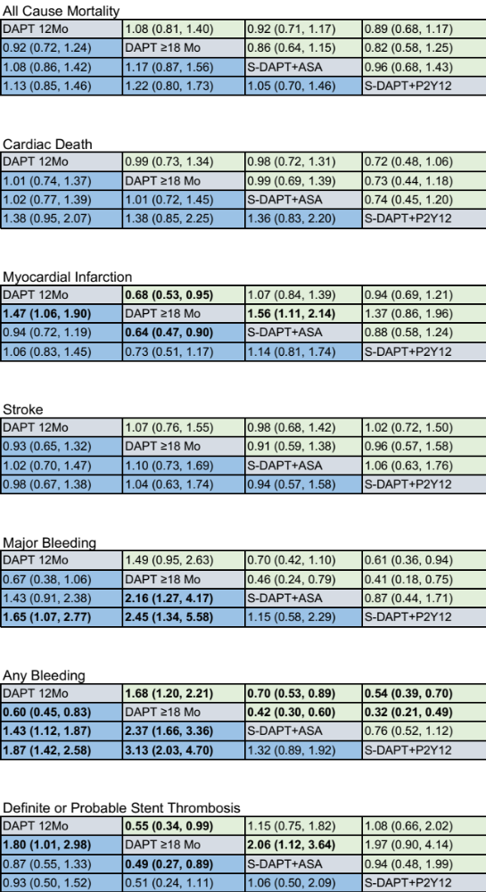
Table 9 The number of participants with acute coronary syndrome who had each outcome
Trial | Treatment | All-cause  mortality | MI | Major bleeding | Any bleeding | Definite or probable ST
TICO [1] | S-DAPT+P2Y12 | 16 | 6 | 25 | 53 | 6
TICO [1] | DAPT 12Mo | 23 | 11 | 45 | 83 | 4
GLOBAL LEADERS [27] | S-DAPT+P2Y12 | 38 | 50 | 28 | NA | NA
GLOBAL LEADERS [27] | DAPT 12Mo | 51 | 52 | 54 | NA | NA
REDUCE [5] | S-DAPT+ASA | 23 | 26 | NA | 24 | 12
REDUCE [5] | DAPT 12Mo | 16 | 22 | NA | 29 | 6
DAPT-STEMI [8] | S-DAPT+ASA | 3 | 8 | NA | 3 | 3
DAPT-STEMI [8] | DAPT 12Mo | 6 | 8 | NA | 5 | 4
IVUS-XPL+EXCELLENT+RESET [28] | S-DAPT+ASA | 9 | 7 | 4 | 9 | 6
IVUS-XPL+EXCELLENT+RESET [28] | DAPT 12Mo | 11 | 9 | 6 | 14 | 4
SMART-DATE [9] | S-DAPT+ASA | 35 | 24 | 6 | 35 | 15
SMART-DATE [9] | L-DAPT | 39 | 10 | 10 | 51 | 10
ITALIC [15] | S-DAPT+ASA | 4 | 7 | 0 | NA | 5
ITALIC [15] | DAPT 12Mo | 9 | 9 | 2 | NA | 3
PRODIGY [29] | S-DAPT+ASA | 56 | 39 | 6 | 3 | 5
PRODIGY [29] | L-DAPT | 52 | 33 | 9 | 18 | 10
ISAR-SAFE [30] | S-DAPT+ASA | 5 | 6 | 1 | 3 | 2
ISAR-SAFE [30] | DAPT 12Mo | 7 | 8 | 2 | 5 | 2
DAPT Study [31] | L-DAPT | 27 | 88 | 9 | 35 | 32
DAPT Study [31] | S-DAPT+ASA | 24 | 39 | 13 | 76 | 9
NA, the concrete outcomes was not available; MI, myocardial infarction; ST, stent thrombosis

Table 10 Pooled estimates of the network meta-analysis of each endpoint in Participants with Acute Coronary Syndrome
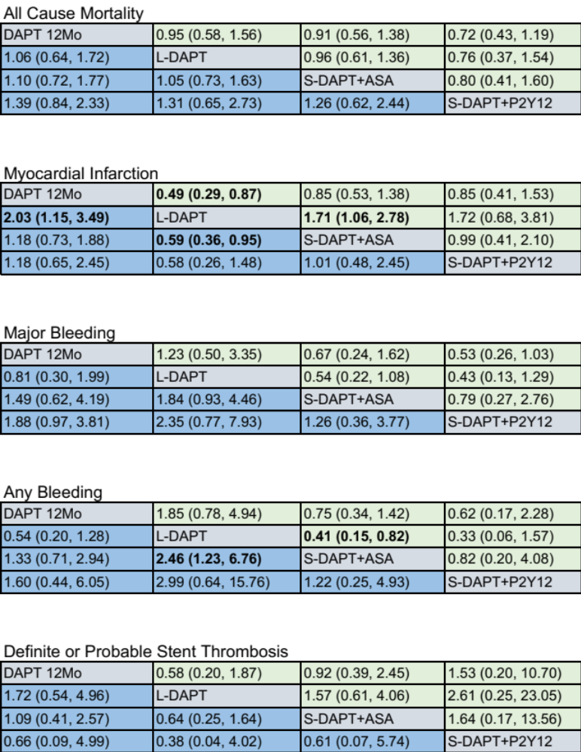

Fig3 Rankograms Demonstrating the Probability of Each Therapy Ranked at Each Endpoint in Participants with acute coronary syndrome
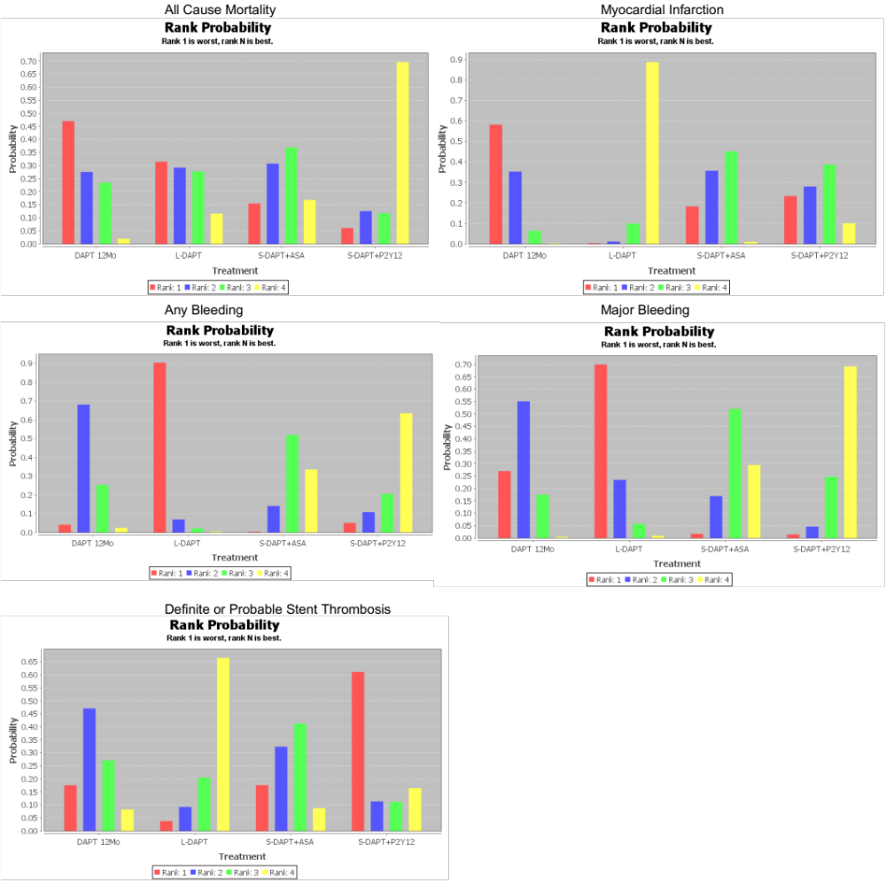

Table 11 Node-splitting analysis of inconsistency for all endpoints in participants with acute coronary syndrome
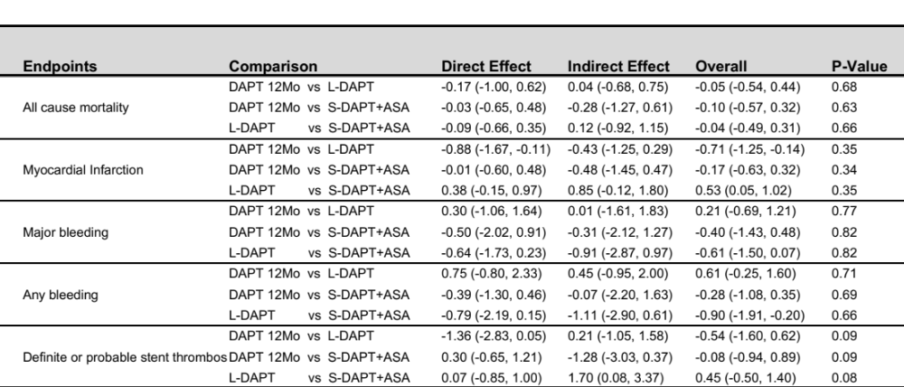
Table 12 The number of participants with newer-generation drug-eluting stents who had each outcome

Trial | Stent  type | Treatment | No. | All-cause  mortality | MI | Major bleeding | Any bleeding | Definite or probable ST
TICO [1] | BP-SES | S-DAPT+P2Y12 | 1527 | 16 | 6 | 25 | 53 | 6
TICO [1] | BP-SES | DAPT 12Mo | 1529 | 23 | 11 | 45 | 83 | 4
STOPDAPT-2 [2] | EES | S-DAPT+P2Y12 | 1500 | 21 | 13 | 3 | 6 | 4
STOPDAPT-2 [2] | EES | DAPT 12Mo | 1509 | 18 | 11 | 16 | 23 | 1
TWILIGHT [3] | DES | S-DAPT+P2Y12 | 3555 | 34 | 95 | 34 | 141 | 14
TWILIGHT [3] | DES | DAPT 12Mo | 3564 | 45 | 95 | 69 | 250 | 19
SMART-CHOICE [4] | EES/BP-SES/ZES | S-DAPT+P2Y12 | 1495 | 21 | 11 | 12 | 28 | 3
SMART-CHOICE [4] | EES/BP-SES/ZES | DAPT 12Mo | 1498 | 18 | 17 | 14 | 49 | 2
REDUCE [5] | MASCOT | S-DAPT+ASA | 733 | 23 | 26 | NA | 24 | 12
REDUCE [5] | MASCOT | DAPT 12Mo | 727 | 16 | 22 | NA | 29 | 6
GLOBAL LEADERS [6] | BES | S-DAPT+P2Y12 | 7980 | 224 | 248 | 163 | NA | 64
GLOBAL LEADERS [6] | BES | DAPT 12Mo | 7988 | 253 | 250 | 169 | NA | 64
OPTIMA-C [7] | BES/ZES | S-DAPT+ASA | 683 | 2 | 1 | 1 | NA | 0
OPTIMA-C [7] | BES/ZES | DAPT 12Mo | 684 | 3 | 1 | 1 | NA | 1
DAPT-STEMI [8] | BES/EES/ZES | S-DAPT+ASA | 433 | 3 | 8 | NA | 3 | 3
DAPT-STEMI [8] | BES/EES/ZES | DAPT 12Mo | 437 | 6 | 8 | NA | 5 | 4
SMART-DATE [9] | EES/ZES/BES | S-DAPT+ASA | 1357 | 35 | 24 | 6 | 35 | 15
SMART-DATE [9] | EES/ZES/BES | L-DAPT | 1355 | 39 | 10 | 10 | 51 | 10
NIPPON [10] | BES | L-DAPT | 1653 | 7 | 1 | 12 | NA | 1
NIPPON [10] | BES | S-DAPT+ASA | 1654 | 16 | 4 | 11 | NA | 2
ITALIC [15] | EES | S-DAPT+ASA | 926 | 11 | 12 | 0 | NA | 6
ITALIC [15] | EES | L-DAPT | 924 | 20 | 9 | 4 | NA | 3
IVUS-XPL study [11] | EES | S-DAPT+ASA | 699 | 5 | 1 | 5 | NA | 2
IVUS-XPL study [11] | EES | DAPT 12Mo | 701 | 10 | 0 | 7 | NA | 2
I-LOVE-IT 2 [13] | BP-SES | S-DAPT+ASA | 909 | 14 | 42 | 13 | 57 | 12
I-LOVE-IT 2 [13] | BP-SES | DAPT 12Mo | 920 | 17 | 37 | 7 | 60 | 8
DAPT Study [32] | EES | L-DAPT | 2345 | 49 | 48 | 21 | 57 | 6
DAPT Study [32] | EES | DAPT 12Mo | 2358 | 26 | 72 | 7 | 30 | 16

SECURITY [18] | ZES/BES/EES | S-DAPT+ASA | 682 | 14 | 21 | 5 | 6 | 3
SECURITY [18] | ZES/BES/EES | DAPT 12Mo | 717 | 15 | 19 | 8 | 10 | 3
OPTIMIZE [20] | ZES | S-DAPT+ASA | 1563 | 43 | 49 | 10 | 35 | 13
OPTIMIZE [20] | ZES | DAPT 12Mo | 1556 | 45 | 42 | 14 | 45 | 12
PRODIGY [33] | ZES/EES | L-DAPT | 496 | 30 | 16 | 30 | NA | 4
PRODIGY [33] | ZES/EES | S-DAPT+ASA | 492 | 25 | 12 | 25 | NA | 1
EXCELLENT [23] | EES | S-DAPT+ASA | 540 | 3 | 9 | 2 | 3 | 3
EXCELLENT [23] | EES | DAPT 12Mo | 539 | 4 | 6 | 3 | 9 | 1

NA, the concrete outcomes was not available; MI, myocardial infarction; ST, stent thrombosis; L-DAPT, longer than 12 months DAPT; DAPT 12Mo,12 months DAPT; S-DAPT+ASA, shorter than 6-month DAPT followed by aspirin monotherapy; S-DAPT+P2Y12, shorter than 6-month DAPT followed by a P2Y12 receptor inhibitor monotherapy; BES, biolimus-eluting stent ; ZES, zotarolimus-eluting stent; BP-SES, biodegradable polymer sirolimus-eluting stent; EES, everolimus-eluting stent; MASCOT, The Multinational Abluminal Sirolimus Coated Bio-engineered Stent

Table 13 Pooled estimates of the network meta-analysis of each endpoint in Participants with newer-generation drug-eluting stents
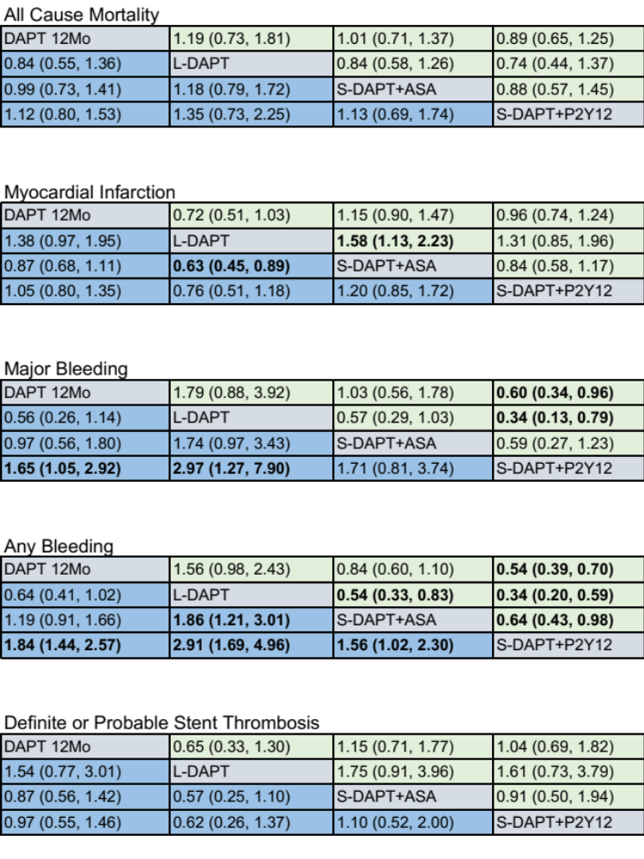

Fig. 4 Rankograms demonstrating the probability of each therapy ranked at Each endpoint in participants with newer-generation drug-eluting stents

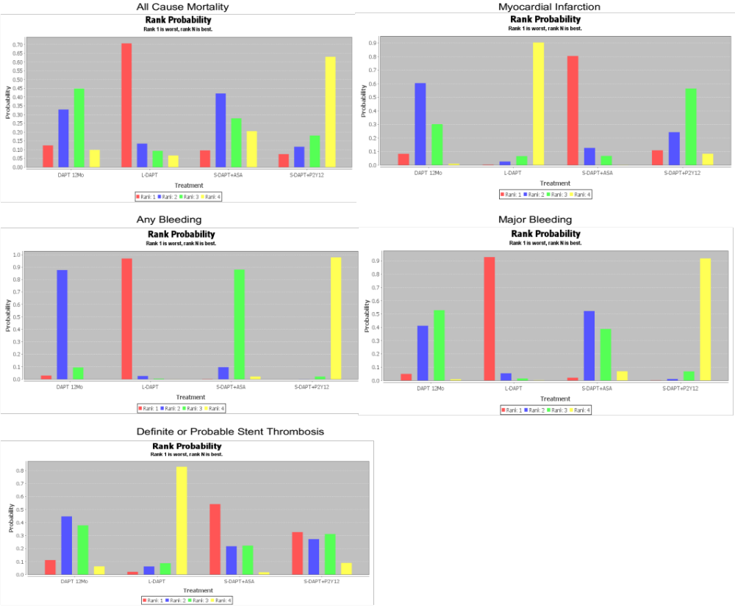

Table 14 Node-splitting analysis of inconsistency for all endpoints in participants with newer-generation drug-eluting stents

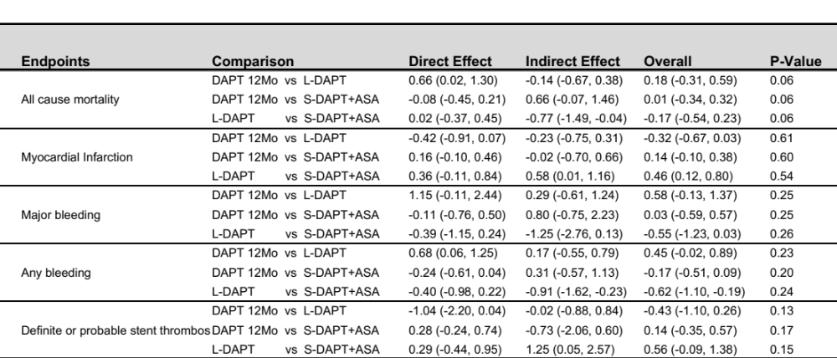
REFERENCES:
[1] Kim BK, Hong SJ, Cho YH, Yun KH, Kim YH, Suh Y, et al. Effect of Ticagrelor Monotherapy vs Ticagrelor With Aspirin on Major Bleeding and Cardiovascular Events in Patients With Acute Coronary Syndrome: The TICO Randomized Clinical Trial. Jama. 2020;323:2407-16.
[2] Watanabe H, Domei T, Morimoto T, Natsuaki M, Shiomi H, Toyota T, et al. Effect of 1-Month Dual Antiplatelet Therapy Followed by Clopidogrel vs 12-Month Dual Antiplatelet Therapy on Cardiovascular and Bleeding Events in Patients Receiving PCI: The STOPDAPT-2 Randomized Clinical Trial. JAMA - Journal of the American Medical Association. 2019;321:2414-27.
[3] Mehran R, Baber U, Sharma SK, Cohen DJ, Angiolillo DJ, Briguori C, et al. Ticagrelor with or without aspirin in high-risk patients after PCI. New England Journal of Medicine. 2019;381:2032-42.
[4] Hahn JY, Song YB, Oh JH, Chun WJ, Park YH, Jang WJ, et al. Effect of P2Y12 Inhibitor Monotherapy vs Dual Antiplatelet Therapy on Cardiovascular Events in Patients Undergoing Percutaneous Coronary Intervention: the SMART-CHOICE Randomized Clinical Trial. JAMA. 2019;321:2428‐37.
[5] De Luca G, Damen SA, Camaro C, Benit E, Verdoia M, Rasoul S, et al. Final results of the randomised evaluation of short-term dual antiplatelet therapy in patients with acute coronary syndrome treated with a new-generation stent (REDUCE trial). EuroIntervention. 2019;15:e990-e8.
[6] Vranckx P, Valgimigli M, Jüni P, Hamm C, Steg PG, Heg D, et al. Ticagrelor plus aspirin for 1 month, followed by ticagrelor monotherapy for 23 months vs aspirin plus clopidogrel or ticagrelor for 12 months, followed by aspirin monotherapy for 12 months after implantation of a drug-eluting stent: a multicentre, open-label, randomised superiority trial. The Lancet. 2018;392:940-9.
[7] Lee BK, Kim JS, Lee OH, Min PK, Yoon YW, Hong BK, et al. Safety of six-month dual antiplatelet therapy after secondgeneration drug-eluting stent implantation: OPTIMA-C randomised clinical trial and OCT substudy. EuroIntervention. 2018;13:1923-30.
[8] Kedhi E, Fabris E, van der Ent M, Buszman P, von Birgelen C, Roolvink V, et al. Six months versus 12 months dual antiplatelet therapy after drug-eluting stent implantation in ST-elevation myocardial infarction (DAPT-STEMI): randomised, multicentre, non-inferiority trial. BMJ (Clinical research ed). 2018;363:k3793.
[9] Hahn J-Y, Bin Song Y, Oh J-H, Cho D-K, Lee JB, Doh J-H, et al. 6-month versus 12-month or longer dual antiplatelet therapy after percutaneous coronary intervention in patients with acute coronary syndrome (SMART-DATE): a randomised, open-label, non-inferiority trial. Lancet. 2018;391:1274-84.
[10] Nakamura M, Iijima R, Ako J, Shinke T, Okada H, Ito Y, et al. Dual Antiplatelet Therapy for 6 Versus 18 Months After Biodegradable Polymer Drug-Eluting Stent Implantation. Jacc-Cardiovascular Interventions. 2017;10:1189-98.
[11] Hong S-J, Shin D-H, Kim J-S, Kim B-K, Ko Y-G, Choi D, et al. 6-Month Versus 12-Month Dual-Antiplatelet Therapy Following Long Everolimus-Eluting Stent Implantation The IVUS-XPL Randomized Clinical Trial. Jacc-Cardiovascular Interventions. 2016;9:1438-46.
[12] Helft G, Steg PG, Le Feuvre C, Georges JL, Carrie D, Dreyfus X, et al. Stopping or continuing clopidogrel 12 months after drug-eluting stent placement: The OPTIDUAL randomized trial. European Heart Journal. 2015;37:365-74.
[13] Han Y, Xu B, Xu K, Guan C, Jing Q, Zheng Q, et al. Six Versus 12 Months of Dual Antiplatelet Therapy After Implantation of Biodegradable Polymer Sirolimus-Eluting Stent: randomized Substudy of the I-LOVE-IT 2 Trial. Circulation Cardiovascular interventions. 2016;9:e003145.
[14] Schulz-Schüpke S, Byrne RA, Ten Berg JM, Neumann FJ, Han Y, Adriaenssens T, et al. ISAR-SAFE: A randomized, double-blind, placebo-controlled trial of 6 vs. 12 months of clopidogrel therapy after drug-eluting stenting. European Heart Journal. 2015;36:1252-63.
[15] Didier R, Morice MC, Barragan P, Noryani AAL, Noor HA, Majwal T, et al. 6-Versus 24-Month Dual Antiplatelet Therapy After Implantation of Drug-Eluting Stents in Patients Nonresistant to Aspirin Final Results of the ITALIC Trial (Is There a Life for DES After Discontinuation of Clopidogrel). Jacc-Cardiovascular Interventions. 2017;10:1202-10.
[16] Mauri L, Kereiakes DJ, Yeh RW, Driscoll-Shempp P, Cutlip DE, Steg PG, et al. Twelve or 30 months of dual antiplatelet therapy after drug-eluting stents. New England Journal of Medicine. 2014;371:2155-66.
[17] Lee CW, Ahn JM, Park DW, Kang SJ, Lee SW, Kim YH, et al. Optimal duration of dual antiplatelet therapy after drug-eluting stent implantation: a randomized, controlled trial. Circulation. 2014;129:304‐12.
[18] Colombo A, Chieffo A, Frasheri A, Garbo R, Masotti-Centol M, Salvatella N, et al. Second-Generation Drug-Eluting Stent Implantation Followed by 6-Versus 12-Month Dual Antiplatelet Therapy The SECURITY Randomized Clinical Trial. Journal of the American College of Cardiology. 2014;64:2086-97.
[19] Collet JP, Silvain J, Barthélémy O, Rangé G, Cayla G, Van Belle E, et al. Dual-antiplatelet treatment beyond 1 year after drug-eluting stent implantation (ARCTIC-Interruption): a randomised trial. Lancet. 2014;384:1577-85.
[20] Feres F, Costa RA, Abizaid A, Leon MB, Marin-Neto JA, Botelho RV, et al. Three vs Twelve Months of Dual Antiplatelet Therapy After Zotarolimus-Eluting Stents The OPTIMIZE Randomized Trial. Jama-Journal of the American Medical Association. 2013;310:2510-22.
[21] Valgimigli M, Campo G, Monti M, Vranckx P, Percoco G, Tumscitz C, et al. Short-versus long-term duration of dual-antiplatelet therapy after coronary stenting: A randomized multicenter trial. Circulation. 2012;125:2015-26.
[22] Kim BK, Hong MK, Shin DH, Nam CM, Kim JS, Ko YG, et al. A new strategy for discontinuation of dual antiplatelet therapy: The reset trial (real safety and efficacy of 3-month dual antiplatelet therapy following endeavor zotarolimus-eluting stent implantation). Journal of the American College of Cardiology. 2012;60:1340-8.
[23] Gwon HC, Hahn JY, Park KW, Song YB, Chae IH, Lim DS, et al. Six-month versus 12-month dual antiplatelet therapy after implantation of drug-eluting stents: The efficacy of xience/promus versus cypher to reduce late loss after stenting (EXCELLENT) randomized, multicenter study. Circulation. 2012;125:505-13.
[24] Park SJ, Park DW, Kim YH, Kang SJ, Lee SW, Lee CW, et al. Duration of dual antiplatelet therapy after implantation of drug-eluting stents. New England Journal of Medicine. 2010;362:1374-82.
[25] Cho S, Shin DH, Kim JS, Kim BK, Ko YG, Choi D, et al. Rationaleand design: impact of intravascular ultrasound guidance on long-term clinical outcomes of everolimus-eluting stents in long coronary lesions. Contemp Clin Trials. 2015;40:90-94
[26] Feres F, Costa RA, Abizaid A, Leon MB, Marin-Neto JA, Botelho RV, et al. Three vs Twelve Months of Dual Antiplatelet Therapy After Zotarolimus-Eluting Stents The OPTIMIZE Randomized Trial. Jama-Journal of the American Medical Association. 2013;310:2510-22.
[27] Tomaniak M, Chichareon P, Onuma Y, Deliargyris EN, Takahashi K, Kogame N, et al. Benefit and Risks of Aspirin in Addition to Ticagrelor in Acute Coronary Syndromes: A Post Hoc Analysis of the Randomized GLOBAL LEADERS Trial. JAMA Cardiol. 2019;4:1092-101.
[28] Jang JY, Shin DH, Kim JS, Hong SJ, Ahn CM, Kim BK, et al. Optimal duration of DAPT after second-generation drug-eluting stent in acute coronary syndrome. PLoS One. 2018;13:e0207386.
[29] Costa F, Vranckx P, Leonardi S, Moscarella E, Ando G, Calabro P, et al. Impact of clinical presentation on ischaemic and bleeding outcomes in patients receiving 6- or 24-month duration of dual-antiplatelet therapy after stent implantation: a pre-specified analysis from the PRODIGY (Prolonging Dual-Antiplatelet Treatment After Grading Stent-Induced Intimal Hyperplasia) trial. Eur Heart J. 2015;36:1242-51.
[30] Lohaus R, Michel J, Mayer K, Lahmann AL, Byrne RA, Wolk A, et al. Six Versus Twelve Months Clopidogrel Therapy After Drug-Eluting Stenting in Patients With Acute Coronary Syndrome: An ISAR-SAFE Study Subgroup Analysis. Sci Rep. 2016;6:33054.
[31] Yeh RW, Kereiakes DJ, Steg PG, Windecker S, Rinaldi MJ, Gershlick AH, et al. Benefits and Risks of Extended Duration Dual Antiplatelet Therapy After PCI in Patients With and Without Acute Myocardial Infarction. J Am Coll Cardiol. 2015;65:2211-21.
[32] Hermiller JB, Krucoff MW, Kereiakes DJ, Windecker S, Steg PG, Yeh RW, et al. Benefits and Risks of Extended Dual Antiplatelet Therapy After Everolimus-Eluting Stents. JACC Cardiovasc Interv. 2016;9:138-47.
[33] Valgimigli M, Borghesi M, Tebaldi M, Vranckx P, Parrinello G, Ferrari R. Should duration of dual antiplatelet therapy depend on the type and/or potency of implanted stent? A pre-specified analysis from the PROlonging Dual antiplatelet treatment after Grading stent-induced Intimal hyperplasia studY (PRODIGY). Eur Heart J. 2013;34:909-19.

