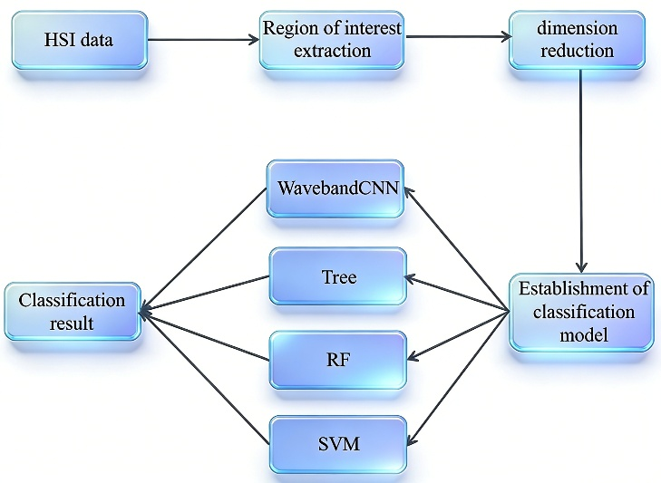
Fig.1 Flowchart of potatoes defect detection using hyperspectral images.

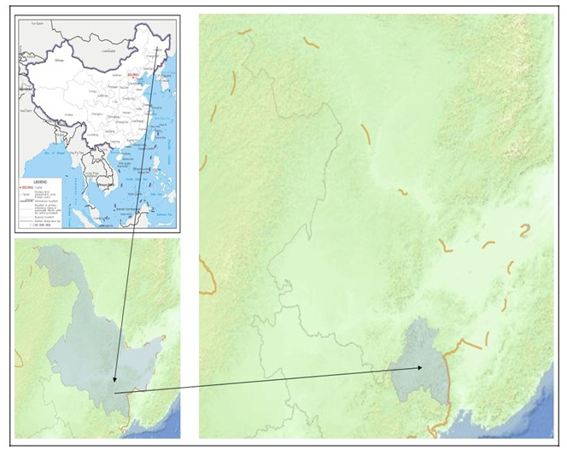
Fig.2. Geographical map of potato harvesting area
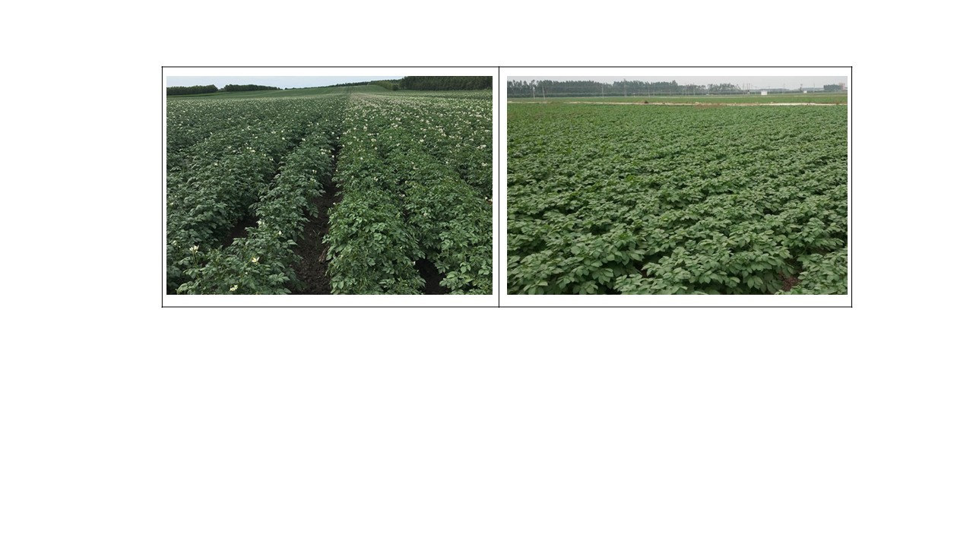
Fig.3. Potato planting base

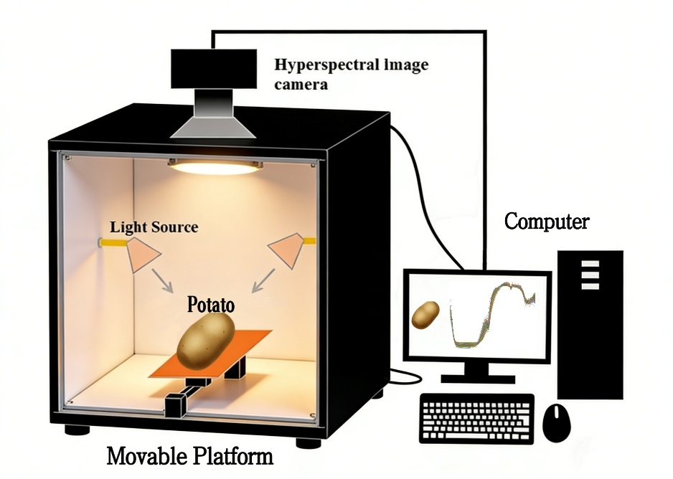
Fig.4. Schematic diagram of hyperspectral imaging system

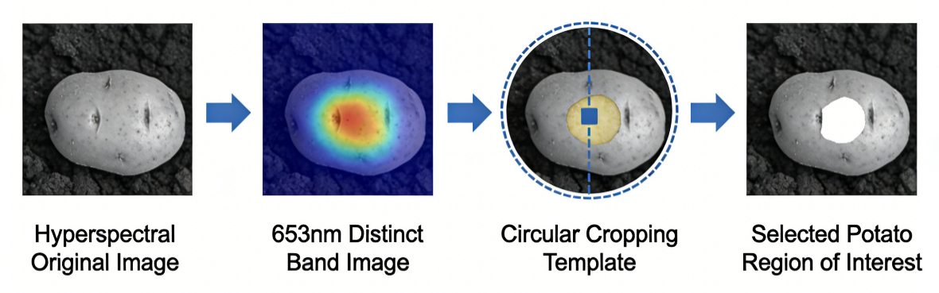
Fig.5. Region of interest extraction process
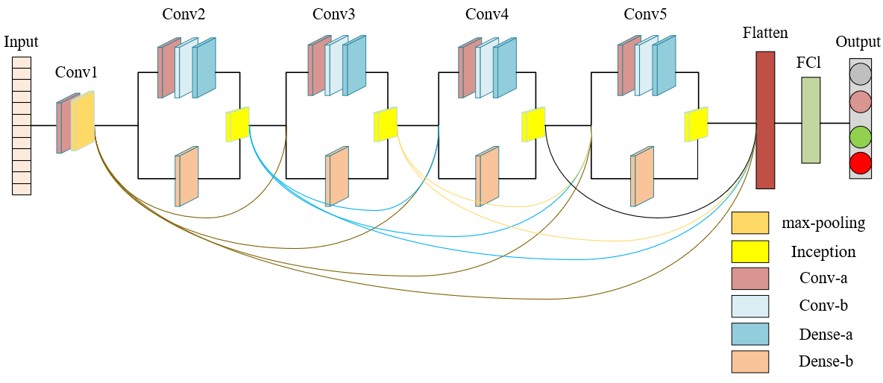Fig. 6. WavebandCNN model structure diagram.

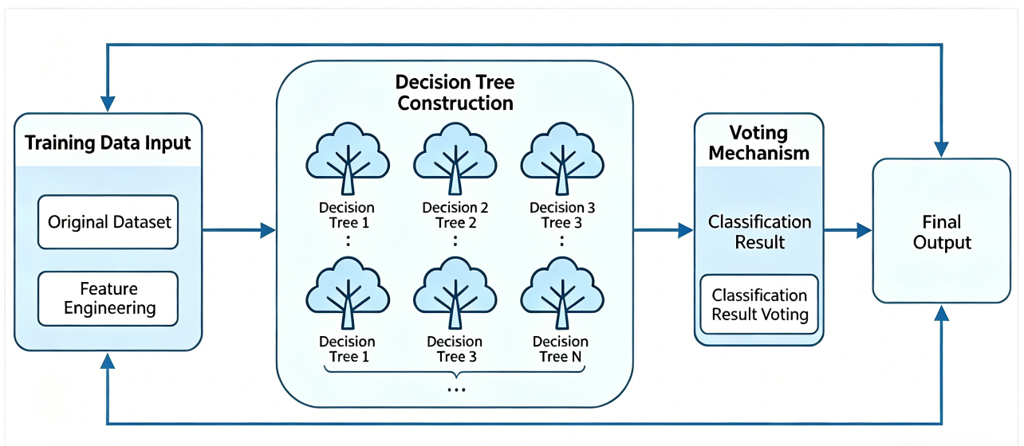
Fig. 7. Random forest algorithm training structure

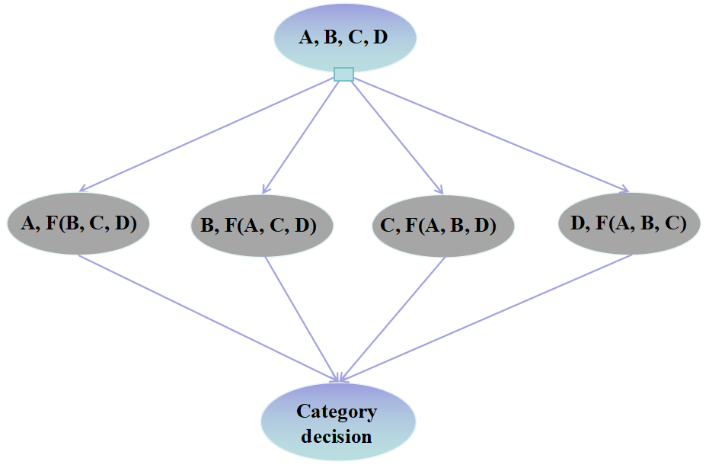
Fig. 8. Multi-categorical SVM classification model
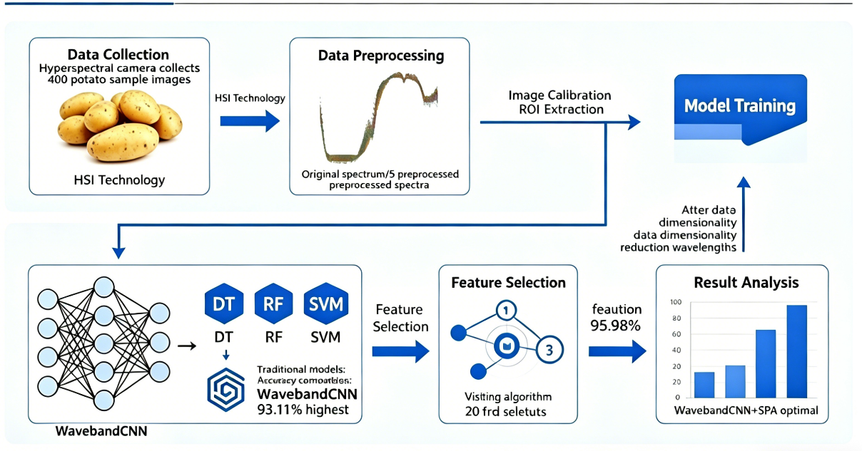
Fig. 9. Research implementation process

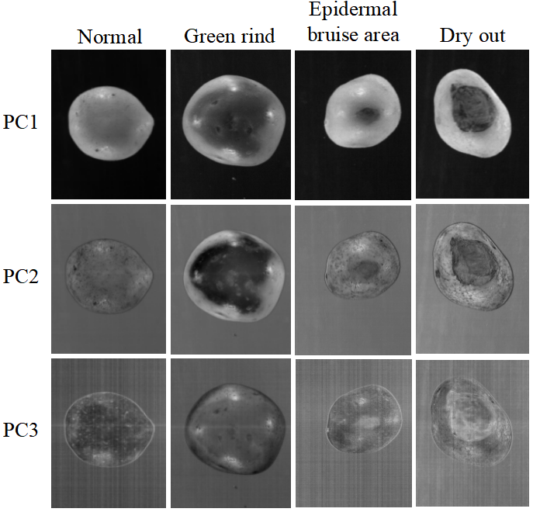
Fig. 10. The first three principal component images of the four samples

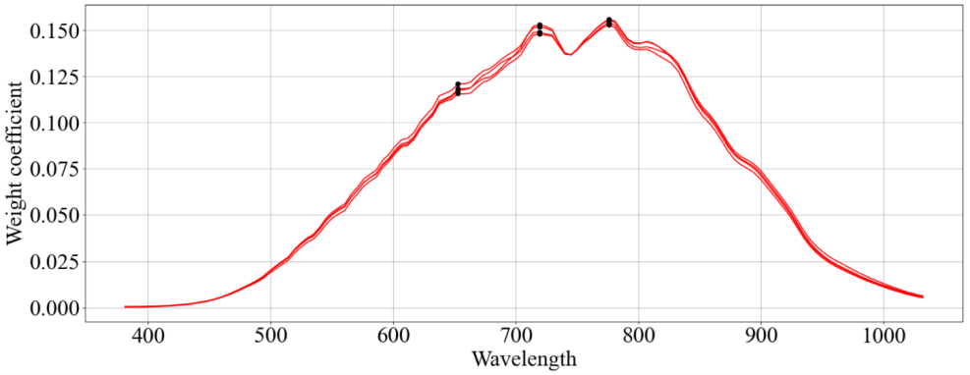
Fig. 11. Map of PC1 weighting factors.

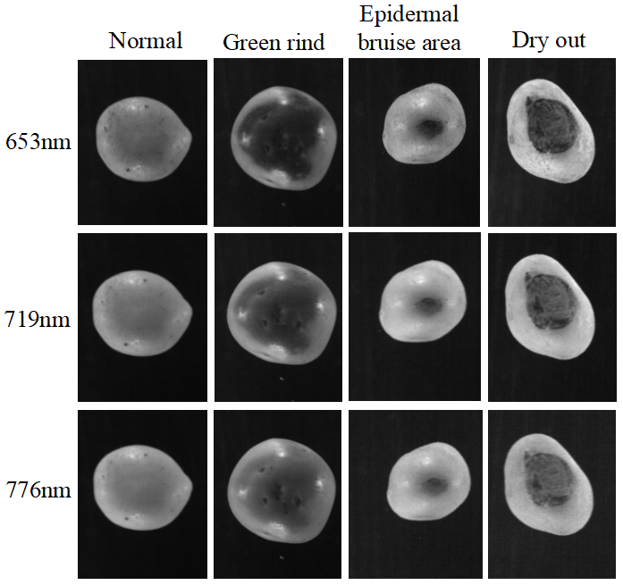
Fig. 12. Images of wavelengths corresponding to the extreme values of the weighting coefficients of PC1
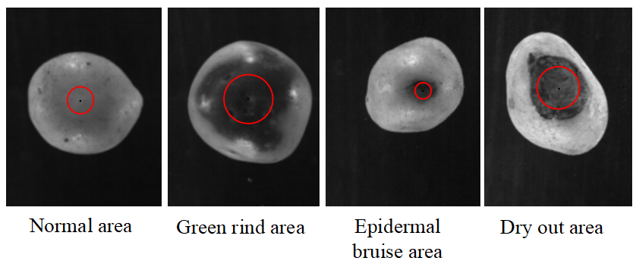
Fig. 13. Extraction of regions of interest
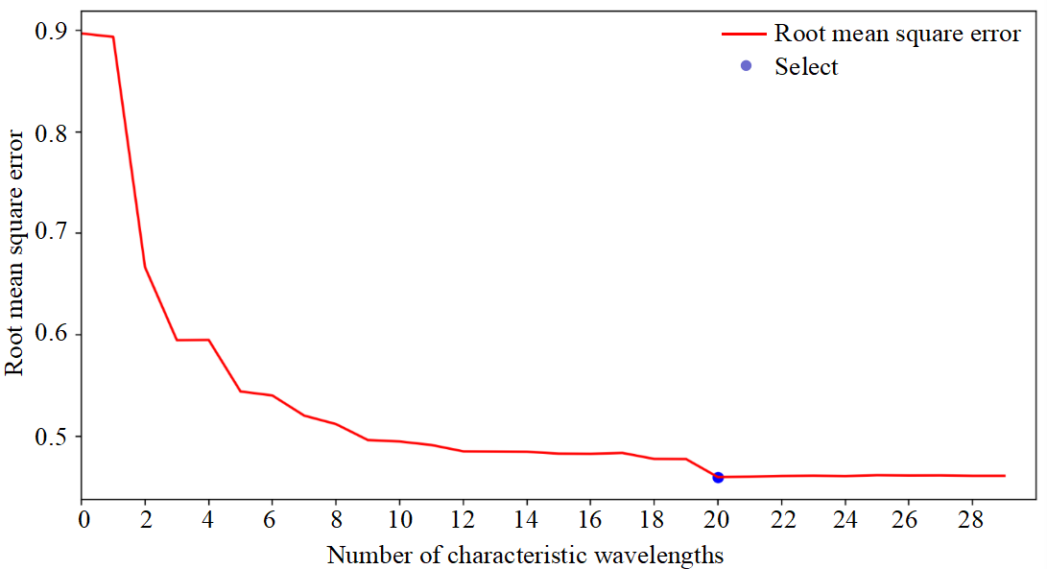
Fig. 14. Relationship between the number of characteristic wavelengths and RMSE.

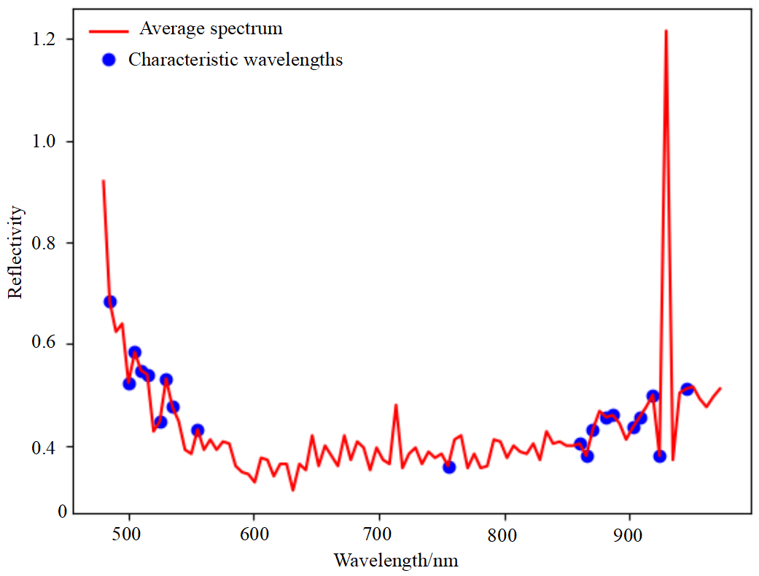
Fig. 15. Distribution map of characteristic wavelength points selected by SPA

