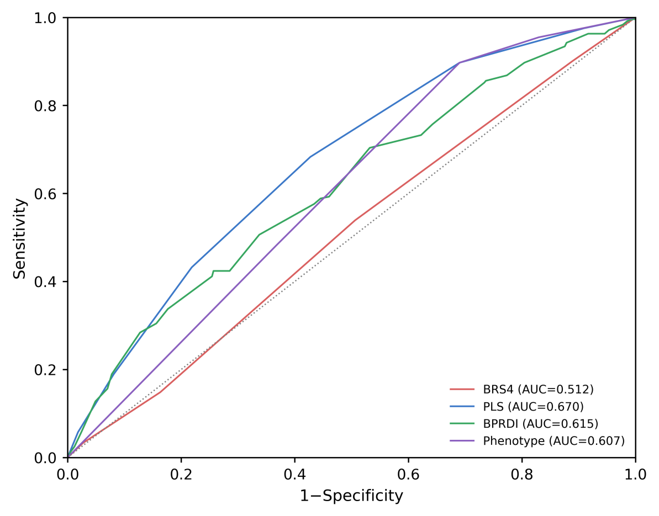
Supplementary Fig. 1 Receiver operating characteristic curves for single-marker discrimination predicting 5-year incident CMM risk. BRS4, behavioral risk score; PLS, physiological load score; BPRDI, behavioral physiological risk discordance index; CMM, cardiometabolic multimorbidity; AUC, area under the receiver operating characteristic curve.

