5hmC and TET2 Dysregulation in Bladder Cancer: Diagnostic and Prognostic Implications
Wiktoria Strasenburg^{1*}, Jakub Jóźwicki¹, Urszula Rogalla-Ładniak², Daria Piątkowska¹, Jakub Wojtasik³, Dariusz Grzanka¹

Antigen | Host and Clonality | Clone | Vendor | Dilution, Incubation | Positive controls | Procedure, Visualisation
5hmC | Rabbit, Polyclonal | #39769 | Active Motif | 1:1000,  32 min | Testis | High pH Antigen Retrieval CC1,  ultraView Universal DAB Detection Kit Hematoxylin II
TET2 | Rabbit, Polyclonal | GTX124205 | GeneTex | 1:100,  32 min | Lymph node | High pH Antigen Retrieval CC1, ultraView Universal DAB Detection Kit , Hematoxylin II
Table S1. Detailed information about antibodies and immunohistochemical protocols.

Gene | Forward primer sequence | Reverse primer sequence
TET2 | 5' CCAACCAAAAGAACAGCTGC 3' | 5' CTGCCACATTAGGACCTGCT 3'
GAPDH | 5' GTGGTCTCCTCTGACTTCAACA 3' | 5' CTCTTCCTCTTGTGCTCTTGCT 3'
Table S2. Sequences of primers used for TET2 target gene and GAPDH reference gene
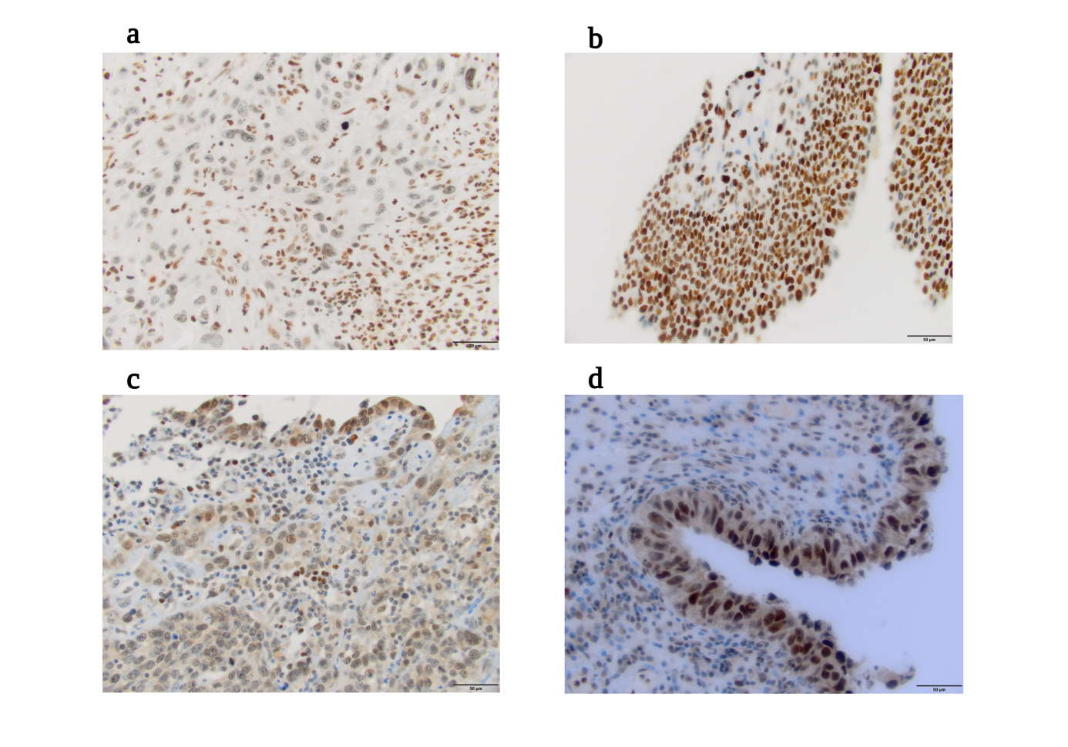
Figure S1. Representative immunohistochemical staining of 5hmC and TET2 in BLCA and adjacent non-tumour tissues (original magnification, ×40). (a) weak 5hmC staining in BLCA tissue; (b) strong 5hmC staining in adjacent non-tumour tissue; (c) weak TET2 staining in BLCA tissue; (d) strong TET2 staining in adjacent non-tumour tissue.

Variable | Univariate analysis |  |  | Multivariate analysis
Variable | HR | 95%CI | p value | HR | 95% CI | p value
TET2 (low vs high) | 0.786 | 0.579-1.068 | 0.1239 | 0.858 | 0.619-1.187 | 0.3543
Gender (female vs male) | 0.887 | 0.639-1.231 | 0.4720 | 0.863 | 0.609-1.225 | 0.4097
Age ≤60 vs > 60 | 1.911 | 1.297-2.817 | 0.0011 | 1.818 | 1.191-2.777 | 0.0057
pT status pTa-pT1 vs pT2-pT4
pN status pN0 vs pN+ | 2.289 | 1.668-3.141 | <0.0001 | 2.248 | 1.636-3.088 | <0.0001
Table S3. Univariate and multivariate Cox proportional hazards models for overall survival in BLCA patients from the TCGA cohort. Hazard ratios (HRs) with 95% confidence intervals (CIs) are presented. P< 0.05 was considered statistically significant; significant values are shown in bold.

Variable | Univariate analysis |  |  | Multivariate analysis
Variable | HR | 95%CI | p value | HR | 95% CI | p value
TET2 (low vs high) | 0.118 | 0.023-0.602 | 0.010 | 0.784 | 0.142-4.331 | 0.780
Gender (female vs male) | 1.323 | 0.451-3.884 | 0.610 | 1.612 | 0.421-6.171 | 0.486
Age ≤60 vs > 60 | 1.040 | 0.345-3.130 | 0.945 | 1.654 | 0.355-7.699 | 0.522
pT status pTa-pT1 vs pT2-pT4
pN status pN0 vs pN+ | 4.259 | 0.905-20.046 | 0.067 | 3.295 | 0.617-17.591 | 0.163
Table S4.Univariate and multivariate Cox proportional hazards models for overall survival in BLCA patients from the RT-qPCR cohort. Hazard ratios (HRs) with 95% confidence intervals (CIs) are presented. P< 0.05 was considered statistically significant; significant values are shown in bold.

