Supplementary material

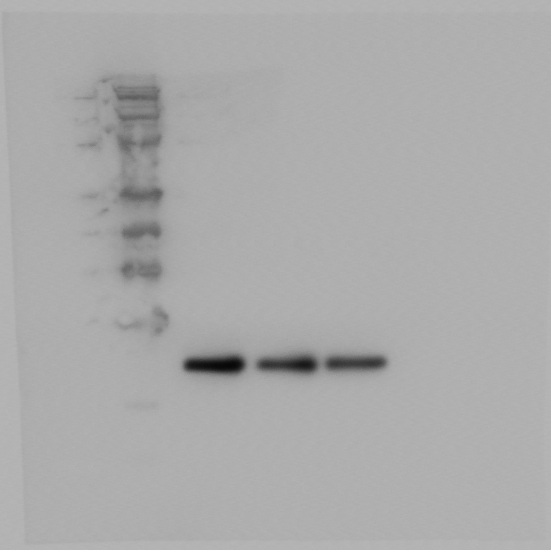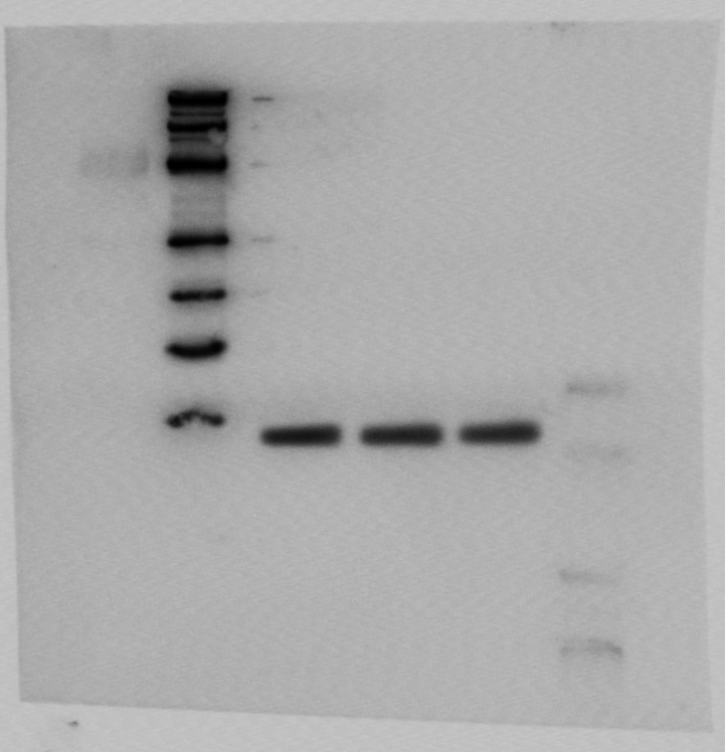
Full uncropped gels and blots images of Western blot analysis of CREG1 protein expression (24 kDa) after siRNA transfection in the U2OS group. GAPDH (38 kDa) was used as a loading control.
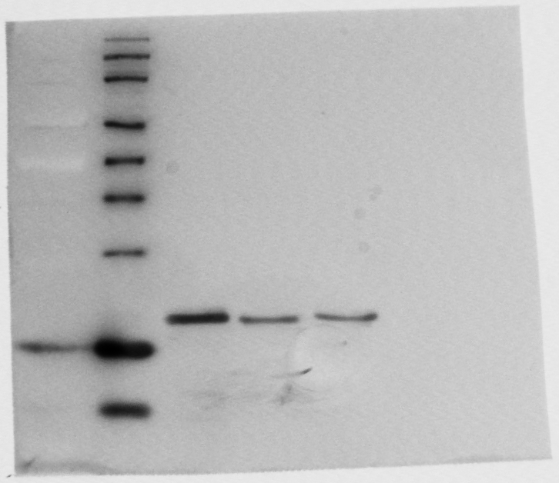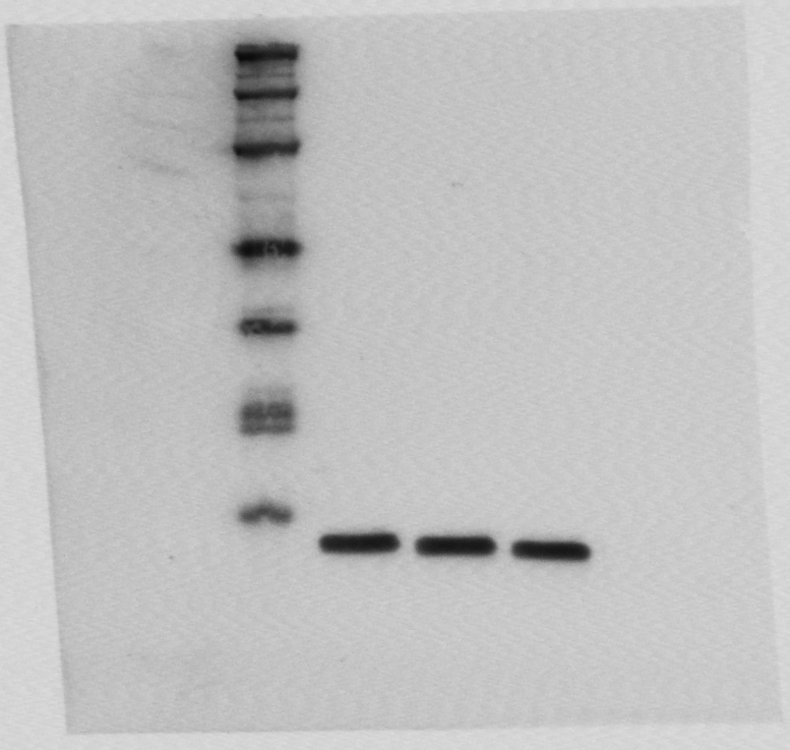
Full uncropped gels and blots images of Western blot analysis of CREG1 protein expression (24 kDa) after siRNA transfection in the 143B group. GAPDH (38 kDa) was used as a loading control.

