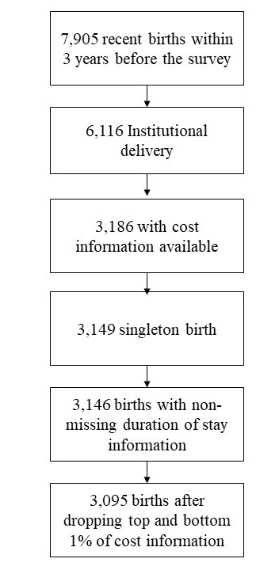
Supplementary Figure 1. Trial profile
Supplementary Table 1. Description of the variables used in the study
Explanatory variables | Categories | Description
Place of delivery | Public | Delivery took place in a government health facility
 | Private | Delivery occurred in a private hospital/clinic or other private medical facility
Mode of delivery | Vaginal | Normal or assisted vaginal birth
 | CS | CS delivery
Birth assisted by | Neither doctor nor a nurse/midwife/paramedic | Delivery was not assisted by a formally trained medical professional.
 | Either one | Delivery was assisted by either a doctor or a nurse/midwife/paramedic.
 | Both | Delivery was assisted by both a doctor and a nurse/midwife/paramedic.
Stay duration | <6 Hours | Mother discharged within six hours of delivery.
 | 6-23 Hours | Stayed for at least six hours but less than 24 hours.
 | 1-3 days | Stayed between one and three days.
 | 3-5 days | Stayed between three and five days
 | 5+ days | Stayed five or more days.
Wealth Index | Poorest | Households belonging to the lowest 20% of the wealth index distribution.
 | Poorer | Households belonging to the second 20% of the wealth index distribution.
 | Middle | Households belonging to the third 20% of the wealth index distribution.
 | Richer | Households belonging to the fourth 20% of the wealth index distribution.
 | Richest | Households belonging to the highest 20% of the wealth index distribution.
Residence | Rural | Respondent's type of place of residence is rural.
 | Urban | Respondent's type of place of residence is urban.
Division | Dhaka | Respondent lives in the Dhaka division
 | Barisal | Respondent lives in the Barisal division
 | Chattogram | Respondent lives in the Chattogram division
 | Khulna | Respondent lives in the Khulna division
 | Mymensingh | Respondent lives in the Mymensingh division.
 | Rajhshahi | Respondent lives in the Rajshahi division
 | Rangpur | Respondent lives in the Rangpur division.
 | Sylhet | Respondent lives in the Sylhet division.

Supplementary Figure 2. Histogram of regression model residuals for total delivery cost, Bangladesh, BDHS 2022.
