Appendix

Appendix 1. Univariate logistic regression results
Table A1. Results of univariate logistic regression
Characteristic | N | Event N | OR | 95% CI | p-value
History of abdominal surgery
no | 158 | 24 | — | —
yes | 208 | 58 | 2.16 | 1.27, 3.67 | 0.004
Peritonitis signs developing during conservative
no | 338 | 61 | — | —
yes | 28 | 21 | 13.62 | 5.54, 33.48 | <0.001
Heart rate | 366 | 82 | 1.09 | 1.06, 1.12 | <0.001
24-hour NLR increase after admission | 366 | 82 | 2.27 | 1.80, 2.86 | <0.001
fecal sign
no | 234 | 27 | — | —
yes | 132 | 55 | 5.48 | 3.22, 9.30 | <0.001
Mesenteric vascular sign
no | 333 | 60 | — | —
yes | 33 | 22 | 9.10 | 4.19, 19.77 | <0.001

Appendix 2. Multivariate logistic regression results with coefficients and standard error
Table A2. Results of multivariate logistic regression (coefficients and SE)
Characteristic | N | Event N | Estimate | SE | 95% CI | p-value
History of abdominal surgery
no | 158 | 24 | — | — | —
yes | 208 | 58 | 0.7429931750 | 0.3631830777 | 0.0311674230, 1.4548189271 | 0.041
Peritonitis signs developing during conservative
no | 338 | 61 | — | — | —
yes | 28 | 21 | 2.2519484067 | 0.5410328184 | 1.1915435682, 3.3123532453 | <0.001
Heart rate | 366 | 82 | 0.0825267906 | 0.0179936114 | 0.0472599602, 0.1177936209 | <0.001
24-hour NLR increase after admission | 366 | 82 | 0.8547182111 | 0.1505556396 | 0.5596345798, 1.1498018424 | <0.001
fecal sign
no | 234 | 27 | — | — | —
yes | 132 | 55 | 1.3721945962 | 0.3757556697 | 0.6357270166, 2.1086621757 | <0.001
Mesenteric vascular sign
no | 333 | 60 | — | — | —
yes | 33 | 22 | 1.5679361109 | 0.5544314935 | 0.4812703517, 2.6546018702 | 0.005
Abbreviations: CI = Confidence Interval, OR = Odds Ratio, SE = Standard Error, NA

Appendix 3. Goodness‑of‑fit tests

Table A3. Goodness‑of‑fit for the multivariate logistic regression model
Deviance | Number in dataframe | Number in model | Missing | AIC | BIC | C-statistic | McFadden's R² | Cox & Snell's R² | Nagelkerke's R²
224.4976 | 366 | 366 | 0 | 238.4976 | 265.816 | 0.8936791 | 0.4234905 | 0.3627388 | 0.5538737

Appendix 4. Classification accuracy at different risk thresholds
Table A4. Classification accuracy of the model at different risk thresholds
Risk score threshold | Linear Predictor Cutoff Point | Sensitivity (%) | Specificity (%) | PPV (%) | NPV (%) | Accuracy (%) | Precision (%) | Recall (%) | F1
≥ 0% | -Inf | 100.0 | 0.0 | 22.4 |  | 22.4 | 22.4 | 100.0 | 0.366
≥ 10% | -2.1972246 | 87.8 | 65.8 | 42.6 | 94.9 | 70.8 | 42.6 | 87.8 | 0.574
≥ 20% | -1.3862944 | 76.8 | 82.4 | 55.8 | 92.5 | 81.1 | 55.8 | 76.8 | 0.646
≥ 30% | -0.8472979 | 74.4 | 89.4 | 67.0 | 92.4 | 86.1 | 67.0 | 74.4 | 0.705
≥ 40% | -0.4054651 | 73.2 | 92.6 | 74.1 | 92.3 | 88.3 | 74.1 | 73.2 | 0.736
≥ 50% | 0.0000000 | 63.4 | 95.4 | 80.0 | 90.0 | 88.3 | 80.0 | 63.4 | 0.707
≥ 60% | 0.4054651 | 54.9 | 96.5 | 81.8 | 88.1 | 87.2 | 81.8 | 54.9 | 0.657
≥ 70% | 0.8472979 | 50.0 | 98.9 | 93.2 | 87.3 | 88.0 | 93.2 | 50.0 | 0.651
≥ 80% | 1.3862944 | 31.7 | 99.3 | 92.9 | 83.4 | 84.2 | 92.9 | 31.7 | 0.473
≥ 90% | 2.1972246 | 23.2 | 99.6 | 95.0 | 81.8 | 82.5 | 95.0 | 23.2 | 0.373
≥ 100% | Inf | 0.0 | 100.0 |  | 77.6 | 77.6 |  | 0.0

Appendix 5. Internal validation (10‑fold cross‑validation)

Table A5. AUC estimates from the logistic model validated by 10‑fold cross‑validation
model | AUC | se | lower | upper
Logistic GLM | 0.8723806 | 0.02411451 | 0.8251171 | 0.9196442

Table A6. Internal validation C‑index
Validation method |  | C-index | 95% CI | SE
cross-validated prediction |  | 0.872 | 0.825-0.920 | 0.024
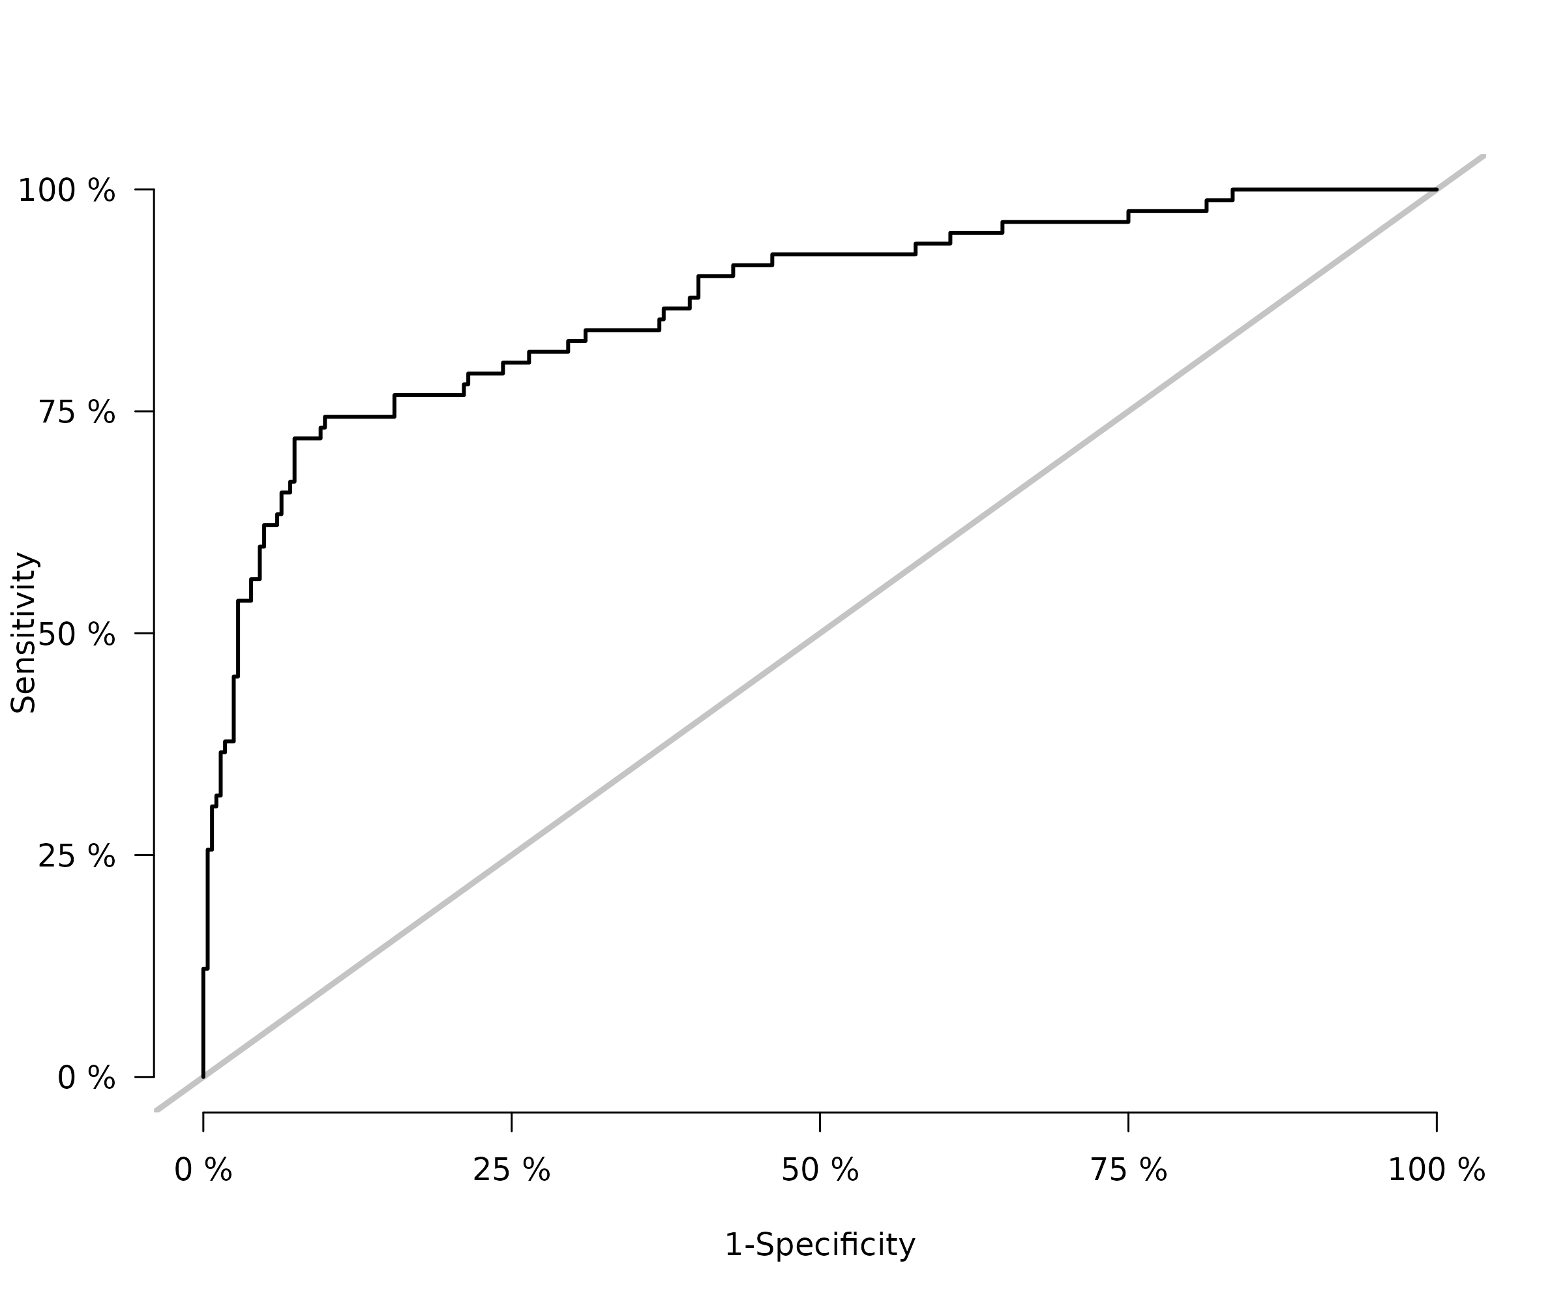Fig. A1 K‑fold cross‑validation ROC curves (k‑fold CV; riskRegression package).

