Supplementary Materials

Deep versus light sedation and 28-day mortality in mechanically ventilated sepsis: a causal analysis of two intensive care databases
Lujun Shao, Gaochao Lv, Yi Yuan, Cheng Xu, Huiyu Tai, Yue Li

Supplementary Methods
S1. Databases and data access
Two publicly available, de-identified critical care databases were used. The Medical Information Mart for Intensive Care IV (MIMIC-IV, version 3.1) contains the electronic health records of patients admitted to the intensive care units (ICUs) of a single tertiary academic medical centre in the United States. The eICU Collaborative Research Database (eICU-CRD, version 2.0) is a multicentre database aggregating ICU records contributed by hospitals across the United States. Both databases were accessed under credentialed PhysioNet access and were queried using Google BigQuery; data extraction was performed in Structured Query Language and all subsequent processing and analysis in R.
S2. Definition of sepsis
In MIMIC-IV, sepsis was identified using the database’s pre-computed Sepsis-3 definition, which requires evidence of suspected infection (the co-occurrence of antibiotic administration and microbiological culture sampling within a defined interval) together with an acute increase of at least two points in the Sequential Organ Failure Assessment (SOFA) score. In eICU-CRD, for which no pre-computed Sepsis-3 definition is available, sepsis was identified from the diagnosis records using International Classification of Diseases, Ninth Revision, Clinical Modification (ICD-9-CM) codes 995.91 (sepsis), 995.92 (severe sepsis), and 785.52 (septic shock); International Classification of Diseases, Tenth Revision, Clinical Modification (ICD-10-CM) codes A41 (other sepsis, all subcodes), R65.20 (severe sepsis without septic shock), and R65.21 (severe sepsis with septic shock); and recorded diagnosis strings containing the term “sepsis”.
S3. Invasive mechanical ventilation
In MIMIC-IV, the receipt and timing of invasive mechanical ventilation were determined from documented ventilation events and ventilator settings, and the start of invasive ventilation was taken as the onset of ventilation. In eICU-CRD, invasive mechanical ventilation was identified using the intubation indicator in the Acute Physiology and Chronic Health Evaluation (APACHE) physiology table together with respiratory documentation. Patients who received only non-invasive ventilation were not eligible. Eligibility required invasive mechanical ventilation to have been initiated within 24 hours of ICU admission.
S4. Sedation depth: extraction and classification of the Richmond Agitation-Sedation Scale
In MIMIC-IV, Richmond Agitation-Sedation Scale (RASS) scores were extracted from the charted observations (item identifier 228096). In eICU-CRD, RASS scores were extracted from the nursing flowsheet records in which the sedation scale was documented as the RASS. For each patient, all RASS values recorded during the first 48 hours of invasive mechanical ventilation were retrieved, and patients with fewer than six values in this window were excluded to ensure reliable classification. The median of the available RASS values was computed and used to classify the sedation strategy as deep (median ≤ −3), light (median −2 to 0), predominantly agitated (median ≥ +1), or intermediate (a median value falling between the deep and light strata). The median number of RASS assessments per patient within the window was 12 (interquartile range 10–13) in the MIMIC-IV cohort and 28 (interquartile range 15–46) in the eICU-CRD cohort; the median RASS score was −4 in the deep sedation group and −1 in the light sedation group of the MIMIC-IV cohort.
S5. Outcome definitions
The primary outcome, 28-day all-cause mortality, was ascertained from the structured death records of each database. In MIMIC-IV, date of death is derived from hospital records linked to the Massachusetts State Registry of Vital Records and Statistics, so that deaths occurring after hospital discharge are captured; accordingly, 28-day mortality in the primary cohort includes post-discharge deaths and was measured from time zero (48 hours after the initiation of invasive mechanical ventilation). In eICU-CRD, where vital status after hospital discharge is not recorded, 28-day mortality in the validation cohort reflects death within 28 days of time zero occurring before hospital discharge. ICU mortality and in-hospital mortality were determined from the discharge disposition records. Delirium was defined as at least one positive Confusion Assessment Method for the ICU (CAM-ICU) assessment recorded after time zero and was evaluated in the MIMIC-IV cohort only, because uniformly documented CAM-ICU data were not available in eICU-CRD; the secondary outcome of delirium therefore applies to the primary cohort alone.
S6. Covariate definitions
Age, sex, and race or ethnicity were obtained from the patient and admission records, and ICU type from the first ICU unit of the admission. The SOFA score and the Simplified Acute Physiology Score II (SAPS-II) were each taken as the worst (highest) value recorded within the first 48 hours, from the databases’ derived severity-of-illness tables; in eICU-CRD the APACHE IVa score was used as the corresponding measure of physiological derangement. The Charlson Comorbidity Index was derived from recorded diagnosis codes. Laboratory covariates were summarized as the worst value within the first 48 hours—the highest value for serum lactate, serum creatinine, and white blood cell count, and the lowest value for haematocrit. Septic shock was identified by a documented requirement for vasopressor support during the first 48 hours of invasive ventilation. The use and cumulative duration of sedative agents, neuromuscular blocking agents, and systemic corticosteroids during the exposure window were derived from the medication administration records of MIMIC-IV. The item identifiers and source tables used to construct each variable are listed in Table S4.
S7. Norepinephrine-equivalent vasopressor dose
Vasopressor exposure was summarized as the maximum norepinephrine-equivalent infusion rate recorded during the first 48 hours of invasive ventilation, obtained from the MIMIC-IV derived concept norepinephrine_equivalent_dose. This derived concept implements the equipotent conversion proposed in the scoping review of vasopressor dose equivalence by Goradia and colleagues. The norepinephrine-equivalent dose, expressed in micrograms per kilogram per minute, was computed as the sum of the norepinephrine infusion rate, the epinephrine infusion rate, one-tenth of the phenylephrine infusion rate, one-hundredth of the dopamine infusion rate, and the vasopressin infusion rate multiplied by 2.5; the vasopressin term was first converted from units per hour to units per minute. Metaraminol and angiotensin II, which appear in the original formula, were not administered in this cohort and were therefore not included. The highest value across the exposure window was retained for each patient.
S8. Missing data and multiple imputation
Missing data were confined to the laboratory covariates. In the MIMIC-IV cohort, serum lactate was missing for 11.9% of patients, and serum creatinine, haematocrit, and white blood cell count were each missing for fewer than 0.1%; all other covariates were complete. In the eICU-CRD cohort, serum lactate was missing for 24.8% of patients, the APACHE IVa score for 5.1%, and serum creatinine, haematocrit, and white blood cell count for 0.1%, 0.4%, and 0.6% respectively. Missing values were imputed by predictive mean matching using chained equations, with the exposure, all other covariates, and the outcome included in the imputation model. The primary analysis used a single imputed dataset; the multiple-imputation sensitivity analysis generated five imputed datasets, in each of which the complete propensity-score and outcome analysis was repeated, with the resulting estimates combined using Rubin’s rules.
S9. Propensity score estimation, weighting, and balance assessment
The propensity score—the probability of receiving deep rather than light sedation given the baseline covariates—was estimated by multivariable logistic regression. The MIMIC-IV model included all 30 covariates listed in Table S1; the eICU-CRD model included the 10 covariates listed in Table S3, the reduced set reflecting the covariates reliably recorded in that database (Methods). Stabilized inverse probability of treatment weights targeting the average treatment effect were computed, and to limit the influence of extreme weights they were truncated at the 99th percentile. After weighting, the effective sample size was 1,889 in the deep sedation group and 4,682 in the light sedation group of the MIMIC-IV cohort, and 197 and 603 respectively in the eICU-CRD cohort. Covariate balance before and after weighting was assessed by the absolute standardized mean difference, computed for every covariate; for binary covariates the standardized difference was used so that the metric is comparable across all variables and consistent with Table 1. A standardized mean difference below 0.1 was considered to indicate adequate balance. Balance is reported in Table S1 (MIMIC-IV) and Table S3 (eICU-CRD) and is displayed graphically in Figure S2 and Figure S3.
S10. Outcome models and sensitivity analyses
In the weighted sample, binary outcomes were analysed with logistic regression containing the exposure as the only covariate, yielding odds ratios; time to death within 28 days was analysed with a weighted Cox proportional hazards model, yielding a hazard ratio; and the absolute difference in 28-day mortality was estimated with a weighted linear model. Confidence intervals were obtained using a robust (sandwich) variance estimator. The proportional hazards assumption underlying the Cox model was assessed using scaled Schoenfeld residuals and was not satisfied (global test P < 0.001); the hazard ratio is therefore reported as an average effect over the 28-day follow-up period, and the odds ratio and the risk difference, which are defined at the fixed 28-day time point and do not require this assumption, are the principal effect measures for the primary outcome. Three sensitivity analyses were performed: 1:1 nearest-neighbour propensity score matching without replacement, using a caliper of 0.2 standard deviations of the logit of the propensity score; the multiple-imputation analysis described in Section S8; and an E-value analysis. The E-value was computed for the point estimate and for the confidence limit nearer the null, and quantifies the minimum strength of association, on the risk-ratio scale, that an unmeasured confounder would need to have with both the exposure and the outcome, beyond the measured covariates, to reduce the observed association to the null. Effect modification was assessed in four prespecified subgroups by repeating the weighted analysis within strata and testing a multiplicative exposure-by-subgroup interaction term.
S11. Software
All analyses were conducted in R (version 4.5.2). Inverse probability of treatment weighting and balance assessment used the WeightIt and cobalt packages; propensity score matching used MatchIt; weighted outcome models used the survey and survival packages; multiple imputation used the mice package; and the E-value analysis used the EValue package. All statistical tests were two-sided, and a P value below 0.05 was considered statistically significant.

Supplementary Tables
Table S1. Covariate balance before and after inverse probability of treatment weighting, MIMIC-IV primary cohort.
Covariate | SMD before weighting | SMD after weighting
Age | 0.246 | 0.022
Male sex | 0.112 | 0.017
Race or ethnicity
White | 0.226 | 0.028
Black | 0.044 | 0.007
Hispanic | 0.039 | 0.009
Asian | 0.009 | 0.017
Other or unknown | 0.208 | 0.016
ICU type
Coronary care unit | 0.107 | 0.006
Cardiac vascular ICU | 0.221 | 0.064
Medical ICU | 0.215 | 0.020
Medical / surgical ICU | 0.011 | 0.004
Surgical ICU | 0.043 | 0.033
Trauma surgical ICU | 0.140 | 0.017
Other | 0.027 | 0.008
SOFA score | 0.684 | 0.062
SAPS-II | 0.419 | 0.035
Charlson Comorbidity Index | 0.080 | 0.008
Septic shock | 0.167 | 0.002
Lactate (worst, 48 h) | 0.587 | 0.070
Creatinine (worst, 48 h) | 0.237 | 0.024
Haematocrit (worst, 48 h) | 0.090 | 0.002
White cell count (worst, 48 h) | 0.139 | 0.007
Norepinephrine-equivalent dose | 0.135 | 0.019
Propofol use | 0.054 | 0.006
Midazolam use | 0.391 | 0.036
Dexmedetomidine use | 0.420 | 0.050
Lorazepam use | 0.180 | 0.017
Neuromuscular blocker use | 0.752 | 0.056
Neuromuscular blockade duration | 0.723 | 0.082
Systemic corticosteroid use | 0.237 | 0.035
Values are absolute standardized mean differences (SMD); for binary covariates the standardized difference is reported, so that the metric is comparable with Table 1. The propensity score was estimated by multivariable logistic regression including all listed covariates, and stabilized inverse probability of treatment weights truncated at the 99th percentile were applied. Before weighting, 21 covariates had an SMD of at least 0.1; after weighting all 30 covariates had an SMD below 0.1, the largest residual imbalance being that for the duration of neuromuscular blockade (0.082). The standardization denominator was held constant at its unweighted value so that the before- and after-weighting columns are directly comparable. ICU, intensive care unit; SOFA, Sequential Organ Failure Assessment; SAPS-II, Simplified Acute Physiology Score II.

Table S2. Baseline characteristics of the eICU-CRD external validation cohort, according to sedation strategy.
Characteristic | Light sedation (n = 618) | Deep sedation (n = 226) | SMD
Age, years, mean (SD) | 63.8 (15.1) | 63.3 (16.4) | 0.03
Male sex, n (%) | 337 (54.5) | 115 (50.9) | 0.07
APACHE IVa score, median (IQR) | 90 (72–107) | 101 (82–120) | 0.42
Worst value within first 48 h
Lactate, mmol/L, median (IQR) | 2.2 (1.4–4.0) | 3.4 (1.8–6.1) | 0.41
Creatinine, mg/dL, median (IQR) | 1.5 (0.9–2.6) | 1.8 (1.0–2.9) | 0.00
Haematocrit, %, median (IQR) | 29.0 (25.1–33.2) | 27.4 (23.9–32.5) | 0.15
White cell count, ×10⁹/L, median (IQR) | 15.9 (11.1–21.6) | 17.4 (12.1–24.0) | 0.06
Vasopressor use, n (%) | 250 (40.5) | 78 (34.5) | 0.12
Renal replacement therapy, n (%) | 19 (3.1) | 2 (0.9) | 0.16
Medical or medical/surgical ICU, n (%) | 427 (69.1) | 168 (74.3) | 0.12
Continuous variables are presented as mean (standard deviation, SD) or median (interquartile range, IQR); categorical variables as number (percentage). The standardized mean difference (SMD) is the absolute crude (unweighted) value computed on the observed data; for binary covariates the standardized difference is reported. The APACHE IVa score and laboratory variables contained missing values (APACHE IVa, 5.1%; lactate, 24.8%; creatinine, 0.1%; haematocrit, 0.4%; white cell count, 0.6%); descriptive statistics reflect observed values, and missing data were handled by multiple imputation in the analysis (Supplementary Methods, Section S8). The corresponding standardized differences computed on the imputed analytic dataset are shown in Table S3 and differ owing to imputation, particularly for lactate, which had 24.8% missing values in eICU-CRD. APACHE, Acute Physiology and Chronic Health Evaluation; ICU, intensive care unit; eICU-CRD, eICU Collaborative Research Database.

Table S3. Covariate balance before and after inverse probability of treatment weighting, eICU-CRD external validation cohort.
Covariate | SMD before weighting | SMD after weighting
Age | 0.029 | 0.033
Male sex | 0.073 | 0.003
APACHE IVa score | 0.421 | 0.021
Lactate (worst, 48 h) | 0.296 | 0.004
Creatinine (worst, 48 h) | 0.003 | 0.019
Haematocrit (worst, 48 h) | 0.151 | 0.010
White cell count (worst, 48 h) | 0.052 | 0.038
Vasopressor use | 0.123 | 0.013
Renal replacement therapy | 0.157 | 0.048
Medical or medical/surgical ICU | 0.116 | 0.027
Values are absolute standardized mean differences (SMD), computed on the multiply imputed analytic dataset; for binary covariates the standardized difference is reported. The propensity score was estimated by logistic regression including the 10 listed covariates, and stabilized inverse probability of treatment weights truncated at the 99th percentile were applied. Before weighting, six covariates had an SMD of at least 0.1; after weighting all 10 covariates had an SMD below 0.1, the largest residual imbalance being that for renal replacement therapy (0.048). The reduced covariate set, relative to the primary cohort, reflects the variables reliably recorded in eICU-CRD; sedative and neuromuscular blocking agents were not included because their administration was substantially under-captured in the database (Methods). APACHE, Acute Physiology and Chronic Health Evaluation; ICU, intensive care unit; eICU-CRD, eICU Collaborative Research Database.

Table S4. Source tables and item identifiers used to construct study variables.
Variable | Database | Source table and item identifier
RASS score | MIMIC-IV | chartevents; item identifier 228096
RASS score | eICU-CRD | nursecharting; records with sedation scale recorded as RASS
Propofol | MIMIC-IV | inputevents; item identifier 222168
Midazolam | MIMIC-IV | inputevents; item identifier 221668
Dexmedetomidine | MIMIC-IV | inputevents; item identifier 225942
Lorazepam | MIMIC-IV | inputevents; item identifier 225974
Opioids | MIMIC-IV | inputevents; fentanyl 221744, hydromorphone 225154
Neuromuscular blockers | MIMIC-IV | inputevents; vecuronium 222062, rocuronium 222315, cisatracurium 221555 and 229632
Systemic corticosteroids | MIMIC-IV | inputevents; hydrocortisone 229617, methylprednisolone 221289, dexamethasone 226732
Lactate | MIMIC-IV | labevents; item identifier 50813
Creatinine | MIMIC-IV | labevents; item identifier 50912
Haematocrit | MIMIC-IV | labevents; item identifier 51221
White cell count | MIMIC-IV | labevents; item identifier 51301
Item identifiers refer to MIMIC-IV version 3.1. Severity-of-illness scores (SOFA, SAPS-II, APACHE IVa), the Charlson Comorbidity Index, sepsis status, and mechanical ventilation status were obtained from the derived concept tables of each database as described in the Supplementary Methods. RASS, Richmond Agitation-Sedation Scale; SOFA, Sequential Organ Failure Assessment; SAPS-II, Simplified Acute Physiology Score II; APACHE, Acute Physiology and Chronic Health Evaluation.

Table S5. Covariate balance before and after propensity score matching, MIMIC-IV primary cohort.
Covariate | SMD before matching | SMD after matching
Age | 0.237 | 0.019
Male sex | 0.114 | 0.017
Race or ethnicity
White | 0.220 | 0.010
Black | 0.043 | 0.020
Hispanic | 0.037 | 0.017
Asian | 0.008 | 0.017
Other or unknown | 0.196 | 0.015
ICU type
Coronary care unit | 0.100 | 0.023
Cardiac vascular ICU | 0.240 | 0.042
Medical ICU | 0.205 | 0.002
Medical / surgical ICU | 0.011 | 0.010
Surgical ICU | 0.042 | 0.052
Trauma surgical ICU | 0.152 | 0.006
Other | 0.019 | 0.024
SOFA score | 0.605 | 0.050
SAPS-II | 0.376 | 0.037
Charlson Comorbidity Index | 0.079 | 0.010
Septic shock | 0.174 | 0.014
Lactate (worst, 48 h) | 0.473 | 0.055
Creatinine (worst, 48 h) | 0.204 | 0.011
Haematocrit (worst, 48 h) | 0.084 | 0.002
White cell count (worst, 48 h) | 0.126 | 0.003
Norepinephrine-equivalent dose | 0.120 | 0.016
Propofol use | 0.053 | 0.025
Midazolam use | 0.374 | 0.021
Dexmedetomidine use | 0.440 | 0.012
Lorazepam use | 0.198 | 0.001
Neuromuscular blocker use | 0.630 | 0.046
Neuromuscular blockade duration | 0.550 | 0.063
Systemic corticosteroid use | 0.210 | 0.014
Values are absolute standardized mean differences (SMD) before and after 1:1 nearest-neighbour propensity score matching without replacement, performed with a caliper of 0.2 standard deviations of the logit of the propensity score; for binary covariates the standardized difference is reported. Matching produced 2,186 matched pairs; 642 deep sedation and 3,463 light sedation patients were left unmatched. Consistent with the matching estimand, the standardization denominator is the standard deviation of the deep sedation group, so the before-matching values differ slightly from the average-treatment-effect values in Table S1. Before matching, 21 covariates had a standardized difference of at least 0.1; after matching all 30 covariates had a standardized difference below 0.1, the largest being that for the duration of neuromuscular blockade (0.063). The propensity score itself was also well balanced after matching (standardized difference 0.057). ICU, intensive care unit; SOFA, Sequential Organ Failure Assessment; SAPS-II, Simplified Acute Physiology Score II.

Supplementary Figure Legends
Figure S1. Distribution of the estimated propensity score, MIMIC-IV cohort.
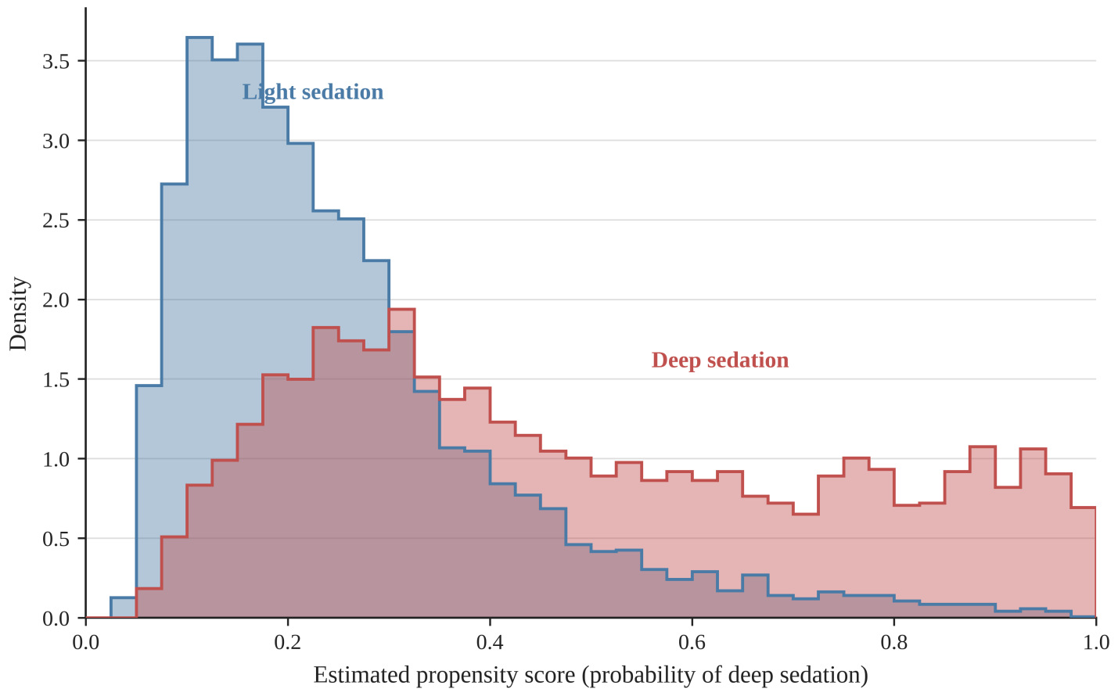
Distribution of the estimated propensity score for receipt of deep sedation, shown separately for the deep and light sedation groups before weighting, in the MIMIC-IV primary cohort. The substantial overlap of the two distributions across the range of the propensity score indicates that the positivity assumption is reasonably satisfied and that the groups are comparable for the purpose of weighting.
The propensity score was estimated by multivariable logistic regression including all 30 baseline covariates listed in Table S1.
Figure S2. Covariate balance before and after inverse probability of treatment weighting, MIMIC-IV cohort.
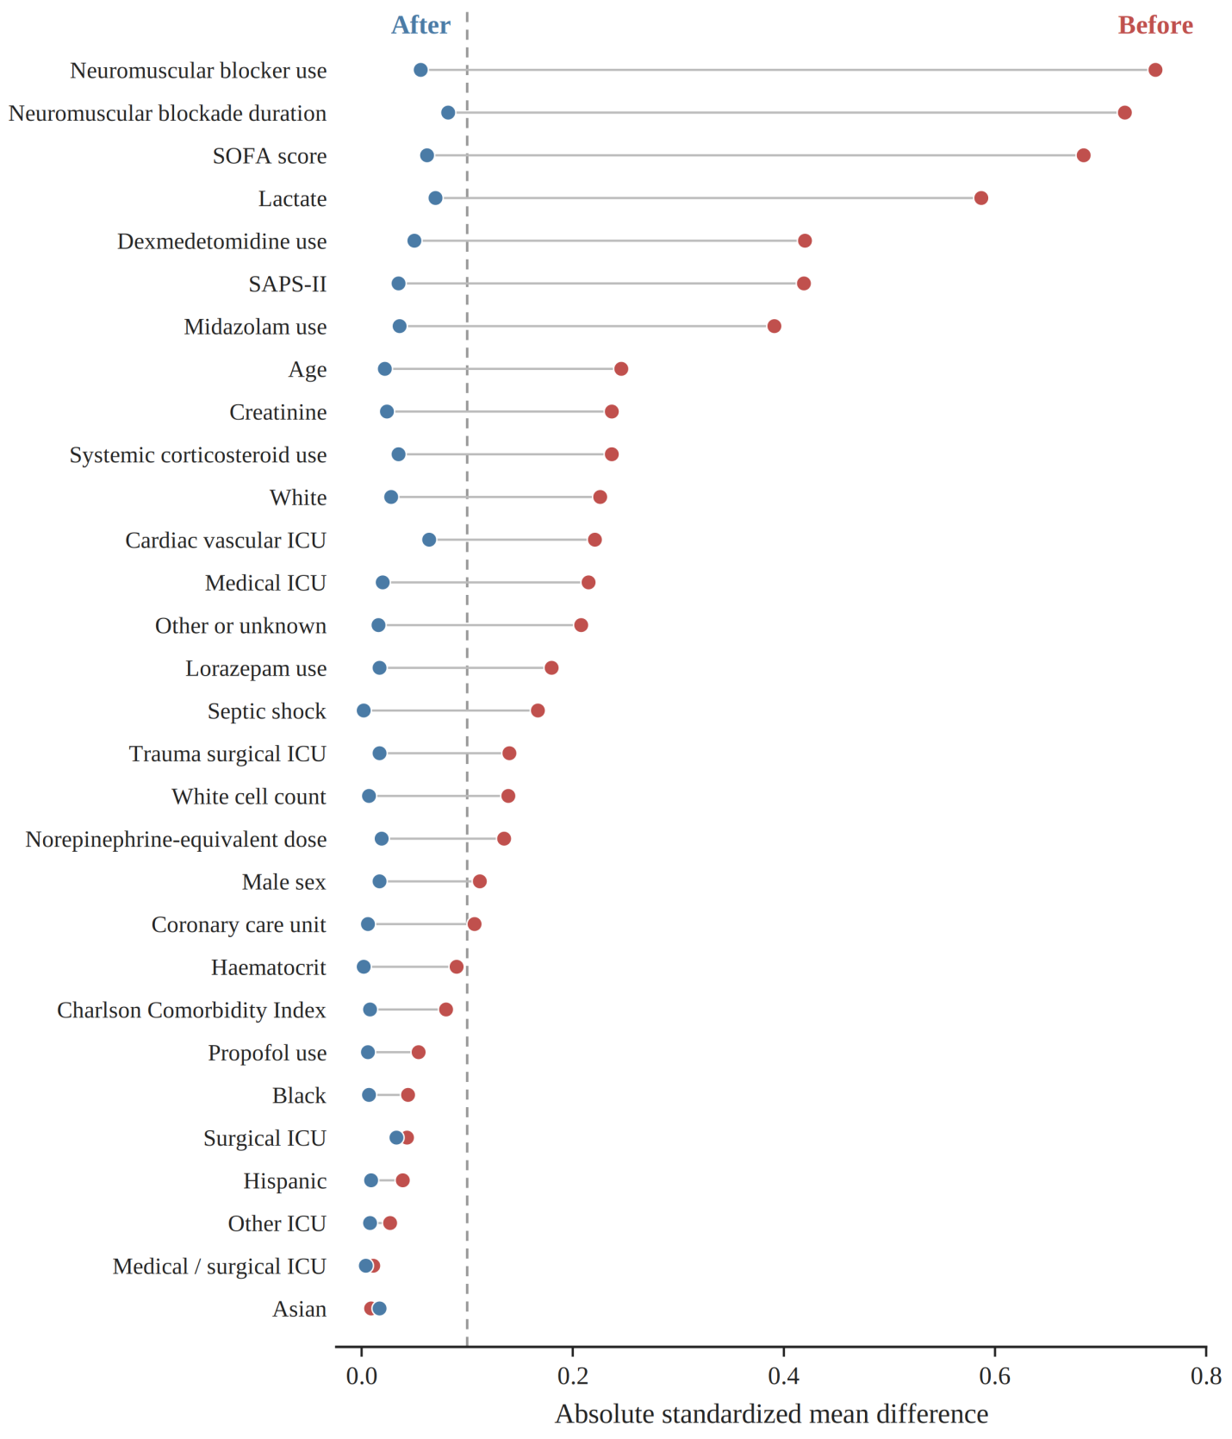
Love plot showing the absolute standardized mean difference for each of the 30 baseline covariates before and after inverse probability of treatment weighting in the MIMIC-IV primary cohort. Before weighting, several covariates—most notably the use and duration of neuromuscular blockade, the SOFA score, and serum lactate—were substantially imbalanced; after weighting, all covariates lay below the 0.1 threshold.
The vertical reference line is drawn at a standardized mean difference of 0.1. Corresponding numerical values are given in Table S1. SOFA, Sequential Organ Failure Assessment.
Figure S3. Covariate balance before and after inverse probability of treatment weighting, eICU-CRD cohort.
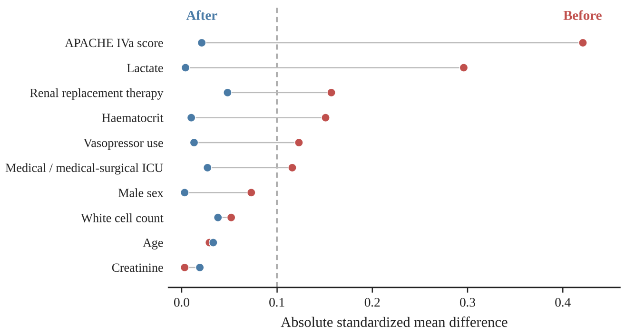
Love plot showing the absolute standardized mean difference for each of the 10 baseline covariates before and after inverse probability of treatment weighting in the eICU-CRD external validation cohort. Imbalances present before weighting, including those in the APACHE IVa score and serum lactate, were removed by weighting, with all covariates lying below the 0.1 threshold thereafter.
The vertical reference line is drawn at a standardized mean difference of 0.1. Corresponding numerical values are given in Table S3. APACHE, Acute Physiology and Chronic Health Evaluation; eICU-CRD, eICU Collaborative Research Database.

